1. A screenshot of a computer

   Description automatically generated
2. A screenshot of a computer

   Description automatically generated
3. A close-up of a computer screen

   Description automatically generated
4. A screen shot of a computer

   Description automatically generated
5. 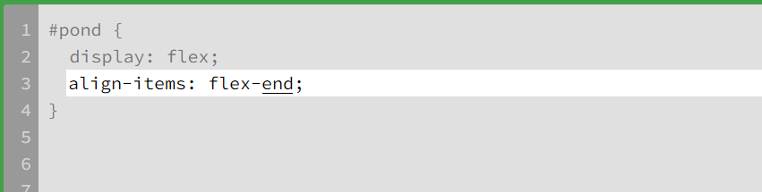
6. A screenshot of a computer

   Description automatically generated
7. A white rectangular object with black text

   Description automatically generated
8. A screen shot of a computer

   Description automatically generated
9. 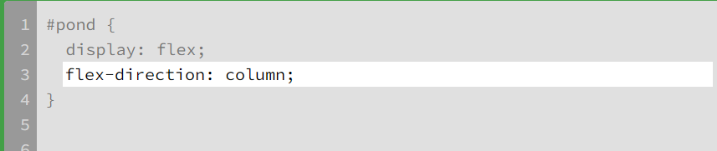
10. A screenshot of a computer program

    Description automatically generated
11. A screenshot of a computer

    Description automatically generated
12. A close-up of a computer screen

    Description automatically generated
13. A screenshot of a computer

    Description automatically generated
14. A white line on a gray background

    Description automatically generated
15. A white line on a gray background

    Description automatically generated
16. A screenshot of a computer

    Description automatically generated
17. A screenshot of a computer

    Description automatically generated
18. A white line on a gray background

    Description automatically generated
19. A screenshot of a computer

    Description automatically generated
20. A white line on a gray background

    Description automatically generated
21. 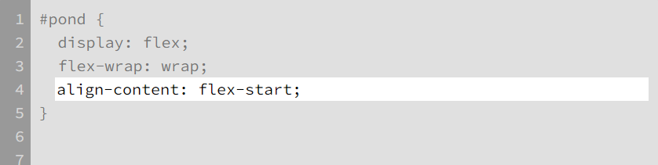
22. A screenshot of a computer

    Description automatically generated
23. A screenshot of a computer

    Description automatically generated
24. A screenshot of a computer

    Description automatically generated