

# HANOI UNIVERSITY OF SCIENCE AND TECHNOLOGY

**SCHOOL OF INFORMATION AND COMMUNICATION TECHNOLOGY**

------------

PROJECT REPORT

*AI Snake game problem*

Class: Introduction to Artificial Intelligence – 131117

**GROUP**

1. Trương Anh Huy – 20200287
2. Tống Trần Minh Đức –
3. Bùi Hữu Thành Công –

# INTRODUCTION

In the course Introduction to AI, we have studied about several kinds of Intelligent Agents such as simple reflex agents, model-based reflex agents, goal-based agents, utility-based agents, knowledge-based agents. Among them, utility-based agents, consider search cost and the path cost in the progress of trying to reach the goal. This agent is the topic we choose for our programming project.

In this report, we present the AI gardening problem and propose some methods for solving this problem. We will also concentrate on explain in details how each algorithm works with some helpful analyses.

**Contents**

1. Presentation of the subject 1
2. Description of the problem 2
   1. Detailed description of the problem 2
   2. Problem formulation 2
3. Algorithm selection 3
   1. Algorithm for searching 4
      1. A* Search Algorithm 4
      2. Breadth First Search(BFS) 5
   2. Algorithm for traversing :Depth First Search Algorithm (DFS) 6
4. Algorithms implementation in the propose problem 6
   1. Main difficulty 6
   2. Propose a solution to deal with the difficulties 7
   3. Algorithm improvement by the solution 8
5. Results comparison of the algorithm used for solving the problem 8
   1. Providing quantitative performance indicators 8
   2. Explaining these results 9
6. Conclusion and further discussions 10
7. List of tasks 10
   1. Programming tasks 10
   2. Analytic tasks 10
8. List of bibliographic reference 11

## Presentation of the subject

There is a m x m square grid. We denote (x,y) is the location of one square. The grid contains the following:

* + A snake which spans a few adjacent squares (Denote 1 for the head and 2 for body)
  + A food in a single square (only one food can exist at a time) (Denote 3)
  + Empty squares (Denote 0)

**0**

**3**

**0**

**0**

**0**

**0**

**0**

**1**

**0**

**0**

**0**

**0**

**2**

**0**

**0**

**0**

**0**

**2**

**0**

**0**

**0**

**0**

**0**

**0**

**0**

The snake starts at the middle of screen with an initial length and can perform the following actions:

* + The head of the snake can move in 4 directions: up, down, left, right; dragging the whole body along.

The snake can not go the direction of its adjacent body part

For example: the snake can not go down in the instance above.

* + When the head is in the same position as the food, the snake eats the food and increase its length by 1. After this, a new food is spawn at a random square where there is not a part of the snake (a 0 square)
  + The snake dies when the head meets any other body part or go outside of the grid.

Functionality of the AI:

* + The AI can control the snake in any direction (according to the rule).
  + The goal is to stay alive while eating food whenever possible

(prioritize survivability above all else).

## Description of the problem

### Detailed description of the problem

* + - The environment is known, fully observable, stochastic (deterministic in between eating section), static and discrete. Thus, the solution is not a fixed sequence of actions.
    - There are two main parts in this problem to deal with:
      * Searching: to find a path to the food
      * Traversing: guarantee snake's survival when no path to food is available and after eating food.
* How we solve these problems:
* To solve searching problem we use search algorithms
* To solve the traversing problem we make sure the snake always has a path from its head to its tail

## Problem formulation

* + - States:
* A list of unfixed size listing all the square which is body part of the snake from head to tail. Each square consists of:
  + The position of the square
  + The direction that square is heading
* The position of the food
  + - Initial state: A list of size INITIAL_LENGTH (the length the snake starts with) listing all body part of the snake and a randomly generated food position.
    - Actions: go up, go down, turn left, turn right.
    - Transition model: Expected effects
    - Goal test: This checks whether the snake is at its maximum length
    - Path cost: each action cost 1, so the path cost is number of actions taken.

## Algorithm selection

For searching the shortest path, we apply two algorithms: A* searching algorithm and Breadth first search algorithm (BFS).

For traversing we apply several methods to guarantee the snake's survival

* BFS is one of the best algorithms to find the shortest path in matrix problem. To find the shortest path, all you have to do is start from the source and perform a BFS and stop when you found your destination. The only additional thing you need to do is have an array previous[] which will store the previous node for every node visited.
* A* searching algorithm is also one of the best algorithms to find the shortest path in matrix problem. This algorithm is complete and optimal. Besides, the heuristic function in this problem is quite clear, which is the Manhattan distance (the sum of absolute differences between two point coordinates).
* Combining A* search(or BFS) algorithm with DFS algorithm, we can find the shortest path and traverse through every single cell in the matrix.

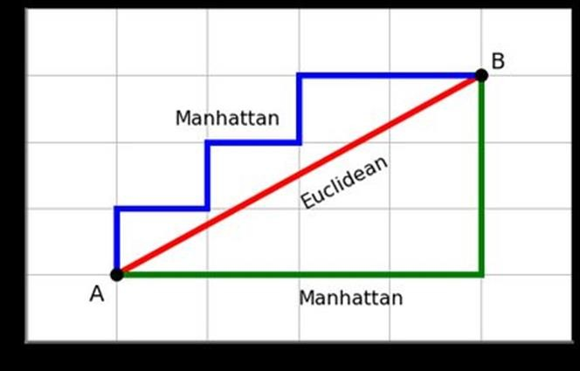

### Algorithm for searching: 3.1.1 A* Search Algorithm

We apply the A* search into this problem:

* + - Consider a square grid having many obstacles and we are given a starting cell and a target cell. We want to reach the target cell (if possible) from the starting cell as quickly as possible. So here we use A* Search Algorithm.
    - The heuristic function in this algorithm is the Manhattan distance (the sum of the absolute differences between coordinates of two points) of the point considered. (For example, the Manhattan distance between (x1,y1) and (x2,y2) is |x1 - x2| + |y1 - y2|)
    - The reason we use Manhattan distance:
      * It is admissible.
      * Since we can only move the blocks 1 at a time and in only one of 4 directions (right, left, top, bottom), the optimal scenario for each block is that it has a clear, unobstructed path to its goal state.

### 3.1.2 Breadth First Search(BFS)

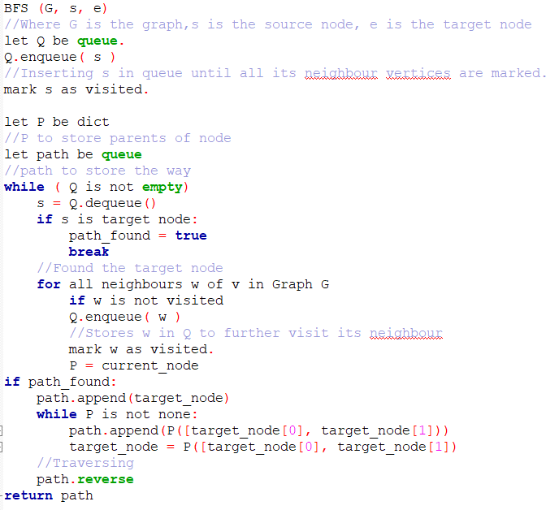We apply the BFS into this problem:

* + - * Consider a square grid having many obstacles and we are given a starting cell and a target cell. There are many ways to traverse graphs. BFS is the most commonly used approach, so we apply this algorithm.
      * Let's first start out with search - and search for a target node. Besides the target node, we'll need a start node as well. The expected output is a path that leads us from the start node to the target node.
      * When we're reconstructing the path (if it is found), we're

going backwards from the target node, through it's parents, retracing all the way to the start node. Additionally, we might want to reverse the path for our own intuition of going from the start_node towards the target_node.

### ~~3.1.3 Depth First Search(DFS)~~

Depth first search yields such bad results that we no longer consider it.

### Algorithm for traversing

For traversing we have the following algorithm:

* Step 1: The snake use a searching algorithm to find a path from its head to the food (from now referred as path 1). Move to step 4 if path 1 is not available.
* Step 2: Create a virtual snake identical to the original snake and let it follow path 1. Then, check if there a path is available from the virtual snake's head to its tail (from now refereed as path 2). If path 2 not available go to step 4.

Note: If path 2 is available we refereed to path 1 as a safe path.

* Step 3: If both path 1 and 2 are available, let the snake follow path1
* Step 4: If path 1 or path 2 is not available, let the snake follow its tail.

Note:

+) All these steps are repeated for each move of the snake

+) From now on, a safe path is referring to a path that if the snake follows it through, there will still be a path from the snake's head to its tail.

I.e. if path 2 is available then path 1 is safe

+) The action performed in step 4 will be referred to as a recover, and the way that the snake follows its tail we be referred as a recovery method.

## Algorithms implementation in the propose problem

During the work, we have faced some difficulties and come up with corresponding solutions:

* + - At first, we let the snake follow the safe path to food once it is found. But as the snake moves a shorter path may emerge since the obstacles change as the snake dragging its body along
* We decide to search for new path every time the snake moves. This will increase calculation time but decrease number of steps taken which is the priority of our evaluation.
  + - Recovery methods (as mentioned in traversing algorithm), how the snake follow its tail, greatly affect the performance of the AI. This will be our main focal point as the searching problem is quite simple:
      * If we only use search algorithm with no recovery method the snake will most likely die shortly after start.

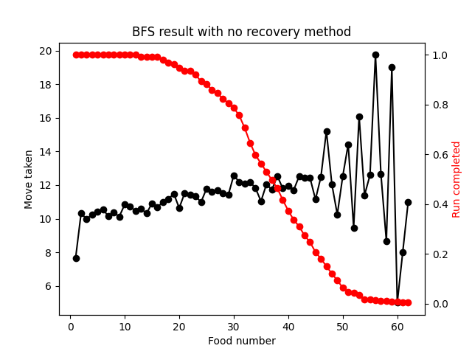

* + - * After that we decide to add a recovery method: if path 1 is not safe or when path 1 is not available do not follow it, instead make the snake follow the shortest path to its tail (search algorithm is used after each move of the snake to check for path to food)

Using this method, most run are stuck in a loop so we add a maximum number of moves without eating (when this number is reached the run is immediately terminated) and yield the following result

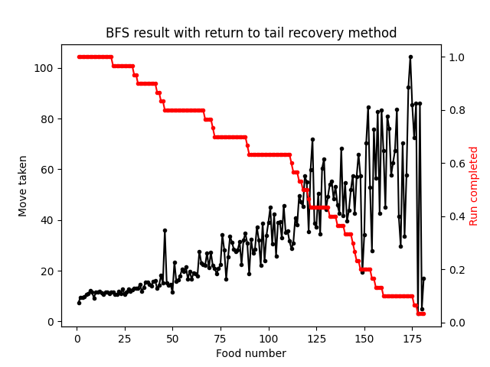

* + - * Since using the above method most run is terminated because of loop. We decide to change the recovery method to move the snake away from its tail if a safe path 1 is not available instead of the shortest path to tail to allow the snake to live longer without entering a loop

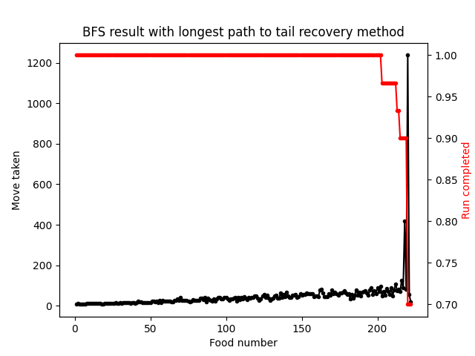

* + - * Using the above algorithm, there are still some cases that the snake got stuck in a loop. So we add a new method that makes the snake move to a random safe square when a safe path 1 is not available and move without eating has passed half of its maximum value

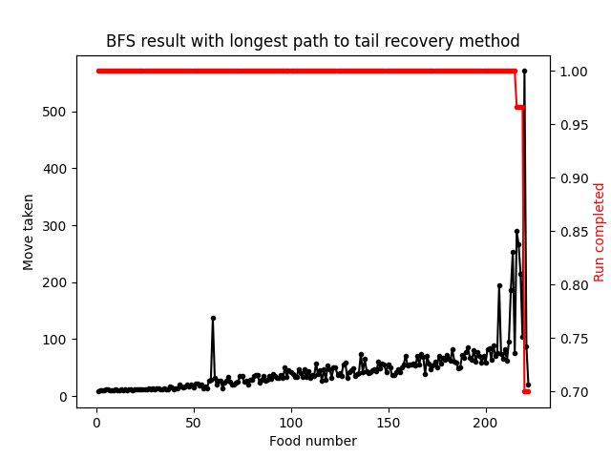

* + - * We try to mix random and longest path recover method (depend on odd or even food number) to see if the result get better but it seems to get worse so we revert back to previous recover method

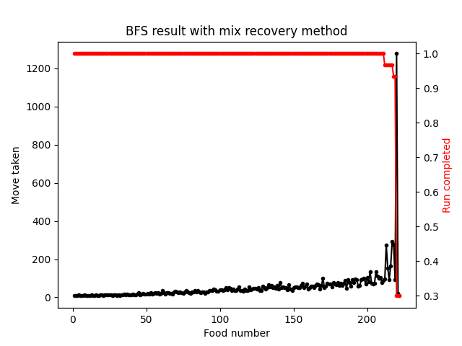

* + - * We could not find a recover method that make the whole algorithm complete (or maybe it's already is with limitless moves) this will be studied further in future project

## Results comparison of the algorithm used for solving the problem

### Providing quantitative performance indicators

* + - Total number of test cases for each algorithm: 100.

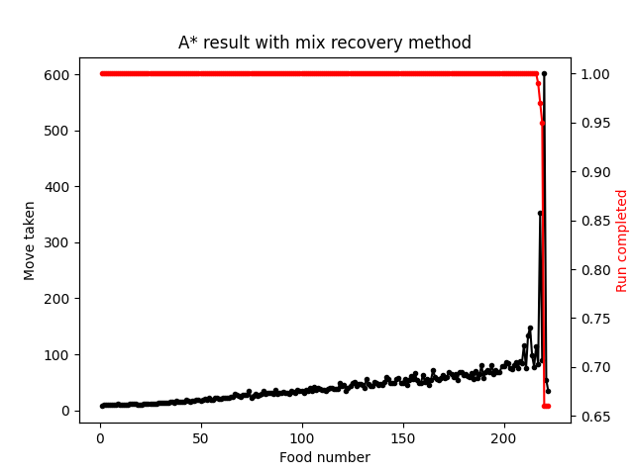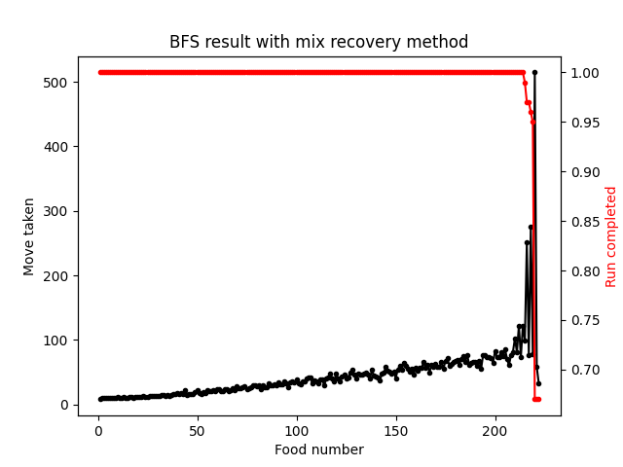

Graph 5 & 6

* + - Percentage of problem completion for each algorithm
      * A* search : 66%.
      * DFS : 67%.
    - Number of move taken to eat food can be seen in the above graphs
    - A* algorithms generally costs lest time to run but due to the inconsistency in hardware performance no exact evaluation can be given

=> Beside the time factor, these two algorithms gives quite similar results

## Explaining these results

* + - Graph explanation: for each time the snake eats a food, the number of step it took from the last time it eats a food will be return and stored in a list, this number will be taken and then be averaged out in a number runs. The average value is illustrated in the graph with the black line, with x-axis show the number of the food and the y-axis(on the right) show the number of step taken.

However, not all runs finish at the last food with the snake winning, some runs end prematurely with snake gets stuck and run out of moves, these run will be taken out of the equation at the point of their termination so they do not affect the average move taken after that point. Run completed is used to show the portion of runs that make it to the food number n, illustrated with the red line, with y-axis(on the right) show the portion of runs.

* + - For the graph from 2 to 4, we run a total of 30 runs for each recovery method with a grid size of 10x10.
      * + For algorithm with no recovery method most of the runs were terminated before reaching 40 score
        + After adding the first recovery method, the snake get the shortest path to its tail when no safe path to food is available, the snake can get near 200 points but still can not complete the game, since the longer the snake the more likely for it to get stuck in a loop with this method
        + When change to the second recovery method, the snake get to the furthest point from its tail when no safe path to food is available, this method allow more room for the snake to move and make a little more "chaos" pattern which avoid loop, the result is all runs get pass the 175 mark which hardly any of the previous could get and near 70% of them complete the game
        + Though the previous recovery method is quite good, we can still improve our algorithm by using the third recovery method, which the same as above but if the snake has moved pass half of it maximum move without eating the snake will now move to a random safe block if no safe path to food is available instead of move away from its tail. This will break loop of the snake and allow better result at the end of the game (less runs get terminated near the end). Though this has little effect on the number of runs that actually finished
        + We then try a different recovery method, which the same as the third one above but now the random safe block method is not only used if half of maximum move without eating is pass but also for every odd food number. We try to create more chaos to see if we can improve steps taken and runs finished. But this greatly reduce the number of runs finished instead so we abort this method and revert to the previous one (the number may not be as extreme as that of the graph if a larger number of runs were tested)

* + - For graph 5 & 6, we use the third recovery method mentioned above (with longest path to tail and random move at half max move to avoid loop) for both algorithm , the only difference came from choosing the searching algorithm: A* search or BFS. In general, for the small size test cases, the execution time between these two do not show any noticeable differences. But for some larger size problems, the BFS’s time for searching might be over 3 times slower than A* search. This is reasonable since the A* search is more well developed, so it should be more effective. However, the total steps and complete rate of 2 algorithms are quite similar for most cases.
    - A* search and BFS have the same space complexity in theory, which is O(b^d) as they store all generated nodes in the memory.

|  |  |  |  |
| --- | --- | --- | --- |
| **Criterion** | **A* search** | **BFS** | **DFS** |
| **Complete?** | Yes | Yes | No |
| **Time Complexity** | (Depends on the heuristic) | O(b^d) | O(b^m) |
| **Space Complexity** | O(b^d) | O(b^d) | O(bm) |
| **Optimal?** | No | Yes | No |

## Conclusion and further discussions

* + In conclusion, we believe that we manage to solve this problem quite well. We have created a simple AI to play the classic Snake Game. However, there is still much work to do left to make this more efficient. Because as you could see, we couldn’t create a complete algorithm.
  + During the project, we have learnt a lot of things: A* search algorithms, BFS algorithms, DFS algorithms. We have learnt how these algorithms work, how to apply, combine them, how to choose the right algorithms to deal with the problem, how to analyse data. This is the first time our team have had a team-work project, which we believe is very essential for our future. Thanks to the team, we have finished this project.
  + Further discussions: In the future, we hope that we can continue to develop this project to make it more efficient (reduce steps taken and improve complete rate even make a completed algorithm). We hope that in the future we can apply machine learning to the problem (which we tried but to no avail)

## List of tasks

### Programming tasks:

* Implementing the snake game: Truơng Anh Huy.
* Implementing BFS Algorithms: Truơng Anh Huy.
* Implementing A* Search Algorithms: Tống Trần Minh Đức.
* Implementing DFS Algorithms: Bùi Hữu Thành Công.
* Optimizing code: All

### Analytic tasks:

* Proposing project: Trương Anh Huy
* Evaluate algorithms: Trương Anh Huy
* Report preparation: Tống Trần Minh Đức and Bùi Hữu Thành Công

## List of bibliographic reference

* *A* Search: Concept, Algorithm, Implementation, Advantages, Disadvantages,* Source: [https://www.brainkart.com/article/A--Search--](https://www.brainkart.com/article/A--Search--Concept%2C-Algorithm%2C-Implementation%2C-Advantages%2C-Disadvantages_8883/) [Concept,-Algorithm,-Implementation,-Advantages,-Disadvantages_8883/](https://www.brainkart.com/article/A--Search--Concept%2C-Algorithm%2C-Implementation%2C-Advantages%2C-Disadvantages_8883/)
* *Depth First Search,* Source: [https://en.wikipedia.org/wiki/Depth-](https://en.wikipedia.org/wiki/Depth-first_search) [first_search](https://en.wikipedia.org/wiki/Depth-first_search)
* Existing package used: pygame - by Pygame community, matplotlib - by Michale Droettboom, et al