EX1:
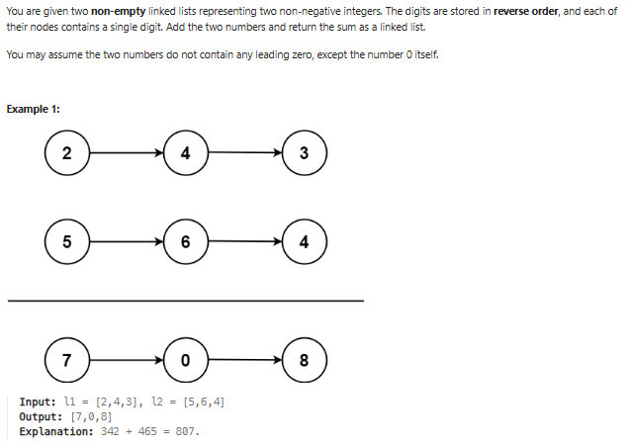
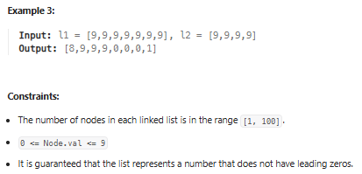

_{Bài} giải:
_{// Online Java Compiler}
// Use this editor to write, compile and run your Java code online
_{import java.util.List;}
_{import java.util.LinkedList;}

_{class Main {}
public static void main(String[] args) {
List<Integer> linkList1 = new LinkedList<>();
List<Integer> linkList2 = new LinkedList<>();
List<Integer> output = new LinkedList<>();

_{//build l1}
_{linkList1.add(2);}
_{linkList1.add(4);}
_{linkList1.add(3);}
_{//build l1}
_{linkList2.add(5);}
_{linkList2.add(6);}
_{linkList2.add(4);}

System.out.println("Linked List1: ");
_{showLinkList(linkList1);}

System.out.println("Linked List2: ");
_{showLinkList(linkList2);}

Long bigNumber=addTwoNumbers(linkList1, linkList2);
// List<String> stringStream = bigNumber.chars().map(String::valueOf);

}

public static void showLinkList(List<Integer> receivedLinkList)
{
for(Integer listElement : receivedLinkList) System.out.println(listElement);
}

public static int addTwoNumbers(List<Integer> list1, List<Integer> list2) {

// List<String> numberString1 = list1.stream().map(String::valueOf).toList();

// List<String> numberString2 = list2.stream().map(String::valueOf).toList();

int longNum = list1.stream().reduce(0, (a,b) -> a*10+b) + list2.stream().reduce(0, (a,b) -> a*10+b);

_{return longNum;}
}

}

Bài giải:
// Online Java Compiler
// Use this editor to write, compile and run your Java code online
import java.util.Set;
import java.util.HashSet;

class Main {
public static void main(String[] args) {
String randomString = "pwwkew";

// sliding window
int left = 0;
Set<Character> setChars = new HashSet<>();

for( int right = 0; right < randomString.length(); right ++) {
char receivedchar = randomString.charAt(right);

while(setChars.contains(receivedchar)) {
char removedChar = randomString.charAt(left);
setChars.remove(removedChar);
left++;
}

setChars.add(receivedchar);
}
System.out.println(setChars);
}
}

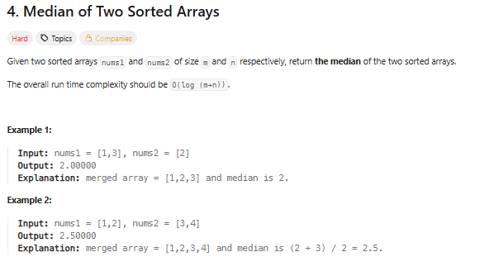
Bài giải:
double findMedian(int[] A, int[] B) {
int m = A.length, n = B.length;
int total = m + n;

int i = 0, j = 0;
int prev = 0, curr = 0;

for (int k = 0; k <= total / 2; k++) {
prev = curr;

if (i < m && (j >= n || A[i] <= B[j])) {
curr = A[i++];
} else {
curr = B[j++];
}
}

return (total % 2 == 0)
? (prev + curr) / 2.0
: curr;
}

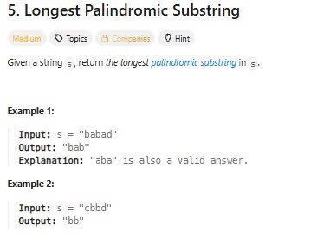

class Main {

public static String longestPalindrome(String s) {
if (s == null || s.length() == 0) return "";

String result = "";

for (int center = 0; center < s.length(); center++) {

// case 1: odd length
String p1 = expand(s, center, center);

// case 2: even length
String p2 = expand(s, center, center + 1);

// lấy chuỗi dài hơn
String longer = p1.length() > p2.length() ? p1 : p2;

if (longer.length() > result.length()) {
result = longer;
}
}

return result;
}

private static String expand(String s, int left, int right) {

while (left >= 0 && right < s.length()
&& s.charAt(left) == s.charAt(right)) {
left--;
right++;
}

// sau khi vượt biên → quay lại 1 bước
return s.substring(left + 1, right);
}

public static void main(String[] args) {
System.out.println(longestPalindrome("babad")); // bab hoặc aba
System.out.println(longestPalindrome("cbbd")); // bb
}
}

