

|  |  |
| --- | --- |
| Student Name / Student ID | Kieu Le Dang Khoa / 001032431  Tran Minh Tuan / 001004854 |
| Coursework | COMP1640 : Enterprise Web Software Development |
| Class | TCS1801 |
| Deadline | 12th April 2018 |
| Degree program | BSC (Hons) Computing |
| Ho Chi Minh City, Vietnam | |

**Table of Contents**

**1.** **Introduction**. 3

**2.** **System Requirement.** 3

**2.1.** **Hardware.** 3

2.1.1. Server 3

2.1.2. Client 3

**2.2. Software.** 4

2.2.1. Server 4

2.2.2. Client 4

**3.** **Development software** 4

**4.** **Technology** 4

**5.** **Introduction about Scrum.** 5

**6.** **Database** 6-11

• Data types and validation 6-7

Table Definition 7-11

**7.** **Site Design.** 11-20

• **Use Case.** 11-12

• **Activity Diagram** 12-20

• **Workflow** 21-22

**8.** **Functionality.** 23-26

• **UML Class diagrams.** 23-23

• **Wireframe.** 24-24

• **Code snippets.** 24-26

**9.** **Testing.** 27-34

• **Test Plan.** 27-30

• **Test case** 31-32

• **Test Log.** 33-33

• **User stories in the product backlog.** 34-34

**10.** **Agile Methods.** 35-39

• Burn down chart. 35-34

• Minutes of meetings. 36-38

**11.** **Screencast and Presentation** 39-51

DOCUMENT GROUP

# **Introduction**.

Nowaday, "University Forum" is known as a community for students to support learning each other - whatever your knowledge is good or bad.

Understanding the needs of students. We created this site to assist students upload their ideas as well as additional comments from other students for this idea. In addition, administrators can create new accounts for new students or the managers who can download them if the idea is good.

# **System Requirement.**

## **Hardware.**

### Server

|  |  |
| --- | --- |
| Processor | Intel Core i5 and NVIDIA GTX 960M or higher |
| Memory | 4GB RAM or greater. |
| Modem/ADSL | Connecting to internet 24/24 |

### Client

|  |  |
| --- | --- |
| Processor | Intel Core i5 and NVIDIA GTX 960M or higher |
| Memory | 4GB RAM or greater. |
| Monitor | Super VGA or higher resolution with 256 colors. |
| Pointing Device | Microsoft Mouse, Microsoft IntelliMouse®, or compatible pointing device. |
| Modem/ADSL | Connecting to internet 24/24 |

## **2.2. Software.**

### 2.2.1. Server

|  |  |
| --- | --- |
| Operation System | Windows 7/8/10 |
| Browser | Internet Explorer 10, Chrome or Firefox latest. |
| Database | Microsoft SQL Server 2008 |
| Software | IIS 6.0 or higher |
|  | Java SDK 1.8 |
|  | Glassfish Server. |
|  | Primer faces |

### 2.2.2. Client

|  |  |
| --- | --- |
| Operation System | Windows 7 or later. |
| Browser | chrome or Firefox latest |

# **Development software**

* Microsoft SQL Server 2008 or higher
* NetBeans 7.4 or higher
* JDK 1.7 or higher
* Internet Explorer 10, Chrome or Firefox latest.

# **Technology**

* J2EE
* JSP, Servlet
* EJB
* JQuery
* Bootstrap

# **Introduction about Scrum.**

Scrum is an agile process that allows anyone to focus on delivering the highest business value in the shortest time. It will repeatedly inspect actual working software and rapidly sets the priorities in the best way to deliver the highest priority features (every two weeks to one month).

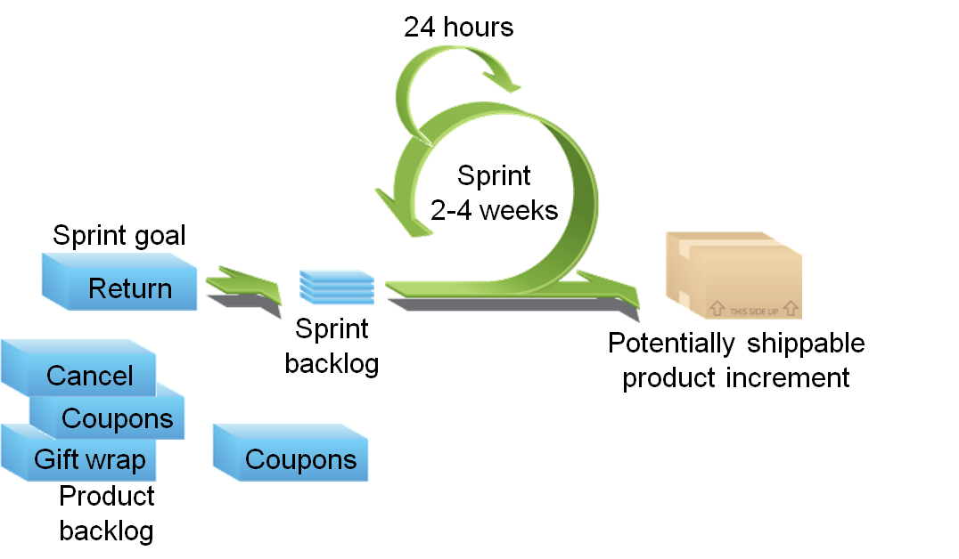

In my project, scrum help my team developing a product progresses in a month-short with the requirements are captured as items in a list of “product backlog”.

# **Database**

## Data types and validation

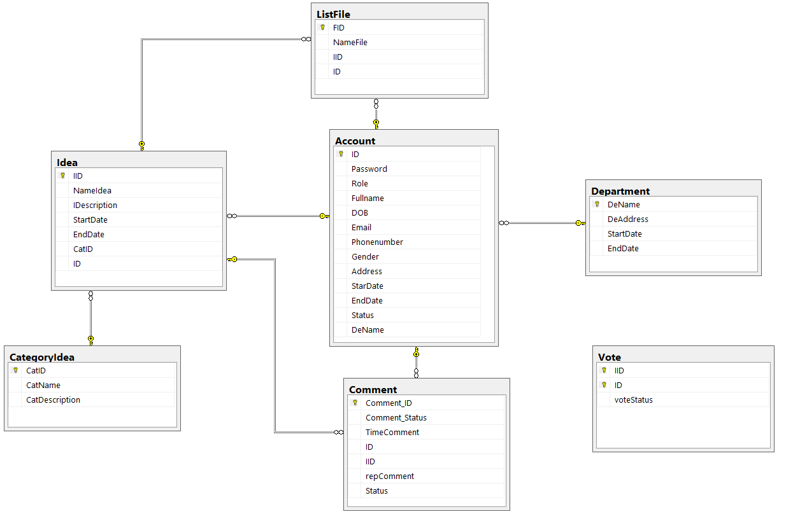

### Table Definition

Account

|  |  |  |  |  |  |  |
| --- | --- | --- | --- | --- | --- | --- |
| Key | Field Name | Data Type | Length | Allow Null | Default value | Description |
| PK | ID | Varchar | 50 | No |  | Id of Account |
| FK | DeName | Nvarchar | 200 | No |  | Name of Department |
|  | Password | Varchar | 50 | No |  | Password of account |
|  | Role | Varchar | 30 | No |  | Role of account |
|  | Fullname | Nvarchar | 50 | No |  | Fullname of user |
|  | DOB | Datetime |  | No |  | Date of birth of user |
|  | Email | Nvarchar | 100 | No |  | Email address of user |
|  | Phonenumber | int |  | No |  | Phone number of user |
|  | Gender | Nvarchar | 30 | No |  | Gender of user |
|  | Address | Nvarchar | 1000 | No |  | Address of user |
|  | StartDate | Datetime |  | No |  | Date begin create account |
|  | EndDate | Datetime |  | No |  | Date expiration of account |
|  | Status | Bit |  | No |  | Status of account (E.g. Disable, Enable) |

Department

|  |  |  |  |  |  |  |
| --- | --- | --- | --- | --- | --- | --- |
| Key | Field Name | Data Type | Length | Allow Null | Default value | Description |
| PK | DeName | Nvarchar | 200 | No |  | Name of Department |
|  | DeAddress | Nvarchar | 200 | No |  | Address of Department |
| x | StartDate | Datetime | Datetime | No |  | Date begin create Department |
| x | EndDate | Datetime | Datetime | No |  | Date expiration of Department |

Comment

|  |  |  |  |  |  |  |
| --- | --- | --- | --- | --- | --- | --- |
| Key | Field Name | Data Type | Length | Allow Null | Default value | Description |
| PK | Comment_ID | Int |  | No |  | Id of comment |
| FK | ID | Varchar | 50 | No |  | Id of account |
| FK | IID | Int |  | No |  | Id của idea |
|  | Comment_Status | Varchar | 5000 | No |  | Status of comment (E.g. Commented, liked) |
|  | TimeComment | Datetime |  | No | GETDATE() | Time of comment |
|  | repComment | Varchar | 5000 | Yes |  | Reply of comment |
|  | Status | Bit |  | No |  |  |

ListFile

|  |  |  |  |  |  |  |
| --- | --- | --- | --- | --- | --- | --- |
| Key | Field Name | Data Type | Length | Allow Null | Default value | Description |
| PK | FID | int |  | No |  | Id of list file |
| FK | IID | Varchar | 50 | No |  | Id of idea |
| FK | ID | int |  | No |  | Id of account |
|  | NameFile | Varchar | 50 | No |  | Name of file |

CategoryIdea

|  |  |  |  |  |  |  |
| --- | --- | --- | --- | --- | --- | --- |
| Key | Field Name | Data Type | Length | Allow Null | Default value | Description |
| PK | CatID | int |  | No |  | Id of Category |
|  | CatName | varchar(5000) |  | No |  | Name of Category |
|  | CatDescription | varchar(5000) |  | No |  | Description of Category |

Vote

|  |  |  |  |  |  |  |
| --- | --- | --- | --- | --- | --- | --- |
| Key | Field Name | Data Type | Length | Allow Null | Default value | Description |
| PK | IID | Int |  | No |  | Id of Idea |
| PK | ID | Varchar | 50 | No |  | Id of Account |
|  | VoteStatus | Int |  | No |  | Status of vote |

Idea

|  |  |  |  |  |  |  |
| --- | --- | --- | --- | --- | --- | --- |
| Key | Field Name | Data Type | Length | Allow Null | Default value | Description |
| PK | IID | int |  |  |  | Id of idea |
| FK | ID | Varchar | 50 |  |  | Id of account |
| FK | CatID | Int |  |  |  | Id of Category |
|  | NameIdea | Varchar | 100 |  |  | Name title of idea |
|  | Idescription | varchar | 5000 |  |  | Description of idea |
|  | StartDate |  |  |  |  | Date begin post idea |
|  | EndDate |  |  |  |  | Date end post idea |

**.Working Planning**

|  |  |  |
| --- | --- | --- |
| **Members** | **Roles** | **Works** |
| **Kieu Le Dang Khoa** | **Developer**  **Tester**  **Leader** | **+Design Database**  **+Post New Idea.**  **+Comment Ideas and Reply Comment Ideas.**  **+Design Interface**  **+Login and Log out**  **+Testing: register, insert category, insert department…** |
| **Tran Minh Tuan** | **Developer**  **Tester**  **Member** | **+Design Interface**  **+Register, Insert Department, edit account, insert category.**  **+Testing: post new idea, comment ideas, reply ideas, login and logout….** |

# **Site Design.**

This website design is very suitable for the all size of Desktop and Mobile. In the website interface, the design make all function clearly that can attract to the user at the first time they use.

Because this website is about the forum of The University. So, it is will support all the students for the purpose for the education.

## **Use Case.**

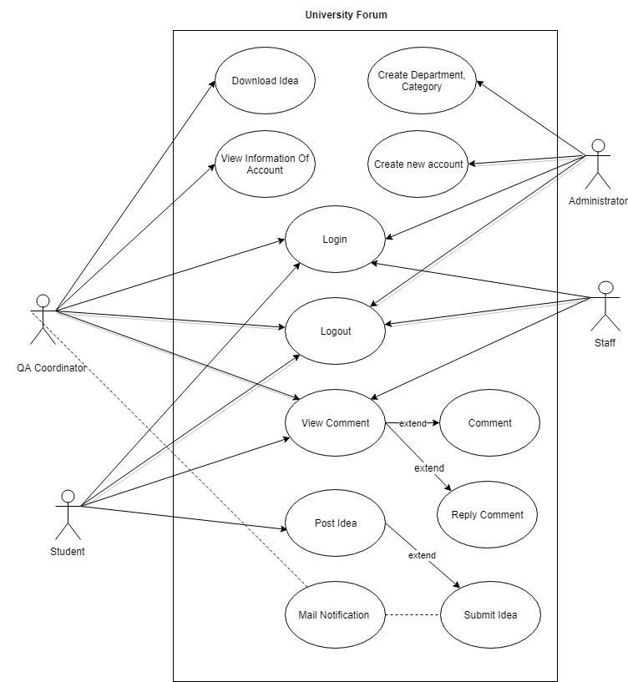

## **Activity Diagram**

Login Fuction

**C:\Users\QUOCTIEN\Downloads\login (1).png**

Logout function

**C:\Users\QUOCTIEN\Downloads\logout.png**

Show information of user

**C:\Users\QUOCTIEN\Downloads\showinfor2.png**

Create new Account

**C:\Users\QUOCTIEN\Downloads\createAccount.png**

Update information of Account

**C:\Users\QUOCTIEN\Downloads\Untitled Diagram (3).png**

Show List of Idea



Download Idea



Send Comment



## **Workflow**





# **Functionality.**

## **UML Class diagrams.**

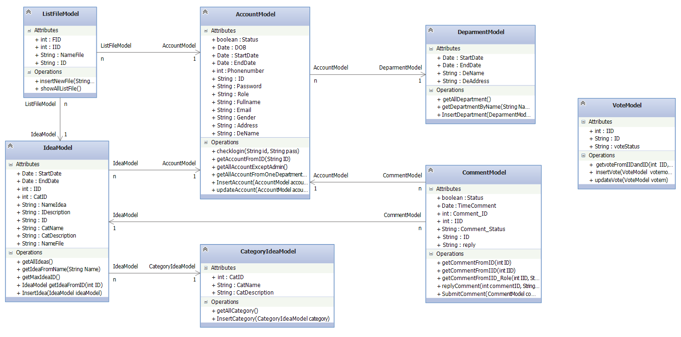

## **Wireframe.**



## **Code snippets.**

Login for user by level of account

Source Code of Login Controller.

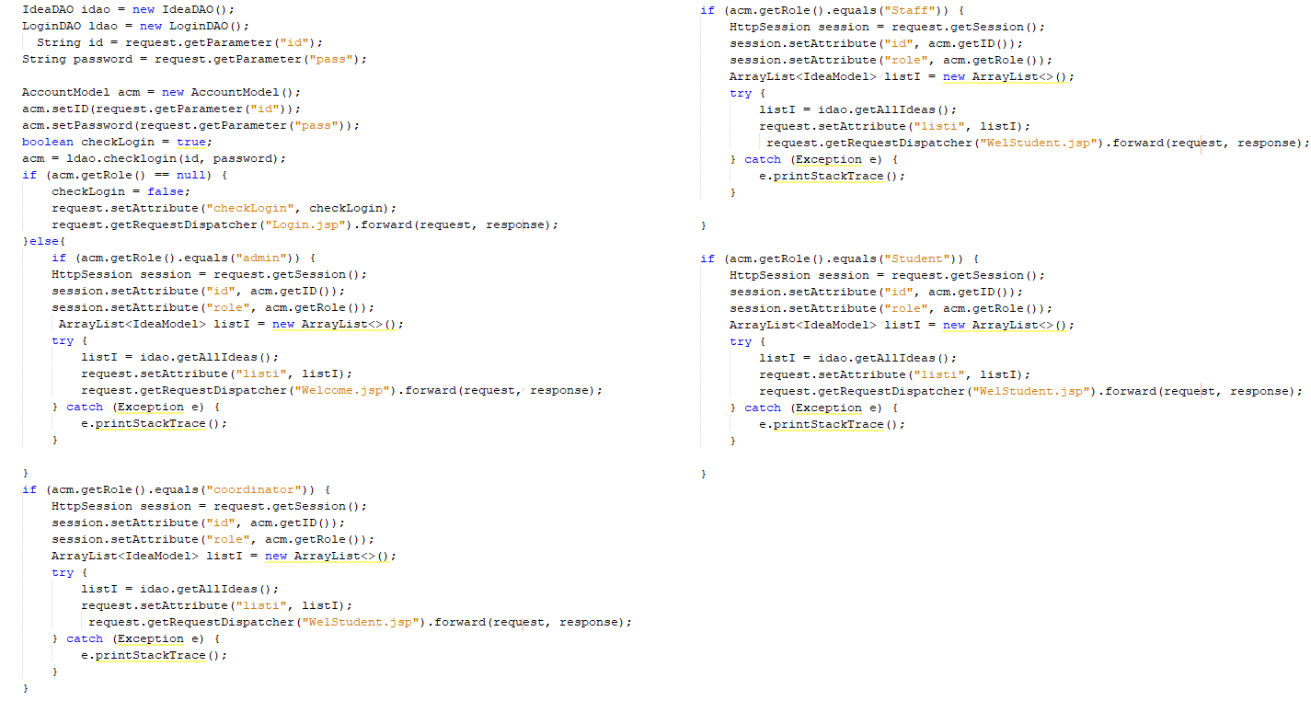

Interface Login for User

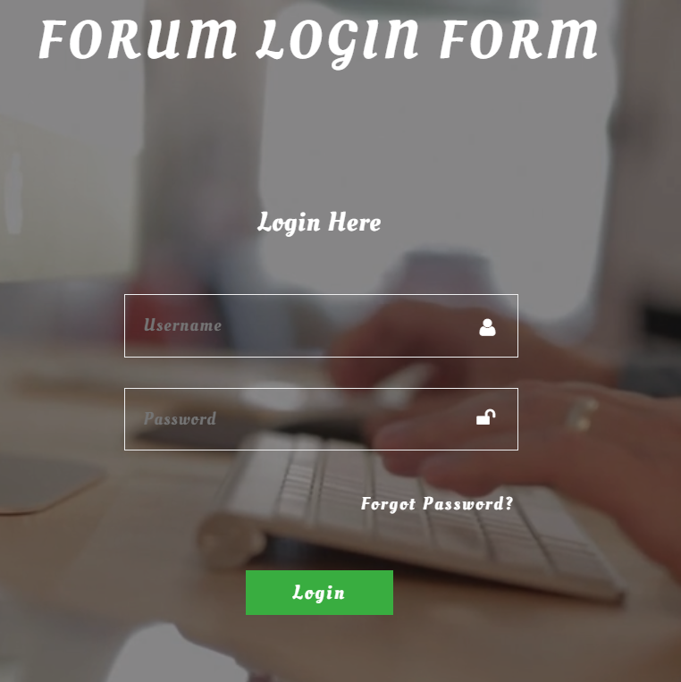

# **Testing.**

## **Test Plan.**

|  |
| --- |
| **1.** **Scope of the tests**  **1.1 Target**  The objective of this test plan is to ensure a high degree of confidence in the correctness and usefulness of the Website of University Forum  **1.2 Reference Material**   * 1. The software specifications and requirements (SRS.doc)   2. Software Architecture Document (SAD.doc)   3. Definition of Terms and Acronyms   4. Verizon Regional E911 Electric Guide Interface (psali2002.doc)   5. Pacific Bell E911 System Management Gateway (MSG Training Reference Guide)   **1.3 Limit**  Testing will be done at some point in the product life cycle is built. Testing is depending on an activity. Therefore, the test plan is a continuing activity undertaken during the development life cycle of the University system   Test plan must be developed for each level of product testing. |
| **2. Testing environment**  **2.1 Test Site**  Hyperlink website: http://localhost:8080/UniversityForum/  **Program Modules**  User interface  Manual implementation of a set of test cases must be done on all aspects of the user interface to ensure correct operation products. Where more testing will include all the requirements in the SRS.  Work series  Batch job will be executed on the same data set as the old batch jobs and output must be directly compared for accuracy.  Database  The SQL queries are selected will be made directly through tools such as SQL * Plus to verify the correct operation of the causes and stored procedures.  **2. 2 Requirement hardware and software configuration**  **2.2.1. Hardware**  Microsoft Windows PC with a broadband connection  One Microsoft Windows PC or UNIX computer with a broadband connection to a personal computer in the above  **2.2.2 Software**  1 - Installation of Windows 7, 8, 8.1, 10 or old version such as window XP  1 - Microsoft Internet Explorer 5.0, 5.5, 6.0  1 - Resin EE  1 - Sun J2RE version 1.3  1 - Microsoft Office (Word, Excel) for reports and tracking error.  **2.2.3 Browser**  This web can run in Microsoft Internet Explorer 8 or above.  This web can run in Firefox 2.0 or above.  This web can run in Google Chrome 1.x.  This webs can run in Apple Safari 2.x.  **2.3 Participating organizations:** without the participation of the company  **2.4 Power requirements**: must be 10 people who have the following experience:  Make sure that entire application under test is broken down into smaller modules can run. Need to write the test cases for each individual module. As if you can split the module completely out of smaller parts.  Write the whole, description and clear error report. Need to avoid only give bad bugs found but also to provide the effects of the error and all possible solutions. Remember do not forget to test an innovative work and challenges. Ultimately, it depends on the skill and experience of you, so you handle this challenge like.  Record the new conditions, the facilities acquired in the test. Keep the file while testing applications. Using this observation as preparation for complete test report. Good habits will help provide detailed and complete test report is quite clear.  **2.5 Preparing and training how to need by test teams:** Set up teams composed of the following persons   |  |  |  | | --- | --- | --- | | **Job** | **Transfer** | **Performed week** | | Development of test cases | Test Case | 1 | | Develop scripts for automated testing |  | 2 | | Prepare the test database |  | 2 | | Perform the test |  | 2 | | Report an error |  | 3 | | Inspection Report completed | Test Case Report | 3 |   **Responsibility**  All of the developers are responsible for completing all tasks component testing and integration. |
| **3.** **Test details (for each test)**  **3.1 Approaches**   * + 1. **Unit Testing**   This process involves the testing of particular system components. These components are isolated from other portions and tested for their input, output, and module procedures.   * + 1. **Integration Testing**   Integration testing procedures incorporate system components and how they perform together functionally between one another. System parts are built together forming new interfaces and these are tested to determine   * + 1. **System Testing**   This involves the complete integration of all system components and how they perform as a whole unit. This type of testing validates the entire system as a functional entity.  **3.2 Approach**  **3.2.1 Unit Test**  - Unit testing: The Testing has done in development of the process while developer completes the unit development. Besides, the object of this testing is to verify correctness of the module. This purpose of unit testing will check that as individual parts are functioning as expected. The developer typically carries out unit testing.  - Integration testing: System Integration Testing will start after the individual software modules are integrated as a group. A typical software project consists of multiple modules & different developers develop these. The Integration testing is focuses to check that after integrating modules is two modules are communicating with each other or not. It is critical to test every module’s effect on the entire program model. Most of the issues are observed in this type of testing.  - System testing: This is the first time end to end testing of application on the complete and fully integrated software product before it is launch to the market.  **3.2.1.1 Login valid user**  Login as specific user (Analysts, Executives and Managers) and input their password. System should display main screen and executive summary showing Managed business units.  **3.2.1.2 Login Invalid user test case**  Login as specific user (Analysts, Executives and Managers) after that user need to input incorrect password. System should display screen with authentication-failed message.  **3.2.1.3 QA Coordinate**  **3.2.1.4 Administrator**  **3.2.1.5 Staff**  **3.2.1.6 Student**  **3.3 Data to be recorded:** people using the site system, the level of reactive sites on the second |
| **4. Test schedule (for each test or test group) including time estimates for the following:** |

|  |  |  |  |  |
| --- | --- | --- | --- | --- |
| **No.** | **What is being tested** | **Process to testing** | **Test data used** | **Expected Results** |
| 1. | Create the new idea | Get full information of the idea | Get with the evidence such as PDF file | Insert Successful!  The Data can upload and it will add on the database. |
| 2. | Create the new idea | Get full information of the idea | Miss the evidence such as PDF file.  Get it empty! | Insert Fail!  The Data cannot upload and it will not add on the database. |
| 3. | Create the new idea | After get full information and click upload the idea but the day is over deadline | Get with the evidence such as PDF file | Insert Fail!  The Data cannot upload and it will not add on the database. The date is over deadlined |
| 4. | Create the new idea | Get full information of the idea during cutting the Wi-Fi connection |  | Insert Fail!  The Data cannot upload and it will not add on the database. |
| 5. | Create the new account by Admin | Get full information about data entry for the user | The information about data entry for the user | Insert Successful!  The Data can create and it will add on the database. |
| 6. | Create the new account by Admin | Get empty and submit | Get empty information | Insert Fail!  The Data cannot create and it will not add on the database. |
| 7. | QA Coordinator get the documents from the users | Manage the document by checking | The document is suitable/ valid | The QA Coordinator can refer it to solve |
| 8. | QA Coordinator get the documents from the users | Manage the document by checking | The document is not suitable/ invalid | The QA Coordinator cannot refer it to solve |

## **Test case**

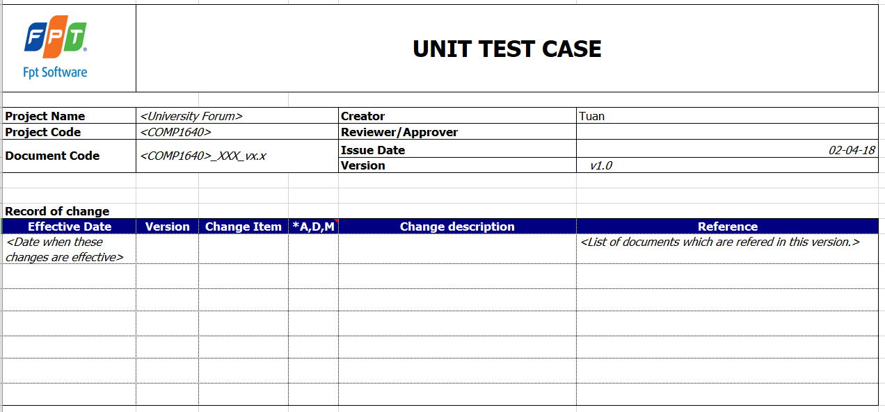

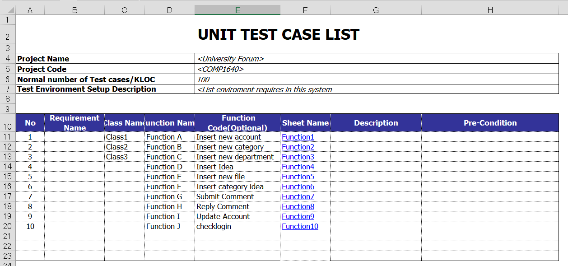

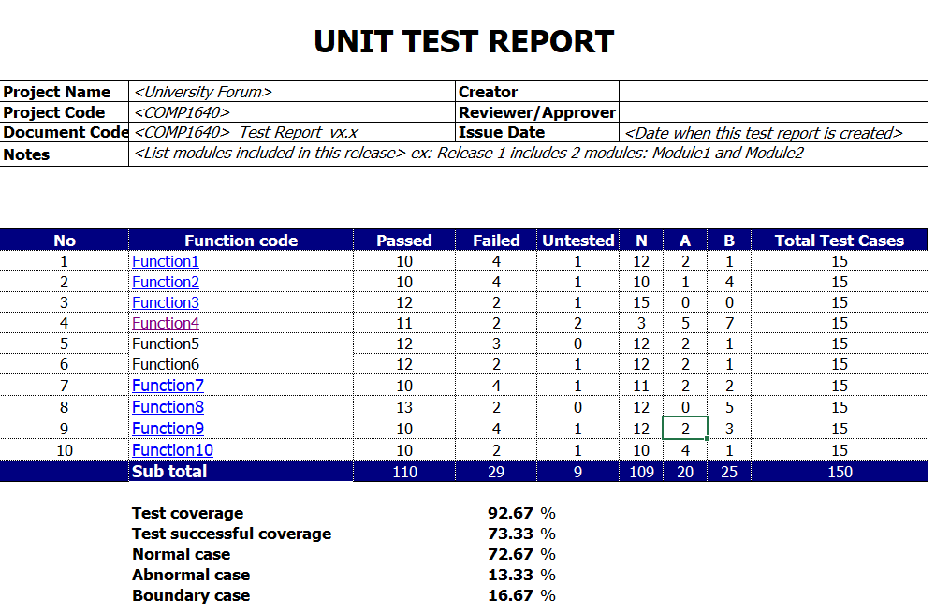

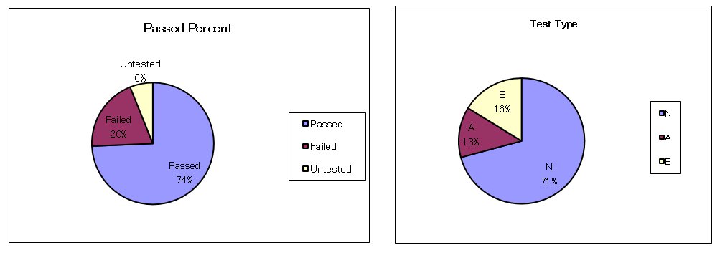

## **Test Log.**

|  |  |  |  |  |  |  |
| --- | --- | --- | --- | --- | --- | --- |
| **No.** | **Planning of Test** | **Process to testing** | **Test data used** | **Show the message/Result** | **Start Date** | **Status** |
| 1. | Create the new idea | Get full information of the idea | Get with the evidence such as PDF file | Insert Successful!  The Data can upload and it will add on the database. | 30/03/2018 | Good |
| 2. | Create the new idea | Get full information of the idea | Miss the evidence such as PDF file.  Get it empty! | Insert Fail!  The Data cannot upload and it will not add on the database. | 30/03/2018 | Good |
| 3. | Create the new idea | After get full information and click upload the idea but the day is over deadline. | Get with the evidence such as PDF file | Insert Fail!  The Data cannot upload and it will not add on the database. The date is over deadlined. | 30/03/2018 | Good |
| 4. | Create the new idea | Get full information of the claims during cutting the Wi-Fi connection |  | Insert Fail!  The Data cannot upload and it will not add on the database. | 30/03/2018 | Good |
| 5. | Create the new account by Admin | Get full information about data entry for the user | The information about data entry for the user | Insert Successful!  The Data can create and it will add on the database. | 30/03/2018 | Good |
| 6. | Create the new account by Admin | Get empty and submit | Get empty information | Insert Fail!  The Data cannot create and it will not add on the database. | 30/03/2018 | Good |
| 7. | QA Coordinator get the documents from the users | Manage the document by checking | The document is suitable/ valid | The QA Coordinator can refer it to solve | 30/03/2018 | Good |
| 8. | QA Coordinator get the documents from the users | Manage the document by checking | The document is not suitable/ invalid | The QA Coordinator cannot refer it to solve | 30/03/2018 | Good |

## **User stories in the product backlog.**

|  |  |  |
| --- | --- | --- |
| **User Stories No.** | **User Stories** | **Date** |
| 1 | As QA coordinator, i can oversee all the process. | 2 |
| 2 | As QA coordinator. I want to the responsible for managing the process for the all department and the encouraging students to contribute. | 1 |
| 3 | As QA Manager, i can be categorised (tagged) all ideas from a list of categories at the point when they are submitted. | 1 |
| 4 | As QA coordinator, i can add additional categories at any time, and can delete categories, but only if they have not been used. | 1 |
| 5 | As QA coordinator, i want to ideas and comments can be posted anonymously, although the author’s details will be stored in the database so any inappropriate ideas can be investigated | 1 |
| 6 | As QA coordinator, i want to all new ideas are disabled after a closure date for new ideas, but comments can continue to be done until a final closure date | 2 |
| 7 | As QA coordinator, when once an idea is submitted. I want the system emails a notification to the Department’s QA Coordinator. | 3 |
| 8 | As QA coordinator, I need to be able to download all the selected contributions after the final closure date in a ZIP file for transfer out of the system | 1 |
| 9 | As student, i can have the opportunity to submit one or more ideas. | 3 |
| 10 | As student, i must agree to Terms and Conditions before me can submit. | 1 |
| 11 | As student, i can the optionally upload documents to support my ideas. | 2 |
| 12 | As student, i can see all submitted ideas and can comment on any idea.Besides that, i can also give the Thumbs Up or Thumbs Down for any idea, but only once for any idea. | 4 |
| 13 | As student, I want to my comments are visible to both staff and students. | 1 |
| 14 | As author of an idea. I want to receives an automatic email notification whenever a comment is submitted to any of their ideas by a student (but not by a member of staff). | 2 |
| 15 | As staff, i can see all submitted ideas and can comment on any idea. Besides that, i can also give the Thumbs Up or Thumbs Down for any idea, but only once for any idea. | 4 |
| 16 | As a administrator , i needed to maintain any system data, e.g. closure dates for each academic year, staff details, student details. | 2 |
| 17 | As staff, i want to be provide all lists of Most Popular Ideas (+1 for Thumbs Up, -1 for Thumbs Down) such as Most Viewed Ideas, latest Ideas and latest comments. | 2 |
| 18 | As Staff, i want to my comments are only visible to other staff. | 1 |
| 19 | As a Staff, i want to The interface must be suitable for all devices (eg mobile phones, tablets, desktops). | 2 |
| 20 | As a student, i want to The interface must be suitable for all devices (eg mobile phones, tablets, desktops). | 1 |
| 21 | As QA coordinator, i want to Statistical analysis (e.g. number of ideas per Department) needs to be available | 1 |
| 22 | As QA coordinator, I want the lists of ideas need to be paginated (5 per page) | 2 |
|  |  | Total : 40 |

# **Agile Methods.**

## Burn down chart.

## Minutes of meetings.

|  |  |  |  |
| --- | --- | --- | --- |
| **Start Day** | **Planning of Topic** | **Describe** | **Minutes** |
| 02/02/2018 | The Planning | - Gather all of information of the team and combine it.  - Note the step to step for doing project. | 120 minutes |
| 09/02/2018 | The Analysis and the Researching | - Researching all of information  - Analysis all of the Requirement  - Analysis the new version of technologies that can support to build our project. | 280 minutes |
| 02/03/2018 | Start to Process Design | - Design the database.  - Design the ERD and User Case  - Design the Interface of the website.  - Write Product Backlog | 3600 minutes |
| 09/03/2018 | Start to Process Coding | - Get all the functions of the website that following the scenario.  - Get all the methods of the website that following the scenario. | 4800 minutes |

* **Sprints.**

|  |  |  |  |  |
| --- | --- | --- | --- | --- |
| **User Stories No.** | **User Stories** | **Spend per day** | **Start Date** | **End Date** |
|  | **Sprint 1** |  |  |  |
| 1 | As QA coordinator, i can oversee all the process. | 2 | 09/02/2018 | 11/02/2018 |
| 2 | As QA coordinator. I want to the responsible for managing the process for the all department and the encouraging students to contribute. | 1 | 11/02/2018 | 12/02/2018 |
| 3 | As QA Manager, i can be categorised (tagged) all ideas from a list of categories at the point when they are submitted. | 1 | 12/02/2018 | 13/02/2018 |
| 4 | As QA coordinator, i can add additional categories at any time, and can delete categories, but only if they have not been used. | 1 | 13/02/2018 | 14/02/2018 |
| 5 | As QA coordinator, i want to ideas and comments can be posted anonymously, although the author’s details will be stored in the database so any inappropriate ideas can be investigated | 1 | 14/02/2018 | 15/02/2018 |
|  | Result | 6 | 09/02/2018 | 15/02/2018 |
|  | **Sprint 2** |  |  |  |
| 1 | As QA coordinator, i want to all new ideas are disabled after a closure date for new ideas, but comments can continue to be done until a final closure date | 2 | 15/02/2018 | 17/02/2018 |
| 2 | As QA coordinator, when once an idea is submitted. I want the system emails a notification to the Department’s QA Coordinator. | 3 | 17/02/2018 | 20/02/2018 |
| 3 | As QA coordinator, I need to be able to download all the selected contributions after the final closure date in a ZIP file for transfer out of the system | 1 | 20/03/2018 | 21/03/2018 |
| 4 | As student, i can have the opportunity to submit one or more ideas. | 3 | 21/03/2010 | 24/03/2018 |
| 5 | As student, i must agree to Terms and Conditions before me can submit. | 1 | 24/03/2018 | 25/03/2018 |
|  | Result | 10 | 15/02/2018 | 25/03/2018 |
|  | **Sprint 3** |  |  |  |
| 1 | As student, i can the optionally upload documents to support my ideas. | 2 | 25/02/2018 | 27/02/2018 |
| 2 | As student, i can see all submitted ideas and can comment on any idea.Besides that, i can also give the Thumbs Up or Thumbs Down for any idea, but only once for any idea. | 4 | 27/02/2018 | 31/02/2018 |
| 3 | As student, I want to my comments are visible to both staff and students. | 1 | 31/02/2018 | 01/03/2018 |
| 4 | As author of an idea. I want to receives an automatic email notification whenever a comment is submitted to any of their ideas by a student (but not by a member of staff). | 2 | 01/03/2018 | 03/03/2018 |
| 5 | As staff, i can see all submitted ideas and can comment on any idea. Besides that, i can also give the Thumbs Up or Thumbs Down for any idea, but only once for any idea. | 4 | 03/03/2018 | 07/03/2018 |
|  | Result | 13 | 25/02/2018 | 07/03/2018 |
|  | **Sprint 4** |  |  |  |
| 1 | As a administrator , i needed to maintain any system data, e.g. closure dates for each academic year, staff details, student details. | 2 | 07/03/2018 | 09/03/2018 |
| 2 | As staff, i want to be provide all lists of Most Popular Ideas (+1 for Thumbs Up, -1 for Thumbs Down) such as Most Viewed Ideas, latest Ideas and latest comments. | 2 | 09/03/2018 | 11/03/2018 |
| 3 | As Staff, i want to my comments are only visible to other staff. | 1 | 11/03/2018 | 12/03/2018 |
| 4 | As a Staff, i want to The interface must be suitable for all devices (eg mobile phones, tablets, desktops). | 2 | 12/03/2018 | 14/03/2018 |
| 5 | As a student, i want to The interface must be suitable for all devices (eg mobile phones, tablets, desktops). | 1 | 14/03/2018 | 15/03/2018 |
|  | Result | 8 | 07/03/2018 | 15/03/2018 |
|  | **Sprint 5** |  |  |  |
| 1 | As QA coordinator, i want to Statistical analysis (e.g. number of ideas per Department) needs to be available | 1 | 21/03/2018 | 22/03/2018 |
| 2 | As QA coordinator, I want the lists of ideas need to be paginated (5 per page) | 2 | 22/03/2018 | 24/03/2018 |
|  | Result | 3 | 21/03/2018 | 24/03/2018 |

# **Screencast and Presentation**

**Login Page**

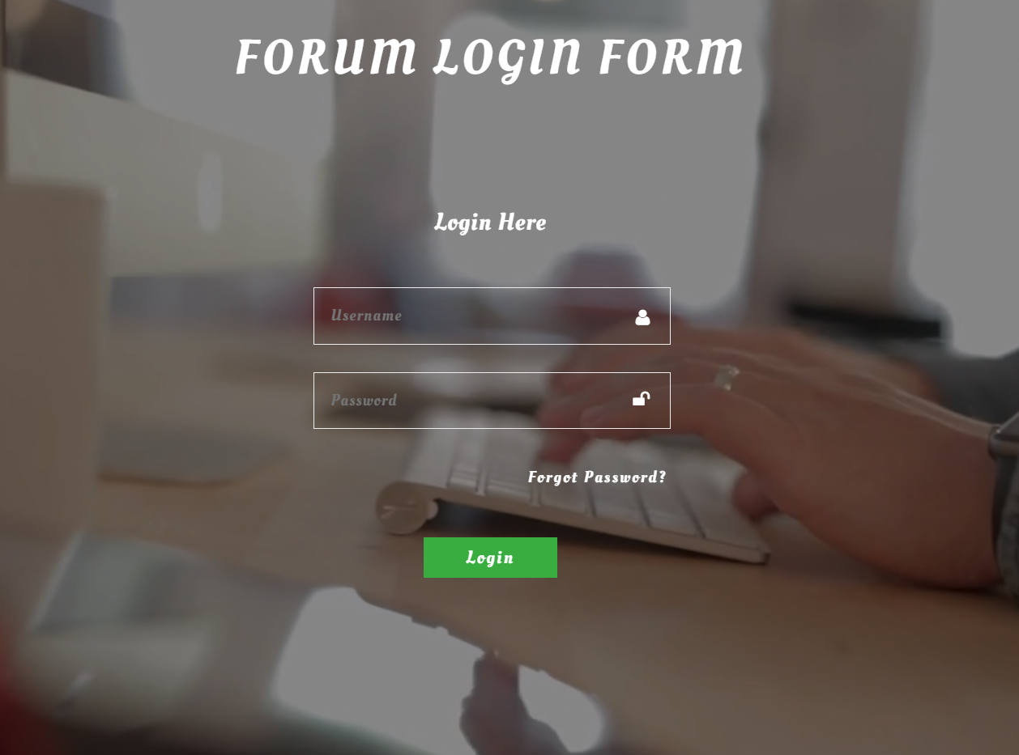

|  |  |  |  |  |  |
| --- | --- | --- | --- | --- | --- |
| **No.** | **Name** | **Type** | **Validation** | **Event** | **Description** |
| 1 | Username | Textfield | Cannot blank!! |  | The Username of Account |
| 2 | Password | TxtPassword | Cannot blank!!! |  | The Password of Account |
| 3 | Login | Button |  | Click | Login successful will show the message and go to dashboard page or Profile Page |

**Download Idea File Page**

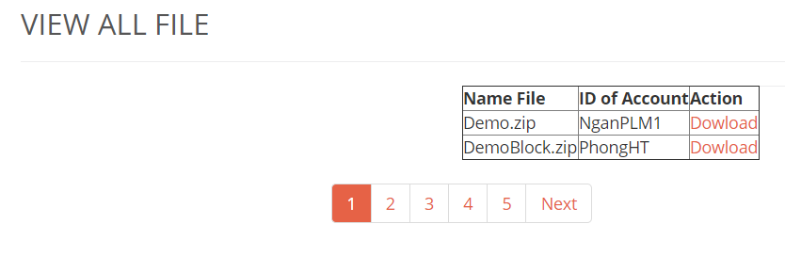

|  |  |  |  |  |  |  |
| --- | --- | --- | --- | --- | --- | --- |
| **No.** | **Name** | **Type** | **Validation** | **Event** | **Description** | **Status** |
| 1 | NameFile | Textfield |  |  | Name File of Idea |  |
| 2 | ID of Account | Textfield |  |  | ID of Account |  |
| 3 | Action | Button |  | Click | Download file idea of student |  |

**Department Page**

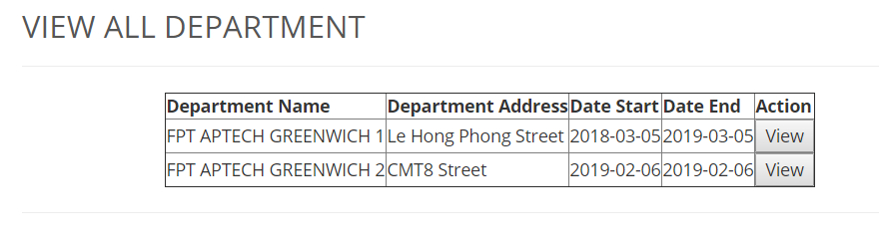

|  |  |  |  |  |  |  |
| --- | --- | --- | --- | --- | --- | --- |
| **No.** | **Name** | **Type** | **Validation** | **Event** | **Description** | **Status** |
| 1 | Department name | Textfield |  |  | Name of Department |  |
| 2 | Department Address | Textfield |  |  | Address of department |  |
| 3 | Date Start | datetime |  |  | Date start of the department |  |
| 4 | Date End | datetime |  |  | date end of the department |  |
| 5 | Action | Button |  | Click | View department information detail |  |

**Management Account page**

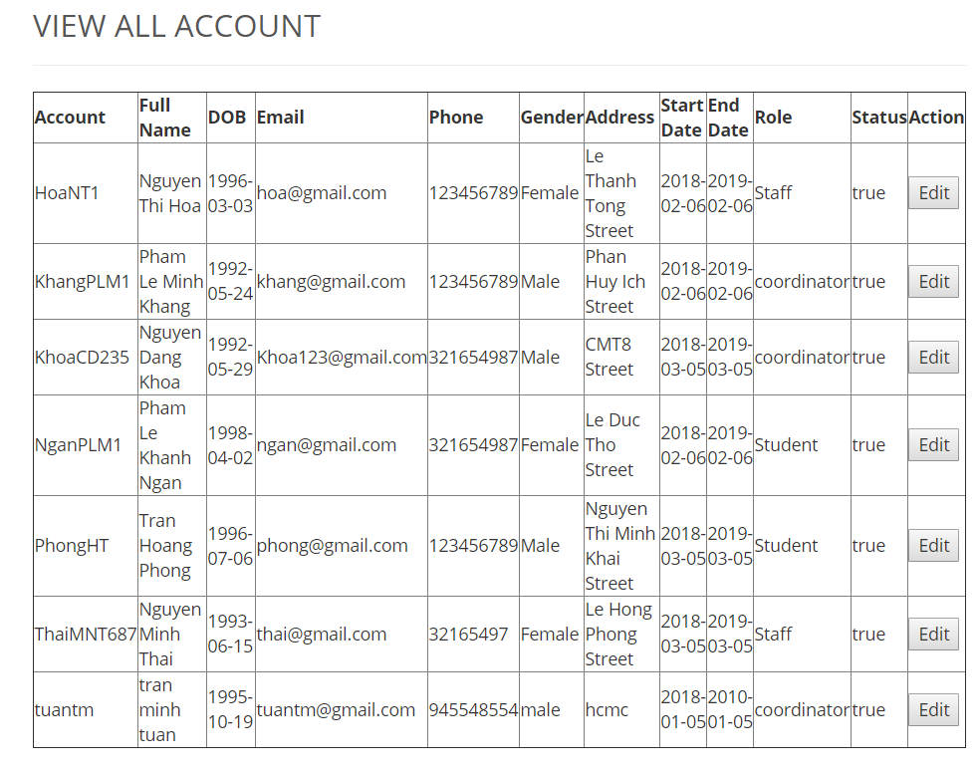

|  |  |  |  |  |  |  |
| --- | --- | --- | --- | --- | --- | --- |
| **No.** | **Name** | **Type** | **Validation** | **Event** | **Description** | **Status** |
| 1 | Account | Textfield |  |  | Username of account |  |
| 2 | Fullname | Textfield |  |  | Fullname of user |  |
| 3 | DOB | Textfield |  |  | DOB of user |  |
| 4 | Email | Textfield |  |  | Email of user |  |
| 5 | Phone | Textfield |  |  | Phone of user |  |
| 6 | Gender | Textfield |  |  | Gender of user |  |
| 7 | Address | Textfield |  |  | Address of user |  |
| 8 | Start Date | Textfield |  |  | Start date or user |  |
| 9 | End Date | Textfield |  |  | End date of user |  |
| 10 | Role | Textfield |  |  | Role of user |  |
| 11 | Status | Textfield |  |  | Status of user (E.g. Enable, Disable) |  |
| 12 | Action | Button |  | Click | Updating value information of user |  |

**Insert Department Page**

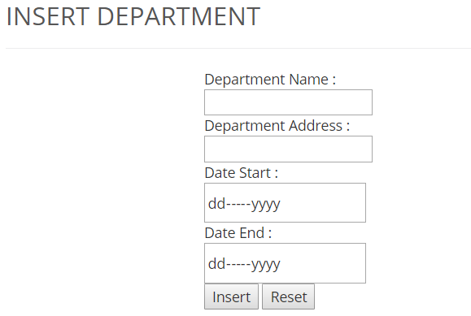

|  |  |  |  |  |  |
| --- | --- | --- | --- | --- | --- |
| **No.** | **Name** | **Type** | **Validation** | **Event** | **Description** |
| 1 | Department name | Textfield |  |  | Name of Department |
| 2 | Department Address | Textfield |  |  | Address of department |
| 3 | Date Start | datetime |  |  | Date start of the department |
| 4 | Date End | datetime |  |  | date end of the department |
| 5 | Insert | Button |  | Click | Insert new department to database |
| 6 | Reset | Button |  | Click | Reset all field was input |

**Insert new account (of administrator) page.**

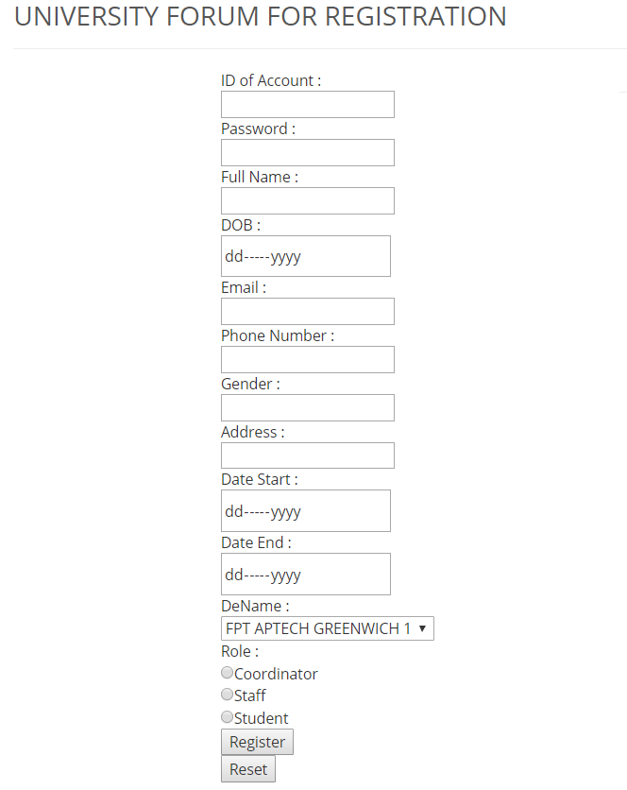

|  |  |  |  |  |  |
| --- | --- | --- | --- | --- | --- |
| **No.** | **Name** | **Type** | **Validation** | **Event** | **Description** |
| 1 | Id of account | Textfield |  |  | Id of Account (E.g. StudetID) |
| 2 | Password | Textfield |  |  | Password of user |
| 3 | Full Name | Textfield |  |  | Fullname of user |
| 4 | DOB | datetime |  |  | Dob of user |
| 5 | Email | Textfield |  |  | Email of user |
| 6 | Phone Number | number |  |  | Phone number of user |
| 7 | Gender | Radio Button |  |  | Gender of user |
| 8 | Address | Textfield |  |  | Address of user |
| 9 | Start Date | Datetime |  |  | Start date of account |
| 10 | End Date | datetime |  |  | End date of account |
| 11 | DeName | Selection |  |  | Department of account |
| 12 | Role | Radio button |  |  | Role of user |
| 13 | Register | Button |  | Click | Insert new account to databasse |
| 14 | Reset | Button |  | Click | Reset alll field was input |

**Post new idea Page**

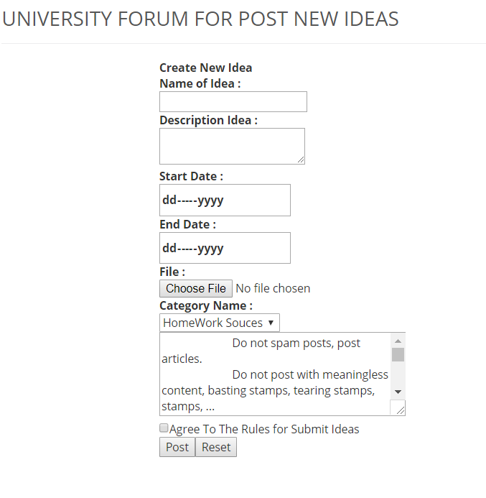

|  |  |  |  |  |  |
| --- | --- | --- | --- | --- | --- |
| **No.** | **Name** | **Type** | **Validation** | **Event** | **Description** |
| 1 | Name of idea | Textfield |  |  | Name of Idea |
| 2 | **Description idea** | Textarea |  |  | **Description of idea** |
| 3 | Start Date | datetime |  |  | Start date post idea |
| 4 | End date | datetime |  |  | Deadline of idea |
| 5 | File | button |  | Click | Upload file idea |
| 6 | Category Name | Combobox |  |  | Category of Idea |
| 7 | Confine rule | Checkbox |  | Click | Terms and Conditions of Use |
| 8 | Post | Button |  | Click | Post new idea into forum |
| 9 | Reset | Button |  | Click | Reset all field was input |