Readme.docx

Project 2 Part 3 - Huy Nguyen and Christopher Nguyen

CSE 3330 Section 003

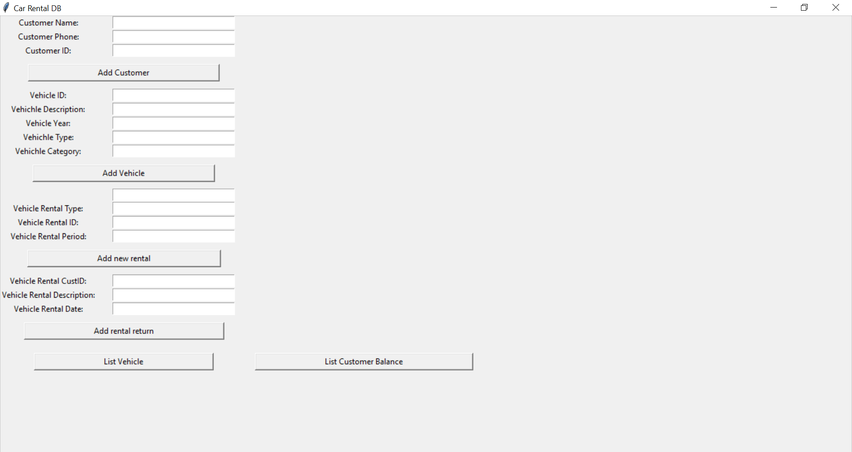

Installation Instructions:

1. Download the file Code and unzip it.
2. Run the python script carRental.py using the command on the terminal ‘python3 carRental.py’

Functionalities:

Task 1.

1. Type in your name, phone, and a number in its respective boxes.

1a. Name should be no more than 64 characters long, phone must be exactly 14 characters, and number must be an integer.

1. Click the button ‘Add Customer’
2. Your information will be stored onto the database file ‘carrental.db’

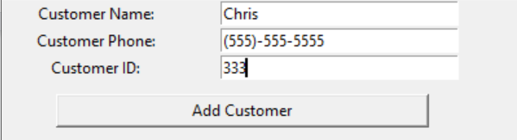

Task 2.

1. Type in an identification number for vehicle, a description, its year, type and category in its respective boxes
2. 17 Character String in the Vehicle ID, A String up to 64 characters for description, and an integer for year, type and category
3. Click the button ‘Add Vehicle’
4. Your information will be stored onto the database file ‘carrental.db’

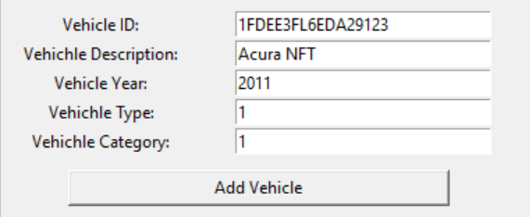

Task 3.

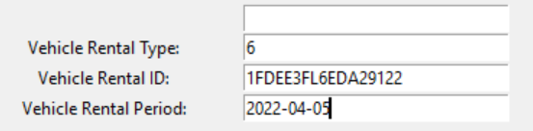

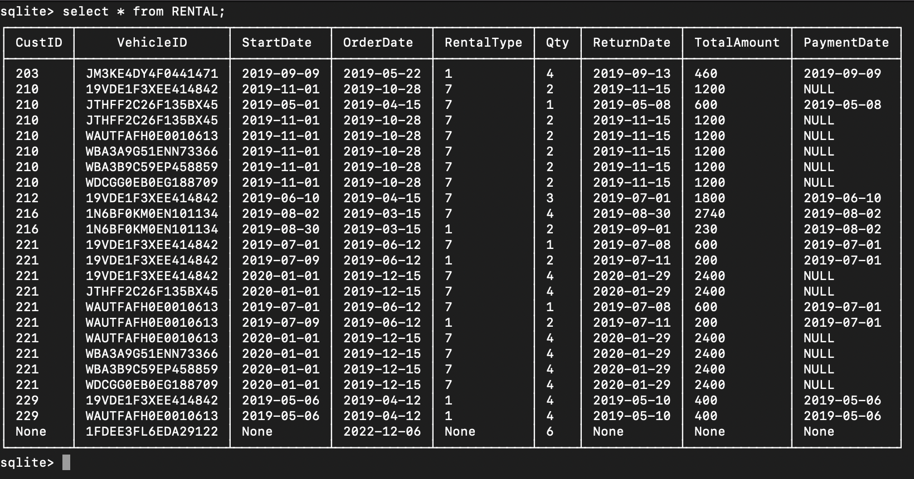

1. You should be able to add a new rental using the rental type,vehicleID and time period
2. Then click ‘Add new rental’
3. The program will know if the car is available for rent by looking in the RENTAL database to see if the car is currently available or not
4. If the parameters are correct, the program will print ‘Available’ and insert the parameters onto the database, and if not, the program will print ‘Not Available’ and not insert into rental.

Task 4.

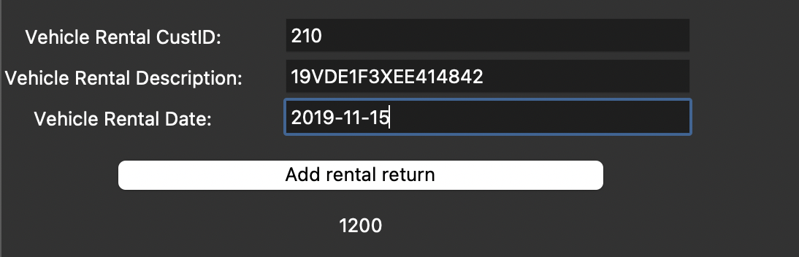

1. To return a rental car, user can put in the customer ID, the vehicle description, and the rental return date.
2. Then click ‘Add rental return’
3. It will print out the total payment for the car.

Task 5.

1. Enter a customer name or a customer ID
2. Click the button ‘List Customer Balance’
3. If a name or ID is found in the rental database, and there is vehicle that has not yet been returned, there will be a number below the button ‘List Customer Balance’

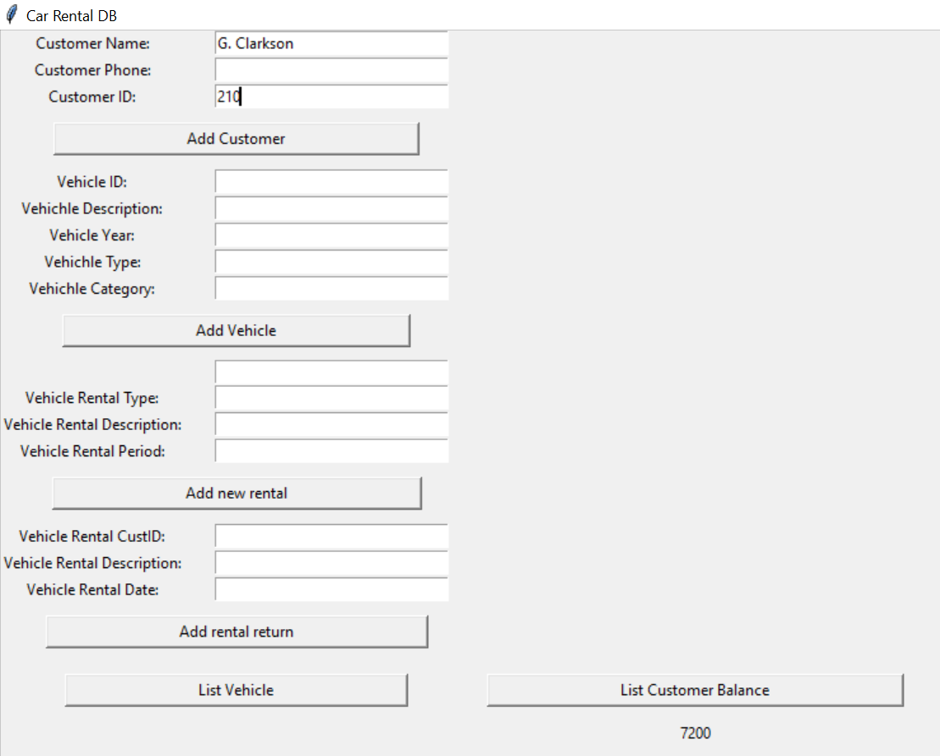

1. Type either the Vehicle ID or the Vehicle Description into the respective boxes that are filled in below
2. Press the button ‘List Vehicle’
3. If the vehicle is found in the database and has a rental, the GUI will show the ID and description of the vehicle

