# Task 4

NoSQL databases, unlike traditional relational databases (SQL), are designed to handle unstructured, semi-structured, or large-scale distributed data. NoSQL databases, such as MongoDB, prioritize flexibility, scalability, and speed over strict table-based schemas. MongoDB is a document-oriented NoSQL database that stores data in JSON-like BSON format, allowing complex data structures to be stored within a single document. These documents can vary in structure, providing flexibility in data modeling.

MongoDB offers several advantages, such as horizontal scalability through sharding, where large datasets can be distributed across multiple servers. It also supports replication, ensuring high availability and data redundancy by replicating data across multiple nodes. MongoDB uses collections to group documents, which are analogous to tables in relational databases but more flexible, as documents within a collection can have different fields and data types.

A key feature of MongoDB is its ability to handle embedded documents and arrays, allowing developers to store related data together and perform complex queries without the need for JOIN operations. MongoDB also supports indexing, aggregation pipelines, and various query operators that facilitate data retrieval and manipulation.

Exercises in Studio 3T demonstrated practical aspects of MongoDB, such as creating collections, importing JSON documents, and using visual query builders for querying and filtering data. It further illustrated how MongoDB’s aggregation framework can be used for data transformation and analysis, showcasing the power of this NoSQL solution in handling complex data workloads.

## Lesson 4 exercise 1

## Lesson 4 exercise 3

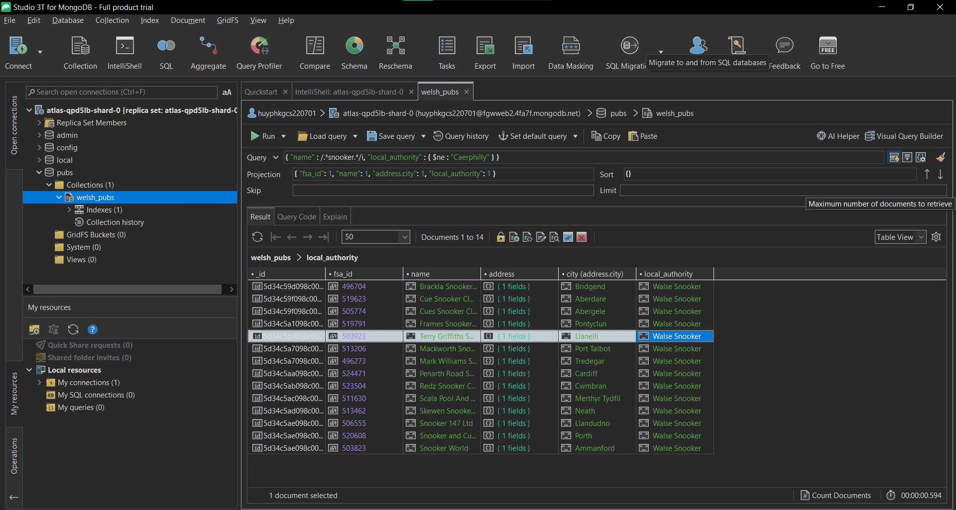

## Lesson 5 exercise 3

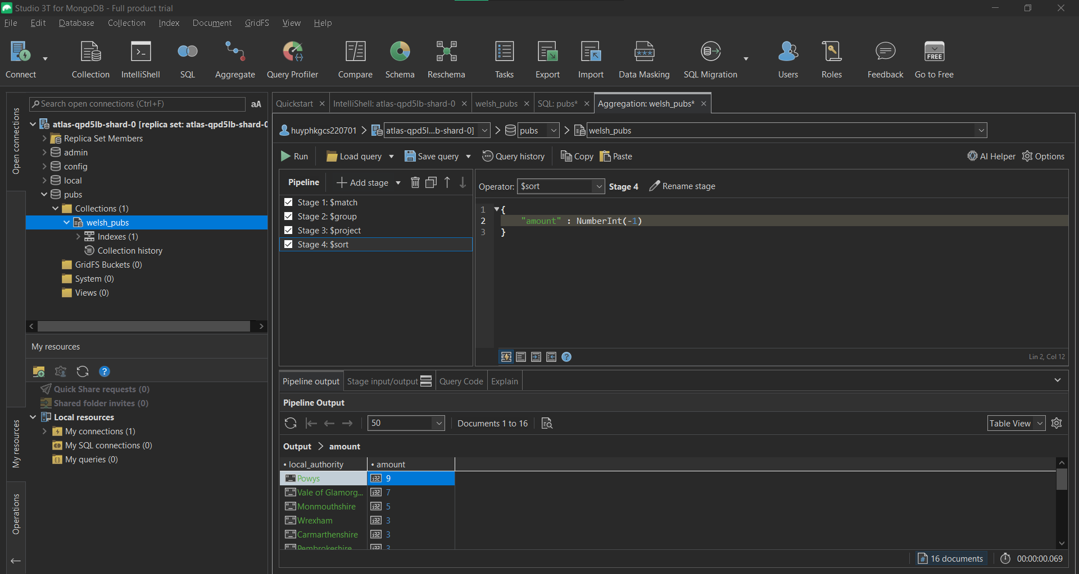

## Lesson 6 exercise 2

