PHẦN 1 — SETUP FRONTEND (React + Vite)
1.Tạo React + Vite
npm create vite@latest frontend
Chọn:
✔ Framework: React
✔ Variant: JavaScript + SWC
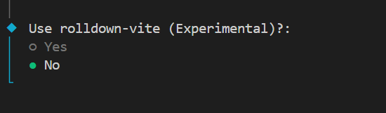
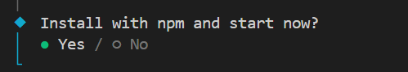
2. Cài dependency & chạy
cd frontend
npm install
npm run dev
PHẦN 2 — SETUP BACKEND (ASP.NET Core Web API)
1. Tạo Web API
cd ..
dotnet new webapi -n backend
2.Chạy backend
cd backend
dotnet run
http://localhost:5162/swagger/index.html

3.Cài Swagger package
cd backend
dotnet add package Swashbuckle.AspNetCore

Thêm icon : npm install react-icons

