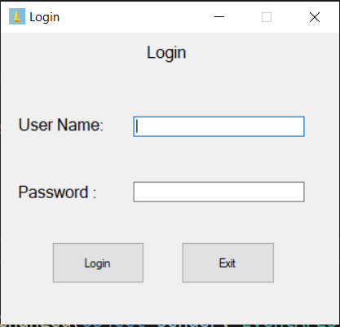Login window

Enter the correct user name and password to login

Main menu

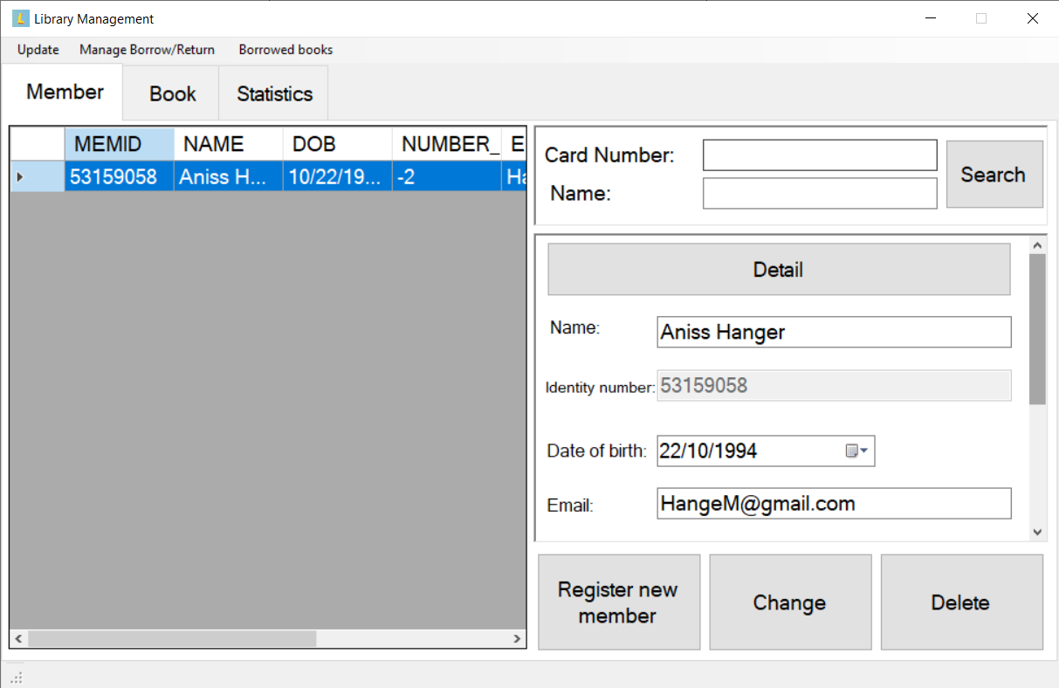

More details about member’s infomation

Search with card number or member’s name

Member tab

Delete member

Change member’s infomation

Add a new member

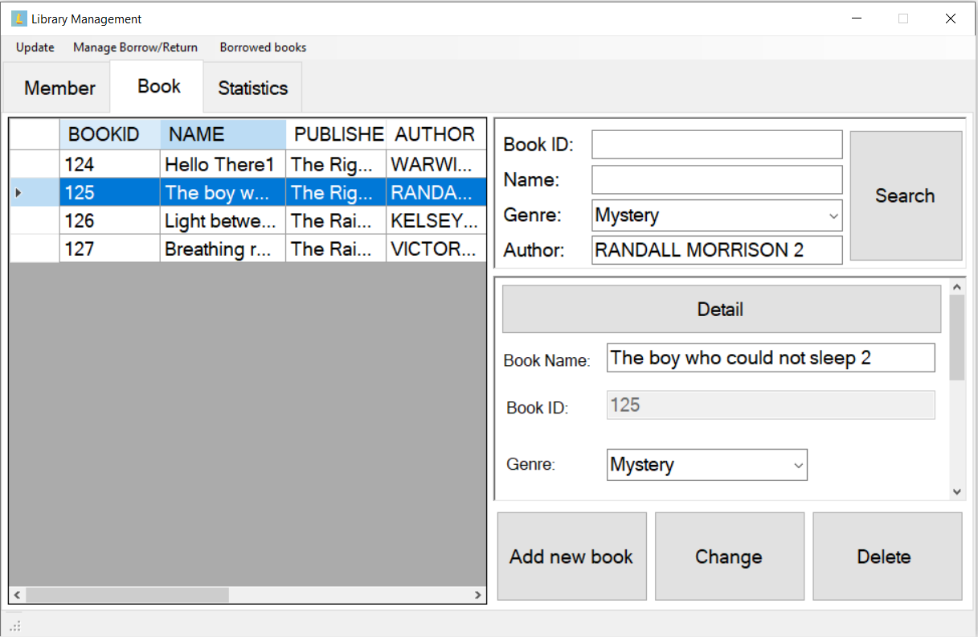

Delete book

Change book’s infomation

Add new book to library

More details about book

Search book with book iD, name, genre and author.

Book tab

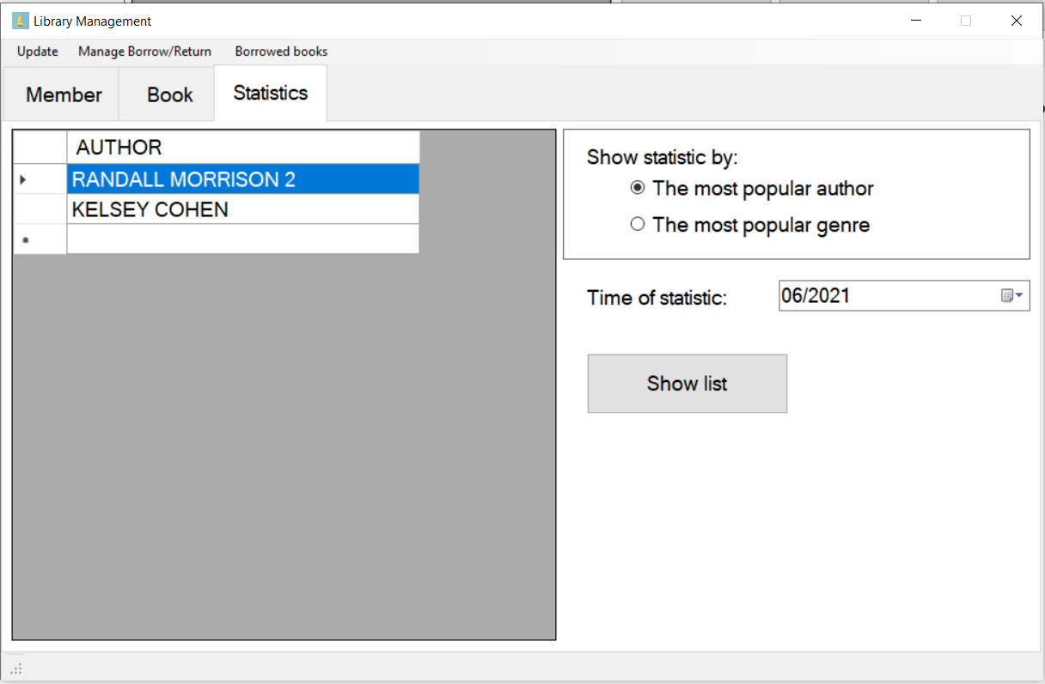

Show statistic

Chose time

Chose how to show statistic by

Statistics tab

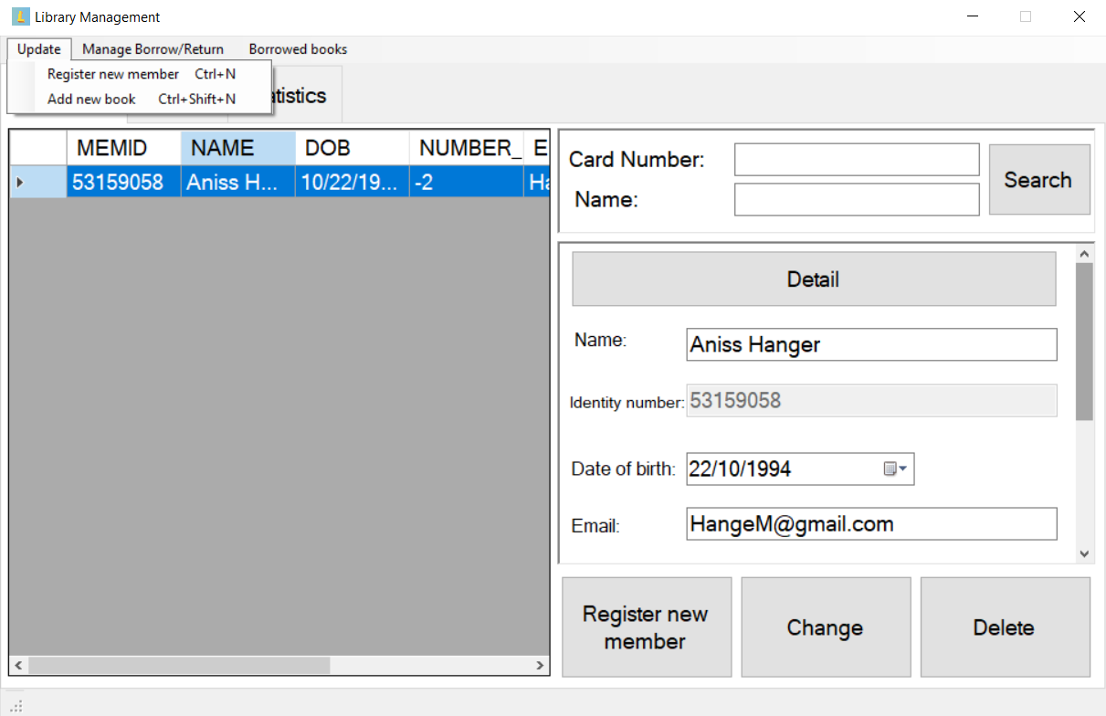Update Menu

(same function with the button on main menu)

Add new member or book

Register new member

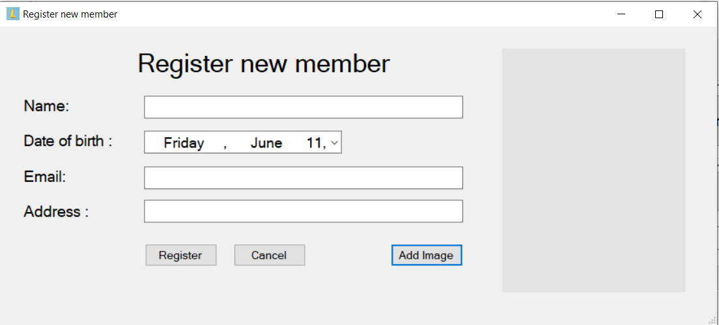

Enter member’s infomation

Confirm register

Add images of new member

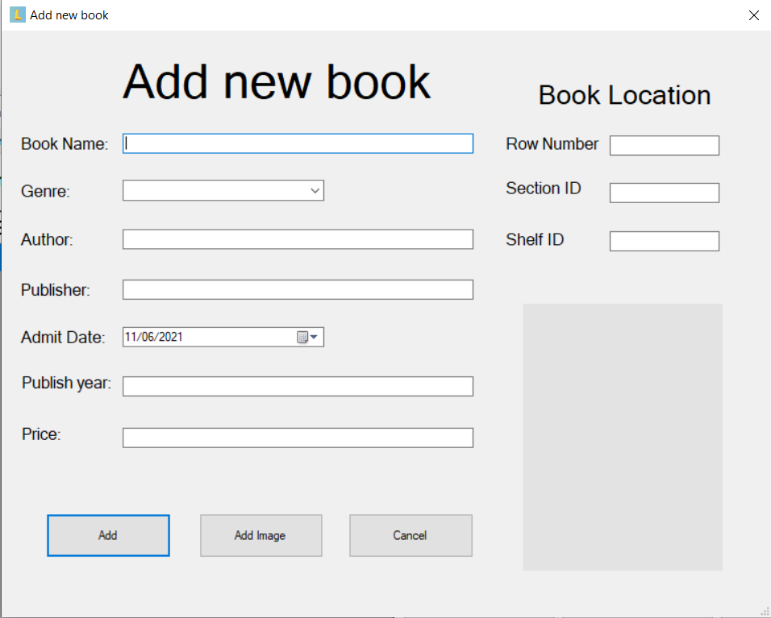Add new book

Enter new book’s location in library

Enter information about new book

Confirm

Add images of new book

Manage Borrow/Return Menu

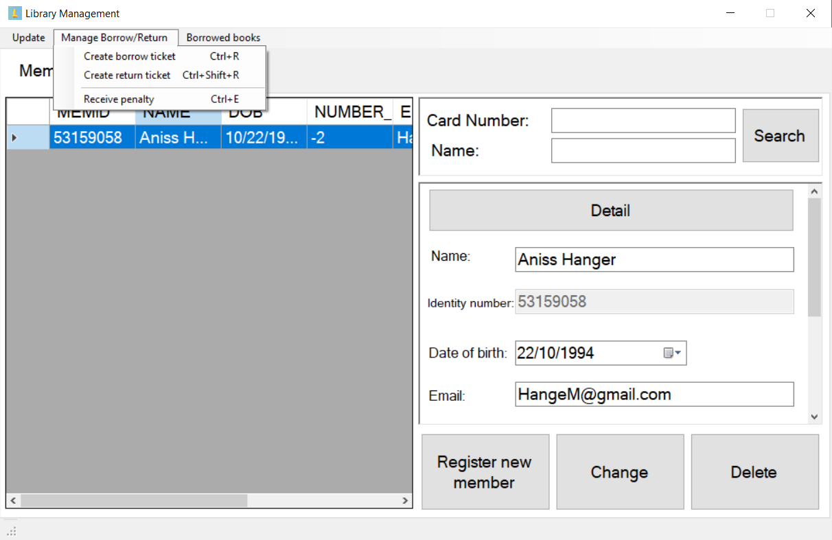

Create borrow/return ticket or recerive penalty

Create borrow ticket 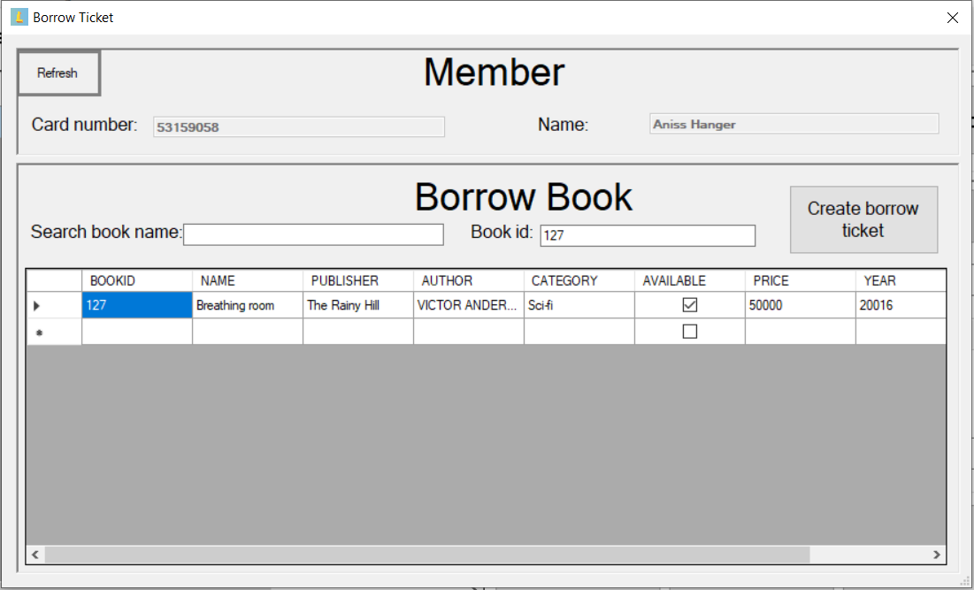

Tick of untick to choose which books will be borrow

Search book with name or id

Confirm

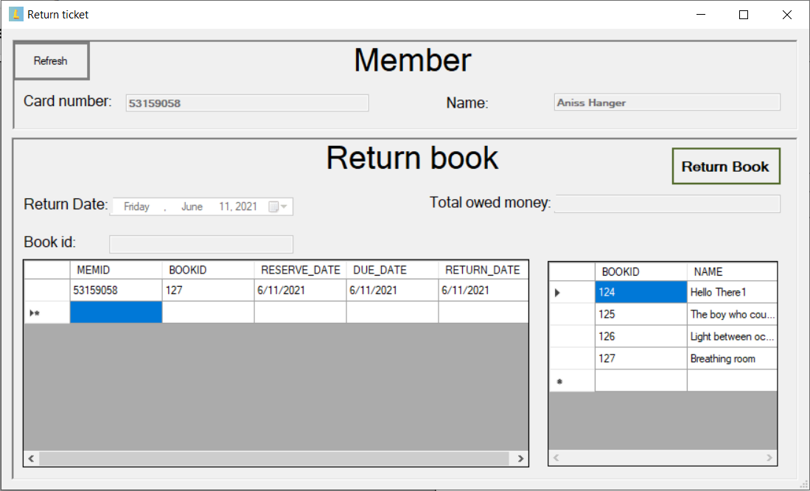Create return ticket

Confirm

Choose book return

Receive penalty

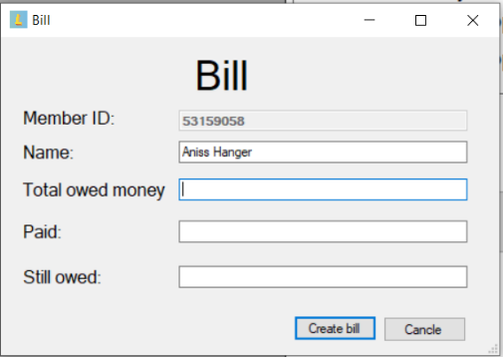

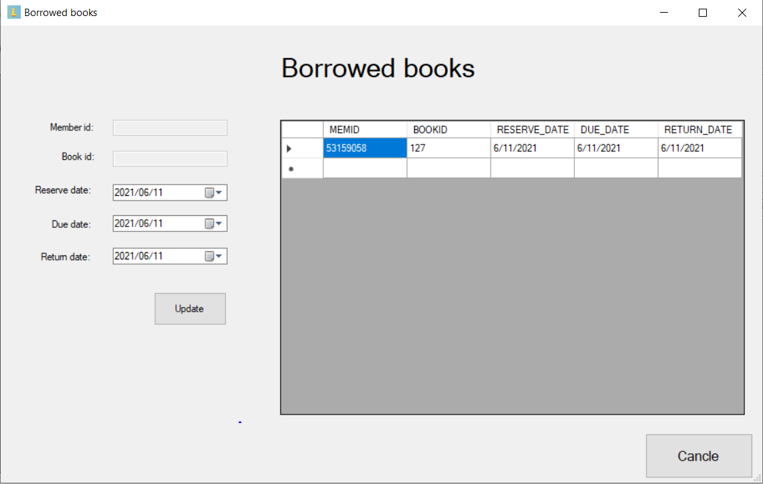Borrowed Books

Update new borrowed books

Choose Time