+ About Us

* **About Us**

**ASEANHR** is the most popular jobsite specializing in providing jobs vacancies and high qualification human resource to our partners. We have grown from specializing in online jobs advertising, recruitment and sourcing employees of all standards for businesses and organizations across the Asia.

Through our dedicated team of internationally-trained experts, we combine state-of-the-art technology, data analysis and a comprehensive network of partners to find the right person for your business. Calling on our well-established network of potential candidates, we conduct the screening process, saving your company time while ensuring you secure the perfect person to help your business grow.

Our success and expertise has led to thousands of jobseekers using our services every day to search the more than 3,600 live jobs advertise.

* **Our Vision**
  + Try our best to support our clients for more success.
* **Our Mission**
  + To provide jobs vacancies to all job seekers and professional staffs to our clients and provide quality service to achieve our clients' goals.
* **Core Values**
  + **Ownership -** Taking care of the company and customers as we were one’s own.
  + **Integrity -** Acting with honesty and honor with the truth and value.
  + **Commitment -** Committing to great product, service, and other initiatives that impact lives within and outside the organization.
  + **Responsiveness -** Responding and act promptly in all our interactions with our customers.
  + **Reliability-** In the delivery of our products and services, we will ensure that Quality, Value, and Service are attained and sustained.
  + **Innovativeness –** Always continuously search for newer and better ways to improve what we do.
  + **Trust** - We will treat each other with mutual respect and will never undermine each other.
* **About our promotion**
  + Free jobs posting Service
  + Free CV posting service
  + Free CV offered Service
  + Free Advertising
  + Free jobs search...etc.
* **About Advertising Service**
  + Facebook page “Aseanhr”
  + www.aseanhr.com

**+ Our Service**

* Jobs Posting Service

1. Urgent Jobs Posting
   1. There is 1 duration date of Job Postings is 1Month (1 Position =$15/Month)
   2. The Urgent Job Posting can be found in top of all job pages and job list pages. It is top of the basic job posting.

**Benefits**

* + Always above of basic job list
  + Employer can refresh their announcement to the top of front page.
  + CV offer 5 candidates
  + Free customer care: Our trained Customer Service Officers will be glad to help you. They can advise you on:
    - How to post on our Jobsite to attract job seekers you need.
    - How to improve your job announcements.
    - Other service of website

1. Basic Jobs Posting
   * There are 2 duration date of Job Postings. One is for 15 days and another for 30 days.
   * The Basic Job Posting can be found in all job pages and job list pages. It is below the urgent job posting.

**Benefits**

* + Your jobs announcement will appear in job list pages
  + Employer can refresh their announcement to the top of front page.
  + Free customer care: Our trained Customer Service Officers will be glad to help you. They can advise you on:
    - How to post on our Jobsite to attract job seekers you need.
    - How to improve your job announcements.
    - Other service of website
* **CV offered Service**
* **Recruitment Agencies & Recruitment Employers**
  + **Recruitment Employer**
    - Your company’s logo will appear in the “Recruitment Employers box” in the Homepage.
    - Job seekers can view your company’s profile for all job listed directly with one click.

**Price**

* + Free of charge for Recruitment Agencies and Employers

**Benefits**

* + Unlimited job posting announcements
  + Your logo shown on the Homepage.
  + Free customer care: Our Customer Service Officers will be glad to help you for concern and more information   
    
* **Banner Advertising**
  + **Banner advertising in ASEANHR Homepage**

**ASEANHR** provides Banner Advertising Service to the Advertisers who want to promote their services, products or even their brand.

**Price Rate**

|  |  |  |  |  |
| --- | --- | --- | --- | --- |
| Homepage 15Days | | | | |
| *Banner Location* | *Price* | *Size* | *Duration* | *Benefit* |
| Location A | $168 | 728x90 | 1Month |  |
| Location B | $35 | 300x250 | 1Month |  |

**Sample Banner Advertising**  
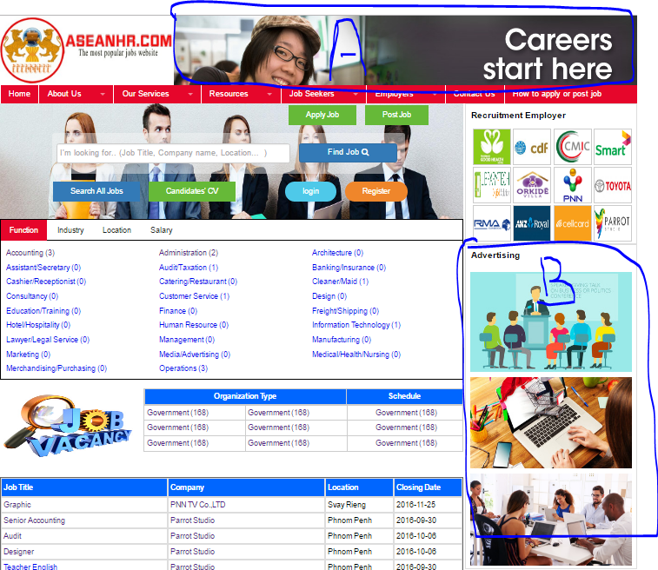

+ Resources

* CV & Cover Letter
* CV Sample
* Employer development
* Career Development
* Interview Development
* Attractive Candidates
* Other

+ Job Seekers

* Create Account
* Create CV & Cover Letter
* Post CV & Cover Letter
* Search Job
* Interview Question & Answer
* Others

+ Employers

* Create Account
* Post Jobs
* Search Candidates’ CV
* Payment Methods