Convert project version: <https://www.worldofleveldesign.com/categories/ue4/ue4-convert-update-projects.php>

Tank architecture:

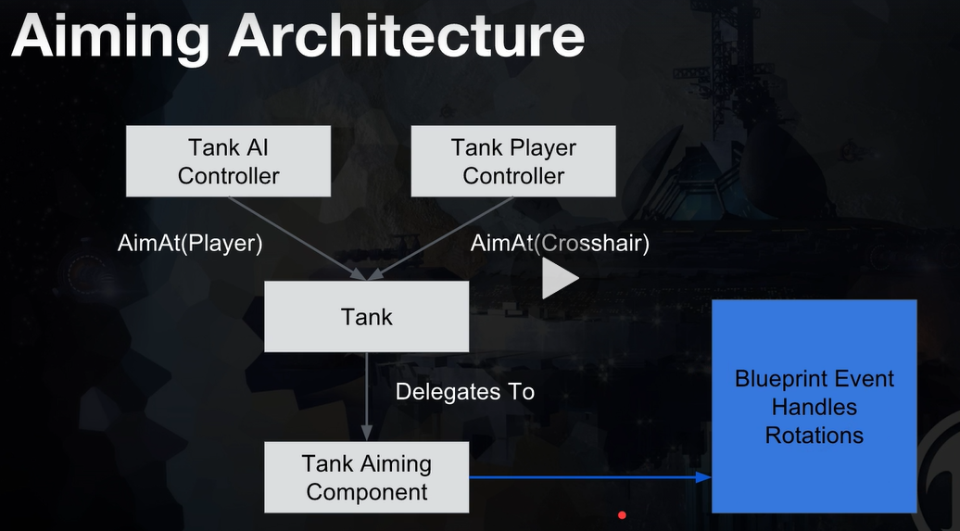

Both the tank AI and Tank player controllers MUST talk to the Tank

* The tank provides the framework, the functions. The controllers call those functions.

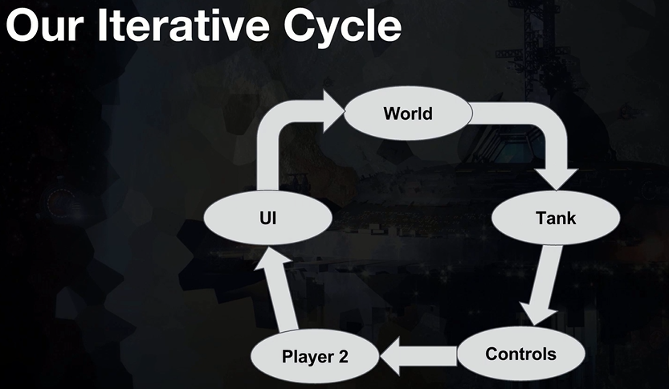

Landscape:

* Less storage than Static Mesh
* Support Level of Detail (LOD) & streaming
* Good built-in tools for sculpting
* Work well with mini-maps