Software Requirements Specification
for
WalkingSG
Version 5.0
Prepared by Trinh Hoang Huy
Group 3 – SCS2
September 5th
Table of Contents
Table of Contents ii
Revision History ii
1. Introduction 1
1.1 Purpose 1
1.2 Document Conventions 1
1.3 Intended Audience and Reading Suggestions 1
1.4 Product Scope 1
1.5 References 1
2. Overall Description 2
2.1 Product Perspective 2
2.2 Product Functions 2
2.3 User Classes and Characteristics 2
2.4 Operating Environment 2
2.5 Design and Implementation Constraints 2
2.6 User Documentation 2
2.7 Assumptions and Dependencies 3
3. External Interface Requirements 4
3.1 User Interfaces 4
3.2 Hardware Interfaces 7
3.3 Software Interfaces 7
3.4 Communications Interfaces 7
4. System Features 8
4.1 Authentication 8
4.2 Preference Management 9
4.3 Search & Map Interface 10
4.4 Routing & Scoring Engine 11
4.5 Live Navigation 13
4.6 Community Hazard & Local Feed 14
5. Other Nonfunctional Requirements 15
5.1 Performance Requirements 15
5.2 Safety Requirements 15
5.3 Security Requirements 15
5.4 Software Quality Attributes 15
5.5 Business Rules 15
6. Other Requirements 16
Appendix A: Glossary 16
Appendix B: Analysis Models 16
Appendix C: To Be Determined List 16
Appendix D: Data Dictionary 17

Revision History
Name | Date | Reason For Changes | Version
Trinh Hoang Huy | August 31st | Initial Requirements Proposal | 1.0
Hemanth | September 4th | Update Data Dictionary | 2.0
Trinh Hoang Huy | September 5th | Refine Functional Requirements | 3.0
Lin Ziqi | September 5th | Update UI  Update Content page | 4.0
Trinh Hoang Huy | September 5th | Final touch on the first SRS Version (Reformat for better look) | 5.0

Introduction

Purpose
- This system is a pedestrian-first, mobile-based navigation application scoped specifically to the geographic boundaries of Singapore. It provides personalized pedestrian routing based on user mobility constraints, real-time weather, and community-driven accessibility scoring.

Document Conventions
- Functional requirements are identified by a unique sequence tag (e.g., REQ-AUTH-01). Priorities (High, Medium, Low) are explicitly stated for major features and inherited by their sub-requirements.

Intended Audience and Reading Suggestions
- This document is intended for backend developers, frontend mobile developers, UI/UX designers, and project managers. Developers should focus heavily on Section 4 (System Features) and Section 5 (Other Nonfunctional Requirements), while designers should focus on Section 3 (External Interface Requirements).

Product Scope
- WalkingSG aims to solve the "last mile" and pedestrian navigation gaps left by vehicle-centric apps. The software allows users to define physical mobility needs (e.g., wheelchair, stroller) and environmental preferences (e.g., maximum shelter). It calculates five distinct routes for every query, ranking the top choice dynamically based on the user's profile. It relies on community reports to adjust the "confidence score" of individual map segments, ensuring real-time hazard avoidance.

References
<Placeholder>

Overall Description

Product Perspective
- WalkingSG is a new, self-contained mobile application. It operates as a front-end interface that relies heavily on external mapping APIs (OneMap, OpenStreetMap) for baseline geospatial data, while maintaining its own proprietary database for user profiles, saved preferences, and custom map-segment confidence scores.

Product Functions
- Account creation and password recovery.
- Management of personal mobility and environmental preferences.
- Calculation and display of 5 distinct pedestrian route types (Direct, Maximum Shelter, Barrier-Free, Low-Effort, Wide/Quiet).
- Live, GPS-based turn-by-turn navigation.
- Community hazard reporting and dynamic path-segment scoring.
- Location-based Local Hazard News Feed.

User Classes and Characteristics
- Standard Pedestrians: High frequency of use, seeking sheltered or direct routes.
- Mobility-Impaired Users (Wheelchair/Stroller): Require high accuracy on step-free ("Barrier-Free") routing. Zero tolerance for unmapped stairs.
- Elderly Walkers: Prefer "Low-Effort" routes avoiding steep inclines.

Operating Environment
- The software will operate as a cross-platform mobile application (iOS 15+ and Android 10+). It requires an active internet connection (4G/5G/WiFi) and active device GPS functionality.

Design and Implementation Constraints
- Geographic scope is strictly locked to Singapore's coordinate bounding box.
- The system shall not calculate vehicular, bicycle, or public transit routing. It is exclusively optimized for walking and pedestrian-supportive personal mobility aids.
- Data consumption must be minimized to maintain performance on typical mobile data plans.

User Documentation
<List the user documentation components (such as user manuals, on-line help, and tutorials) that will be delivered along with the software. Identify any known user documentation delivery formats or standards.>

Assumptions and Dependencies
<List any assumed factors (as opposed to known facts) that could affect the requirements stated in the SRS. These could include third-party or commercial components that you plan to use, issues around the development or operating environment, or constraints. The project could be affected if these assumptions are incorrect, are not shared, or change. Also identify any dependencies the project has on external factors, such as software components that you intend to reuse from another project, unless they are already documented elsewhere (for example, in the vision and scope document or the project plan).>

2.7.1 Assumptions
- GPS Signal Availability: It is assumed that the end-user's device has a functional GPS sensor capable of maintaining an accuracy threshold of within 10 meters, and that Singapore’s urban canyons (e.g., the Central Business District or Marina Bay) do not consistently block satellite positioning signals.
- Continuous Cellular Internet: It is assumed that users maintain active mobile data packages (4G/5G) or are connected to urban public WiFi networks during routing queries and live navigation.
- Active Mobility Compliance: It is assumed that standard pedestrians and mobility-impaired users comply with physical path markers, speed regulations under the Singapore Active Mobility Act, and real-world construction signs, treating app recommendations as advisory.

2.7.2 Dependencies
- Singapore Land Authority (SLA) OneMap APIs: The system depends entirely on SLA’s OneMap APIs for baseline address lookup, autocomplete suggestions, base map tiles, and foundational wheelchair-accessible networks. Any service disruption on SLA's production server directly degrades routing capabilities.
- Firebase Cloud Messaging (FCM) & Apple Push Notifications (APNs): The instant local hazard news broadcasting mechanism relies on steady integrations with third-party cloud messaging push pipelines to reach active devices within 5-kilometer bounding boxes.

External Interface Requirements

User Interfaces
Login

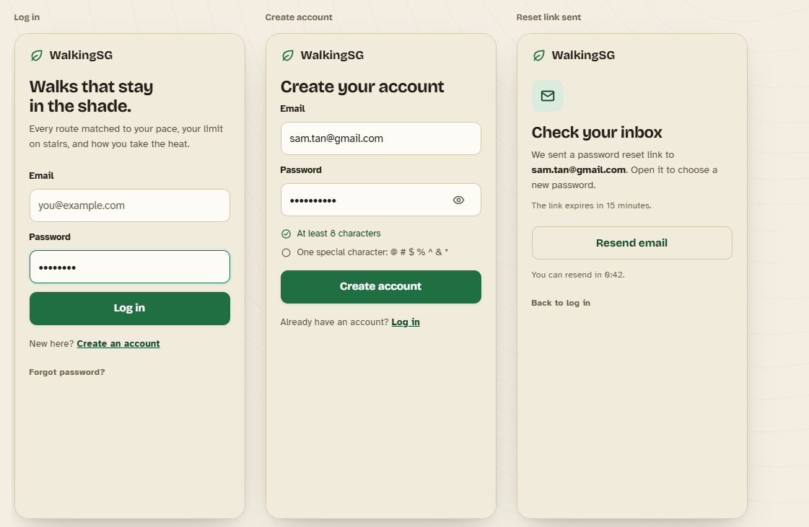

Profile and preferences

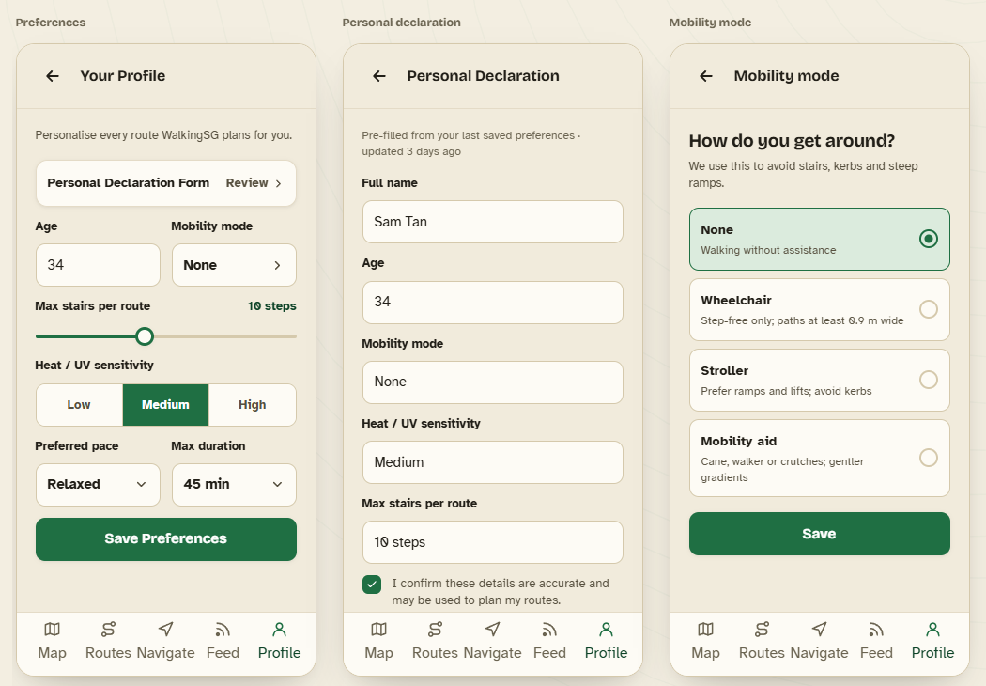

Search and Map

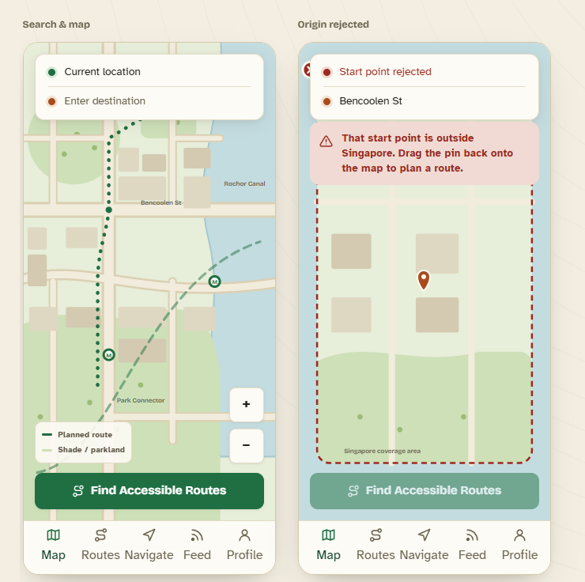

Route Result

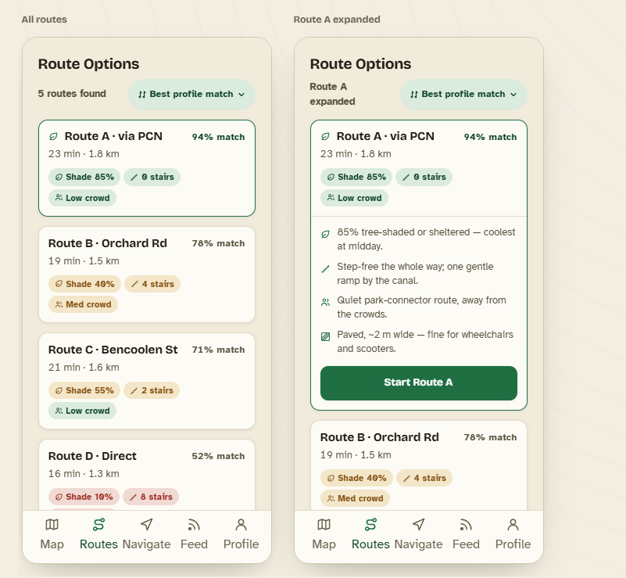
Live Navigation

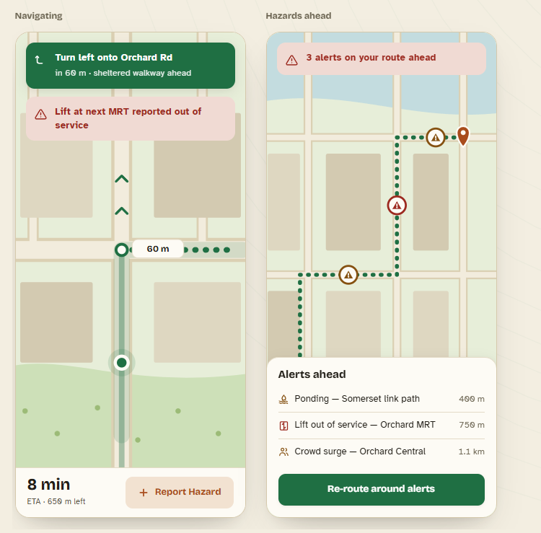

Local Feed

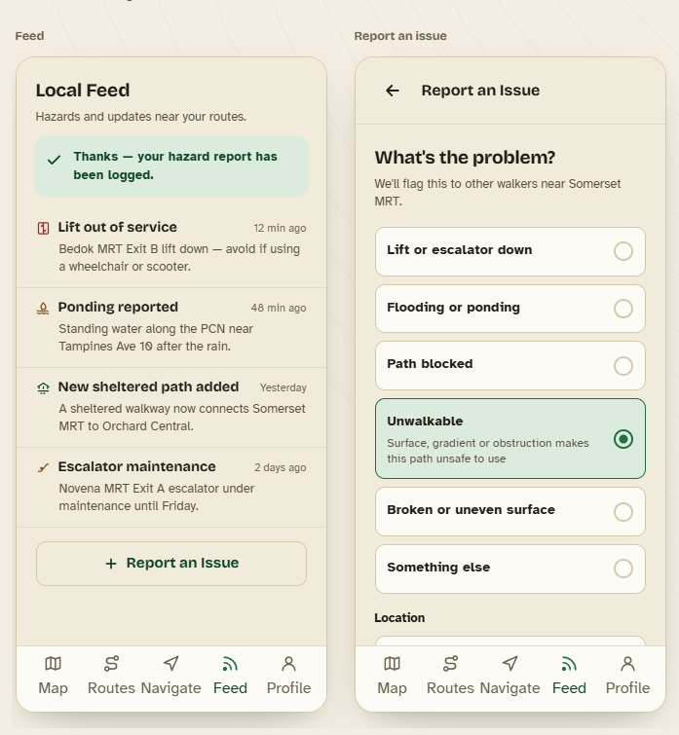

Hardware Interfaces
- The software must interface with the mobile device's internal GPS sensor to receive continuous coordinate updates (latitude/longitude/heading) during active navigation.

Software Interfaces
- OneMap API: Used for address autocomplete, base map rendering, and baseline barrier-free routing data.
- Database (e.g., PostgreSQL): Stores user profiles, hashed passwords, and path-segment confidence tables.

Communications Interfaces
<Describe the requirements associated with any communications functions required by this product, including e-mail, web browser, network server communications protocols, electronic forms, and so on. Define any pertinent message formatting. Identify any communication standards that will be used, such as FTP or HTTP. Specify any communication security or encryption issues, data transfer rates, and synchronization mechanisms.>

System Features

Authentication
4.1.1 Description and Priority
- High priority. Handles secure user access, account creation, credential validation, and session lifecycle management.
4.1.2 Stimulus/Response Sequences
- User opens app -> System prompts login/register -> User submits credentials -> System validates against database -> System authenticates, generates session token, and grants access.
4.1.3 Functional Requirements
REQ-AUTH-01: The system must allow a user to register a new account using an
email address and password.

- REQ-AUTH-01.1: The system must verify that the provided email address is not already linked to an existing account.

- REQ-AUTH-01.2: The system must display the error message "Email already in use" if a duplicate email registration is attempted.

- REQ-AUTH-01.3: The system must enforce a minimum password length of 8 characters.

- REQ-AUTH-01.4: The system must enforce the inclusion of at least one special character (e.g., @, #, $, %, ^, &, *) in the password.

- REQ-AUTH-01.5: The system must verify the ownership of the email address with a one-time 6-digit code sent to the registered email.

- REQ-AUTH-01.6: The system must expire the one-time code 10 minutes after it is issued.

- REQ-AUTH-01.7: The system must activate the account only after successful code verification.

REQ-AUTH-02: The system must allow a user to log in using their registered email
and password.

    - REQ-AUTH-02.1: The system must deny access and display the error message "Invalid email or password" if the provided credentials do not match database records.

    - REQ-AUTH-02.2: The system must lock the user account for 15 minutes after 5 consecutive failed login attempts.

REQ-AUTH-03: The system must provide a "Forgot Password" function to recover
lost account access.

- REQ-AUTH-03.1: The system must send a password reset link to the user's
registered email address upon request.

- REQ-AUTH-03.2: The system must invalidate the password reset link 15 minutes after it is generated.

- REQ-AUTH-03.3: The system must enforce the standard password strength
requirements (REQ-AUTH-01.3, REQ-AUTH-01.4) when the user sets a new password.

REQ-AUTH-04: The system must allow an authenticated user to securely log out.

- REQ-AUTH-04.1: The system must terminate the active session token upon logout and redirect the user to the login screen.

REQ-AUTH-05: The system must allow users to edit and manage their profile.

- REQ-AUTH-05.1: The system must send a password reset link to the user's
registered email address upon request.

- REQ-AUTH-05.2: The system must allow users to delete their account

- REQ-AUTH-05.3: The system must prompt the user for confirmation before account deletion.

- REQ-AUTH-05.4: The system must permanently delete the user's account and associated data from the database once confirmed.

Preference Management
4.2.1 Description and Priority
- High priority. Manages the user's physical mobility constraints and environmental preferences that dynamically dictate the routing engine's weightage formula.
4.2.2 Stimulus/Response Sequences
- User navigates to profile -> User modifies mobility or route preferences -> System validates inputs -> System saves preferences to database -> System applies new weights to all subsequent route calculations.
4.2.3 Functional Requirements
REQ-PREF-01: The system must display a "Personal Declaration Form" within the
user profile interface.

- REQ-PREF-01.1: The system must automatically pre-fill the form with the user's most recently saved database preferences upon loading.

REQ-PREF-02: The system must provide a dropdown menu for “mobility_needs” to
dictate physical routing constraints.

    - REQ-PREF-02.1: The “mobility_needs” dropdown must strictly contain the following options: None, Wheelchair, Stroller, Mobility Aid.

    - REQ-PREF-02.2: The system must default the “mobility_needs” field to "None" for newly registered accounts.

REQ-PREF-03: The system must provide a dropdown menu for “route_preference”
to dictate the primary sorting factor for generated routes.

- REQ-PREF-03.1: The “route_preference” dropdown must strictly contain the following options: Direct, Maximum Shelter, Barrier-Free, Low-Effort, Wide/Quiet.

- REQ-PREF-03.2: The system must default the “route_preference” field to "Direct" for newly registered accounts.

REQ-PREF-04: The system must provide boolean toggles for secondary
environmental preferences.

- REQ-PREF-04.1: The system must accept a boolean input for “prioritize_well_lit_paths”.

- REQ-PREF-04.2: The system must accept a boolean input for “avoid_unpaved_terrain”.

REQ-PREF-05: The system must allow the user to save their modified preferences.

- REQ-PREF-05.1: The system must commit the updated form data to the database under the active user's unique ID.

- REQ-PREF-05.2: The system must immediately clear any locally cached route preferences and apply the updated variables to the routing engine for the very next search query.

REQ-PREF-06: The system must provide a numeric input field for "Age" within the
user profile interface.

- REQ-PREF-06.1: The system must only accept positive integers for the age field.

REQ-PREF-07: The system must provide a selection for "Heat / UV sensitivity" to
dictate routing preferences regarding shaded or indoor paths.

- REQ-PREF-07.1: The "Heat / UV sensitivity" selection must strictly contain the following options: Low, Medium, High.

- REQ-PREF-07.2: The system must default this field to "Medium" for newly registered accounts.

Search & Map Interface
4.3.1 Description and Priority
- High priority. Handles the primary user interface where the map is rendered, and origin/destination points are defined.
4.3.2 Stimulus/Response Sequences
- User grants GPS permission → System renders map and centers on current location → User inputs destination → System validates the coordinates.
4.3.3 Functional Requirements
REQ-MAP-01: The system must render an interactive map interface using the
selected external map provider API.

    - REQ-MAP-02.1: The system must auto-fill the "Origin" input field with the user's current GPS location if permission is granted.

REQ-MAP-02: The system must prompt the user for device location (GPS)
permissions upon first entering the main UI.

    - REQ-MAP-02.1: The system must auto-fill the "Origin" input field with the user's current GPS location if permission is granted.

    - REQ-MAP-02.2: The system must leave the "Origin" input field blank for manual entry if GPS permission is denied.

REQ-MAP-03: The system must provide autocomplete suggestions for address
searches using the external Search API.

REQ-MAP-04: The system must validate all input Origin and Destination
coordinates against the Singapore geographical bounding box.

- REQ-MAP-04.1: The system must reject the routing request if the Origin coordinate falls outside the predefined Singapore bounding box.

- REQ-MAP-04.2: The system must display the text "Invalid location. Please select a valid origin within Singapore" if the Origin coordinate falls outside the predefined Singapore bounding box.

- REQ-MAP-04.3: The system must reject the routing request if the Destination coordinate falls outside the predefined Singapore bounding box.

- REQ-MAP-04.4: The system must display the text "Invalid location. Please select a valid destination within Singapore" if the Destination coordinate falls outside the predefined Singapore bounding box.

REQ-MAP-05: The system must display markers for the origin and destination on
the map interface once selected.

Routing & Scoring Engine
4.4.1 Description and Priority
- High priority. The core algorithmic backend that generates multiple paths, applies the user's preferences, and ranks the results based on segment confidence.
4.4.2 Stimulus/Response Sequences
- System receives valid Origin/Destination → Engine calculates 5 routes → Engine applies profile weights → System displays sorted routes.
4.4.3 Functional Requirements
REQ-RTE-01: The routing engine must return exactly 5 distinct route variants for
every valid search query.

- REQ-RTE-01.1: The engine must generate a "Direct Route" optimized solely for the shortest physical distance.

- REQ-RTE-01.2: The engine must generate a "Maximum Shelter Route" maximizing covered linkways and indoor paths.

- REQ-RTE-01.3: The engine must generate a "Barrier-Free Route" containing zero stairs, escalators, or curbs.

- REQ-RTE-01.4: The engine must generate a "Low-Effort Route" minimizing steep elevation changes.

- REQ-RTE-01.5: The engine must generate a "Wide/Quiet Route" maximizing Park Connector Network (PCN) usage.

- REQ-RTE-01.6: The system must return a “No route available” payload for a specific route variant if no path satisfies that variant's unique physical constraints, while continuing to generate the remaining viable variants.

REQ-RTE-02: The system must process routing metadata for each generated route.

    - REQ-RTE-02.1: The routing engine must calculate the total estimated walking time.

    - REQ-RTE-02.2: The routing engine must calculate the total physical distance.

    - REQ-RTE-02.3: The routing engine must calculate the sheltered distance percentage.

    - REQ-RTE-02.4: The system must append the calculated walking time to the route response payload.

    - REQ-RTE-02.5: The system must append the calculated distance to the route response payload.

    - REQ-RTE-02.6: The system must append the calculated sheltered percentage to the route response payload.

    - REQ-RTE-02.7: The system must display "Distance information not available" or "Estimated travel time not available" if the respective data is incomplete.

REQ-PREF-03: The routing engine must filter out any map segment possessing a
confidence score below -10 when generating the "Barrier-Free Route".

REQ-PREF-04: The system must calculate a final match score on a scale of 0 to
100 for each route using the user's saved “route_preference” and “mobility_needs”.

REQ-PREF-05: The system must present the 5 routes to the user in a UI drawer.

- REQ-PREF-05.1: The system must sort the displayed routes in descending order based on their match score.

  - REQ-RTE-05.1.1: The system must resolve identical match scores by prioritizing the route with the shorter estimated walking time.

  - REQ-RTE-05.1.2: The system must prioritize the route with the higher sheltered distance percentage if the estimated walking times are also tied.

- REQ-PREF-05.2: The system must visually highlight the route with the highest match score with a "Starred" badge.

Live Navigation
4.5.1 Description and Priority
- High priority. Provides the active turn-by-turn guidance once a user selects a route.
4.5.2 Stimulus/Response Sequences
- User selects a route → System initiates tracking → User moves → System updates instructions → User reaches destination → System updates segment confidence.
4.5.3 Functional Requirements
REQ-NAV-01: The system must anchor the map view to the user's real-time GPS
coordinate during active navigation.

REQ-NAV-02: The system must display a text-based directional instruction.

    - REQ-NAV-02.1: The system must dynamically update the text instruction based on the user's progression along the route polyline.

REQ-NAV-03: The system must monitor the user's deviation from the active route.

    - REQ-NAV-03.1: The system must trigger an automatic route recalculation if the user's GPS coordinate deviates from the active path by more than 20 meters for 5 consecutive seconds.

    - REQ-NAV-03.2: The system must take the current location of the user as the new origin during recalculation.

REQ-NAV-04: The system must detect when the user arrives at the destination.

- REQ-NAV-04.1: The system must consider the route completed when the user's GPS coordinate is within a 5-meter radius of the destination point.

- REQ-NAV-04.2: The system must automatically increment the confidence score of all traversed map segments by +1 upon successful route completion.

REQ-NAV-05: The system must automatically update the metric information
(remaining distance and estimated time) as the user travels through the route.

Community Hazard & Local Feed
4.6.1 Description and Priority
- Medium priority. Handles the crowdsourced data loop, allowing users to report unwalkable checkpoints and view local warnings.
4.6.2 Stimulus/Response Sequences
- User taps “Live Report” → System logs hazard → System updates database → System displays hazard on the local feed for nearby users.
4.6.3 Functional Requirements
REQ-HAZ-01: The system must display a "Live Report" button on the screen during
active navigation.

REQ-HAZ-02: The system must allow the user to report a map segment as
"Unwalkable" via the Live Report button.

    - REQ-HAZ-02.1: The system must prompt the user for confirmation before submitting the report.

    - REQ-HAZ-02.2: The system must map the hazard to the specific route segment closest to the user's current GPS coordinate.

    - REQ-HAZ-02.3: The system must deduct 2 points from that specific map segment's confidence score in the database upon report confirmation.

REQ-HAZ-03: The system must provide a dedicated "News/Hazards" screen.

    - REQ-HAZ-03.1: The system must query the database for all map segments with a negative confidence score.

    - REQ-HAZ-03.2: The system must filter the queried hazards to only include those located within a strictly 5-kilometer radius of the user's current GPS location.

    - REQ-HAZ-03.3: The system must display the filtered list of hazards to the user.

    - REQ-HAZ-03.4: The system must sort the displayed hazard list chronologically, showing the most recently reported hazards at the top.

Other Nonfunctional Requirements

Performance Requirements
- The system must render the 5 calculated route variants on the map interface within 3.0 seconds of the user submitting a valid destination over a standard 4G connection.

- The system must update the user's live GPS location marker on the map with a maximum latency of 1.0 second from receiving the device's signal.

- The live hazard feed must successfully load within 2.0 seconds of the user navigating to the News screen.

Safety Requirements
- The app must automatically hide the navigation screen if it detects the phone moving faster than 15 kilometers per hour.

- The routing engine must drop any map data older than 30 days from its calculations to prevent routing users into undocumented construction zones or closed pathways.

Security Requirements
- The backend database must encrypt all stored user passwords using a cryptography hashing algorithm.

- The backend must automatically invalidate a user's active session token after 30 days of inactivity.

Software Quality Attributes
- TESTABILITY: The routing engine must return an identical route payload when queried with identical Origin, Destination, and preference variables over 100 consecutive requests.

- ROBUSTNESS: The app must reload the active navigation screen in 1.5 seconds or less when the user switches back to it from another app.

- ADAPTABILITY: The system must apply changes to the confidence score configuration file without requiring a source code recompilation.

Business Rules
- The system must restore a map segment's confidence score to its default baseline exactly 72 hours after a single "Live Report" deduction.
- The system must grant profile editing privileges exclusively to the user account matching the profile's unique User ID.

Other Requirements
<Define any other requirements not covered elsewhere in the SRS. This might include database requirements, internationalization requirements, legal requirements, reuse objectives for the project, and so on. Add any new sections that are pertinent to the project.>
Appendix A: Glossary
<Define all the terms necessary to properly interpret the SRS, including acronyms and abbreviations. You may wish to build a separate glossary that spans multiple projects or the entire organization, and just include terms specific to a single project in each SRS.>
Appendix B: Analysis Models
<Optionally, include any pertinent analysis models, such as data flow diagrams, class diagrams, state-transition diagrams, or entity-relationship diagrams.>
Appendix C: To Be Determined List
<Collect a numbered list of the TBD (to be determined) references that remain in the SRS so they can be tracked to closure.>

Appendix D: Data Dictionary
Term | Definition | Attribute | Relationships
User | A registered person with an account and credentials logged into the app’s database. The user will also have a profile which will have all their preferences according to their needs. |  | Every user will have their own credentials to access their account and a profile specific to the person.
Credentials | A combination of email and password to authenticate access into the user’s account. Credentials are created on registration for the app. Credentials can be reset securely with a link if the user forgets them to regain access. |  | Input by user, saved by the system in the database for when the user may need to access his account.
Profile | Users’ data that they have provided to personalise their account. Data includes preferences, personal details and past usage data. Data can be updated by profile when necessary. | mobility_needs, route_preference, prioritize_well_lit_path, avoid_unpaved_terrain, age, heat_uv_sensitivity | Created and modifiable by user, data in profile is used by the system to generate the optimal route according to user preferences.
Current Location | Users’ current reported geolocation which is obtained via device’s GPS location. This can only be obtained when the user provides permission to access this data. |  | Used by system to produce the route if the user decides that the current location is either the origin or destination.
Origin | The user’s starting location which is input to compute a route. Location can be obtained either via autofilling current location or obtaining manual input from the user directly. |  | Decided by the user when computing the route, used by the system as the starting location for the route.
Destination | The end location for the trip where the user wishes to reach. The location can be obtained via autofilling current location or receiving manual input from the user directly. |  | Decided by the user when computing the route, used by the system as the end location for the route.
Route | The computer path from origin to destination which is generated based on the routing algorithm taking into account the total length of the journey and the user’s preferences. |  | The user takes the route as output from this app. The route takes into account preferences from the profile, origin, destination, map segments and reported hazards to compute the most suitable route for the user.
Map segments | An individual stretch of walkable path that routes are built from and against which confidence is recorded. |  | The system combines and matches map segments to form the route for the user.
Hazard | A hazard is an object or obstruction to a map segment, which could be a part of a computed route for a user, that can cause harm to the user or prevent them from reaching their destination via the route. |  | User reports hazards he observes along his route/journey.

