Họ và tên: Phạm Quốc Huy

Lớp: 21SE4

Mã Sinh viên: 21IT413

Lớp học phần: Phát triển ứng dụng Đa nền tảng (3)

**Lab 1: I Am Rich**

1. ***The splash screen when running Flutter on the device.***

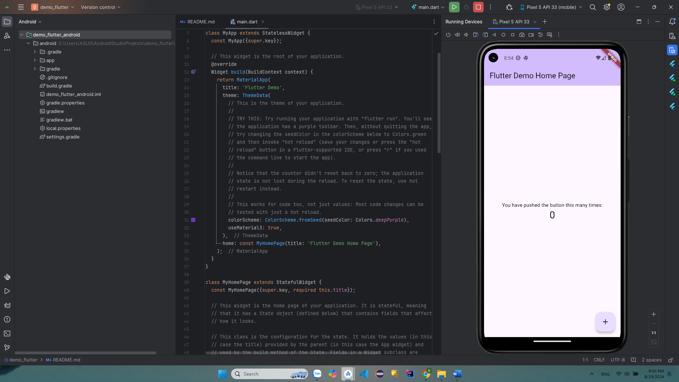

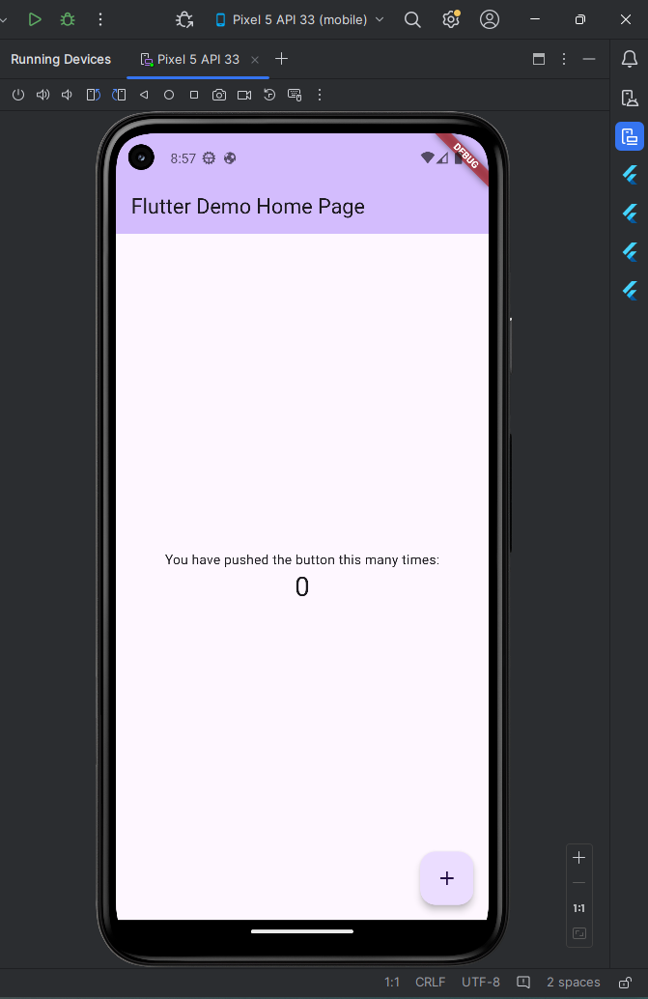

1. ***I Am Rich Structure***

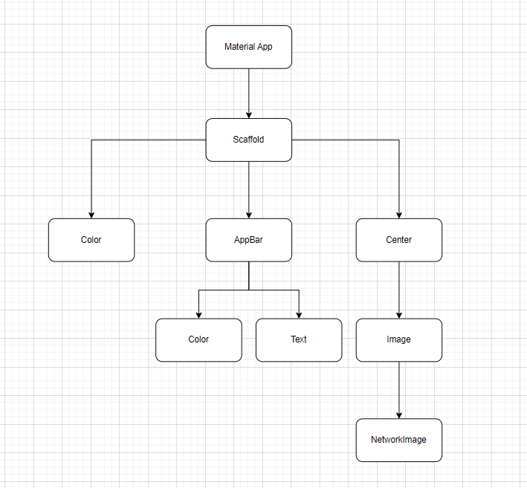

1. ***Creating a New Flutter Project from Scratch.***

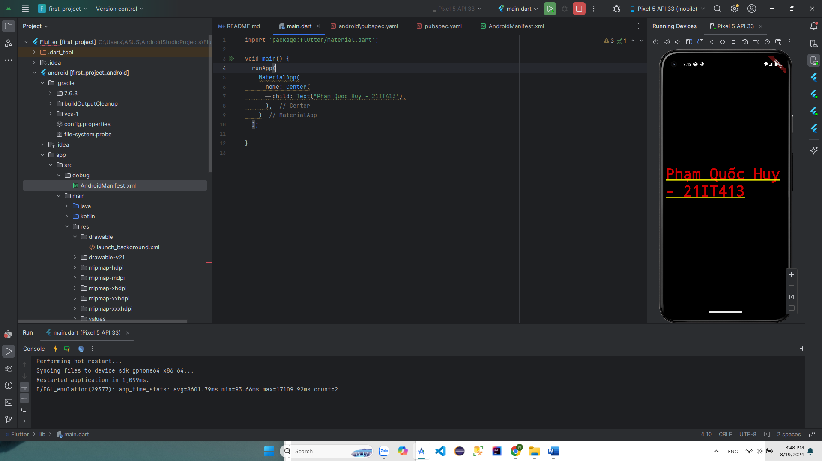

1. ***Scaffolding a Flutter app***

* *Use Image URL to display on app and use appbar in application*

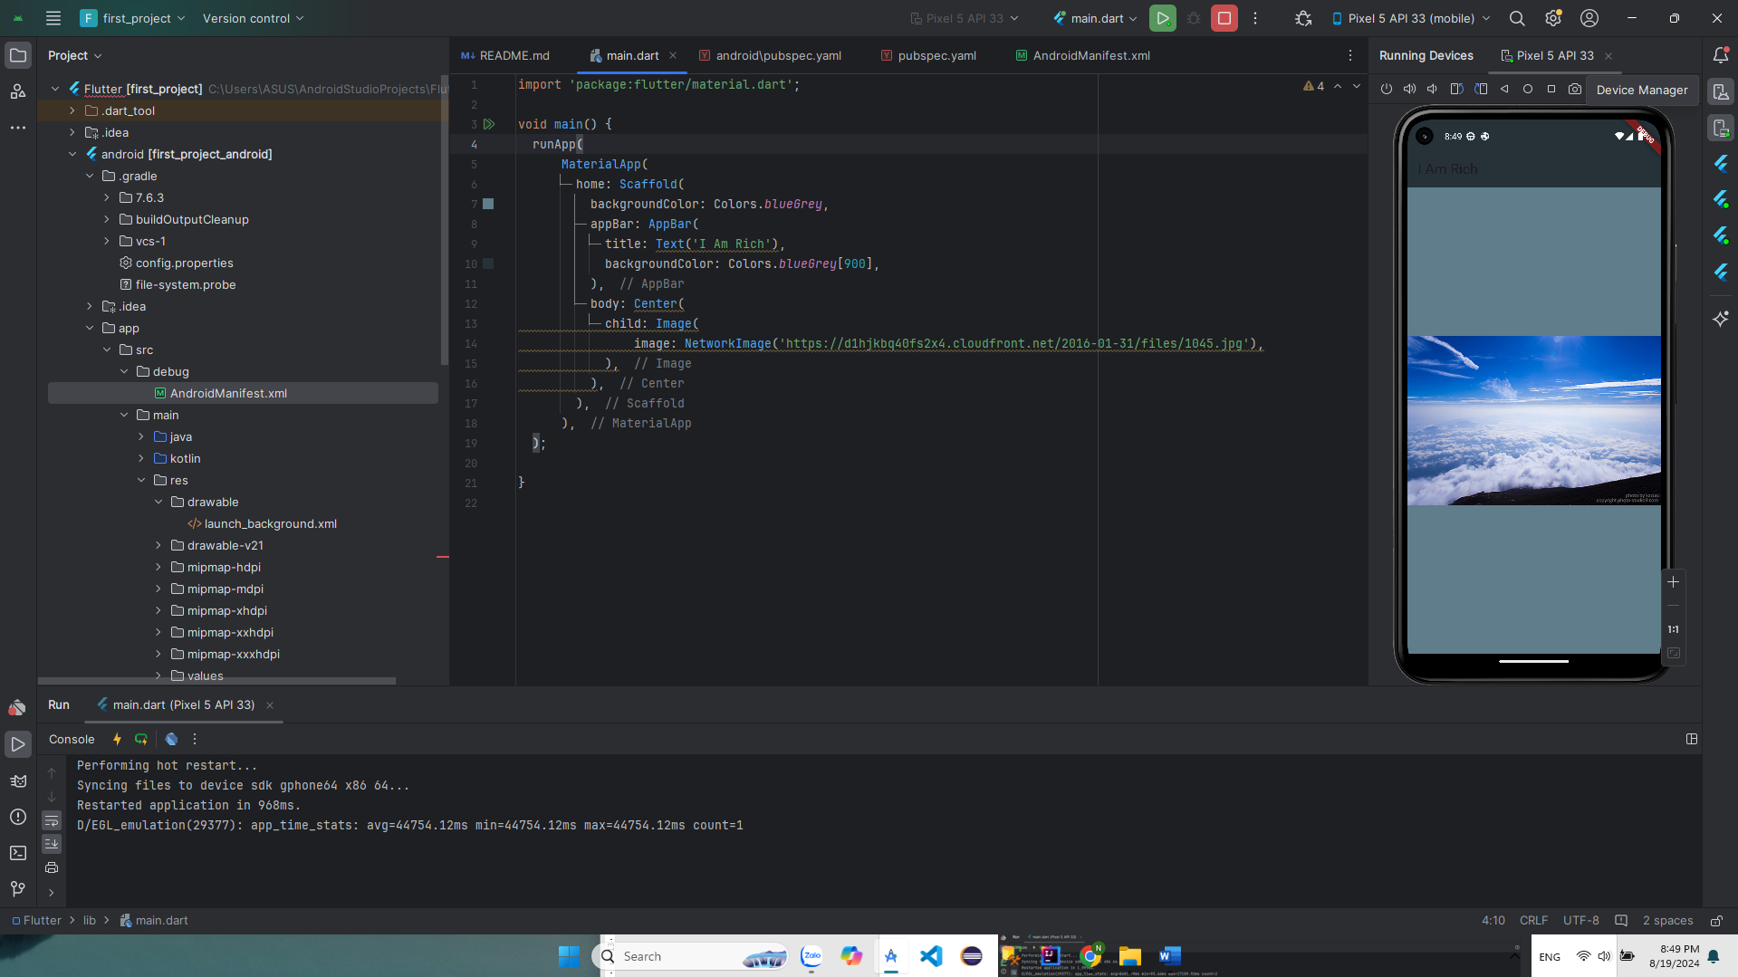

* *Using Image Assets in Flutter*

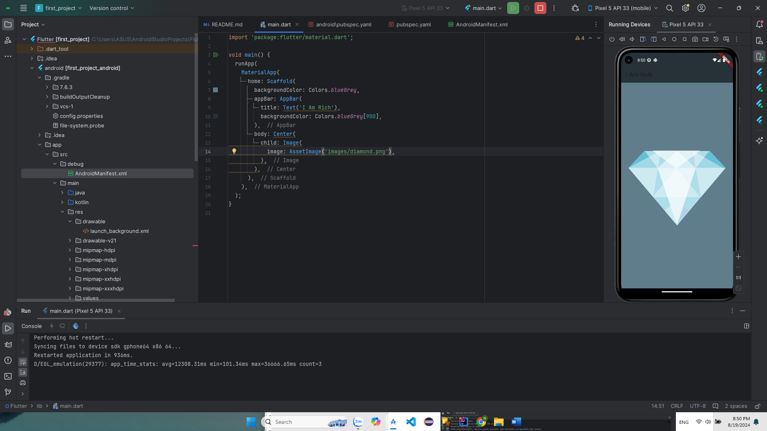

1. ***Working with Assets in Flutter & the Pubspec file***

* *Edit the Image path in Asset of pubspec.yaml file*
  + *Point to the images folder and the image 'diamond.png' just created in the project.*

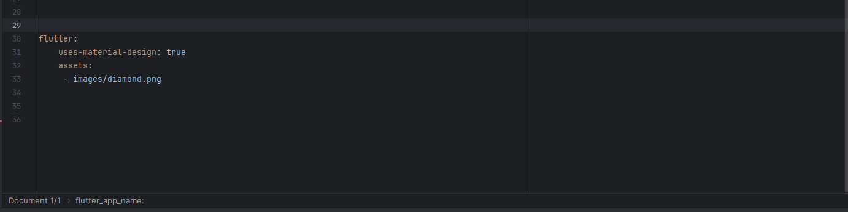

* *Rename the application in the pubspec file.*

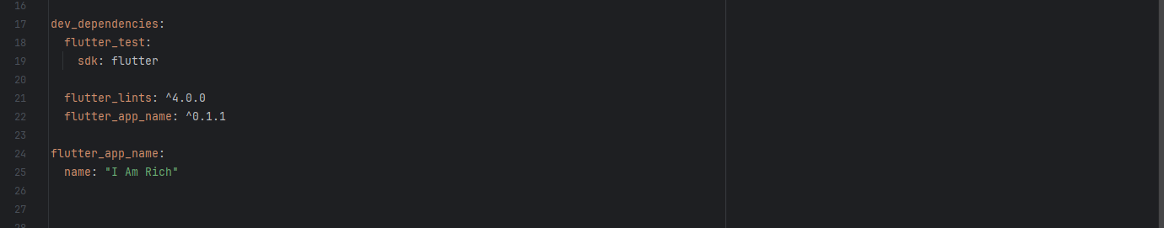

* *Screenshot of the app after using Image Asset in Flutter*

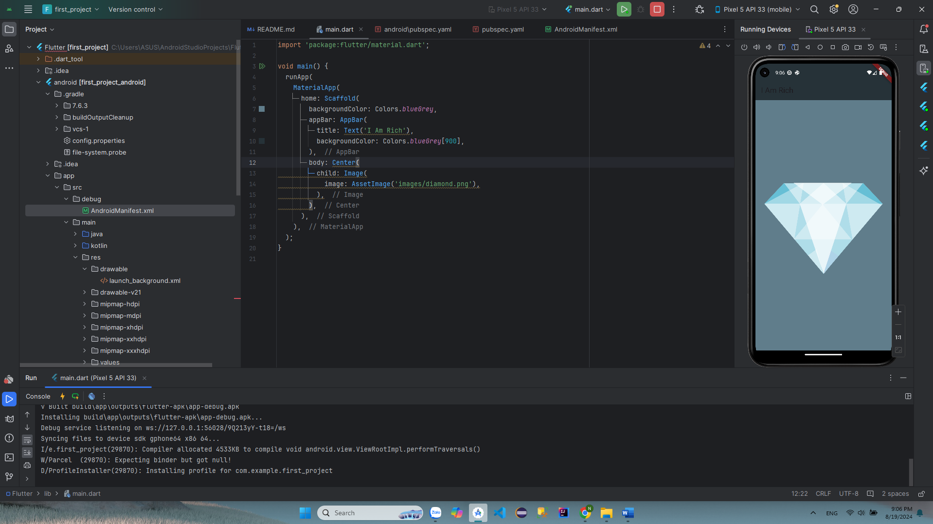

1. ***How to Add App Icons to the iOS and Android Apps***

* *Use appicon.co website to generate app icons suitable for each device screen resolution size*

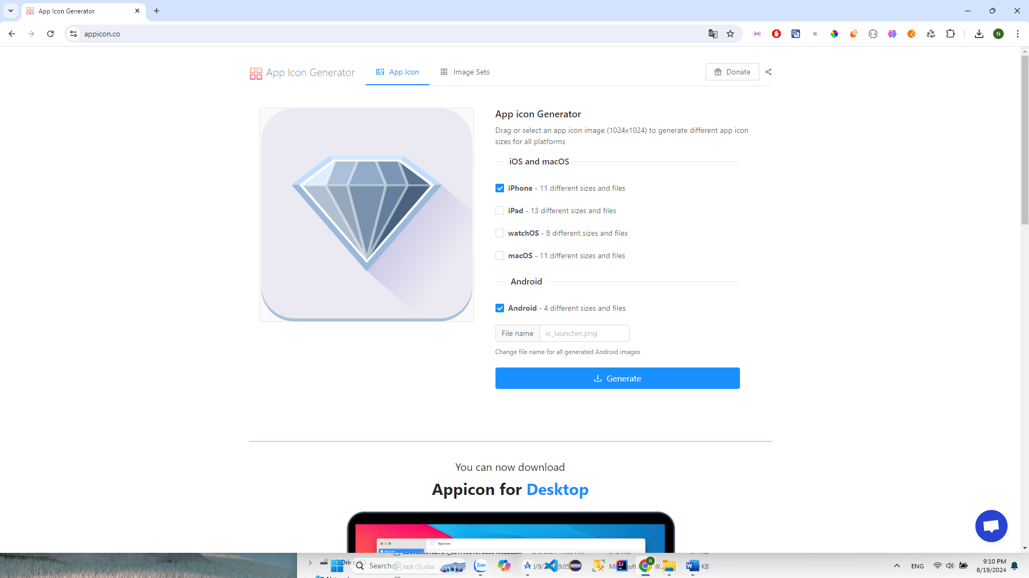

* *Download and Extract*

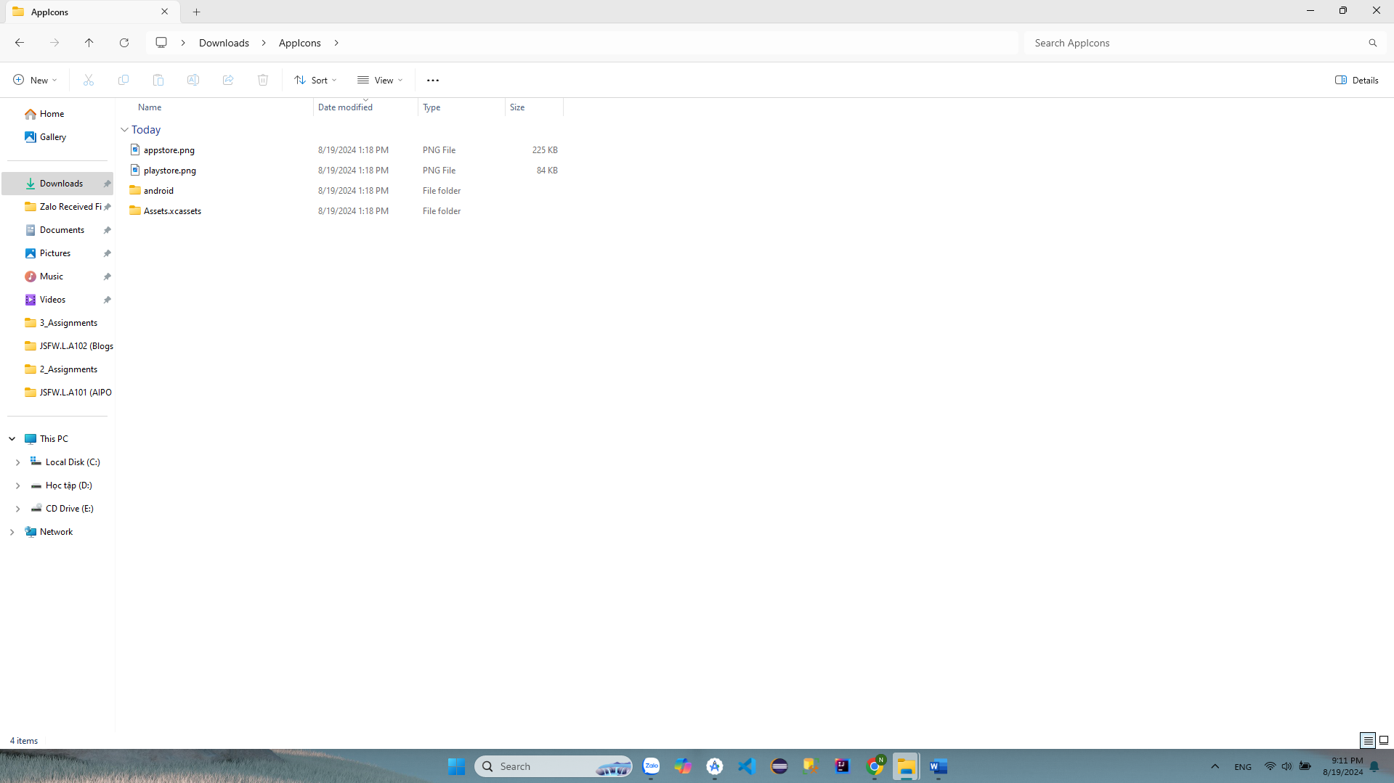

* *Copy the downloaded icons to the path "C:\Users\ASUS\AndroidStudioProjects\Flutter\android\app\src\main\res"*

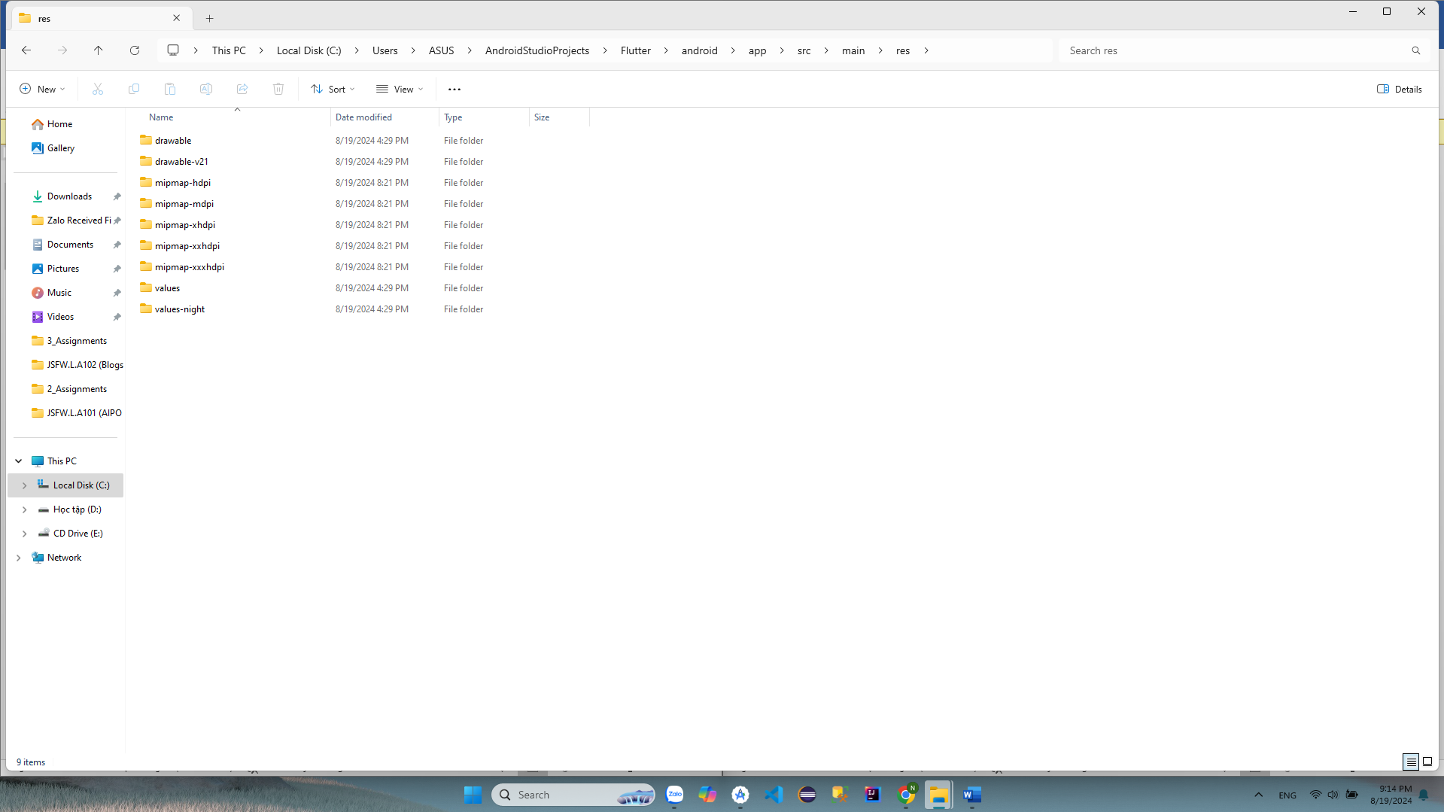

* *Similarly, copy the icons of the downloaded AppIcon.appiconset folder to the path "C:\Users\ASUS\AndroidStudioProjects\Flutter\ios\Runner\Assets.xcassets\AppIcon.appiconset"*

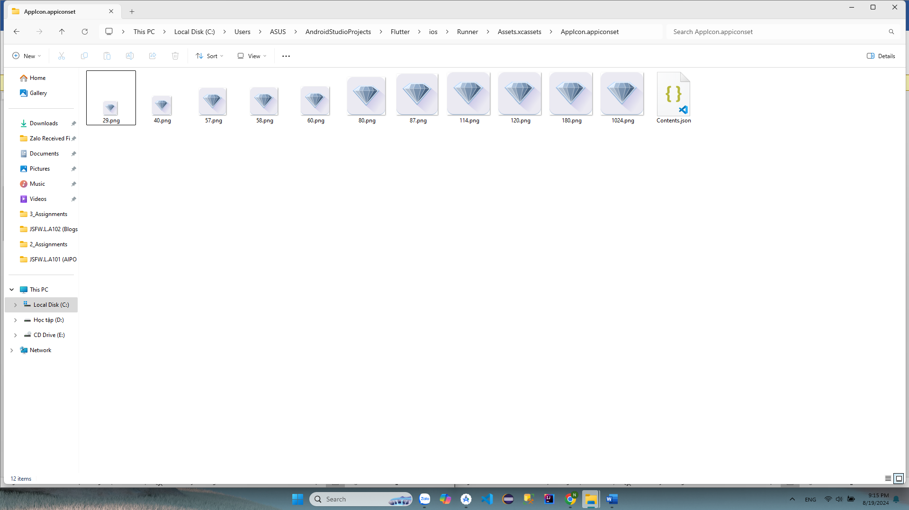

* *Run the application and see the results displayed*
* 