**REPORT**

**LAB 5: XYLOPHONE**

***Student name: Pham Quoc Huy***

***Student ID: 21IT413***

***Student email: huypq.21it@vku.udn.vn***

# Introduction

* The purpose of this lab report is to document the development of a simple xylophone mobile application using Flutter. The xylophone app aims to provide a basic soundplaying functionality, where each button on the screen corresponds to a different note of the xylophone.

The project explores the development of a cross-platform app with a user interface and sound interaction

# Objectives

* To learn how to use Flutter to build a simple interactive mobile app.
* To gain hands-on experience with cross-platform development using the Flutter framework.
* To implement sound-playing functionality using the audioplayers package.

# Methodology

The methodology followed in this lab involved several stages:

1. **Setting Up the Environment:** The Flutter framework was used for crossplatform development. Android Studio was utilized for coding and running the app.
2. **Creating the User Interface:** The app features a simple vertical layout containing seven buttons, each corresponding to a note of the xylophone. These buttons were implemented using Flutter widgets such as Expanded and TextButton.
3. **Implementing Sound Functionality**: The audioplayers package was integrated to handle sound playback. Each button is connected to an audio file representing a note, and these files are triggered when the user taps the buttons.
4. **Testing:** The app was tested on an Android device to ensure that the sound files played correctly

# Results

* The final app is a simple xylophone instrument that successfully plays different notes when each button is tapped. The user interface is responsive, and sound playback occurs without noticeable delay

**Screenshot of the App:**

# Screenshots of the app showing the UI and buttons layout

* **Main.dart**

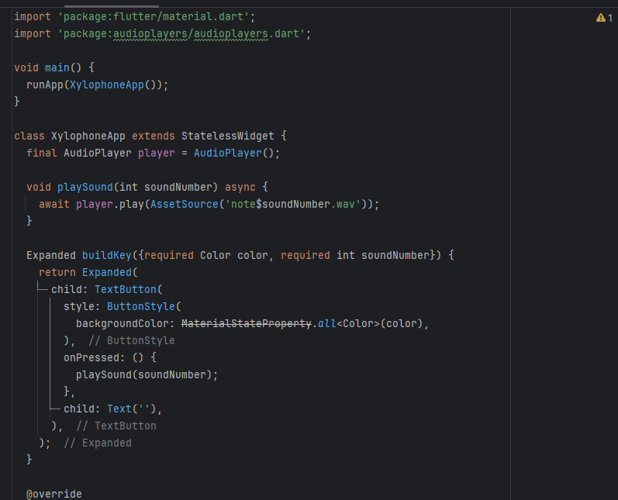

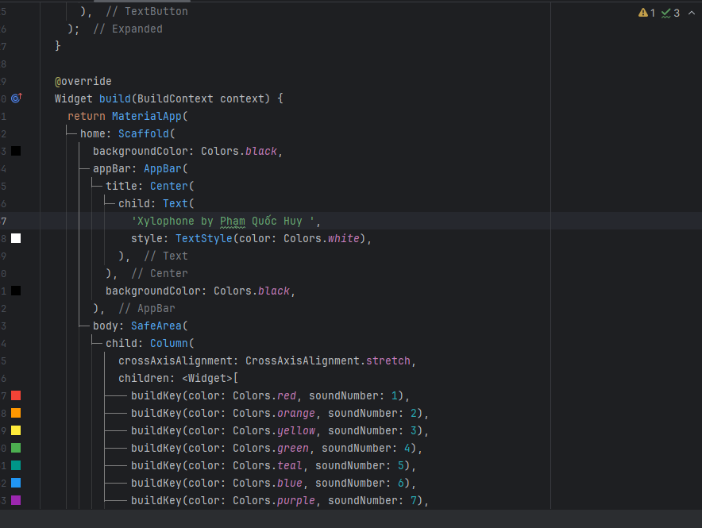

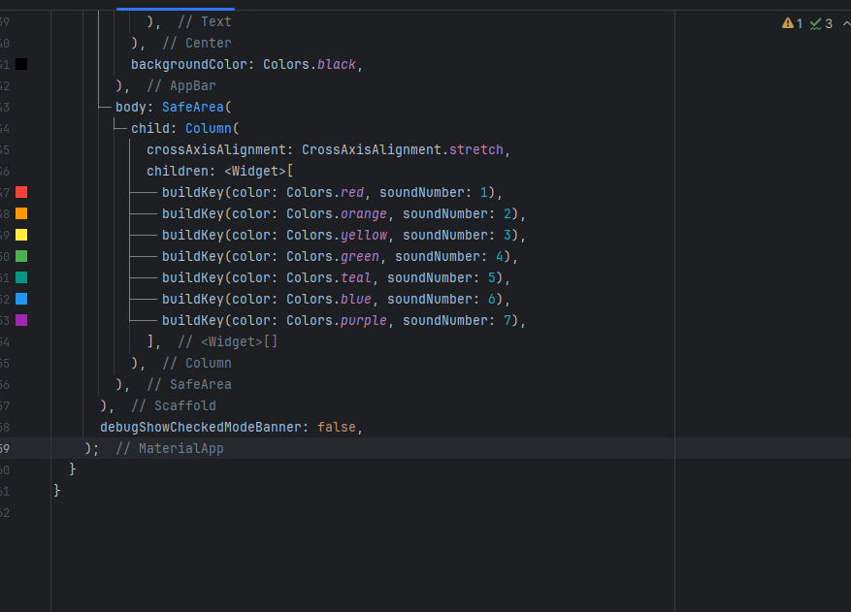

* **Directory Structure:**

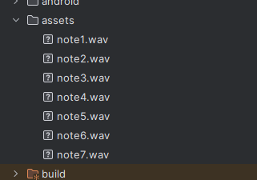

* **Pubspec.yaml**

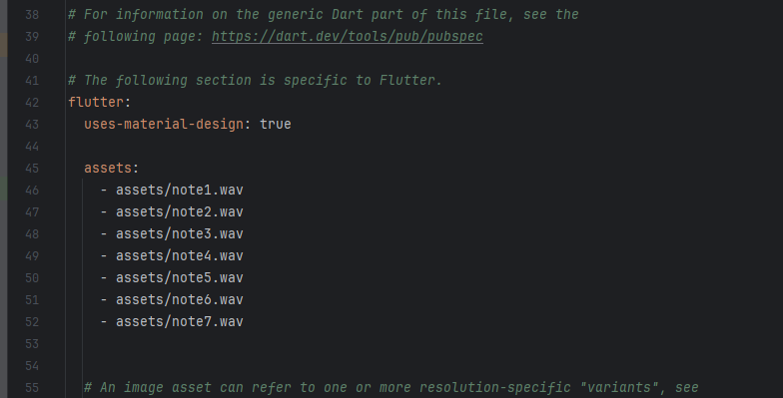

* **Console:**

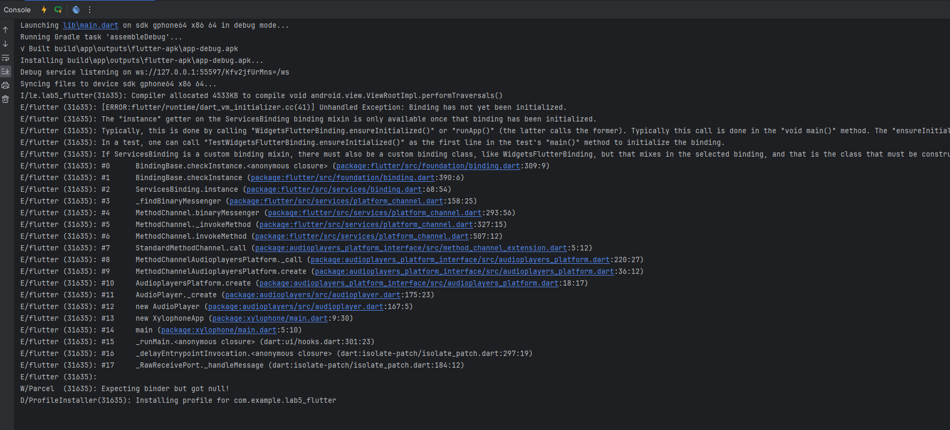

* Screenshot of the app running on the Android device:

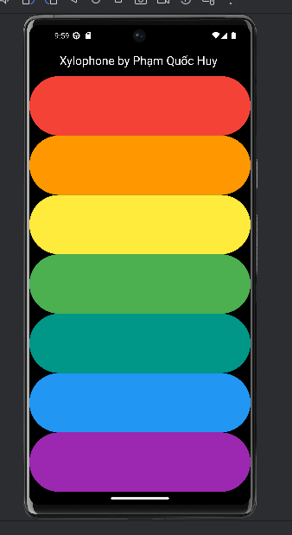

# Discussion

* The results obtained in this lab were successful, with the app functioning as intended. The sound files played correctly, and the user interface was simple yet effective for its purpose.

**Strengths of Cross-Platform Development:**

* The ability to write code once and deploy on multiple platforms is a significant advantage of using Flutter.
* Flutter provides a rich set of pre-built widgets, making UI design faster and more consistent

**Weaknesses:**

* Cross-platform development may not offer the same level of optimization as native development for platform-specific features like performance-intensive tasks.
* Some issues with package compatibility across platforms may arise during development.

# Conclusion

* The xylophone app demonstrated the effectiveness of Flutter for building simple mobile apps with sound functionality. The app met the objectives by playing musical notes upon interaction and using cross-platform tools efficiently.
* For future work, it is recommended to explore more advanced sound features, such as volume control and sound mixing, and to extend the app's functionality with additional instruments