**Ho Chi Minh City University of Technology**

**FACULTY OF COMPUTER SCIENCE & ENGINEERING**



Laboratory Manual

Internet of Things Application Development

Lab 1

Ho Chi Minh City, 03/2021

# Goals:

Install the Mu Editor

First program on Mu and Microbit

Implement a simple clock on Microbit

# Equipment and apparatus:

Mu editor setup file: https://codewith.mu/en/download

Microbit BBC platform

# Experimental Procedure:

* 1. Install Mu editor (for Windows)

Download and run the Mu setup file, follow the wizard to install the software on your Windows PC/Laptop.

In the case the Mu installation is not successful, an online editor can be used at <https://python.microbit.org/v/2.0>

* 1. First program on Microbit

Step 1: Make sure that the python program is for the microbit platform by clicking on the Mode button, and select BBC micro:bit

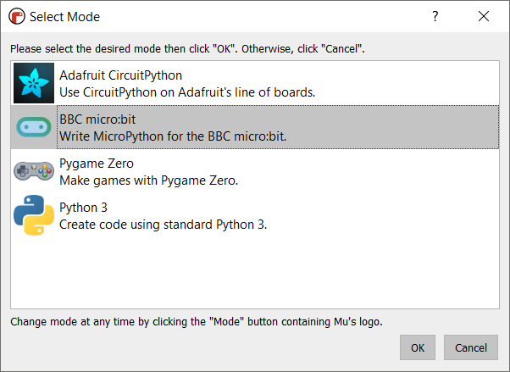

Step 2: Implement the blinky program as follows:

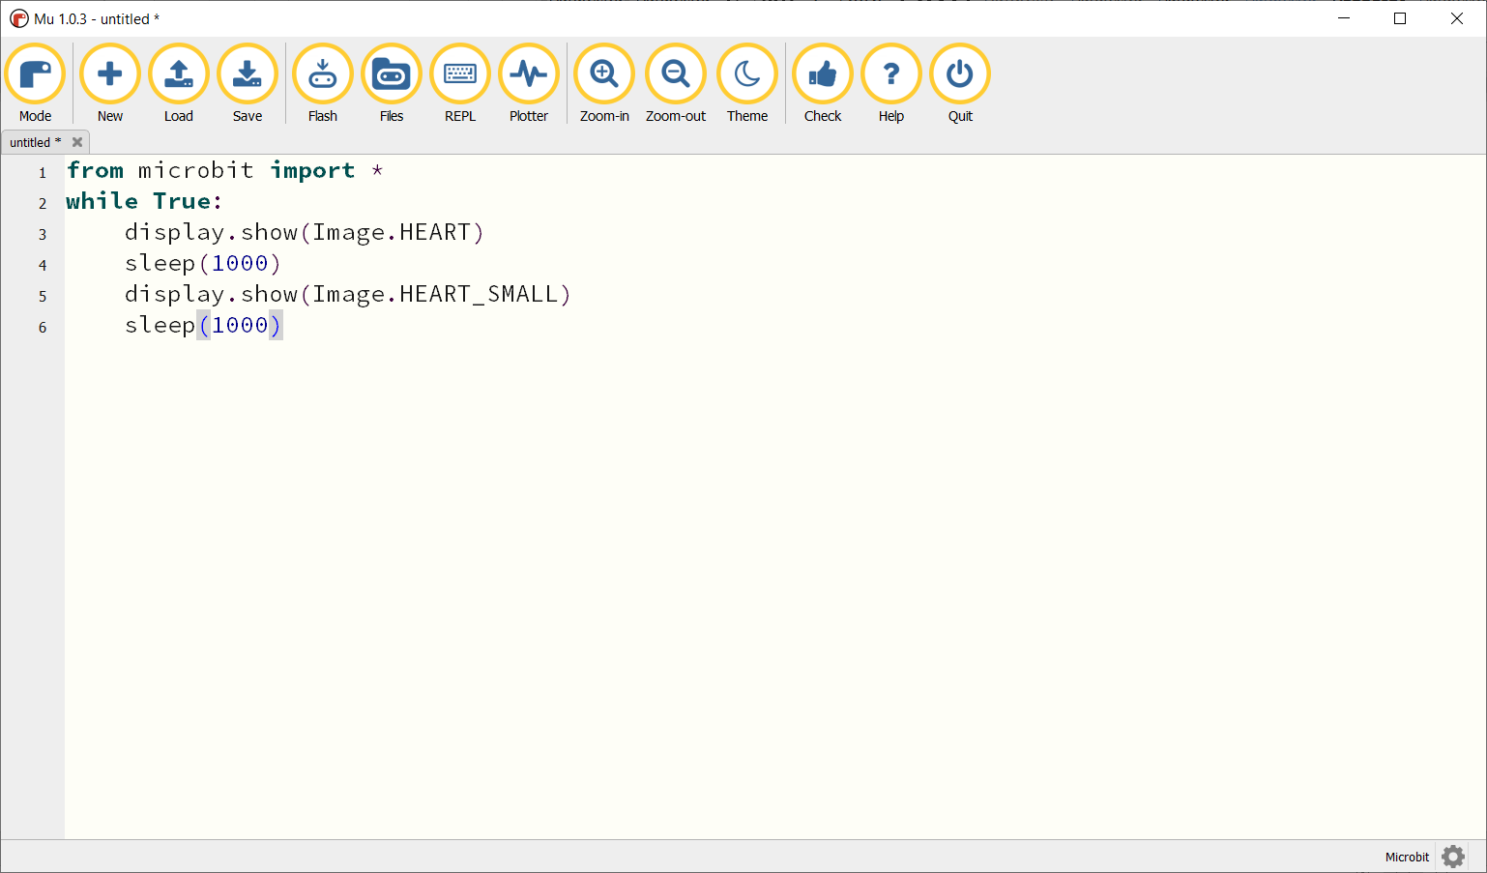

Step 3: Connect the Microbit platform and download the program by clicking on the **Flash button**.

If there is a warning, please try to download the program again.

**Step 4: Please answer the following questions?**

1. What is/are the difference(s) between from microbit import * and import microbit?

import microbit imports the entire module and from microbit import * is importing all the classes, functions and variables from that module, so it's just down to user preference.

Using import * is useful for beginners and practice, but as your code becomes more complex you may want to look at the previous two import methods. This is because it is difficult to determine what items used in the code are coming from 'microbit'.

1. In the case import microbit is used, re-implement the blinky program and present your python source code in this report.

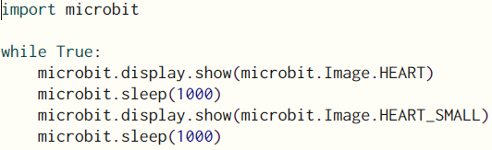

* 1. The clock program

In this subsection, students are proposed to simulate the behaviors of a second hand in a clock. For every 5 seconds, the display on the microbit is changed and kept looping forever. The Image.CLOCK1, Image.CLOCK2, … can be used in your program.

Moreover, students have to follow the principle that there is only one sleep(100) is used on the program, and should be the last instruction in the while loop.

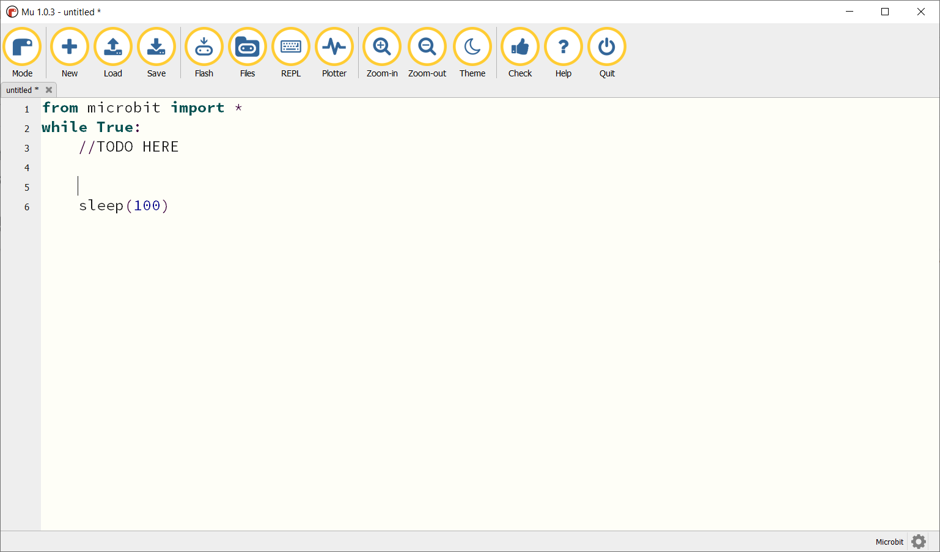

**Present your python source code in the report.**

