IELTS WRITING
TASK 1 PRACTICE LIBRARY
  - 70 illustrated prompts · 7 question types · 10 prompts per type
Cambridge IELTS 15, 16, 17, 18, 19 and 21 + newly designed practice visuals

What is included
This file reorganises the 24 Writing Task 1 pages from the Cambridge PDFs you provided, keeping the original question pages and graphics as images. To provide 10 prompts per type, 46 additional ORIGINAL practice questions and visuals have been created. Their figures are intentionally fictional, for exam-style practice only; they are not Cambridge questions or real-world measurements.

How to practise
Allow around 20 minutes per task. Write at least 150 words. Describe the main features and compare data or changes where relevant. For Cambridge questions, read the prompt inside the original page image. For additional practice, the prompt is editable text above the visual.

Quick index
Type | Cambridge | New practice | Total
Line Graph | 7 | 3 | 10
Bar Chart | 3 | 7 | 10
Pie Chart | 0 | 10 | 10
Table | 0 | 10 | 10
Map / Floor Plan | 4 | 6 | 10
Process Diagram | 6 | 4 | 10
Mixed Charts | 4 | 6 | 10
Source references: IELTS.org Academic sample questions; British Council Academic Writing practice; IELTS Australia / IDP guidance. Guidance available on the official websites.

LINE GRAPH 01/10
Change and trends over time

Visitor numbers at a Caribbean island
CAMBRIDGE ORIGINAL • Cambridge IELTS 15 • Test 2
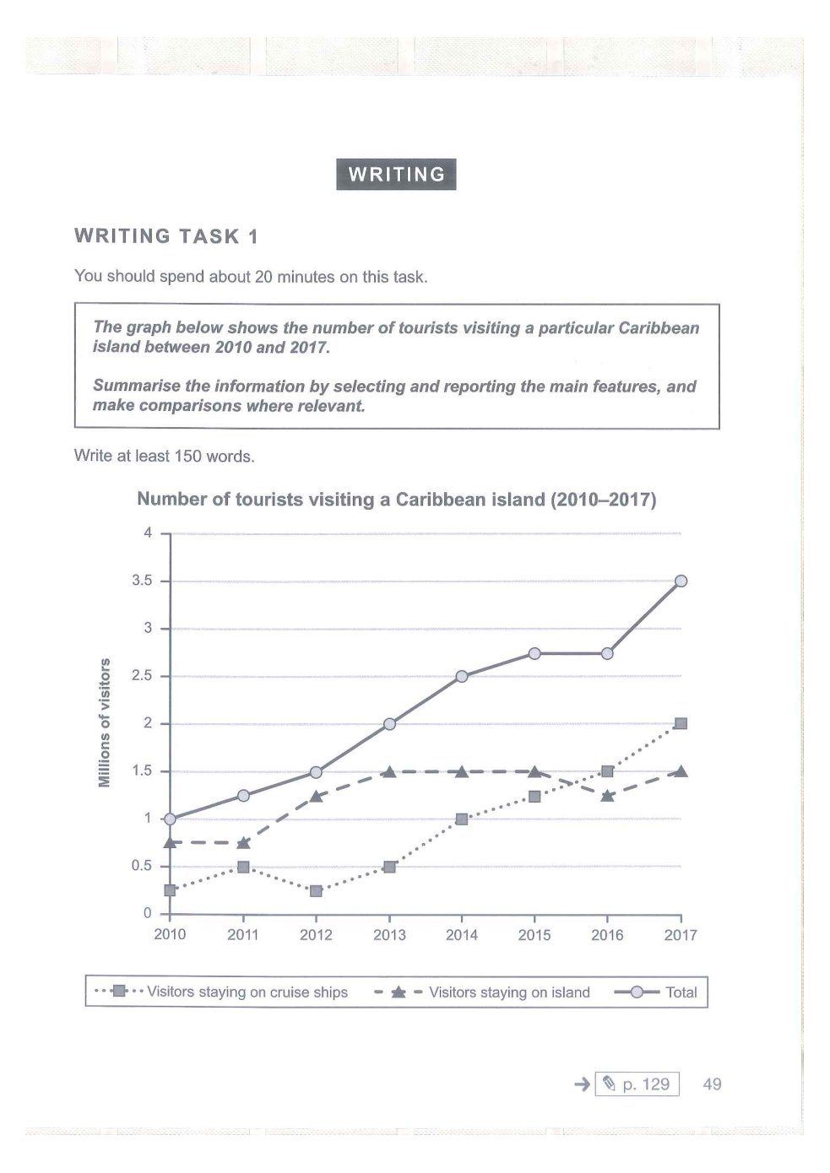

LINE GRAPH 02/10
Change and trends over time

Electrical appliances and housework
CAMBRIDGE ORIGINAL • Cambridge IELTS 16 • Test 1
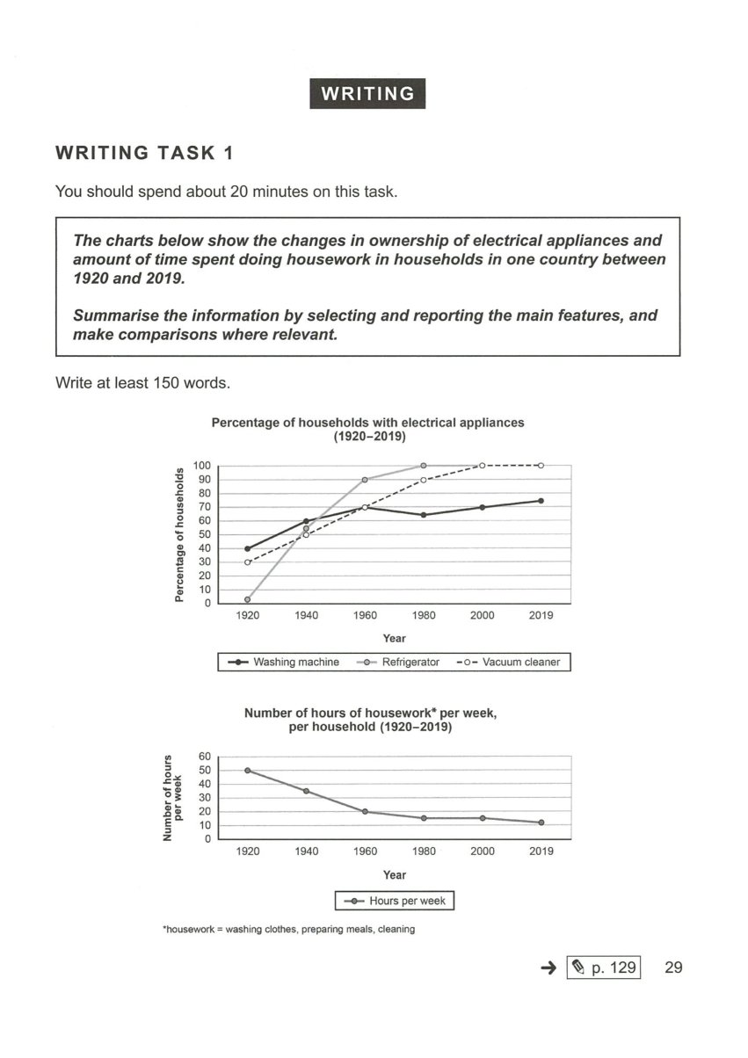

LINE GRAPH 03/10
Change and trends over time

Shop closures and openings
CAMBRIDGE ORIGINAL • Cambridge IELTS 17 • Test 4
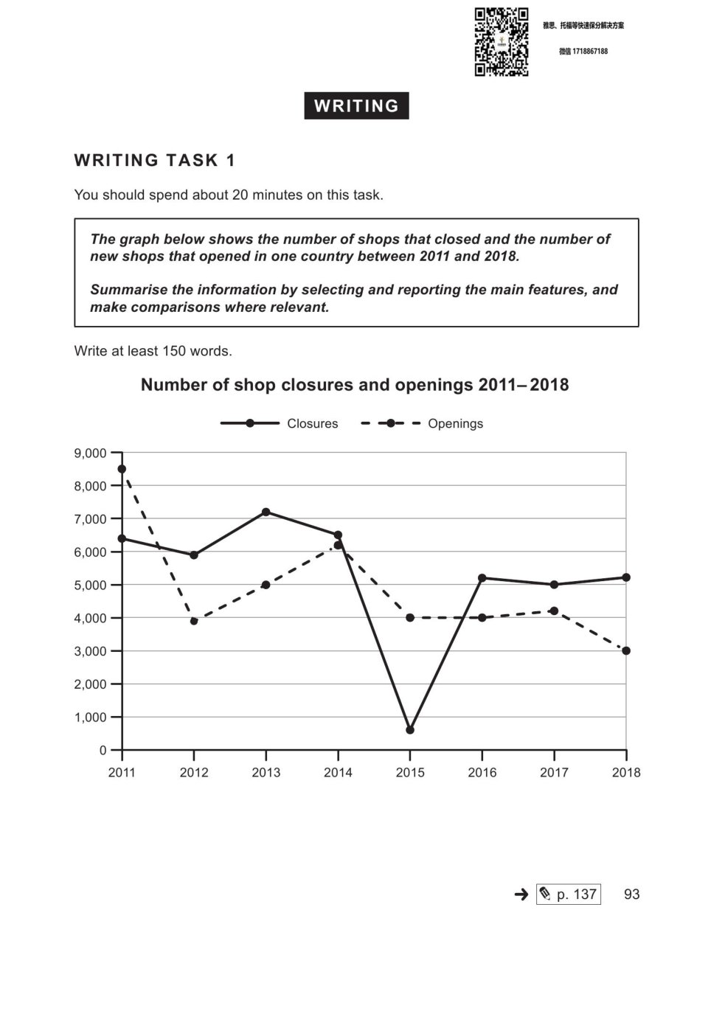

LINE GRAPH 04/10
Change and trends over time

Population living in cities
CAMBRIDGE ORIGINAL • Cambridge IELTS 18 • Test 1
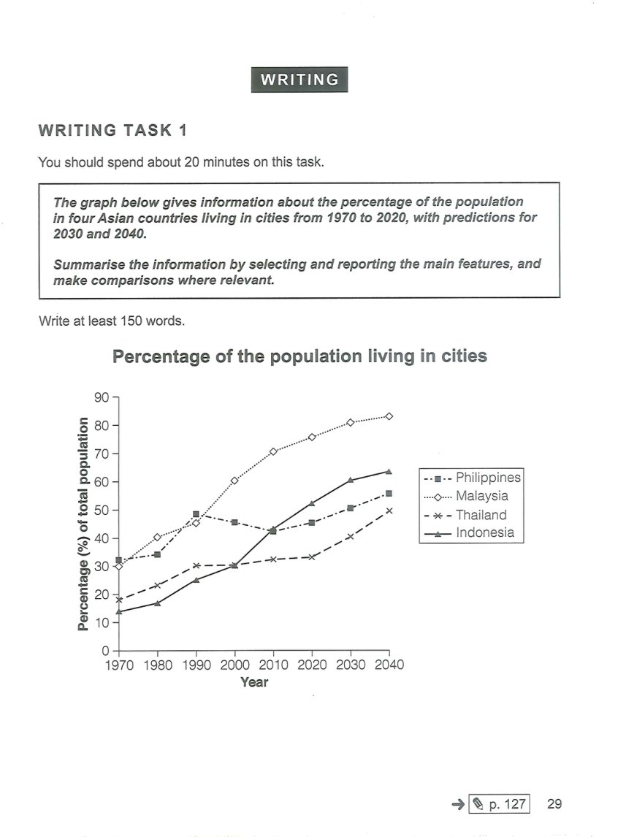

LINE GRAPH 05/10
Change and trends over time

Monthly changes in prices of metals
CAMBRIDGE ORIGINAL • Cambridge IELTS 18 • Test 4
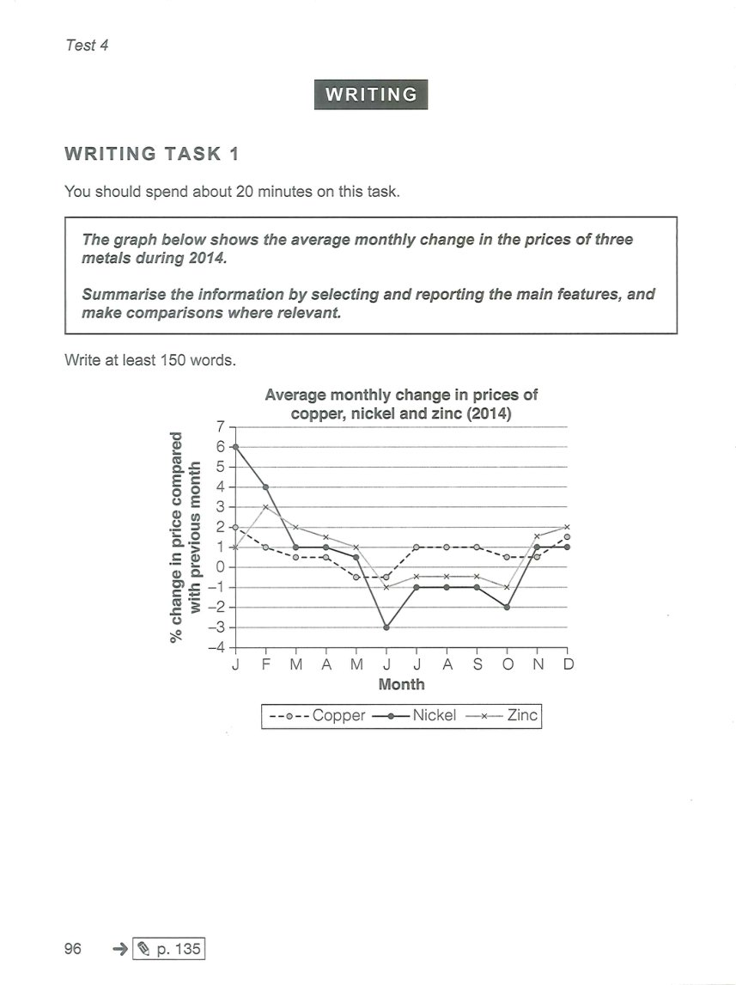

LINE GRAPH 06/10
Change and trends over time

Participation in activities at a sports centre
CAMBRIDGE ORIGINAL • Cambridge IELTS 19 • Test 1
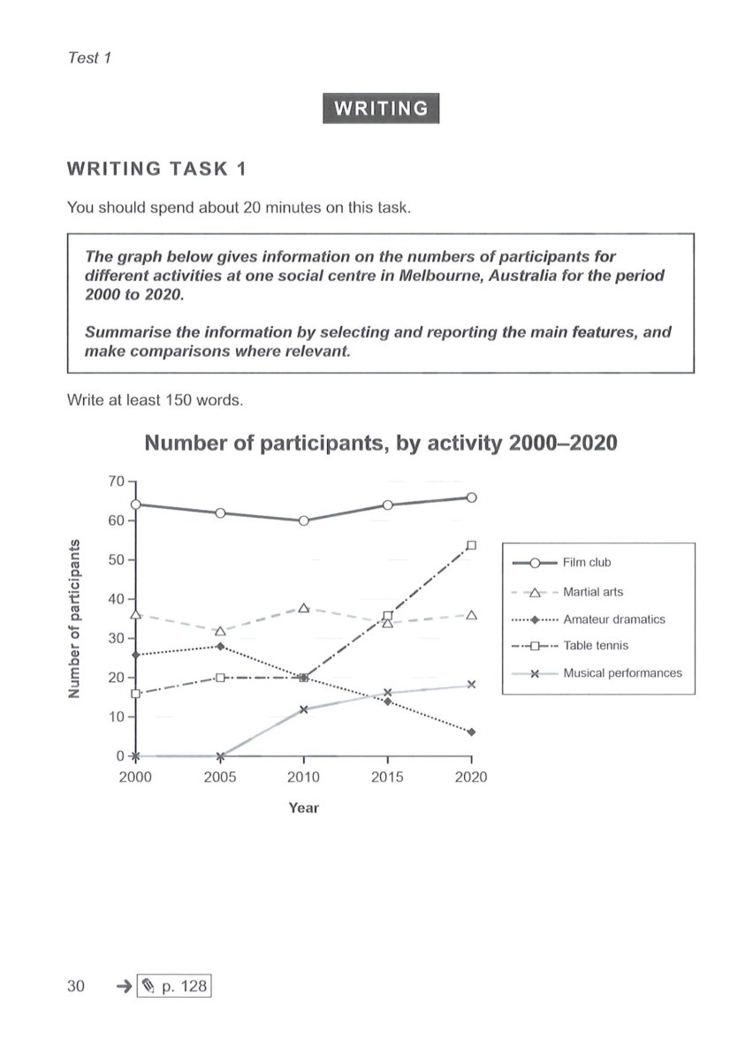

LINE GRAPH 07/10
Change and trends over time

Jobs in economic sectors
CAMBRIDGE ORIGINAL • Cambridge IELTS 21 • Test 1
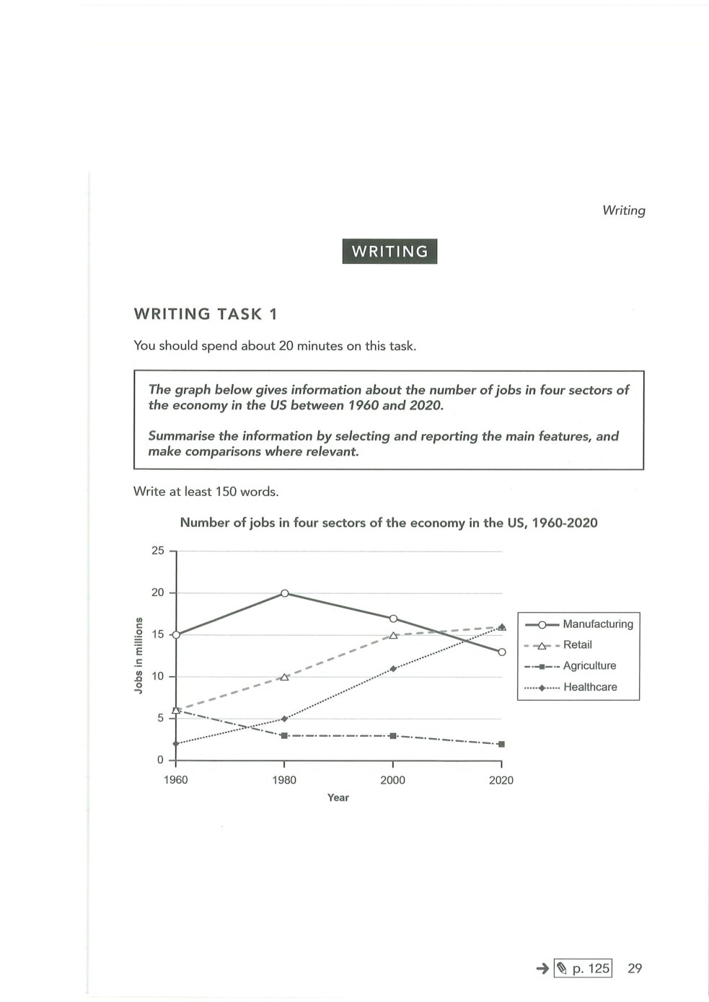

LINE GRAPH 08/10
Change and trends over time

Urban bicycle commuting, 2012–2024
ORIGINAL PRACTICE • Illustrative / fictional data (not an official IELTS question)
The line graph shows the percentage of commuters travelling to work by bicycle in four cities from 2012 to 2024.
Summarise the information by selecting and reporting the main features, and make comparisons where relevant.
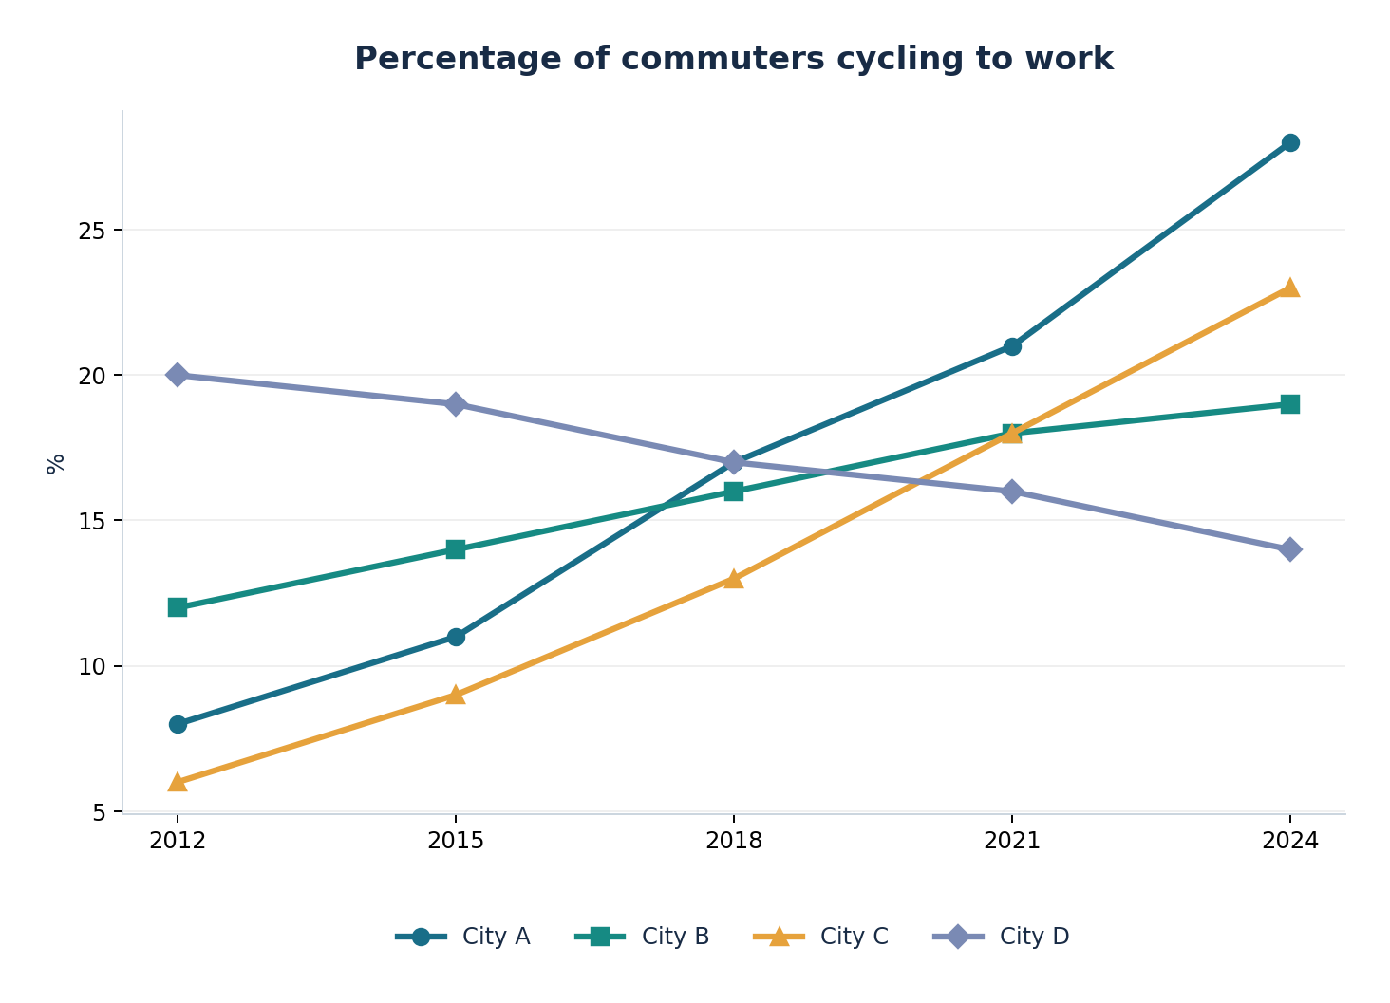

LINE GRAPH 09/10
Change and trends over time

Cinema ticket sales, 2010–2025
ORIGINAL PRACTICE • Illustrative / fictional data (not an official IELTS question)
The line graph compares annual cinema ticket sales in three countries between 2010 and 2025.
Summarise the information by selecting and reporting the main features, and make comparisons where relevant.
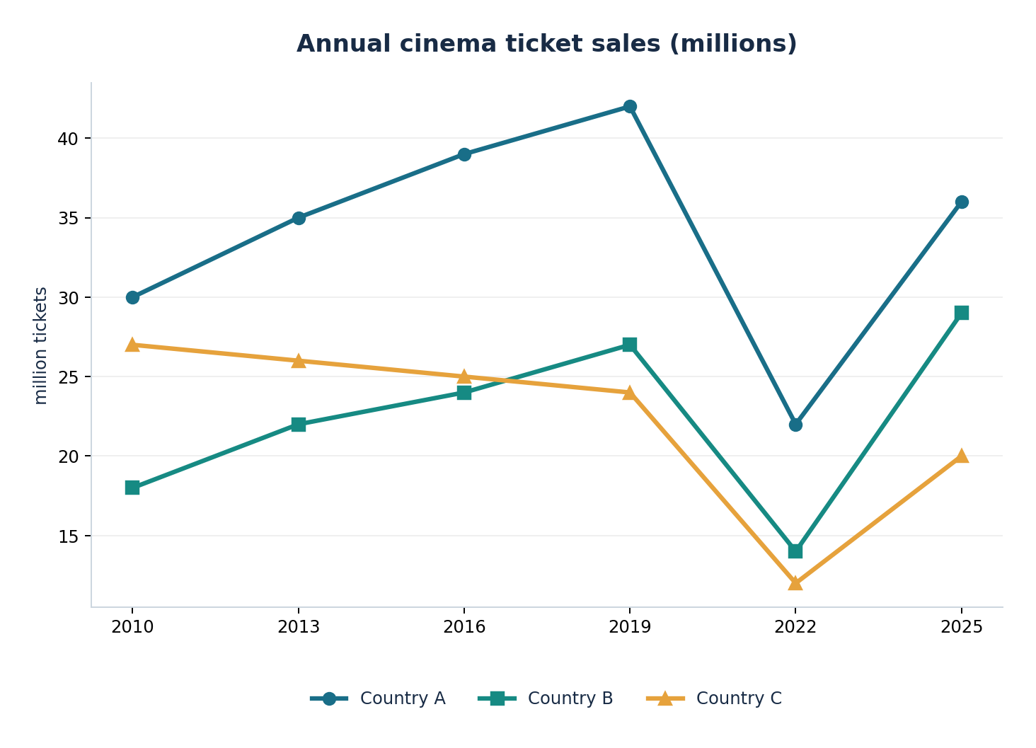

LINE GRAPH 10/10
Change and trends over time

Renewable electricity generation, 2000–2025
ORIGINAL PRACTICE • Illustrative / fictional data (not an official IELTS question)
The graph shows changes in the amount of electricity generated by three renewable energy sources from 2000 to 2025.
Summarise the information by selecting and reporting the main features, and make comparisons where relevant.
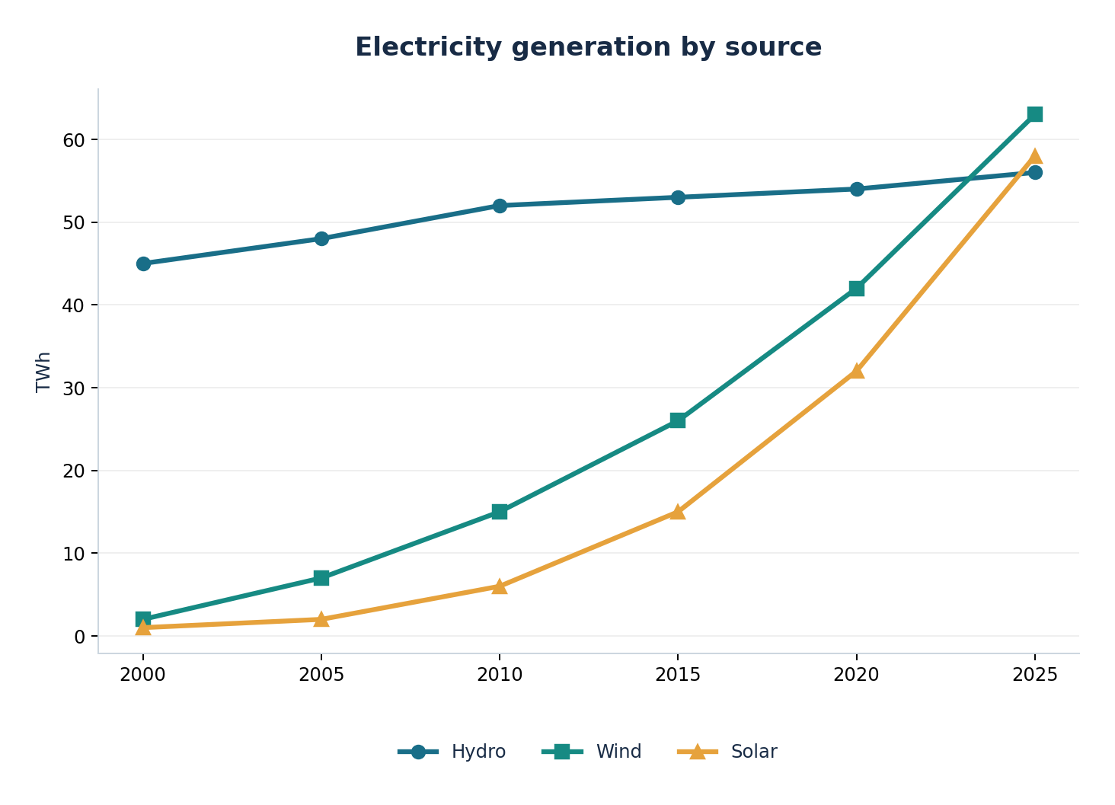

BAR CHART 01/10
Comparisons across categories or periods

Coffee and tea habits in Australian cities
CAMBRIDGE ORIGINAL • Cambridge IELTS 15 • Test 1
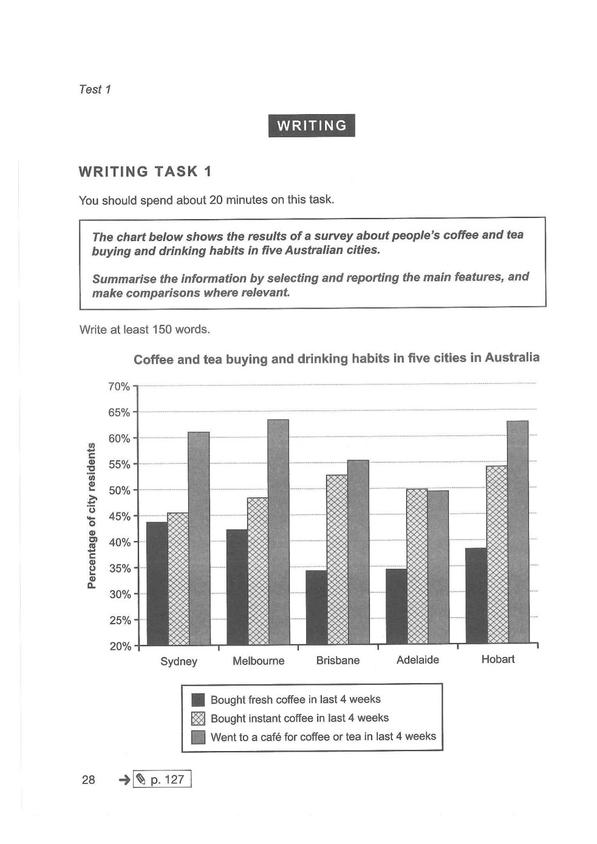

BAR CHART 02/10
Comparisons across categories or periods

Weekly spending by families
CAMBRIDGE ORIGINAL • Cambridge IELTS 17 • Test 3
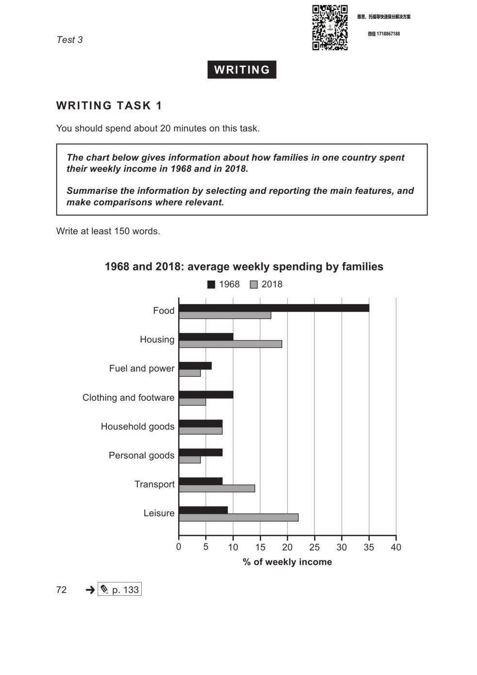

BAR CHART 03/10
Comparisons across categories or periods

Households by income
CAMBRIDGE ORIGINAL • Cambridge IELTS 18 • Test 2
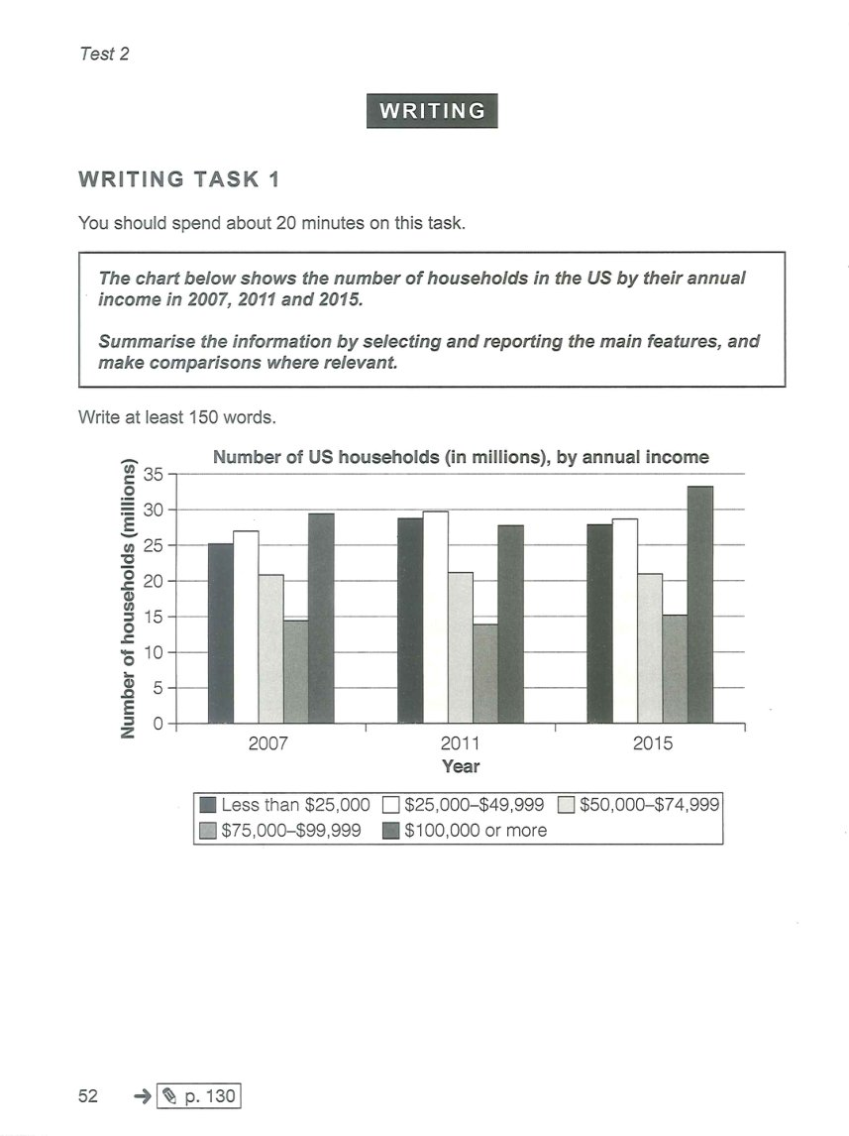

BAR CHART 04/10
Comparisons across categories or periods

Library visits by age group
ORIGINAL PRACTICE • Illustrative / fictional data (not an official IELTS question)
The bar chart compares the average number of visits to public libraries per person in five age groups in 2015 and 2025.
Summarise the information by selecting and reporting the main features, and make comparisons where relevant.
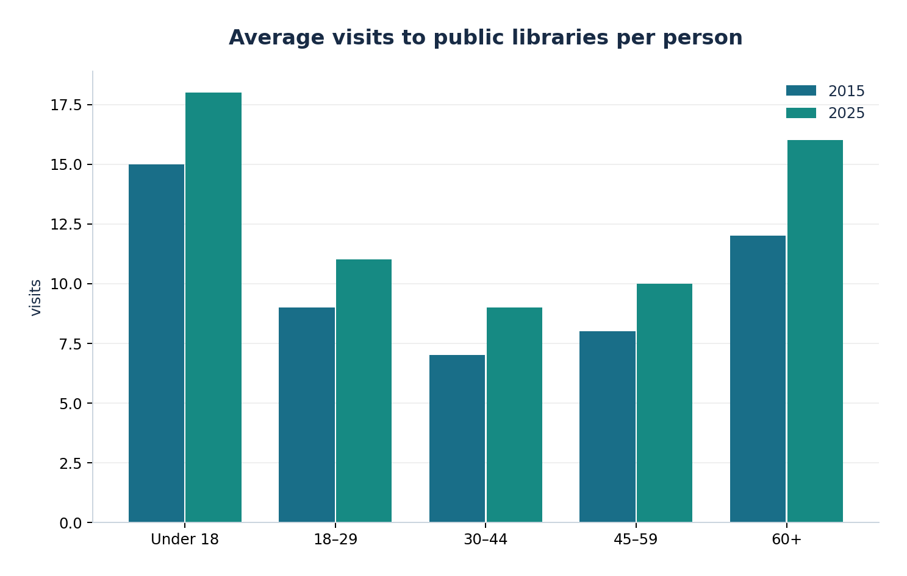

BAR CHART 05/10
Comparisons across categories or periods

Computer ownership in five countries
ORIGINAL PRACTICE • Illustrative / fictional data (not an official IELTS question)
The chart shows the percentage of households owning a desktop or laptop computer in five countries in 2024.
Summarise the information by selecting and reporting the main features, and make comparisons where relevant.
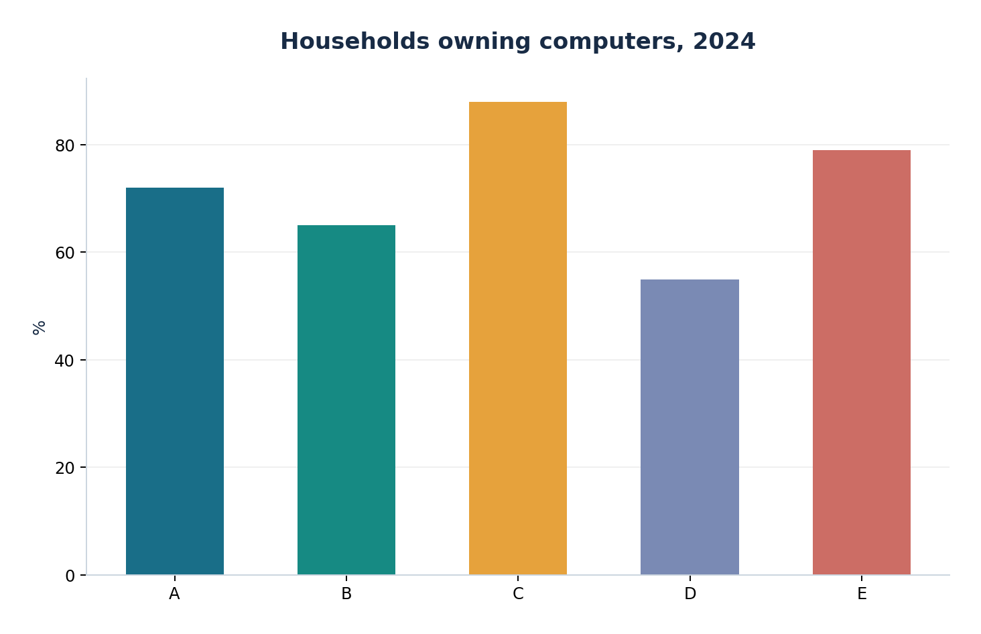

BAR CHART 06/10
Comparisons across categories or periods

Museum attendance across the year
ORIGINAL PRACTICE • Illustrative / fictional data (not an official IELTS question)
The bar chart compares the number of visitors to two museums in four quarters of one year.
Summarise the information by selecting and reporting the main features, and make comparisons where relevant.
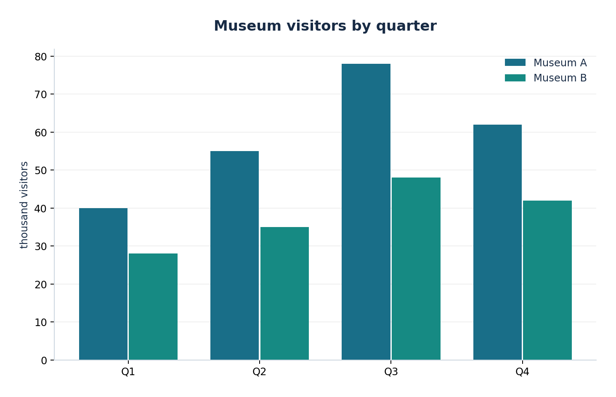

BAR CHART 07/10
Comparisons across categories or periods

Water consumption by industry
ORIGINAL PRACTICE • Illustrative / fictional data (not an official IELTS question)
The bar chart gives the average daily water consumption of five industries in 2010 and 2020.
Summarise the information by selecting and reporting the main features, and make comparisons where relevant.
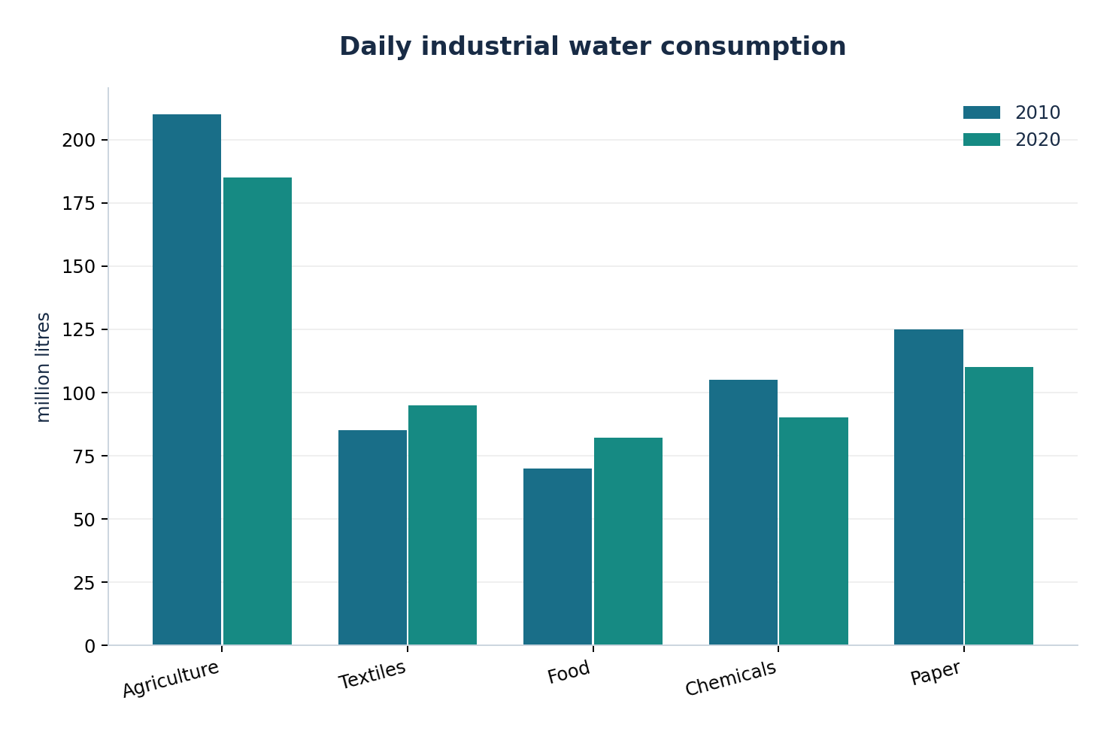

BAR CHART 08/10
Comparisons across categories or periods

Employees working remotely
ORIGINAL PRACTICE • Illustrative / fictional data (not an official IELTS question)
The chart compares the proportion of employees who worked remotely in six sectors in 2019 and 2025.
Summarise the information by selecting and reporting the main features, and make comparisons where relevant.
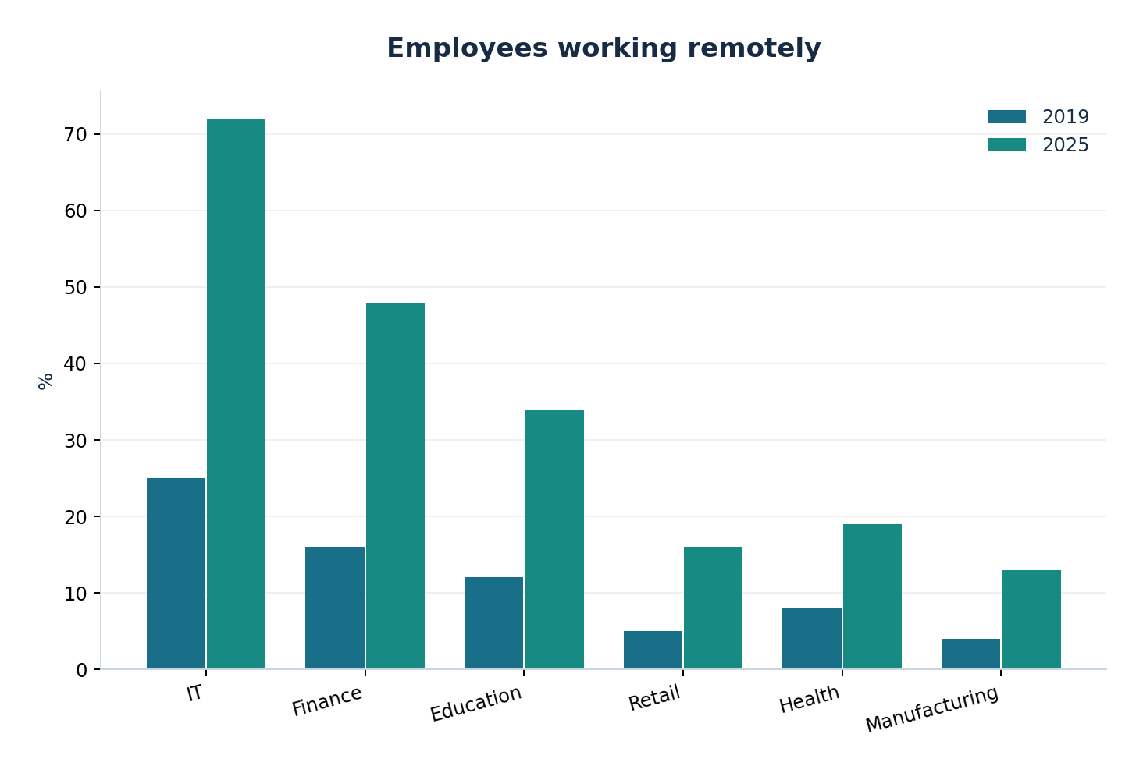

BAR CHART 09/10
Comparisons across categories or periods

Recycling rates in seven regions
ORIGINAL PRACTICE • Illustrative / fictional data (not an official IELTS question)
The bar chart shows household recycling rates in seven regions in 2025.
Summarise the information by selecting and reporting the main features, and make comparisons where relevant.
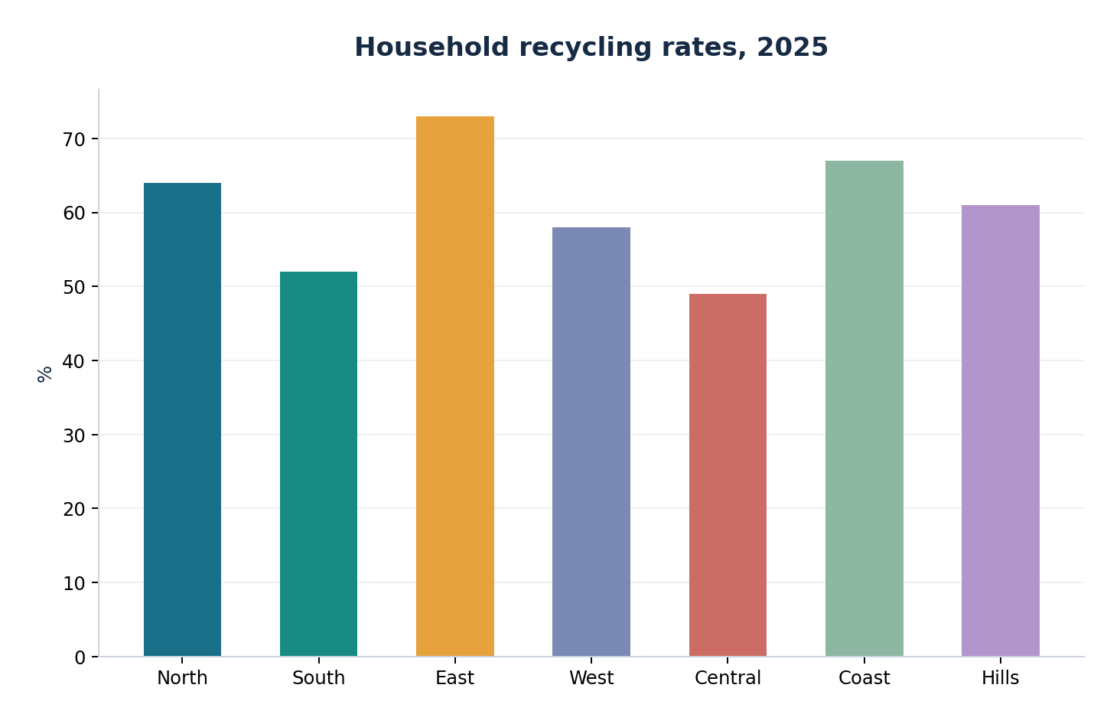

BAR CHART 10/10
Comparisons across categories or periods

International students by subject
ORIGINAL PRACTICE • Illustrative / fictional data (not an official IELTS question)
The chart shows the number of international university students enrolled in five subjects in 2015 and 2025.
Summarise the information by selecting and reporting the main features, and make comparisons where relevant.
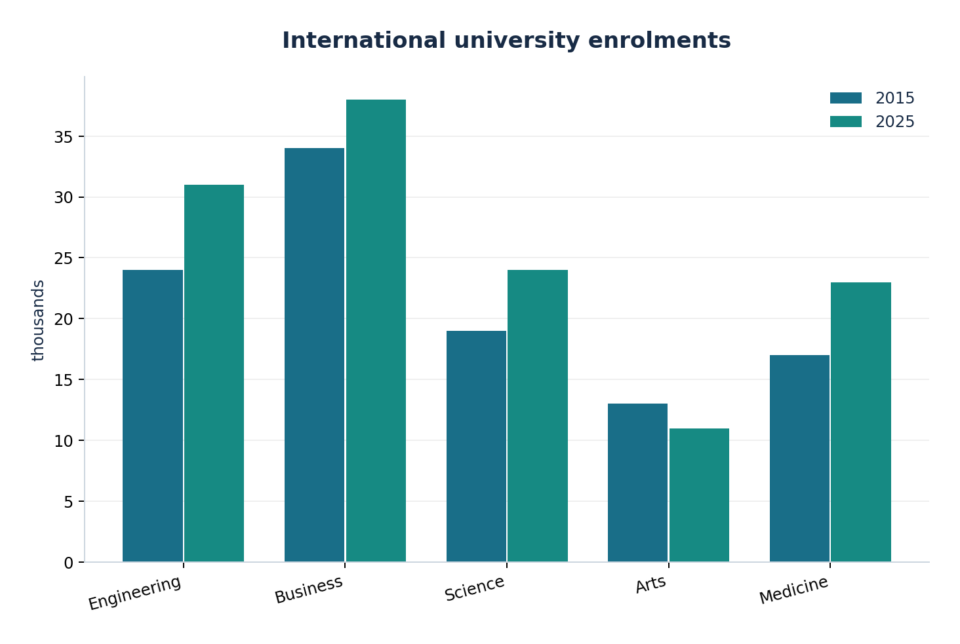

PIE CHART 01/10
Proportions and percentage breakdowns

Household spending in 2025
ORIGINAL PRACTICE • Illustrative / fictional data (not an official IELTS question)
The pie chart illustrates how an average household distributed its annual expenditure across six categories in 2025.
Summarise the information by selecting and reporting the main features, and make comparisons where relevant.
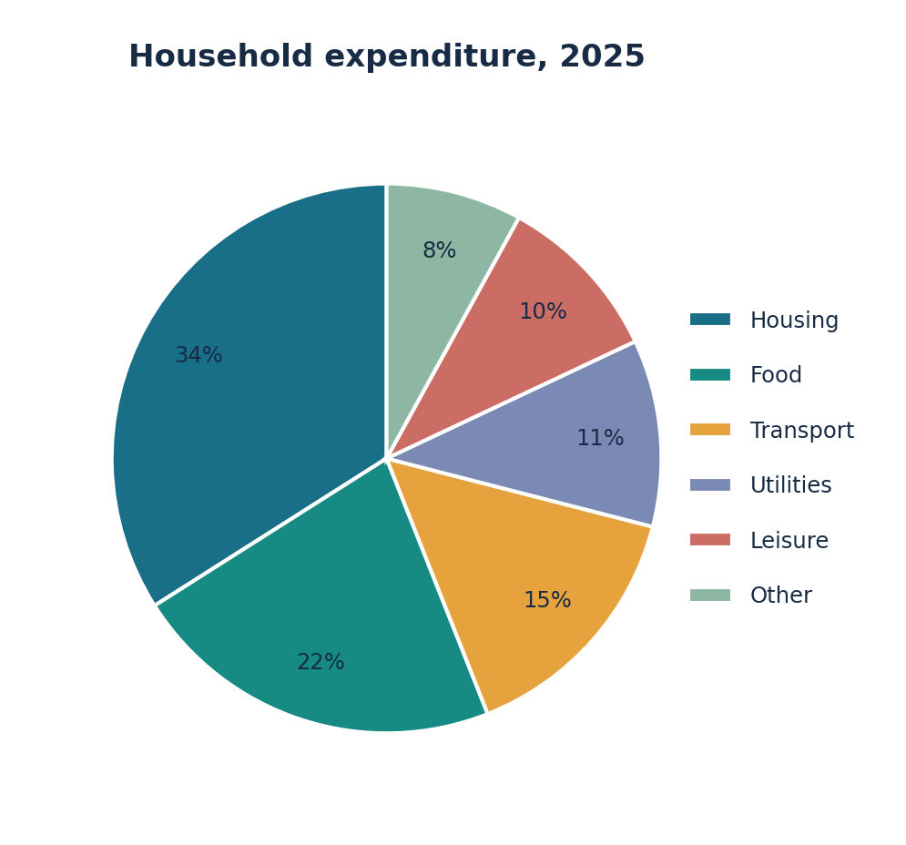

PIE CHART 02/10
Proportions and percentage breakdowns

Sources of electricity in 2024
ORIGINAL PRACTICE • Illustrative / fictional data (not an official IELTS question)
The pie chart shows the percentage of electricity generated from six sources in a country in 2024.
Summarise the information by selecting and reporting the main features, and make comparisons where relevant.
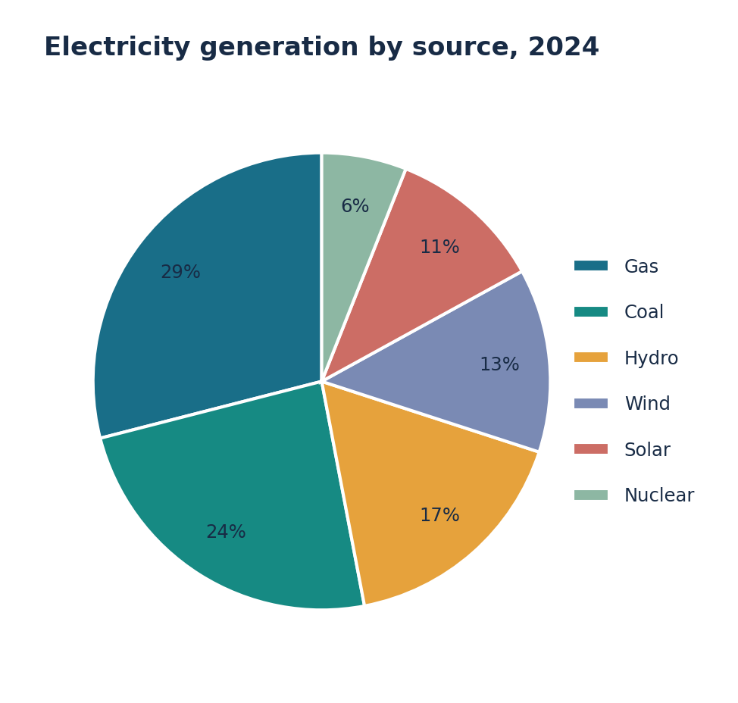

PIE CHART 03/10
Proportions and percentage breakdowns

Ways of travelling to school
ORIGINAL PRACTICE • Illustrative / fictional data (not an official IELTS question)
The pie chart compares the means of transport used by secondary-school pupils in one city.
Summarise the information by selecting and reporting the main features, and make comparisons where relevant.
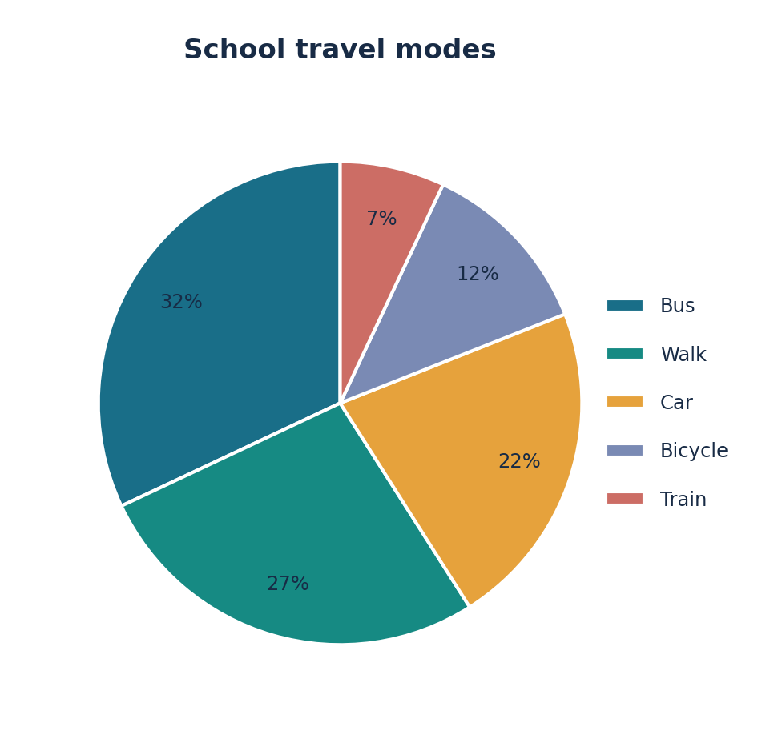

PIE CHART 04/10
Proportions and percentage breakdowns

Reasons for visiting a museum
ORIGINAL PRACTICE • Illustrative / fictional data (not an official IELTS question)
The pie chart displays the main purposes of visits to a city museum in 2025.
Summarise the information by selecting and reporting the main features, and make comparisons where relevant.
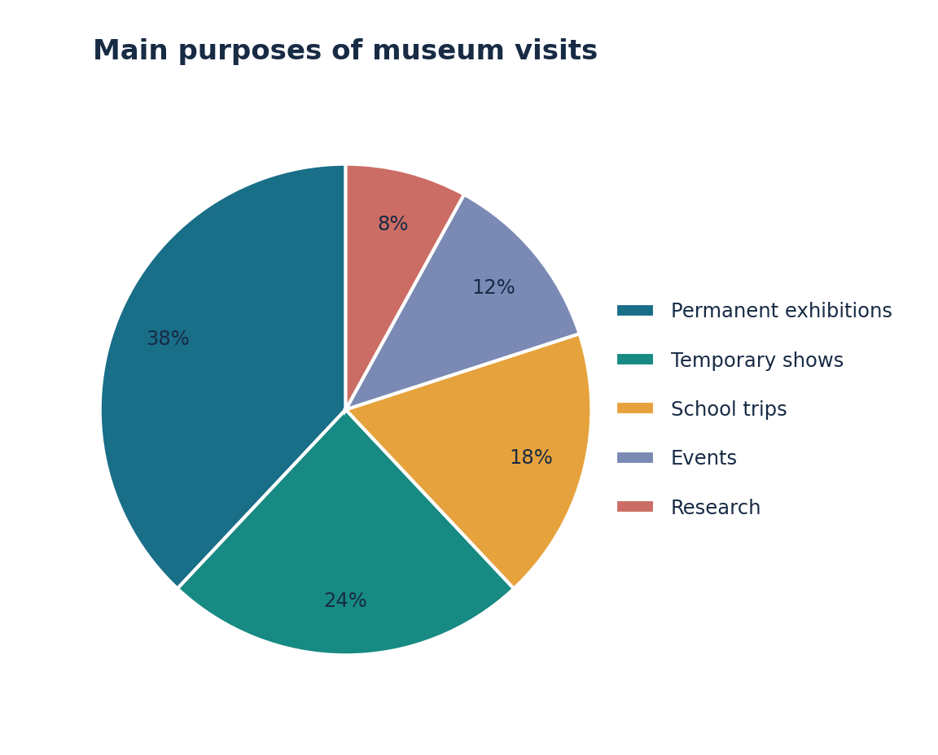

PIE CHART 05/10
Proportions and percentage breakdowns

Household waste composition
ORIGINAL PRACTICE • Illustrative / fictional data (not an official IELTS question)
The pie chart shows the composition of waste collected from households in one town in 2023.
Summarise the information by selecting and reporting the main features, and make comparisons where relevant.
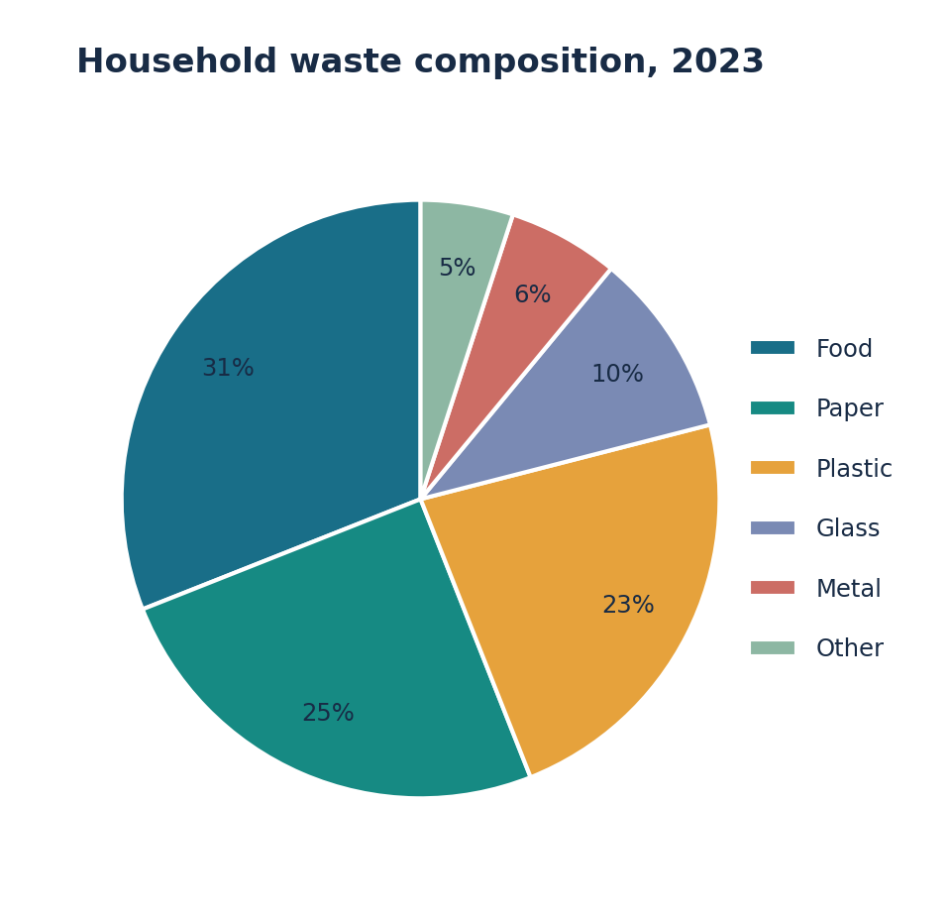

PIE CHART 06/10
Proportions and percentage breakdowns

Use of freshwater
ORIGINAL PRACTICE • Illustrative / fictional data (not an official IELTS question)
The chart gives the proportions of freshwater used by five sectors in a country in 2020.
Summarise the information by selecting and reporting the main features, and make comparisons where relevant.
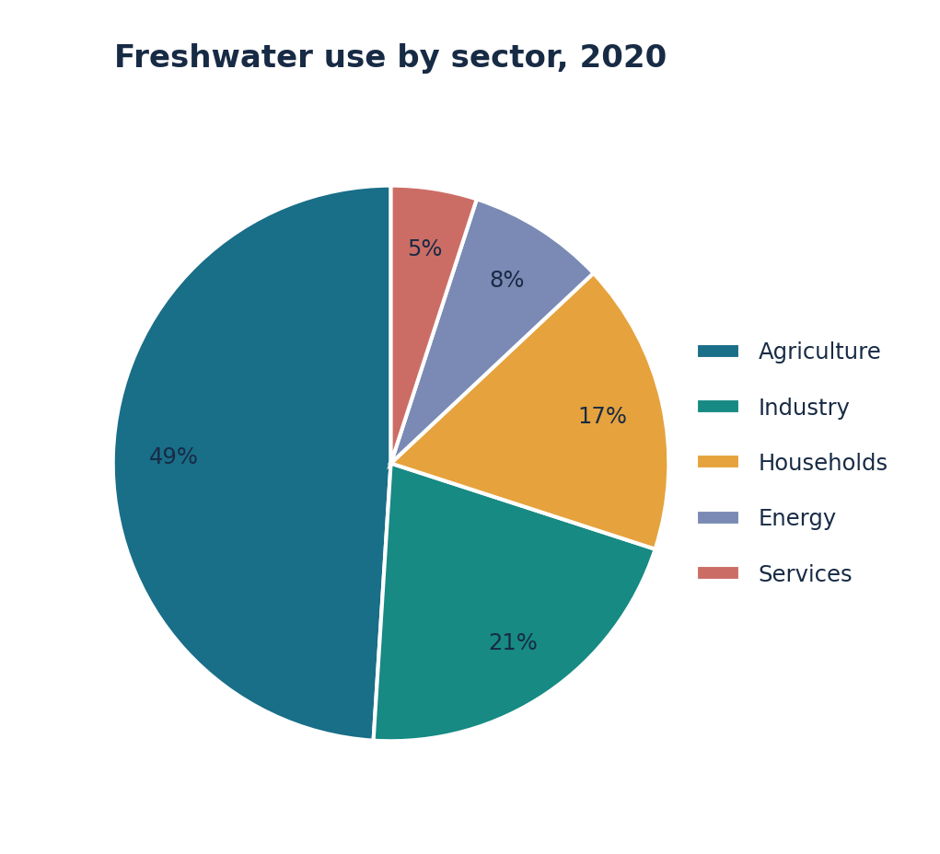

PIE CHART 07/10
Proportions and percentage breakdowns

Employment by sector
ORIGINAL PRACTICE • Illustrative / fictional data (not an official IELTS question)
The pie chart shows the distribution of employed adults among six sectors in 2025.
Summarise the information by selecting and reporting the main features, and make comparisons where relevant.
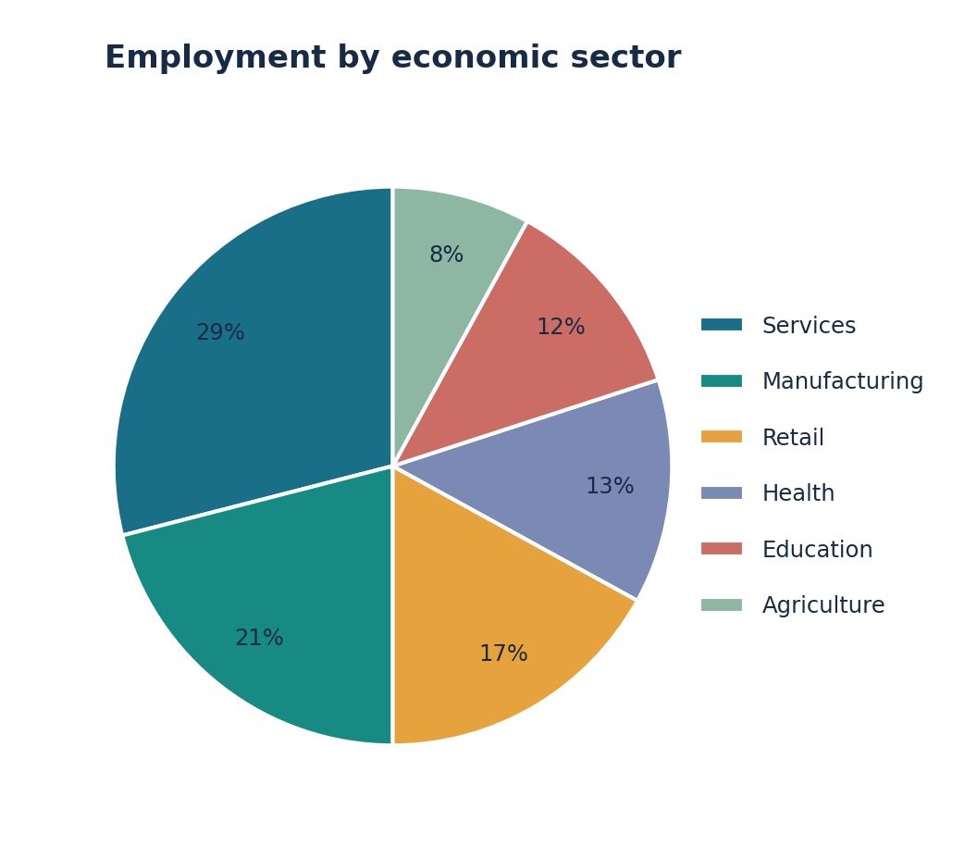

PIE CHART 08/10
Proportions and percentage breakdowns

Preferred digital learning tools
ORIGINAL PRACTICE • Illustrative / fictional data (not an official IELTS question)
The pie chart reports the favourite online-learning tools of 1,000 university students.
Summarise the information by selecting and reporting the main features, and make comparisons where relevant.
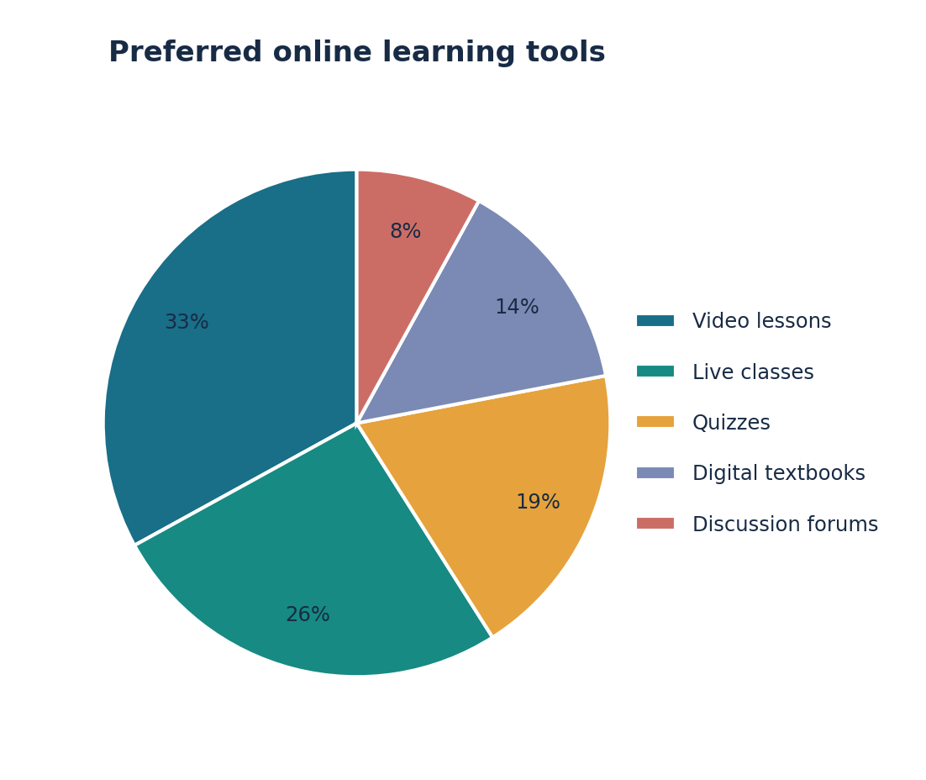

PIE CHART 09/10
Proportions and percentage breakdowns

Holiday destination choices
ORIGINAL PRACTICE • Illustrative / fictional data (not an official IELTS question)
The pie chart illustrates the destinations chosen by residents of a city for their main holiday in 2024.
Summarise the information by selecting and reporting the main features, and make comparisons where relevant.
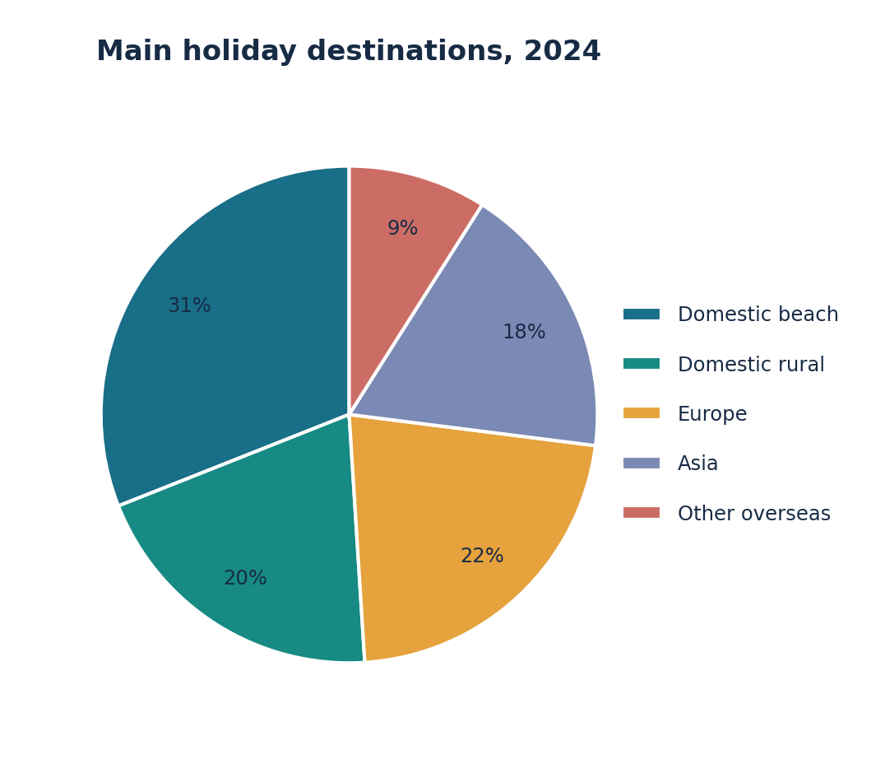

PIE CHART 10/10
Proportions and percentage breakdowns

Public transport funding
ORIGINAL PRACTICE • Illustrative / fictional data (not an official IELTS question)
The pie chart shows how a city’s public transport budget was divided among six purposes in 2026.
Summarise the information by selecting and reporting the main features, and make comparisons where relevant.
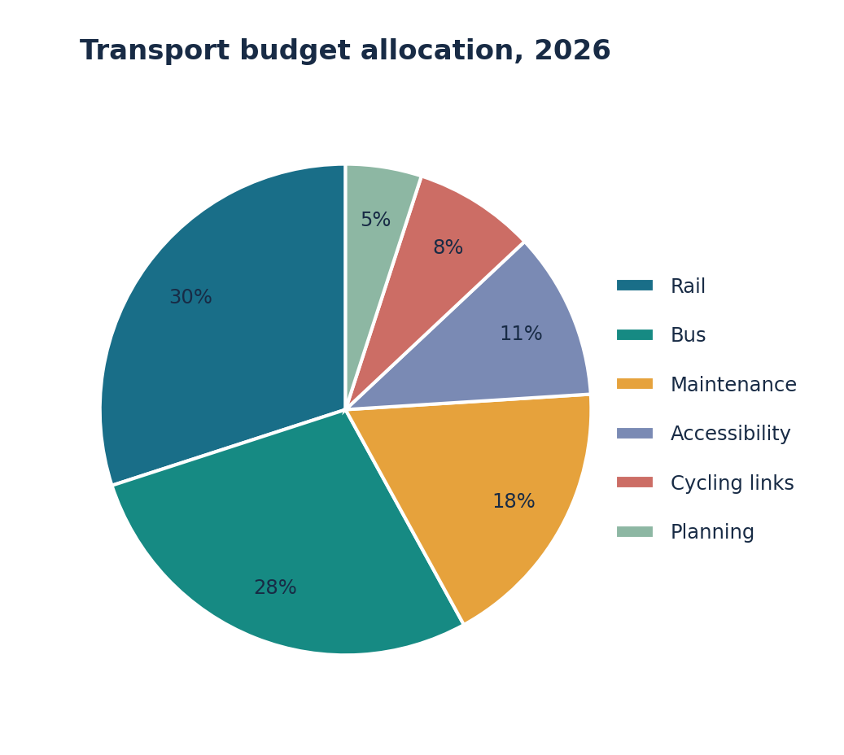

TABLE 01/10
Numerical comparisons in tables

University enrolment by faculty
ORIGINAL PRACTICE • Illustrative / fictional data (not an official IELTS question)
The table compares student enrolment at a university across five faculties in 2015, 2020 and 2025.
Summarise the information by selecting and reporting the main features, and make comparisons where relevant.
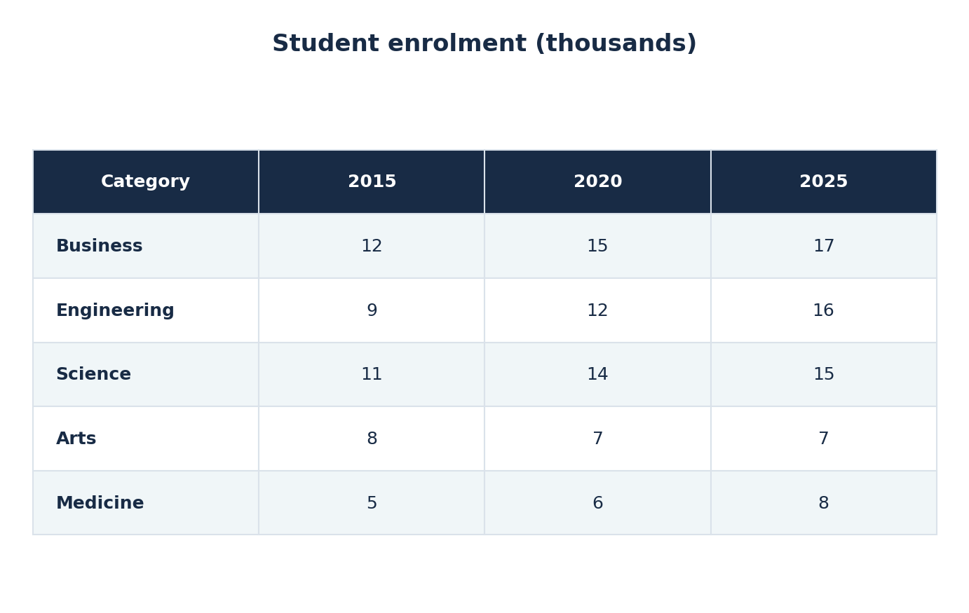

TABLE 02/10
Numerical comparisons in tables

Average monthly rent
ORIGINAL PRACTICE • Illustrative / fictional data (not an official IELTS question)
The table shows average monthly rents in four neighbourhoods for three kinds of housing in 2025.
Summarise the information by selecting and reporting the main features, and make comparisons where relevant.
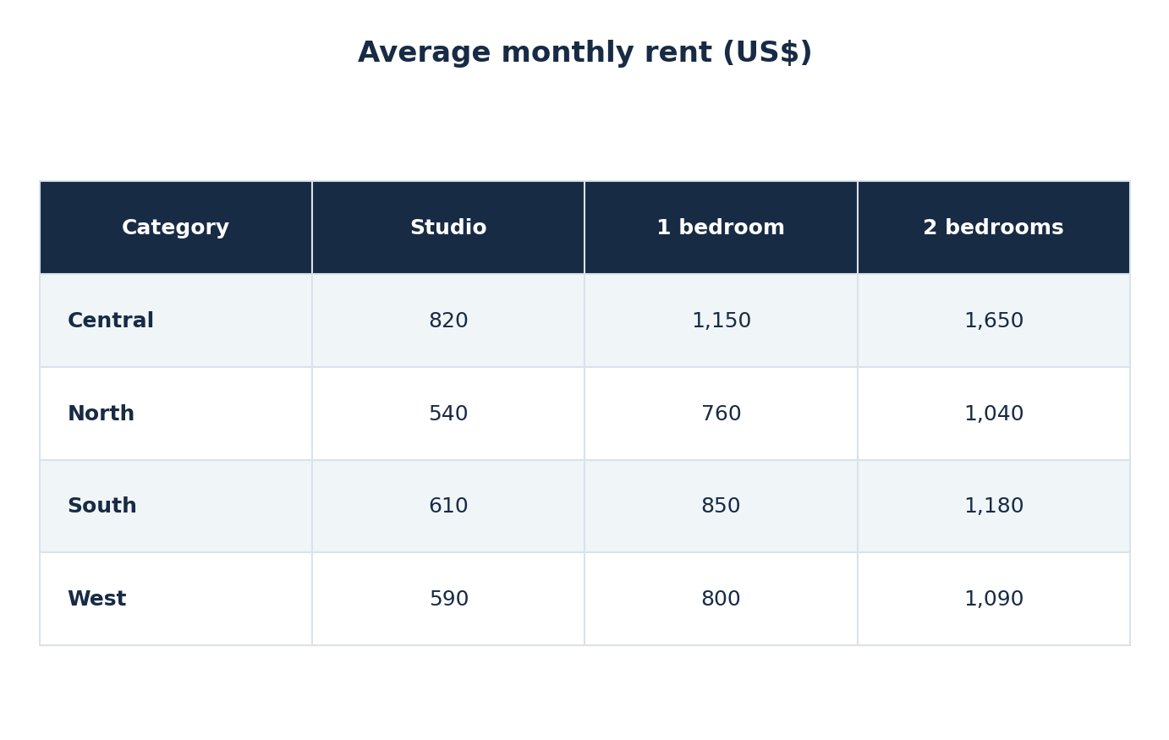

TABLE 03/10
Numerical comparisons in tables

Visitors to national parks
ORIGINAL PRACTICE • Illustrative / fictional data (not an official IELTS question)
The table gives annual visitor numbers to five national parks in 2010, 2015 and 2020.
Summarise the information by selecting and reporting the main features, and make comparisons where relevant.
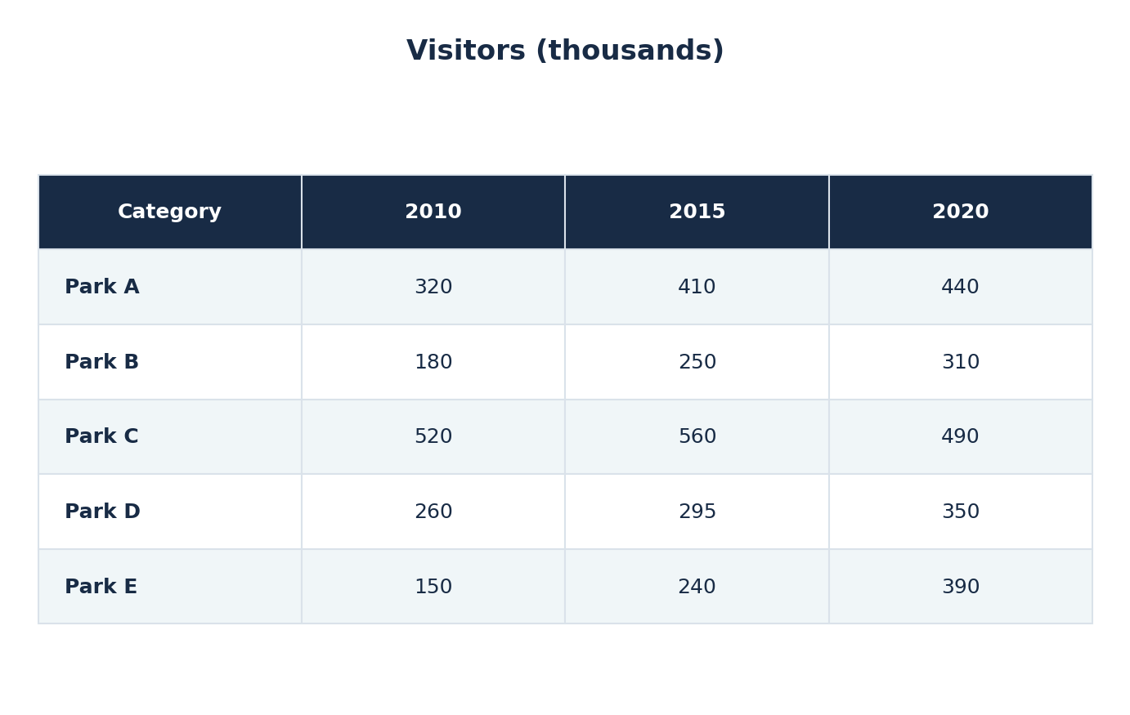

TABLE 04/10
Numerical comparisons in tables

International food prices
ORIGINAL PRACTICE • Illustrative / fictional data (not an official IELTS question)
The table compares the prices of four food products in three countries in 2024.
Summarise the information by selecting and reporting the main features, and make comparisons where relevant.
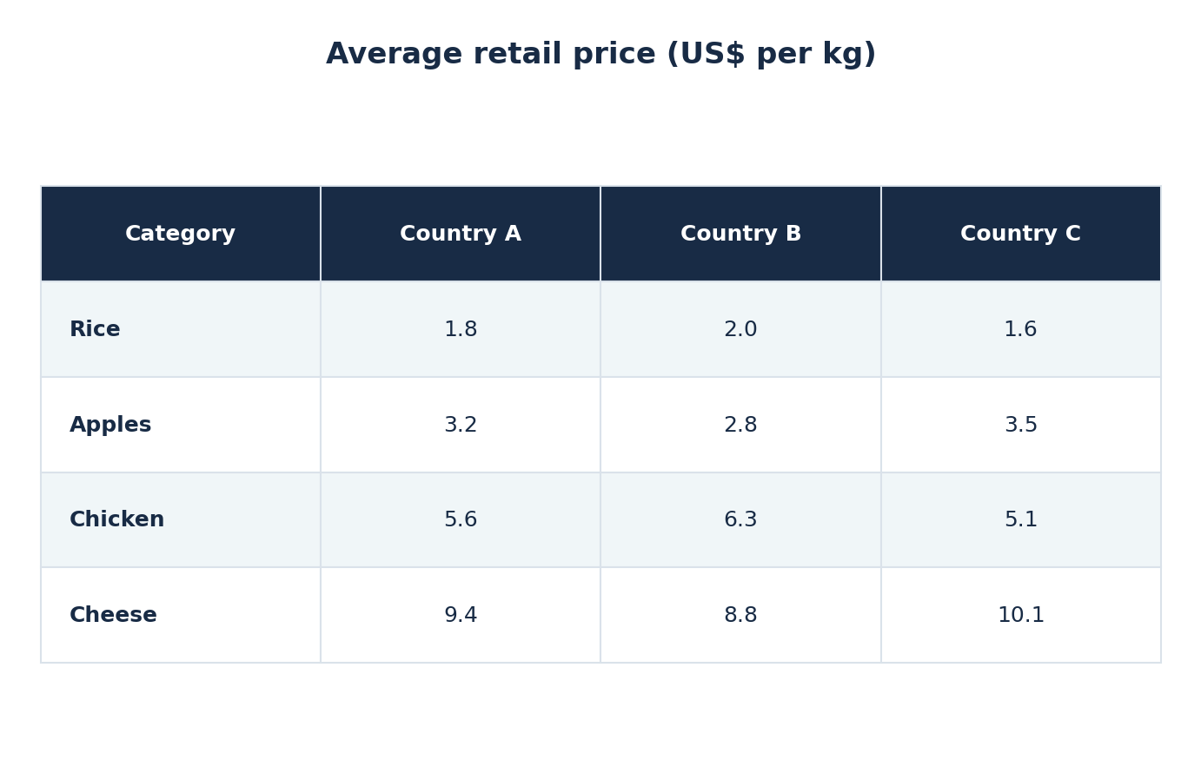

TABLE 05/10
Numerical comparisons in tables

Hospital staffing
ORIGINAL PRACTICE • Illustrative / fictional data (not an official IELTS question)
The table shows the numbers of healthcare employees in four hospital departments in 2018 and 2025.
Summarise the information by selecting and reporting the main features, and make comparisons where relevant.
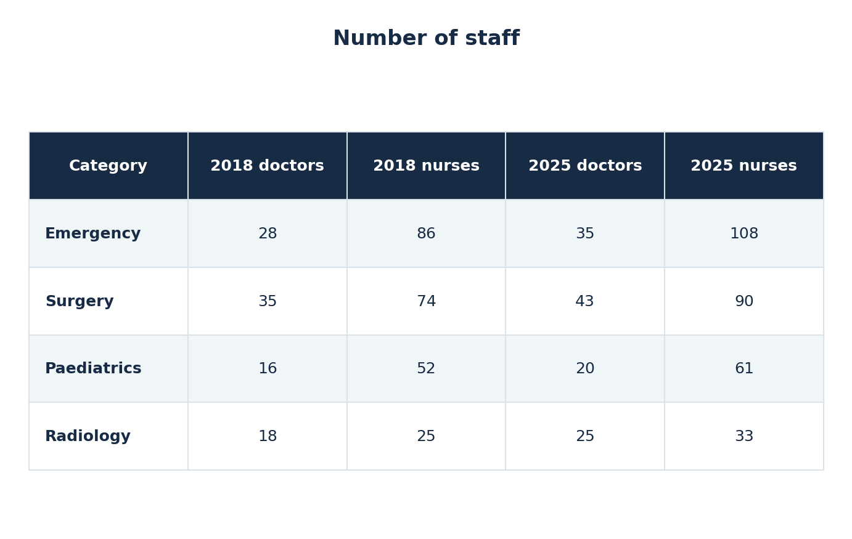

TABLE 06/10
Numerical comparisons in tables

Annual rainfall and temperature
ORIGINAL PRACTICE • Illustrative / fictional data (not an official IELTS question)
The table presents the average annual rainfall and temperature in five cities in 2000 and 2020.
Summarise the information by selecting and reporting the main features, and make comparisons where relevant.
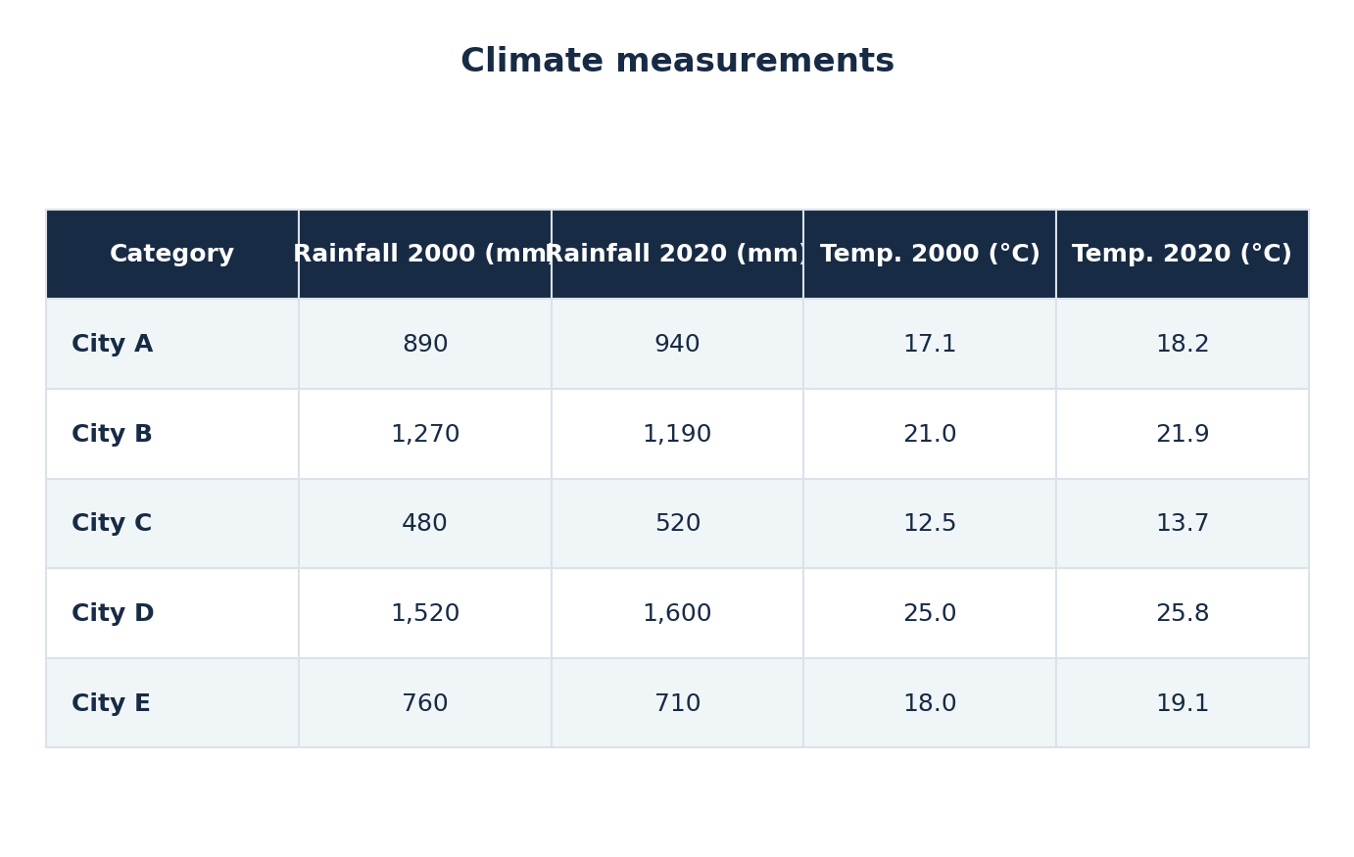

TABLE 07/10
Numerical comparisons in tables

Daily internet use by age
ORIGINAL PRACTICE • Illustrative / fictional data (not an official IELTS question)
The table compares daily internet use among four age groups in three years.
Summarise the information by selecting and reporting the main features, and make comparisons where relevant.
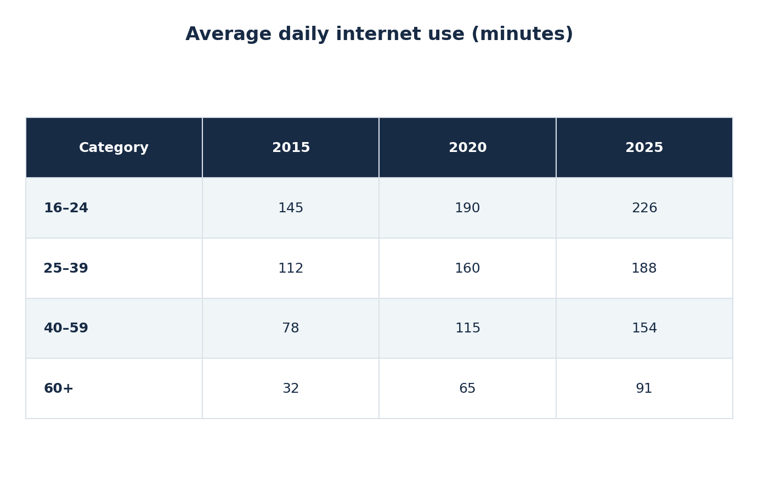

TABLE 08/10
Numerical comparisons in tables

Export earnings by product
ORIGINAL PRACTICE • Illustrative / fictional data (not an official IELTS question)
The table displays export earnings for five products in 2019, 2022 and 2025.
Summarise the information by selecting and reporting the main features, and make comparisons where relevant.
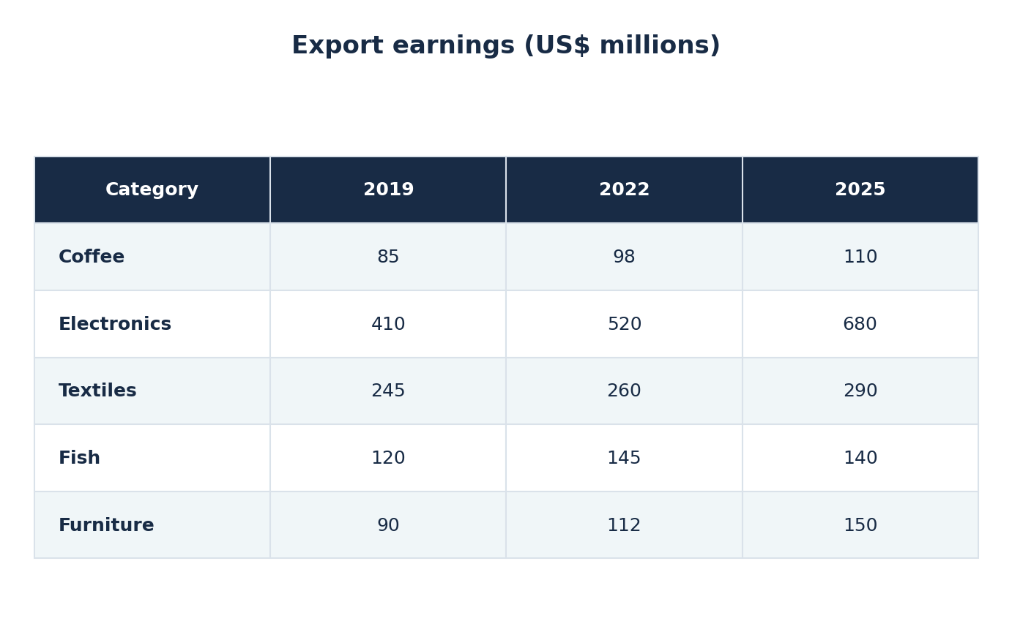

TABLE 09/10
Numerical comparisons in tables

Energy used in office buildings
ORIGINAL PRACTICE • Illustrative / fictional data (not an official IELTS question)
The table shows electricity use in four types of office building during three seasons.
Summarise the information by selecting and reporting the main features, and make comparisons where relevant.
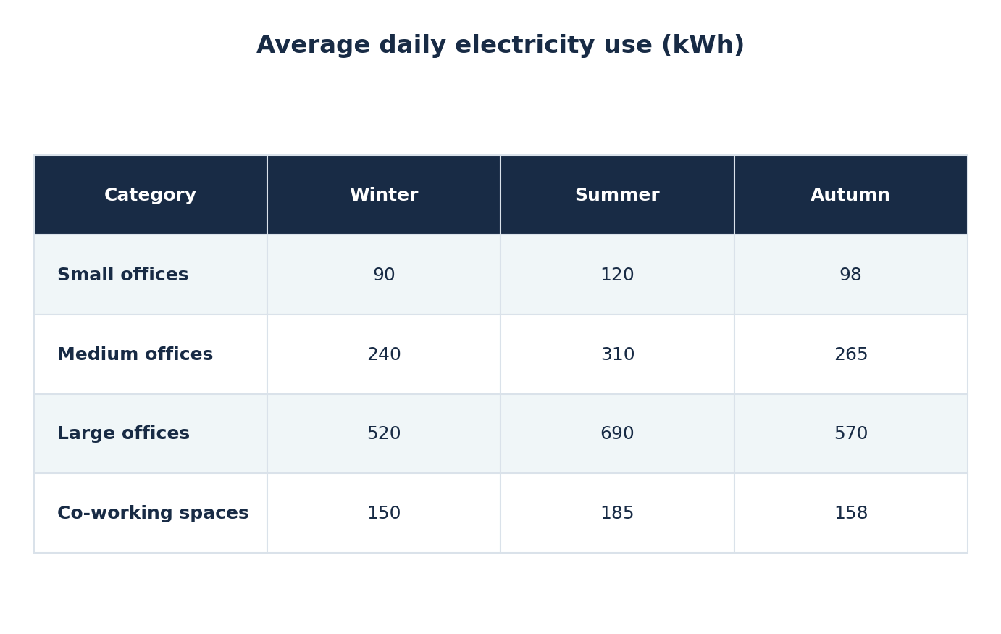

TABLE 10/10
Numerical comparisons in tables

Sports participation by gender
ORIGINAL PRACTICE • Illustrative / fictional data (not an official IELTS question)
The table shows the percentages of men and women participating in five sports in a city in 2025.
Summarise the information by selecting and reporting the main features, and make comparisons where relevant.
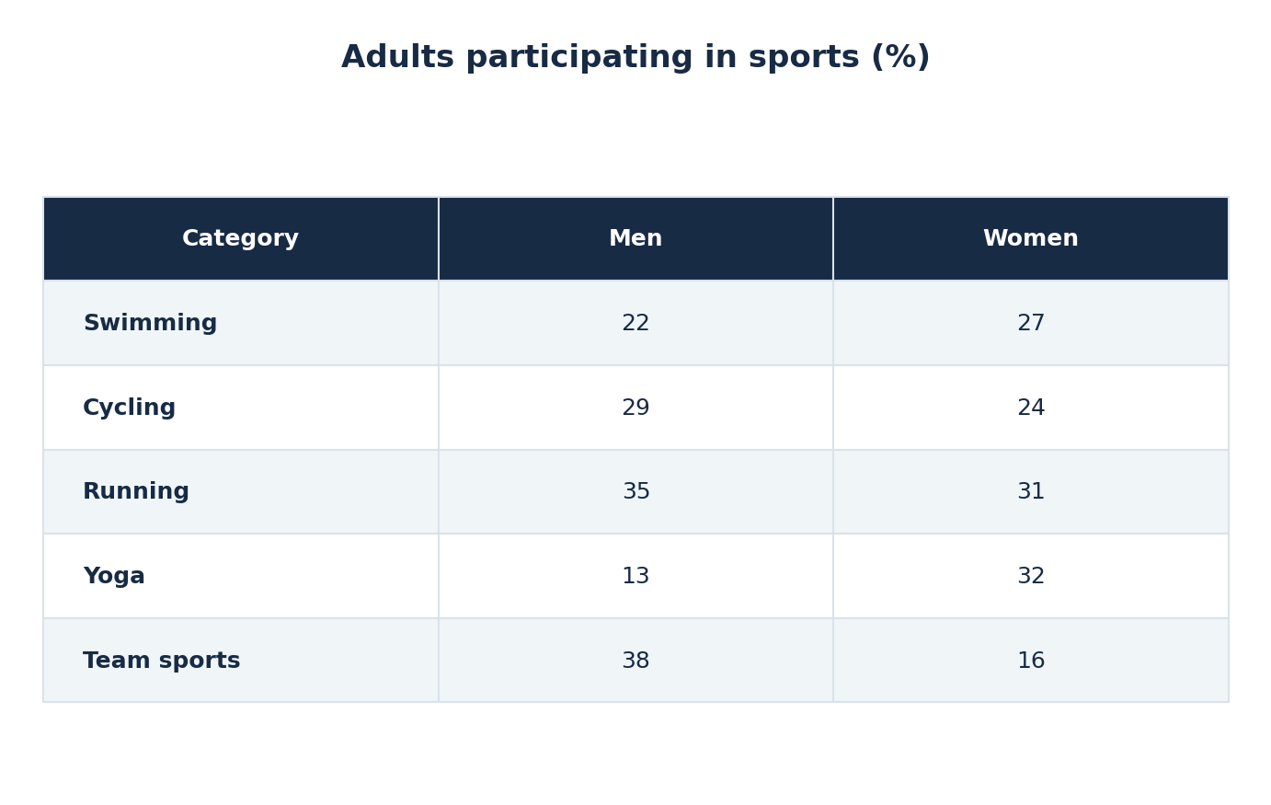

MAP / FLOOR PLAN 01/10
Changes to places, plans and layouts

Changes to an industrial area
CAMBRIDGE ORIGINAL • Cambridge IELTS 17 • Test 1
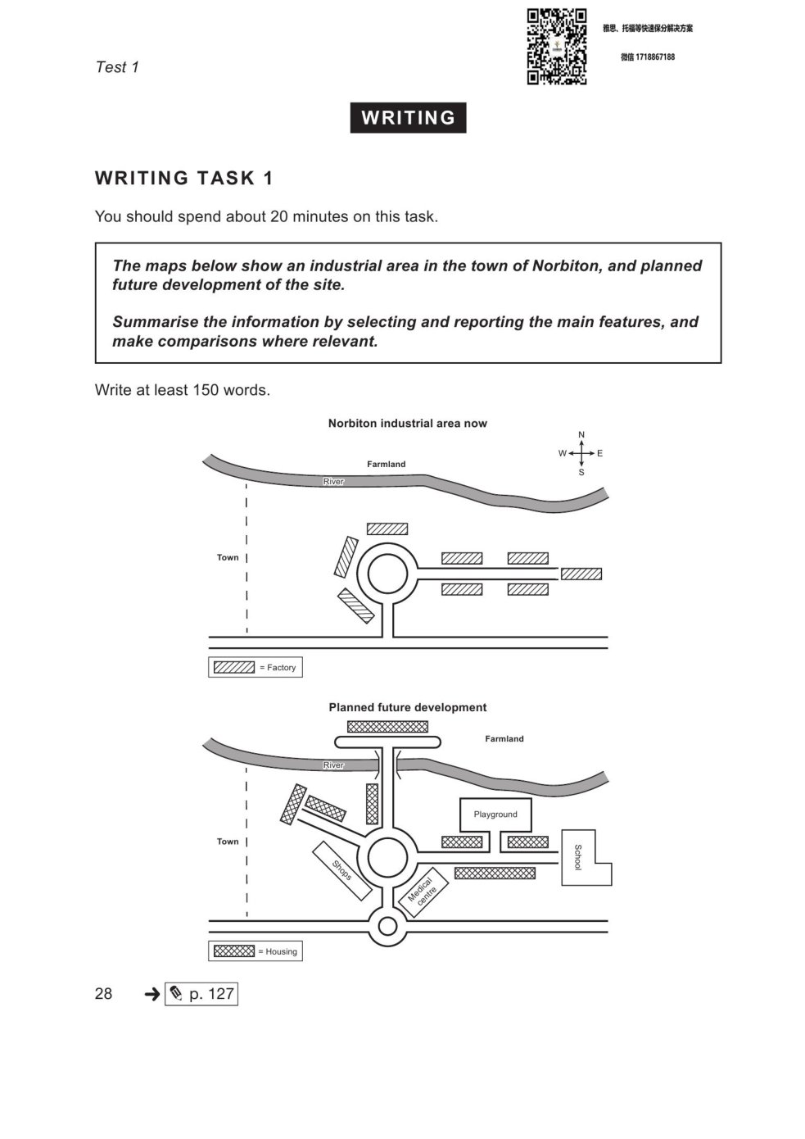

MAP / FLOOR PLAN 02/10
Changes to places, plans and layouts

Floor plans of a public library
CAMBRIDGE ORIGINAL • Cambridge IELTS 18 • Test 3
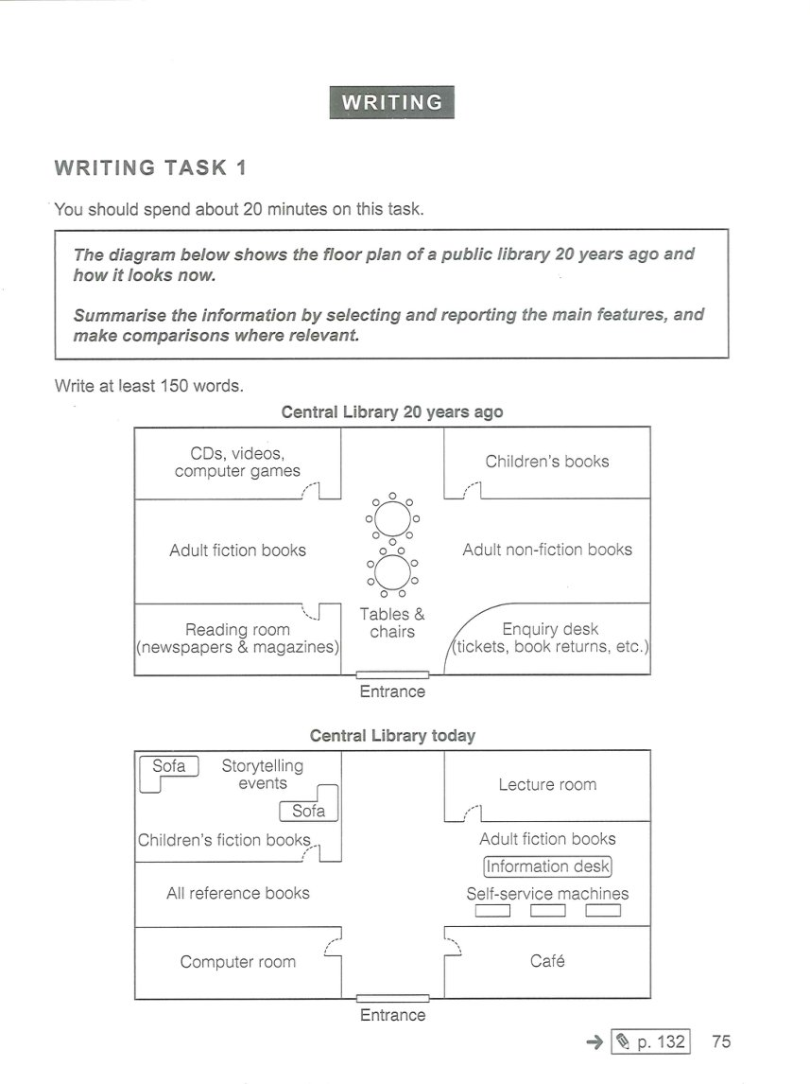

MAP / FLOOR PLAN 03/10
Changes to places, plans and layouts

Park layouts before and after redevelopment
CAMBRIDGE ORIGINAL • Cambridge IELTS 19 • Test 2
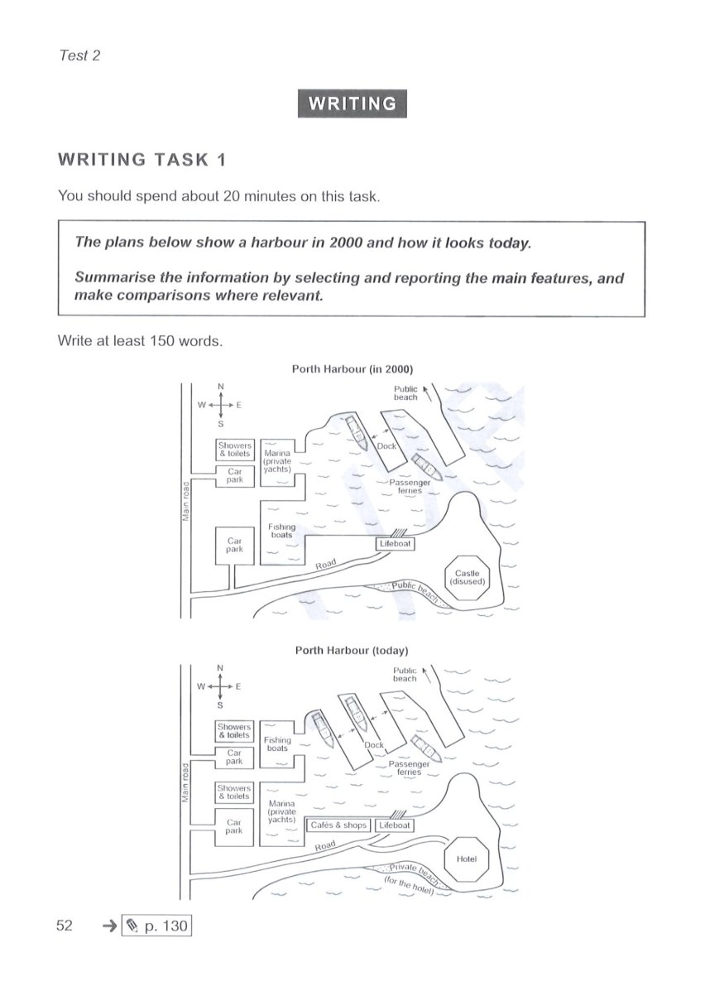

MAP / FLOOR PLAN 04/10
Changes to places, plans and layouts

Changes to a school library
CAMBRIDGE ORIGINAL • Cambridge IELTS 21 • Test 2
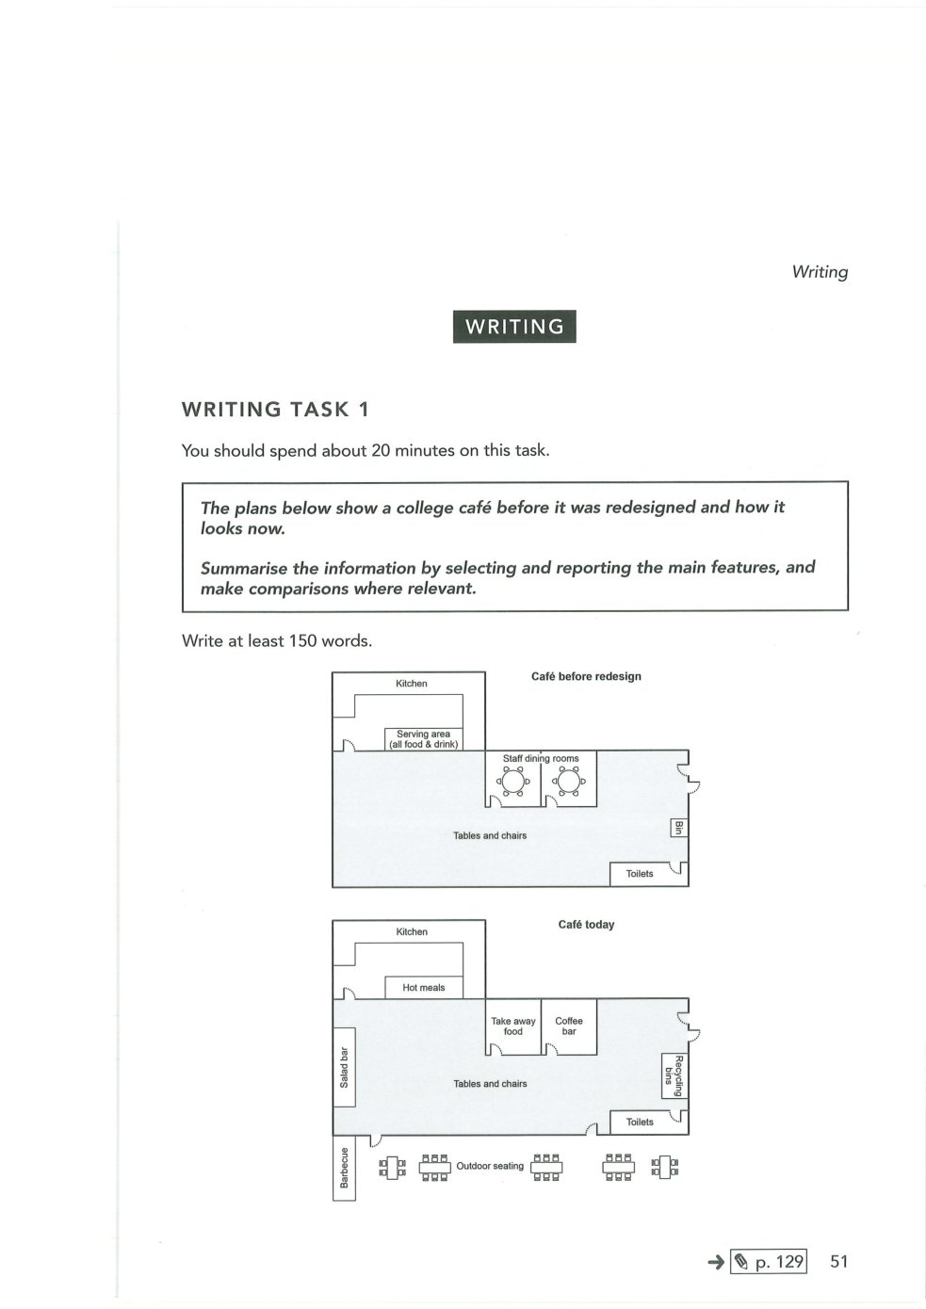

MAP / FLOOR PLAN 05/10
Changes to places, plans and layouts

A riverside town, 2000 and 2025
ORIGINAL PRACTICE • Illustrative / fictional data (not an official IELTS question)
The maps show how a riverside town changed between 2000 and 2025.
Summarise the information by selecting and reporting the main features, and make comparisons where relevant.
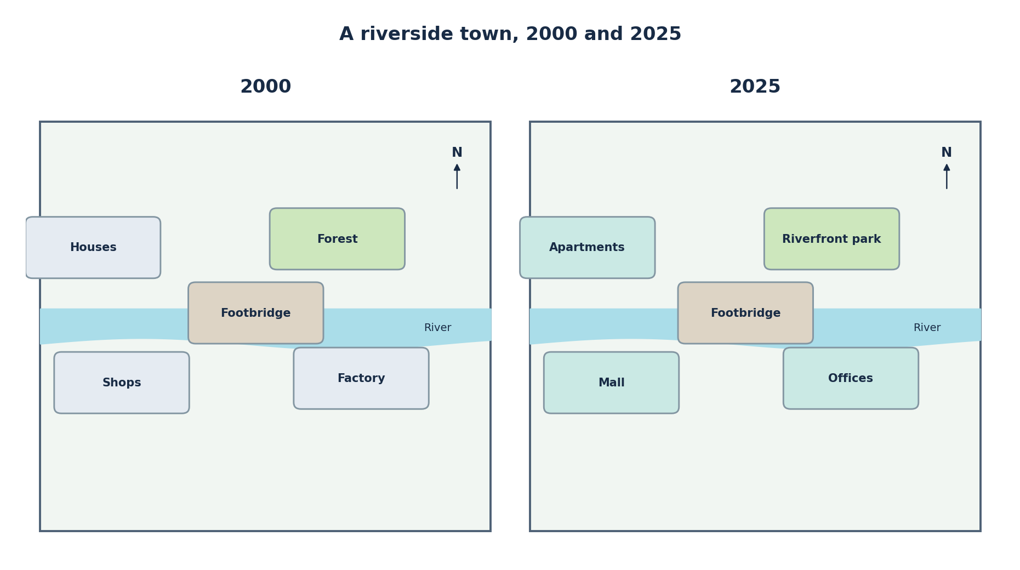

MAP / FLOOR PLAN 06/10
Changes to places, plans and layouts

A public park before and after renovation
ORIGINAL PRACTICE • Illustrative / fictional data (not an official IELTS question)
The two maps show the layout of a public park before and after its renovation.
Summarise the information by selecting and reporting the main features, and make comparisons where relevant.
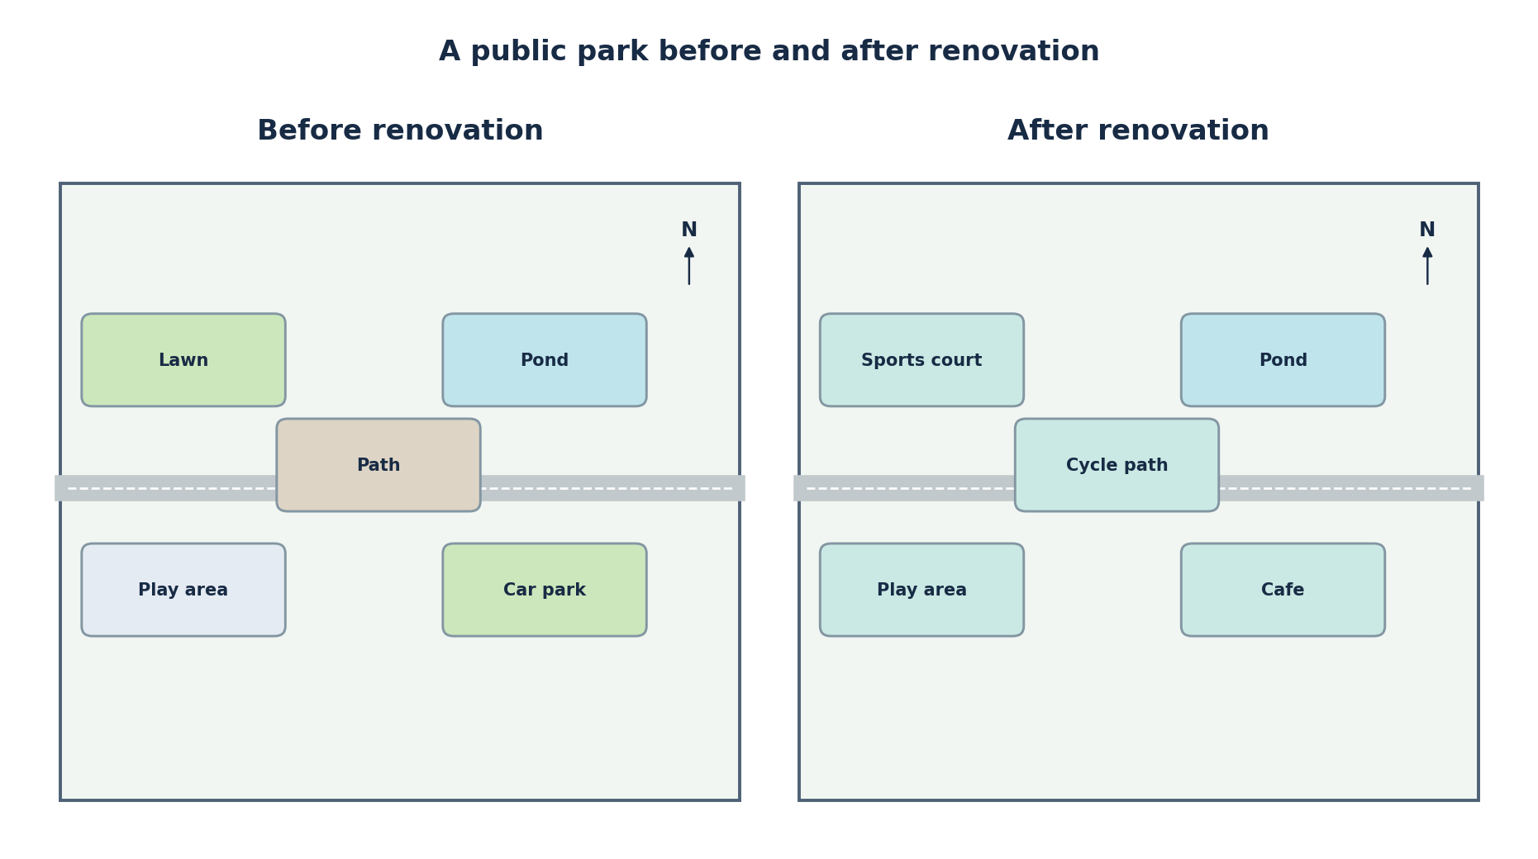

MAP / FLOOR PLAN 07/10
Changes to places, plans and layouts

A university campus in 2010 and 2025
ORIGINAL PRACTICE • Illustrative / fictional data (not an official IELTS question)
The maps compare a university campus in 2010 with its layout in 2025.
Summarise the information by selecting and reporting the main features, and make comparisons where relevant.
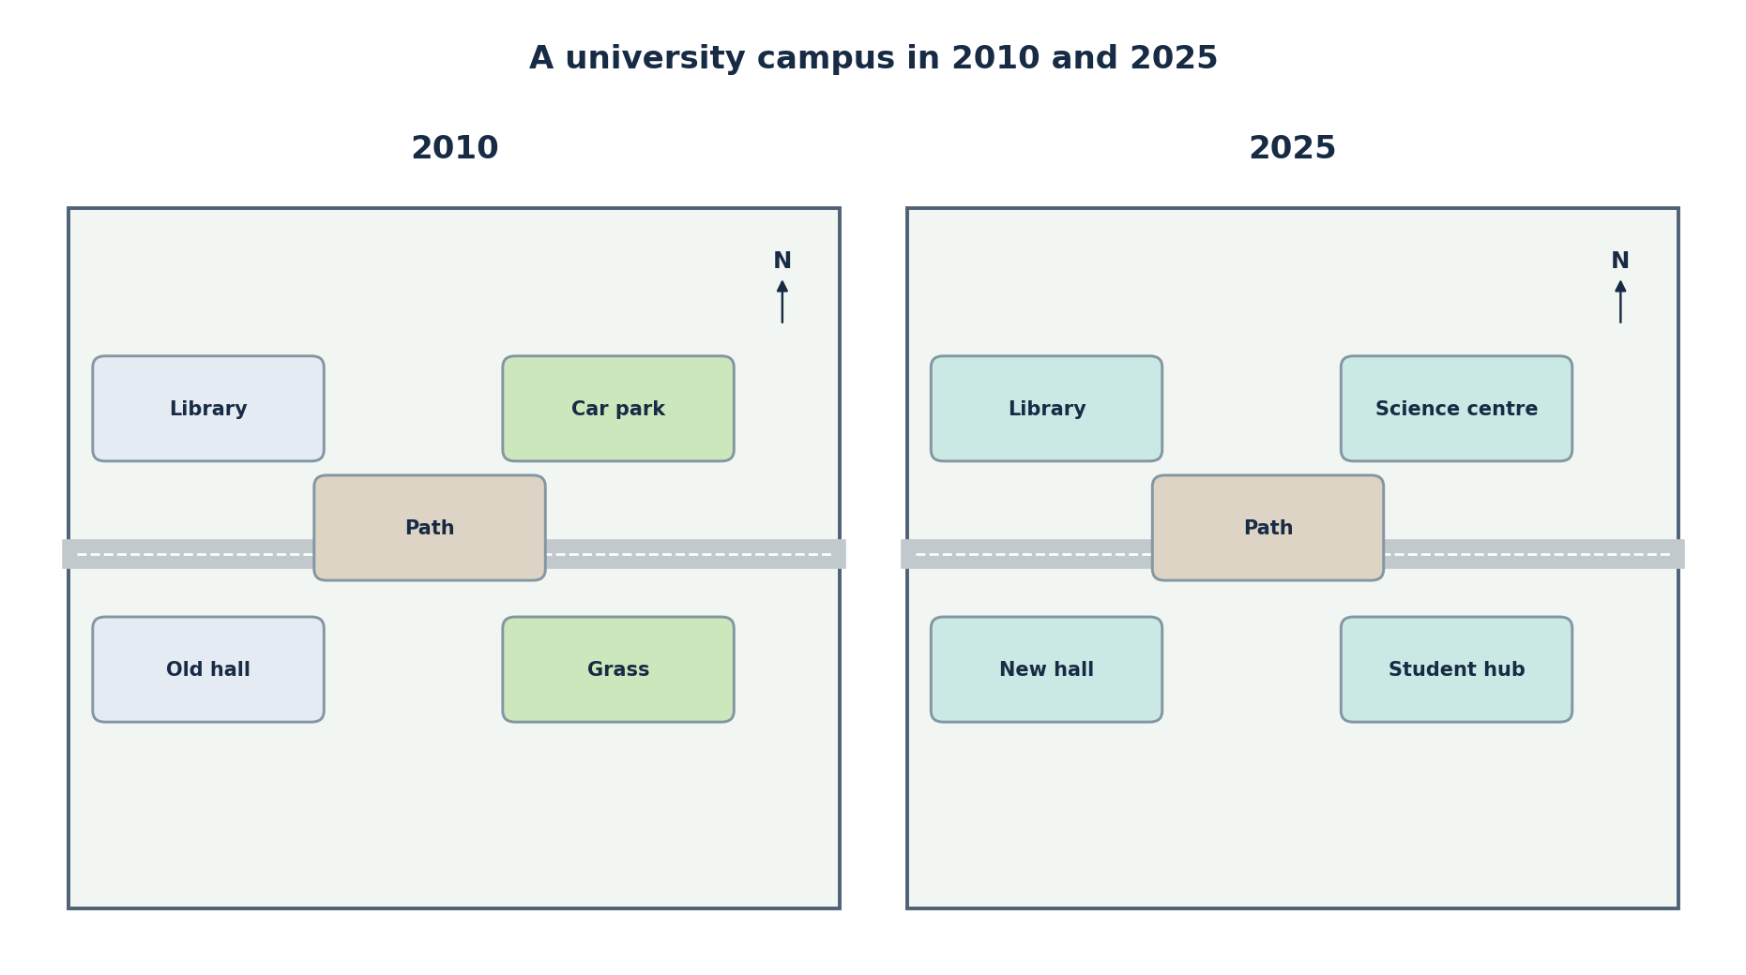

MAP / FLOOR PLAN 08/10
Changes to places, plans and layouts

A seaside neighbourhood in 1995 and 2025
ORIGINAL PRACTICE • Illustrative / fictional data (not an official IELTS question)
The plans illustrate changes in a coastal neighbourhood between 1995 and 2025.
Summarise the information by selecting and reporting the main features, and make comparisons where relevant.
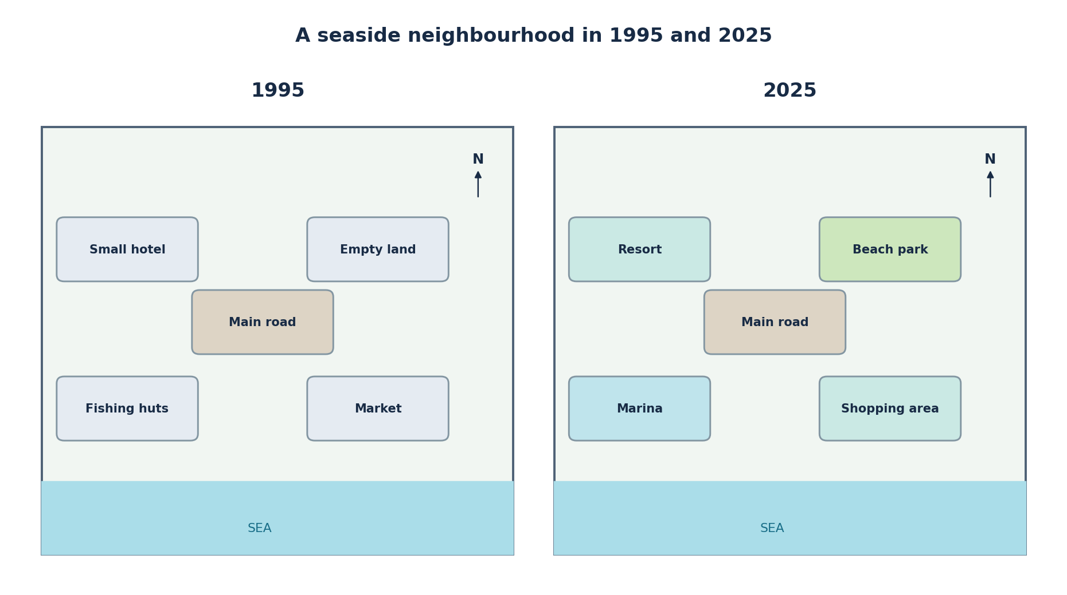

MAP / FLOOR PLAN 09/10
Changes to places, plans and layouts

A village before and after redevelopment
ORIGINAL PRACTICE • Illustrative / fictional data (not an official IELTS question)
The maps show a small village before and after a redevelopment project.
Summarise the information by selecting and reporting the main features, and make comparisons where relevant.
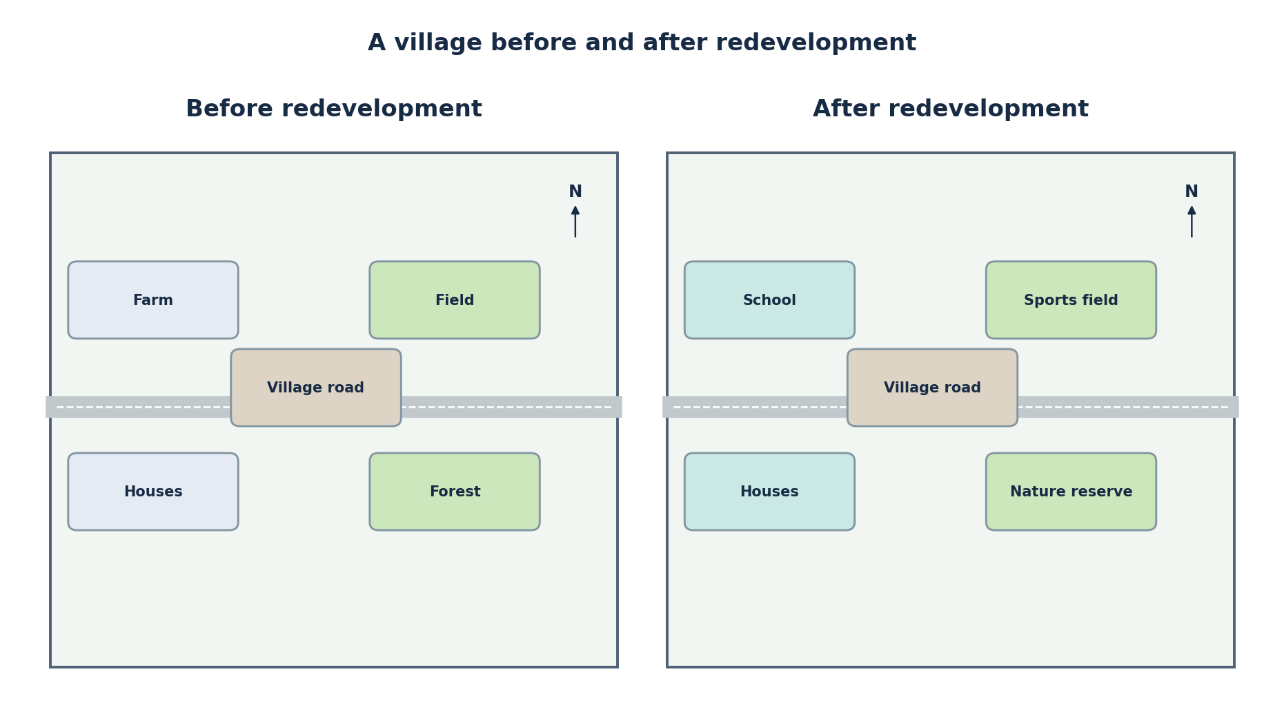

MAP / FLOOR PLAN 10/10
Changes to places, plans and layouts

The ground floor of a community centre
ORIGINAL PRACTICE • Illustrative / fictional data (not an official IELTS question)
The floor plans show how the ground floor of a community centre was redesigned in 2024.
Summarise the information by selecting and reporting the main features, and make comparisons where relevant.
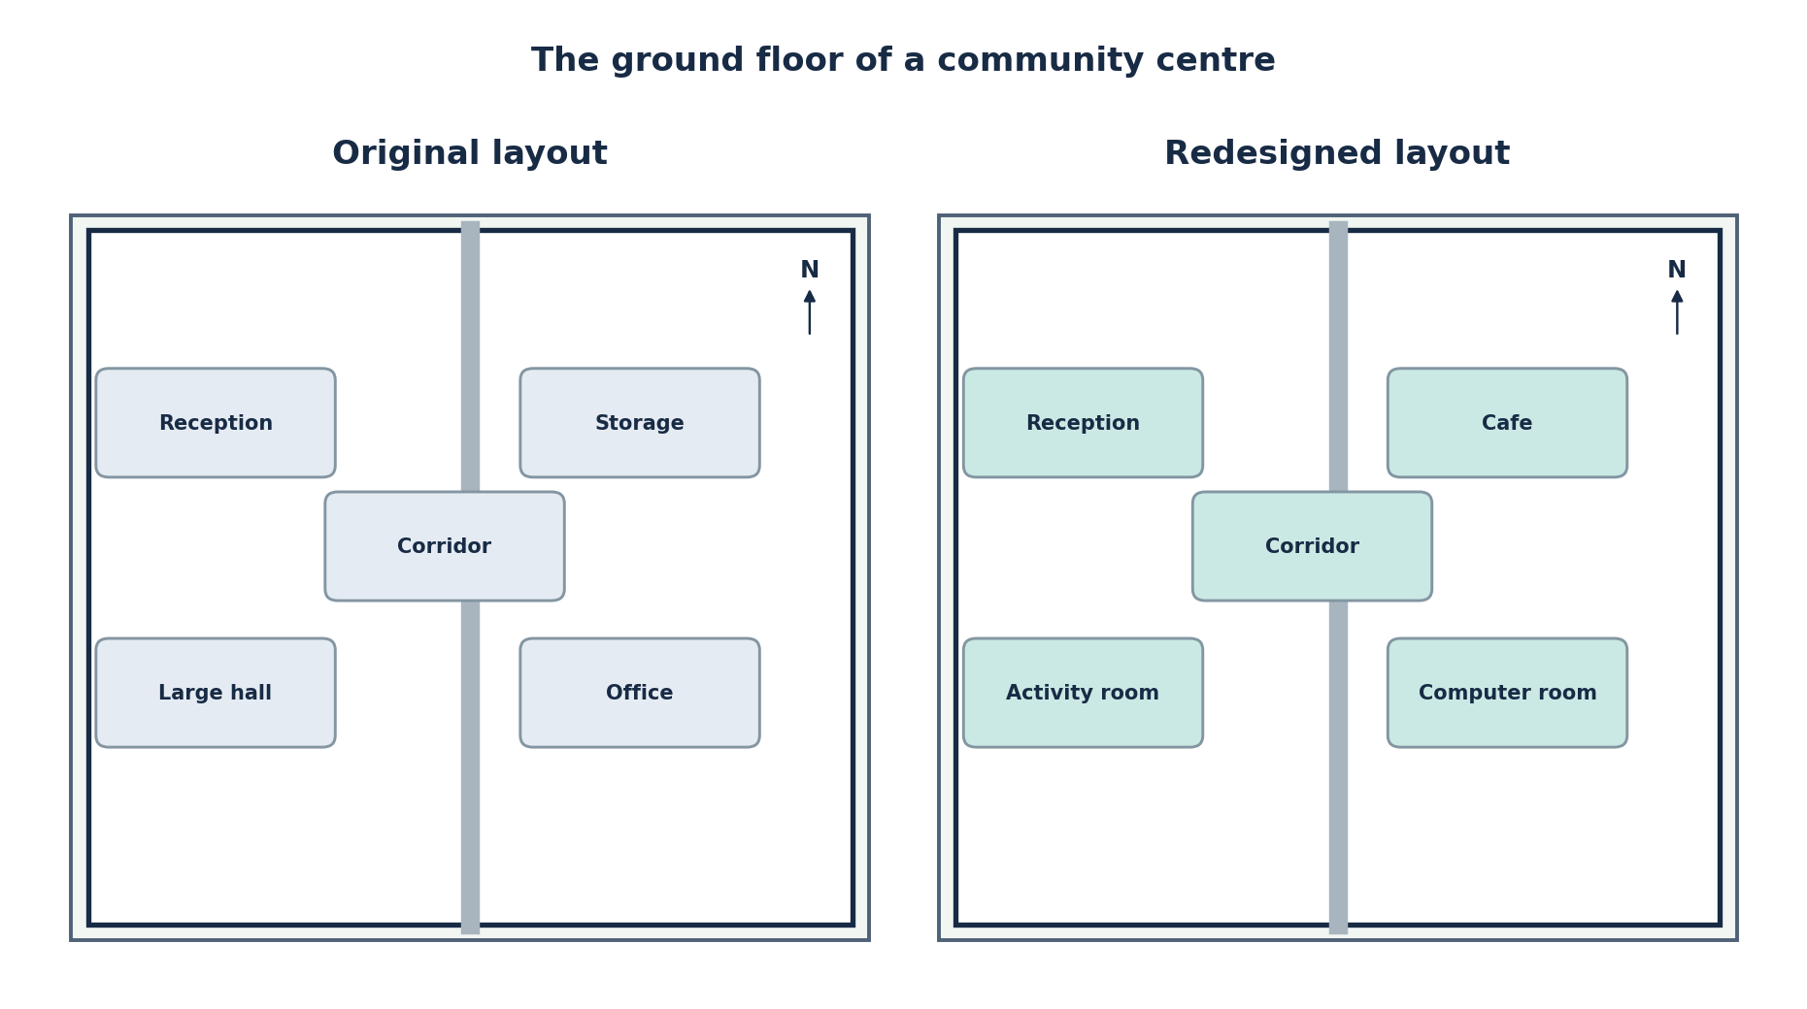

PROCESS DIAGRAM 01/10
Stages of natural or human-made processes

Manufacturing instant noodles
CAMBRIDGE ORIGINAL • Cambridge IELTS 15 • Test 3
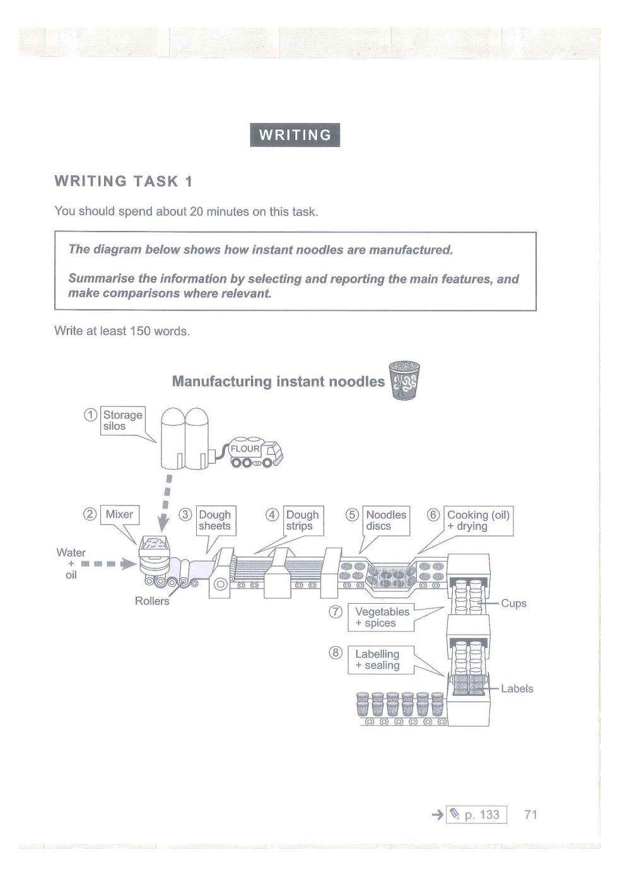

PROCESS DIAGRAM 02/10
Stages of natural or human-made processes

Producing sugar from sugar cane
CAMBRIDGE ORIGINAL • Cambridge IELTS 16 • Test 2
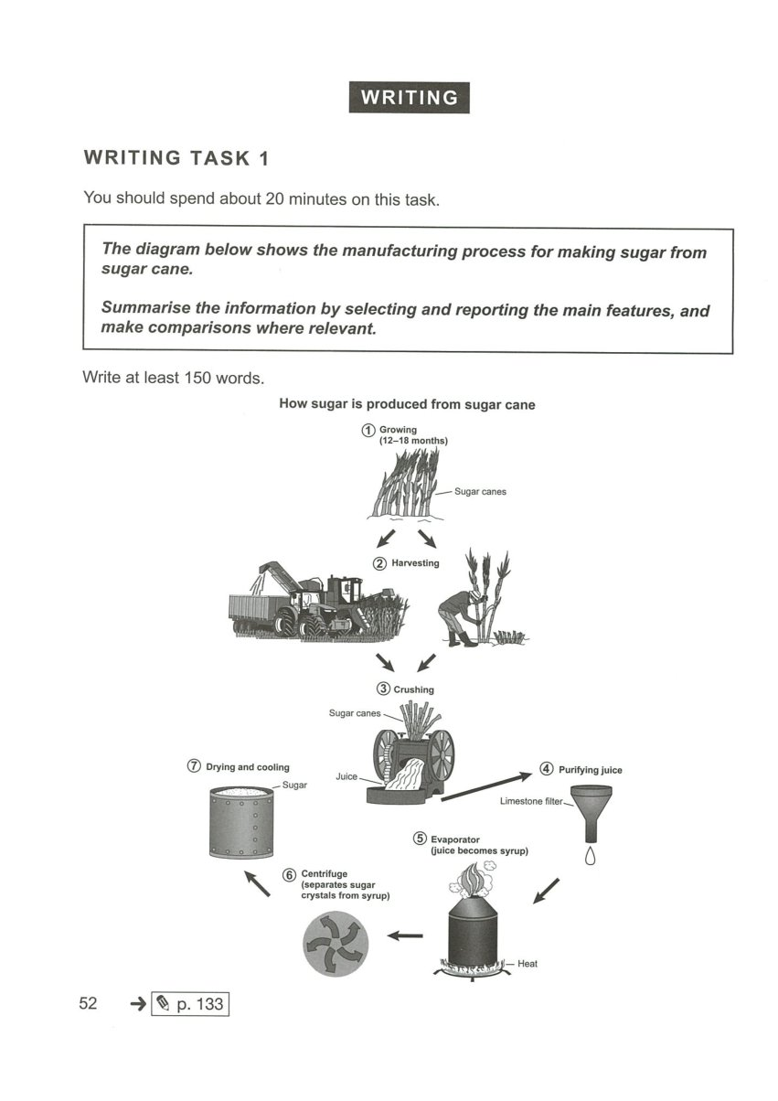

PROCESS DIAGRAM 03/10
Stages of natural or human-made processes

Solar panel and water heating
CAMBRIDGE ORIGINAL • Cambridge IELTS 16 • Test 3
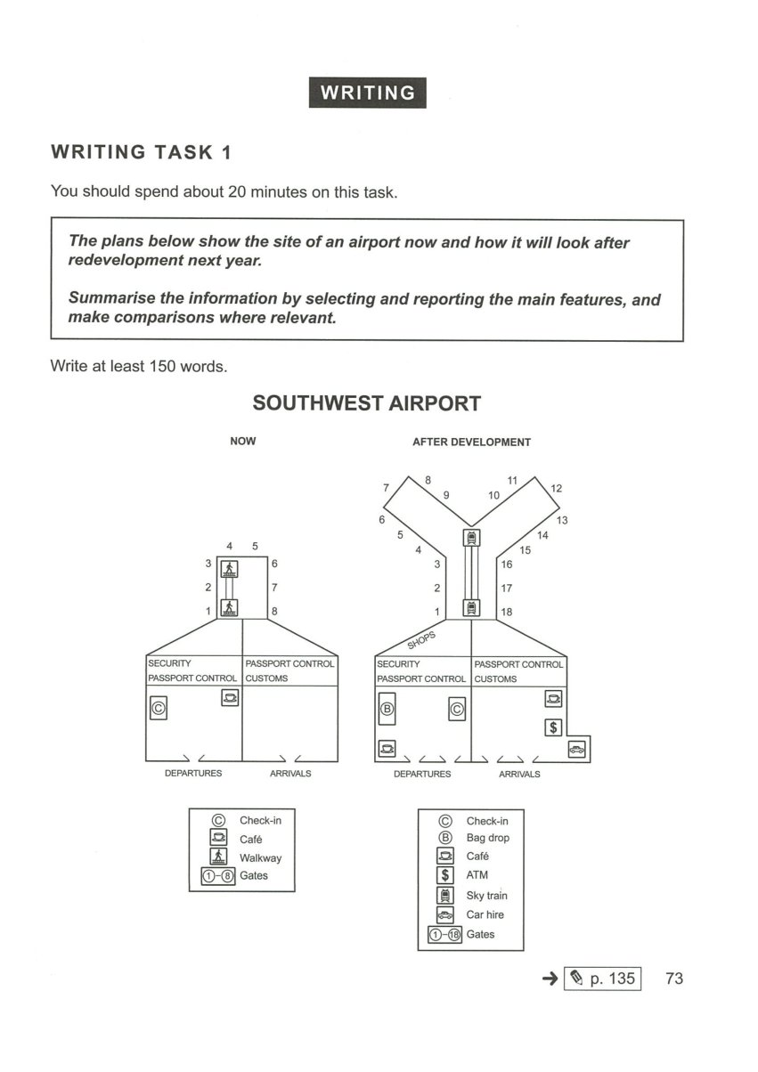

PROCESS DIAGRAM 04/10
Stages of natural or human-made processes

Recycling plastic bottles
CAMBRIDGE ORIGINAL • Cambridge IELTS 16 • Test 4
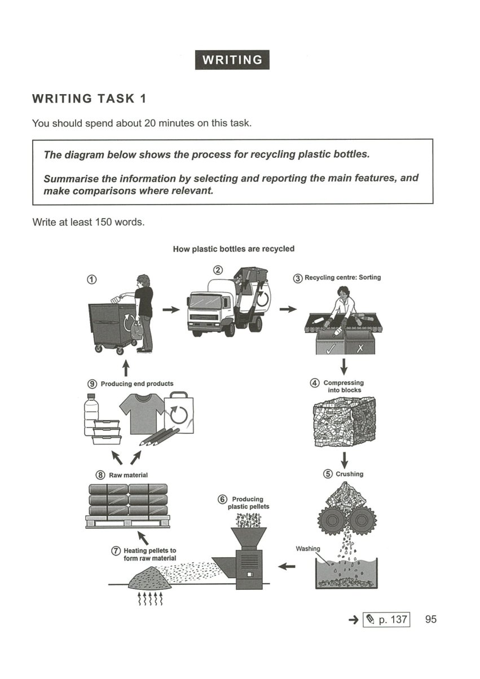

PROCESS DIAGRAM 05/10
Stages of natural or human-made processes

Production of biofuel
CAMBRIDGE ORIGINAL • Cambridge IELTS 19 • Test 3
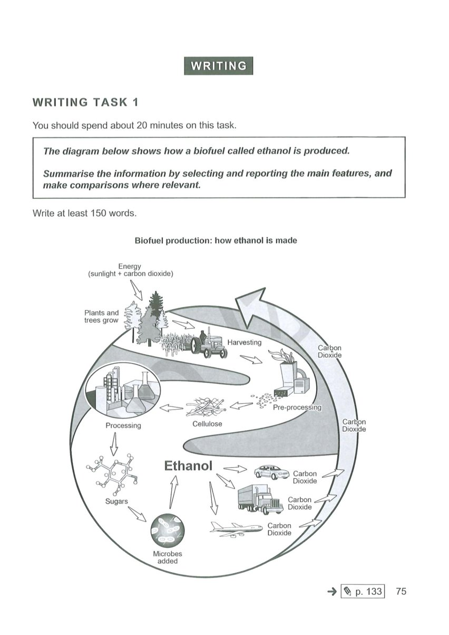

PROCESS DIAGRAM 06/10
Stages of natural or human-made processes

Formation of a volcanic island
CAMBRIDGE ORIGINAL • Cambridge IELTS 21 • Test 3
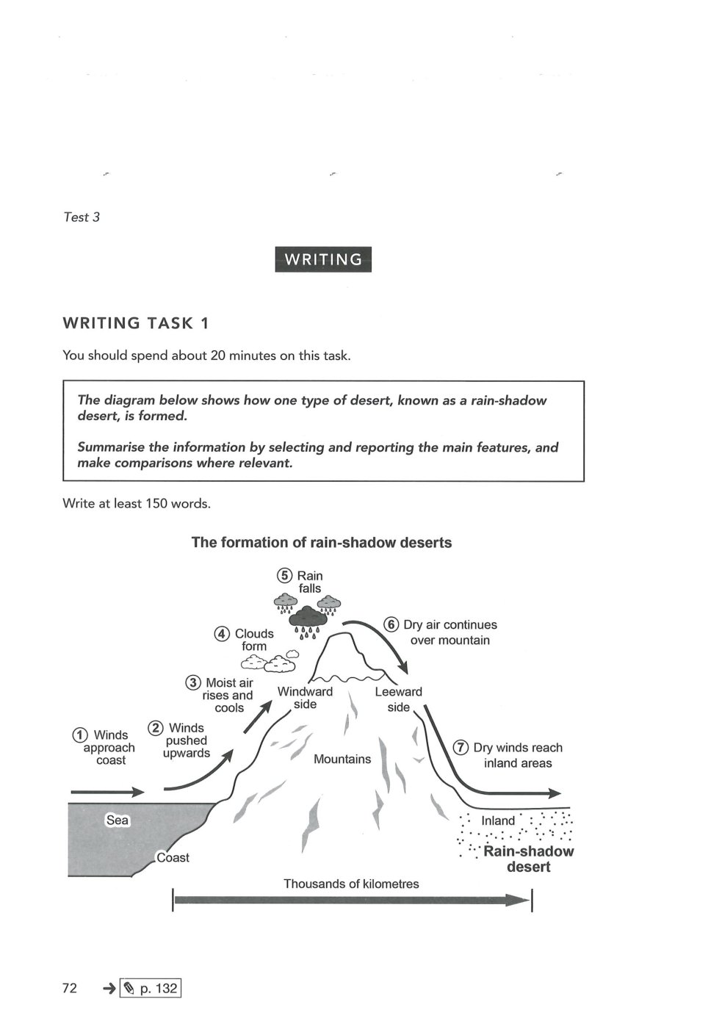

PROCESS DIAGRAM 07/10
Stages of natural or human-made processes

Recycling glass containers
ORIGINAL PRACTICE • Illustrative / fictional data (not an official IELTS question)
The diagram illustrates the main stages involved in collecting and recycling used glass bottles.
Summarise the information by selecting and reporting the main features, and make comparisons where relevant.
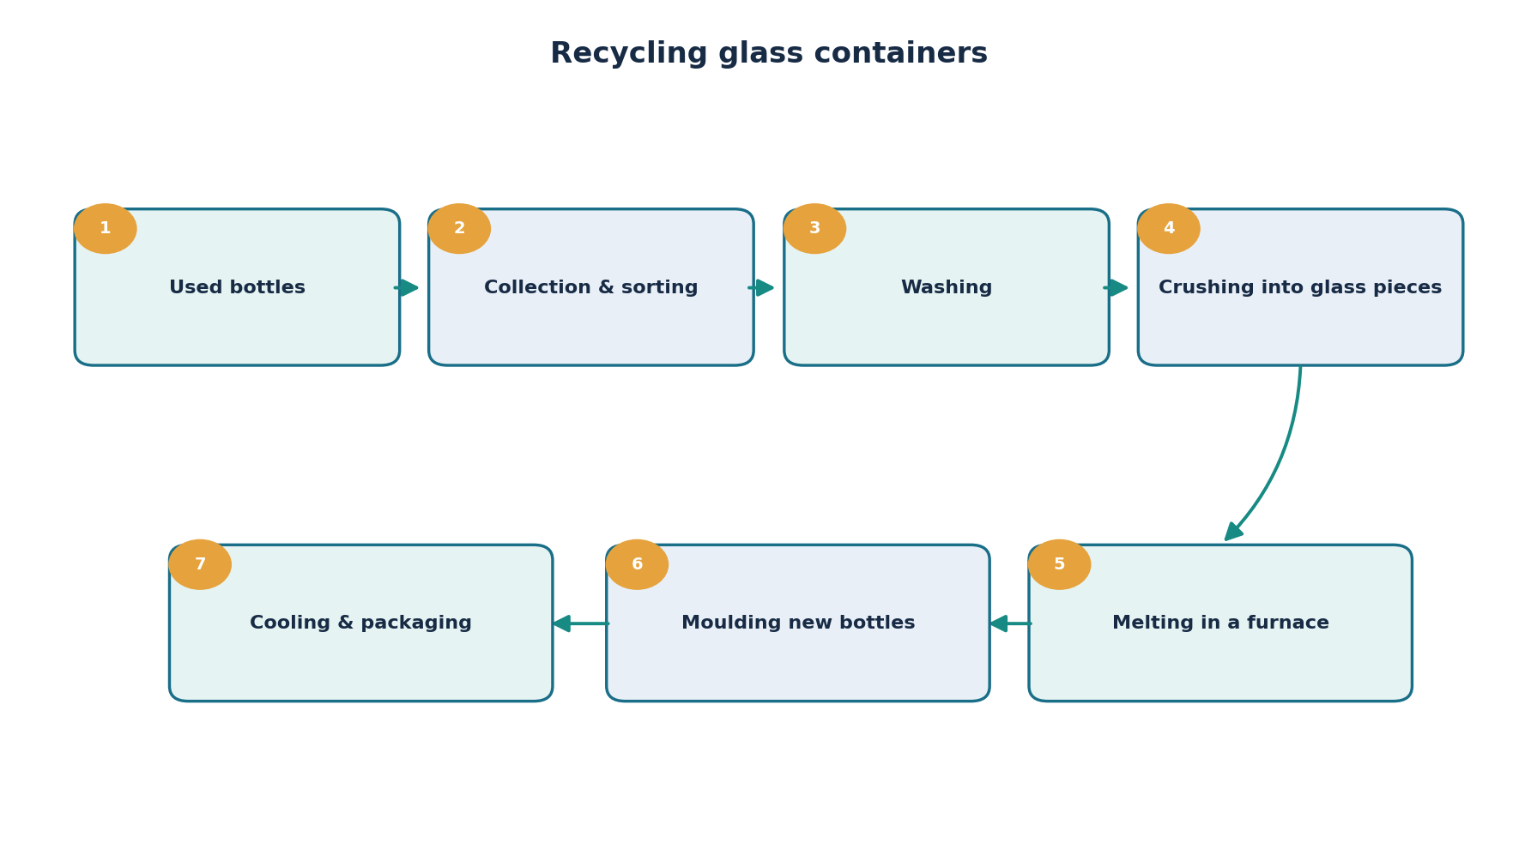

PROCESS DIAGRAM 08/10
Stages of natural or human-made processes

Producing drinking water
ORIGINAL PRACTICE • Illustrative / fictional data (not an official IELTS question)
The process diagram shows how river water is treated to make it suitable for drinking.
Summarise the information by selecting and reporting the main features, and make comparisons where relevant.
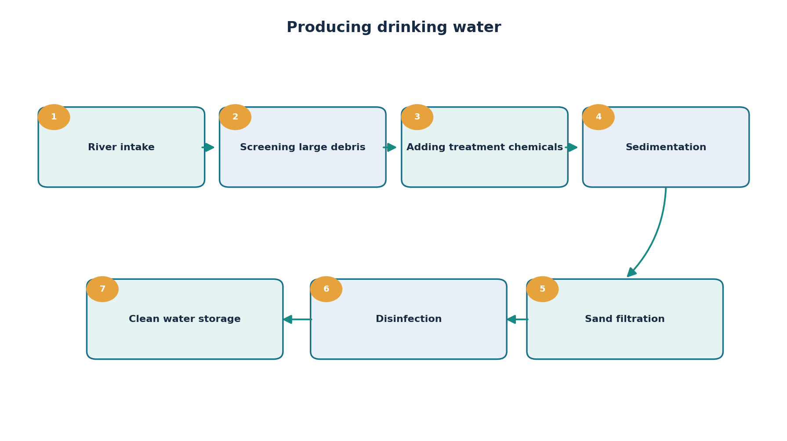

PROCESS DIAGRAM 09/10
Stages of natural or human-made processes

Making bread on an industrial scale
ORIGINAL PRACTICE • Illustrative / fictional data (not an official IELTS question)
The diagram illustrates the stages used to produce bread in a commercial bakery.
Summarise the information by selecting and reporting the main features, and make comparisons where relevant.
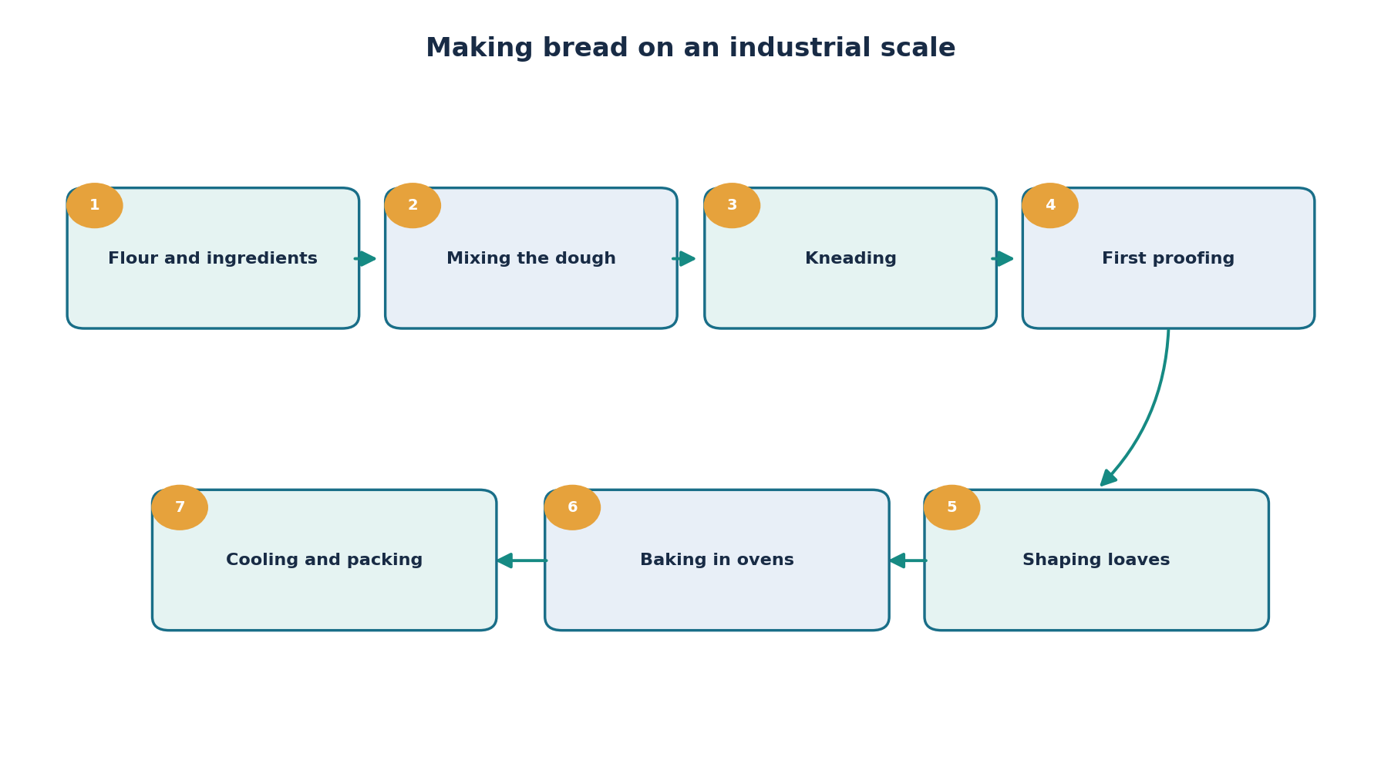

PROCESS DIAGRAM 10/10
Stages of natural or human-made processes

Processing used paper into new products
ORIGINAL PRACTICE • Illustrative / fictional data (not an official IELTS question)
The diagram shows how waste paper is collected and converted into recycled paper products.
Summarise the information by selecting and reporting the main features, and make comparisons where relevant.
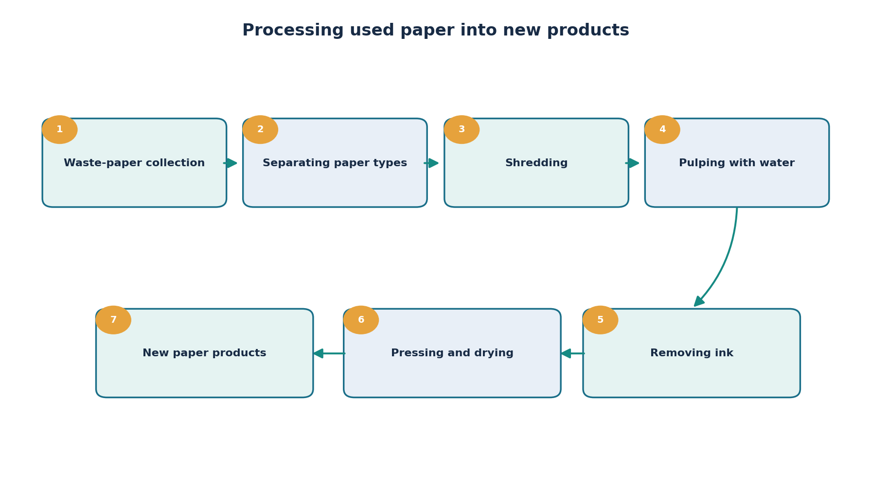

MIXED CHARTS 01/10
Two related visuals presented together

Anthropology graduates: destinations and salaries
CAMBRIDGE ORIGINAL • Cambridge IELTS 15 • Test 4
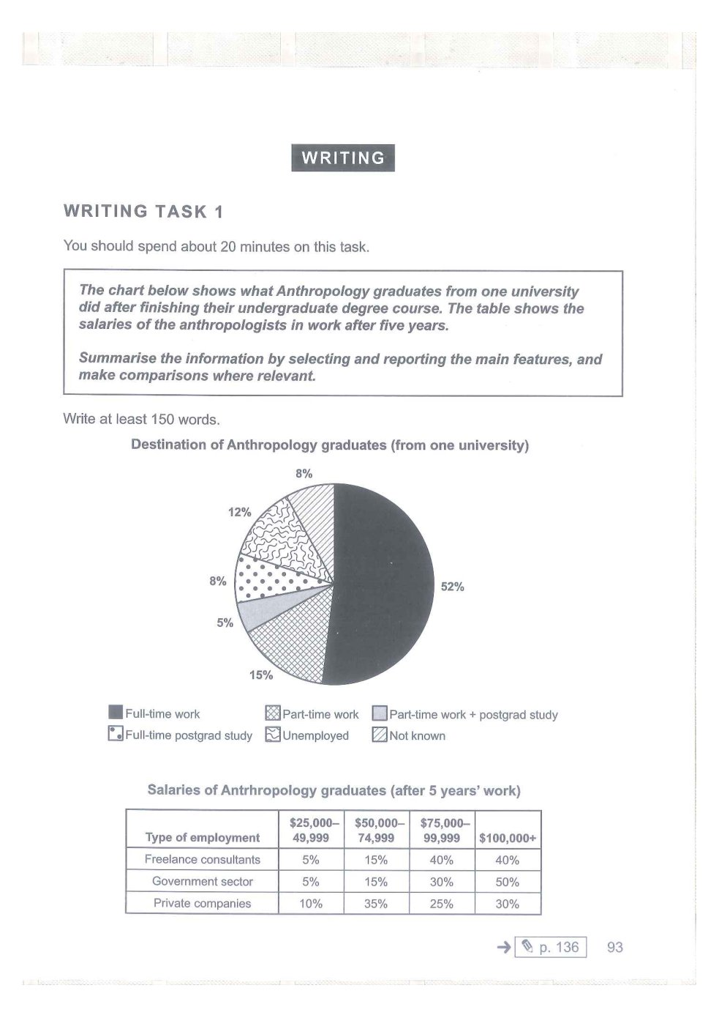

MIXED CHARTS 02/10
Two related visuals presented together

Public budget breakdown
CAMBRIDGE ORIGINAL • Cambridge IELTS 17 • Test 2
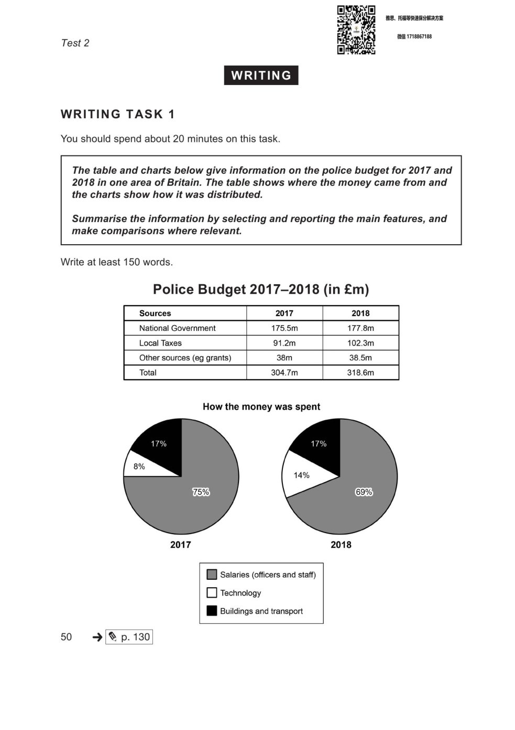

MIXED CHARTS 03/10
Two related visuals presented together

Dance-class attendance and locations
CAMBRIDGE ORIGINAL • Cambridge IELTS 19 • Test 4
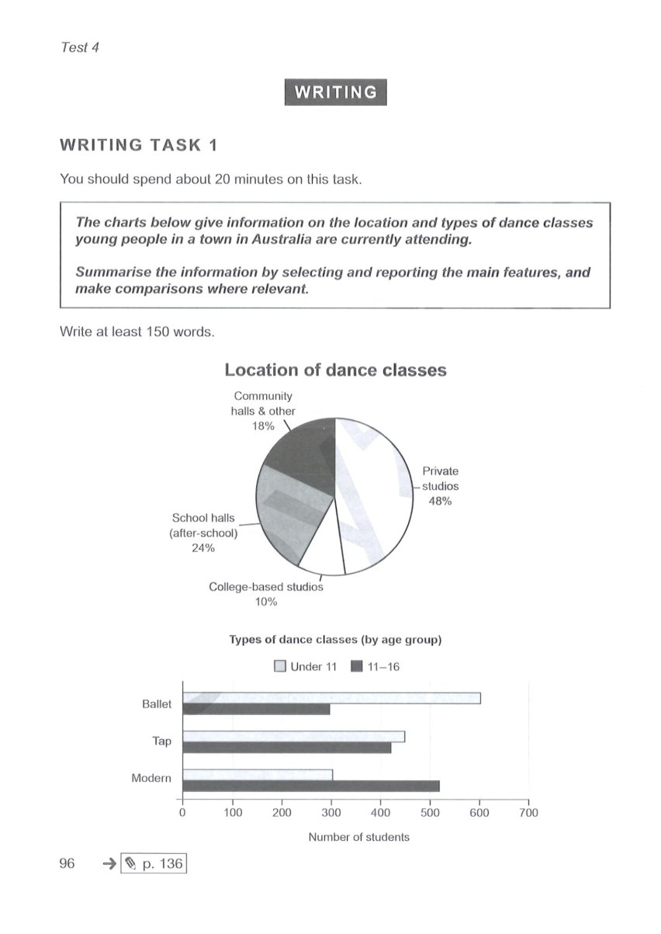

MIXED CHARTS 04/10
Two related visuals presented together

The film industry: markets and figures
CAMBRIDGE ORIGINAL • Cambridge IELTS 21 • Test 4
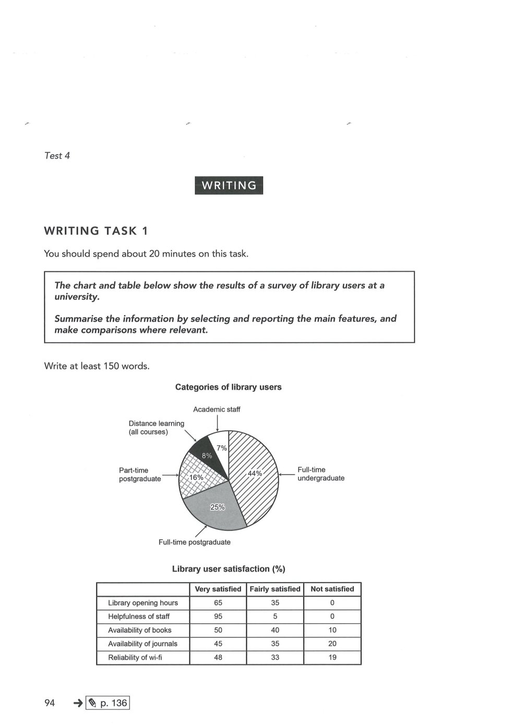

MIXED CHARTS 05/10
Two related visuals presented together

Passenger arrivals and transport modes
ORIGINAL PRACTICE • Illustrative / fictional data (not an official IELTS question)
The line graph shows annual passenger arrivals at a regional airport from 2015 to 2025, while the pie chart shows how passengers travelled from the airport in 2025.
Summarise the information by selecting and reporting the main features, and make comparisons where relevant.
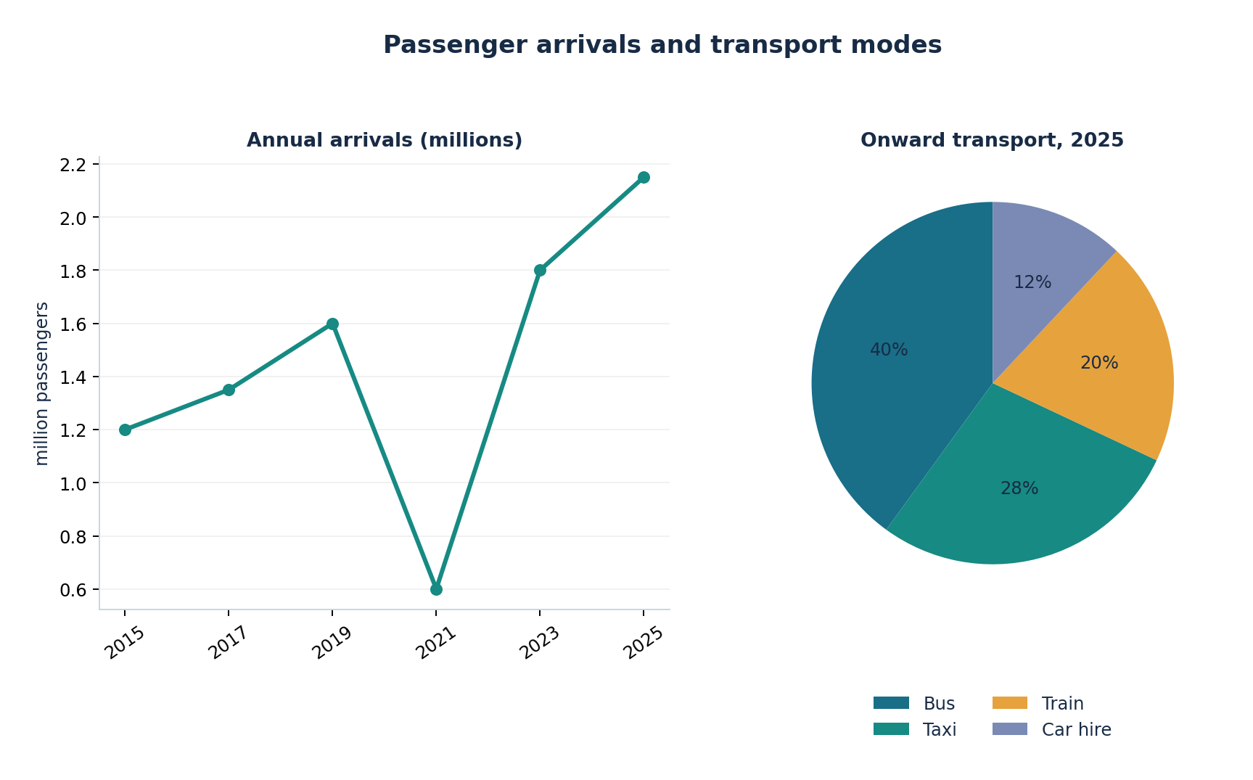

MIXED CHARTS 06/10
Two related visuals presented together

Household energy: use and sources
ORIGINAL PRACTICE • Illustrative / fictional data (not an official IELTS question)
The bar chart compares household energy consumption in four categories in 2010 and 2025, while the pie chart shows energy sources in 2025.
Summarise the information by selecting and reporting the main features, and make comparisons where relevant.
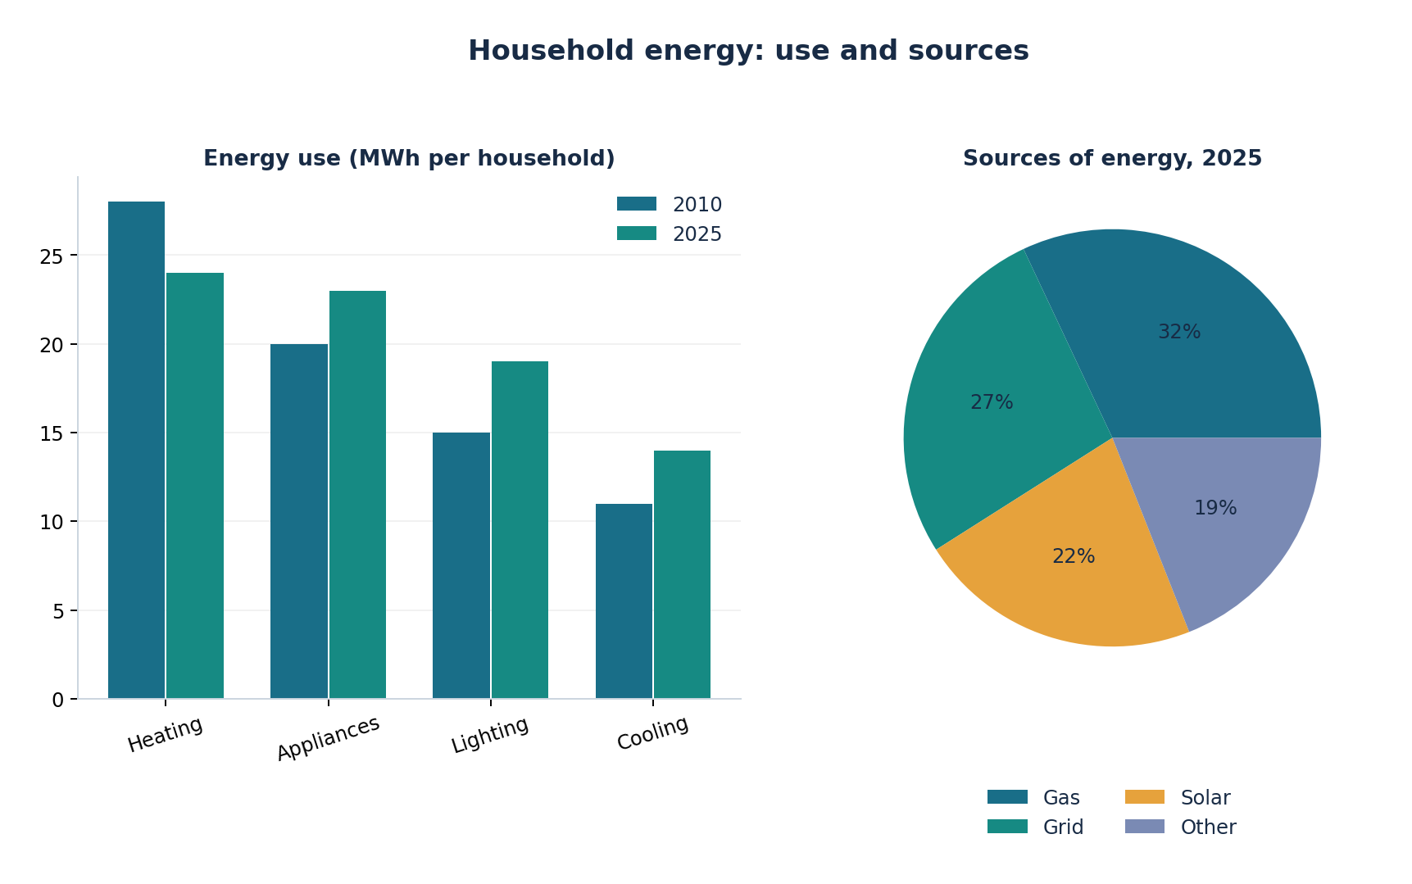

MIXED CHARTS 07/10
Two related visuals presented together

Graduates and employment outcomes
ORIGINAL PRACTICE • Illustrative / fictional data (not an official IELTS question)
The bar chart compares university graduates in four faculties in 2024, and the table shows employment rates six months after graduation.
Summarise the information by selecting and reporting the main features, and make comparisons where relevant.
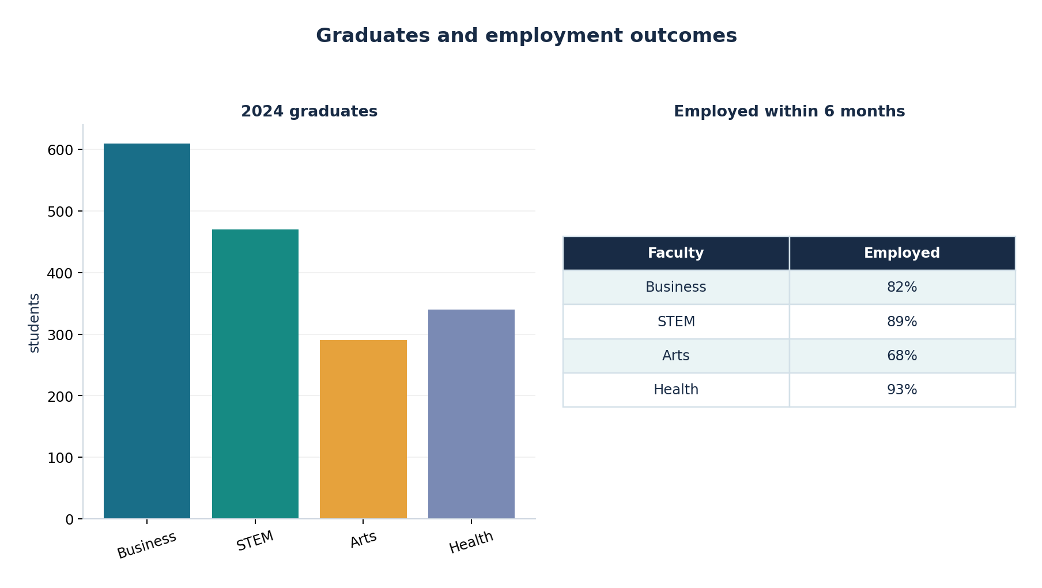

MIXED CHARTS 08/10
Two related visuals presented together

Tourism spending and visitor numbers
ORIGINAL PRACTICE • Illustrative / fictional data (not an official IELTS question)
The line graph shows overseas visitor numbers between 2015 and 2025, while the table presents their average spending per visit.
Summarise the information by selecting and reporting the main features, and make comparisons where relevant.
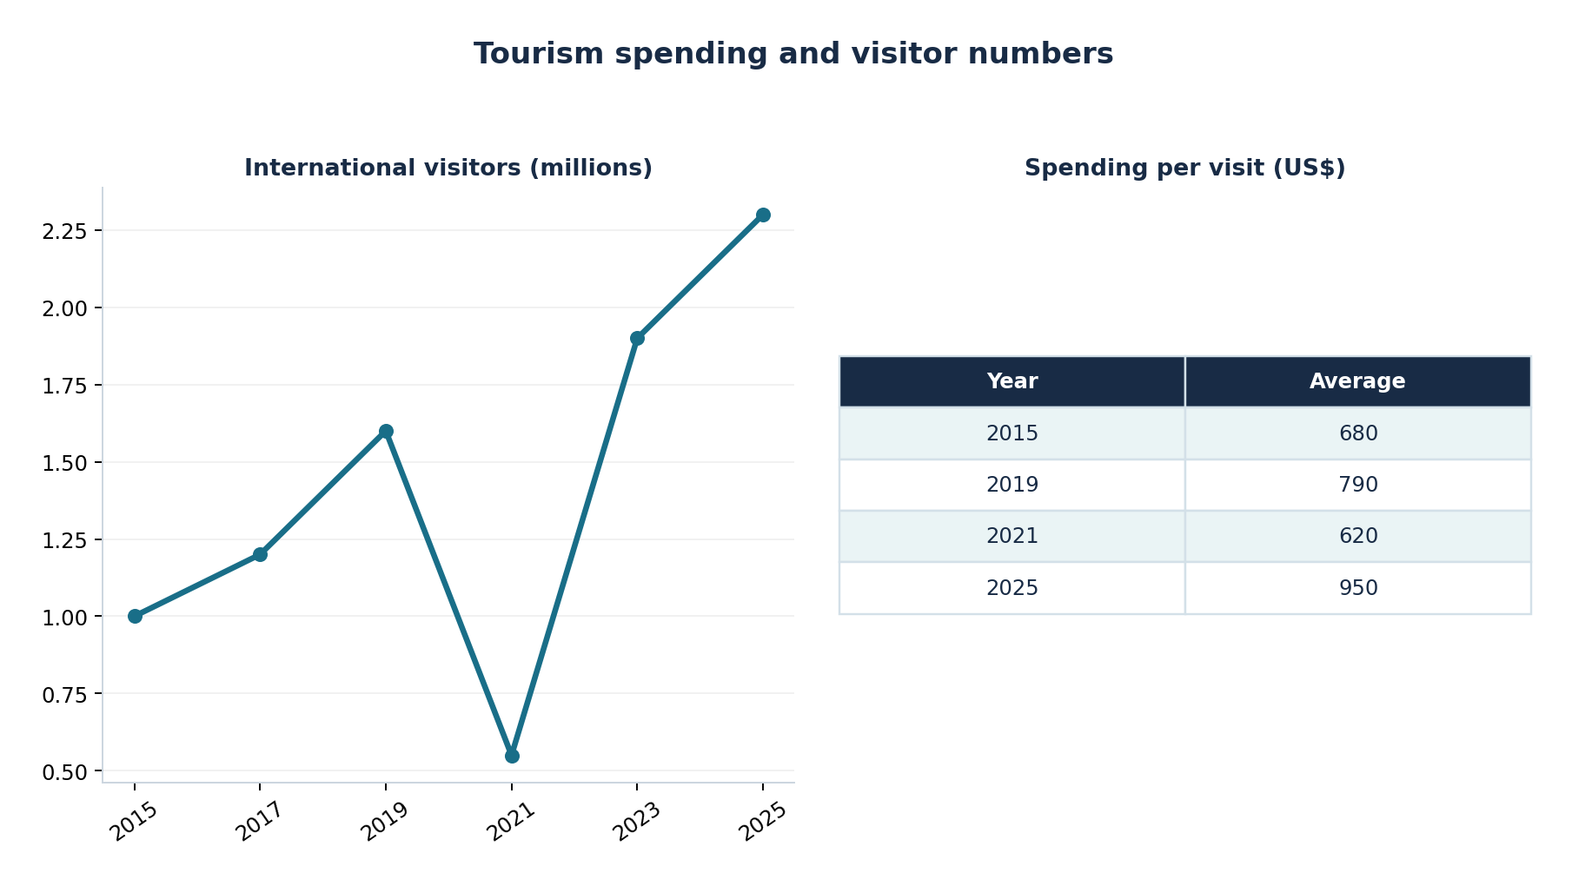

MIXED CHARTS 09/10
Two related visuals presented together

Transport satisfaction and journey time
ORIGINAL PRACTICE • Illustrative / fictional data (not an official IELTS question)
The pie chart shows satisfaction with public transport in 2025, and the bar chart compares typical commute times by mode.
Summarise the information by selecting and reporting the main features, and make comparisons where relevant.
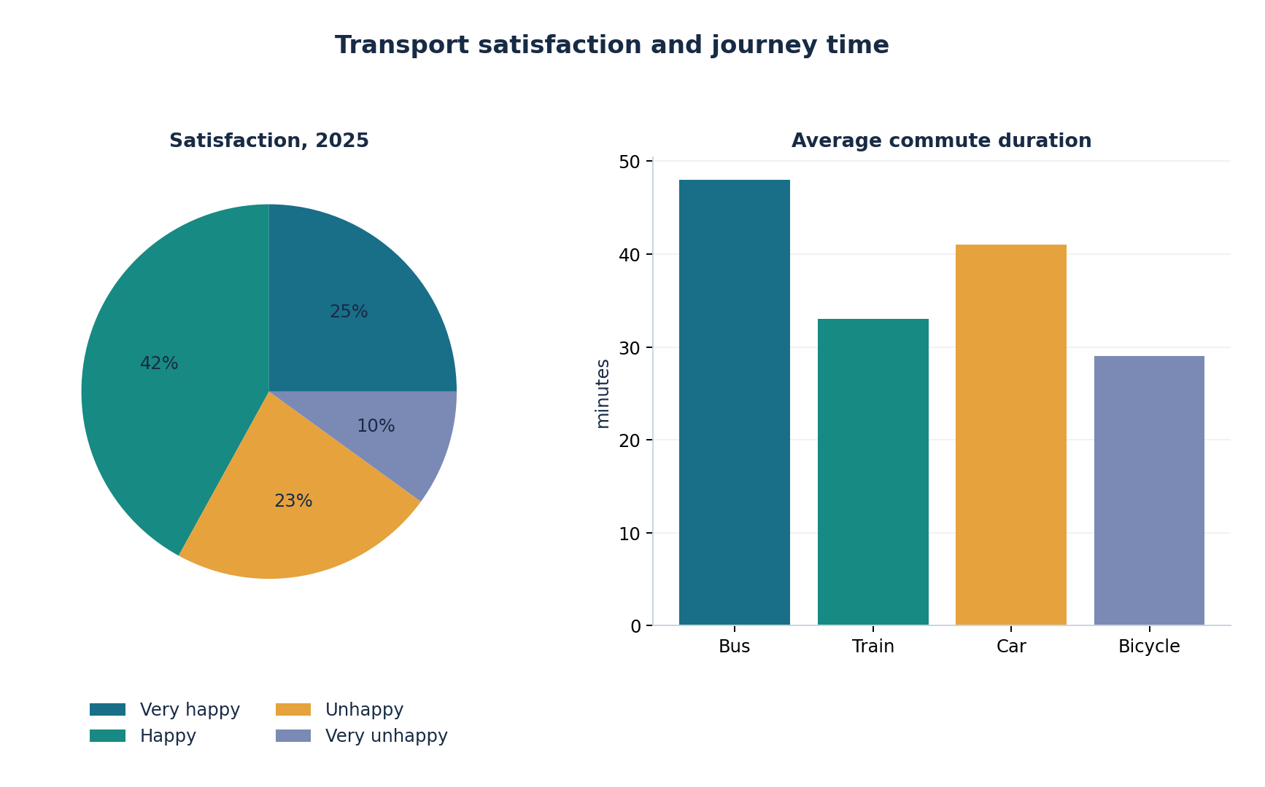

MIXED CHARTS 10/10
Two related visuals presented together

Electric vehicle sales and charging stations
ORIGINAL PRACTICE • Illustrative / fictional data (not an official IELTS question)
The bar chart shows electric-car sales in four regions in 2024, while the line graph displays the number of public charging stations from 2020 to 2025.
Summarise the information by selecting and reporting the main features, and make comparisons where relevant.
