**VIETNAM NATIONAL UNIVERSITY**

**HO CHI MINH CITY UNIVERSITY OF TECHNOLOGY**

**FACULTY OF MECHANICAL ENGINEERING**

 -----❖-----



**PROJECT**

**TRANSMISSION SYSTEM**

Instructor: Prof. Nguyễn Hữu Lộc

Student’s name: Nguyễn Quang Huy ID: 2153385

Huỳnh Lê Hùng ID: 2152605

**PROBLEM 10A: DESIGN OF TRANSMISSION SYSTEMS FOR DRUM DRYING**

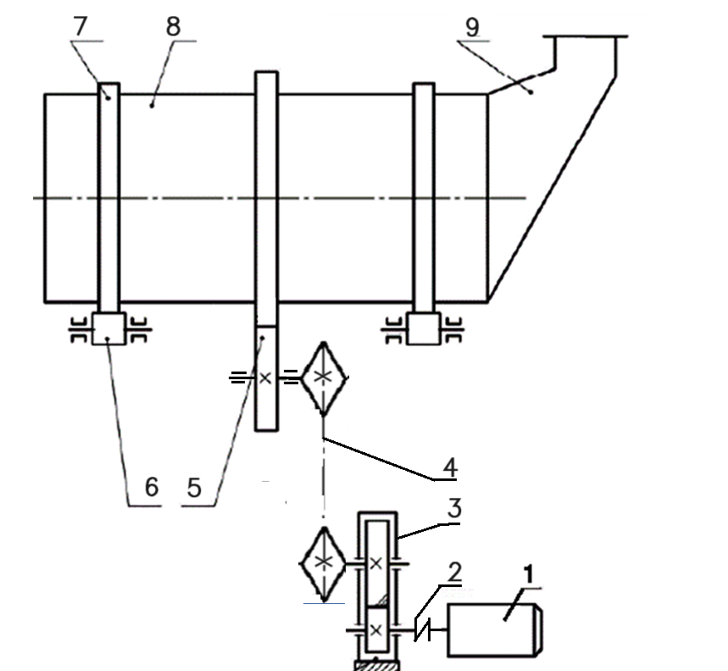

Hệ thống truyền động bao gồm:

1- Động cơ điện; 2- Nối trục đàn hồi; 3- Hộp giảm tốc bánh răng nghiêng 1 cấp; 4- Bộ truyền xích (u = 1); 5- Bộ truyền bánh răng trụ hở; 6, 7 – Con lăn; 8- Thùng sấy; 9- Nạp liệu. Tỉ số truyền cặp bánh răng thùng trôn u = 10.

**Option 6:** Design parameters

|  |  |
| --- | --- |
| Power P (kW) | 2.2 |
| Rotational speed (rpm) | 20 |
| Working hour | 8000h |
| Working shift | 1 |

## **CHAPTER I: MOTOR SELECTION AND TRANSMISSION RATIO DISTRIBUTION**

* 1. **General efficiency of transmission system**

According to table 2.3, we choose the efficiencies of machines elements as follows:

* The efficiency of chain:

ηchain = 0.90

* The efficiency of lubricated gear:

ηgear = 0.97

* The efficiency of open gear:

ηopen gear = 0.94

* The efficiency of rolling-contact bearings:

ηrolling = 0.99

* The efficiency of coupling:

ηcoupling = 0.98

The general efficiency of transmission system:

ηgeneral = ηchain × ηrolling3 × ηgear × ηopen gear × ηcoupling

ηgeneral = 0.90 × 0.993 × 0.97 × 0.94 × 0.98 = 0.78

* 1. **Required power of motor**
* Working power of system:

P = 2.2 kW

* Rotational speed of drum drying:

n = 20 rpm

* Required power of motor:

* 1. **Motor selection and transmission ratio**

According to the calculated required power, we choose the standard motor power as 3.0 kW. With that standard motor power, we have the following options to choose our motor as well as its rotational speed and transmission ratio.

|  |  |  |  |  |  |
| --- | --- | --- | --- | --- | --- |
|  | Rotational speed (rpm) | General transmission usys | Chain uch | Spur gear u12 | Open gear u34 |
| Motor 1 | 2870 | 143.5 | 1.79 | 8 | 10 |
| **Motor 2** | **1420** | **71** | **1.13** | **6.3** | **10** |
| Motor 3 | 970 | 48.5 | 0.97 | 5 | 10 |
| Motor 4 | 715 | 35.75 | 0.89 | 4 | 10 |

**Table 1.1: Motor selection and transmission system**

Based on table Motor SGA (Company CMG, Australia). We chose Motor 2 with a rotational speed of 1420 rpm.

* 1. **Parameters of transmission system**

Power P on shaft

Pmotor = 2.82 kW

(satisfied)

Rotational speed on shafts:

Torque on shafts:

* 1. **End of chapter**

We have the following table of parameters of the transmission system:

**Table 1.2: Parameters of transmission system**

|  |  |  |  |  |  |  |  |  |
| --- | --- | --- | --- | --- | --- | --- | --- | --- |
| Parameters | Shaft | | | | | | | |
| Motor | I | | II | | III | | Working |
| Power P (kW) | 2.82 | 2.763 | | 2.653 | | 2.364 | | 2.2 |
| Ration u | 1 | | 6.3 | | 1.13 | | 10 | |
| Rotational speed (rpm) | 1420 | 1420 | | 225.4 | | 199.47 | | 19.95 |
| Torque T (Nm) | 18.965 | 18.582 | | 112.405 | | 113.181 | | 1053.133 |

Where:

* Motor Shaft: connecting the motor to the coupling
* Shaft I: connecting the coupling to the single stage helical gear reducer
* Shaft II: connecting the single stage helical gear reducer to the Chain.
* Shaft III: connecting the Chain to the open gear drive.
* Working Shaft: connecting the open gear drive to the drying drum.

## **CHAPTER II. DESIGN AND SELECT FOR CHAIN**

**2.1 Parameters calculated from 1:**

Input parameters: = 3.966 kW, = 120 rpm, u = 2.54

**2.2 Preliminary selection of the number of teeth**

Number of teeth for driving sprocket:

Number of teeth for driven sprocket:

**2.3 Condition factor K calculation**

Where:

1 - The using the electric power and load out of the effect up the drives: calm

1 - Factor taking into account the influence of center distance a = (30÷50)pc

1 - Factor taking into account the effect of drive chain arrangement

1 - Adjustable sprocket shaft

1.5 - Factor taking into account the effect of lubrication, in the case of drip lubrication

1.12 - Duty factor, when working 1 shift

From here infer:

**2.4 Power calculation**

We have:

Where:

Substitute the factors and values into the formula we get:

**2.5 Select chain pitch**

According to table 5.4 from file Chapter 5 Chain Drive, respectively and rotational speed we select with

**2.6 Checking chain pitch calculation**

Where: is chosen from table 5.3 in file Chapter 5 Chain Drive.

is satisfied

**2.7 Center distance a**

Choose

**2.8 The number of links**

The number of links is determined by the formula:

Choose X = 124

**2.9 The chain length**

**2.10 Determine the force on each shaft:**

Initial belt tension:

[] 1.5 MPa for V-Belt

Tension per belt:

Useful force:

Useful force per belt:

Force acting on shaft:

**2.11 Stress in belt drive and service life**

Maximum belt stress in belt drive:

Service life:

**2.12 Summary**

|  |  |  |
| --- | --- | --- |
| V-Belt type B | | Unit |
| *Small pulley diameter d1* | 160 | mm |
| *Big pulley diameter d2* | 355 | mm |
| *Center distance a* | 587.43 | mm |
| *Belt length L* | 2000 | mm |
| *Contact angle α1* | 161.1 | degree |
| *Number of the belts z* | 2 |  |
| *Initial tension Fo* | 414 | N |
| *Tangential force Ft* | 518.66 | N |
| *Shaft load Fr* | 816.76 | N |
| *Service life* | 8000 | hours |

## **CHAPTER III. DESIGN OF GEAR DRIVE**

### 3.1 Single stage helical reducer

#### 3.1.1 Calculation on reducer shafts

Power of the driving wheel: PI = 2.763 kW

Power of the driven wheel: PII = 2.653 kW

Helical gear ratio: u = 6.3

Number of revolutions of driving wheel: nI = 1420 rpm

Number of revolutions of driven wheel: nII = 225.4 rpm

Torque on driving wheel: TI = 18.582 Nm

Torque on driven wheel: TII = 112.405 Nm

#### 3.1.2 Select the driving and driven gear material

*Following the Table 6.13 Contact and Bending Endurance Limits and :*

Driving gear: choose C45 with hardness HB1 = 255 HB, heat treatment is

normalization, structural improvement.

Driven gear: choose C45 with hardness HB2 followed by formula H1 ≥ H2 +

(10 – 15) HB, so HB2 = 228 HB, heat treatment is normalization, structural

improvement.

#### 3.1.3 Determine the allowable contact stress [] and bending stress []

Contact fatigue limit

+ For driving gear:

= 2HB1 + 70 = 2260 + 70 = 580 MPa

+ For driving gear:

= 2HB2 + 70 = 2228 + 70 = 526 MPa

Safety factor

= = 1.1

Base number of cycle NHO

=30HB12.4 = 302552.4 = 17.9 106

=30HB22.4 = 302282.4 = 13.68 106

== 5 106

Service life of the transmission system

LH = 8000 hours

The equivalent number of cycles if the gear is working with working load and

number of revolution n is constant:

= = 60cn1LH = 60 1 1420 = 681.6 106

= = 60cn2LH = 60 1 225.4 = 108.19 106

Life coefficient

KHL = and KFL =

Because: NHE1 > NHO1; NHE2 > NHO2 so = = 1

and NFE1 > NFO1; NFE2 > NFO2 so = = 1

Allowable contact stress for the driving gear and driven gear

🡪 With helical spur gear, we have:

= 453 MPa

Satisfied []min [] 1.25[]min with []min = []

Bending endurance limit

= 1.8HB

= 1.8HB1 = 1.8 255 = 459 MPa

= 1.8HB2 = 1.8 228 = 410.4 MPa

Safety factor: SF = 1.75

Factor of the two-way rotation on fatigue strength: KFC = 1 when one-way rotation.

Allowable bending stress

[] = = 459 = 262.286 MPa

[] = = 410.4 = 234.514 MPa

Allowable bending stress when overload

[]max = 0.8 = 646 MPa

[]max = 0.8 = 360 MPa

Allowable contact stress when overload:

[]max = 2.8 = 1260 Mpa

#### 3.1.4 Select the gear width factor according to the standard:

According to table 6.15, we have

According to table 6.4 Factors

#### 3.1.5 The center distance :

Center distance :

According to the standard series we choose

#### 3.1.6 The module m according to the center distance aw

mn = (0,01 ÷ 0,02)aw = (0,01 ÷ 0,02)100 = 1 ÷ 2 mm

We choose mn = 2 mm

#### 3.1.7 Total number of teeth

Because of the helical gear, we have:

We choose z1 = 13 teeth

So number of driving teeth z2 = z1u = z1 6.3 = 82 teeth

Ratio between face width and center distance

= = 0.5

🡪b2 = 50 mm and b1 = b2 + 5 = 55 mm

Tooth inclination angle

#### 3.1.8 Recalculate the gear speed ratio u

u = = = 6.308

#### 3.1.9 Geometry parameters of gear drive

Parameter of the pitch circle

* Driving gear: d1 = = = 27.37 mm
* Driven gear: d2 = = = 172.63 mm

Outside diameter

* Driving gear: da1 = d1 + 2mn = 27.37 + 22 = 31.37 mm
* Driven gear: da2 = d2 + 2mn = 172.63 + 22 = 176.63 mm

Root diameter

* Driving gear: df1 = d1 – 2.5mn = 27.37 - 2.5 2 = 22.37 mm
* Driven gear: df2 = d2 – 2.5mn = 172.63 - 2.5 2 = 167.63 mm

#### 3.1.10 Peripheral speed v and the angle of helical gear

According to table 6.3 we choose grade of accuracy 9 with vgh = 6 m/s

#### 3.1.11 The value of the forces acting on gear mesh

Peripheral force

Axial force

Radial force

The normal force

#### 3.1.12 Dynamic load factor

According to table 6.6 Factors and , we choose

and

According to table 6.11 Factors , we choose

(because )

#### 3.1.13 Checking stress

Contact stress

With

For helical gear we have

= 453 MPa

Where:

(because both driving and driven gear are C45 steel)

As so the gear has enough contact strength

Equivalent gear teeth

Bending stress

[] = 262.286 MPa

[] = 234.514 Mpa

Where:

As so the gear has enough bending strength

### 3.2 Open gear drive

#### 3.2.1 Calculations of transmission in gear drive

Power of the driving wheel: PIII = 2.364 kW

Power of the driven wheel (drying drum): PWorking = 2.2 kW

Straight spur gear ratio u = 10

Number of revolutions of driving wheel: nIII = 199.47 rpm

Number of revolutions of driven wheel: ndrum = 19.95 rpm

Torque on driving wheel TIII = 113.181 Nm

Torque on driven wheel Tdrum = 1053.133 Nm

#### 3.2.2 Select the driving and driven gear material

*Following the Table 6.13 Contact and Bending Endurance Limits and :*

Driving gear: choose C45 with hardness HB3 = 195 HB, heat treatment is

normalization, structural improvement.

Driven gear: choose C45 with hardness HB4 followed by formula H3 ≥ H4 +

(10 – 15) HB, so HB4 = 180 HB, heat treatment is normalization, structural

improvement.

#### 3.2.3 Determine the allowable contact stress [] bending stress []

Contact fatigue limit

+ For driving gear:

= 2HB3 + 70 = 2195 + 70 = 460 MPa

+ For driving gear:

= 2HB4 + 70 = 2180 + 70 = 430 MPa

Safety factor

= = 1.1

Base number of cycle NHO

=30HB32.4 = 302002.4 = 9.402 106

=30HB42.4 = 301802.4 = 7.758 106

== 5 106

Service life of the transmission system

LH = 8000 hours

The equivalent number of cycles if the gear is working with working load and

number of revolution n is constant:

= = 60cn3LH = 60 1 199.47 = 95.75 106

= = 60cn4LH = 60 1 19.95 = 9.58 106

Life coefficient

KHL = and KFL =

Because: NHE3 > NHO3; : NHE4 > NHO4; NFE3 > NFO3; NFE4 > NFO4

so and

Allowable contact stress for the driving gear and driven gear

With straight spur gear, we have:

Bending endurance limit

= 1.8HB

= 1.8HB = 1.8 195 = 351 MPa

= 1.8HB = 1.8 180 = 324 MPa

Safety factor: SF = 1.75

Factor of the two-way rotation on fatigue strength: KFC = 1 when one-way rotation.

Allowable bending stress

[] = = 351 = 200.571 MPa

[] = = 324 = 185.143 MPa

#### 3.2.4 Total number of teeth

Choose the number of teeth of driving gear

Therefore,

#### 3.2.5 Calculating factor:

+ For driving gear:

+ For driven gear:

#### 3.2.6 Select the gear width factor according to the standard:

According to table 6.16, we have

According to table 6.4 Factors

#### 3.2.7 The module m according to the bending stress []

As standard, we choose m = 3 mm

#### 3.2.8 Geometry parameters of gear drive:

Parameter of the pitch circle

* Driving gear:
* Driven gear:

Outside diameter

* Driving gear:
* Driven gear:

Root diameter

* Driving gear:
* Driven gear:

The center distance

Face width

* Driven gear:
* Driving gear:

#### 3.2.9 Peripheral speed v:

v= = = 0.627 m/s

According to table 6.3 we choose grade of accuracy 9 with vgh = 3 m/s

#### 3.2.10 The value of the forces acting on gear mesh

Peripheral force

Radial force

The normal force



#### 3.2.11 Dynamic load factor

According to table 6.5 Factors and , we choose

and

#### 3.2.12 Checking bending stress

#### 3.3 Summary

|  |  |  |  |
| --- | --- | --- | --- |
|  | Parameter | | Value |
| Single stage helical reducer | The pitch diameter | Driving wheel |  |
| Driven wheel |  |
| The root diameter | Driving wheel |  |
| Driven wheel |  |
| The pitch outside diameter | Driving wheel |  |
| Driven wheel |  |
| Number of teeth | Driving wheel | 13 |
| Driven wheel | 82 |
| Open gear drive | The pitch diameter | Driving wheel |  |
| Driven wheel |  |
| The root diameter | Driving wheel |  |
| Driven wheel |  |
| The pitch outside diameter | Driving wheel |  |
| Driven wheel |  |
| Number of teeth | Driving wheel | 20 |
| Driven wheel | 200 |

## **CHAPTER IV. CALCULATE AND DESIGN THE SHAFT**

**4.1 Choose material and allowable stresses:**

We choose the same material with the gear C45 for the shaft I with hardness , heat treatment is normalization, structural improvement with the allowable stress and the allowable torsion:

We choose the same material with the gear C45 for the shaft II with hardness , heat treatment is normalization, structural improvement with the allowable stress and the allowable torsion:

Preliminary choosing allowable torsional stress for shaft 1, 3 and for shaft 2

Select preliminary diameter of shaft I:

Select preliminary diameter of shaft II:

Select preliminary diameter of shaft II:

**4.2 Select the length of shaft I:**

- Select preliminary diameter of shaft I: .

- Select the smallest diameter of shaft I at the position of the belt with .

- The preliminary diameter at the bearing:

- The preliminary diameter at the oil seal ring:

- The preliminary diameter at the gear:

-

-

**4.3 Calculate the reaction forces acting on shaft I:**

**SHAFT I**

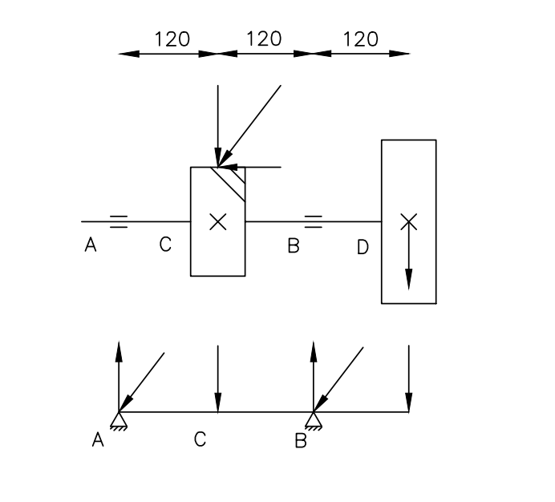 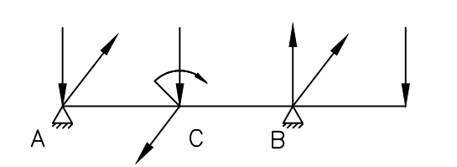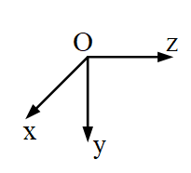

Frb

Frb

Fa1

Fr1

Ft1

Ft1

Fr1

RAy

RBy

RBx

RAx

Ma1

Moment caused by axial force:

The torque acting on the shaft:

The moment equilibrium equation in y-z plane at location A:

The force equilibrium equation on y axis is:

The moment equilibrium equation in x-z plane at location A:

The force equilibrium equation on x axis is:

**4.4 Diagram of bending moment and torque diagram of shaft I:** 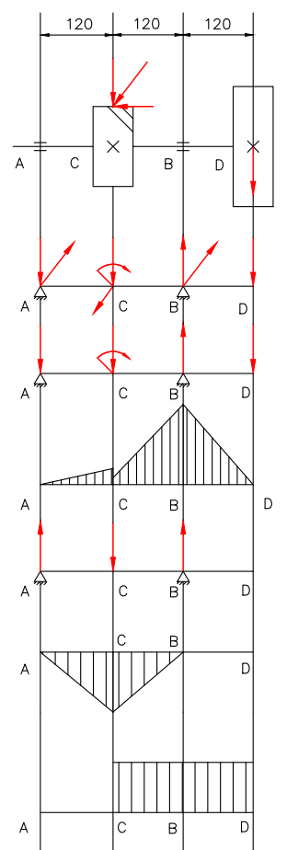

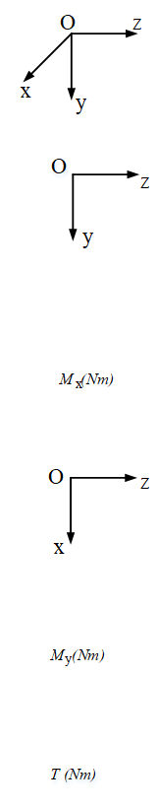

Fa1

Fr1

Ft1

Frb

RAy

RAx

Frb

RBy

RBx

Fr1

Ma1



Ft1

RBy

Fr1

RAy

Frb

Ma1

98.01

Mx (Nm)

20.03

6.06

Ft1

RBx

RAx

My (Nm)

48.7

82.329

T (Nm)

According to moment distribution diagram, the most critical position is section B:

Shaft I is made of Normalized 45-steel ⇒ Allowable bending stress [𝜎] = 85 𝑀𝑃a

Shaft diameter at section B is determined:

According to the standard we can choose d = 45 mm

Calculation for static strength:

Equivalent moment at C, D:

Shaft diameter at section C is determined:

Because at position C there is a keyway, the 5% increase is 23.08 mm, and according to the standard we can choose d = 55 mm.

Shaft diameter at section D is determined:

Because at position D there is a keyway, the 5% increase is 21.47 mm, and according to the standard we can choose d = 36 mm.

**4.5 Calculations and design preliminary parameter for the shaft II**

- Select preliminary diameter of shaft II: .

- The preliminary diameter at the bearing: .

- The preliminary diameter at the oil seal ring:

- The preliminary diameter at the helical gear:

- The preliminary diameter at the straight spur gear:

-

-

**4.6 Calculate the reaction forces acting on shaft II:**

**Shaft II**

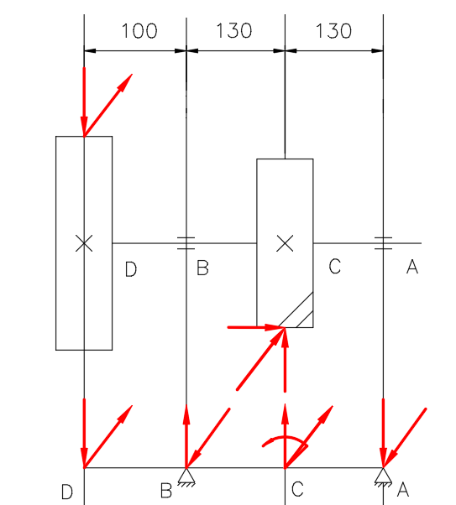

Fr2

Ft2

Fa2

Ft3

Fr3

Fr3

Ft3

RBy

RBx

RAy

RAx

Fr2

Ft2

Ma2

Moment caused by axial force:

The torque acting on the shaft:

The moment equilibrium equation in y-z plane at location A:

The force equilibrium equation on y axis is:

The moment equilibrium equation in x-z plane at location A:

The force equilibrium equation on x axis is:

**4.7 Diagram of bending moment and torque diagram of shaft II:**

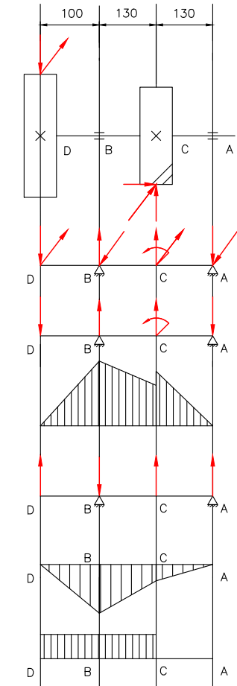

Mx (Nm)

My (Nm)

T (Nm)

Fr3

Ft3

Fr2

Ft2

Fa2

Fr3

Ft3

RBy

RBx

RAy

RAx

Fr2

Ft2

Ma2

Fr3

RBy

RAy

Fr2

Ma2

Ft3

RBx

RAx

Ft2

89.785

246.681

83.87

48.95

70.58

197.345

According to moment distribution diagram, the most critical position is section B:

Shaft II is made of Normalized 45-steel ⇒ Allowable bending stress [𝜎] = 70 𝑀𝑃a

Shaft diameter at section B is determined:

According to the standard we can choose d = 50 mm

Calculation for static strength:

Equivalent moment at C, D:

Shaft diameter at section D is determined:

Because at position D there is a keyway, the 5% increase is 30.649 mm, and according to the standard we can choose d = 45 mm

Shaft diameter at section C is determined:

Because at position C there is a keyway, the 5% increase is 32.46 mm, and according to the standard we can choose d = 60 mm

**4.8 Calculations and design preliminary parameter for the shaft III**

- Select preliminary diameter of shaft III: .

- The preliminary diameter at the chain:

- The preliminary diameter at the bearing: .

- The preliminary diameter at the oil seal ring:

- The preliminary diameter at the straight spur gear:

-

-

**4.6 Calculate the reaction forces acting on shaft II:**

**Shaft II**

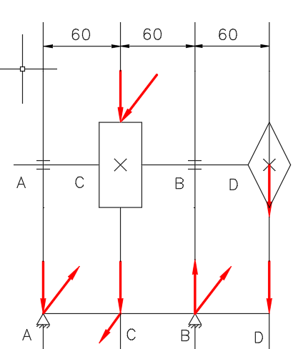

Fx

Fx

Ft3

RBx

RBy

Fr3

RAx

RAy

Fr3

Ft3

The torque acting on the shaft:

The moment equilibrium equation in y-z plane at location A:

The force equilibrium equation on y axis is:

The moment equilibrium equation in x-z plane at location A:

The force equilibrium equation on x axis is:

**4.7 Diagram of bending moment and torque diagram of shaft II:**

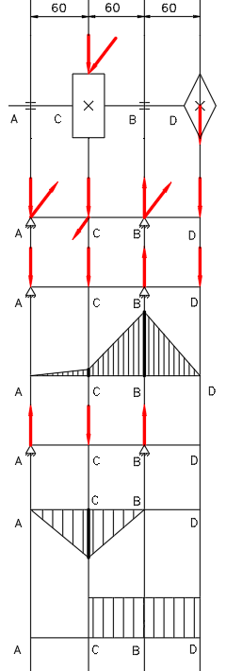

113.181

T (Nm)

My (Nm)

Mx (Nm)

6.176

113.181

FAx

RBx

Ft3

Fr3

RAy

Fx

Fx

Fx

94.74

RBy

RBx

RAx

RAy

Fr3

Ft3

RBy

Ft3

Fr3

According to moment distribution diagram, the most critical position is section C:

Shaft III is made of Normalized C45-steel, Allowable bending stress [𝜎] = 70 𝑀𝑃a

Shaft diameter at section C is determined:

Because at position D there is a keyway, the 5% increase is 29.335 mm, and according to the standard we can choose d = 40 mm

Calculation for static strength:

Equivalent moment at B, D:

Shaft diameter at section D is determined:

Because at position D there is a keyway, the 5% increase is 25.464 mm, and according to the standard we can choose d = 30 mm

Shaft diameter at section B is determined:

According to the standard we can choose d = 35 mm

**4.8 Summary the diameter:**

**Shaft I**

|  |  |  |  |  |
| --- | --- | --- | --- | --- |
|  | A (Bearing) | B (Bearing) | C (gear) | D (belt) |
| d(mm) | 45 | 45 | 55 | 36 |

**Shaft II**

|  |  |  |  |  |
| --- | --- | --- | --- | --- |
|  | A (Bearing) | B (Bearing) | C (Helical gear) | D (Straight spur gear) |
| d(mm) | 50 | 50 | 60 | 45 |

**Shaft III**

|  |  |  |  |  |
| --- | --- | --- | --- | --- |
|  | A (Bearing) | B (Bearing) | C (Straight spur gear) | D (Chain) |
| d(mm) | 35 | 35 | 40 | 30 |

**4.9 Choose the Preliminary key for the shaft:**

- We choose the same material with the gear C45, heat treatment is normalization, structural improvement.

- For the shaft I, we have the key at the position of the belt and the gear with the diameter of each part:

- We choose the key at the belt with the standard parameter:

- We choose the key at the gear with the same width at the belt:

- Calculation with the crushing condition for the key at the gear:

With:

+ : the working length of the key.

+ : the depth of the keyway.

+ : the tangential force acting on the shaft.

+ Allowable volume stress (based on table 9.5 in the reference [1], the key is C45 and the system is static load).

- Calculation:

- At the belt:

- At the gear:

With:

+ : the working length of the key.

+ : the width of the key.

+ : the tangential force at the gear.

+ : the tangential force at the belt.

+ Allowable shear stress (the key is C45 and the system is static load.).

- For the shaft II, we have the key at the position of the helical gear and the straight spur gear with the diameter of each part:

- We choose the key at the straight spur gear with the standard parameter:

- We choose the key at the helical gear with the same width at the straight spur gear:

- Calculation with the crushing condition for the key at the helical gear in the reducer:

With:

+ : the working length of the key.

+ : the depth of the keyway.

+ : the tangential force acting on the shaft.

+ Allowable volume stress (the key is C45 and the system is static load).

- Calculation:

- At the straight spur gear:

- At the helical gear:

With:

+ : the working length of the key.

+ : the width of the key.

+ : the tangential force at the straight spur gear.

+: the tangential force at the helical gear.

+ Allowable shear stress (the key is C45 and the system is static load.).

**4.10 Checking the shaft according to the safety factor:**

- Calculation for static strength for the shaft I:

(satisfied)

- Calculation for static strength for the shaft II:

(satisfied)

**-** Calculation for the fatigue strength and the equivalent stress when overload:

- With

- Where:

+ For shaft I:

+

+ For shaft II:

+

+ *:* based on the figure 2.11 - Giáo trình Cơ sở thiết kế máy:

.

+ : based on table 10.4 - Giáo trình Cơ sở thiết kế máy:

*+*

*+ ,* Based on table 10.8 - Giáo trình Cơ sở thiết kế máy:

**Calculate**

On shaft I:

On shaft II:

On shaft I:

On shaft II:

**Calculate**

On shaft I:

On shaft II:

**Calculate**

On shaft I:

On shaft II:

On shaft I:

On shaft II:

On shaft I:

On shaft II:

On shaft I:

On shaft II:

**Calculate**

On shaft I:

On shaft II:

**Table For Summary**

**Shaft I:**

|  |  |  |  |  |
| --- | --- | --- | --- | --- |
|  | A | B | C | D |
|  |  |  |  |  |
|  |  |  |  |  |
|  |  | 10.96 |  | 0 |
|  |  |  |  |  |
|  | **⎯** |  |  | **⎯** |
|  | **⎯** |  |  |  |
|  | **⎯** |  |  | **⎯** |

Shaft I satisfied the fatigue strength condition and flexural rigidity

**Shaft II:**

|  |  |  |  |  |
| --- | --- | --- | --- | --- |
|  | A | B | C | D |
|  |  |  |  |  |
|  |  |  |  |  |
|  |  | 21.39 |  | 0 |
|  |  |  |  |  |
|  | **⎯** |  |  | **⎯** |
|  | **⎯** |  |  |  |
|  | **⎯** |  |  | **⎯** |

Shaft II satisfied the fatigue strength condition and flexural rigidity

**4.11 Check the equivalent stress when overload**

+ For the shaft I:

+ For the shaft II:

On shaft I:

On shaft II:

|  |  |  |  |  |
| --- | --- | --- | --- | --- |
| Shaft |  |  |  |  |
| I | A | 0 | 0 | 0 |
| B |  |  |  |
| C |  |  |  |
| D | 0 |  |  |
| II | A | 0 |  | 0 |
| B | 21.39 | 4.02 | 22.5 |
| C |  |  |  |
| D | 0 |  |  |

Shaft I and II satisfied the condition.

## **CHAPTER V. CALCULATE AND DESIGN THE BEARING**

**5.1 Calculations and design the bearing in shaft I**

**Shaft I**

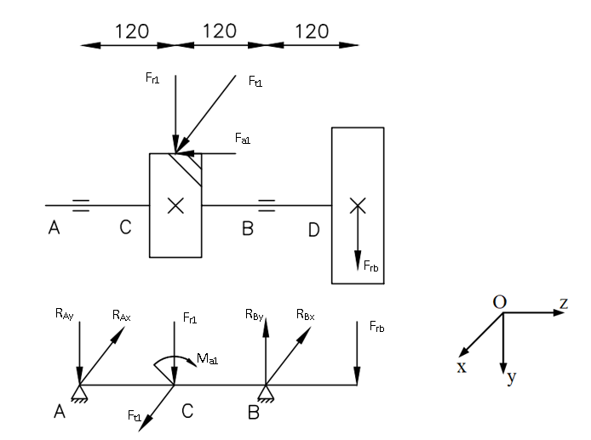

- Number of revolutions on shaft I:

- The preliminary diameter at the bearing:

- Service life of the transmission system:

- Axial force:

- The centrifugal force acting on the bearing at A and B:

Due to so we chose

This satisfies the condition that deep groove ball bearing is suggested:

Select single row deep groove ball bearing bearings

Based on **Schedule 9.1** in reference [55] we have:

|  |  |  |  |  |  |  |
| --- | --- | --- | --- | --- | --- | --- |
|  |  |  |  |  |  |  |
|  |  |  |  |  |  |  |

So

Based on the table 11.3 - Giáo trình Cơ sở thiết kế máy,

With

We calculate the load at B with the formula:

Where:

+: Coefficient of load specificity

+: Coefficient of temperature

+: Coefficient of which ring rotate, V=1 if internal ring rotate

- Longevity of bearing in million rounds:

- The dynamic load sustainability:

With: : Grade of bending line for ball bearing.

=> The condition is satisfied

- Re-calculate the longevity of bearing:

- Service life of the bearing:

- Test for static load:

and

Where:

: Static notational load.

: Allowable static notational load..

: Coefficient of centripetal load (based on table 11.6 - Giáo trình Cơ sở thiết kế máy).

: Coefficient of axial load (based on table 11.6 - Giáo trình Cơ sở thiết kế máy).

Because so condition is satisfied.

- Limited number of revolutions of bearing:

Where:: Center diameter of rollers,

: Number of revolutions

Based on Table 11.7 - Giáo trình Cơ sở thiết kế máy, we have:

with deep groove ball bearing lubricated with grease.

Because , condition is satisfied.

**5.2 Calculations and design the bearing in shaft II**

**Shaft II**

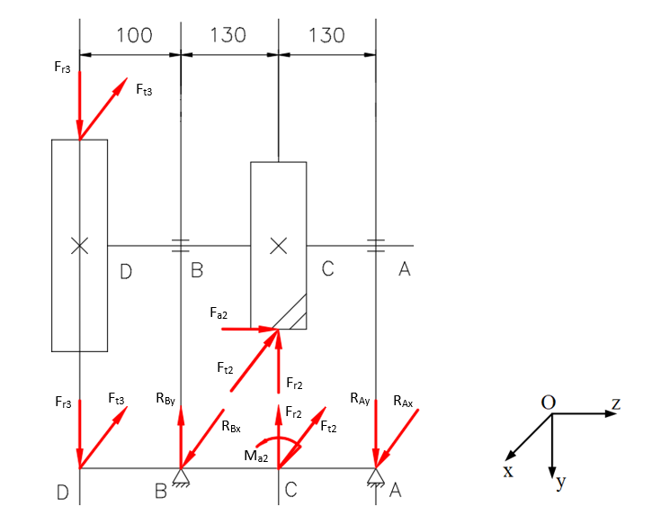

- Number of revolutions on shaft I:

- The preliminary diameter at the bearing:

- Service life of the transmission system:

- Axial force:

- The centrifugal force acting on the bearing at A and B:

Due to so we chose

This satisfies the condition that deep groove ball bearing is suggested:

Select single row deep deep groove ball bearing

Based on **Schedule 9.1** in reference [55] we have:

|  |  |  |  |  |  |  |
| --- | --- | --- | --- | --- | --- | --- |
|  |  |  |  |  |  |  |
|  |  |  |  |  |  |  |

So

Based on the table 11.3 - Giáo trình Cơ sở thiết kế máy,

With

We calculate the load at B with the formula:

Where:

+: Coefficient of load specificity

+: Coefficient of temperature

+: Coefficient of which ring rotate, V=1 if internal ring rotate

- Longevity of bearing in million rounds:

- The dynamic load sustainability:

With: : Grade of bending line for ball bearing.

=> The condition is satisfied

- Re-calculate the longevity of bearing:

- Service life of the bearing:

- Test for static load:

and

Where:

: Static notational load.

: Allowable static notational load..

: Coefficient of centripetal load (based on table 11.6 - Giáo trình Cơ sở thiết kế máy).

: Coefficient of axial load (based on table 11.6 - Giáo trình Cơ sở thiết kế máy).

Because so condition is satisfied.

- Limited number of revolutions of bearing:

Where:: Center diameter of rollers,

: Number of revolutions

Based on Table 11.7 - Giáo trình Cơ sở thiết kế máy, we have:

with deep groove ball bearing lubricated with grease.

Because , condition is satisfied.

**5.3 Summary**

Bearings in shaft I:

|  |  |  |  |  |  |  |
| --- | --- | --- | --- | --- | --- | --- |
|  |  |  |  |  |  |  |
|  |  |  |  |  |  |  |

Bearings in shaft II:

|  |  |  |  |  |  |  |
| --- | --- | --- | --- | --- | --- | --- |
|  |  |  |  |  |  |  |
|  |  |  |  |  |  |  |

## **CHAPTER VI. LUBRICATION METHOD**

The contact stress on the gear:

The peripheral speed v:

The hardness of the gear:

We have the formula:

Base on the graph 13.9 Cơ sở thiết kế máy - Nguyễn Hữu Lộc

Base on the table 13.1, we choose ISO VG 2

# CASE STUDY 2: SCREW JOINT

**Exercise 8:** A horizontal bar subjected to loads F, N is held tightly by a group of 6 bolts and arranged as shown in Figure 8. Use bolt joints with gaps. Bolts have strength class 3.6. Let's define:

a) Analyze and determine the force acting on each bolt.

b) Diameter d1 and choose bolt.

c) Select bolts in case of using bolt joints without gaps.

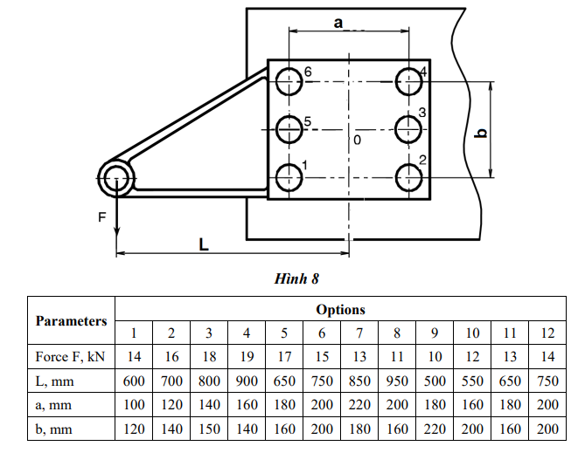

Figure 8



**Option 7:**

* Force F (kN): F = 13 (kN) = 13000 (N)
* L (mm) = 850 (mm)
* a (mm) = 220 (mm)
* b (mm) = 180 (mm)

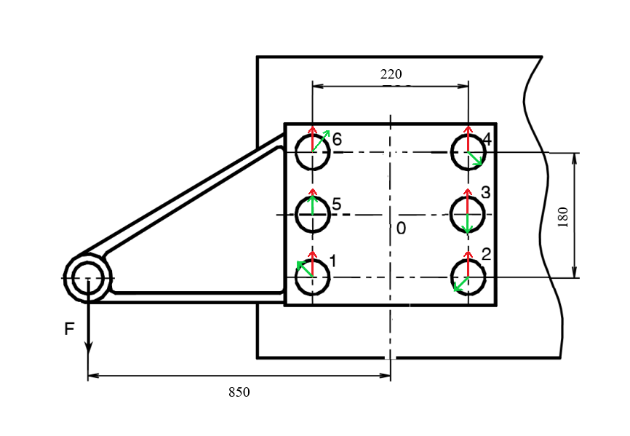

Note: FM

FF

1. **Analyze and determine the force acting on each bolt.**

First, we specify the center of gravity of the support with 8 bolts. The center of gravity of the bolt group is the intersection 0 of two centerline.

Moving force F to center of gravity 0, we have force F passing through the center of gravity and moment M:

Due to the acting of force F, bolts 1-6 the same force FFi:

Since the distances from the centers of bolts 1, 2, 4, 6 to the center of gravity 0 are equal, the force caused by the moment M at the bolts has the same value:

Since the distances from the centers of bolts 3, 5 to the center of gravity 0 are equal, the force caused by the moment M at the bolts has the same value:

Where:

From the formula of the sum of the force:

Therefore, the load acting on bolt 1 is the largest:

**The tightening force (the required screwing up force) V:**

If a bolted joint with a clearance with a factor of safety k = 1.3 and a coefficient of friction f = 0.18 is used, then

1. **Determine the diameter d1 and choose the bolt.**

The bolts have strength class 3.6 so that

* The yield strength
* The allowable tensile stress = 90 MPa

Where [s] = 2 based on table 17.6 (assume that the diameter of the bolts is from )

The diameter d1 of the bolt is :

Select bolt M56 has d1 = 50.046 mm

1. **Select bolts in case of using bolt joints without gaps.**

The bolt diameter due to the use of a gapless bolt joint is determined by the formula:

where (Based on table 17.5)

From here:

By standard, we select M20, d1 = 17.249 mm

**Exercices 9** Calculate the bolt holding the metal support on the wall as shown in Figure 9.1. The force F acts at an angle ↑ with the horizontal. Static weight (constant). Bolt material has strength grade 5.6. Request:

a) Analyze and determine the force acting on each bolt.

b) Determine the required screwing up force V

c) Diameter d1 and choose the bolt.

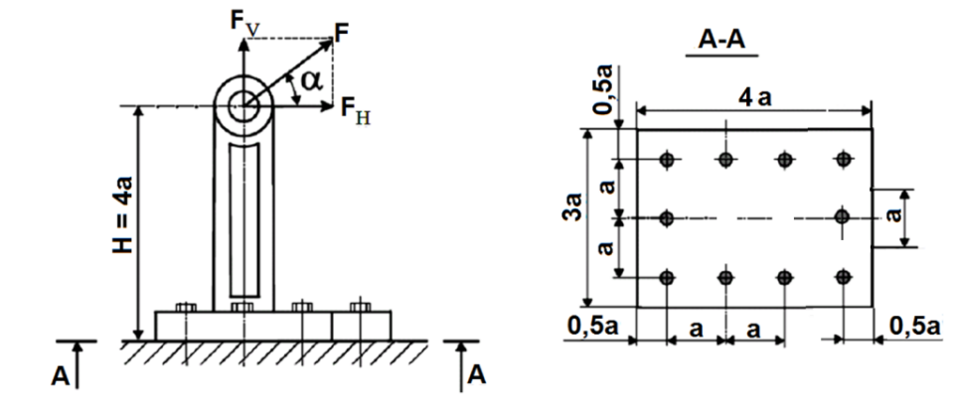Figure 9.1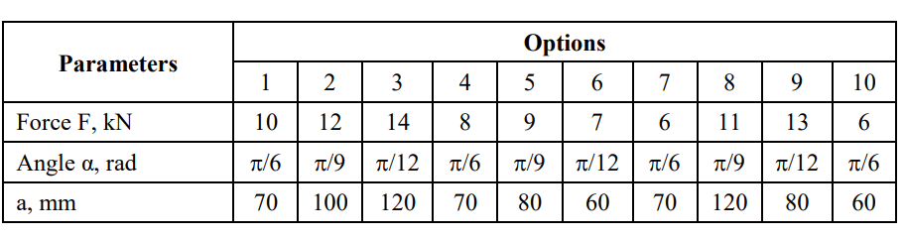

**Option 4:**

* Force F (kN): F = 8 (kN) = 8000 (N)
* Angle (rad) = /6 (rad)
* a (mm) = 70 (mm)

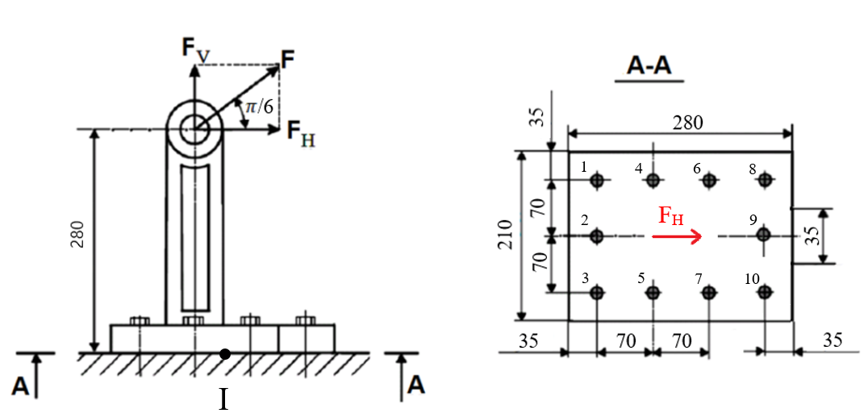

Figure 9.2

1. **Analyze and determine the force acting on each bolt.**

Hypothesis 1: The bolts are tightened, the joint surface rotates around the axis passing through center of gravity I (Figure 9.2)

1) The force F is classified into two components: FV perpendicular to the joint surface and FH parallel to the joint surface. Moving the force F to the center of gravity I of the joint, we have the component of the bolt axial force:

the force lies in the joint surface:

and overturning moment:

1. **Determine the required screwing up force V.**

2) We determine the tightening force V so that the joint surface is not split open:

We choose k = 1.5 - factor of safety;

z = 10 - number of screws;

- bolt axial external load;;

- j;

is the elastic section modulus of the area of the joint

3) Bolt tightening force so that the joint surface does not slip V2

4) Equivalent calculated load and bolt diameter

Comparing the two values V1 and V2, we choose the screwing up force (tightening force V1 = ) so that the joint surface is not split open.

1. **Determine the diameter d1 and choose the bolt.**

5) Load acting on the bolt due to the overturning moment component M:

6) Equivalent calculated load:

7) Bolt diameter:

The bolts have strength class 5.6 so that

* The yield strength
* The allowable tensile stress = 100 MPa

Where [s] = 3 based on table 17.6 (assume that the diameter of the bolts is from )

8) By standard, we select bolt M12 with diameter d1 = 10.106 mm

9) Crushing stress in the joint surface:

Therefore, if the crossbar is made of steel, the crushing strength condition is satisfied. Crushing strength is also satisfactory even when the crossbar is made of wood or concrete materials.