

SWP391 PROJECT REPORT
Software Requirement Specification
Group 5

– Hanoi, Aug 2026 –
Table of Contents
Change Log 4
Definition and Acronyms 5
I. Overall Requirements 5
1. Context Diagram 5
2. Main Business Flow 5
2.1 Candidate Self-Service (BF-01) 5
2.2 End-to-End Recruitment (BF-02) 5
2.3 Business Flow Name (Code) 6
3. Conceptual Data Model 6
3.1 Entity Relationship Diagram 6
3.2 Entity Descriptions 7
3.3 Data Business Rules 8
4. User Requirements 8
4.1 Actors 8
4.2 Use Cases (UC) 9
4.3 Use Case Diagrams 9
4.4 Permission Matrix 10
5. System Functionalities 10
5.1 Screen Inventory 11
5.2 External API Inventory 11
5.3 Background Job Inventory 11
II. Functional Requirements 11
1. Feature Name1 12
1.1 SubFeature Name1.1 12
1.2 SubFeature Name1.2 12
2. User Authentication 12
2.1 User Register 12
2.2 User Login 12
3. System Administration 12
3.1 System Settings 12
3.2 User Management 13
4. Feature NameN 14
5. Background Job Inventory 14
5.1 Unlock Expired Locked Accounts (JOB-01) 14
5.2 Clean Up Old Audit Log Entries (JOB-02) 14
6. External API Inventory 15
6.1 HTTP Method: URL pattern (API-ID) 15
6.2 VnPay Webhook (API-02) 15
6.3 SePay Webhook (API-03) 15
III. Requirement Appendix 15
1. Business Rules 15
2. System Messages 16
3. Other Requirements 16

Change Log
Date | A*  M, D | In charge | Change Description
10/9 | A | Create context diagram
10/9 | A | Create Entity Relationship Diagram
10/9 | A | Create Business Flow Name
*A - Added M - Modified D - Deleted

I. Overall Requirements

1. Context Diagram
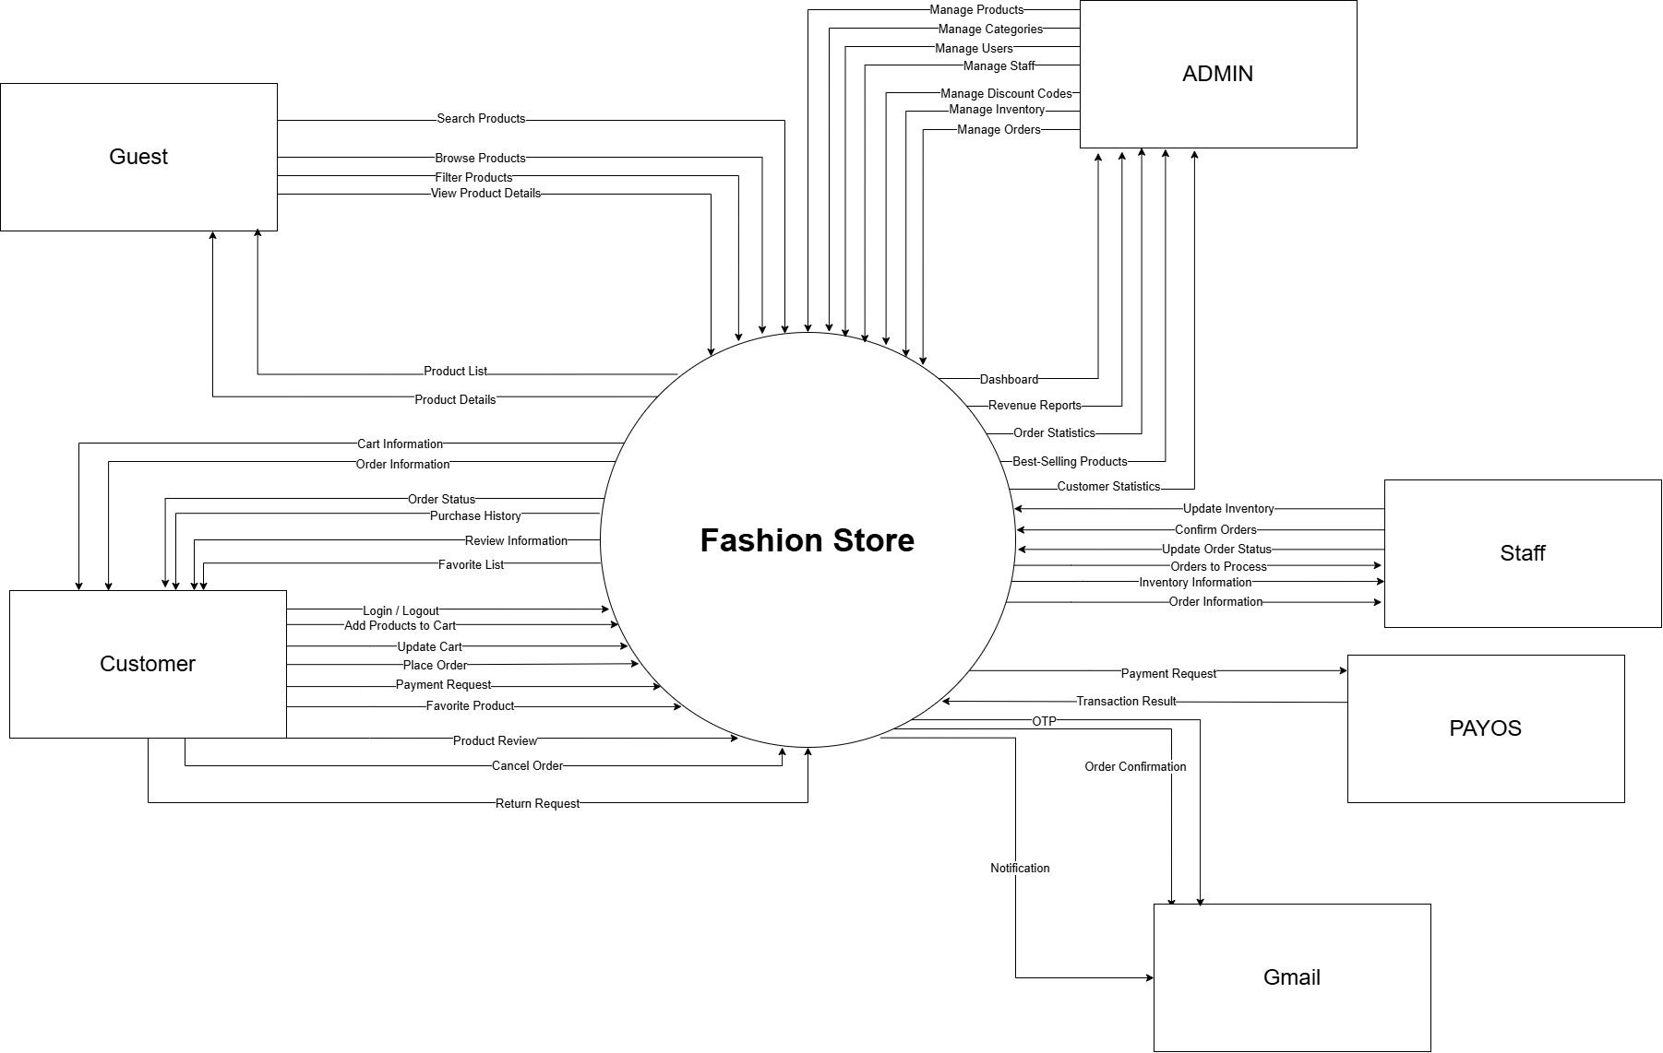

2. Main Business Flow

2.1 Candidate Self-Service (BF-01)
Trigger: Candidate creates an account.
End condition: Candidate has seen the final outcome of all applications.
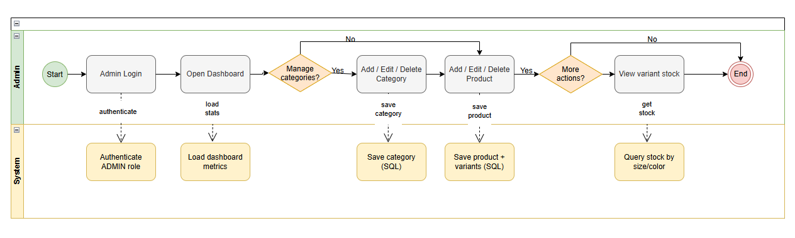
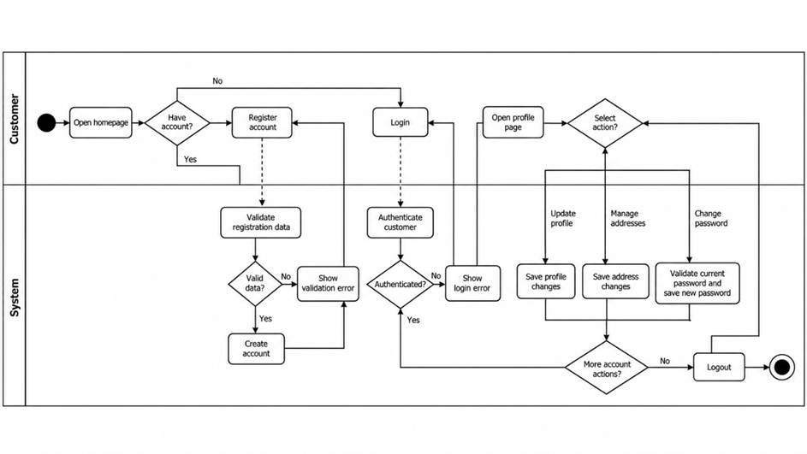
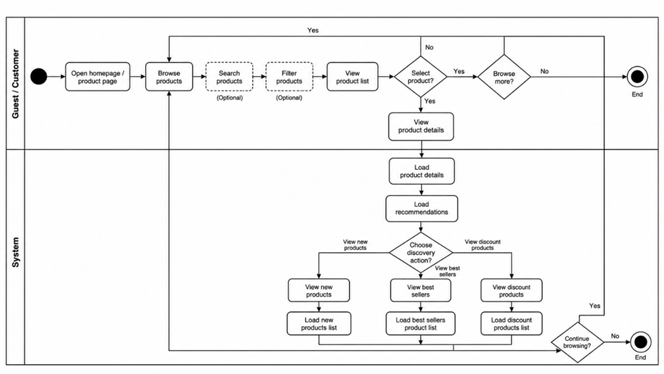
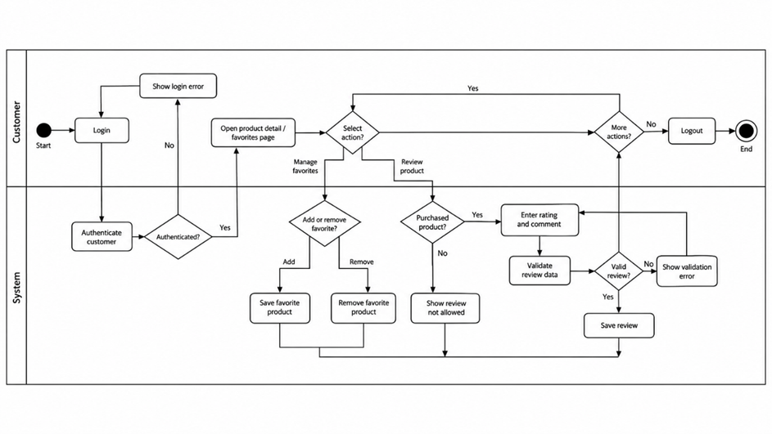

2.2 End-to-End Recruitment (BF-02) Thuấn

2.3 Business Flow Name (Code) đạt
…

3. Conceptual Data Model TRUNG

3.1 Entity Relationship Diagram

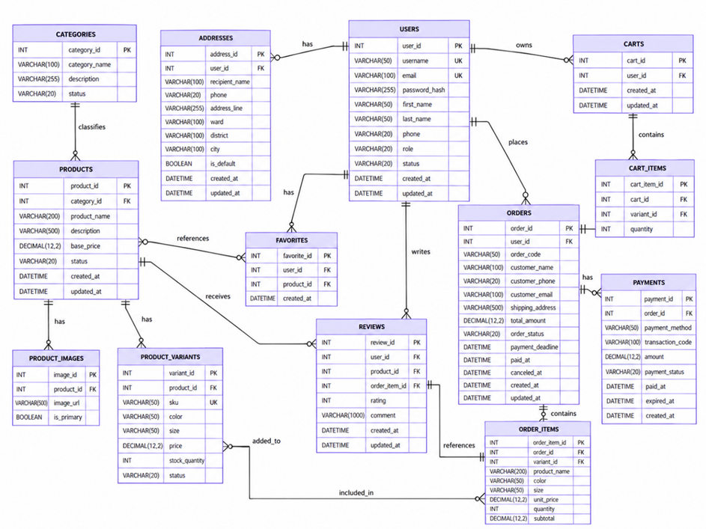

3.2 Entity Descriptions
Entity: User
Field | Value
Purpose | Every person with an account in the system, regardless of role.
Key business attributes | Full name, username, email address, role (Admin / HR Manager / Interviewer / Candidate), account status
Business identity | Username unique across the entire system. Email unique across the entire system.
Status / lifecycle | Active (normal) · Inactive (deactivated by Admin) · Locked (temporary — after repeated failed sign-in attempts)
Entity: Job Posting
Field | Value
Purpose | A job opening created by HR Manager, visible to Candidates when Active.
Key business attributes | Job title, department, location, job description, requirements, salary range (optional), application deadline
Business identity | No natural unique key. Multiple postings with the same title in the same department are permitted.
Status / lifecycle | Draft → Active → Closed (one-way)
Entity: Application
Field | Value
Purpose | A Candidate's expression of interest in a specific Job Posting, with CV attached.
Key business attributes | Which Candidate, which Job Posting, CV file, cover letter (optional), current pipeline stage, submission date
Business identity | A Candidate may submit at most one Application per Job Posting. This combination is unique.
Status / lifecycle | Applied → Screening → Interview → Offer → Hired (terminal) or Rejected (terminal, from any stage); Withdrawn (terminal — Candidate-initiated from Applied or Screening only)
Entities: Internal Note, Interview
[Add one block per additional entity following the same structure.]
Field | Value
Purpose | {{ENTITY_PURPOSE}}
Key business attributes | {{KEY_ATTRIBUTES}}
Business identity | {{BUSINESS_IDENTITY}}
Status / lifecycle | {{STATUS_VALUES}}

Entity: Users

Field | Value
Purpose | Stores registered user accounts and authentication information for customers, staff, and administrators.
Key business attributes | FullName, Email, PasswordHash, Phone, Role, Status, CreatedAt.
Business identity | UserId is the primary key. Email must be unique across all accounts.
Status / lifecycle | Active or Locked. Default status is Active. Roles are Customer, Staff, and Admin.
Review note: Guest is not stored as an account role in the Users table.
Entity: Addresses

Field | Value
Purpose | Stores shipping addresses associated with registered users.
Key business attributes | UserId, RecipientName, Phone, AddressLine, City, IsDefault.
Business identity | AddressId is the primary key. UserId references Users.
Status / lifecycle | An address can be created, updated, deleted, or marked as the default address. No separate status column exists.

Entity: Categories

Field | Value
Purpose | Classifies products into categories and supports hierarchical product organization.
Key business attributes | Name, ParentId, Gender, Season.
Business identity | CategoryId is the primary key. ParentId optionally references another category.
Status / lifecycle | No explicit status column exists in the base schema.

Entity: Products

Field | Value
Purpose | Stores product information used for catalog browsing, new products, best sellers, and discounted products.
Key business attributes | CategoryId, Name, Description, BasePrice, DiscountPrice, ViewCount, SoldCount, CreatedAt, Status.
Business identity | ProductId is the primary key. CategoryId references Categories.
Status / lifecycle | Active or Inactive. Default status is Active.

Review note: CreatedAt, Sold Count và Discount Price là những trường quan trọng để giải thích ba chức năng New Products, Best Sellers và Discount Products. Tuy nhiên, tiêu chí lọc/sắp xếp cụ thể cần được mô tả ở phần Business Rules.

Entity: ProductVariants

Field | Value
Purpose | Represents purchasable variations of a product based on size and color.
Key business attributes | ProductId, Size, Color, StockQuantity, Sku.
Business identity | VariantId is the primary key. Sku must be unique. ProductId references Products.
Status / lifecycle | StockQuantity records available stock. No separate variant status field exists in the base schema.

Entity: ProductImages

Field | Value
Purpose | Stores image references associated with products.
Key business attributes | ProductId, ImageUrl, IsPrimary.
Business identity | ImageId is the primary key. ProductId references Products.
Status / lifecycle | Images may be added or removed. IsPrimary identifies an image intended as the primary image.

Entity: Favorites

Field | Value
Purpose | Stores products saved to a registered user's favorites list.
Key business attributes | UserId, ProductId, CreatedAt.
Business identity | FavoriteId is the primary key. The combination of UserId and ProductId must be unique.
Status / lifecycle | A favorite record is created when a product is saved and deleted when it is removed.
Business Rule: A user cannot save the same product multiple times because of the unique constraint on (UserId, ProductId).
Entity: Reviews

Field | Value
Purpose | Stores customer ratings and comments associated with products and purchased order items.
Key business attributes | UserId, ProductId, OrderItemId, Rating, Comment, CreatedAt.
Business identity | ReviewId is the primary key. UserId, ProductId, and OrderItemId are foreign keys.
Status / lifecycle | A review is created when submitted. The base schema contains no review status or updated-at field.
Business Rules from DB:
- Rating must be between 1 and 5.
- Comment is optional and supports up to 1,000 characters.
- Each review references an existing OrderItem.

Entity: Carts

Field | Value
Purpose | Stores shopping carts belonging to registered users.
Key business attributes | UserId.
Business identity | CartId is the primary key. UserId is unique and references Users.
Status / lifecycle | A cart is associated with a user and can contain multiple cart items.

Entity: CartItems

Field | Value
Purpose | Stores product variants and quantities selected in shopping carts.
Key business attributes | CartId, VariantId, Quantity.
Business identity | CartItemId is the primary key. CartId and VariantId reference their respective entities.
Status / lifecycle | Cart items may be added, have their quantities changed, or be removed.

Entity: Orders

Field | Value
Purpose | Stores customer orders, shipping address references, discount usage, total amount, and order/payment status.
Key business attributes | UserId, AddressId, DiscountCodeId, OrderStatus, PaymentStatus, TotalAmount, CreatedAt.
Business identity | OrderId is the primary key. UserId, AddressId, and optional DiscountCodeId reference related records.
Status / lifecycle | OrderStatus: Pending, Confirmed, Shipping, Delivered, Cancelled, Returned. PaymentStatus: Unpaid, Paid, Refunded.

Entity: OrderItems

Field | Value
Purpose | Stores purchased product variants, quantities, and prices recorded at purchase time.
Key business attributes | OrderId, VariantId, Quantity, PriceAtPurchase.
Business identity | OrderItemId is the primary key. OrderId and VariantId are foreign keys.
Status / lifecycle | Order items are associated with an order. No independent status field exists in the base schema.

Entity: DiscountCodes

Field | Value
Purpose | Defines discount codes that may be applied to eligible orders.
Key business attributes | Code, DiscountType, Value, MinOrderValue, StartDate, EndDate, UsageLimit, CreatedBy.
Business identity | DiscountCodeId is the primary key. Code must be unique. .
Status / lifecycle | The base schema supports percent and fixed discount types, optional validity dates, and usage limits. No separate status column exists.

Entity: Users

Field | Value
Purpose | Stores registered user accounts and authentication information for customers, staff, and administrators.
Key business attributes | FullName, Email, PasswordHash, Phone, Role, Status, CreatedAt.
Business identity | UserId is the primary key. Email must be unique across all accounts.
Status / lifecycle | The base schema supports percent and fixed discount types, optional validity dates, and usage limits. No separate status column exists.

3.3 Data Business Rules
Rule | Description | Enforced On
Unique email | No two user accounts may share the same email address. | Account registration and email updates
Role-based access | Users may only access functions permitted by their assigned roles: Customer, Staff, or Admin. | Authentication and authorization
Password security | User passwords must be stored securely using password hashing rather than plain text. | Account registration and password updates
Profile ownership | Users may only view and update their own personal information unless explicitly authorized. | Profile management
Address ownership | Each shipping address must belong to a registered user. Users may only manage their own addresses. | Address management
One default address | Each user may have at most one default shipping address at a time. | Address creation and updates
Active products only | Only eligible active products may appear in public product listings. | Home Page and product listings
New product ordering | New products are displayed according to their creation dates, with recently added products appearing first. | New Products
Best-selling products | Best-selling products are ranked according to recorded sales information. | Best Sellers
Valid product discounts | A discounted product must have a valid discounted price that is lower than its original price. | Discount Products
Unique favorites | A customer may save a particular product to their favorites list only once. | Favorite management
Favorite ownership | Customers may only view and modify their own favorite lists. | Favorite management
Valid ratings | Product ratings must be integer values between 1 and 5. | Review submission
Purchase verification | Customers must satisfy the required purchase conditions before submitting a product review. | Review & Rating
Review ownership | Each review must be associated with the customer and product to which it belongs. | Review creation and retrieval

4. User Requirements

4.1 Actors
# | Actor | Description
1 | Guest | An unauthenticated visitor who can browse the homepage, view new products, best-selling products, discounted products, and register or log in to an account.
2 | Customer | An authenticated customer who can manage personal information, change passwords, manage shipping addresses, add or remove favorite products, and submit eligible product ratings and reviews.
3 | Staff | An authenticated employee who can log in, log out, and access operational functions permitted by the system's role-based authorization rules.
4 | Admin | An authenticated administrator responsible for accessing administrative functions and managing system activities according to administrator permissions.

4.2 Use Cases (UC)
4.2.1 Iteration 1 – User Account and Authentication
ID | Use Case | Feature | Use Case Description
UC-01 | View Home Page | Home Page | Allows visitors and registered users to access the homepage and view available content.
UC-02 | Login | User Authentication | Allows registered users to authenticate using email and password.
UC-03 | Register Account | User Registration | Allows guests to create a customer account by providing valid registration information.
UC-04 | View / Update Profile | User Profile | Allows authenticated customers to view and update their personal information.
UC-05 | Change Password | Password Management | Allows authenticated users to change their current password after successful verification.
UC-06 | Logout | User Authentication | Allows authenticated users to terminate their current login session.
UC-07 | Access Authorized Features | Role & Permission | Restricts access to protected system functions according to the authenticated user's role.
UC-08 | Manage Shipping Addresses | Address Management | Allows customers to add, edit, delete, and select a default shipping address.

4.2.2 Iteration 2 –Product Discovery and Customer Engagement
ID | Use Case | Feature | Use Case Description
UC-09 | View New Products | New Products | Allows guests and customers to view products classified as newly added.
UC-10 | View Best-Selling Products | Best Sellers | Allows guests and customers to view products ranked according to the system's sales criteria.
UC-11 | View Discounted Products | Discount Products | Allows guests and customers to view products with an applicable product-level discount.
UC-12 | Manage Favorite Products | Favorite | Allows customers to add products to and remove products from their favorites list.
UC-13 | Rate and Review Products | Review & Rating | Allows eligible customers to submit product ratings and written reviews.

4.3 Use Case Diagrams

4.3.1 UCs for Guest
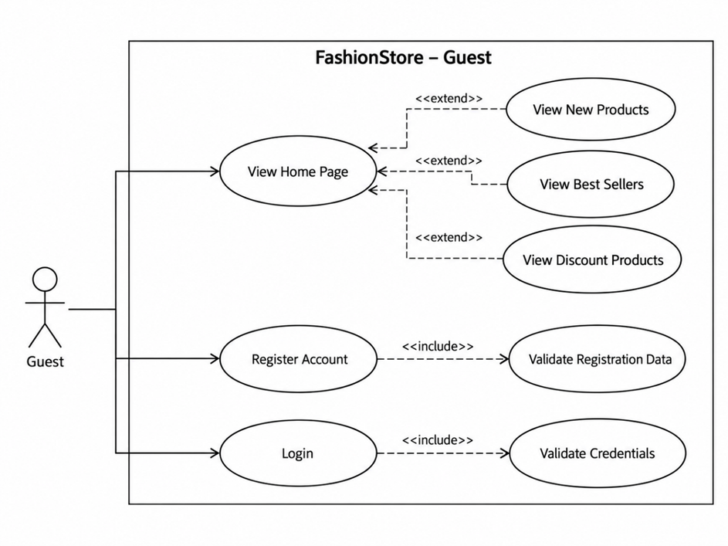

4.3.2 UCs for Customer

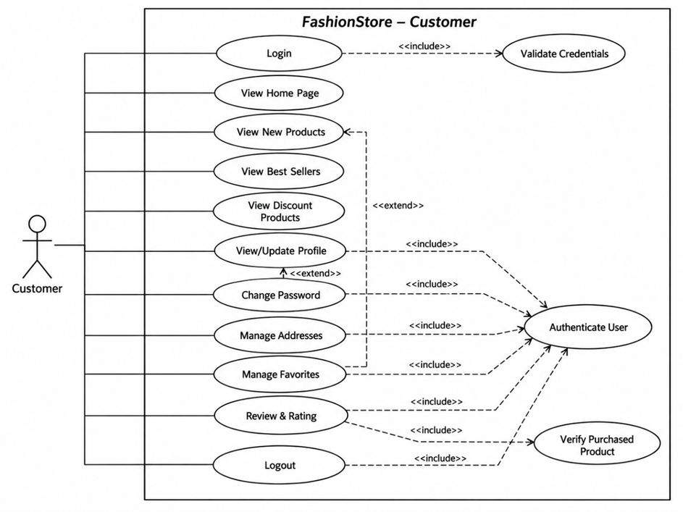

4.3.3 UCs for Staff

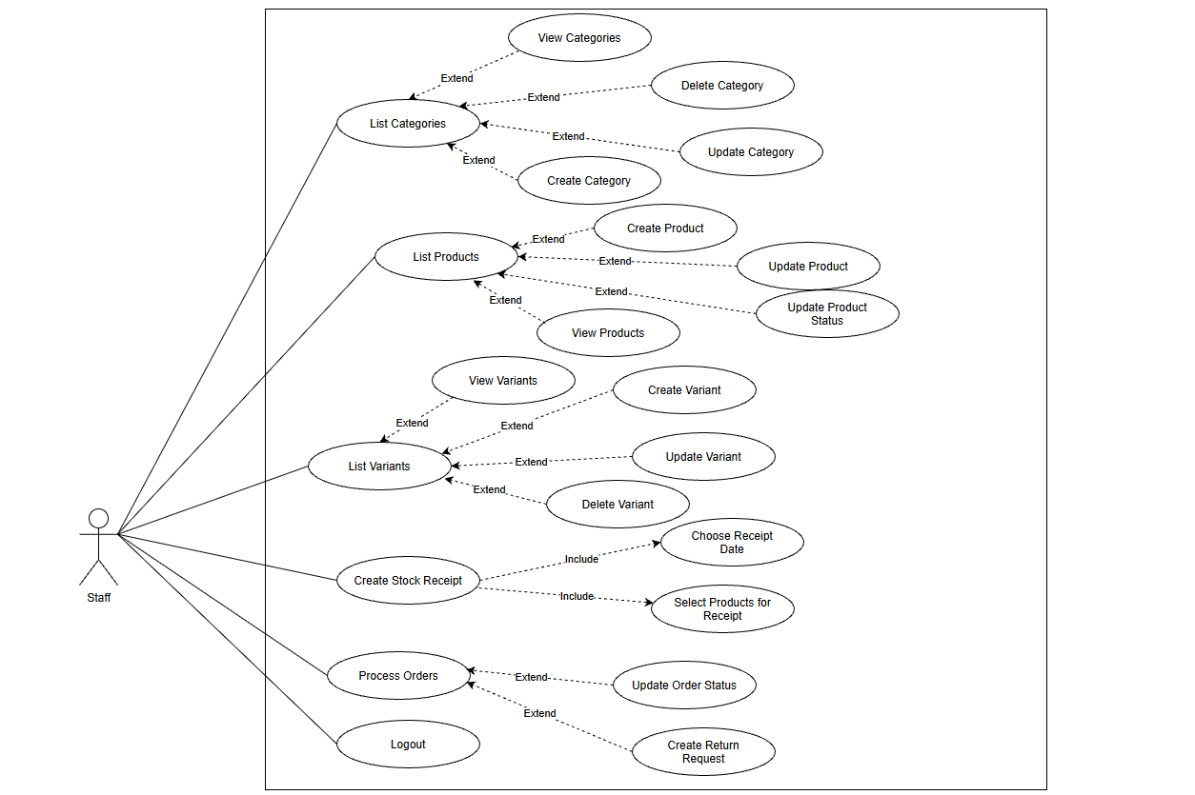
4.3.3 UCs for Admin
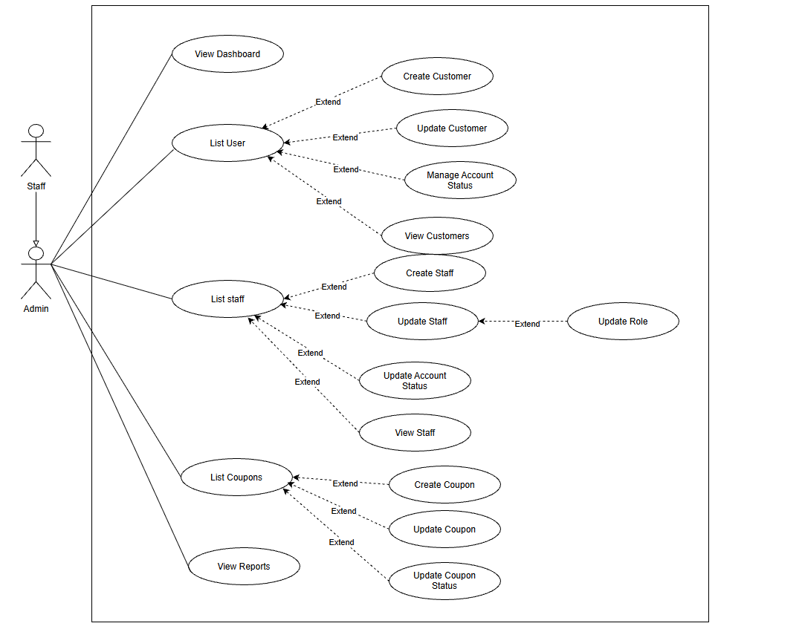

4.4 Permission Matrix
Full = unrestricted · Restricted = conditions apply (see footnotes) · No = denied
Function | Guest | Customer | Staff | Admin
View Home Page | Full | Full | Full | Full
Login | Full | Full | Full | Full
Register Customer Account | Full | No | No | No
View / Update Own Profile | No | Full | Restricted | Restricted
Change Own Password | No | Full | Full | Full
Logout | No | Full | Full | Full
Access Role-Protected Features | Restricted | Restricted | Restricted | Restricted
Manage Shipping Addresses | No | Full | No | No
View New Products | Full | Full | Full | Full
View Best Sellers | Full | Full | Full | Full
View Discount Products | Full | Full | Full¹ | Full
Add / Remove Favorites | No | Full | No | No
Submit Product Review | No | Restricted | No | No

5. System Functionalities

5.1 Screen Inventory

a. Screen Flow

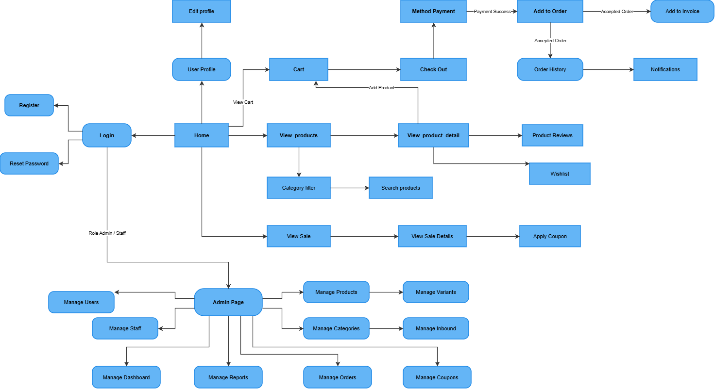

b. Screen List

# | Screen Name | Feature | Description
1 | Home Page | Home Page | Main landing page to browse store and navigate features.
2 | Login | Authentication | Authenticate users to access personal accounts.
3 | Register | Authentication | Create a new customer account.
4 | Reset Password | Authentication | Recover account password via email.
5 | User Profile | Account Management | View personal information and account details.
6 | Edit profile | Account Management | Update personal info and delivery address.
7 | View_products | Product Catalog | Browse the fashion product catalog.
8 | Category filter | Product Browsing | Filter products by category, size, and color.
9 | Search products | Product Browsing | Search items by keywords.
10 | View_product_detail | Product Browsing | View product details, gallery, and select variants.
11 | Product Reviews | Customer Feedback | View customer ratings and product reviews.
12 | Wishlist | Favorites | View and manage saved favorite items.
13 | Cart | Shopping Cart | Manage selected items, quantities, and subtotal.
14 | Check Out | Order Processing | Select delivery address and shipping options.
15 | Method Payment | Payment Gateway | Choose a payment method (PayOS or COD).
16 | Add to Order | Order Confirmation | Confirm order and validate inventory.
17 | Add to Invoice | Invoicing | View order invoice and payment receipt.
18 | Order History | Order Tracking | Track past orders and delivery status.
19 | Notifications | Customer Notifications | View order updates and system notifications.
20 | View Sale | Promotions | View ongoing discount and sale promotions.
21 | View Sale Details | Promotions | View sale campaign details and discount items.
22 | Apply Coupon | Discount Management | Enter or select discount coupon code.
23 | Admin Page | Administration | Central navigation hub for admin and staff.
24 | Manage Users | User Management | View and manage customer accounts.
25 | Manage Staff | Staff Management | Manage staff accounts and role assignments.
26 | Manage Products | Catalog Management | Create, edit, and manage products.
27 | Manage Variants | Catalog Management | Manage product sizes, colors, and stock.
28 | Manage Categories | Category Management | Manage product categories and classifications.
29 | Manage Inbound | Warehouse Management | Manage supplier stock import receipts.
30 | Manage Dashboard | Analytics | View sales metrics and business statistics.
31 | Manage Reports | Reporting | Export sales and financial reports.
32 | Manage Orders | Order Fulfillment | Process, approve, and track customer orders.
33 | Manage Coupons | Promotion Management | Create and manage discount codes

5.2 External API Inventory
[Fill details of each external API into the table with the columns and sample data as below]
# | API Name | Calling Path | Description
1 | PayOS Payment Link API | FashionStore → PayOS | Creates an online payment link for an existing customer order.
2 | PayOS Payment Verification | FashionStore ↔ PayOS | Verifies payment information and retrieves the payment result associated with an order.
3 | PayOS Payment Webhook | PayOS → FashionStore | Receives payment notifications, verifies webhook authenticity, and updates the payment record and order status.
4 | Email Notification Service | FashionStore → SMTP Mail Server | Sends order confirmation emails and successful payment receipts to customers.

5.3 Background Job Inventory
# | Job Name | Group | Description
1 | Asynchronous Email Processing | Event-triggered / Async | Processes email-sending operations asynchronously without blocking the main request.
2 | Asynchronous Order Processing Task | Event-triggered / Async | Executes an asynchronous task initiated by an order-related operation. The detailed purpose and failure behavior require further verification.

II. Functional Requirements

1. Home Page

1.1 Home Page

1.1.1 Home Page Screen
Public homepage with product sections and navigation.

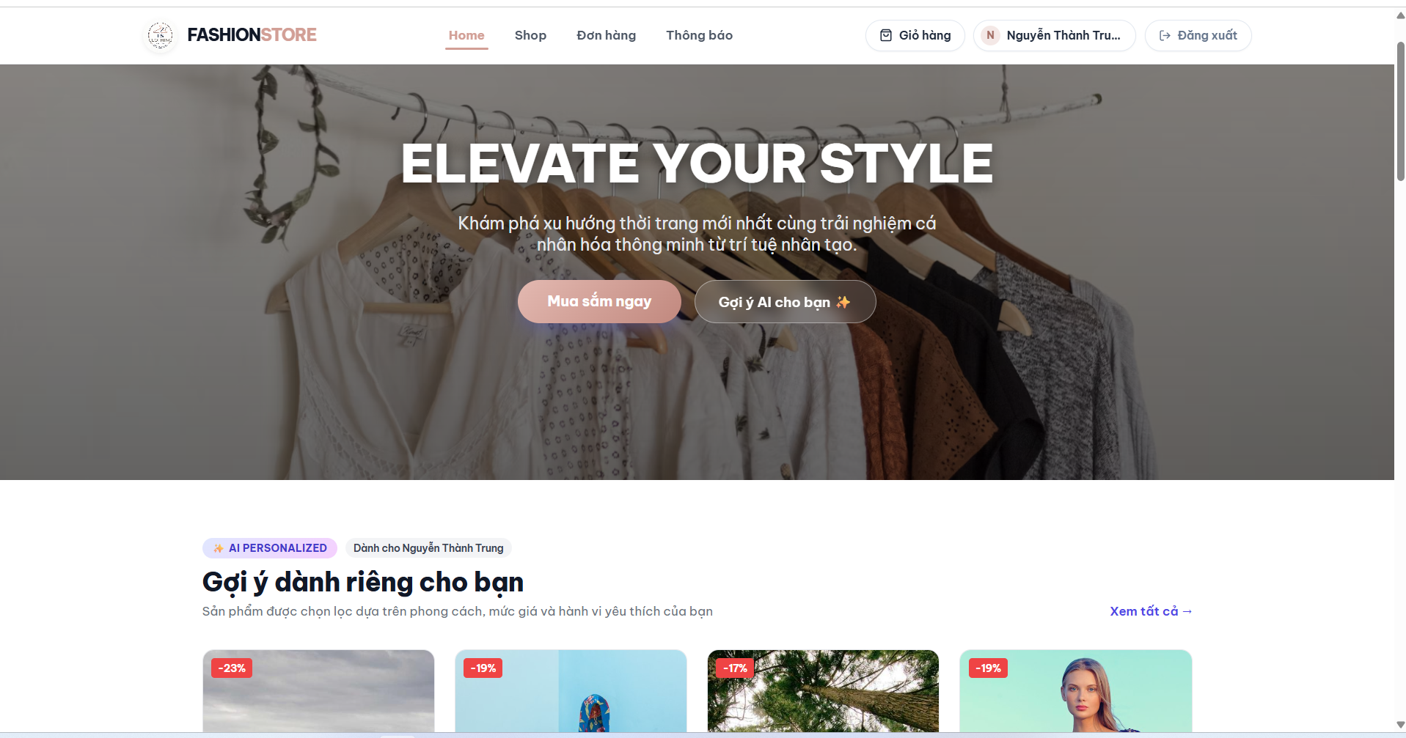

Figure FR-01. Home Page – conceptual screen mockup.

Brief Description: This screen allows guests and authenticated users to browse fashion products and navigate to the main features of FashionStore.

Field Name | Description
Logo | Displays the FashionStore brand and links to the homepage.
Navigation Menu | Displays navigation links to primary categories and pages.
Log out | Logs the current user out of the application.
Banner / Shop Now | Shows a featured promotion and navigates to a related product section.
Product Card | Shows the product image, name and price.
Favorite Icon | Allows an authenticated customer to save a product.
Account / Login | Opens the user account area or login screen.

2. User Login

2.1 User Login

2.1.1 User Login (UC-02, Iter1)
Email and password authentication screen.

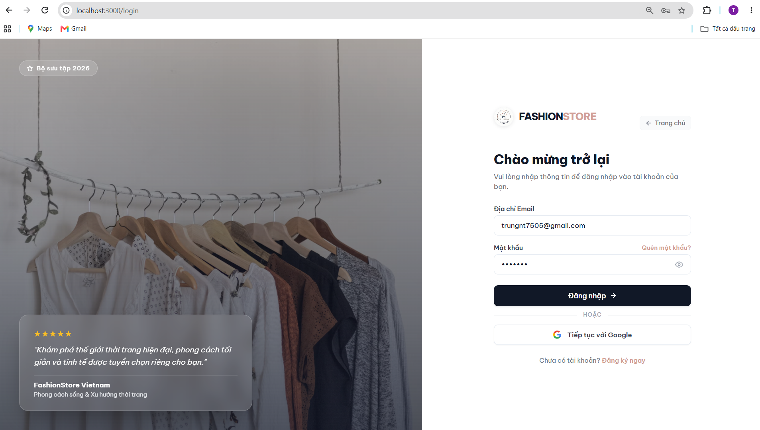
Figure FR-02. User Login – conceptual screen mockup.

Brief Description: This screen allows registered customers, staff and administrators to sign in with their account credentials.

Field Name | Description
Email Address | Accepts the registered email address.
Password | Accepts the account password in masked format.
Show Password Icon | Toggles password visibility.
Login Button | Submits credentials for authentication.
Create New Account | Navigates to the registration screen.
Google login button | Login through google account.
Forgot Password Link | Appears in the conceptual mockup; password reset belongs to Iteration 3.

3. User Register

3.1 User Register

3.1.1 User Register (UC-03, Iter1)
Customer registration form with required details.

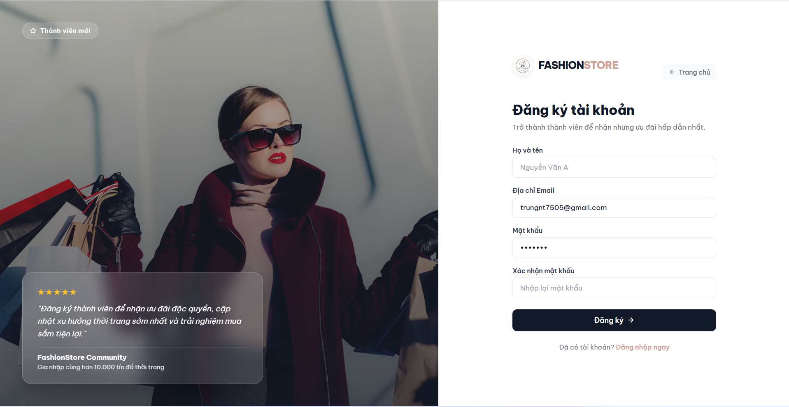
Figure FR-03. User Register – conceptual screen mockup.

Brief Description: This screen allows a guest to create a new customer account by submitting valid registration details.

Field Name | Description
Full Name | Accepts the customer’s full name.
Email Address | Accepts the email address used to register the account.
Password | Accepts the proposed account password.
Confirm Password | Requires the user to re-enter the proposed password.
Show Password Icon | Toggles the visibility of password inputs.
Register Button | Submits the registration form.
Login Link | Returns existing users to the login screen.

4. User Profile - View

4.1 User Profile - View

4.1.1 User Profile - View (UC-04, Iter1)
View account profile information.

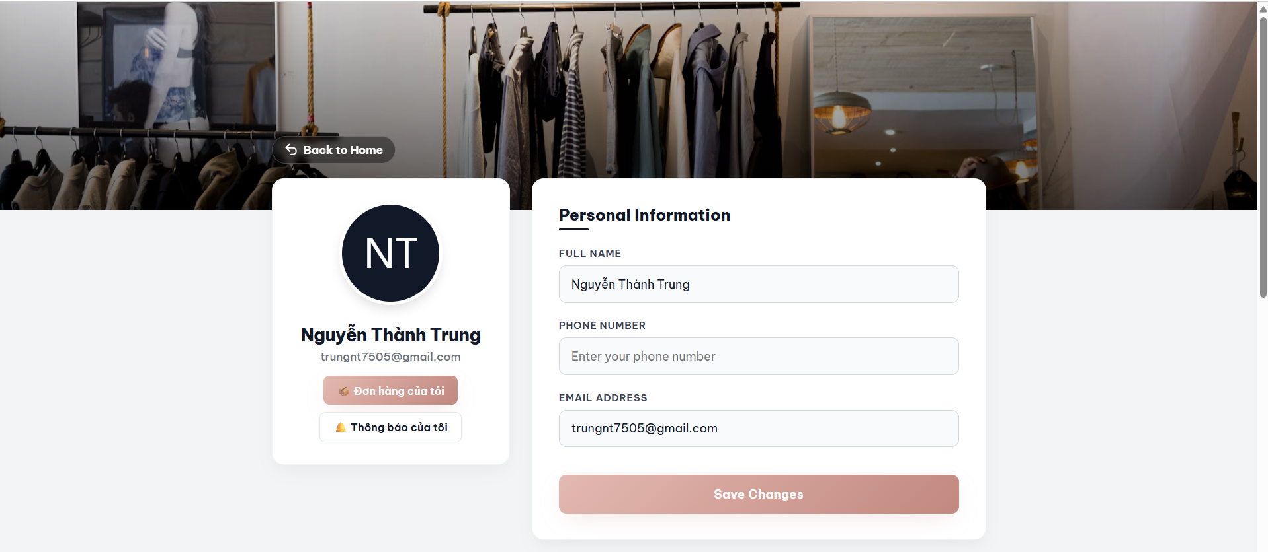Figure FR-04. User Profile - View – conceptual screen mockup.

Brief Description: This screen allows an authenticated customer to view the personal details associated with their account.

Field Name | Description
Profile Photo | Displays the customer avatar in the conceptual interface.
Full Name | Displays the customer’s name.
Email | Displays the registered email address.
Phone | Displays the saved phone number.
Sidebar Menu | Opens Addresses, Favorites, and Change Password.

5. User Profile - Edit

5.1 User Profile - Edit

5.1.1 User Profile - Edit (UC-04, Iter1)
Update eligible personal profile fields.

Figure FR-05. User Profile - Edit – conceptual screen mockup
Brief Description: This screen allows an authenticated customer to update editable personal information.

Field Name | Description
Full Name | Accepts an updated full name.
Phone | Accepts an updated contact number.
Email Address | Accepts an updated email address.
Save Changes Button | Validates and submits the updated profile fields.

6. Change Password

6.1 Change Password

6.1.1 Change Password (UC-05, Iter1)
Enter current password and new password with confirmation.

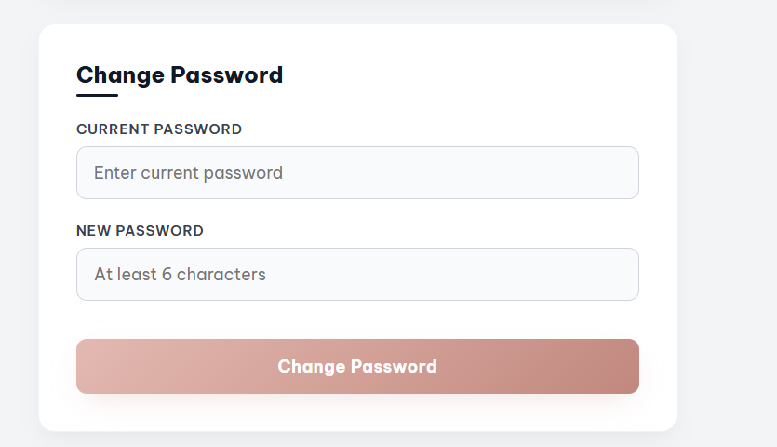
Figure FR-06. Change Password – conceptual screen mockup.

Brief Description: This screen allows an authenticated user to change their password after verifying the existing password.

Field Name | Description
Current Password | Accepts the existing account password.
New Password | Accepts the replacement password.
Update Password Button | Validates the form and submits a password change request.

7. Address Management

7.1 . Address Management

7.1.1 Address Management (UC-08, Iter1)
View shipping addresses and access add, edit, delete and default actions.

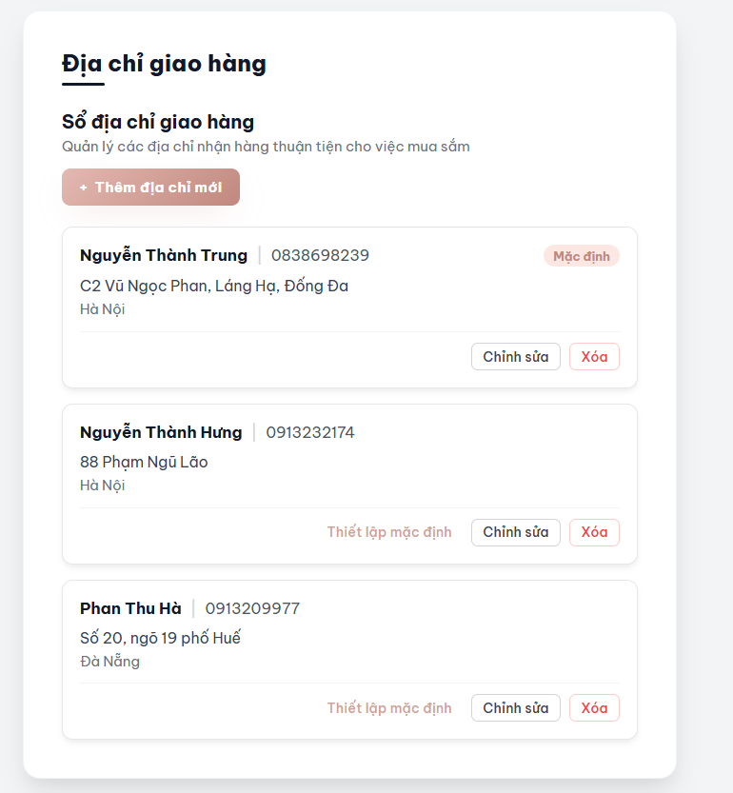
Figure FR-07. Address Management – conceptual screen mockup.

Brief Description: This screen allows an authenticated customer to view, add, edit, delete and select the default shipping address.

Field Name | Description
Address List | Displays the customer’s saved shipping addresses.
Recipient Name | Displays the name of the person receiving an order.
Phone Number | Displays the recipient’s contact number.
Address Details | Displays the delivery location.
Default Label | Identifies the currently selected default address.
Add Address Button | Opens the form for entering a new shipping address.
Edit Icon | Opens the selected address for editing.
Delete Icon | Requests deletion of the selected address.

8. New Products

8.1 . New Products

8.1.1 New Products (UC-09, Iter2)
View recently added products and navigate to product details.

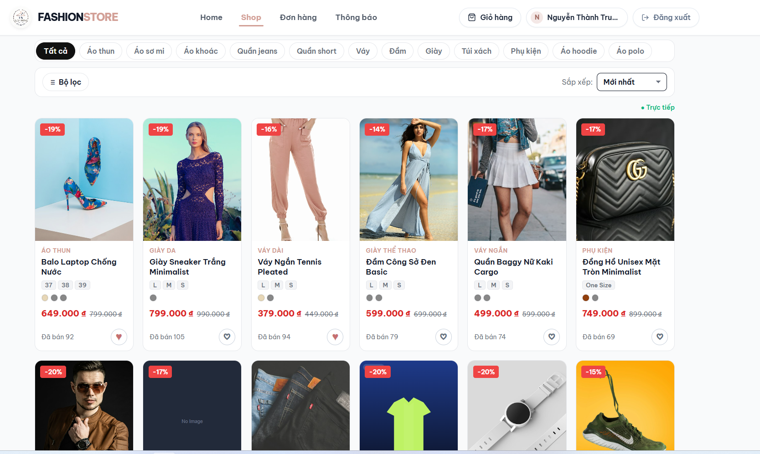
Figure FR-08. New Products – conceptual screen mockup

Brief Description: This screen allows visitors and customers to browse products recently added to FashionStore.

Field Name | Description
Page Title | Identifies the New Products listing.
Category Filter | Narrows the listing by the selected category.
Price Filter | Narrows the listing by a selected price range.
Sort Selector | Changes the visible listing order.
Product Image | Shows the product thumbnail.
Product Name | Displays the product name and opens its details.
Product Price | Displays the product’s listed price.
Favorite Icon | Saves or removes a favorite for authenticated customers.

9. Best Sellers

9.1 . Best Sellers

9.1.1 Best Sellers (UC-10, Iter2)
Browse best-selling products.

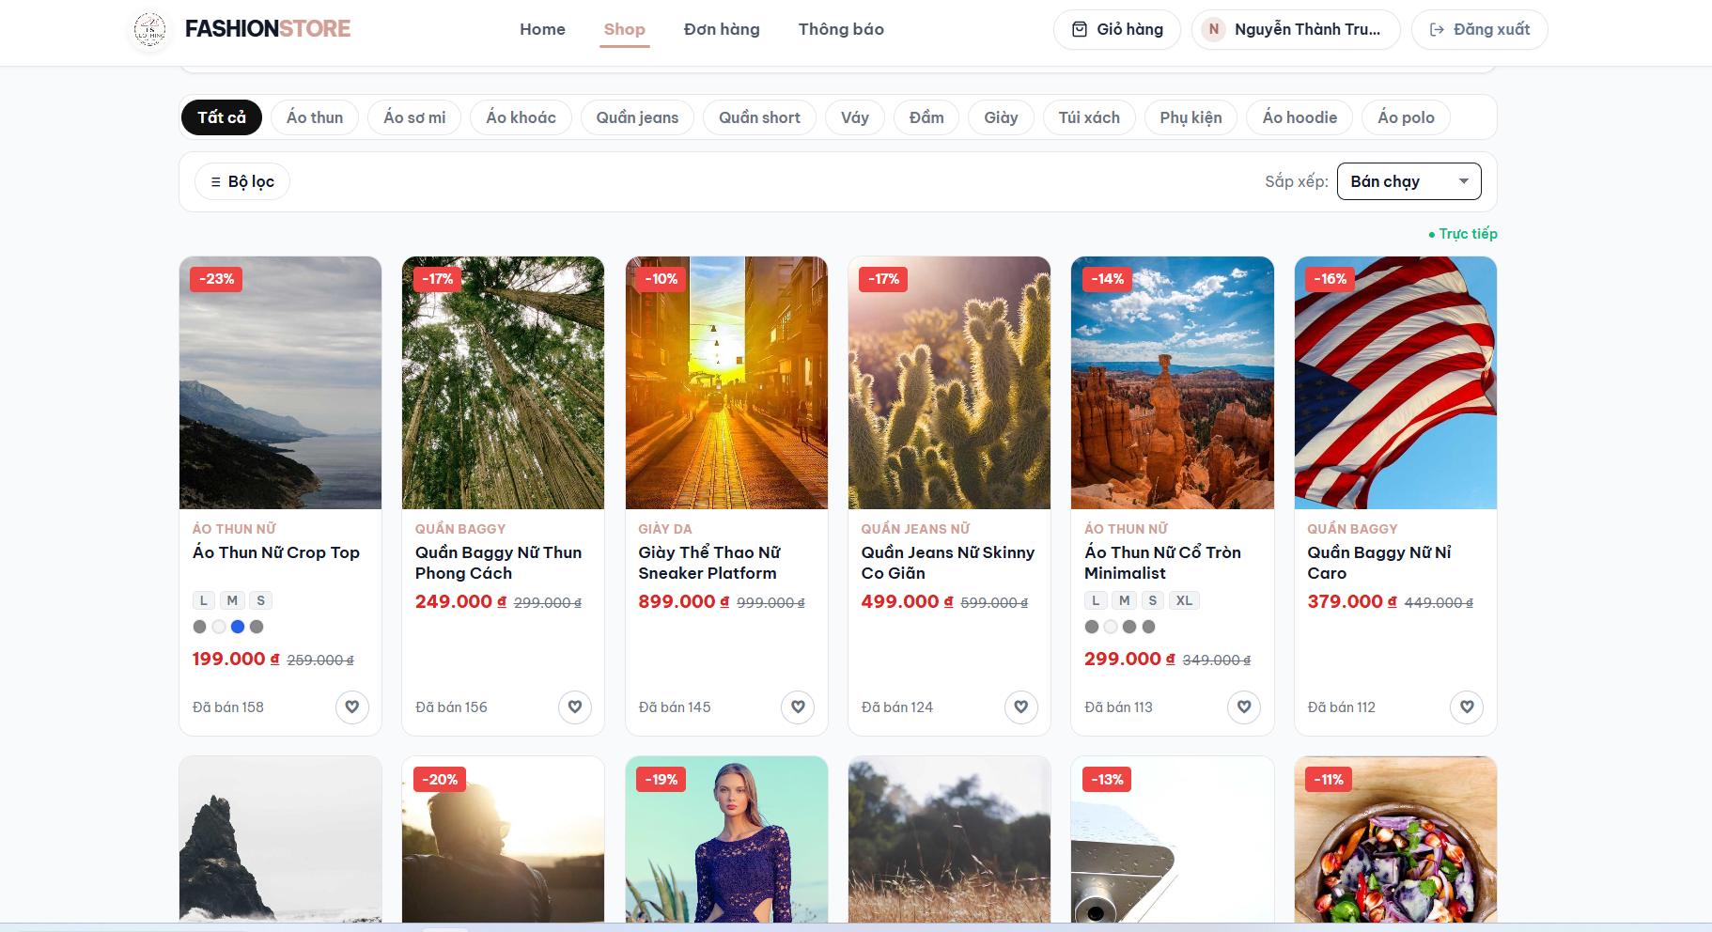
Figure FR-09. Best Sellers – conceptual screen mockup.

Brief Description: This screen displays products ranked using the application’s best-selling criteria.

Field Name | Description
Page Title | Identifies the Best Sellers listing.
Category Filter | Filters best-selling products by category.
Price Filter | Filters visible products by price range.
Product Image | Displays the product thumbnail.
Product Name | Displays the product name.
Product Price | Displays the current product price.
Favorite Icon | Allows eligible customers to save the product.
Product Card | Opens the corresponding Product Details screen.

10. Discount Products

10.1 . Discount Products

10.1.1 Discount Products (UC-11, Iter2)
Browse products displaying applicable product-level discounts.

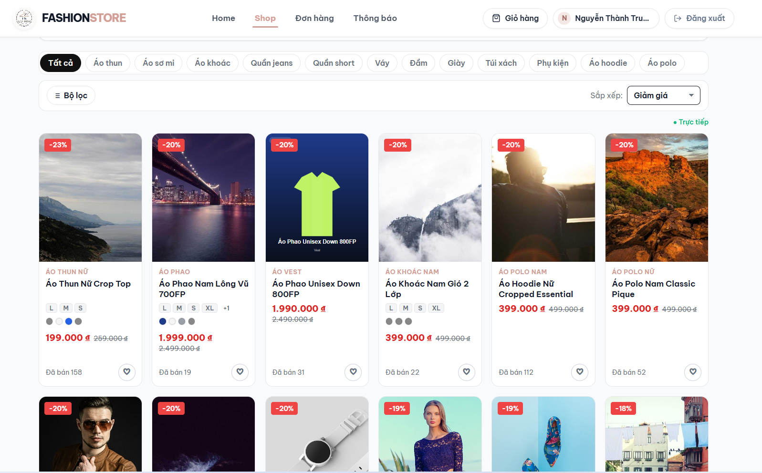
Figure FR-10. Discount Products – conceptual screen mockup.

Brief Description: This screen allows visitors and customers to browse products with displayed product-level discounts.

Field Name | Description
Page Title | Identifies the Discount Products listing.
Category Filter | Limits discounted products by category.
Price Filter | Limits discounted products by price range.
Discount Badge | Displays the advertised discount amount or percentage.
Original Price | Displays the original price for comparison.
Discounted Price | Displays the currently offered product price.
Product Card | Opens the corresponding Product Details screen.
Favorite Icon | Allows an eligible customer to save or remove a favorite.

11. Product Details

11.1 . Product Details

11.1.1 Product Details (Supporting, Iter2)
View product information, variants and available actions
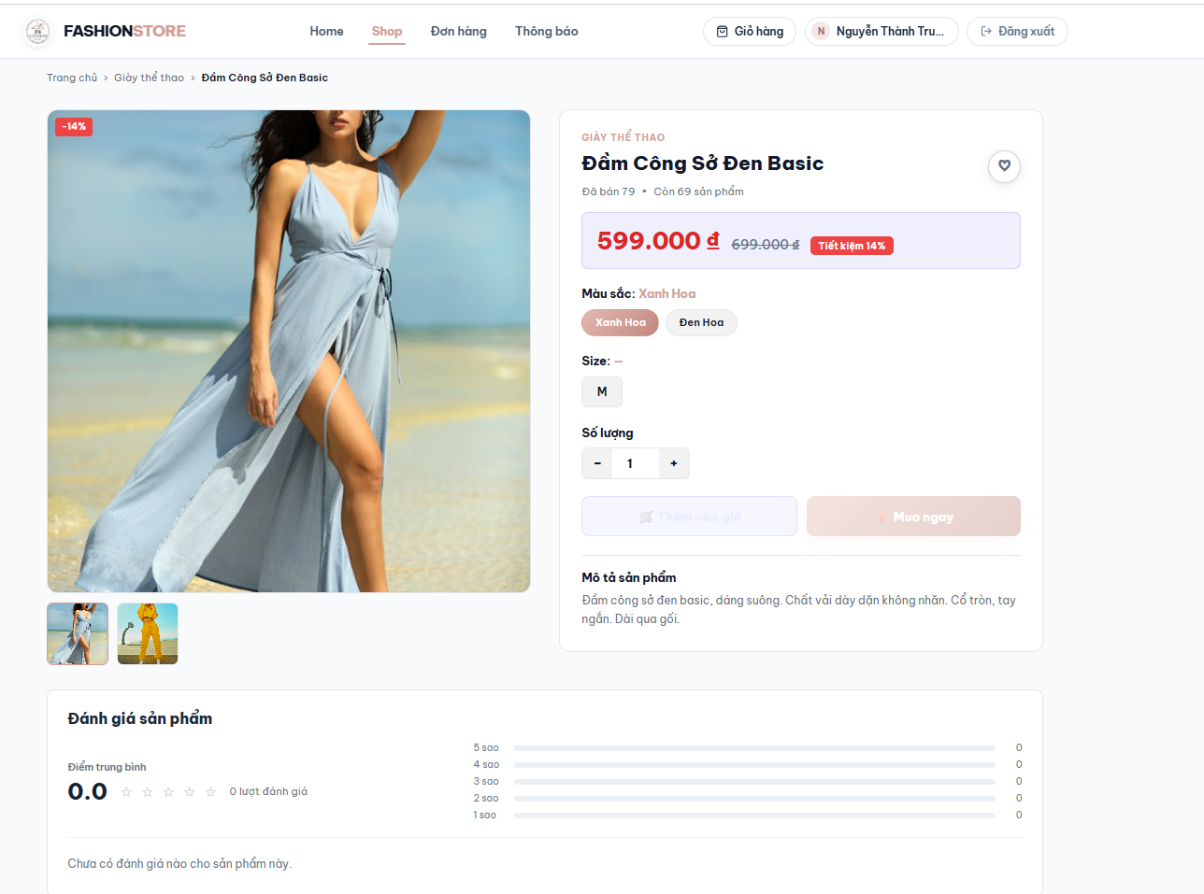
Figure FR-11. Product Details – conceptual screen mockup.

Brief Description: This screen presents information about a selected product and supports navigation to related customer actions.

Field Name | Description
Product Images | Displays the main product image and available image thumbnails.
Product Name | Displays the selected product name.
Rating Summary | Shows the product’s review summary where available.
Price | Displays the current product price.
Color Selector | Allows the customer to choose an available color variant.
Size Selector | Allows selection of an available size variant.
Quantity Control | Allows the customer to specify a desired quantity.
Add to Cart Button | Adds the selected variant and quantity to the cart; cart processing is outside this assigned scope.
Favorite Button | Saves or removes the product from the customer’s favorites.
Description / Reviews Tabs | Switches between product details and reviews.

12. Favorites

12.1 . Favorites

12.1.1 Favorites (UC-12, Iter2)
View saved products and remove favorites.
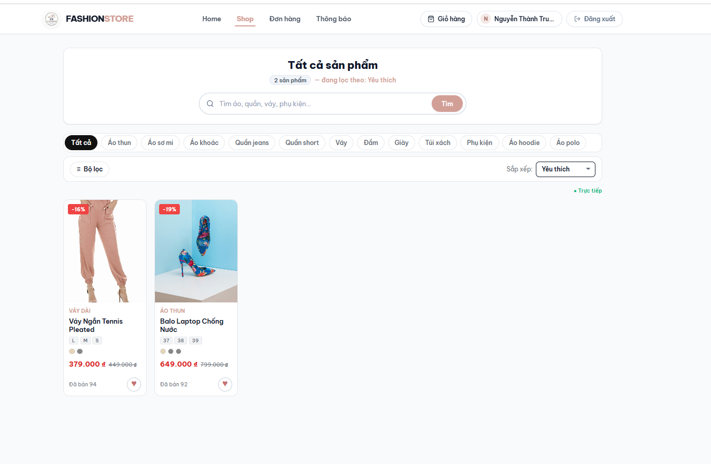
Figure FR-12. Favorites – conceptual screen mockup.

Brief Description: This screen allows an authenticated customer to view and manage products saved to their favorites list.

Field Name | Description
Favorite Product List | Displays products saved by the current customer.
Product Image | Displays the image associated with a saved product.
Product Name | Identifies the saved product.
Product Price | Displays the current listed price.
Favorite Icon | Indicates whether the product is saved.
Remove Icon | Removes the corresponding product from favorites.
Product Row | Allows navigation to the selected product’s details.

13. Review & Rating

13.1 . Review & Rating

13.1.1 Review & Rating (UC-13, Iter2)
Submit product star rating and optional comment where eligible.

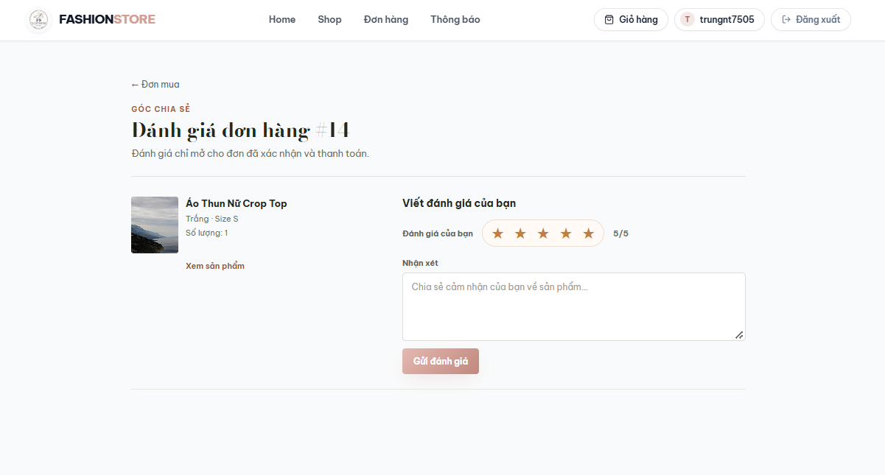
Figure FR-13. Review & Rating – conceptual screen mockup.

Brief Description: This screen allows an eligible authenticated customer to submit a rating and an optional written review for a product.

Field Name | Description
Product Information | Identifies the product being reviewed.
Rating Stars | Allows the user to select a score from one to five.
Comment Field | Accepts an optional written review.
Submit Review Button | Validates eligibility and the rating, then submits the review.

Non-screen functions: Logout (UC-06) and Role & Permission (UC-07) are actions/access-control rules rather than standalone UI mockups. Relevant Staff/Admin destinations should be confirmed against the deployed frontend before adding screenshots.

14. Background Job Inventory

14. Background Job Inventory
14.1 Asynchronous Email Processing (JOB-01)
Trigger: Event-triggered — when the system initiates an email notification.
Purpose: Processes email-sending operations asynchronously to avoid blocking the main application request.
Processing steps:
- Receive an email-sending request from the corresponding business operation.
- Prepare the recipient information, email subject, and message content.
- Submit the email operation for asynchronous execution.
- Attempt to deliver the email through the configured email service.
- Return the processing result or handle an exception according to the implemented error-handling mechanism.
Failure behavior:

Scenario | System behavior
Email server unavailable | The email delivery fails. Error handling depends on the configured mail service and asynchronous execution logic.
Invalid recipient address | The email cannot be delivered successfully.
Email sending fails | The asynchronous operation encounters an error. Logging and retry behavior must follow the implementation.
Asynchronous execution fails | The operation may fail to execute. The application must handle the failure according to its configured execution mechanism.

14.2 Asynchronous Email Processing (JOB-01)
Trigger: Event-triggered — when an order-related business operation initiates asynchronous processing.
Purpose: Executes order-related tasks asynchronously without blocking the initiating application request.
Processing steps:
- Receive an order-related processing request.
- Identify the order and relevant information required for the operation.
- Execute the corresponding asynchronous task.
- Complete the operation according to its implemented business logic.
- Handle processing errors according to the configured exception-handling mechanism.
Failure behavior:

Scenario | System behavior
Database unavailable | Database-dependent operations may fail. Retry behavior depends on the implementation.
Order not found | The operation cannot proceed when the required order record is unavailable.
Invalid order information | The task cannot complete successfully if the required data is invalid.
Asynchronous processing fails | The operation may terminate with an exception. Error handling must follow the implemented logic.

III. Requirement Appendix

1. Business Rules
The following table describes the common business rules applied to the FashionStore system, focusing on user account management, authentication, product discovery, favorites, and product reviews within Iteration 1 and Iteration 2.

GBR-ID | Rule Statement | Applies To | Rationale | Enforced By
GB-01 | Each user account must have a unique email address. | User Registration, User Profile | Prevents duplicate accounts and ensures accurate user identification. | The system validates email uniqueness during registration and email updates.
GB-02 | Users must provide valid credentials to sign in. | User Login | Prevents unauthorized access to user accounts. | The authentication service verifies credentials before granting access.
GB-03 | Users may only access functions permitted by their assigned roles. | Role & Permission | Protects restricted features and separates Customer, Staff, and Admin responsibilities. | The system checks user roles before allowing access to protected functions.
GB-04 | Users may only update their own personal information unless explicitly authorized. | User Profile | Protects personal information from unauthorized modifications. | The backend verifies account ownership and user permissions before processing updates.
GB-05 | Users must provide their correct current password before changing it. | Change Password | Prevents unauthorized password changes. | The system validates the current password before saving the new password.
GB-06 | Users must be authenticated before managing shipping addresses. | Address Management | Protects customers' private shipping information. | The system checks authentication and address ownership before allowing modifications.
GB-07 | Each customer may have at most one default shipping address. | Address Management | Ensures that the system can identify a single preferred shipping address. | The system updates the default-address flag and prevents multiple addresses from remaining selected as default.
GB-08 | Only eligible active products may be displayed in public product listings. | Home Page, New Products, Best Sellers, Discount Products | Prevents unavailable or inactive products from appearing in customer-facing listings. | The product service filters products according to their status.
GB-09 | New products must be ordered according to their creation dates. | New Products | Allows customers to discover recently added products. | The product service sorts eligible products by creation date in descending order.
GB-10 | Best-selling products must be ranked according to recorded sales data. | Best Sellers | Helps customers identify popular products. | The system retrieves and ranks products using the configured sales criteria.
GB-11 | Discounted products must have an applicable product-level discount. | Discount Products | Ensures that customers receive accurate discounted product information. | The system checks discount eligibility and displays the applicable price.
GB-12 | Customers cannot add the same product to their favorites list more than once. | Favorite | Prevents duplicate favorite records. | The system checks the customer-product combination before creating a favorite record.
GB-13 | Only authenticated customers may manage their own favorite products. | Favorite | Protects personal favorite lists from unauthorized access. | The backend verifies authentication and customer ownership.
GB-14 | Product ratings must be between 1 and 5 stars. | Review & Rating | Maintains consistent rating information. | The system validates rating values before saving reviews.
GB-15 | Customers must satisfy purchase-verification requirements before submitting product reviews. | Review & Rating | Helps ensure that reviews are associated with legitimate purchases. | The backend checks the relevant order information before accepting a review.
GB-16 | Users must not continue accessing protected functions using a terminated authentication session. | Logout | Prevents unauthorized access after logout. | The application clears authentication state and requires reauthentication when necessary.

2. Input Validation Requirements
This section defines common input validation requirements for the FashionStore system. These rules ensure data accuracy, consistency, and security across user authentication, account management, address management, favorites, and product reviews.

GVR-ID | Field Name | Validation Rule | Applies To | Error Message
GV-01 | Email | Email must not be empty and must follow a valid email format. | Login, Register, Profile | Please enter a valid email address.
GV-02 | Email Uniqueness | The email address must not already belong to another account. | Register, Profile | This email address is already registered.
GV-03 | Password | Password must not be empty and must satisfy the configured password policy. | Register, Login | Please enter a valid password.
GV-04 | Confirm Password | Confirm Password must match the entered password. | Register, Change Password | Passwords do not match.
GV-05 | Full Name | Full Name must not be empty. | Register, Profile | Full name is required.
GV-06 | Phone Number | Phone number must follow the supported phone-number format. | Profile, Address Management | Please enter a valid phone number.
GV-07 | Current Password | Current Password must match the authenticated user's existing password. | Change Password | Current password is incorrect.
GV-08 | New Password | New Password must satisfy the configured password policy. | Change Password | New password does not meet security requirements.
GV-09 | Recipient Name | Recipient Name must not be empty. | Address Management | Recipient name is required.
GV-10 | Shipping Address | Required address information must not be empty. | Address Management | Please enter a complete shipping address.
GV-11 | Default Address | A user must not have multiple default shipping addresses. | Address Management | Only one default address is allowed.
GV-12 | Favorite Product | The selected product must exist and must not already be saved by the customer. | Favorite | This product is already in your favorites.
GV-13 | Rating | Rating must be an integer between 1 and 5. | Review & Rating | Please select a rating from 1 to 5 stars.
GV-14 | Review Comment | Review comment must not exceed 1,000 characters. | Review & Rating | Review comment exceeds the maximum length.
GV-15 | Review Eligibility | The customer must satisfy the purchase-verification conditions. | Review & Rating | You are not eligible to review this product.

3. Other Requirements
…

