REPORT 16/05/2023

In Odoo, there are 3 types of inheritances for extending models:

+ Classical inheritance

+ Extension inheritance

+ Delegation inheritance

Firstly, for the classical inheritance, the inherit object adds all features from it’s parent. These are stored in the same table.

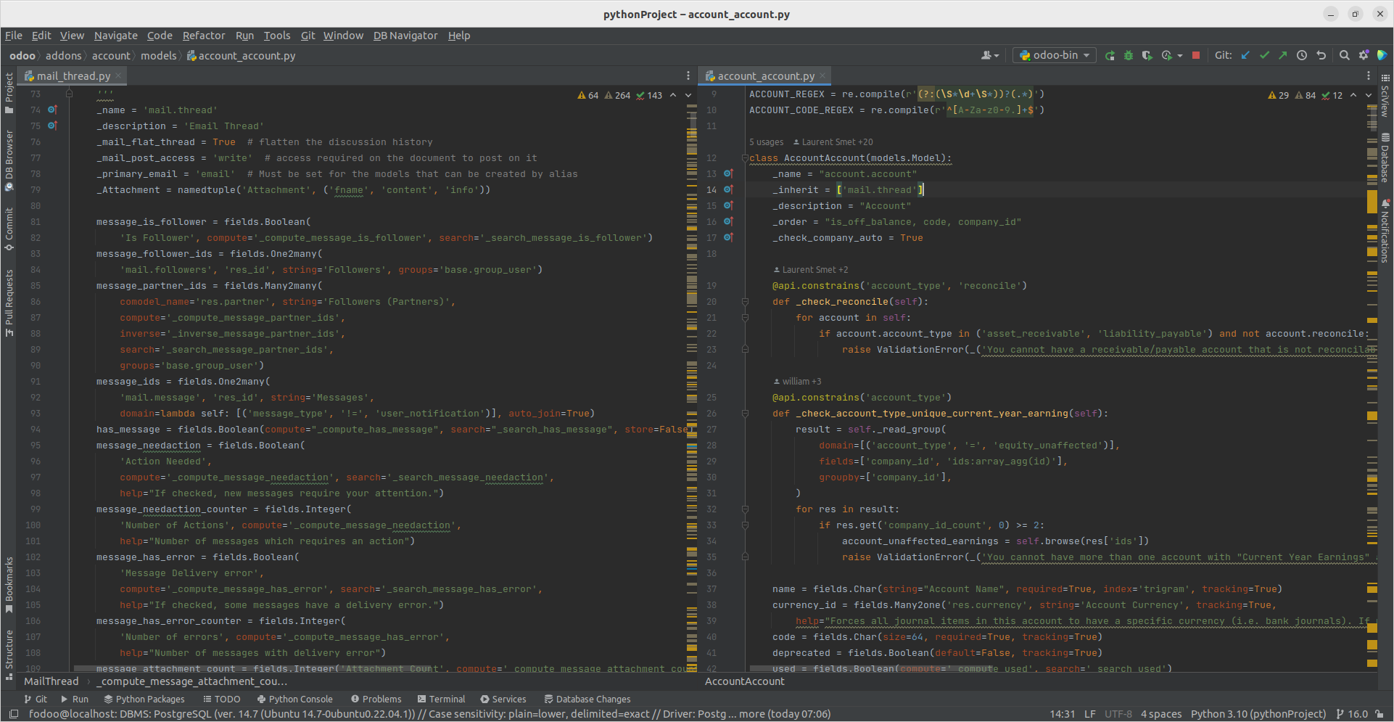

Here we can see that the account_account model inherits with mail thread model. In the parent model, the variable _inherit that include it’s child model, this child still has _name, which to recognize if we compare with extension.

Secondly, about the Extension, the child copies features from the parent. Additionally, it replaces with the existing one. Due to the fact that this inheritances is used when we want to add new fields or methods in the exist and save in different table with parent object.

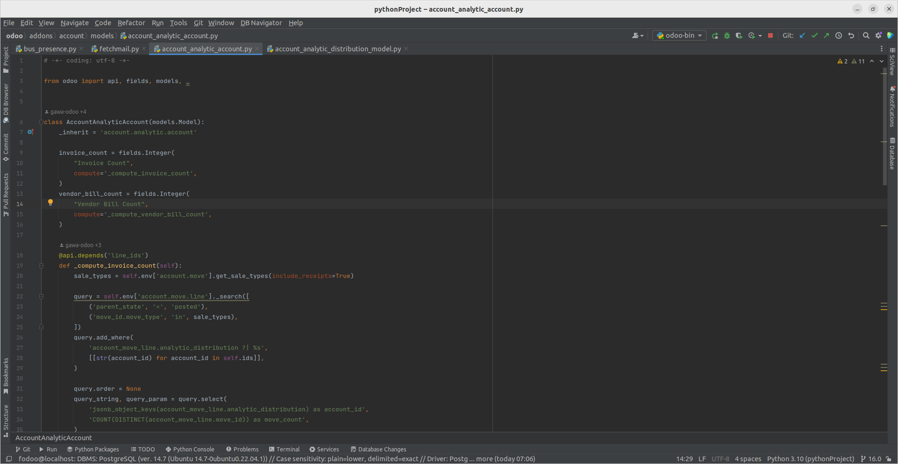

Not like the classical, in extension, it doesn’t have _name and its inherit itself.

At last, in Delegation, we are using the _inherits instead of _inherit in the 2 previous inheritances. Just like extension that it is used to copy from the parent but the different is that this new one can be stored a lot of objects that synchronized data.

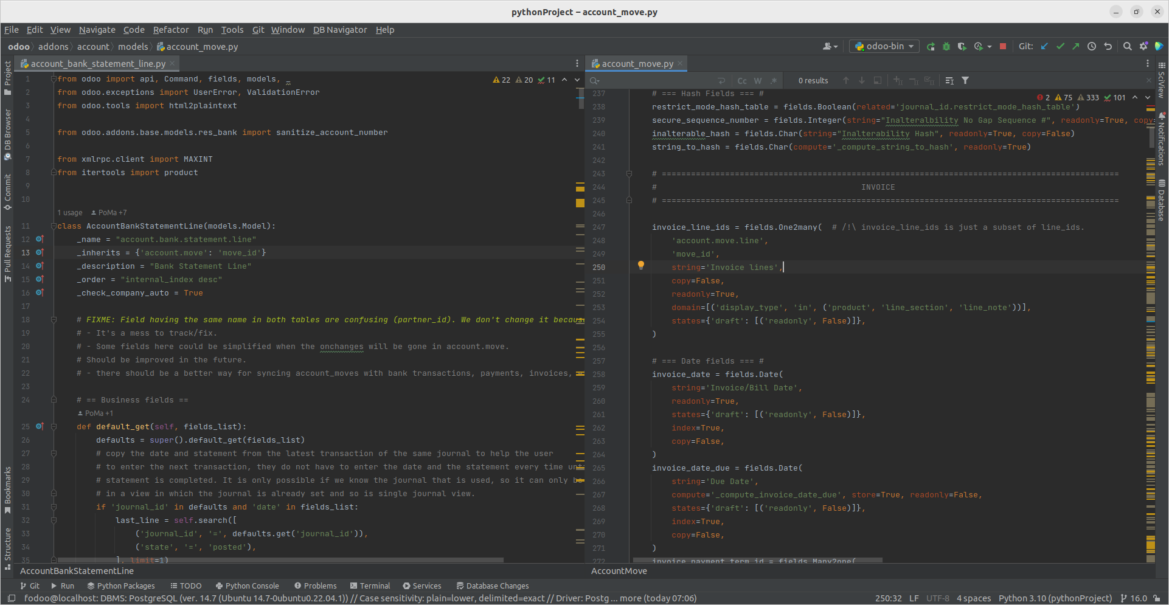First of all, it shows that account_move model has an one to many relationship with account_bank_statement_line model. Duo to that the child model as known as account_bank_statement_line model will have a delegation inheritance that uses _inherits in spite of _inherit from 2 first types of inheritances.