#### 安装软件列表

1. nginx-1.13.9
2. php-7.2.3

yum **install** -y gcc gcc-c++ openssl openssl-devel

//下载nginx源码包

wget http://nginx.org/download/nginx-1.13.9.tar.gz

//下载pcre源码包

wget https://ftp.pcre.org/pub/pcre/pcre-8.41.tar.gz

//下载zlib源码包

wget http://www.zlib.net/zlib-1.2.11.tar.gz

//解压

tar zxvf nginx-1.13.9.tar.gz

tar zxvf pcre-8.41.tar.gz

tar zxvf zlib-1.2.11.tar.gz

//进入nginx目录

cd nginx-1.13.9

//配置， -with-pcre=../pcre-8.41 --with-zlib=../zlib-1.2.11 这么写是因为我把zlib和pcre都放在nginx源码包同一级目录下

./configure --prefix=/usr/local/nginx --with-http_ssl_module --with-pcre=../pcre-8.41 --with-zlib=../zlib-1.2.11

//配置成功之后，编译并安装

make && make install

->启动 /usr/local/nginx/sbin/nginx

访问静态ip--》浏览器出现

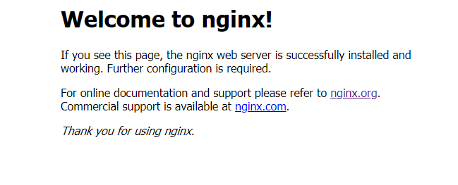

则成功

否则进入：<https://blog.csdn.net/zyhlearnjava/article/details/71908529>

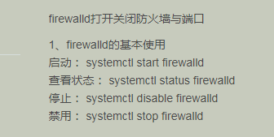

--》》安装php___参考网址：、

https://my.oschina.net/cxgphper/blog/2050504

yum install -y libxml2 libxml2-devel

//下载php的安装文件

wget http://cn2.php.net/distributions/php-7.2.3.tar.gz

//解压

tar zxvf php-7.2.3.tar.gz

//进入解压后的目录

cd php-7.2.3

//配置安装参数

./configure \

--prefix=/usr/local/php \

--with-config-file-path=/usr/local/php \

--enable-mbstring \

--enable-ftp \

--with-gd \

--with-jpeg-dir=/usr \

--with-png-dir=/usr \

--with-mysql=mysqlnd \

--with-mysqli=mysqlnd \

--with-pdo-mysql=mysqlnd \

--with-pear \

--enable-sockets \

--with-freetype-dir=/usr \

--with-zlib \

--with-libxml-dir=/usr \

--with-xmlrpc \

--enable-zip \

--enable-fpm \

--enable-xml \

--enable-sockets \

--with-gd \

--with-zlib \

--with-iconv \

--enable-zip \

--with-freetype-dir=/usr/lib/\

--enable-soap \

--enable-pcntl \

--enable-cli\

--with-curl

./configure

--prefix=/usr/local/php \  
 --with-curl \  
 --with-freetype-dir \  
 --with-gd \  
 --with-gettext \  
 --with-iconv-dir\  
 --with-kerberos \  
 --with-libdir=lib64 \  
 --with-libxml-dir \  
 --with-mysqli \  
 --with-openssl \  
 --with-pcre-regex \  
 --with-pdo-mysql \  
 --with-pdo-sqlite \  
 --with-pear \  
 --with-png-dir \  
 --with-xmlrpc \  
 --with-xsl \  
 --with-zlib \  
 --enable-fpm \  
 --enable-bcmath \  
 --enable-libxml \  
 --enable-inline-optimization \  
 --enable-gd-native-ttf \  
 --enable-mbregex \  
 --enable-mbstring \  
 --enable-opcache \  
 --enable-pcntl \  
 --enable-shmop \  
 --enable-soap \  
 --enable-sockets \  
 --enable-sysvsem \  
 --enable-xml \  
 --enable-zip

若失败：——————》

直接yum一并安装依赖库

# yum -y install libjpeg libjpeg-devel libpng libpng-devel freetype freetype-devel libxml2 libxml2-devel mysql pcre-devel

注意：安装php7beta3的时候有几处配置不过去，需要yum一下，现在php-7.0.2已经不用这样了。

# yum -y install curl-devel

# yum -y install libxslt-devel

//编译安装( 细心、耐心测试安装【排错】 make -->make test--->make install )

make && make install

Linux 安装 mysql 参考网址：

<https://blog.csdn.net/ght886/article/details/80833413>