GeoDF-Adaptive VINS: AECE Manuscript Draft
Target journal: Advances in Electrical and Computer Engineering (AECE), Stefan cel Mare University of Suceava. This draft is written as a source document to be converted into the official AECE Microsoft Word .doc template.
AECE-specific constraints to respect:
- Manuscript format: native Microsoft Word .doc using the AECE template.
- Page count: even number of pages: 8, 10, or 12. Target 8 pages first.
- Keywords: five keywords or phrases, alphabetically ordered.
- Review: double-blind. Remove author names/affiliations from the submitted review copy if the AECE submission workflow requires blind files.
- References: include permanent links, preferably DOI/CrossRef links, where available.
- APC: 300 EUR for accepted papers, plus 25 EUR per page beyond 8 pages according to the current AECE author information page.

Proposed Title
GeoDF-Adaptive: Geometry-Based Dynamic Feature Rejection for Stereo-Inertial Visual Odometry in Dynamic Scenes

Abstract
Dynamic objects violate the static-scene assumption used by feature-based visual-inertial odometry. This paper presents GeoDF-Adaptive, a geometry-based front-end dynamic feature rejection method for stereo-inertial VINS. The method uses temporal epipolar consistency, a Sampson residual dual gate, scene-aware activation, auto-calibrated activation thresholding, and track-level temporal voting. Unlike semantic approaches, GeoDF-Adaptive does not require an object detector, a segmentation model, or dataset-specific training. The method was implemented in a VINS-Fusion stereo-inertial pipeline and evaluated on the original EuRoC and VIODE datasets. On EuRoC, GeoDF-Adaptive preserved static-scene accuracy and improved ATE RMSE by 2.0% to 6.2% on all five tested sequences. On VIODE, it improved ATE in 7 of 12 evaluated environment-level conditions under a +/-3% decision band, including +24.5% on city_day/3_high and +41.3% on city_night/0_none. A feature-level evaluation using VIODE moving-vehicle segmentation masks showed that rejected features in city_day were 8.33x to 31.72x more likely to lie on dynamic objects than random tracked features, while the static-feature false positive rate stayed below 1%. However, high dynamic-density parking-lot scenes remained a limitation because large moving regions can contaminate the fundamental matrix estimate. The module is lightweight: its measured per-frame cost averaged 0.28 ms on a CPU-only host, about 0.56% of the 20 Hz frame budget. The results support GeoDF-Adaptive as a reproducible geometry-only baseline for dynamic-scene stereo-inertial visual odometry.

Keywords
computer vision, dynamic feature rejection, sensor fusion, stereo-inertial odometry, visual odometry

1. Introduction
Visual-inertial odometry (VIO) estimates camera motion by combining visual feature observations with inertial measurements. It is a core component in mobile robots, unmanned vehicles, augmented reality, and autonomous navigation systems. Many practical VIO front-ends, including feature-based stereo-inertial pipelines, rely on the assumption that most tracked visual features belong to a static rigid scene. This assumption is frequently violated in real or simulated traffic environments where moving vehicles, pedestrians, and other dynamic objects produce image motion that is inconsistent with camera ego-motion.
Dynamic-scene VIO is commonly addressed by semantic segmentation, object detection, motion segmentation, robust estimation, or combinations of these techniques. Semantic methods can be effective, but they introduce model dependency, computational load, and dataset or domain assumptions. In contrast, geometry-based methods remain attractive for applied engineering systems because they are reproducible, lightweight in design, and do not require model training. However, a purely geometric dynamic-feature filter must avoid two failure modes: removing useful static features in static scenes and over-trusting a contaminated geometric model when dynamic objects dominate the image.
This paper investigates a geometry-only front-end filter, called GeoDF-Adaptive, for stereo-inertial VINS. The method uses temporal epipolar geometry to identify features that are inconsistent with rigid-scene motion. Unlike always-on filtering, GeoDF-Adaptive self-activates only when a smoothed outlier signal exceeds an auto-calibrated scene threshold. Track-level temporal voting is then used to reduce transient false positives caused by two-frame epipolar noise, fast rotation, or short-term low parallax.
The contribution of this work is not a universal state-of-the-art dynamic VIO system. Instead, it provides a focused engineering contribution: a simple geometry-only feature rejection module, integrated into a stereo-inertial VINS pipeline, and evaluated with both trajectory-level and feature-level metrics on published datasets. The feature-level evaluation is important because trajectory accuracy alone cannot reveal whether rejected points are actually located on moving objects.
The main contributions are:
- A geometry-only front-end dynamic feature rejection method for stereo-inertial VINS using temporal fundamental matrix estimation and Sampson residual dual gating.
- A scene-aware activation mechanism with an auto-calibrated rho_on threshold derived from the running epipolar outlier floor.
- A track-level temporal voting strategy that suppresses transient false positives before hard feature deletion.
- A reproducible evaluation on EuRoC and VIODE, including ATE/RPE trajectory metrics and feature-level detection metrics against VIODE dynamic segmentation masks.
- A limitation analysis showing that high dynamic-density scenes can still degrade the method when the fundamental matrix estimate is contaminated by large moving regions.

2. Related Work
Feature-based VIO systems such as VINS-Fusion estimate camera motion by tracking image features and optimizing visual-inertial residuals. These systems are efficient and accurate in static or mostly static scenes, but they can be affected by dynamic features because those features violate the rigid-scene model used by geometric constraints and visual bundle adjustment.
Classical robust estimation methods, including RANSAC and epipolar outlier rejection, are often used to remove inconsistent correspondences. These approaches are attractive because they are model-free and do not require semantic labels. Nevertheless, they usually operate as generic outlier filters rather than as adaptive dynamic-object filters. If the rejection threshold is too low, useful static features are removed; if it is too high, moving-object features remain in the estimator.
Semantic dynamic SLAM and VIO systems use object detectors or segmentation networks to identify potentially dynamic regions. Methods such as DynaSLAM and dynamic-object-aware VIO pipelines can remove features on cars or people more directly than pure geometry. Their advantage is stronger object-level reasoning, while their drawback is dependence on segmentation quality, computational resources, and category definitions. They may also fail on unseen dynamic classes or in image domains different from the training data.
GeoDF-Adaptive is positioned between generic robust estimation and semantic dynamic filtering. It keeps the implementation in the VIO front-end and uses only geometric consistency. Its goal is not to replace semantic filtering in all cases, but to provide a reproducible engineering baseline for dynamic feature rejection when training-free operation and easy integration are preferred.

Table 1. Positioning Against Related Approaches
Approach family | Uses semantics | Needs training/model | Front-end only | Main limitation
Standard VINS-Fusion [1], [2] | no | no | yes | assumes mostly static scene
Generic RANSAC outlier rejection [7], [8] | no | no | yes | not scene-aware
Robust back-end dynamic VINS (DynaVINS) [6] | no | no | no | modifies back-end optimization
Semantic dynamic SLAM/VIO (DynaSLAM) [5] | yes | yes | varies | detector/segmentation dependency
GeoDF-Adaptive (this work) | no | no | yes | high dynamic density can corrupt F
Standard feature-based VINS [1], [2] assumes a mostly static scene. Generic robust estimation such as RANSAC [7] with epipolar/Sampson residuals [8] removes inconsistent correspondences but is not scene-aware. Back-end methods such as DynaVINS [6] add robustness inside the optimization, while semantic methods such as DynaSLAM [5] rely on a detector or segmentation network. GeoDF-Adaptive stays training-free and front-end only, trading object-level reasoning for reproducibility and easy integration.

3. Proposed Method
GeoDF-Adaptive is inserted in the feature-tracking front-end after temporal KLT tracking and before feature masking and new feature detection [10]. It operates on features that have been tracked between two consecutive frames. Figure 1 shows where the module sits in the pipeline and its internal steps (a)-(f); only this module is added and the stereo-inertial back-end is unmodified.
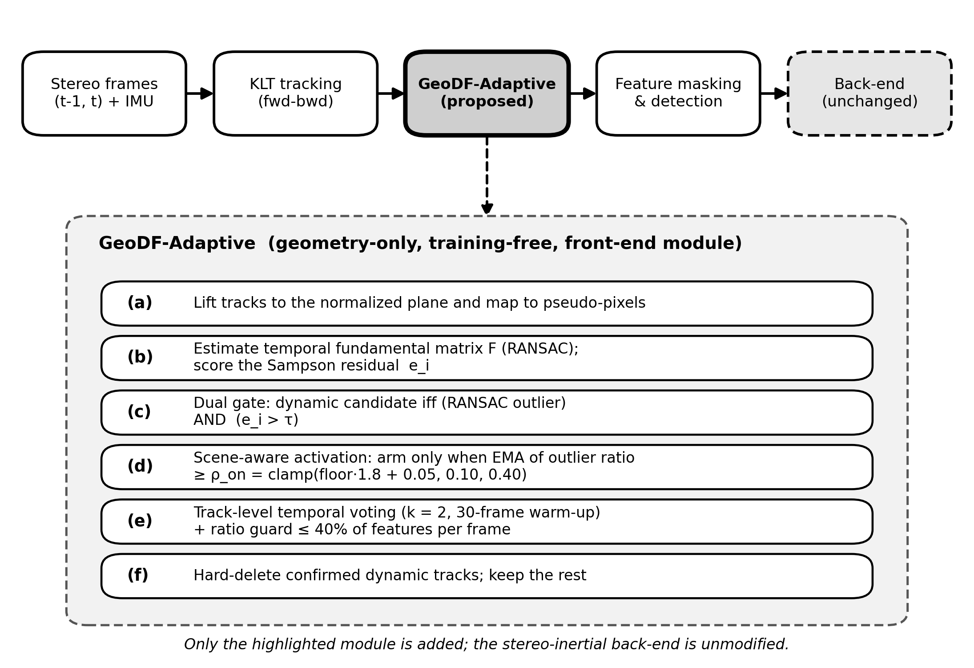
Figure 1. GeoDF-Adaptive front-end pipeline and internal steps (a)-(f).

3.1 Temporal Epipolar Consistency
For a tracked feature correspondence between frame t-1 and frame t, the left-camera image points are lifted to the normalized camera plane and mapped to the pseudo-pixel space used by the VINS front-end. A fundamental matrix F is estimated using RANSAC. For each tracked feature, the Sampson residual is computed as
e_i = ((x_i^T F x'_i)^2) /
((F x'_i)_1^2 + (F x'_i)_2^2 + (F^T x_i)_1^2 + (F^T x_i)_2^2)
where x_i and x'_i are the current and previous homogeneous feature coordinates. A feature is considered a dynamic candidate only when it satisfies both conditions: it is a RANSAC outlier and its Sampson residual is above the configured threshold. This dual gate is used to avoid deleting features due to a single weak signal.

3.2 Scene-Aware Activation
Always-on rejection can damage static or low-dynamic scenes. Therefore, GeoDF-Adaptive maintains an exponential moving average of the frame outlier ratio. The rejection module is armed only when this signal exceeds a threshold rho_on. Instead of using a fixed threshold, the proposed method estimates a running outlier floor for the current scene and computes
rho_on = clamp(floor * 1.8 + 0.05, 0.10, 0.40)
The floor uses asymmetric smoothing: it adapts down faster when the observed outlier ratio decreases and increases slowly when the ratio rises. This prevents short dynamic bursts from inflating the static floor while allowing high-noise scenes to use a more conservative activation threshold.

3.3 Track-Level Temporal Voting
Two-frame epipolar geometry can generate transient false positives under fast rotation, low parallax, or weak texture. To reduce this effect, each feature ID maintains a dynamic-candidate streak. A feature is eligible for hard deletion only after being flagged for at least k consecutive frames. In the evaluated configuration, k=2 and a 30-frame warm-up period is used.

3.4 Integration in Stereo-Inertial VINS
GeoDF-Adaptive does not modify the back-end visual-inertial optimization. It only removes selected feature tracks from the front-end before new feature detection. This design keeps the estimator unchanged and makes the method easy to integrate into an existing VINS-Fusion style pipeline. A per-frame ratio guard additionally caps hard deletions at 40% of tracked features and never reduces the active set below a minimum feature count, so the estimator is never starved even if the gate over-fires.

3.5 Parameter Settings
All experiments used a single fixed configuration (no per-sequence tuning). The stereo temporal cross-check was disabled in the evaluated configuration.

Table: GeoDF-Adaptive Parameters (Evaluated Configuration)
Parameter | Symbol / key | Value
RANSAC reprojection threshold | ransac_th_px | 1.0 px
Sampson dynamic threshold | tau (sampson_th) | 3.0
Min track count to score | min_track_cnt | 2
Min features kept | min_feature_num | 40
Outlier-ratio EMA factor | activate_ema | 0.15
Auto threshold multiplier | auto_mult | 1.8
Auto threshold margin | auto_margin | 0.05
Arm threshold clamp | rho_on range | [0.10, 0.40]
Floor adapt-down / up rate | floor_down / floor_up | 0.02 / 0.004
Disarm hysteresis fraction | deactivate_frac | 0.6
Temporal voting frames | k (vote_frames) | 2
Warm-up frames | warmup_frames | 30
Max reject ratio (guard) | max_reject_ratio | 0.40

4. Experimental Setup
The method was evaluated on two datasets. EuRoC [3] was used as a static-scene safety test because it contains indoor stereo-inertial sequences with accurate ground truth. VIODE [4] was used as the dynamic-scene benchmark because it provides stereo-inertial data, trajectory ground truth, and segmentation masks for moving vehicles.

4.1 Datasets
The EuRoC evaluation used MH_01_easy, MH_02_easy, MH_03_medium, MH_04_difficult, and MH_05_difficult. The VIODE evaluation used three environments: city_day, city_night, and parking_lot. Each environment was evaluated under four dynamic levels: 0_none, 1_low, 2_mid, and 3_high.

4.2 Metrics
Trajectory accuracy was measured using ATE RMSE and RPE RMSE in metres, computed with the evo evaluation toolkit [9] after SE(3) alignment to ground truth. For VIODE, each reported value is the mean and standard deviation over five runs within the same build. EuRoC static safety used repeated baseline and adaptive runs as summarized in the project artifacts.
Feature-level detection was evaluated by matching tracked feature coordinates to the nearest VIODE segmentation mask within 30 ms. A feature was labelled dynamic when it fell inside a vehicle_dynamic_* mask. The main detection metrics were precision lift, recall, and static false-positive rate.

4.3 Implementation and Runtime Measurement
The method was implemented in C++ inside a VINS-Fusion style stereo-inertial pipeline (ROS 2). All experiments used a single consistent build. The per-frame cost of the GeoDF-Adaptive module was logged for every processed frame using the same in-pipeline timer (t_geo) so that the reported overhead reflects the deployed code path rather than a separate micro-benchmark. Runtime statistics were aggregated over all VIODE adaptive trials (60 runs, 74,994 logged frames). The host machine was an Intel Xeon W-11955M CPU (8 cores, 16 threads, 2.60 GHz) with 64 GB RAM, CPU-only, with no GPU acceleration used by the front-end.

5. Results and Discussion

5.1 VIODE Trajectory Results
Table 2 summarizes the VIODE ATE/RPE results. GeoDF-Adaptive improved ATE in 7 of 12 conditions under a +/-3% decision band. The strongest gains were observed in city_day/3_high and city_night/0_none.

Table 2. VIODE N=5 Trajectory Summary
Environment | Level | Baseline ATE | Proposed ATE | Improvement
city_day | 0_none | 0.110 +/- 0.001 | 0.120 +/- 0.000 | -9.7%
city_day | 1_low | 0.138 +/- 0.001 | 0.148 +/- 0.014 | -6.8%
city_day | 2_mid | 0.166 +/- 0.000 | 0.152 +/- 0.009 | +8.1%
city_day | 3_high | 0.409 +/- 0.052 | 0.309 +/- 0.000 | +24.5%
city_night | 0_none | 0.420 +/- 0.002 | 0.246 +/- 0.000 | +41.3%
city_night | 1_low | 0.504 +/- 0.009 | 0.538 +/- 0.036 | -6.7%
city_night | 2_mid | 0.502 +/- 0.010 | 0.460 +/- 0.000 | +8.5%
city_night | 3_high | 0.875 +/- 0.018 | 0.835 +/- 0.026 | +4.6%
parking_lot | 0_none | 0.167 +/- 0.000 | 0.147 +/- 0.003 | +12.1%
parking_lot | 1_low | 0.118 +/- 0.000 | 0.106 +/- 0.000 | +9.7%
parking_lot | 2_mid | 0.144 +/- 0.000 | 0.197 +/- 0.013 | -36.4%
parking_lot | 3_high | 0.119 +/- 0.000 | 0.172 +/- 0.000 | -44.3%
These results show that the method is conditionally effective rather than universally superior. It helps when dynamic features produce clear geometric inconsistency and do not dominate the image. It can degrade when the dynamic object density is high enough to contaminate the fundamental matrix estimate. Figure 2 visualizes the per-condition ATE change against the +/-3% decision band.
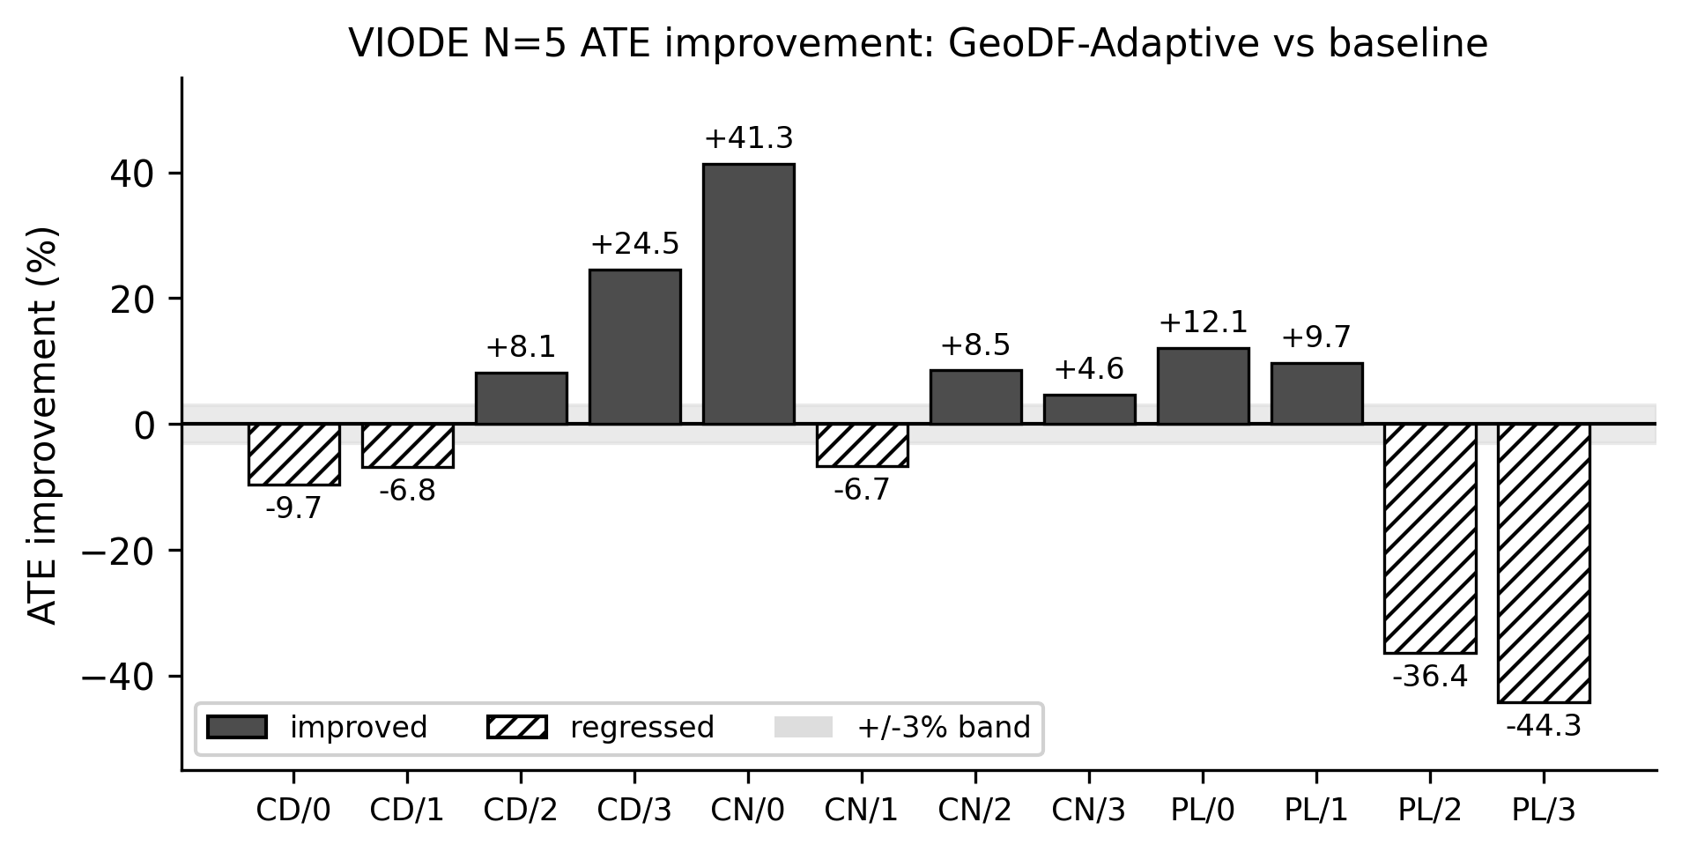
Figure 2. VIODE N=5 ATE improvement of GeoDF-Adaptive over the baseline (CD = city_day, CN = city_night, PL = parking_lot; 0-3 dynamic levels).

5.2 EuRoC Static Safety
Static-scene safety is important because a dynamic-feature filter should not harm odometry in environments where dynamic objects are absent. On EuRoC, GeoDF-Adaptive improved all five tested sequences by 2.0% to 6.2%, indicating that scene-aware activation did not introduce a static-scene regression.

Table 3. EuRoC Static Safety
Sequence | Baseline ATE | Proposed ATE | Improvement
MH_01_easy | 0.185 +/- 0.007 | 0.177 +/- 0.000 | +4.3%
MH_02_easy | 0.169 +/- 0.000 | 0.165 +/- 0.005 | +2.0%
MH_03_medium | 0.292 +/- 0.000 | 0.274 +/- 0.000 | +6.2%
MH_04_difficult | 0.447 +/- 0.000 | 0.436 +/- 0.007 | +2.3%
MH_05_difficult | 0.298 +/- 0.000 | 0.290 +/- 0.009 | +2.6%

5.3 Feature-Level Dynamic Detection
Trajectory metrics alone cannot prove that a filter is removing dynamic-object features. Therefore, the rejected features were compared against VIODE moving-vehicle segmentation masks. On city_day, rejected features were 8.33x to 31.72x more likely to fall on moving vehicles than randomly selected tracked features, while the static false-positive rate stayed below 1%.

Table 4. VIODE Dynamic Feature Detection
Environment | Level | Dynamic base rate | Precision lift | Static FPR
city_day | 1_low | 0.08% | 31.72x | 0.59%
city_day | 2_mid | 1.24% | 12.14x | 0.59%
city_day | 3_high | 4.10% | 8.33x | 0.71%
city_night | 2_mid | 2.0% | 3.02x | 0.8%
city_night | 3_high | 4.9% | 2.89x | 0.7%
parking_lot | 2_mid | 10.7% | 1.48x | 2.8%
parking_lot | 3_high | 14.0% | 1.42x | 3.0%
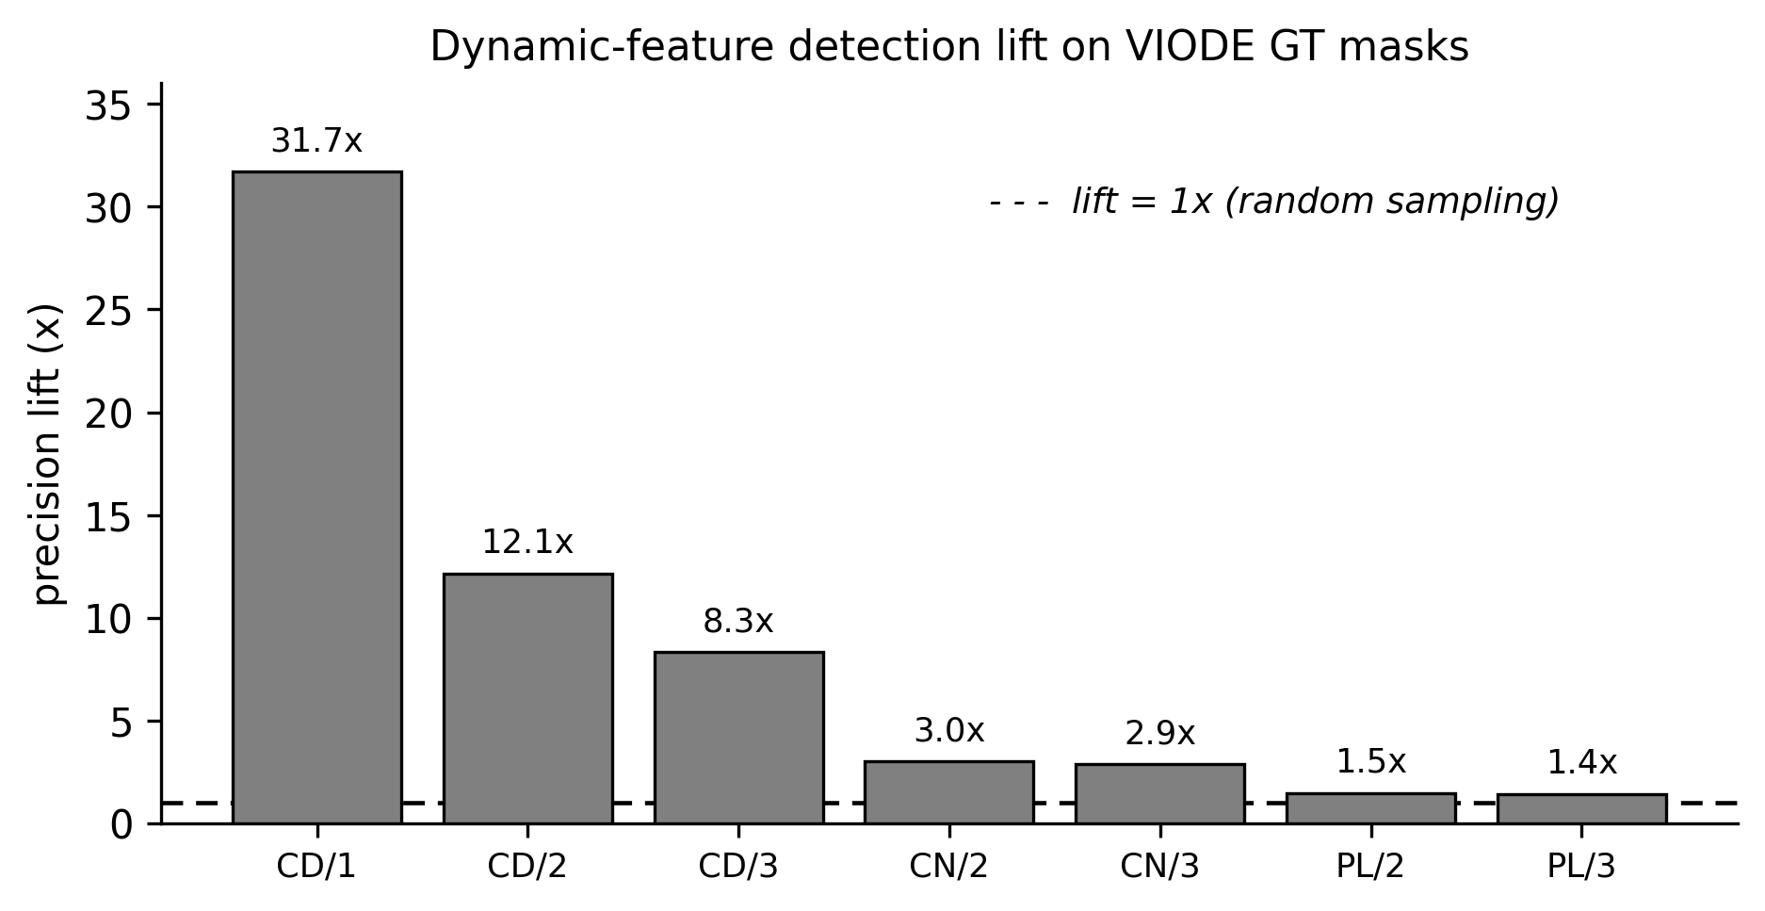
Figure 3. Dynamic-feature detection lift on VIODE moving-vehicle masks. A lift of 1x equals random sampling; higher is better.
The detection results explain both the success and the failure cases. In city_day, the filter strongly concentrates rejections on moving vehicles. In parking_lot, the dynamic base rate is much higher and the lift drops to about 1.4x. This indicates that the geometric separation between static and dynamic features becomes weak when large moving regions affect the fundamental matrix.

5.4 Computational Overhead
Because the module is intended as a lightweight front-end addition, its runtime cost was measured directly in the deployed pipeline. Over 74,994 logged frames across all VIODE adaptive trials, the GeoDF-Adaptive step took a mean of 0.28 ms per frame (median 0.24 ms, 95th percentile 0.53 ms, 99th percentile 0.83 ms). At the 20 Hz image rate of the evaluated sequences, this corresponds to about 0.56% of the 50 ms per-frame budget. The scene-aware gate kept the hard-rejection path active on only 10.3% of frames, so on static or low-dynamic stretches the dominant cost is a single fundamental matrix estimation and Sampson scoring pass, while full rejection and temporal voting run only when the smoothed outlier signal arms the module. These measurements support describing GeoDF-Adaptive as a low-overhead, CPU-only front-end module rather than relying on a qualitative claim.

Table 5. Measured GeoDF-Adaptive Runtime (VIODE, CPU-only)
Metric | Value
Mean per-frame cost | 0.28 ms
Median per-frame cost | 0.24 ms
95th percentile | 0.53 ms
99th percentile | 0.83 ms
Fraction of 50 ms (20 Hz) budget | 0.56%
Frames with rejection armed | 10.3%
Logged frames | 74,994 (60 trials)

5.5 Limitation Analysis
The main limitation is the majority-rigid assumption behind fundamental matrix estimation. If dynamic features occupy large regions of the image, the estimated model can be biased toward moving objects. In this case, the dual gate may delete useful static features or fail to identify the correct dynamic set. The parking_lot results confirm this limitation. Future work should combine the current scene-aware activation with IMU-compensated epipolar scoring, progressive or weighted fundamental matrix estimation, and scene-adaptive hard/soft rejection.

6. Conclusion
This paper presented GeoDF-Adaptive, a geometry-only dynamic feature rejection method for stereo-inertial visual odometry. The method combines temporal epipolar consistency, Sampson residual gating, scene-aware activation, auto-calibrated thresholding, and track-level temporal voting. Experiments on EuRoC and VIODE show that the method preserves static-scene performance and improves several moderate-dynamic VIODE cases. Feature-level evaluation using VIODE moving-vehicle masks confirms that rejected features are substantially more likely to belong to moving objects in favourable scenes. The method is not universal, and high dynamic-density parking-lot scenes remain a limitation. The results support GeoDF-Adaptive as a reproducible geometry-only baseline for applied dynamic-scene VIO research.

References
(IEEE numbered style, as used by AECE. DOIs verified; format the final list in the AECE .doc template. The evo tool [9] has no DOI and is cited as a software repository.)
[1] T. Qin, P. Li, and S. Shen, "VINS-Mono: A robust and versatile monocular visual-inertial state estimator," IEEE Transactions on Robotics, vol. 34, no. 4, pp. 1004-1020, 2018. DOI: 10.1109/TRO.2018.2853729
[2] T. Qin, J. Pan, S. Cao, and S. Shen, "A general optimization-based framework for local odometry estimation with multiple sensors," arXiv preprint arXiv:1901.03638, 2019.
[3] M. Burri, J. Nikolic, P. Gohl, T. Schneider, J. Rehder, S. Omari, M. W. Achtelik, and R. Siegwart, "The EuRoC micro aerial vehicle datasets," The International Journal of Robotics Research, vol. 35, no. 10, pp. 1157-1163, 2016. DOI: 10.1177/0278364915620033
[4] K. Minoda, F. Schilling, V. Wuest, D. Floreano, and T. Yairi, "VIODE: A simulated dataset to address the challenges of visual-inertial odometry in dynamic environments," IEEE Robotics and Automation Letters, vol. 6, no. 2, pp. 1343-1350, 2021. DOI: 10.1109/LRA.2021.3058073
[5] B. Bescos, J. M. Facil, J. Civera, and J. Neira, "DynaSLAM: Tracking, mapping, and inpainting in dynamic scenes," IEEE Robotics and Automation Letters, vol. 3, no. 4, pp. 4076-4083, 2018. DOI: 10.1109/LRA.2018.2860039
[6] S. Song, H. Lim, A. J. Lee, and H. Myung, "DynaVINS: A visual-inertial SLAM for dynamic environments," IEEE Robotics and Automation Letters, vol. 7, no. 4, pp. 11523-11530, 2022. DOI: 10.1109/LRA.2022.3203231
[7] M. A. Fischler and R. C. Bolles, "Random sample consensus: A paradigm for model fitting with applications to image analysis and automated cartography," Communications of the ACM, vol. 24, no. 6, pp. 381-395, 1981. DOI: 10.1145/358669.358692
[8] R. Hartley and A. Zisserman, Multiple View Geometry in Computer Vision, 2nd ed. Cambridge, U.K.: Cambridge Univ. Press, 2004. DOI: 10.1017/CBO9780511811685
[9] M. Grupp, "evo: Python package for the evaluation of odometry and SLAM," 2017. [Online]. Available: https://github.com/MichaelGrupp/evo
[10] J. Shi and C. Tomasi, "Good features to track," in Proc. IEEE Conf. Computer Vision and Pattern Recognition (CVPR), 1994, pp. 593-600. DOI: 10.1109/CVPR.1994.323794

AECE Finalization Checklist
Done:
- [x] References added with verified DOIs (Section References).
- [x] Runtime/overhead measured in-pipeline (Section 5.4, Table 5) — supports the low-overhead claim with data instead of qualitative wording.
- [x] Related Work positioning table cites baselines and prior work.
Remaining:
- [ ] Convert this draft to the official AECE .doc template (a generated .docx is available at docs/MANUSCRIPT_GeoDF-VINS-AECE.docx to copy from).
- [x] Pipeline figure rendered (Figure 1): results/geodf_evaluation/figures/pipeline_geodf_adaptive.{svg,pdf,png} (vector + 300 dpi, grayscale-safe).
- [ ] Keep the manuscript at 8 pages if possible; otherwise use 10 pages and budget 25 EUR per extra page.
- [ ] Confirm five keywords match/approach the AECE keyword list.
- [ ] Prepare the copyright transfer / author's guarantee form.
- [ ] Check plagiarism/originality before submission.

Figure and Build Artifacts
- Figure 1 (pipeline): results/geodf_evaluation/figures/pipeline_geodf_adaptive.svg / .pdf / .png, regenerated by scripts/make_pipeline_figure.py.
- Result figures: results/geodf_evaluation/figures/viode_ate_delta_n5.svg, viode_detection_lift.svg.
- Word export: docs/MANUSCRIPT_GeoDF-VINS-AECE.docx, regenerated by scripts/build_manuscript_docx.sh.

