
CAPSTONE PROJECT REPORT
Report 3 – Software Requirement Specification
ChillnGo – Travel Journey-Sharing Platform with Itinerary Cloning
– Da Nang, September 2026 –

Table of Contents
I. Record of Changes 4
II. Software Requirement Specification 4
1. Product Overview 4
2. User Requirements 5
2.1 Actors 5
2.2 Use Cases 6
2.2.1 Diagram(s) 6
2.2.2 Descriptions 10
3. Functional Requirements 12
3.1 System Functional Overview 12
3.1.1 Screens Flow 12
3.1.2 Screen Descriptions 13
3.1.3 Screen Authorization 15
3.1.4 Non-Screen Functions 15
3.1.5 Entity Relationship Diagram 16
3.2 User Account Management 19
3.2.1 Register / Login 19
3.2.2 Logout 21
3.2.3 Verify Email 22
3.2.4 View / Edit Personal Profile 23
3.3 FE-01: Trip Post Creation & Management 25
3.3.1 Create Trip Post 25
3.3.2 Edit / Delete Trip Post 27
3.3.3 View Trip Post Detail 29
3.4 FE-02: Route Mapping 30
3.4.1 View Route on Map 30
3.5 FE-03: Tagging & Categorization 31
3.5.1 Tag Trip Post 31
3.6 FE-04: Social Interaction 32
3.6.1 Follow / Unfollow User 33
3.6.2 Like / Comment on Trip Post 34
3.6.3 View Notifications 35
3.6.4 Invite Companions 36
3.7 FE-05: Bookmark & Personalized Newsfeed 37
3.7.1 Bookmark Trip Post 37
3.7.2 View Personalized Newsfeed 38
3.8 FE-06: Itinerary Cloning 39
3.8.1 Clone Trip Post to Personal Itinerary 39
3.9 FE-07: Itinerary Editing, Merging & Cost Recalculation 41
3.9.1 Edit / Merge Itinerary & Recalculate Cost 41
3.10 FE-08: Explore & Discovery Page 43
3.10.1 Browse Explore Page & Search/Filter Trip Posts 43
3.11 FE-09: Admin Content Moderation 44
3.11.1 Moderate Trip Posts 44
3.11.2 Manage User Accounts 45
3.12 FE-10: Admin Analytics Dashboard 47
3.12.1 View Analytics Dashboard 47
3.13 FE-11: Photo Check-in 48
3.13.1 Create / Delete Check-in 48
3.14 FE-12: Livestream 49
3.14.1 Start Livestream 49
3.14.2 Watch Livestream & Replay 50
3.15 FE-13: AI Clone & AI Travel Assistant 51
3.15.1 Clone with AI 51
3.15.2 Ask the AI Travel Assistant 53
3.16 FE-14: Your Activity 54
3.16.1 View Your Activity 54
3.17 FE-15: Super Admin Administration 55
3.17.1 Manage Administrators 55
3.17.2 View Audit Log & Configure System Settings 56
4. Non-Functional Requirements 58
4.1 External Interfaces 58
4.1.1 Database Interfaces 58
4.1.2 API Interfaces 58
4.1.3 Frontend Interfaces 58
4.1.4 External Service Interfaces 58
4.2 Quality Attributes 58
4.2.1 Usability 58
4.2.2 Reliability 59
4.2.3 Performance 59
5. Requirement Appendix 59
5.1 Business Rules 59
5.2 Common Requirements 60
5.3 Application Messages List 60
5.4 Other Requirements 61

I. Record of Changes
Date | A*/M, D | In charge | Change Description
24/09/2026 | A | Huỳnh Bá Hiếu | Create the software requirement specification
05/11/2026 | M | Huỳnh Bá Hiếu | Align the SRS with the implemented system: actors, use cases, screens, entities, business rules and external interfaces; add check-in, livestream, AI Copy, AI assistant, Your activity, Super Admin and the Flutter mobile app; add a use case diagram for the new features, screen flow, ERD and screen layouts captured from the running web app (existing diagrams kept)
10/11/2026 | A | Huỳnh Bá Hiếu | Add Premium membership and business accounts: Business Owner and PayOS actors, use cases 36–43 and their diagram, screens, authorization, non-screen functions, entities Order, Business, BusinessPost, sections 3.18 (FE-16) and 3.19 (FE-17), the PayOS interface, business rules BR-023–BR-030, CR-011 and messages MSG16–MSG21; AI limit 10 / 100
11/11/2026 | M | Huỳnh Bá Hiếu | Align with the merged features: password reset by email (3.2.5), reports and moderation (3.11 rewritten), AI catalog (3.11.4), hidden content, stopping live streams, content statistics, deleting a published journey and editing a copied itinerary; accounts are never deleted; new use cases 44–46, screens, entity Report, BR-031–BR-035, MSG22–MSG26; new screenshots of the current screens
11/11/2026 | A | Huỳnh Bá Hiếu | Add travel news aggregation (FE-19): News worker and News sources actors, use cases 47–52 and their diagram, the Newsfeed tabs (3.7.2, new 3.7.3), section 3.20, screens 45–50, entities 26–30, BR-036–BR-040, MSG27–MSG30 and screenshots
11/11/2026 | M | Huỳnh Bá Hiếu | FE-19: news items become posts the AI writes from the original article, with pictures and a post page: use cases 47, 50, 51, screens 46, 49 and new 51, 3.7.3, 3.20.2, 3.20.3, entity 27, BR-036, new BR-041, MSG31 and screenshots
*A - Added M - Modified D - Deleted

II. Software Requirement Specification

1. Product Overview
ChillnGo is a travel social platform that lets travelers share authentic, day-by-day trip itineraries and turn any public trip post into their own editable plan with one click ("Copy Itinerary"). Every trip post is structured data — locations, photos, descriptions, and an estimated cost per day — rendered on an interactive map, rather than a loose photo album or blog paragraph. By combining social discovery (follow, like, comment, bookmark) with a reliable cloning and cost-recalculation engine, ChillnGo shortens the distance between travel inspiration and an actionable plan. Around this core, the implemented system adds photo check-ins, livestreams with replays, an AI Copy that adapts a journey to the traveler’s dates, group, budget and pace, an AI travel assistant, companions on a journey, and an admin console with a Super Admin. It is delivered as a web application (available in Vietnamese, English, Chinese, Japanese and Korean) and a Flutter mobile app for Android and iOS, both using the same REST API.
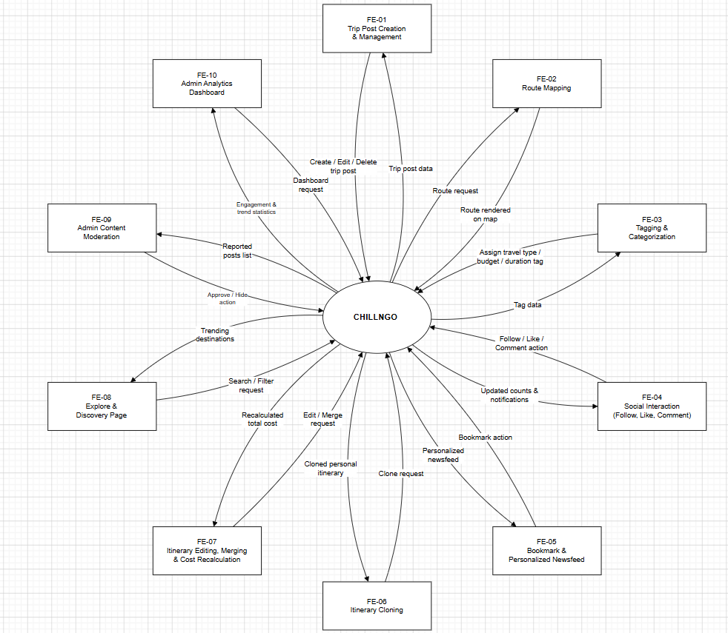
Figure 1: Context Diagram

2. User Requirements

2.1 Actors
Actor | Description
Guest | An unauthenticated visitor who can browse Discover, published journeys, profiles and public live streams, and register or log in (email/password or Google). Must sign in to post, Copy, follow, like, comment, save, check in or go live.
Traveler (Member) | A registered user with a confirmed email who posts journeys and check-ins, goes live, follows other travelers, likes/comments/saves journeys, invites companions, Copys and merges itineraries, uses AI Copy and the AI travel assistant, and manages Your activity.
Admin | A staff account created by the Super Admin, with per-module permissions (users, content, reports, categories, stats, businesses, revenue, news): locks/unlocks regular users, resets their passwords and views statistics. Cannot be followed.
Super Admin | The single top-level account: everything an Admin can do on every account, plus creating, locking and demoting Admins, setting their permissions, reading the audit log and changing system settings (registration, site-wide announcement).
Business Owner | A Traveler who runs a homestay, hotel, restaurant, café or tour. Registers one business page (public after an admin approves it), writes ads, and buys the “Đề xuất” package to be suggested on Discover.
PayOS (external system) | The VietQR payment gateway. Shows the checkout page, receives the bank transfer and notifies the API through a signed webhook; the API can also ask it where a payment stands.
News sources (external systems) | News sites with RSS feeds, Google News search feeds and YouTube channel feeds that the API reads on a schedule. The API also opens each article page: its text is handed to the AI to write the ChillnGo post and is not stored; its pictures are shown by link.
News worker (external system) | A computer run by the team with Agent Reach and logged-in spare accounts. It asks the API which social media sources are due, searches X, Reddit, Facebook, Instagram, YouTube, Xiaohongshu or Bilibili, and sends the items back with its key.

2.2 Use Cases

2.2.1 Diagram(s)
2.2.1.1: Overall Use Case
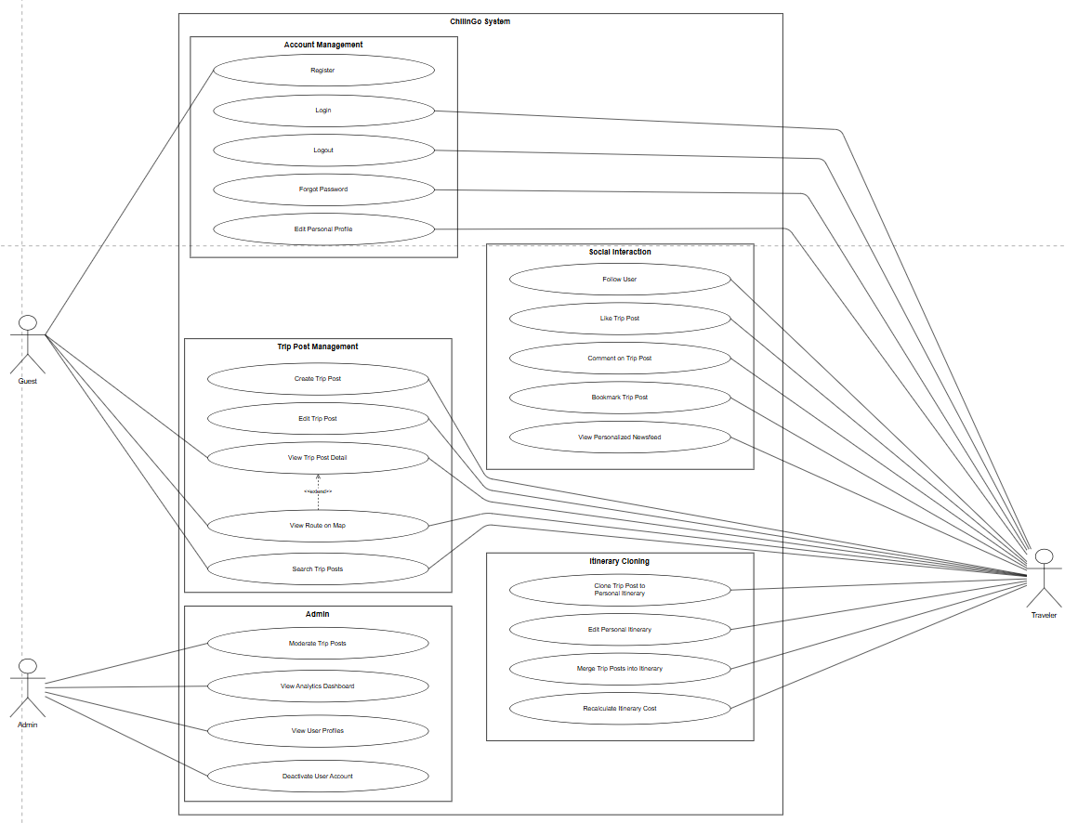
Figure 2: Use Case Overall
2.2.1.2: Trip Post & Cloning Use Case
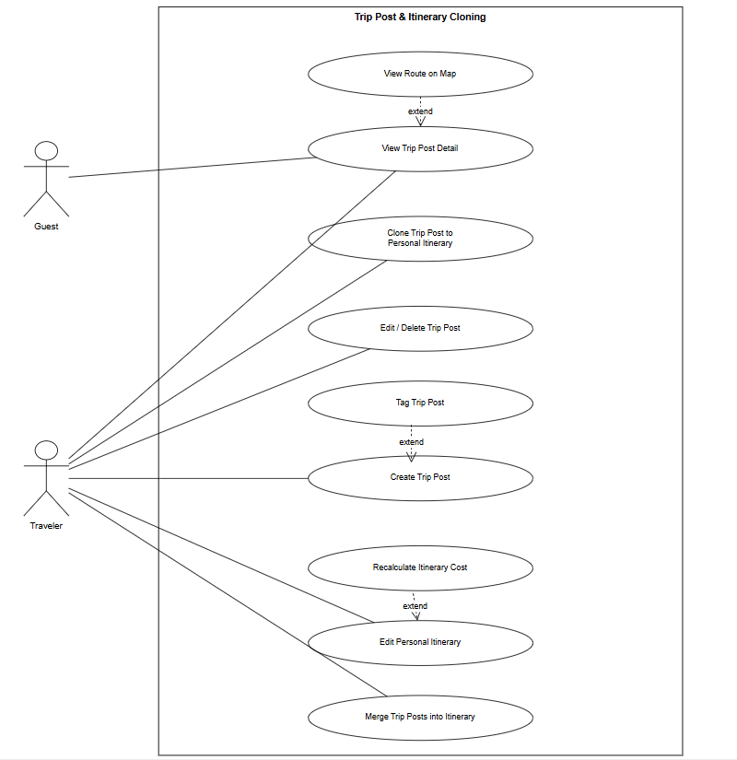
Figure 3: Use Case of Trip Post & Cloning
2.2.1.3: Social Interaction Use Case
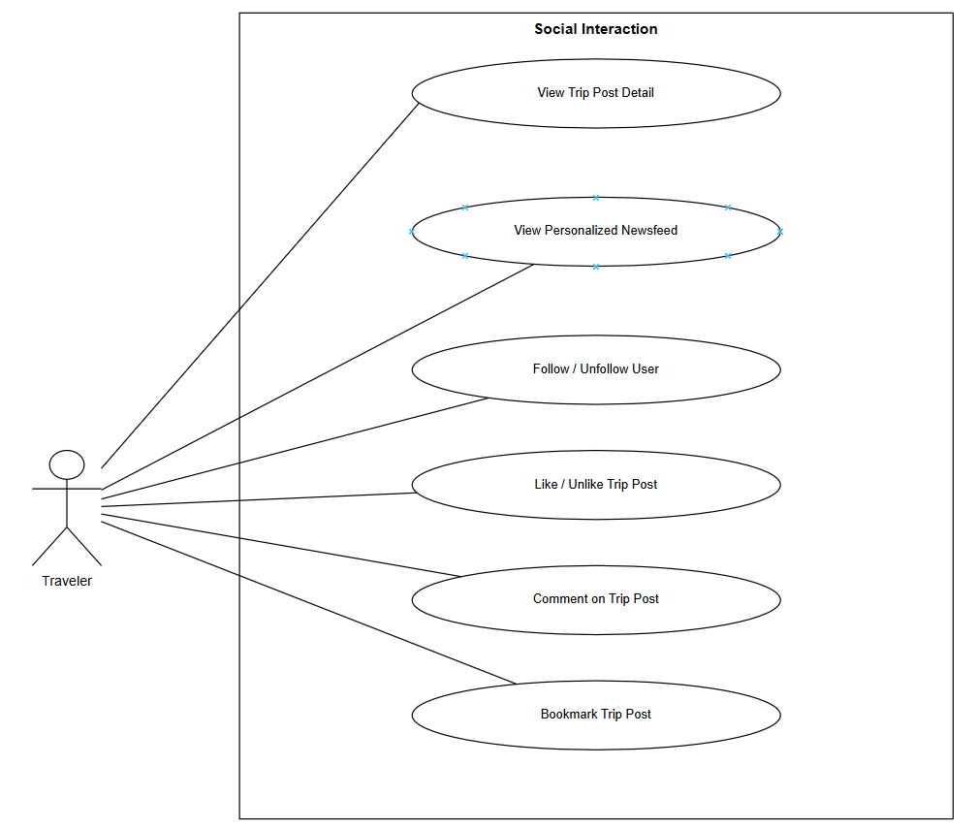
Figure 4: Use Case of Social Interaction
2.2.1.4: Admin Use Case
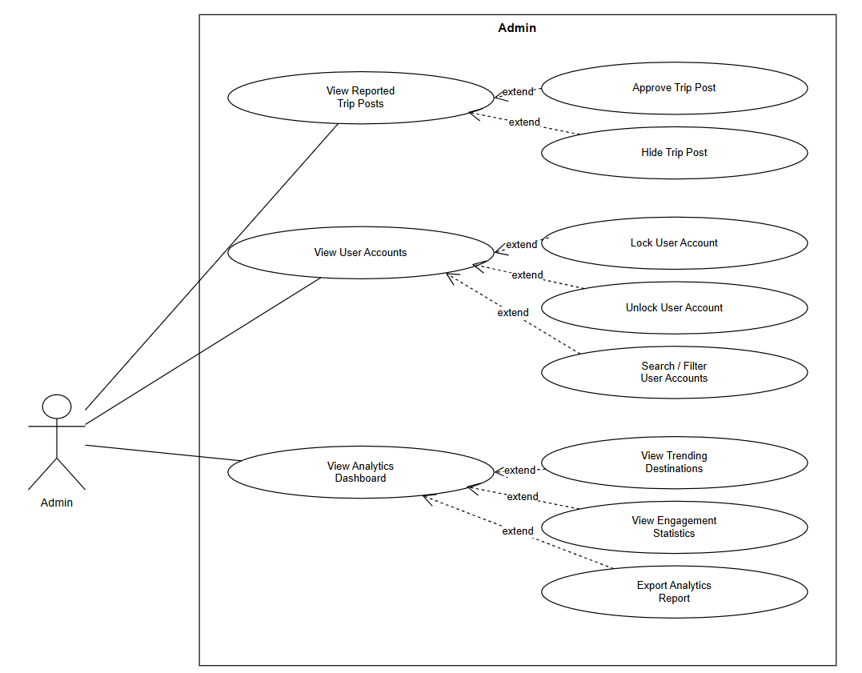
Figure 5: Use Case of Admin
2.2.1.5: Use Case of Features Added During Implementation
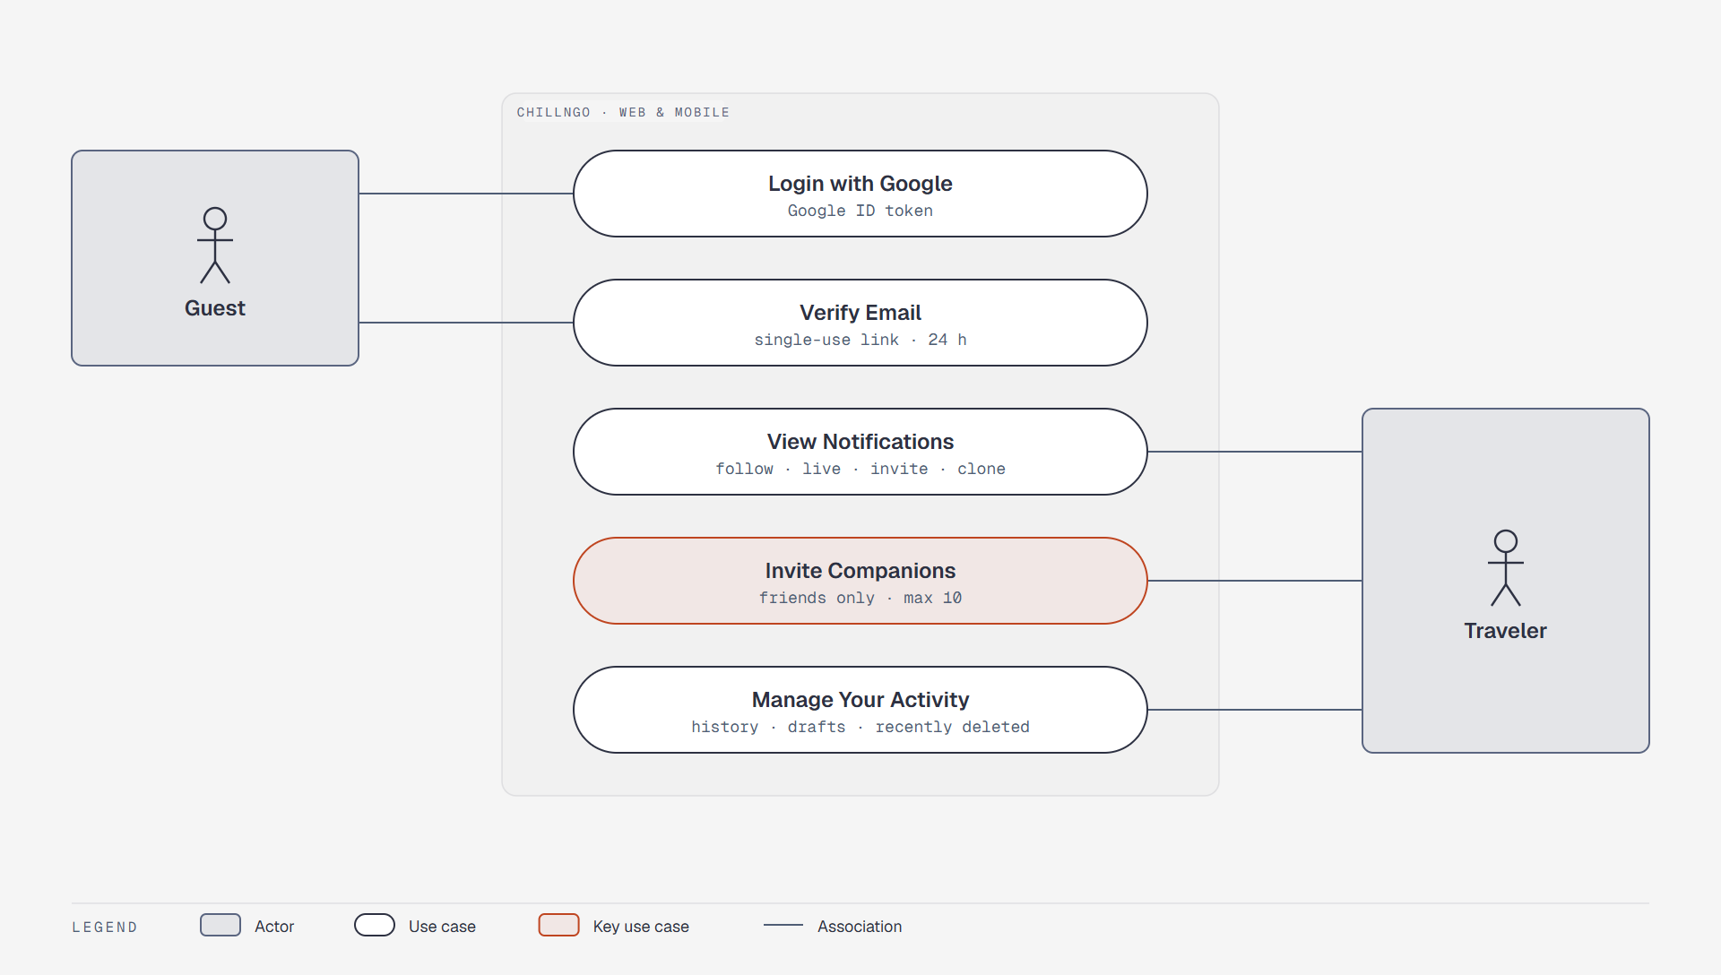
Figure 6: Use Case of account and social features added during implementation
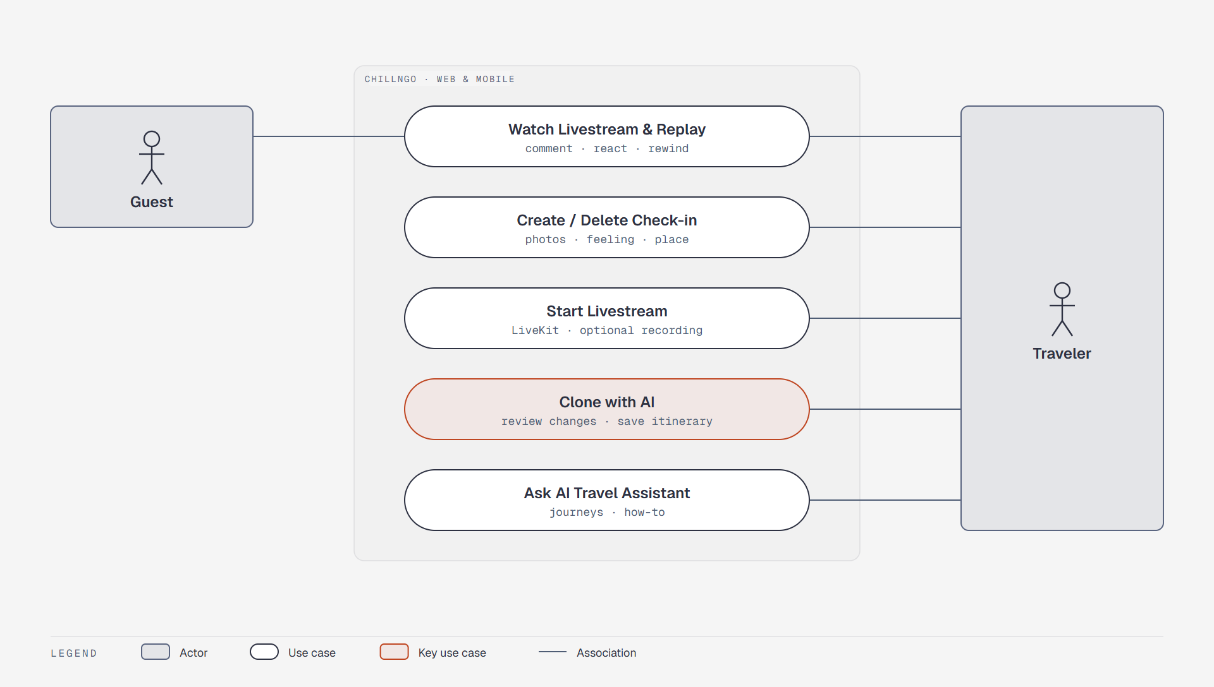
Figure 7: Use Case of check-in, livestream and AI features added during implementation
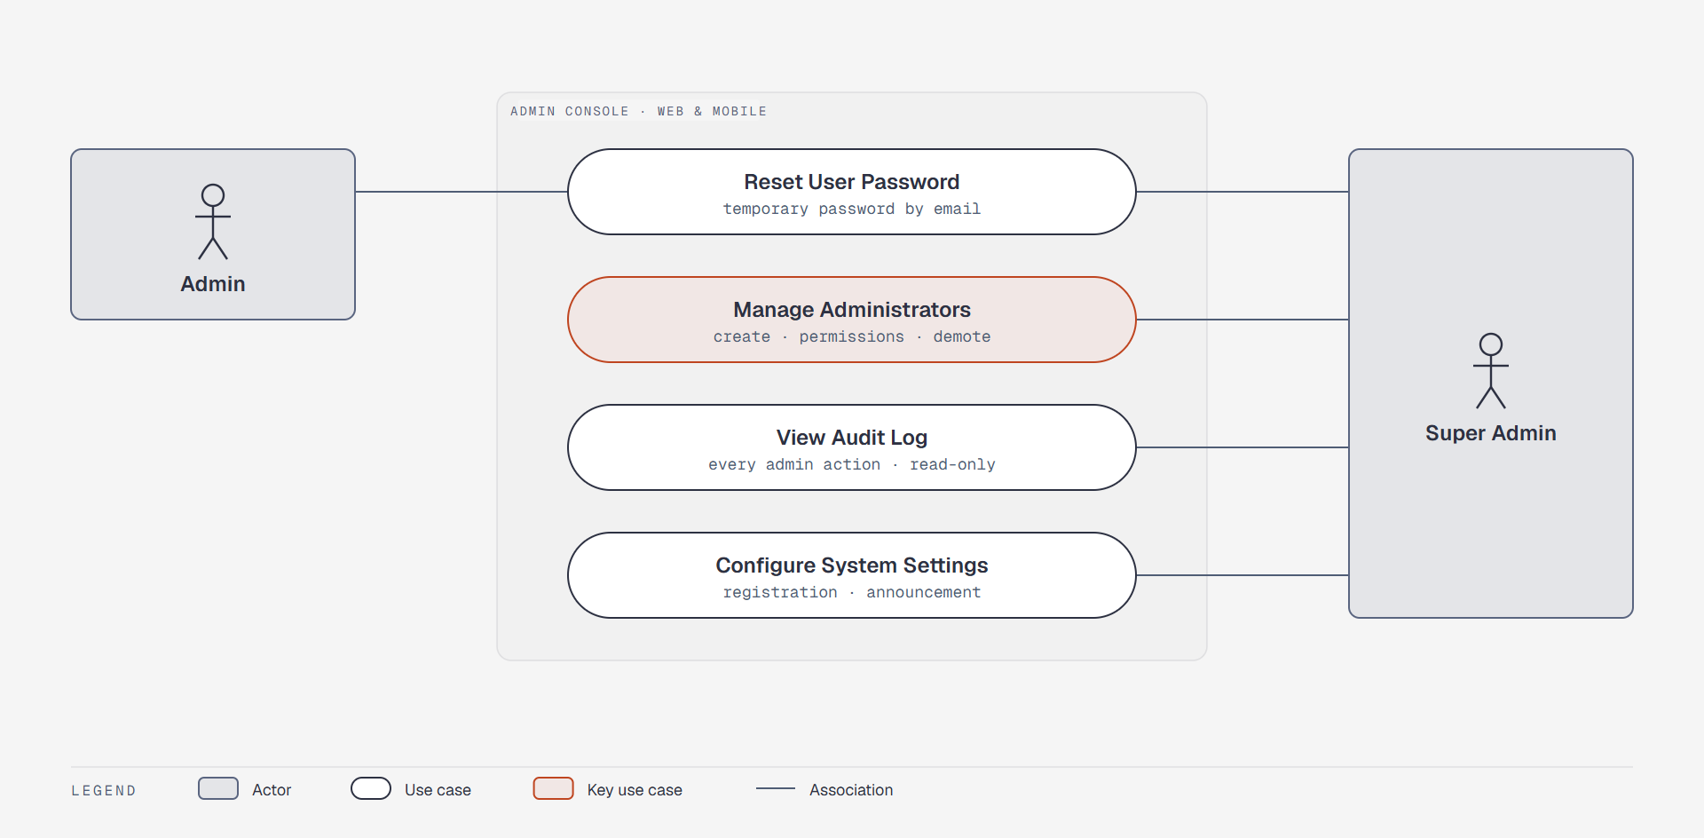
Figure 8: Use Case of administration features added during implementation
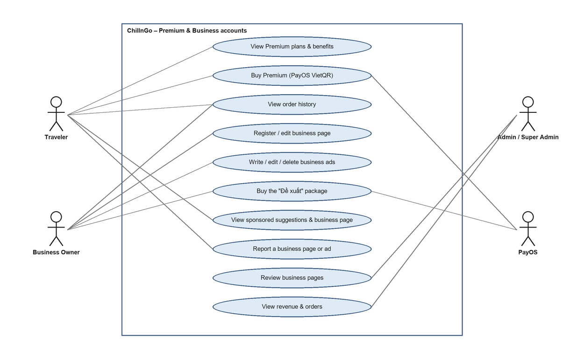
Figure 9: Use Case of Premium membership and business accounts
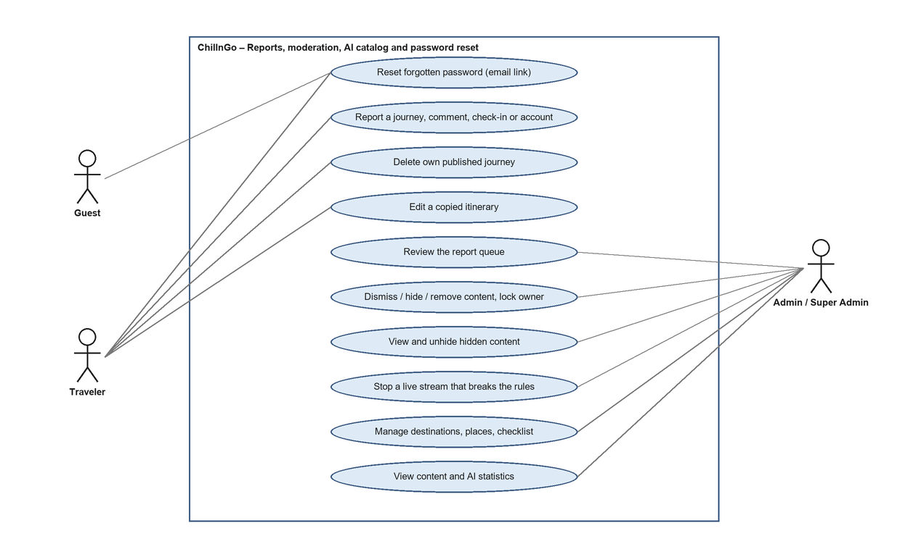
Figure 10: Use Case of reports, moderation, AI catalog and password reset
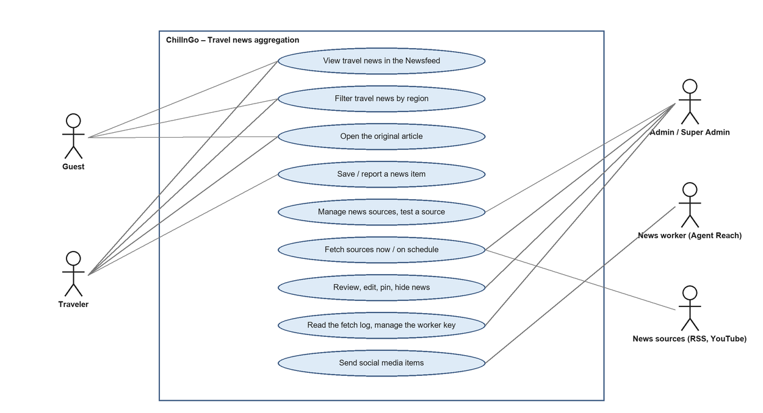
Figure 11: Use Case of travel news aggregation

2.2.2 Descriptions
ID | Use Case | Actors | Use Case Description
01 | Register / Login | Guest, Traveler, Admin, Super Admin | Create an account confirmed by email, or log in with email and password.
02 | Logout | Traveler, Admin, Super Admin | Ends the session on the current device.
03 | Verify Email | Guest | Confirms a new account through the single-use emailed link (valid 24 hours), or sends a new link.
04 | View / Edit Personal Profile | Guest (view), Traveler, Admin | Views a profile; edits one’s own name, username, bio, location, avatar and cover.
05 | Create Trip Post | Traveler | Creates a multi-day journey with stops, photos, notes and estimated costs; saves it as a draft or publishes it.
06 | Edit / Delete Trip Post | Traveler | Updates, duplicates or deletes the author’s own journey; deleted journeys can be restored for 30 days.
07 | Tag Trip Post | Traveler | Sets region, season, budget level and free tags of a journey.
08 | View Trip Post Detail | Guest, Traveler | Displays the full itinerary of a journey with its route map and social actions.
09 | View Route on Map | Guest, Traveler | Displays the stops and the route of a journey or itinerary on a Mapbox map.
10 | Follow / Unfollow User | Traveler | Follows or unfollows another traveler to see their content in the Newsfeed.
11 | Like / Unlike Trip Post | Traveler | Likes a journey or removes the like.
12 | Comment on Trip Post | Traveler | Adds a comment or reply; deletes own comments; the journey author can delete or hide comments.
13 | Bookmark Trip Post | Traveler | Saves a journey to the “want to go” list (Your activity → Saved).
14 | View Personalized Newsfeed | Guest, Traveler | Displays journeys, check-ins and live streams from followed users with one travel news item after every three, or followed users only.
15 | Copy Trip Post to Personal Itinerary | Traveler | Copies a published journey into the traveler’s own editable itinerary.
16 | Edit Personal Itinerary | Traveler | Reorders or removes days of an itinerary.
17 | Merge Trip Posts into Itinerary | Traveler | Appends days picked from other journeys to an itinerary.
18 | Recalculate Itinerary Cost | Traveler | Recalculates the total estimated cost after every change of an itinerary.
19 | Browse Explore Page | Guest, Traveler | Displays Discover: regions, interests and journeys ranked by saves and engagement.
20 | Search & Filter Trip Posts | Guest, Traveler | Searches journeys by keyword and filters them by region, season, interest and budget.
21 | Moderate Reported Content | Admin, Super Admin | Works through the report queue: dismisses, hides or removes the content or locks its owner; restores hidden content and stops live streams that break the rules.
22 | View User Accounts | Admin, Super Admin | Lists, searches and filters accounts by role and status.
23 | Lock/Unlock User Accounts | Admin, Super Admin | Locks an account with a reason, unlocks it, or emails a temporary password.
24 | View Analytics Dashboard | Admin, Super Admin | Displays account, content and AI statistics, daily sign-ups, pending reports and businesses, and revenue.
25 | Login with Google | Guest | Signs in or signs up with a Google account; links to an existing account with the same email.
26 | Create / Delete Check-in | Traveler | Shares up to 4 photos with a caption, a feeling or activity and a place.
27 | Start Livestream | Traveler | Goes live to a public, followers-only or private audience, optionally saving a replay.
28 | Watch Livestream & Replay | Guest, Traveler | Watches a live stream or replay; signed-in viewers comment and react.
29 | Copy with AI | Traveler | Adapts a journey to the traveler’s trip with AI, reviews the changes and saves the result as an itinerary.
30 | Ask AI Travel Assistant | Traveler | Asks questions about journeys and about using the website.
31 | Invite Companions | Traveler | Invites friends to appear as companions on a journey; invitees accept or decline.
32 | View Notifications | Traveler, Admin | Shows notifications about follows, live streams, invitations, Copys and comments.
33 | Manage Your Activity | Traveler | Reviews interactions, drafts, search and account history, saved journeys and saved travel news, and restores deleted items.
34 | Manage Administrators | Super Admin | Creates Admins, sets their permissions, promotes, demotes or locks them (accounts are never deleted).
35 | View Audit Log & Configure Settings | Super Admin | Reads every admin action; opens/closes registration and sets the site-wide announcement.
36 | View Plans & Buy Premium | Traveler, PayOS | Compares Free and Premium and pays for 30 or 365 days of Premium by VietQR on PayOS.
37 | View Order History | Traveler, Business Owner | Lists one’s orders with their status and continues paying an unpaid one.
38 | Register / Edit Business Page | Business Owner | Registers a homestay, hotel, restaurant, café or tour page for admin review, then edits it.
39 | Manage Business Ads | Business Owner | Writes, edits and deletes ads (title, text, photos, offer) on the business page.
40 | Buy “Đề xuất” Package | Business Owner, PayOS | Pays for 30 days of sponsored suggestions on Discover for an approved business.
41 | View Sponsored Suggestions & Business Page | Guest, Traveler | Sees sponsored businesses and ads in Discover’s “Gợi ý nổi bật” and opens a business page; signed-in users can report it.
42 | Review Business Pages | Admin, Super Admin | Approves, rejects with a reason, hides or restores business pages.
43 | View Revenue & Orders | Admin, Super Admin | Sees total and 30-day revenue, revenue per plan, Premium members, sponsored businesses and every order.
44 | Report Content | Traveler | Reports a journey, comment, check-in, account, business page or ad with a reason.
45 | Reset Forgotten Password | Guest | Requests an emailed link and sets a new password; every open session is signed out.
46 | Manage AI Catalog | Admin, Super Admin | Adds and edits the destinations, places and preparation checklist the AI Copy plans from.
47 | View Travel News | Guest, Traveler | Reads the latest travel news in the “Tin du lịch” tab, filters by region and opens a news post inside ChillnGo (text, pictures, link to the original).
48 | Save / Report Travel News | Traveler | Saves a news item to read later (Your activity → Saved) or reports it.
49 | Manage News Sources | Admin, Super Admin | Adds, tests, edits, turns on or off and deletes sources; chooses keywords, region, interval and auto-posting.
50 | Fetch News | Admin, Super Admin, News sources | Fetches due sources every hour or at once (“Cào ngay”); the AI writes a Vietnamese post from each new article and tags it.
51 | Review Travel News | Admin, Super Admin | Posts or rejects waiting news, hides or restores, pins, edits the headline, post, pictures, regions and places, asks the AI to write a post again; reads the fetch log.
52 | Send Social Media News | News worker, Admin, Super Admin | The admin creates or revokes the worker key; the worker fetches the due social media sources with Agent Reach and sends them.

3. Functional Requirements

3.1 System Functional Overview

3.1.1 Screens Flow
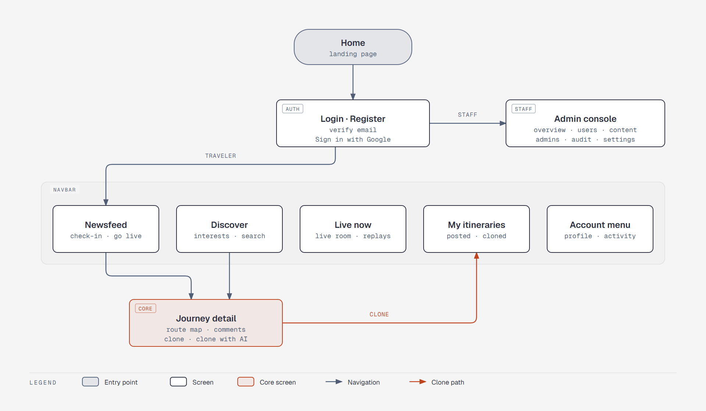
Figure 12: Screen Flow (overview)
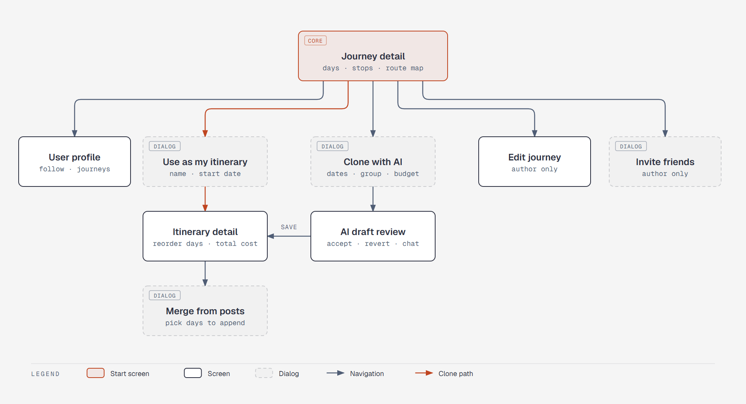
Figure 13: Screen Flow (screens reachable from a journey)
The Flutter mobile app (Android and iOS) provides the same screens laid out for phones: a bottom navigation bar replaces the web navbar, sheets replace dialogs, and staff accounts reach the same admin sections. Both clients call the same REST API, so every function described below applies to web and mobile alike.

3.1.2 Screen Descriptions
# | Feature | Screen | Description
1 | User Account Management | Login | Email/password login and “Sign in with Google”.
2 | User Account Management | Register | Display name, username, email and password with a live password checklist.
3 | User Account Management | Verify Email | Confirms the emailed link; resends the confirmation email.
4 | User Account Management | Personal Profile | Cover, avatar, bio, counts, journeys and check-ins of a user; Follow button on other profiles.
5 | User Account Management | Edit Profile | Updates display name, username, bio, location, avatar and cover.
6 | User Account Management | Account menu | Profile, Edit profile, New post, Your activity and Log out.
7 | Trip Post Management | Post / Edit Journey | Editor: basics, categories and tags, day-by-day stops with map and cost; save draft or publish.
8 | Trip Post Management | Journey Detail | Itinerary, photos, route map, like/comment/save, “Use as my itinerary” and “Copy with AI”.
9 | Social Interaction | Newsfeed | Tabs “Dành cho bạn” (followed users with one news item after every three), “Đang theo dõi” and “Tin du lịch”; the composer.
10 | Social Interaction | Comments | Comment section of a journey with one level of replies.
11 | Social Interaction | Notifications | Dropdown with the latest notifications.
12 | Social Interaction | Invite friends along | Dialog to invite friends as companions of a journey.
13 | Check-in | Check-in dialog | Photos, caption, feeling/activity and place.
14 | Livestream | Live now | Streams live now and recent replays.
15 | Livestream | Start a livestream | Camera check, title, description, audience and save option.
16 | Livestream | Livestream room | Video, comments, reactions and rewind; host controls (end, delete comments, block viewers).
17 | Itinerary Cloning | Use as my itinerary | Dialog to name the copy and choose its start date.
18 | Itinerary Cloning | My Itineraries | Tabs “Posted by me” and “Copyd”.
19 | Itinerary Cloning | Itinerary Detail | Drag to reorder days, remove days, live total cost and route map.
20 | Itinerary Cloning | Merge from other posts | Dialog to pick days from other journeys and append them.
21 | AI | Copy with AI | Step-by-step trip details and draft creation.
22 | AI | AI draft review | Changes with reasons, accept/revert, chat edits, route optimisation, Plan B, checklist, save.
23 | AI | AI travel assistant | Chat panel that answers questions about journeys and the website.
24 | Explore & Discovery | Discover | Region tabs, search with suggestions and history, interest tiles, grid or map.
25 | Explore & Discovery | Interest page / Search results | Journeys for one interest or one query.
26 | Your Activity | Your activity | Interactions, photos and videos, drafts, search history, account history, recently deleted, saved.
27 | Admin | Overview | Account, content and AI statistics, daily sign-ups chart, pending reports and businesses, revenue.
28 | Admin | Users | Search and filter accounts; lock/unlock, reset password, change role. Accounts are only locked, never deleted.
29 | Admin | Administrators | Create Admins and set their permissions (Super Admin).
30 | Admin | Content | Tabs: report queue (by content, with reasons and decisions), hidden content (restore) and live streams (stop).
31 | Admin | Audit log | Read-only log of admin actions (Super Admin).
32 | Admin | Settings | Registration switch and site-wide announcement (Super Admin).
33 | Premium | ChillnGo Premium | Free and Premium benefits, the 30- and 365-day plans with their price, Pay buttons and the order history.
34 | Premium | Payment result | Waits for PayOS to confirm the payment, then shows the plan and its end date (mobile: in-app PayOS page, then the result).
35 | Business | My business | Registration form, review status, business details, the “Đề xuất” package and the ads with their editor.
36 | Business | Business page | Public page: photos, type, address with map link, phone, hours, prices, description and ads.
37 | Explore & Discovery | Featured suggestions | “Gợi ý nổi bật” row on Discover with sponsored businesses and their latest ads, marked “Tài trợ”.
38 | Admin | Businesses | Business review queue by status: approve, reject or hide with a reason, restore.
39 | Admin | Revenue | Revenue summary, revenue per plan, Premium members, sponsored businesses and the list of orders.
40 | User Account Management | Forgot password | Email field that sends a reset link (from “Forgot password?” on the login screen).
41 | User Account Management | Reset password | New password with the live checklist and its confirmation.
42 | Admin Content Moderation | Report dialog | Reason (spam, inappropriate, scam, misinformation, harassment, other) and an optional note.
43 | Itinerary Cloning | Edit itinerary | Name, note, start date, status and every day and stop of a copied itinerary.
44 | Admin | Categories | AI catalog: places, destinations and preparation checklist editors.
45 | Travel News | Newsfeed → Tin du lịch | News only, newest first with pinned news on top; region chips; “Xem thêm tin” loads more.
46 | Travel News | News card | Cover picture, source, time, headline, AI summary, regions and places, like a journey card; opens the news post page; save and the “…” report menu.
47 | Admin | News: Sources | Sources with type, last fetch, counts, on/off and auto-post toggles, “Cào ngay”, edit and delete; “Cào tất cả ngay”.
48 | Admin | News: Source dialog | Name, type, link or keyword, platform, include/exclude keywords, default region, interval, toggles and “Thử nguồn”.
49 | Admin | News: Review tabs | “Chờ duyệt”, “Đã đăng”, “Đã ẩn”, “Bị loại”: bulk and single decisions, pin, “Sửa bài” (headline, summary, paragraphs, pictures, “Viết lại bằng AI”); fetch log; worker key.
50 | Your Activity | Saved → Tin du lịch | Travel news the user saved, with unsave.
51 | Travel News | News post page | Headline, summary, cover or YouTube player, the post’s paragraphs with pictures between them, more pictures, places, the source note and “Đọc bài gốc”; save and report.

3.1.3 Screen Authorization
Screen | Guest | Traveler | Admin
Login / Register / Verify Email | X | X | X
Personal Profile (view) | X | X | X
Edit Profile / Account menu |  | X | X
Post / Edit Journey |  | X
Journey Detail / Route map | X | X | X
Newsfeed | X (log-in prompt) | X
Comments | X (view only) | X
Notifications |  | X | X
Invite friends along |  | X (author)
Check-in dialog / Start a livestream |  | X
Live now / Livestream room | X (watch only) | X
Use as my itinerary / My Itineraries / Itinerary Detail / Merge |  | X
Copy with AI / AI draft review / AI travel assistant |  | X
Discover / Interest page / Search results | X | X | X
Your activity |  | X | X
Admin: Overview |  |  | X (stats permission)
Admin: Users |  |  | X (users permission)
Admin: Content |  |  | X (content or reports permission)
Admin: Administrators / Audit log / Settings |  |  | X (Super Admin only)
ChillnGo Premium / Payment result |  | X
My business |  | X
Business page / Featured suggestions | X | X
Admin: Businesses |  |  | X (businesses permission)
Admin: Revenue |  |  | X (revenue permission)
Forgot / Reset password | X
Report dialog / Edit itinerary |  | X
Admin: Categories (AI catalog) |  |  | X (categories permission)
Newsfeed: Tin du lịch tab | X | X
Save / report a news item |  | X
Admin: News |  |  | X (news permission)
News post page | X | X

3.1.4 Non-Screen Functions
Feature | System Function | Description
Trip Post Management | Signed Image Upload | The API issues a signed Cloudinary upload; the browser sends the image directly and the API checks it (format, size, owner folder) before storing its URL.
Trip Post Management | Retention Cleanup | Purges journeys and check-ins deleted more than 30 days ago, with their Cloudinary images.
Social Interaction | Newsfeed Query | Returns published journeys and check-ins of followed users, newest first, plus the live streams the viewer may watch; the first page of travel news is mixed in.
Social Interaction | Notification Service | Creates notifications (follow, live, invite, Copy, comment) and deletes them after 90 days through a TTL index.
Itinerary Cloning | Copy Engine | Copies a journey’s days and stops into a new Itinerary with new ids, re-dates them from the chosen start date, and increases the source’s Copy count.
Itinerary Cloning | Merge & Cost Recalculation Engine | Appends selected days from other journeys, renumbers and re-dates them, records the sources and recalculates the total estimated cost.
AI | AI Copy Engine | Builds the candidate places, asks the AI models (Gemini → LiveKit Inference), validates the answer, computes costs and feasibility warnings, and keeps drafts for 24 hours.
AI | Assistant Tools | Read-only lookups the assistant may run as the signed-in user (published journeys, one journey, own journeys and drafts, website guide).
Explore & Discovery | Discover Ranking | Lists published journeys ordered by saves and engagement and applies region, season, interest and budget filters.
Livestream | Livestream Monitor & Webhook | Ends streams whose room is gone or whose host left for more than 45 seconds; handles LiveKit webhooks for room end and finished recordings.
User Account Management | Email Service | Sends confirmation emails, password reset links and temporary passwords over SMTP (printed in the terminal when SMTP is not configured).
Admin | Audit Logger | Writes one audit-log row per admin action, with copied names of the actor and target.
Premium | PayOS Client | Creates checkout links and reads payment status from PayOS; requests and webhooks are signed with HMAC-SHA256 over the fields sorted by name.
Premium | Payment Webhook & Reconciliation | Verifies each PayOS webhook, turns an order paid exactly once after checking the amount, extends Premium or the “Đề xuất” package and notifies the buyer. A pending order is also checked with PayOS when the buyer comes back, so a missed webhook loses no payment.
Premium | Plan Entitlements | Reads premiumUntil to decide the daily AI allowance (10 or 100), the livestream quality (720p or 1080p), the replay keeping time (30 or 365 days) and the crown badge.
Premium | Renewal Reminder | Sends one notification when fewer than 3 days of Premium are left.
Livestream | Replay Retention | Sets each replay’s expiry the first time it is seen ready and deletes the file from the bucket once the expiry has passed.
Admin | Automatic Hide | Hides a journey, comment, check-in, business page or ad as soon as 5 different people have reported it; a moderator who dismisses the reports shows it again.
Admin | Content Statistics | Counts journeys, check-ins, live and recorded streams, hidden content, reports and AI requests for the overview.
Travel News | Scheduled Fetch | GitHub Actions calls GET /api/news/cron every hour and Vercel once a day (Bearer CRON_SECRET); up to 12 due sources are read per run.
Travel News | AI Post Writing & Tagging | For up to 6 new items per run: opens the original article, extracts its main text and pictures, and has the AI answer whether it is travel news and write a Vietnamese headline, a 2–3 sentence summary, up to 8 paragraphs, a region and the catalog destinations it mentions; retries 3 times. The article text is not stored.
Travel News | Social Media Worker | tools/news-worker/worker.mjs on a team computer runs Agent Reach for the due social media sources and posts the items with its key (X-Worker-Key).

3.1.5 Entity Relationship Diagram
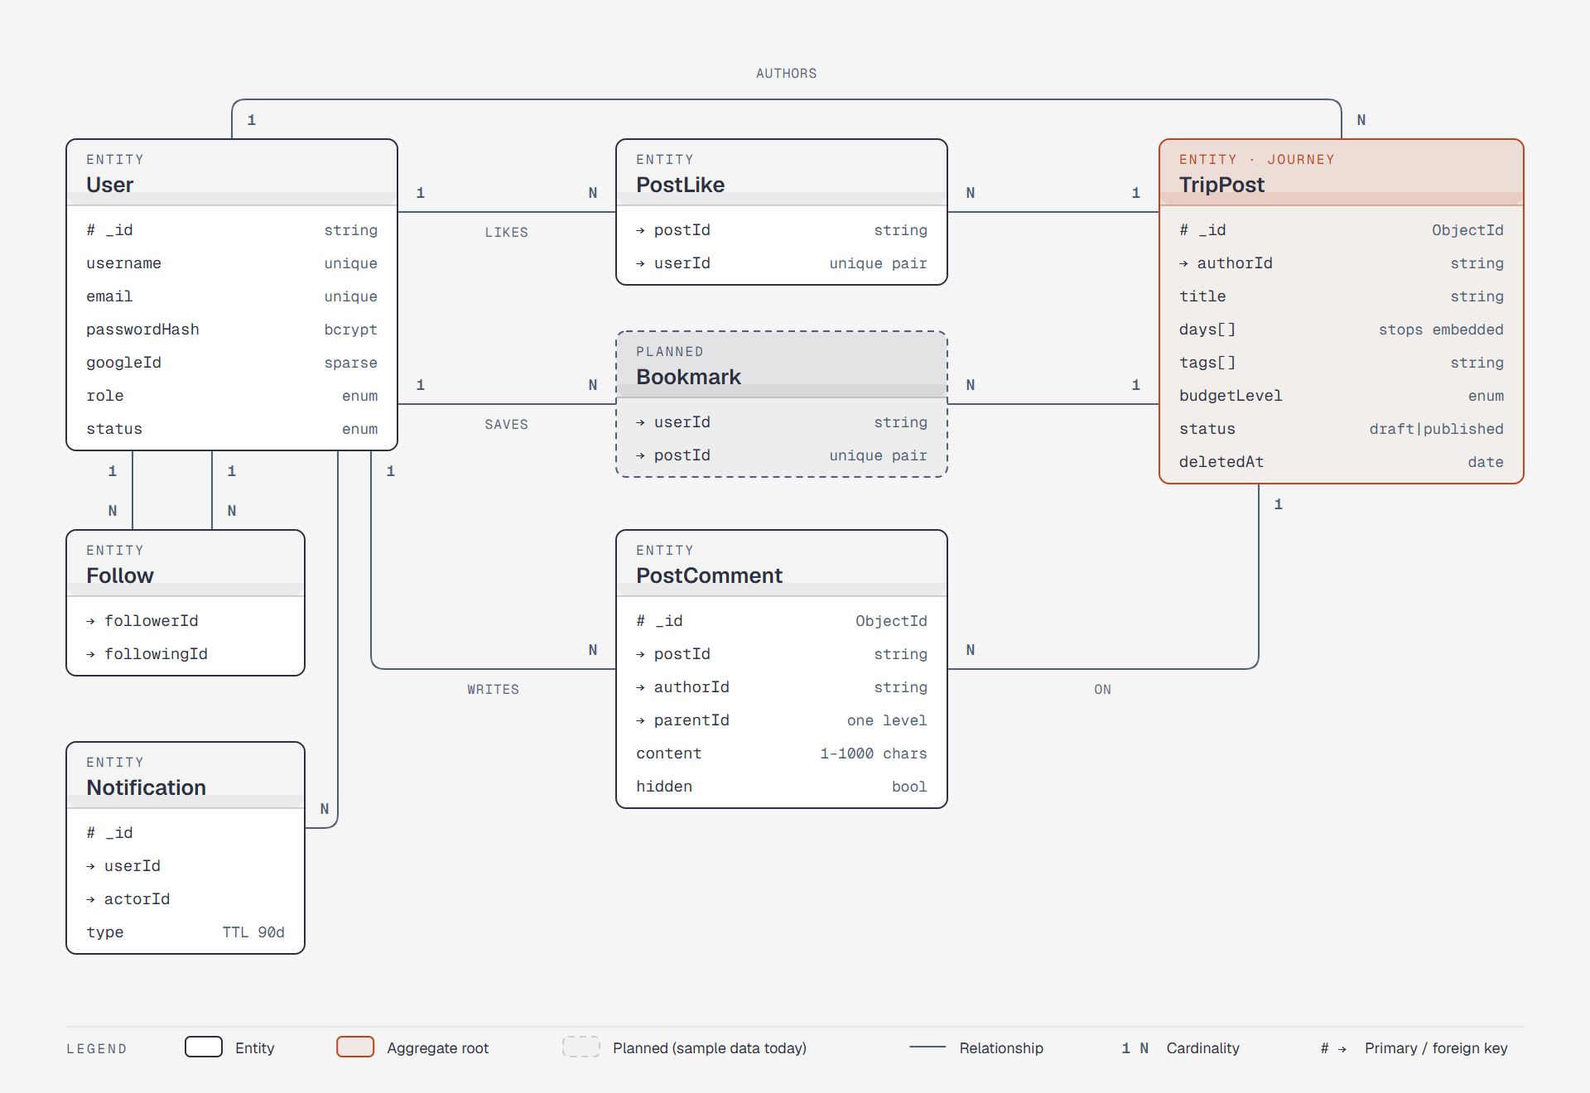
Figure 14: ERD (journeys and social interaction)
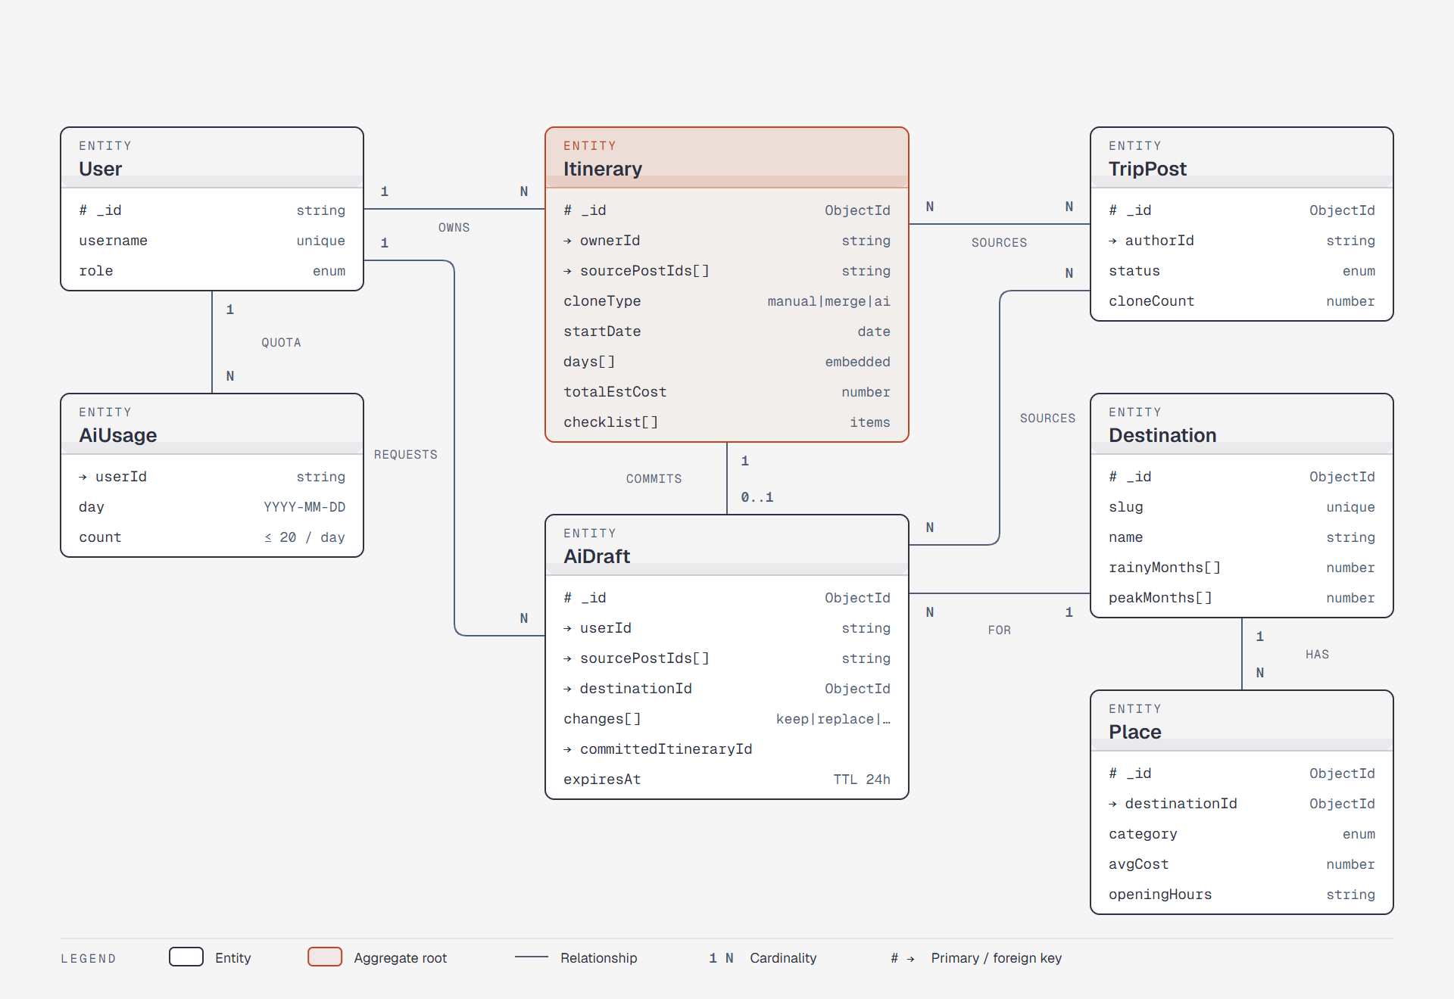
Figure 15: ERD (itineraries and AI Copy)
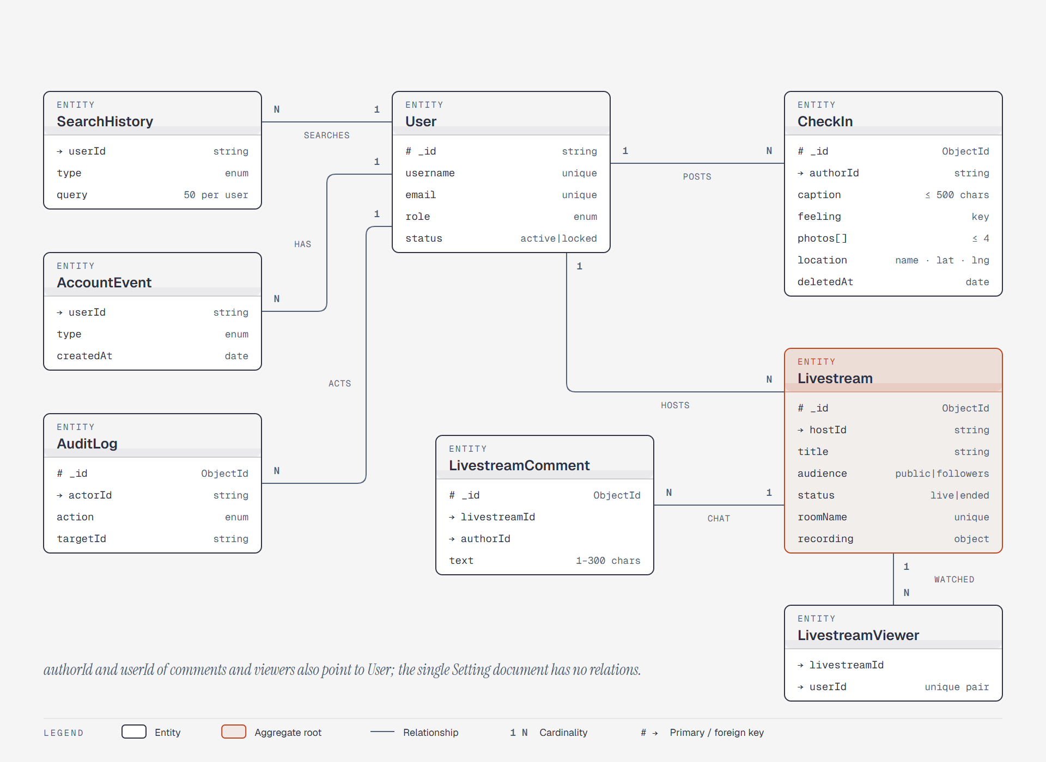
Figure 16: ERD (check-ins, livestreams and account history)
Entities Description
Each entity is a MongoDB collection. Days and stops (locations) are embedded inside TripPost and Itinerary documents, and tags are a string array on TripPost, so they have no collection of their own.
# | Entity | Description
1 | User | An account (Traveler, Admin or Super Admin): credentials (bcrypt hash, Google id), profile, counters, role, admin permissions, lock state and email-verification data.
2 | TripPost | A journey: author, title, summary, cover photos, region, season, budget level, tags, embedded days with stops (name, address, coordinates, notes, cost, photos), route GeoJSON, counters, companions, draft/published status and soft-delete date.
3 | PostLike | A like of a User on a TripPost (unique per pair).
4 | PostComment | A comment or one-level reply on a TripPost; can be hidden by the journey’s author.
5 | Bookmark | A TripPost saved by a User (planned collection; served from sample data today).
6 | Follow | A follow relationship between two Users (follower, following; unique per pair).
7 | Itinerary | A personal plan Copyd, merged or AI-adapted from one or more TripPosts: owner, source journey ids, Copy type, embedded days, total cost, checklist.
8 | Notification | A notification for a User (follow, live, invite, Copy, comment); expires after 90 days.
9 | CheckIn | A photo check-in: up to four photos, caption, feeling or activity and place; soft-deleted.
10 | Livestream | A live session: host, title, audience, status, LiveKit room, statistics, blocked viewers and recording state.
11 | LivestreamComment | A chat comment in a livestream.
12 | LivestreamViewer | One row per signed-in person who watched a livestream (unique viewers).
13 | SearchHistory | A search made by a User (user, place, post, journey); 50 kept per user.
14 | AccountEvent | A change to a User’s own account shown in Account History.
15 | AuditLog | One row per admin action, readable only by the Super Admin.
16 | Setting | The single system-settings document: registration open flag and site-wide announcement.
17 | Destination | A destination known to the AI Copy: name, region, position, rainy and peak months, festivals.
18 | Place | A place of a Destination: category, position, average cost, price level, opening hours, booking need, rating.
19 | AiDraft | An AI Copy draft under review: form input, plan, changes, chat history, checklist; expires after 24 hours.
20 | AiUsage | The number of AI requests a User made on a day (daily limit).
21 | ChecklistTemplate | A preparation-checklist item tagged by trip kind, used by the AI Copy.
22 | Order | A purchase of Premium or the “Đề xuất” package: PayOS order code, buyer, plan, amount, days, status (pending, paid, cancelled, expired), payment time and the plan end it produced.
23 | Business | A business page owned by one user: name, type, address, position, phone, website, photos, prices, opening hours, review status and reason, “Đề xuất” end date, moderation.
24 | BusinessPost | An ad of a Business: title, text, photos, offer line, soft delete and moderation.
25 | Report | One person’s report about a journey, comment, check-in, account, business page or ad: reason, note, a snapshot of the content, status and the moderator’s decision.
26 | NewsSource | A place news comes from: name, type (RSS, Google News, YouTube channel, social media + platform), link or keyword, keywords, default region, on/off, auto-post, interval and the last fetch.
27 | NewsItem | One news post: canonical link (unique), the source’s title and excerpt, the AI’s headline, summary and paragraphs, the cover and up to 12 picture links, when the post was written, kind, author, date, status (queued, pending, published, rejected, hidden), regions, places, pinned, AI status and clicks.
28 | NewsRun | One fetch of a source: how it was started, items read, new, duplicates, filtered, error and duration; kept 30 days.
29 | NewsSave | A news item a user saved, with the time.
30 | NewsWorker | The worker key (SHA-256 hash and its first characters), who created it, when, and when the worker last connected.

3.2 User Account Management

3.2.1 Register / Login
Function trigger:
A guest opens the Register or Login page (the “Get started” / “Log in” buttons in the navbar) and submits the form.
Function description:
- Actors: Guest, Traveler, Admin, Super Admin
- Purpose: Create an account that is confirmed by email, or sign in to an existing account with email and password.
Data Processing:
- Register: validate the display name (1–60 characters), the username (3–30 characters: lowercase letters without accents, digits, “.” or “_”), the email format and the password policy (BR-014). Refuse the request if the Super Admin has closed registration.
- Register: check that the email and the username are not taken, hash the password with bcrypt, create the account as an unverified Traveler and email a single-use confirmation link (BR-017). No session is created yet.
- Login: find the account by email (case-insensitive) and compare the bcrypt hash; refuse accounts whose email is not confirmed, accounts created with Google only, and locked accounts.
- Login: on success issue a signed JWT (default lifetime 7 days) together with the public user profile. The client keeps it in local storage and sends it as a Bearer token.
Screen layout:
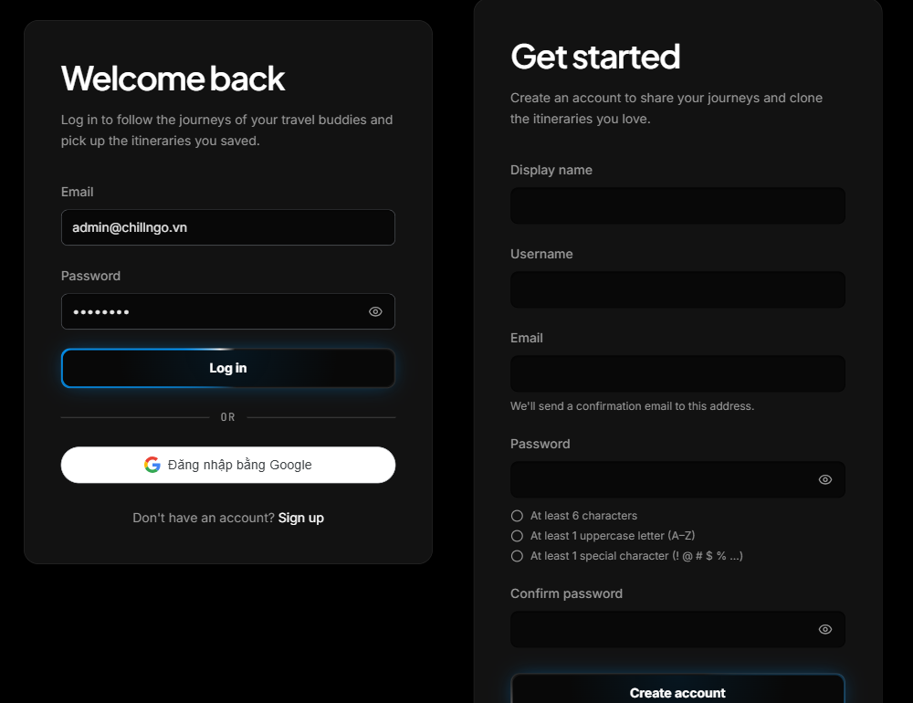
Figure 17: Login and Register screens
Function Details:
Validation:
- Email must have a valid format; it is lowercased before saving, so login is case-insensitive.
- Password must have 6–72 characters with at least one uppercase letter and one special character (register, BR-014). The register form shows a live checklist.
- Email and username must not already be registered.
Business Rules:
- A new account starts with the Traveler role and must confirm its email before the first login (BR-017).
- A wrong email and a wrong password get the same message, so the system does not reveal which emails exist.
- 20 failed login attempts from one IP within 15 minutes are refused with HTTP 429 (BR-015).
Functionalities
Normal case:
- The guest submits valid registration details; the system creates the account and asks the guest to check their email.
- The user opens the emailed link (see 3.2.3), then logs in with email and password.
- The system issues the token and opens the application; staff accounts can also open the admin console.
Abnormal case:
- Wrong email or password: “Incorrect email or password.” (MSG01)
- Email or username already used: “This email is already registered.” / “This username is already taken.”
- Email not confirmed: the system asks the user to confirm it or to resend the confirmation email (MSG13).
- Account created with Google and without a password: the system asks the user to continue with Google.
- Locked account: the system refuses the login and shows the reason given by the admin (MSG11).

3.2.2 Logout
Function trigger:
A signed-in user opens the account menu (avatar in the navbar) and clicks “Log out”.
Function description:
- Actors: Traveler, Admin, Super Admin
- Purpose: End the session on the current device.
Data Processing:
- Remove the JWT and the cached user from the client store (Zustand, persisted in local storage) and drop cached server data.
- Return the user to the public pages.
- Tokens are stateless: besides logout, any 401 answer from the API (expired token, locked account) signs the client out automatically.
Screen layout:
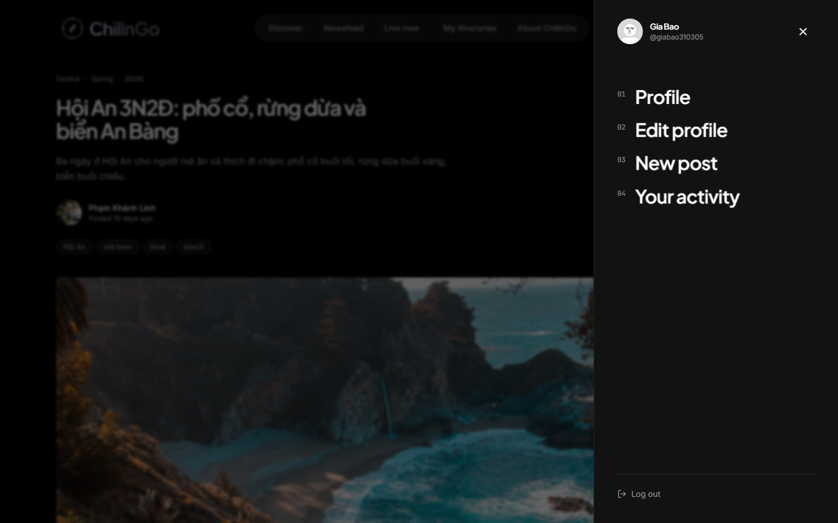
Figure 18: Account menu with the Log out action
Function Details:
Validation:
- The account menu is shown only to a signed-in user.
Business Rules:
- After logout, protected pages (journey editor, itineraries, Your activity, live room, profile edit, admin console) redirect to Login.
Functionalities
Normal case:
- The user clicks “Log out”.
- The system clears the session.
- The user is returned to the public pages.
Abnormal case:
- If the token has expired or the account was locked in the meantime, the next API call returns 401 and the app signs the user out by itself.

3.2.3 Verify Email
Function trigger:
The user opens the confirmation link from the verification email, or asks for a new link from the Login or Verify Email screen.
Function description:
- Actors: Guest
- Purpose: Confirm that the registered email belongs to the user before the first login.
Data Processing:
- Find the account by the SHA-256 hash of the token in the link; the raw token is never stored.
- If the token is valid and less than 24 hours old, mark the email as confirmed, invalidate the token and sign the user in.
- Resend: create a new link that replaces the previous one, at most once a minute, and send it over SMTP.
Screen layout:
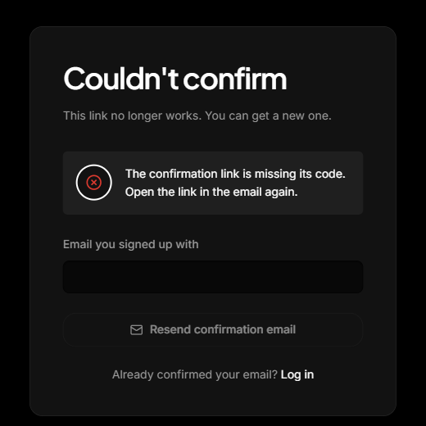
Figure 19: Verify Email screen (invalid link, with Resend confirmation email)
Function Details:
Validation:
- The link must be valid, unused and less than 24 hours old.
- Resend requires an email that is registered and not yet confirmed.
Business Rules:
- Confirmation links are single use and expire after 24 hours (BR-017).
- Forgotten passwords: the user asks for a reset link from “Forgot password?” on the login screen (3.2.5); an Admin can also email a temporary password from User Management.
Functionalities
Normal case:
- The user opens the link.
- The system confirms the email and signs the user in.
- The user lands in the application.
Abnormal case:
- Invalid or expired link: “Couldn't confirm”, with a form to resend the confirmation email.
- Email already confirmed: the system asks the user to log in.
- Resend requested again within a minute: the system asks the user to wait.

3.2.4 View / Edit Personal Profile
Function trigger:
The user opens “Profile” from the account menu or another traveler's name, or clicks “Edit profile”.
Function description:
- Actors: Guest (view), Traveler, Admin
- Purpose: View a public profile (cover, avatar, bio, journeys, check-ins, follower counts) and update one's own profile and images.
Data Processing:
- Fetch the public profile (no email or admin details), the follower/following counts and whether the viewer follows it.
- On edit: validate and save the display name, username, bio and location, and record the change in Account History.
- On image change: request a signed upload, send the image from the browser straight to Cloudinary, then let the API check it (format, under 10 MB) before storing its URL.
Screen layout:
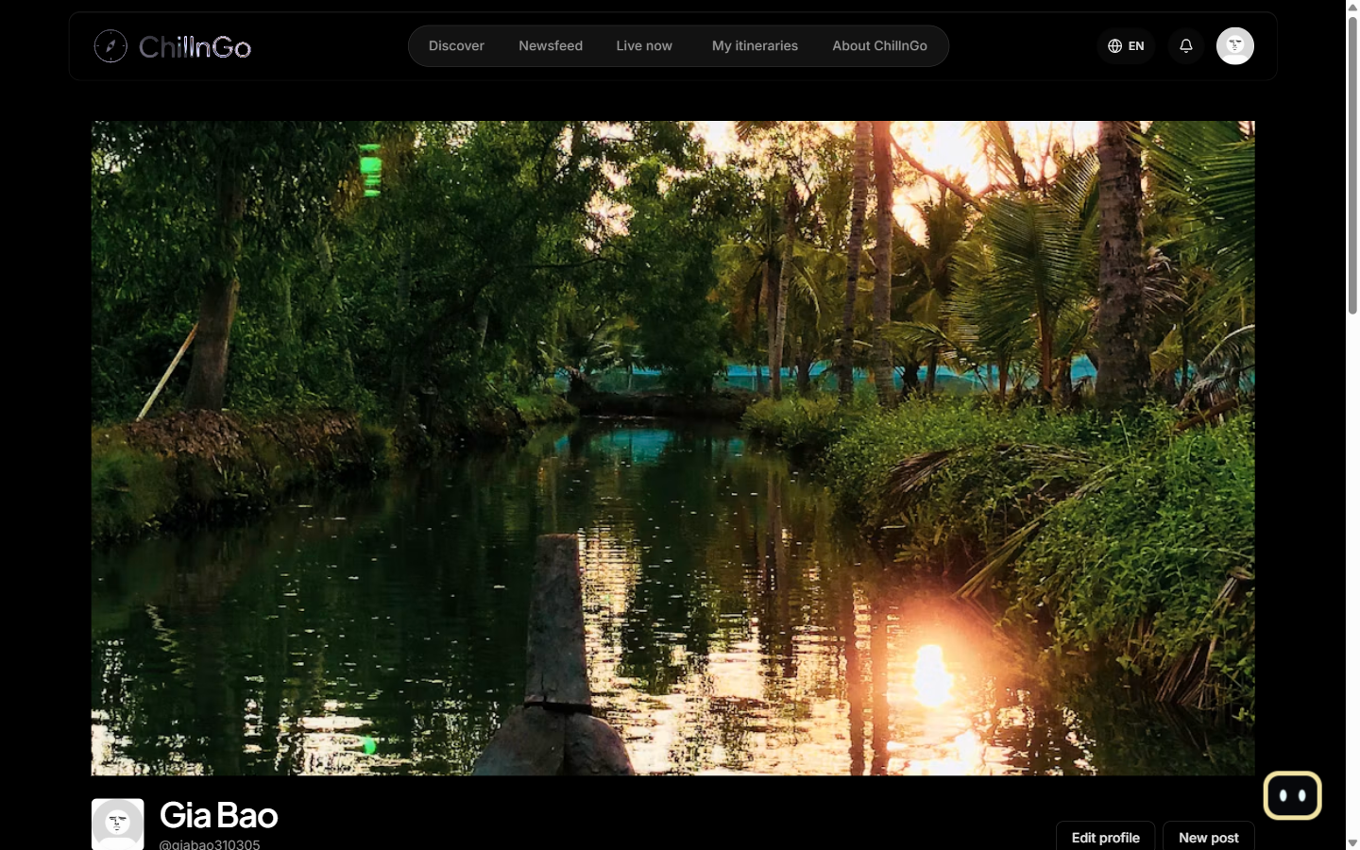
Figure 20: Personal Profile screen
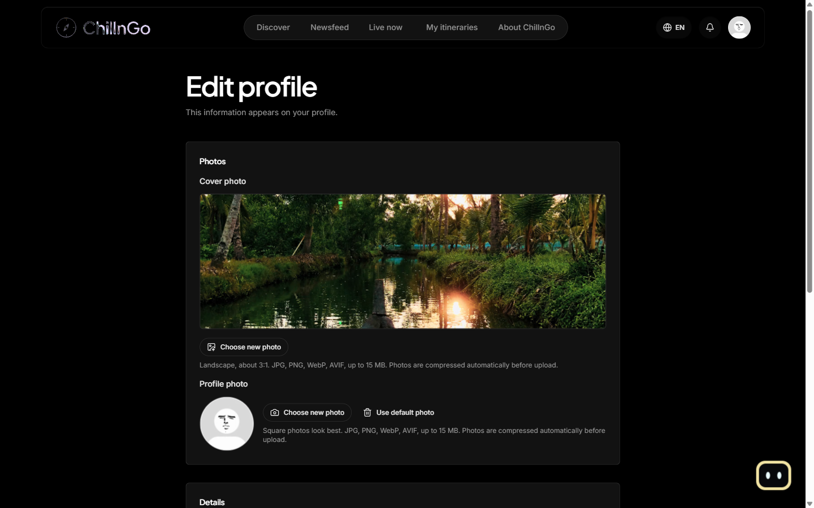
Figure 21: Edit Profile screen
Function Details:
Validation:
- Editable fields: display name (1–60 characters), username (unique), bio, location, avatar and cover photo; the email cannot be changed.
- Images must be JPG, PNG, WebP or AVIF and at most 15 MB; the browser shrinks them before upload.
Business Rules:
- Users can only edit their own profile.
- Profile changes are recorded with a timestamp in Account History (Your activity).
Functionalities
Normal case:
- The user edits the allowed fields and saves.
- The system validates and updates the profile.
- The user sees a success message and the updated profile.
Abnormal case:
- Empty display name: “Please enter a display name.”
- Username already taken: “This username is already taken.”
- Unsupported or oversized image: the image is refused with the list of accepted formats.

3.2.5 Reset Forgotten Password
Function trigger:
The user clicks “Forgot password?” on the login screen and then the link in the email.
Function description:
- Actors: Guest
- Purpose: Get back into an account without help from an admin.
Data Processing:
- The user enters the account’s email; the system always answers the same way, so it does not reveal which emails are registered.
- For a registered, unlocked account the system emails a single-use link valid for 60 minutes; only the SHA-256 hash of its token is stored.
- The link opens “Set a new password”: the new password follows the password rules (BR-014), and is typed twice.
- Saving the password invalidates the link and signs out every open session (tokens issued before the change stop working); the user then logs in.
Screen layout:
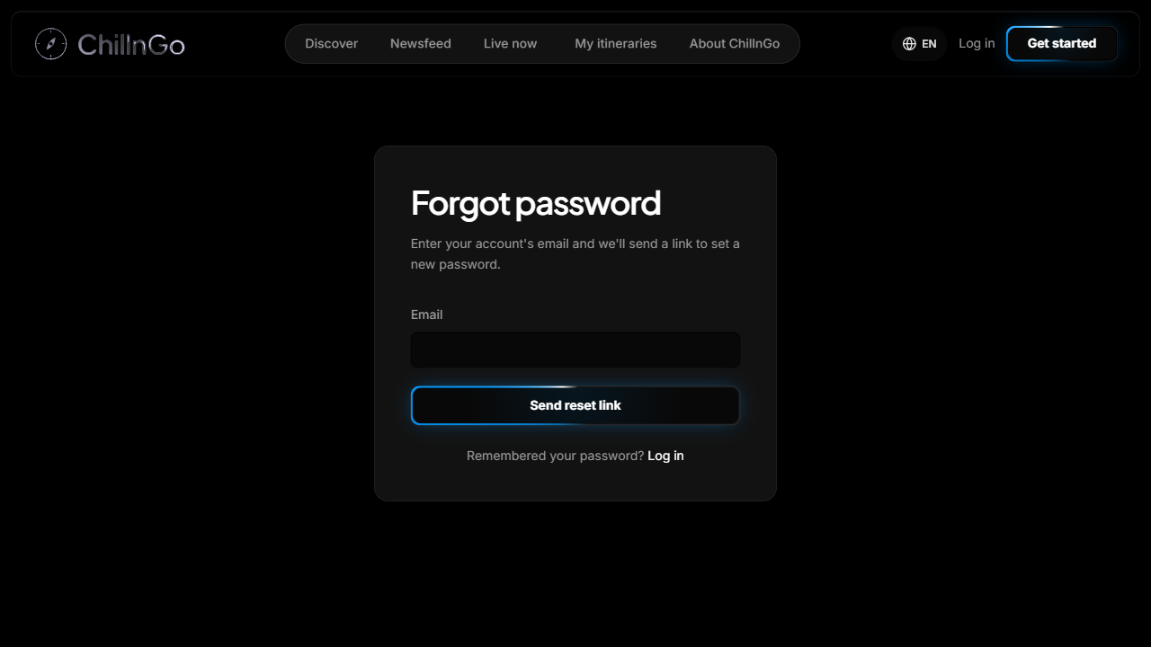
Figure 22: Forgot password screen
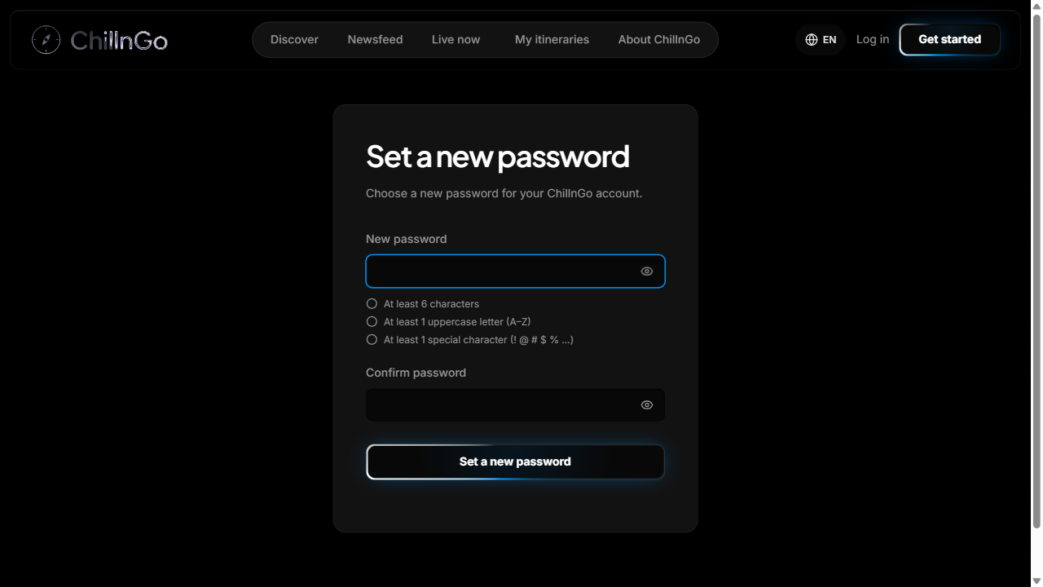
Figure 23: Set a new password screen
Function Details:
Validation:
- A valid email is required; a new link can be requested once a minute.
- The new password and its confirmation must match and follow BR-014.
Business Rules:
- BR-014 and BR-032.
Functionalities
Normal case:
- The user receives the email, sets a new password and logs in with it.
Abnormal case:
- Invalid, used or expired link: “The password reset link is invalid, already used or expired.” (MSG25)
- Requested again within a minute: the system asks the user to wait.

3.3 FE-01: Trip Post Creation & Management

3.3.1 Create Trip Post
Function trigger:
The traveler clicks the prompt on the Newsfeed, “New post” in the account menu, or “Post a journey” on My itineraries.
Function description:
- Actors: Traveler
- Purpose: Publish a multi-day journey (trip post) with stops, photos, notes and estimated costs, or save it as a draft.
Data Processing:
- Basics: title (up to 150 characters), summary (up to 1000 characters) and up to 10 cover photos uploaded directly to Cloudinary.
- Categories: region, season, budget level and tags (see 3.5).
- Itinerary: up to 60 days; each day has a title, a date and up to 30 stops. A stop comes from place search, a pasted Google Maps link or coordinates, or a pin on the map, and has an address, notes, an estimated cost and photos.
- The total estimated cost is added up from the stops automatically, and the route map shows the pinned stops by day.
- “Save draft” keeps the journey as a draft (Your activity → Journeys); “Post a journey” publishes it.
Screen layout:
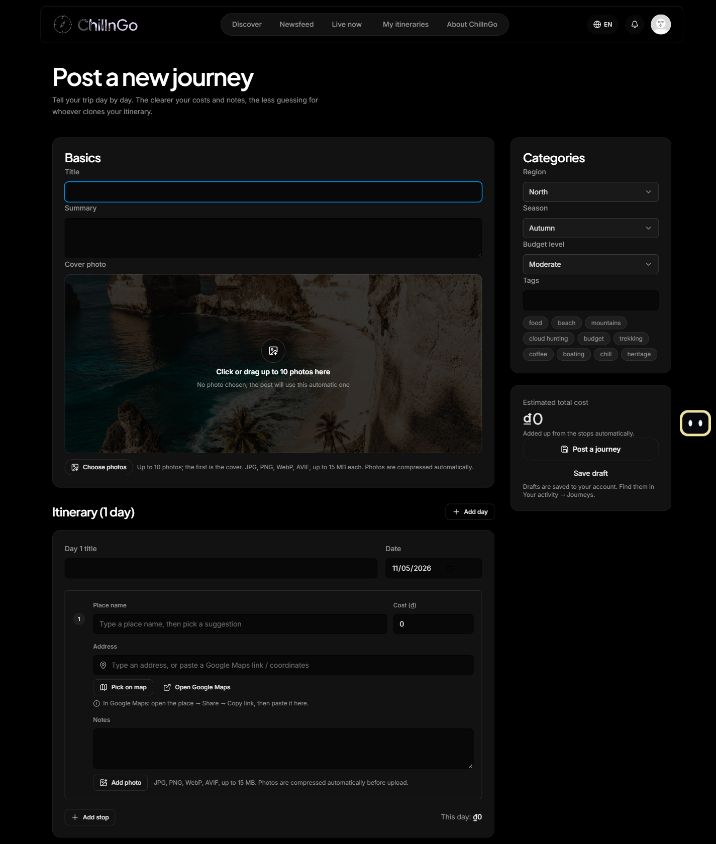
Figure 24: Post a new journey screen
Function Details:
Validation:
- Publishing requires a title and a summary; a draft may be incomplete.
- Coordinates must be valid (latitude −90..90, longitude −180..180) and costs cannot be negative.
Business Rules:
- A journey has at least one day; publishing requires a title and a summary (BR-001).
- Only published journeys are visible to other users (BR-011).
Functionalities
Normal case:
- The traveler fills in the journey and clicks “Post a journey”.
- The system saves the journey and its route.
- The traveler is taken to the published journey.
Abnormal case:
- Missing title or summary when publishing: “Please add a title and a summary before posting.”
- A photo that fails to upload is not attached; the traveler can try again.

3.3.2 Edit / Delete Trip Post
Function trigger:
The author clicks “Edit” on their journey, deletes it from its page (“Delete journey”), from the editor or from Your activity → Journeys.
Function description:
- Actors: Traveler
- Purpose: Let the author update or remove their own journey; a deleted journey can be restored for 30 days.
Data Processing:
- Check ownership (BR-002) and apply the same validation as creation.
- Delete is a soft delete: the journey moves to Your activity → Recently deleted and disappears from the Newsfeed, Discover and search.
- A published journey can be deleted from its own page after a confirmation; it then disappears from the author’s profile and post count.
- Within 30 days the author can restore it or delete it permanently; afterwards it is purged together with its images (BR-016).
- The author can also duplicate the journey or invite friends along as companions (3.6.4).
Screen layout:
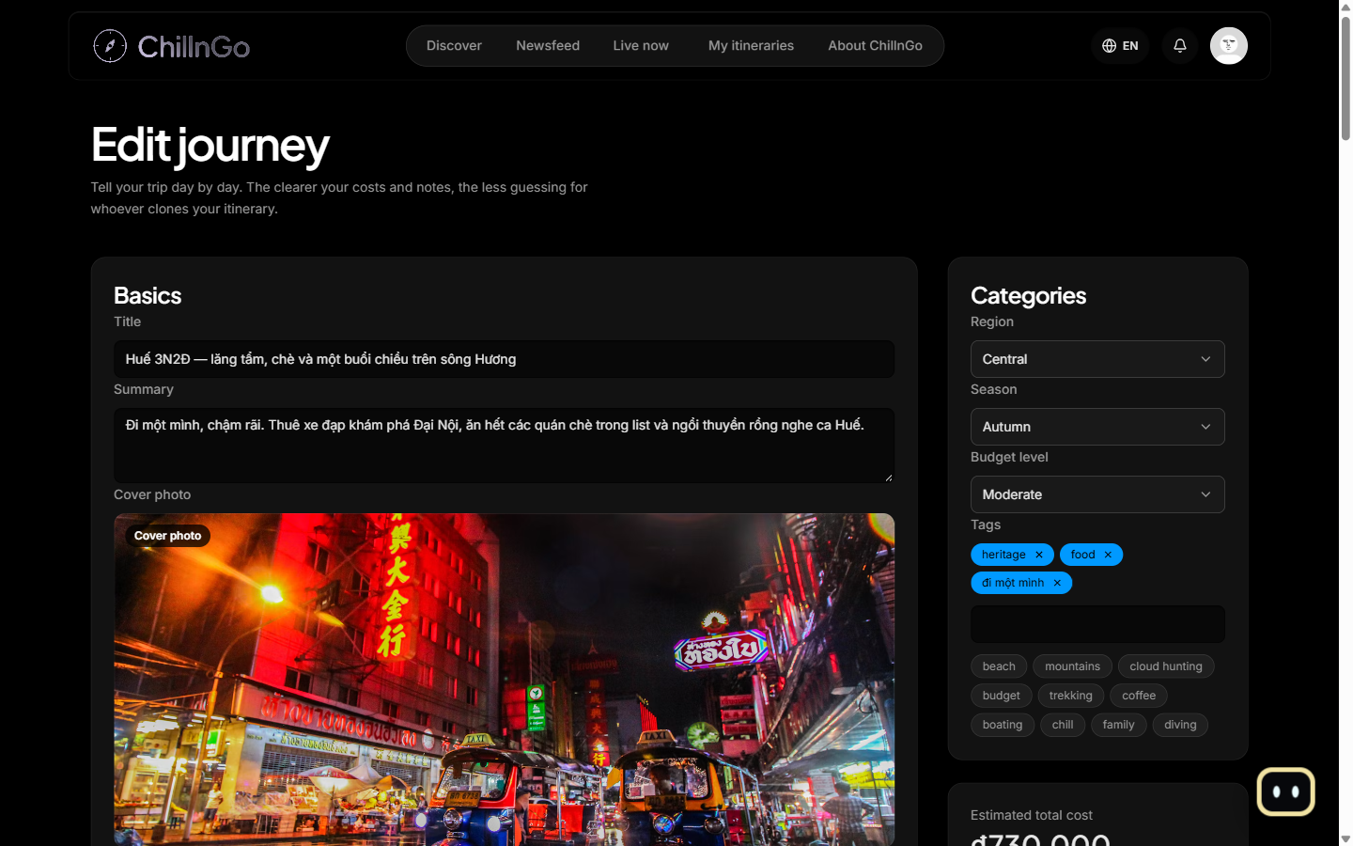
Figure 25: Edit journey screen
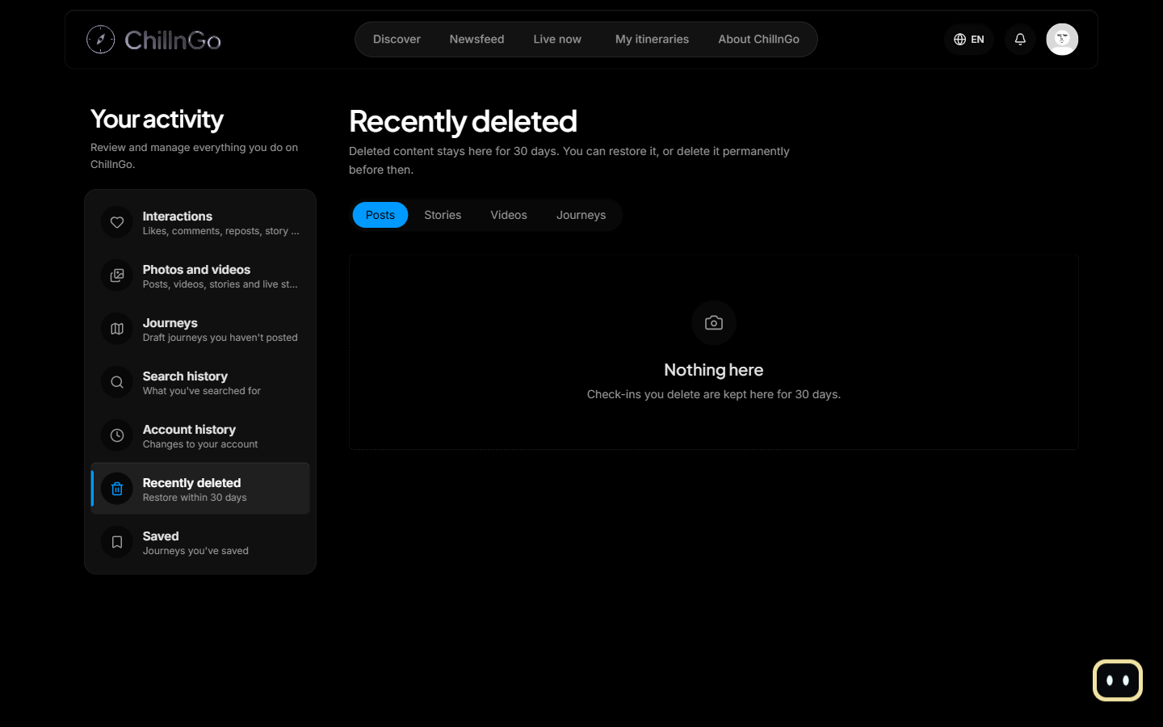
Figure 26: Recently deleted (restore within 30 days)
Function Details:
Validation:
- Only the author can edit, delete, restore or duplicate the journey (BR-002).
- The same field validation as creation applies.
Business Rules:
- Only the author of a journey can modify it (BR-002).
- Deleted journeys can be restored for 30 days (BR-016).
Functionalities
Normal case:
- The author updates the journey or confirms deletion.
- The system applies the change.
- The author sees a success message.
Abnormal case:
- Another user's or a missing journey: “Journey not found.”
- Restore after 30 days: “This journey is past its restore period and was deleted permanently.” (MSG15)

3.3.3 View Trip Post Detail
Function trigger:
The user opens a journey card from the Newsfeed, Discover, a profile, search results or a notification.
Function description:
- Actors: Guest, Traveler
- Purpose: Show the full journey: days, stops, photos, notes, costs, route map and social actions.
Data Processing:
- Fetch the journey with its author and accepted companions, the time span, the total estimated cost and the budget level.
- Fetch the like, comment, save and Copy counts and the viewer's own like/save state.
- Offer like, comment, save, “Use as my itinerary” and “Copy with AI”; the author also sees “Edit” and “Invite friends along”.
Screen layout:
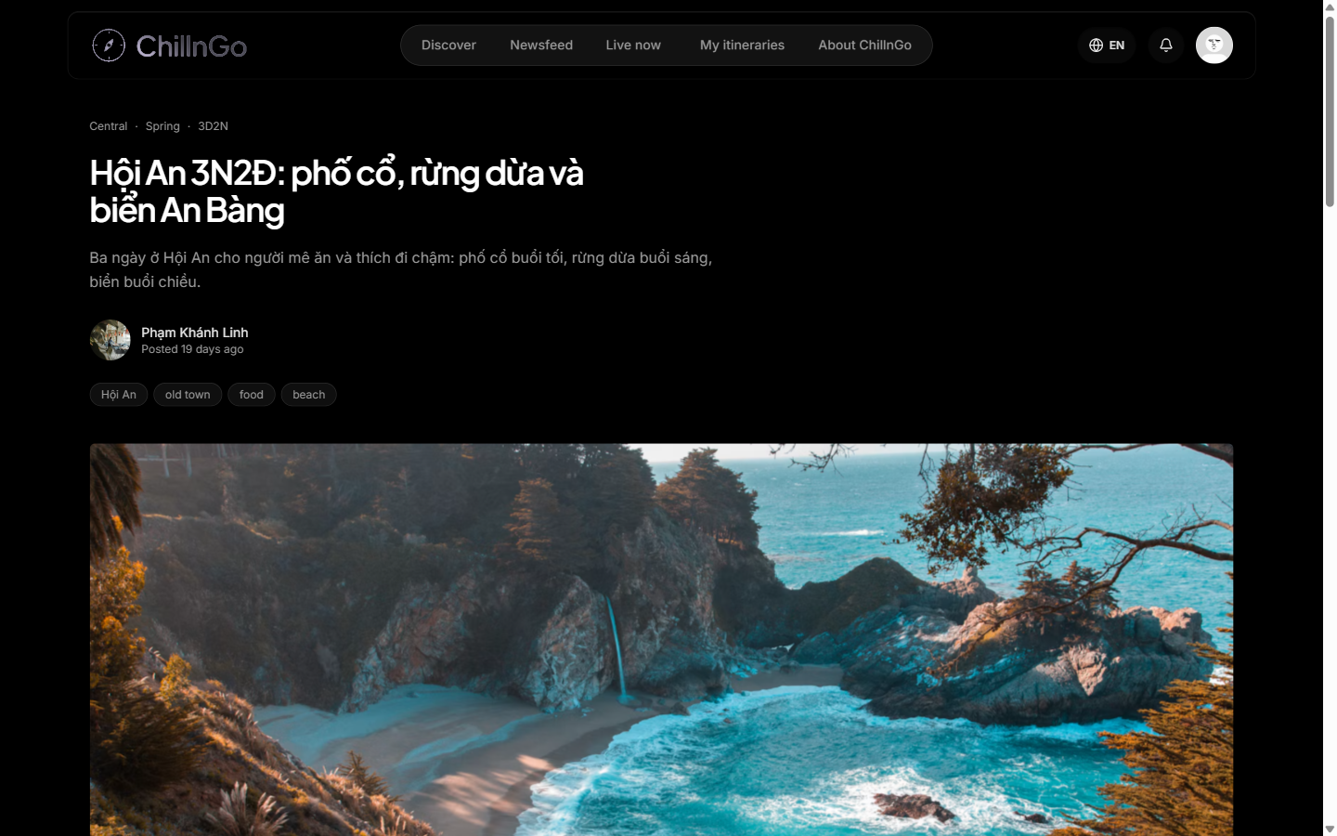
Figure 27: Journey detail screen
Function Details:
Validation:
- The journey must be published and not deleted, unless the viewer is its author.
Business Rules:
- Drafts and deleted journeys are visible only to their author (BR-011).
Functionalities
Normal case:
- The user opens a journey.
- The system shows the itinerary, the route and the social actions.
Abnormal case:
- Missing, draft or deleted journey: “Journey not found.”

3.4 FE-02: Route Mapping

3.4.1 View Route on Map
Function trigger:
The user opens a journey or an itinerary; the route map sits next to the day-by-day itinerary.
Function description:
- Actors: Guest, Traveler
- Purpose: Show the stops of a journey and the route between them on an interactive map.
Data Processing:
- Collect the coordinates of every stop, ordered by day and by stop number.
- Draw numbered markers and the route on a Mapbox map, one colour per day; each leg follows its travel mode (road, flight, water).
- The user can filter by day, zoom and pan, and open directions for a stop; selecting a day or a stop highlights its part of the route.
Screen layout:
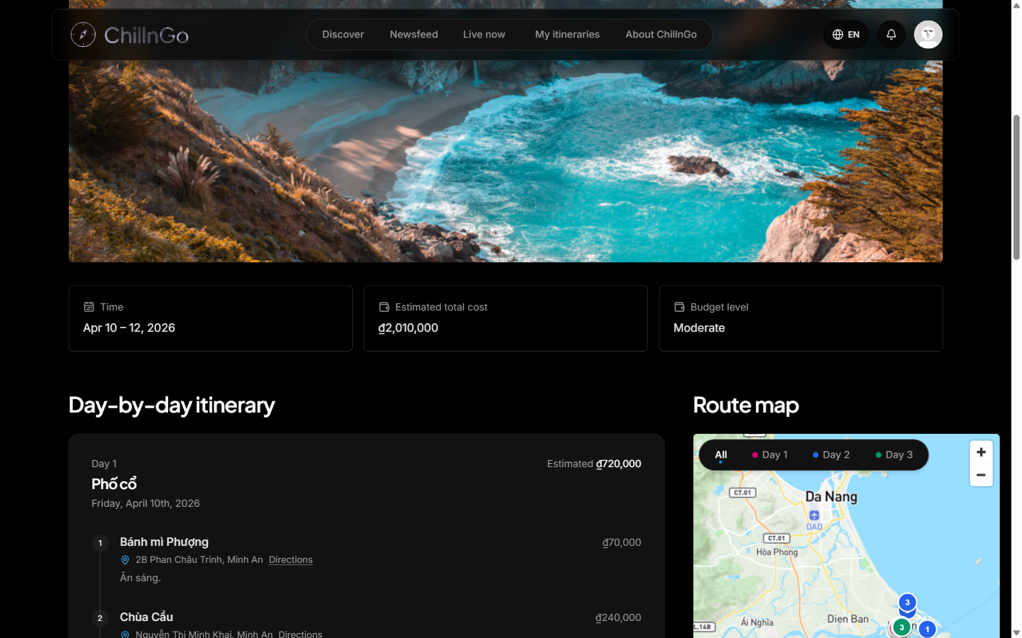
Figure 28: Day-by-day itinerary with the route map
Function Details:
Validation:
- A stop needs valid coordinates to appear on the map.
Business Rules:
- Every journey and itinerary shows its route on an interactive map (CR-001).
Functionalities
Normal case:
- The user opens the journey or itinerary.
- The system draws all markers and the route.
Abnormal case:
- A stop without coordinates is skipped and the rest of the route is still drawn.
- Without a Mapbox token the page shows a static sketch of the route instead of the interactive map.

3.5 FE-03: Tagging & Categorization

3.5.1 Tag Trip Post
Function trigger:
The traveler fills in the Categories panel while creating or editing a journey.
Function description:
- Actors: Traveler
- Purpose: Categorise a journey so that it can be found through Discover, interests, search and filters.
Data Processing:
- Choose exactly one region (North, Central, South, Islands, Abroad), one season and one budget level from drop-down lists.
- Add free tags by typing or by clicking suggested chips (food, beach, mountains, cloud hunting, trekking, …).
- The duration is derived from the number of days in the itinerary and is not typed by the user.
Screen layout:
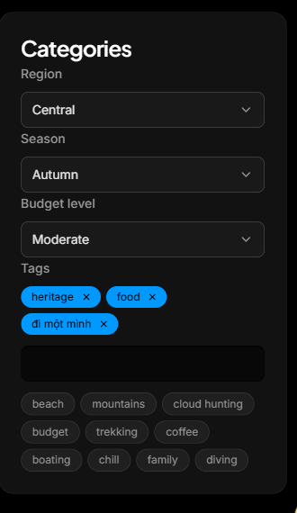
Figure 29: Categories and tags panel in the journey editor
Function Details:
Validation:
- Exactly one region, one season and one budget level.
- At most 20 tags, each 1–40 characters.
Business Rules:
- See BR-003.
Functionalities
Normal case:
- The traveler selects the categories and tags.
- The system saves them with the journey.
Abnormal case:
- More than 20 tags: “At most 20 tags.”

3.6 FE-04: Social Interaction

3.6.1 Follow / Unfollow User
Function trigger:
The traveler clicks “Follow” / “Following” on another traveler's profile.
Function description:
- Actors: Traveler
- Purpose: Follow or unfollow a traveler to see their journeys, check-ins and live streams in the Newsfeed.
Data Processing:
- Toggle the follow relationship (unique per pair) and update both users' follower/following counts in the same request.
- Notify the followed user (“follow” notification).
Screen layout:
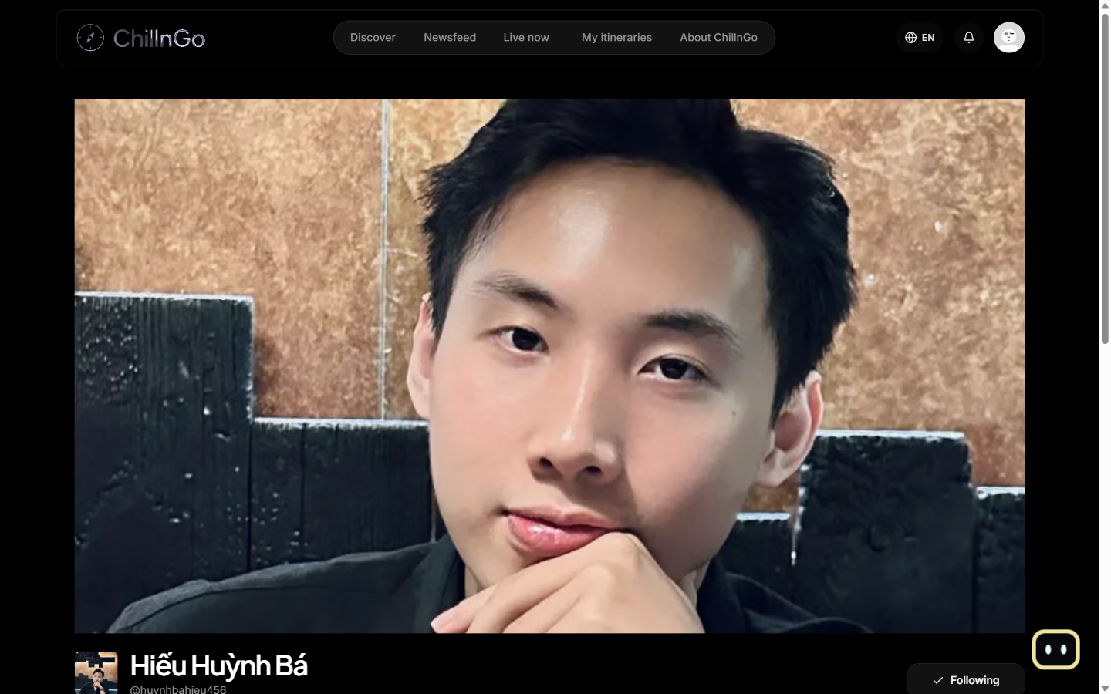
Figure 30: Another traveler's profile with the Follow / Following button
Function Details:
Validation:
- A user cannot follow themselves, and staff accounts cannot be followed (BR-004).
Business Rules:
- See BR-004. Two users who follow each other are friends and can invite each other as companions (BR-020).
Functionalities
Normal case:
- The traveler clicks Follow.
- The system creates the relationship.
- The button changes to “Following”.
Abnormal case:
- Following oneself: “You cannot follow yourself.”
- Missing account: “User not found.”

3.6.2 Like / Comment on Trip Post
Function trigger:
The traveler clicks the like button or writes in the comment box of a journey.
Function description:
- Actors: Traveler
- Purpose: Let travelers like and discuss journeys.
Data Processing:
- Like: toggle the like record for the user/journey pair and update the like count (BR-005).
- Comment: validate the content and save it; replies are one level deep. The journey's author is notified.
- The writer can delete their own comment; the journey's author can delete or hide any comment on the journey (BR-007).
Screen layout:
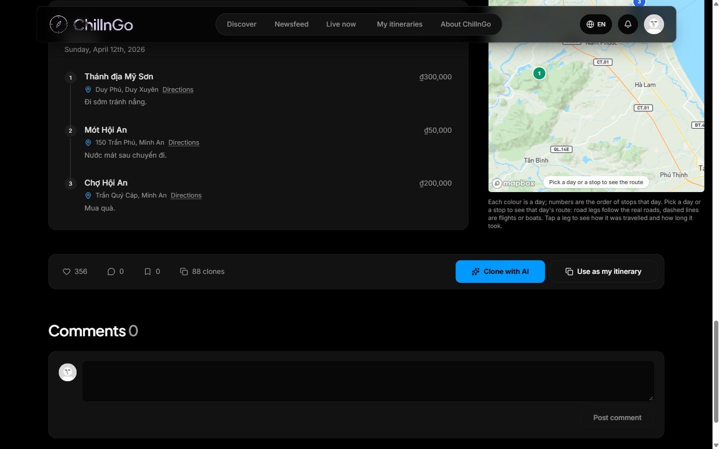
Figure 31: Like, comment, save and Copy actions with the comment section
Function Details:
Validation:
- A comment has 1–1000 characters (BR-006).
- Only the comment's writer or the journey's author can delete it (BR-007).
Business Rules:
- See BR-005, BR-006 and BR-007.
Functionalities
Normal case:
- The traveler likes or comments on the journey.
- The system saves the action and updates the count.
- The traveler sees the new state immediately.
Abnormal case:
- Empty comment: “Please enter a comment.”
- Too long: “Comments can be at most 1000 characters.”
- Deleting someone else's comment: “You cannot delete this comment.”

3.6.3 View Notifications
Function trigger:
The user clicks the bell icon in the navbar.
Function description:
- Actors: Traveler, Admin
- Purpose: Show what happened around the user's account and journeys.
Data Processing:
- Fetch the latest 50 notifications, newest first: new follower, live stream started, companion invitation and answer, journey Copyd, comment, …
- Opening the list marks every notification as read; the unread badge is refreshed periodically.
- Notifications are deleted automatically after 90 days.
Screen layout:
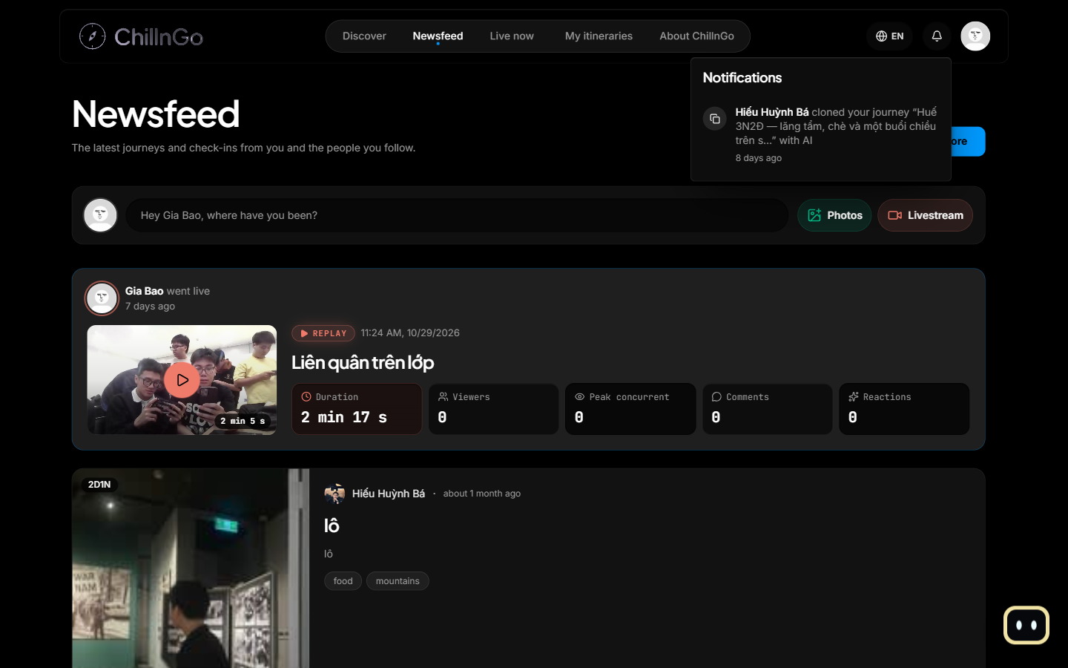
Figure 32: Notifications dropdown
Function Details:
Validation:
- The user must be signed in.
Business Rules:
- Notifications expire after 90 days (TTL index).
Functionalities
Normal case:
- The user opens the bell.
- The system lists the notifications and marks them as read.
- Clicking one opens the related page.
Abnormal case:
- No notifications: an empty state is shown.

3.6.4 Invite Companions
Function trigger:
The author clicks “Invite friends along” on their journey.
Function description:
- Actors: Traveler
- Purpose: Credit the friends who travelled together on a journey.
Data Processing:
- List the author's friends (users who follow each other).
- Invite up to 10 companions per journey; each invitee receives an “invite” notification.
- The invitee accepts (shown on the journey; the author is notified) or declines; the author or the companion can remove the companion later.
Screen layout:
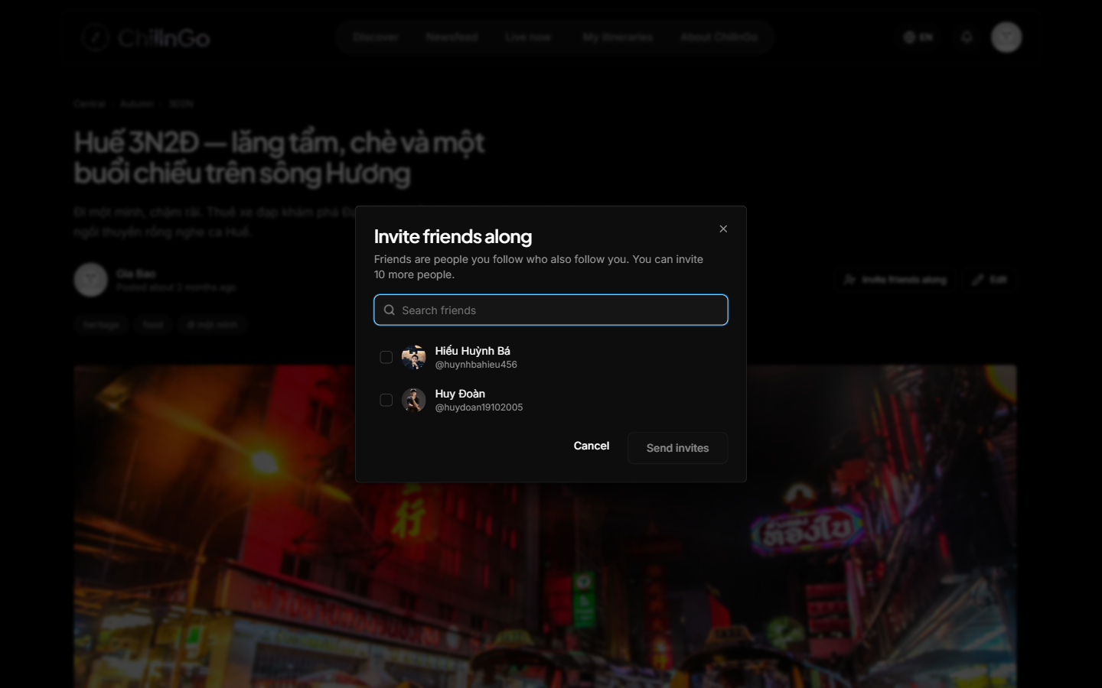
Figure 33: Invite friends along dialog
Function Details:
Validation:
- Only the author can invite; only friends can be invited; at most 10 companions (BR-020).
Business Rules:
- See BR-020.
Functionalities
Normal case:
- The author selects friends and sends the invites.
- The invitees accept or decline.
Abnormal case:
- Not a friend: “You can only invite friends (people who follow each other).”
- Over the limit: “Each journey can invite at most 10 companions.”

3.7 FE-05: Bookmark & Personalized Newsfeed

3.7.1 Bookmark Trip Post
Function trigger:
The traveler clicks the save (bookmark) icon on a journey card or on the journey detail.
Function description:
- Actors: Traveler
- Purpose: Keep journeys in a “want to go” list for later.
Data Processing:
- Toggle the bookmark for the user/journey pair and update the save count.
- Saved journeys are listed in Your activity → Saved.
- Implementation status: bookmarks are still kept in the web client's sample data; the bookmarks collection and its API endpoint are planned.
Screen layout:
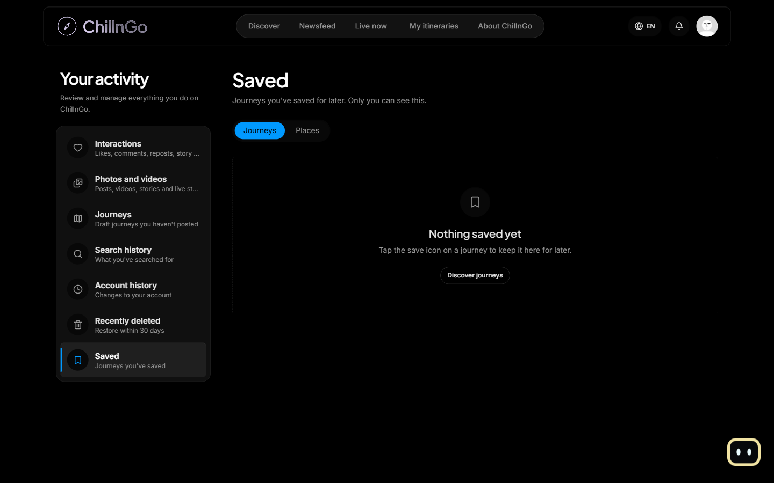
Figure 34: Saved journeys (Your activity → Saved)
Function Details:
Validation:
- The journey must exist and be published.
Business Rules:
- Drafts and deleted journeys are not listed (BR-011).
Functionalities
Normal case:
- The traveler clicks the save icon.
- The system saves or removes the bookmark.
- The icon state changes immediately.
Abnormal case:
- Journey no longer available: “Journey not found.”

3.7.2 View Personalized Newsfeed
Function trigger:
The user opens “Newsfeed” in the navbar.
Function description:
- Actors: Guest, Traveler
- Purpose: Show the latest journeys, check-ins and live streams from the people the traveler follows, together with fresh travel news.
Data Processing:
- Fetch published journeys and photo check-ins of the followed users (and the traveler's own), newest first, page by page.
- Three tabs, kept in the address (?tab=): “Dành cho bạn” puts one published travel news item after every three entries (BR-040); “Đang theo dõi” shows the followed users only; “Tin du lịch” shows news only (3.7.3).
- Signed out, “Dành cho bạn” shows everyone’s latest journeys and check-ins with the same news.
- Show the live streams and recent replays of followed users at the top, with a muted preview.
- The composer at the top opens the journey editor, the check-in dialog or the livestream setup; guests are invited to log in.
Screen layout:
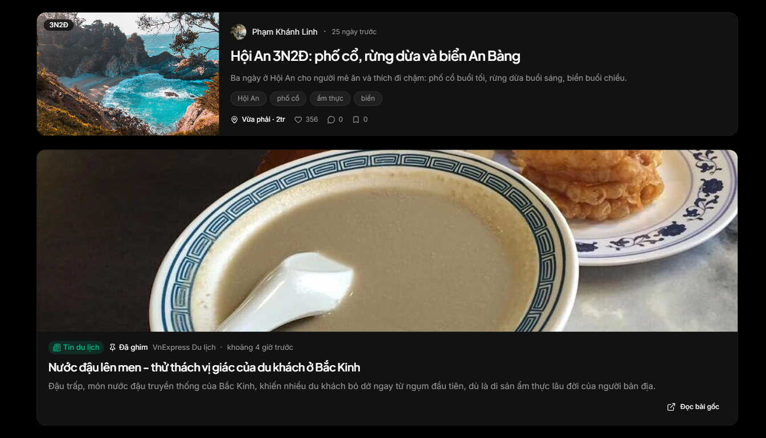
Figure 35: Newsfeed screen, “Dành cho bạn” with a travel news item
Function Details:
Validation:
- Only content the viewer is allowed to see is returned (audience of live streams, published journeys).
Business Rules:
- Drafts and deleted items never appear in the Newsfeed (BR-011).
Functionalities
Normal case:
- The traveler opens the Newsfeed.
- The system shows the items in reverse-chronological order.
Abnormal case:
- The traveler follows nobody yet: “Dành cho bạn” still shows travel news, and the feed suggests discovering journeys.

3.7.3 View, Save and Report Travel News
Function trigger:
The user opens Newsfeed → “Tin du lịch”, or meets a news item in “Dành cho bạn”.
Function description:
- Actors: Guest, Traveler
- Purpose: Read what is new in travel inside ChillnGo, as posts with pictures, with the original article one click away.
Data Processing:
- GET /api/news returns published news, newest first, 20 at a time; on the first page pinned news comes first. A region chip (Miền Bắc, Miền Trung, Miền Nam, Hải đảo, Nước ngoài) filters by region.
- Each card looks like a journey card: the cover picture, the source, the time, the headline, the AI summary, the regions and the catalog places it mentions.
- Clicking the card opens the news post page (/news/:id) inside ChillnGo; GET /api/news/:id returns the post and opening it adds one to the item’s count (who opened it is not recorded).
- The page shows the headline, the summary, the cover, then the paragraphs the AI wrote with the original’s pictures spread between them and the remaining pictures in a gallery; a YouTube video plays on the page instead of the cover.
- The page ends with the places, a note naming the source (“Bài do AI của ChillnGo viết lại từ bài gốc của …”), the original title and “Đọc bài gốc”, which opens the original in a new tab.
- Signed in: the bookmark saves or unsaves the item; saved news is listed in Your activity → Saved → “Tin du lịch”. The “…” menu reports the item (reason as for any report).
Screen layout:
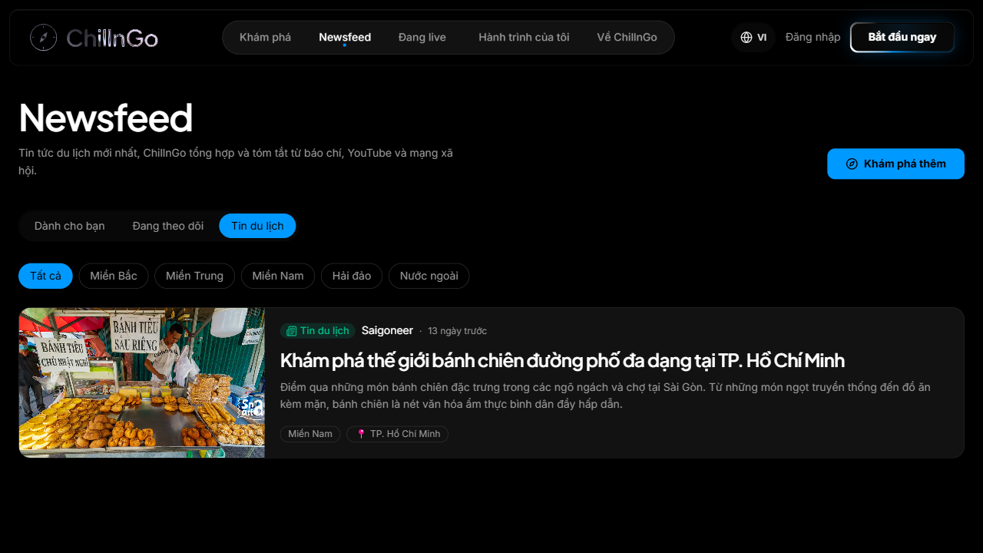
Figure 36: Newsfeed, “Tin du lịch” tab
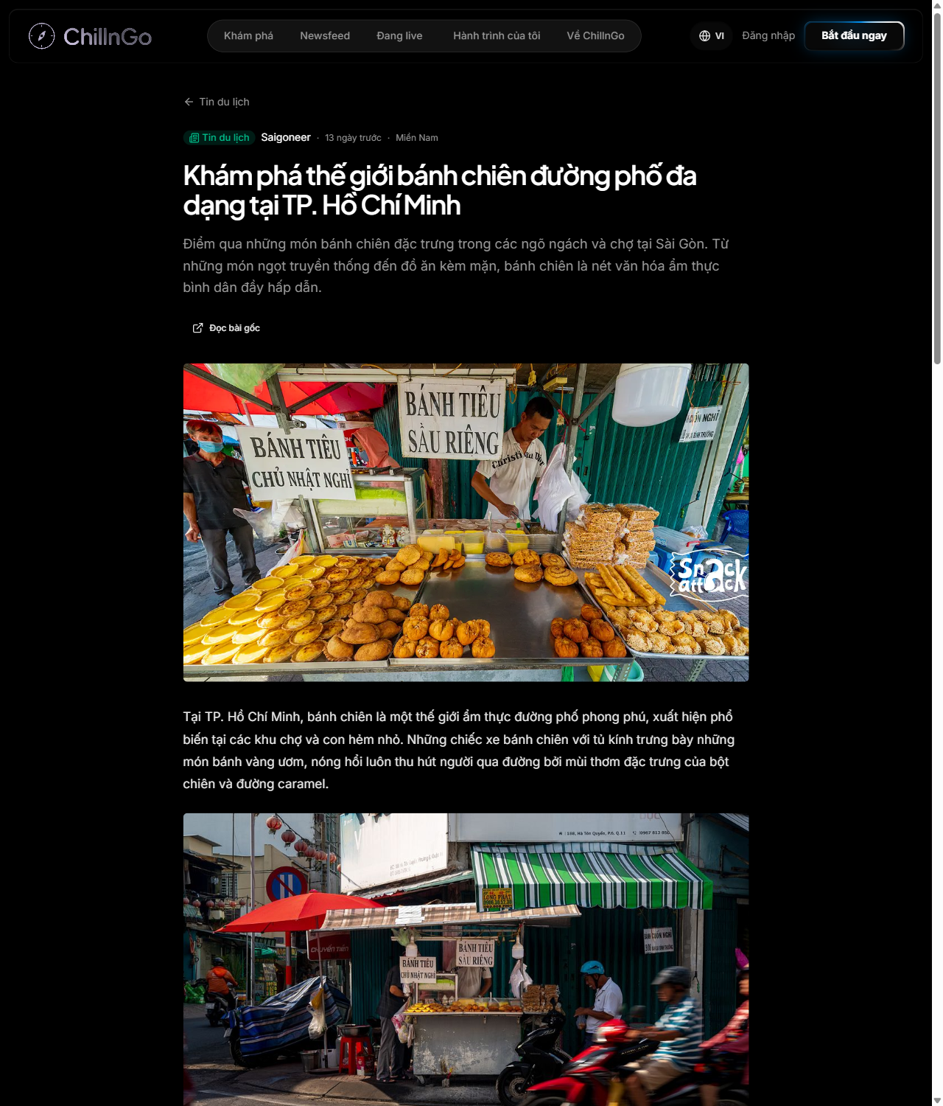
Figure 37: News post page
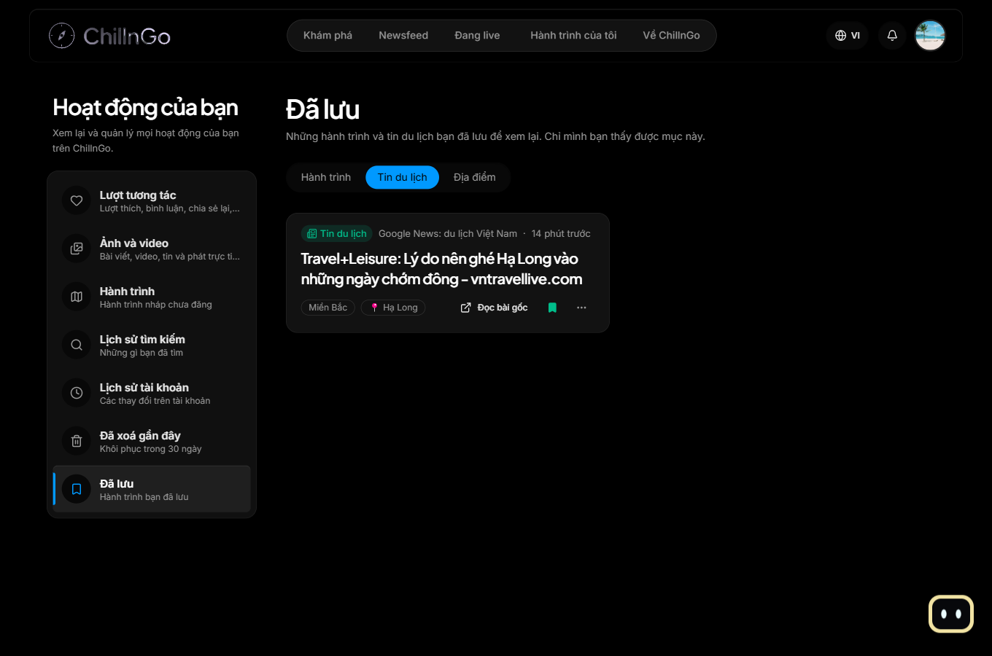
Figure 38: Your activity, saved travel news
Function Details:
Validation:
- Only published news is returned; hidden, rejected and waiting items never reach readers.
- Saving and reporting need a signed-in account.
Business Rules:
- BR-036, BR-040 and BR-031 (reports).
Functionalities
Normal case:
- The user filters by region, opens a post, reads it with its pictures, saves it or follows the link to the original.
Abnormal case:
- No news for the region: “Chưa có tin nào cho vùng này. Thử chọn vùng khác.”
- The news API is unreachable: the tab shows an error and the other tabs keep working.
- The post was hidden or removed meanwhile: the page shows “Không tìm thấy tin”.
- The source no longer serves a picture: that picture is left out of the page.

3.8 FE-06: Itinerary Cloning

3.8.1 Copy Trip Post to Personal Itinerary
Function trigger:
The traveler clicks “Use as my itinerary” on a journey.
Function description:
- Actors: Traveler
- Purpose: Copy a journey into the traveler's own editable itinerary.
Data Processing:
- Show a dialog with the journey summary, an itinerary name (default “<title> (my version)”) and a start date.
- Create an Itinerary owned by the traveler: copy the days and stops with new ids, re-date them from the start date and record the source journey (BR-008).
- Increase the source journey's Copy count and notify its author.
Screen layout:
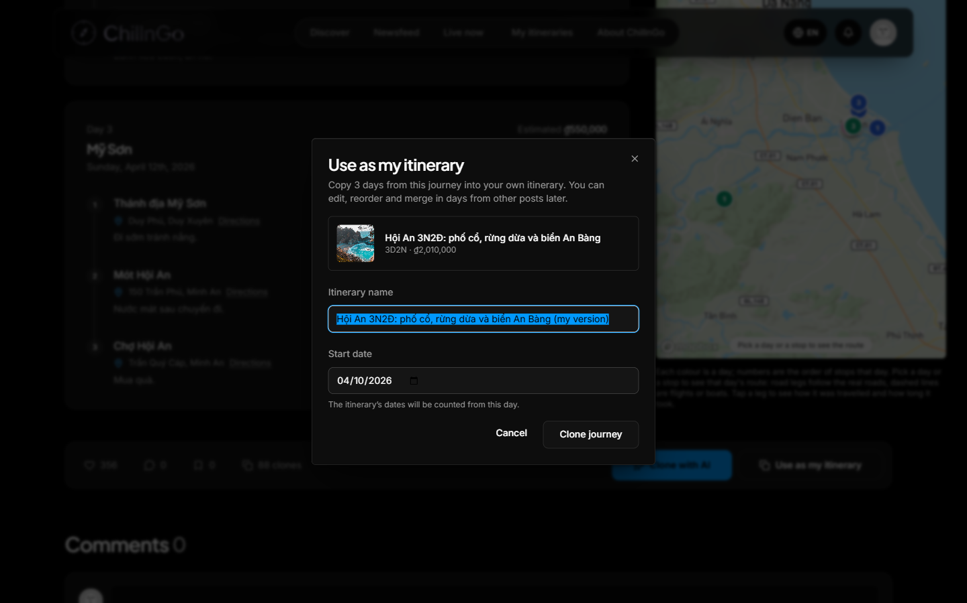
Figure 39: Use as my itinerary dialog
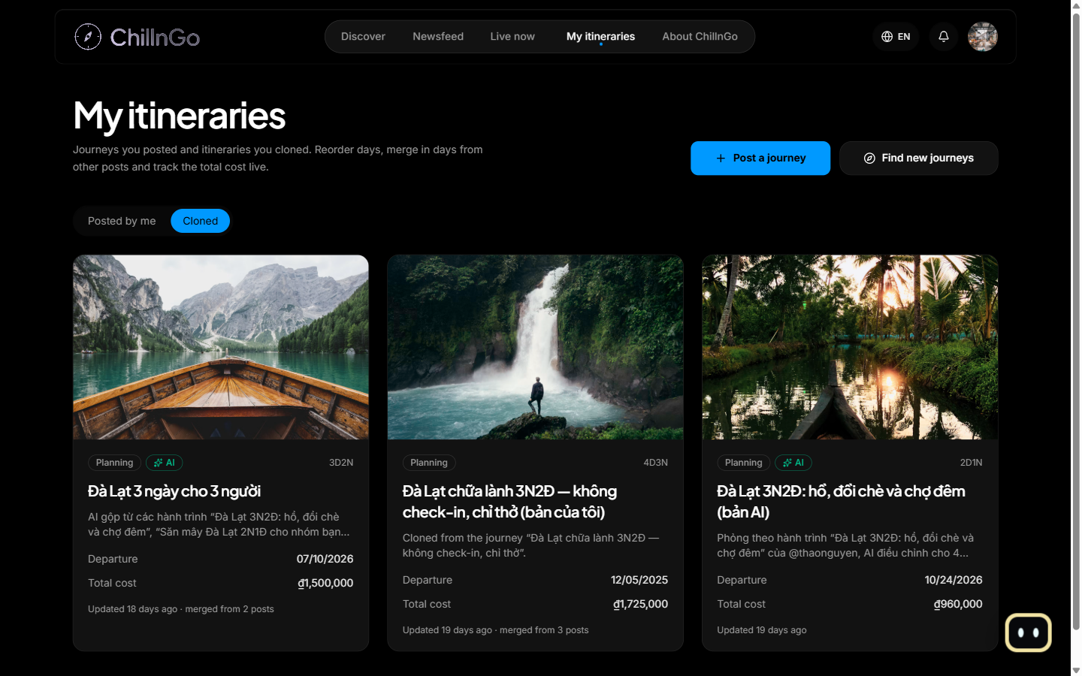
Figure 40: My itineraries — Copyd tab
Function Details:
Validation:
- The source journey must be published, or belong to the traveler.
Business Rules:
- See BR-008.
Functionalities
Normal case:
- The traveler confirms the Copy.
- The system creates the itinerary.
- The new itinerary opens, ready to edit, and is listed under My itineraries → Copyd.
Abnormal case:
- Source journey not available: “Journey not found.”

3.9 FE-07: Itinerary Editing, Merging & Cost Recalculation

3.9.1 Edit / Merge Itinerary & Recalculate Cost
Function trigger:
The traveler opens one of their itineraries, drags a day, removes a day, clicks “Merge from other posts”, or opens “Edit” (/itineraries/:id/edit).
Function description:
- Actors: Traveler
- Purpose: Adapt a Copyd itinerary, merge in days from other journeys and keep the total cost up to date.
Data Processing:
- Reorder days by drag and drop; days are renumbered and re-dated from the start date.
- Remove a day; an itinerary always keeps at least one day.
- Edit page: change the name, note, start date and status, and every day and stop with the journey editor’s day builder; only the copy changes, never the source journey.
- Merge: search journeys, pick their days and append them at the end; they are renumbered and the sources are recorded (BR-009).
- The total cost, the number of days and stops and the list of sources are recalculated after every change (BR-010); the route map follows.
Screen layout:
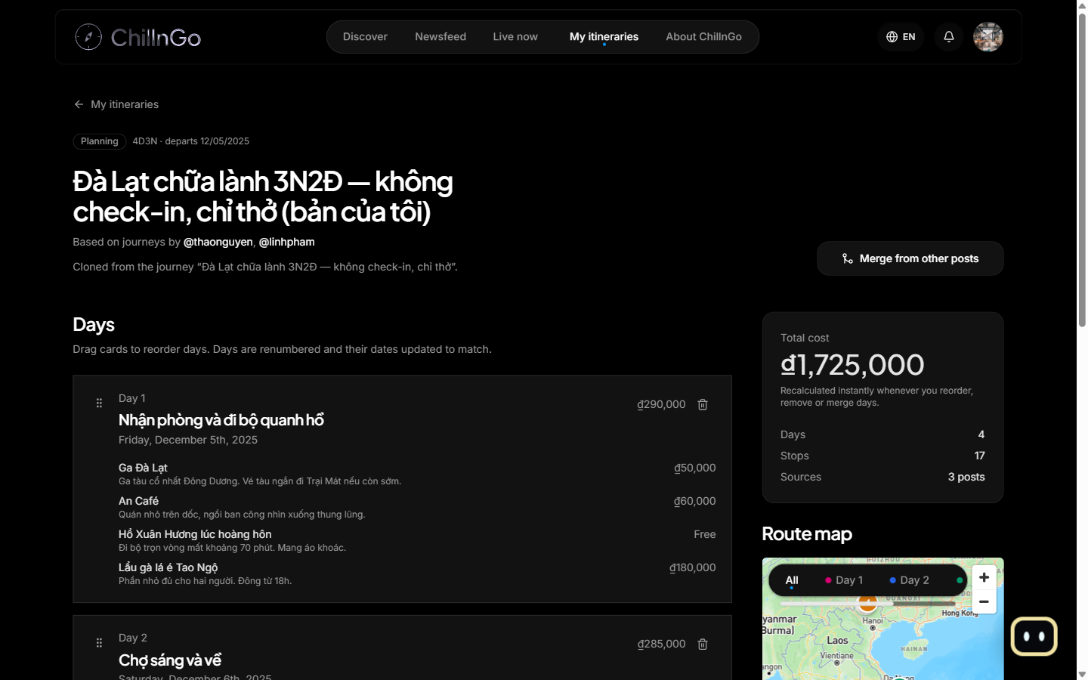
Figure 41: Itinerary detail (reorder days, live total cost)
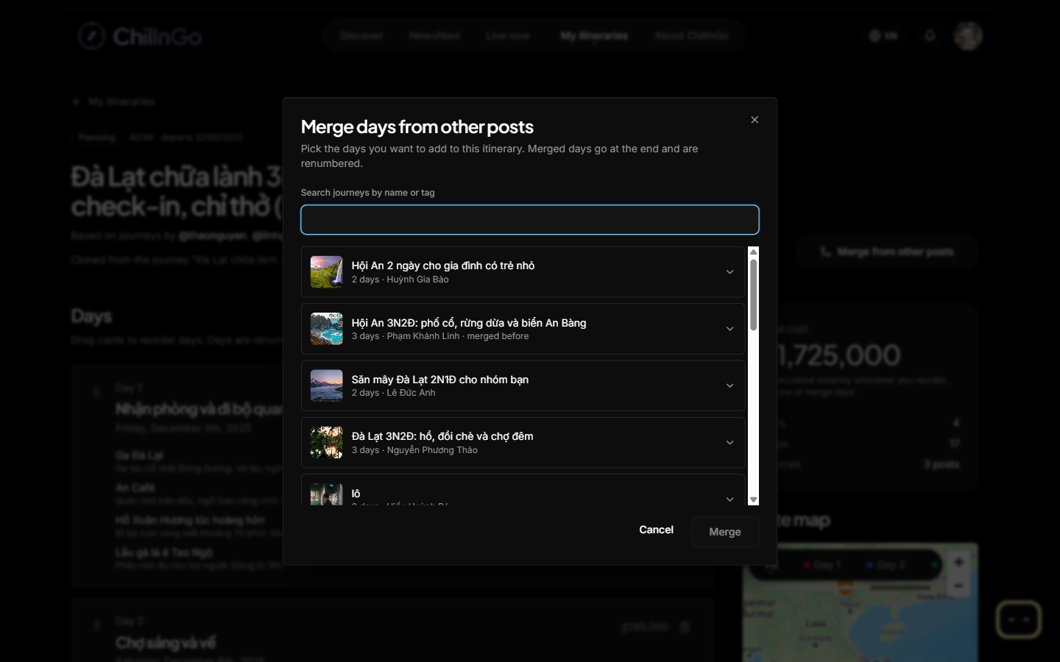
Figure 42: Merge days from other posts dialog
Function Details:
Validation:
- Only the owner can edit or merge into the itinerary.
- An itinerary keeps between 1 and 60 days (BR-021).
Business Rules:
- See BR-009, BR-010 and BR-021.
Functionalities
Normal case:
- The traveler edits or merges.
- The system applies the change and recalculates the totals.
- The traveler sees the updated itinerary and cost.
Abnormal case:
- Removing the last day: “An itinerary needs at least one day.”
- More than 60 days: “An itinerary can have at most 60 days.”

3.10 FE-08: Explore & Discovery Page

3.10.1 Browse Explore Page & Search/Filter Trip Posts
Function trigger:
The user opens “Discover” in the navbar, an interest tile, or submits a search.
Function description:
- Actors: Guest, Traveler
- Purpose: Discover journeys by region, interest and keyword.
Data Processing:
- Show region tabs (All, North, Central, South, Islands, Abroad), a search box with suggestions and the user's search history, and “Explore by interest” tiles.
- Search matches journey titles, places and tags; results can be filtered and shown as a grid or on a map. Searches of a signed-in user are saved in Search history.
- Only published, non-deleted journeys are listed (BR-011), ordered by saves and engagement (BR-013).
Screen layout:
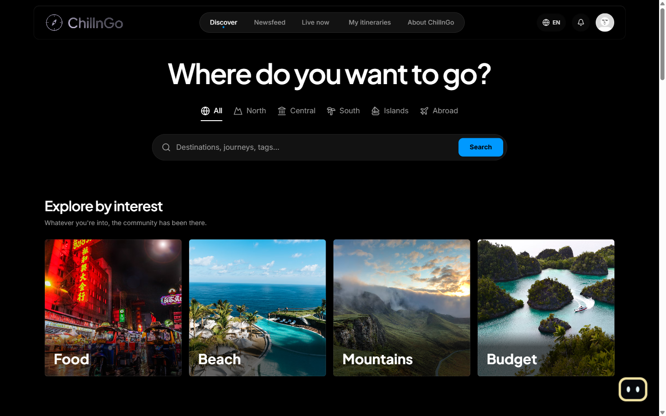
Figure 43: Discover screen
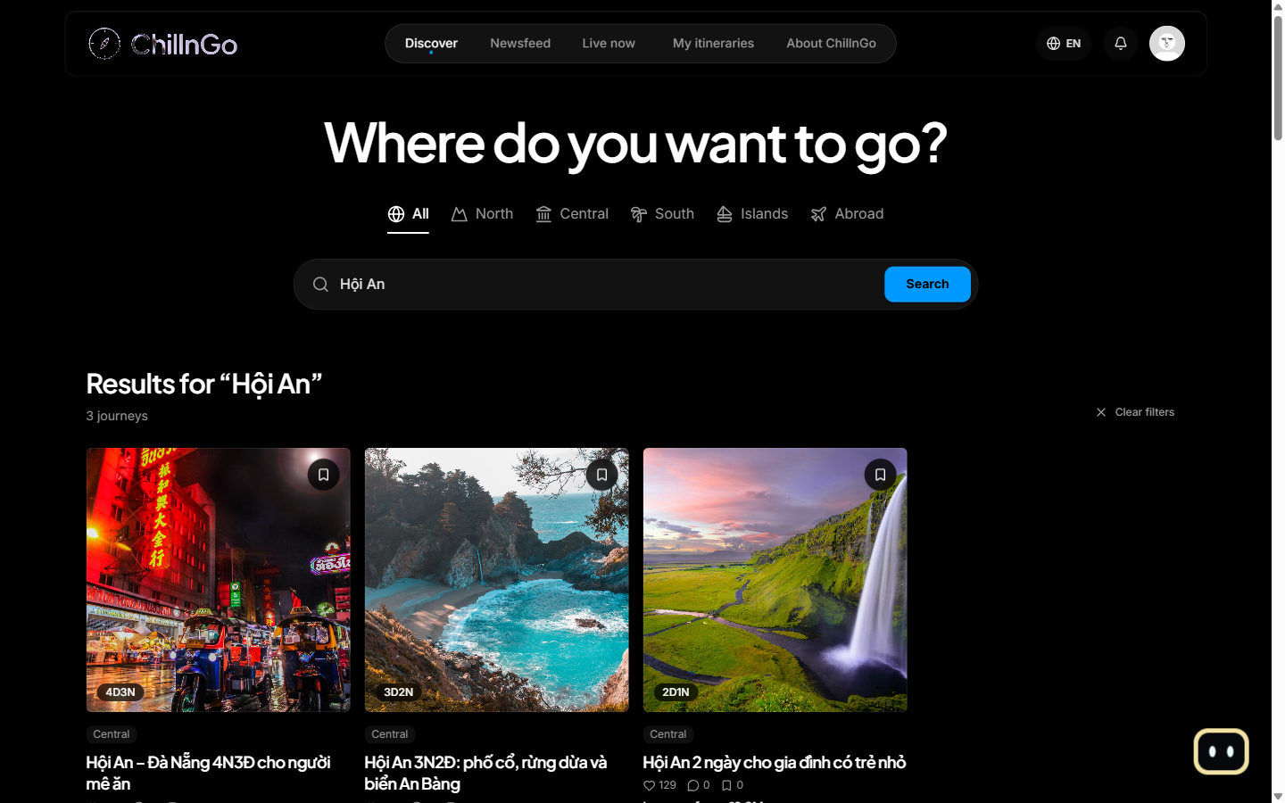
Figure 44: Search results
Function Details:
Validation:
- Filter values must come from the predefined lists (region, season, budget level, interests).
Business Rules:
- See BR-011 and BR-013.
Functionalities
Normal case:
- The user opens Discover or searches.
- The system returns the matching journeys.
- The user opens a journey.
Abnormal case:
- No match: “No journeys found.” (MSG12)

3.11 FE-09: Admin Content Moderation

3.11.1 Report Content
Function trigger:
A signed-in user opens the “…” menu on a journey, comment, check-in, profile, business page or ad and chooses “Report”.
Function description:
- Actors: Traveler
- Purpose: Tell the moderators about content that breaks the rules.
Data Processing:
- The user picks a reason (spam or advertising, inappropriate content, scam, misinformation, harassment or bullying, other) and may add a note (required for “other”, at most 500 characters).
- The system stores the report with a snapshot of the content, so moderators can judge it even after it changes.
- When 5 different people have reported the same content, it is hidden until a moderator decides; its author still sees it, marked “Hidden for a violation”.
Screen layout:
The “…” menu on a journey, comment, check-in, profile, business page or ad opens the report dialog (a dialog on the web, a bottom sheet on mobile) with the reasons and an optional note.
Function Details:
Validation:
- Only content the API stores can be reported; nobody can report themselves or their own content.
- Each person reports a given item once and sends at most 20 reports an hour.
Business Rules:
- BR-031.
Functionalities
Normal case:
- The report is sent and the user sees “Thank you, we’ll look into it.” (MSG22).
Abnormal case:
- Already reported: MSG23.
- Own content: the menu is not shown; the API refuses with SELF_REPORT.
- More than 20 reports in an hour: the system asks the user to try later.

3.11.2 Moderate Reported Content
Function trigger:
An Admin with the reports or content permission, or the Super Admin, opens “Content” in the admin console.
Function description:
- Actors: Admin, Super Admin
- Purpose: Decide on reported content, restore what was hidden by mistake, and stop live streams that break the rules.
Data Processing:
- Report queue: reports grouped by content, most reported first, filtered by status (pending, resolved, dismissed) and content type; each item shows the snapshot, owner, reasons and outcome.
- Decision for every pending report of an item: dismiss (content hidden automatically comes back), hide, remove (journeys and check-ins go to the author’s Recently deleted and cannot be restored by the author; comments are deleted) or lock the owner (needs the users permission too).
- Hidden tab: journeys, check-ins and comments hidden or removed right now, with “Unhide” (content permission).
- Live now tab: every stream on air, private ones included; stopping one ends it at once, keeps the recording and tells the host the reason.
- The owner and every reporter are notified; every decision is written to the audit log.
Screen layout:
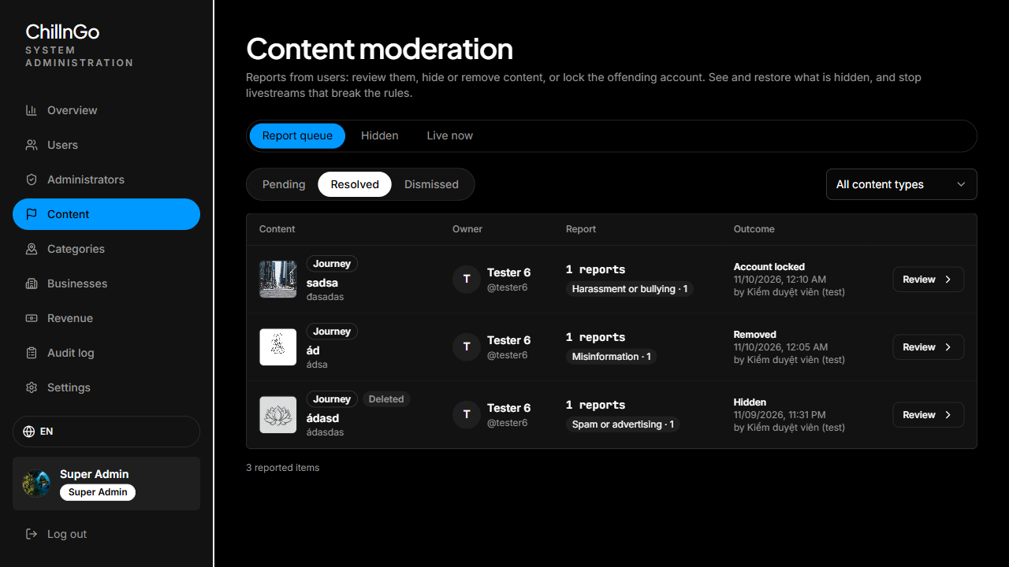
Figure 45: Content moderation, report queue
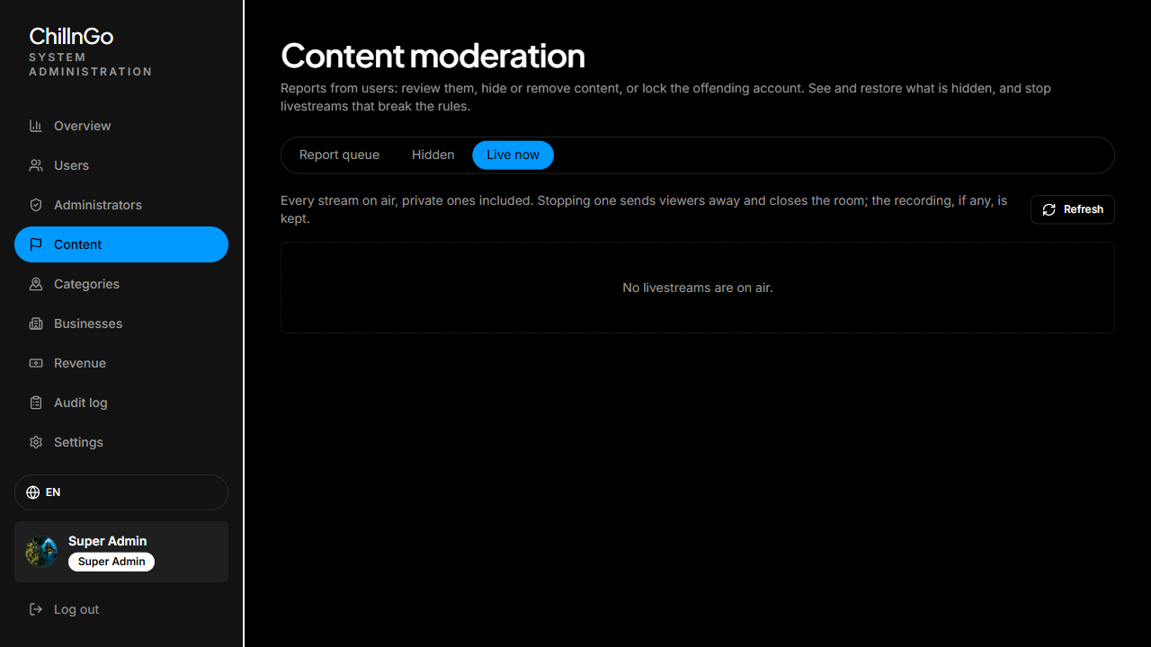
Figure 46: Content moderation, live streams on air
Function Details:
Validation:
- Only staff with the matching permission can open each tab.
- A decision applies only while reports are pending.
Business Rules:
- BR-031, BR-033 and BR-035; every admin action is written to the audit log (CR-007).
Functionalities
Normal case:
- The moderator opens an item, reads the reports and decides; the system applies it, logs it and notifies the people involved.
Abnormal case:
- No pending reports left for the item: “Nothing is waiting for a decision.”
- The content no longer exists: only “Dismiss” is possible.

3.11.3 Manage User Accounts
Function trigger:
An Admin opens “Users” in the admin console.
Function description:
- Actors: Admin, Super Admin
- Purpose: View accounts, lock or unlock them, reset passwords, and (Super Admin) change roles. Accounts are never deleted: banning someone means locking the account.
Data Processing:
- List accounts page by page with search (name, username, email) and filters by role and status; Admins see regular users only.
- Lock with a reason, or unlock; reset the password (a random temporary password is emailed to the owner).
- Super Admin only: promote a user to Admin or demote an Admin.
- Every action is written to the audit log.
Screen layout:
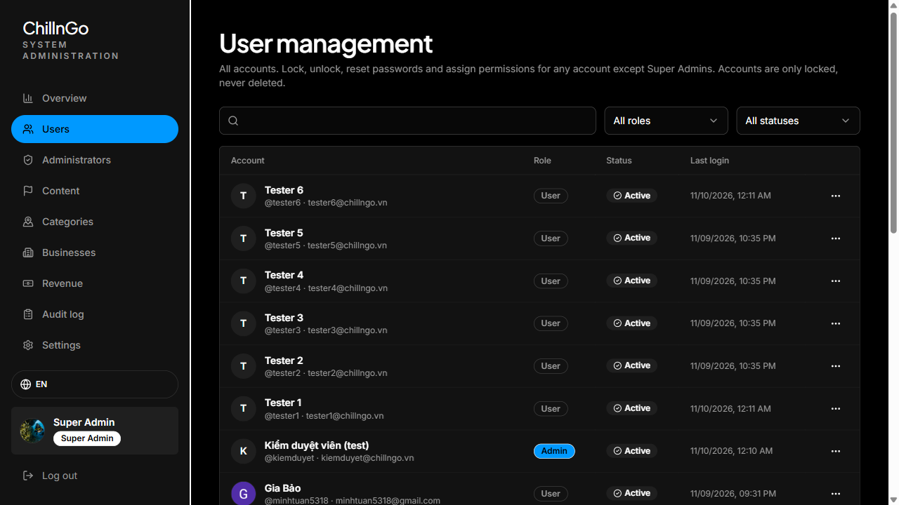
Figure 47: User management screen
Function Details:
Validation:
- Only staff with the users permission can open this section.
- Nobody can act on the Super Admin or on their own account.
Business Rules:
- See BR-012.
Functionalities
Normal case:
- The admin locks or unlocks an account.
- The system applies the change immediately.
- The admin sees the new status.
Abnormal case:
- Acting on the Super Admin or on oneself: the action is refused.
- Admin acting on another Admin: the action is refused (Super Admin only).

3.11.4 Manage AI Catalog
Function trigger:
An Admin with the categories permission, or the Super Admin, opens “Categories” in the admin console.
Function description:
- Actors: Admin, Super Admin
- Purpose: Keep the data the AI Copy plans from correct: it only suggests places that are in the catalog.
Data Processing:
- Places: search and filter by destination and type; add or edit a place (name, destination, type, address, position, cost per person or price level, opening hours, outdoor, booking needed, rating, photo, tags).
- Destinations: name, region, centre and radius, rainy and peak months, festivals; each shows its number of places.
- Packing checklist: items with their tags (beach, mountain, temple, water…), used to build the preparation checklist of an AI draft.
- Every change is written to the audit log.
Screen layout:
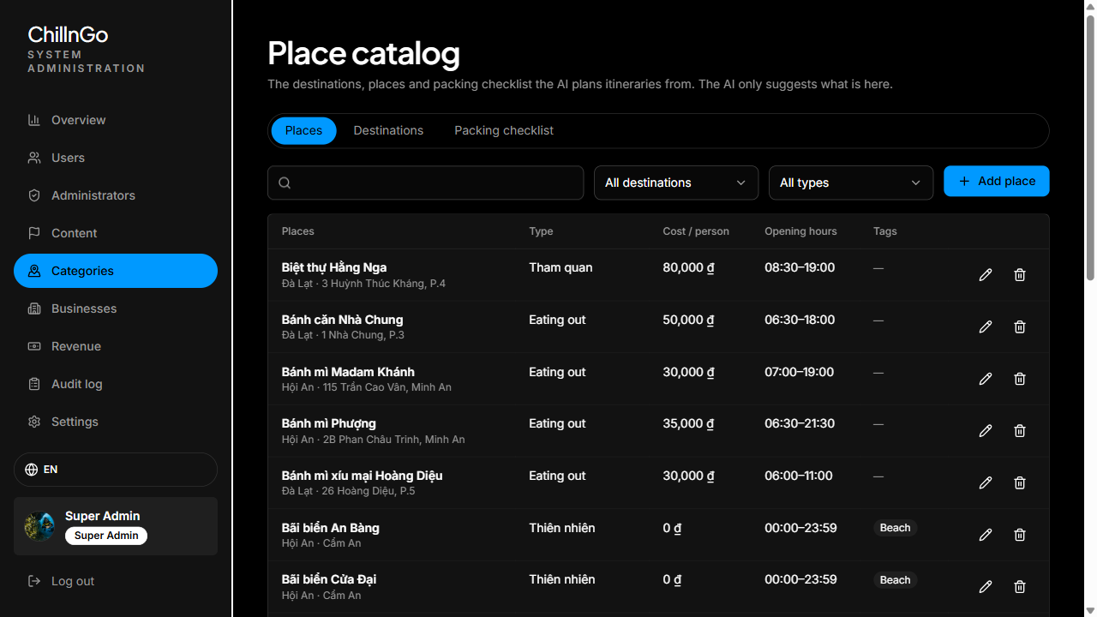
Figure 48: AI catalog, places
Function Details:
Validation:
- Place types are a fixed list (the AI’s output schema is built from it); tags must belong to the catalog vocabularies.
- A destination that still has places, or a place a journey links to, cannot be deleted (409 IN_USE).
Business Rules:
- BR-034.
Functionalities
Normal case:
- The admin saves the record; the next AI Copy for that destination can use it.
Abnormal case:
- Deleting something still in use: refused with a message.
- Duplicate destination slug: refused.

3.12 FE-10: Admin Analytics Dashboard

3.12.1 View Analytics Dashboard
Function trigger:
A staff account with the stats permission opens “Overview” in the admin console.
Function description:
- Actors: Admin, Super Admin
- Purpose: Show account statistics of the platform.
Data Processing:
- Count accounts: total, new sign-ups in the last 7 and 30 days, confirmed emails, accounts linked to Google, locked accounts.
- Chart the daily sign-ups of the last 30 days (also available as a table).
- Super Admin only: accounts per role and admin actions in the last 7 days.
- With the matching permissions: reports waiting (with a link to the queue), business pages waiting for review, revenue of the last 30 days and Premium members.
- Content and activity: published journeys (and the last 7 days), check-ins, streams live now and in 30 days, hidden content, reports in 7 days, AI requests and people using AI today, AI drafts in 7 days.
Screen layout:
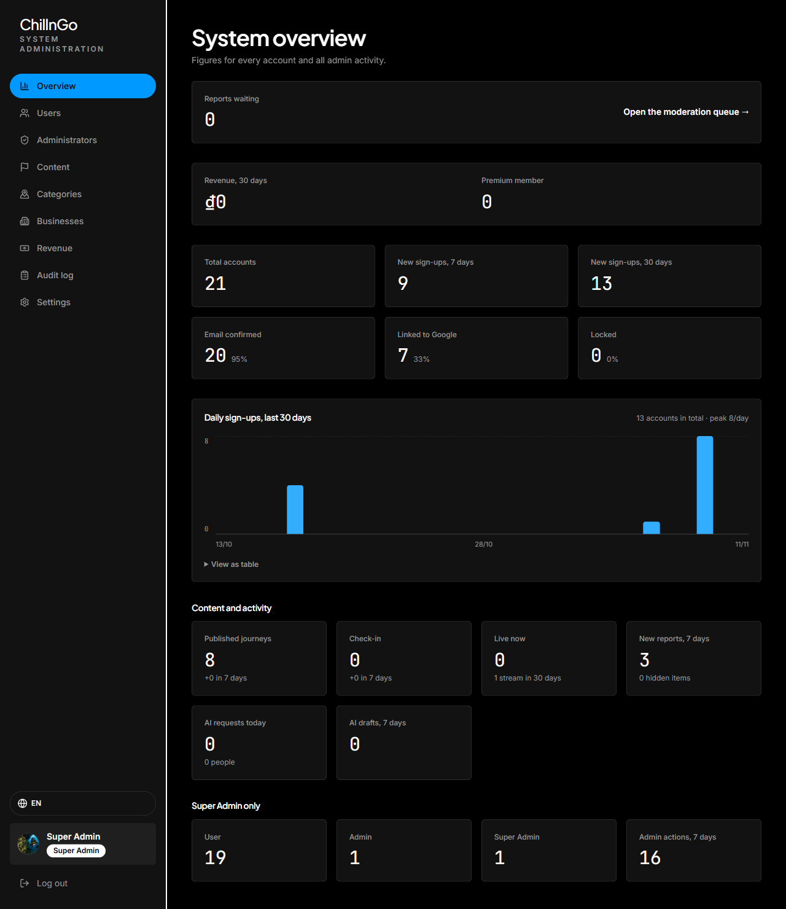
Figure 49: System overview (statistics)
Function Details:
Validation:
- Only staff accounts with the stats permission can open this section.
Business Rules:
- Admins see figures for regular users only; the Super Admin sees every account.
Functionalities
Normal case:
- The admin opens the overview.
- The system shows the aggregated figures and chart.
Abnormal case:
- No sign-ups in the period: the chart shows zero values.

3.13 FE-11: Photo Check-in

3.13.1 Create / Delete Check-in
Function trigger:
The traveler clicks “Photos” in the Newsfeed composer.
Function description:
- Actors: Traveler
- Purpose: Share a quick moment of a trip: photos, a caption, a feeling or activity and a place.
Data Processing:
- Pick up to 4 photos (uploaded straight to Cloudinary into the user's own folder), write a caption (up to 500 characters), choose a feeling or an activity and a place (search or current location).
- Save the check-in; it appears in the followers' Newsfeed and on the profile.
- Delete moves it to Recently deleted for 30 days; deleting permanently also removes its photos from Cloudinary.
Screen layout:
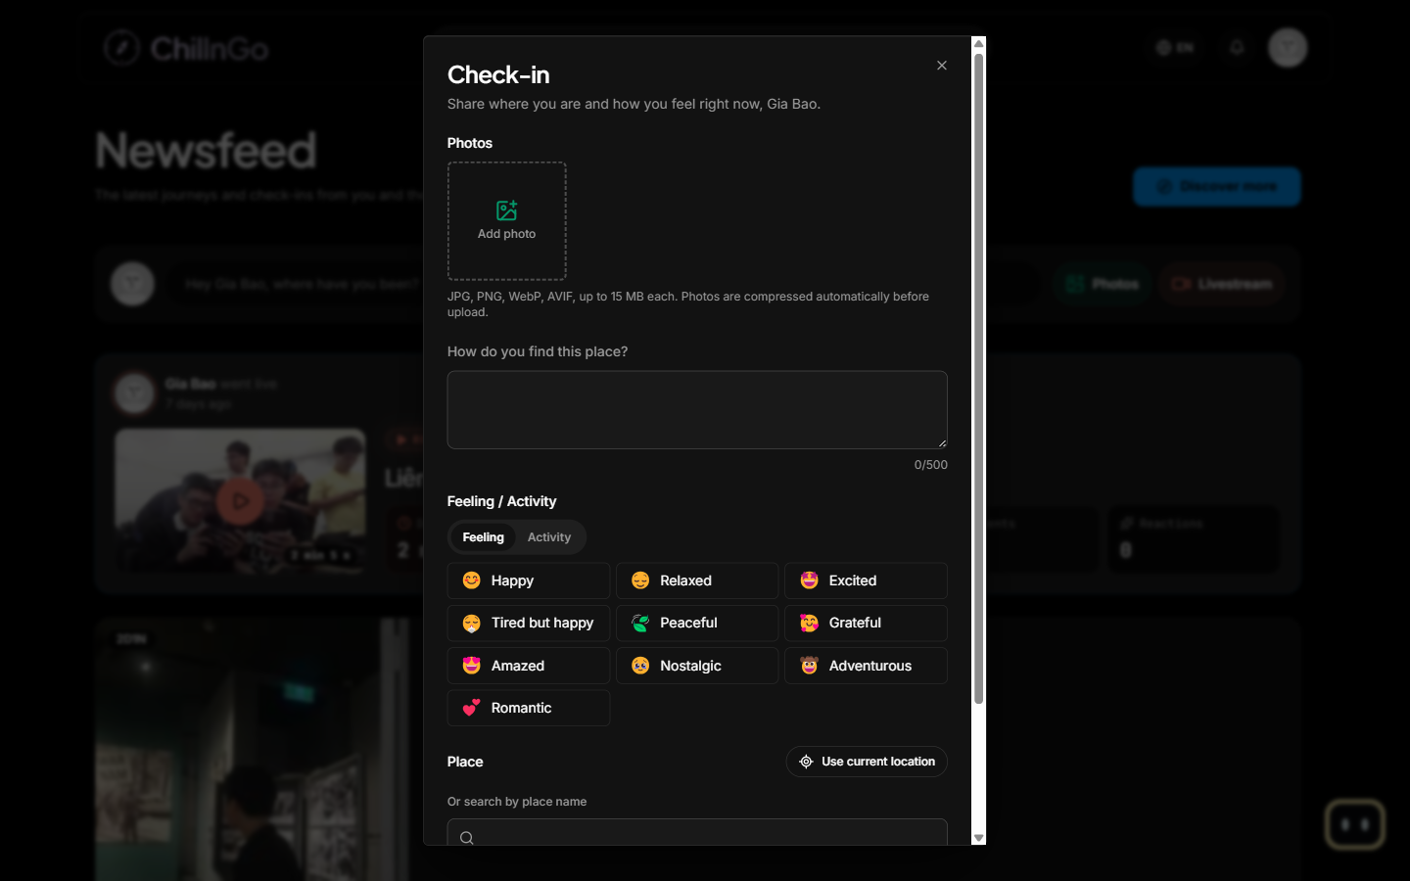
Figure 50: Check-in dialog
Function Details:
Validation:
- A check-in needs at least a photo, a feeling or a caption (BR-022).
- Photos must be the user's own uploads that exist on Cloudinary.
Business Rules:
- See BR-016 and BR-022.
Functionalities
Normal case:
- The traveler fills in the check-in and posts it.
- The system saves it and shows it in the feed.
Abnormal case:
- Nothing filled in: the check-in cannot be posted.
- Restore after 30 days: “This check-in is past its restore period and was deleted permanently.”

3.14 FE-12: Livestream

3.14.1 Start Livestream
Function trigger:
The traveler clicks “Livestream” in the Newsfeed composer or “Go live” on the Live now page.
Function description:
- Actors: Traveler
- Purpose: Broadcast live video from a trip to the chosen audience.
Data Processing:
- Check the camera and microphone, then enter a title, an optional description, the audience (public, followers, private) and whether to save the stream.
- Create a LiveKit room and a short-lived host token; followers are notified when the audience is public or followers.
- The host can end the stream, delete comments and block viewers. A stream whose host is gone for more than 45 seconds ends automatically.
Screen layout:
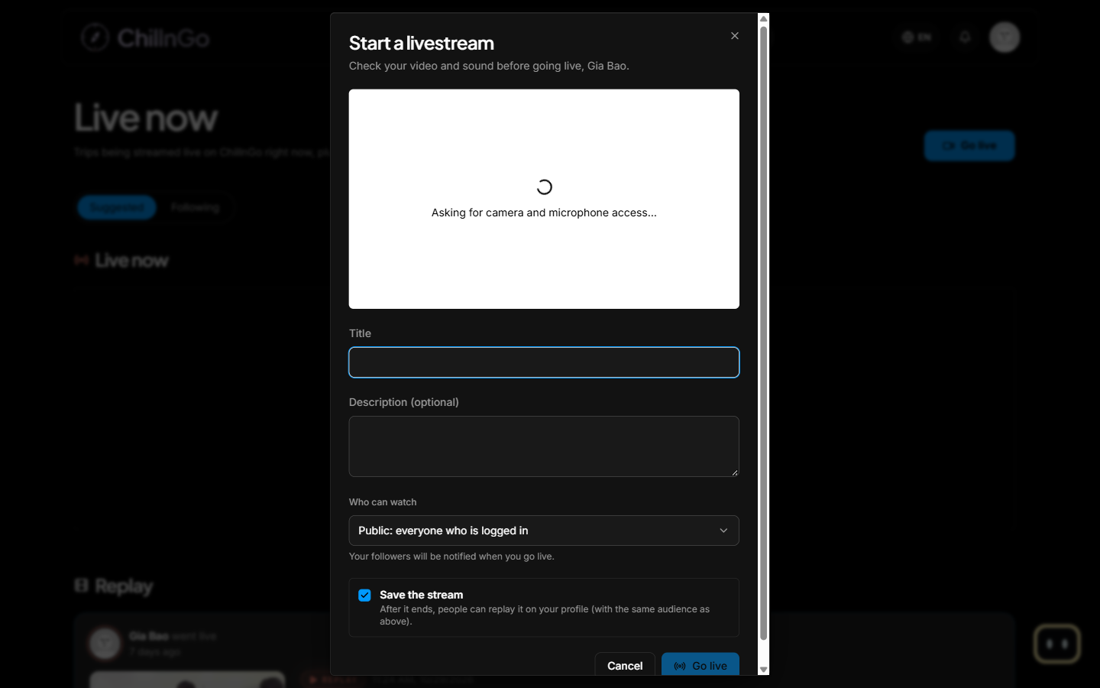
Figure 51: Start a livestream dialog
Function Details:
Validation:
- A title is required.
- A host can have only one live stream at a time (BR-018).
Business Rules:
- See BR-018.
Functionalities
Normal case:
- The traveler checks the camera and goes live.
- Viewers join; the host ends the stream.
- The stream's statistics (and replay, if saved) are kept.
Abnormal case:
- Already live: “You are already live.”
- Livestreaming not configured on the server: the feature is unavailable.

3.14.2 Watch Livestream & Replay
Function trigger:
The user opens a live card in the Newsfeed, the Live now page or a “live” notification.
Function description:
- Actors: Guest, Traveler
- Purpose: Watch live streams and replays and interact with the host.
Data Processing:
- Check the stream's audience, issue a watch-only token and play the video; viewer counts and the peak are updated.
- Signed-in viewers can comment (1–300 characters) and react; a saved stream can be rewound while it is live.
- After the stream ends, a saved replay is played through a signed link valid for 6 hours.
Screen layout:
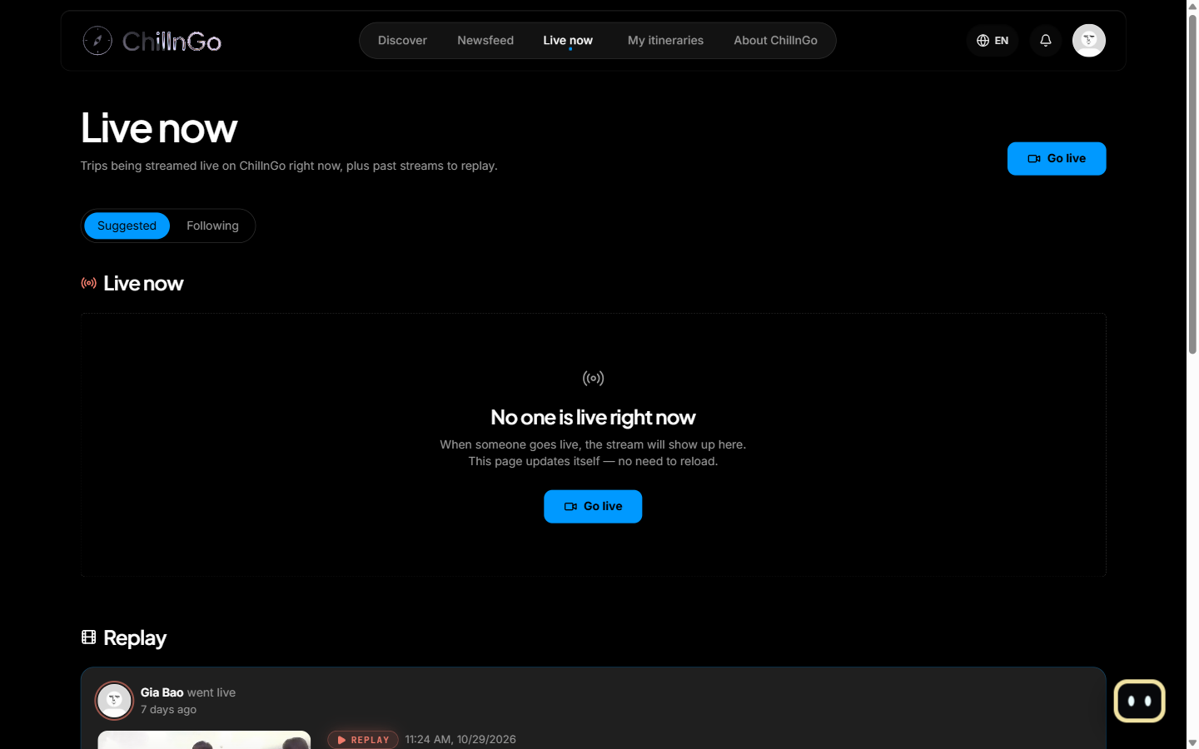
Figure 52: Live now screen with replays
Function Details:
Validation:
- The viewer must be allowed by the audience; blocked viewers cannot join.
Business Rules:
- Followers-only and private streams and their replays are never shown to other users.
Functionalities
Normal case:
- The user opens the stream.
- The system connects the viewer.
- The viewer watches, comments and reacts.
Abnormal case:
- Stream ended: the page shows the end screen and the replay if available.
- Blocked viewer: the viewer cannot join.

3.15 FE-13: AI Copy & AI Travel Assistant

3.15.1 Copy with AI
Function trigger:
The traveler clicks “Copy with AI” on a journey.
Function description:
- Actors: Traveler
- Purpose: Adapt someone's journey to the traveler's own dates, group, budget, interests and pace.
Data Processing:
- Ask the trip details step by step (chat or form): start date, days (1–14), group size (1–30), children or elderly, budget, starting point, interests, pace, and optionally 2–3 journeys of the same destination to merge.
- The AI (Gemini, then LiveKit Inference, whichever answers) plans only with the source stops and the destination's stored places; every answer is validated and sent back at most twice.
- Show a draft with each stop's change (keep, replace, add, remove) and its reason, costs against the budget and time warnings. The traveler accepts or reverts changes, edits by chat, optimises the route, sees Plan B and a preparation checklist.
- Save the draft to My itineraries; drafts expire after 24 hours.
Screen layout:
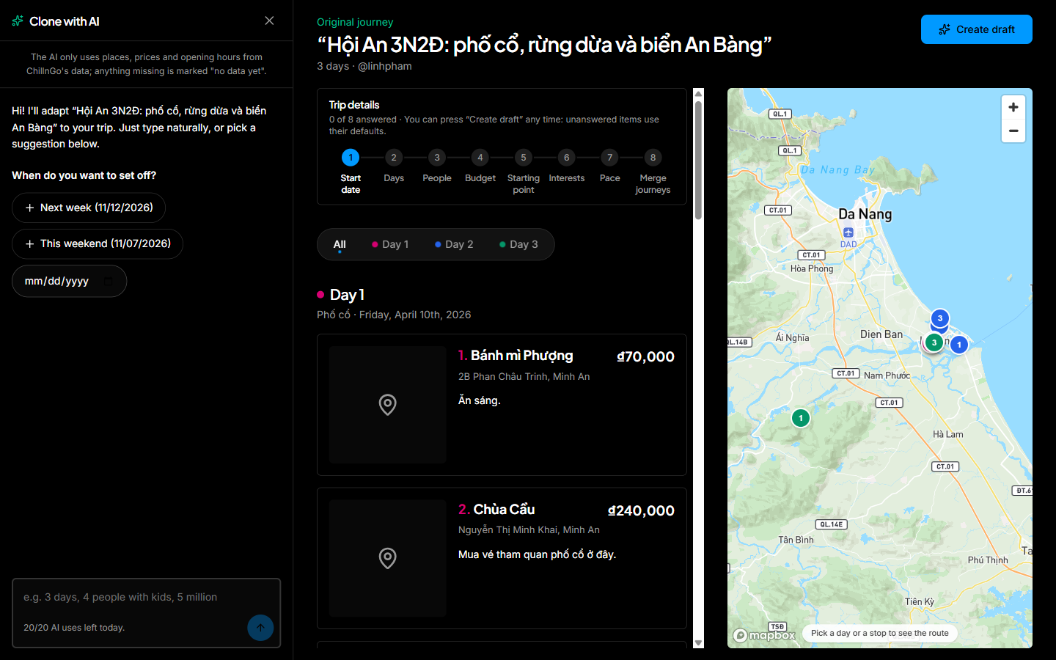
Figure 53: Copy with AI dialog
Function Details:
Validation:
- Each user has 10 AI requests per day, 100 with Premium (BR-019, BR-026).
- Only journeys stored in the database can be adapted.
Business Rules:
- See BR-019. The AI never invents places: costs, distances and warnings are computed by the server.
Functionalities
Normal case:
- The traveler answers the questions and creates the draft.
- The system shows the draft with its changes.
- The traveler reviews it and saves it as an itinerary.
Abnormal case:
- Daily limit reached: “You have used all of today's AI requests.” (MSG14)
- AI unavailable or invalid answer: the request is given back and the traveler can try again later.

3.15.2 Ask the AI Travel Assistant
Function trigger:
The traveler clicks the robot button at the bottom-right of any page.
Function description:
- Actors: Traveler
- Purpose: Answer questions about journeys on ChillnGo and about how to use the website.
Data Processing:
- Send the conversation (up to 20 messages) to the AI and stream the answer back.
- The AI can only use read-only lookups run as the signed-in user: published journeys, one journey's days and costs, the user's own journeys and drafts, and the website guide.
- Journey titles in the answer become links; nothing is stored.
Screen layout:
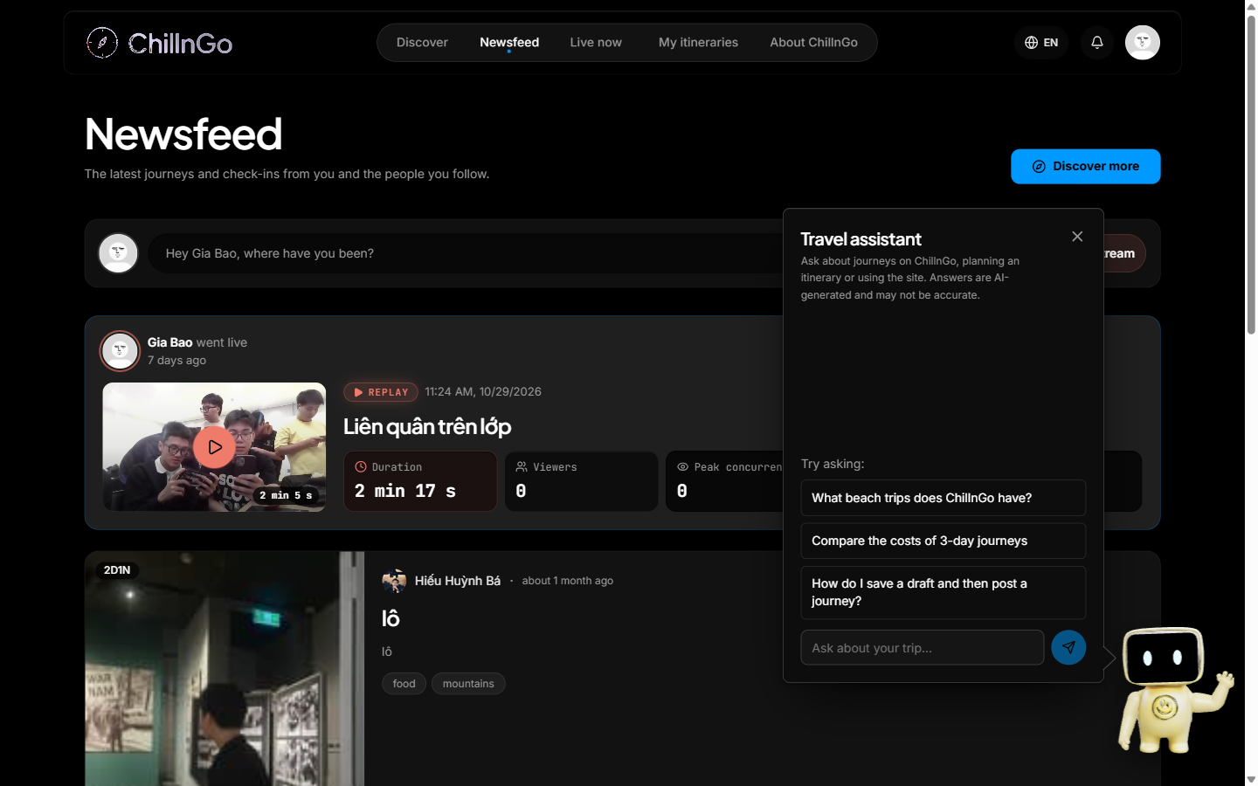
Figure 54: AI travel assistant panel
Function Details:
Validation:
- The user must be signed in; at most 10 questions a minute.
Business Rules:
- The assistant never sees the database directly or other users' private data.
Functionalities
Normal case:
- The traveler asks a question.
- The assistant answers, with links to journeys.
Abnormal case:
- Assistant not configured or busy: a message asks the traveler to try again later.

3.16 FE-14: Your Activity

3.16.1 View Your Activity
Function trigger:
The user opens “Your activity” from the account menu.
Function description:
- Actors: Traveler
- Purpose: Review and manage everything the user has done on ChillnGo.
Data Processing:
- Sections: Interactions (likes, comments, reposts, story replies, reviews), Photos and videos, Journeys (drafts), Search history, Account history, Recently deleted and Saved.
- The user can resume drafts, delete search history entries, and restore or permanently delete recently deleted items.
Screen layout:
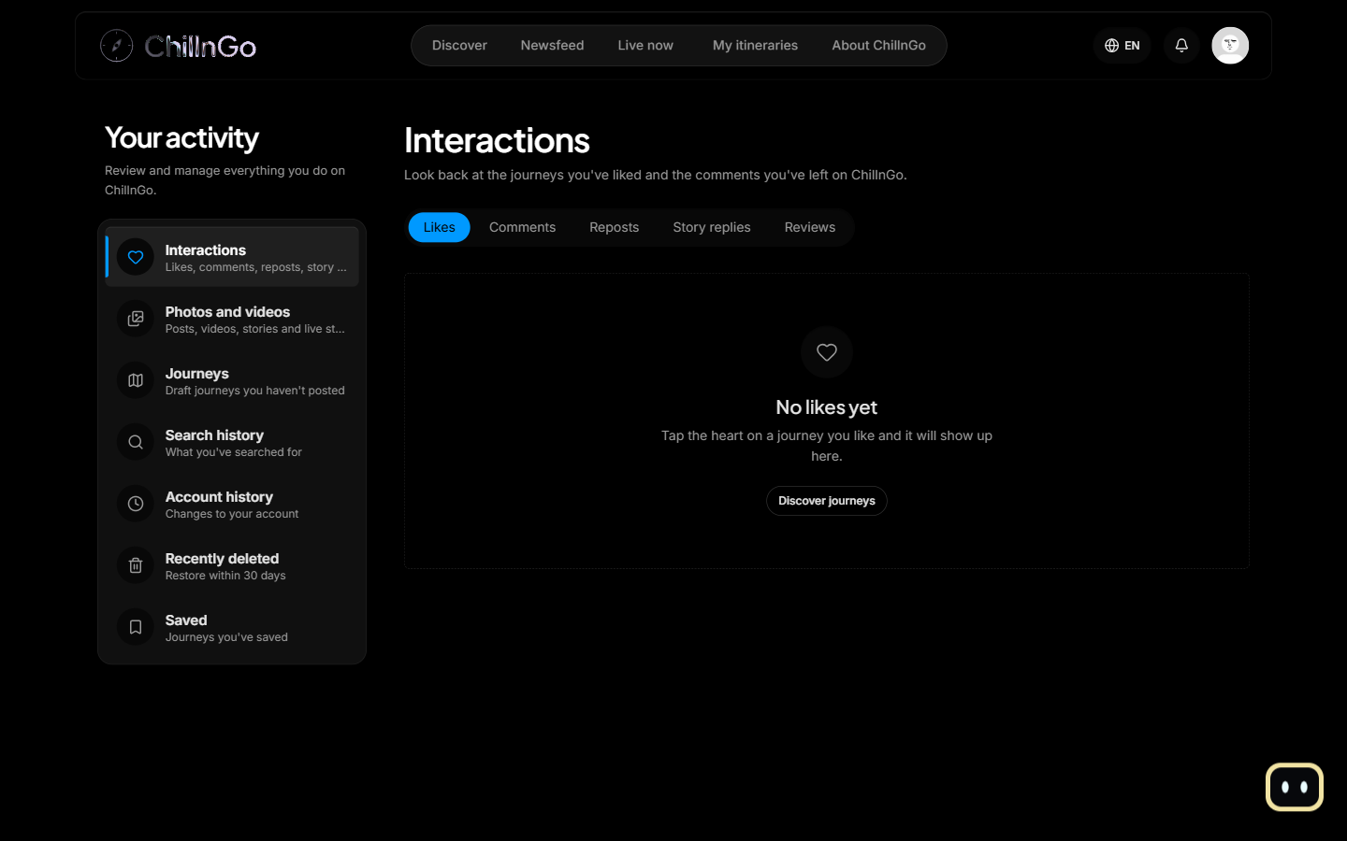
Figure 55: Your activity screen
Function Details:
Validation:
- Each section shows only the signed-in user's own data.
Business Rules:
- See BR-016.
Functionalities
Normal case:
- The user opens a section.
- The system lists the items with the available actions.
Abnormal case:
- Empty section: an empty state with a shortcut is shown.

3.17 FE-15: Super Admin Administration

3.17.1 Manage Administrators
Function trigger:
The Super Admin opens “Administrators” in the admin console.
Function description:
- Actors: Super Admin
- Purpose: Create Admin accounts and decide what each Admin may manage.
Data Processing:
- Create an Admin (display name, username, email, password) with modules: users, content, reports, categories, stats.
- Change an Admin's permissions, lock, unlock or demote an Admin; promote a user from the Users section. Accounts are never deleted.
- Every action is written to the audit log.
Screen layout:
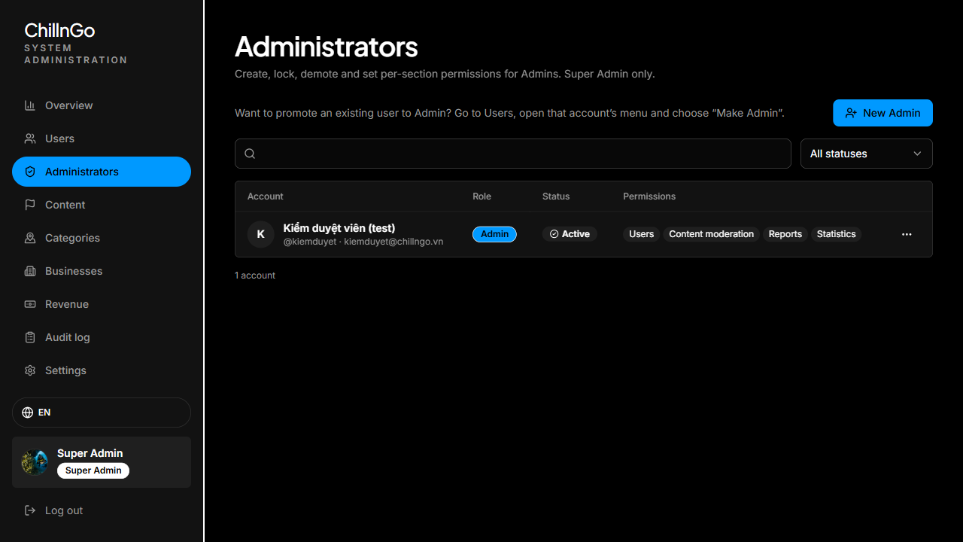
Figure 56: Administrators screen
Function Details:
Validation:
- Only the Super Admin can open this section.
Business Rules:
- The Super Admin account cannot be locked, deleted or re-roled through the application.
Functionalities
Normal case:
- The Super Admin creates or edits an Admin.
- The system saves it and logs the action.
Abnormal case:
- Email or username already used: the creation is refused.

3.17.2 View Audit Log & Configure System Settings
Function trigger:
The Super Admin opens “Audit log” or “Settings” in the admin console.
Function description:
- Actors: Super Admin
- Purpose: Trace every admin action and control platform-wide settings.
Data Processing:
- Audit log: list admin actions newest first with search and an action filter; rows keep copied names so they stay readable after an account is deleted. Rows cannot be edited or deleted.
- Settings: allow or pause new sign-ups (email and first-time Google sign-up) and set a site-wide announcement shown above every page.
Screen layout:
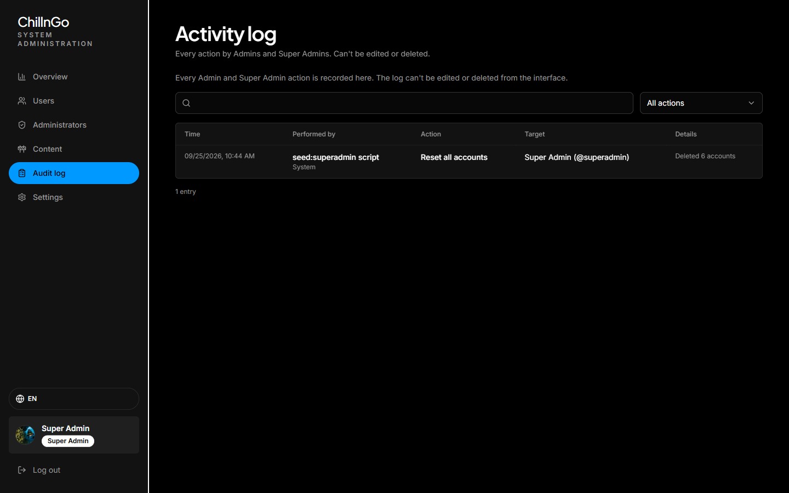
Figure 57: Audit log screen
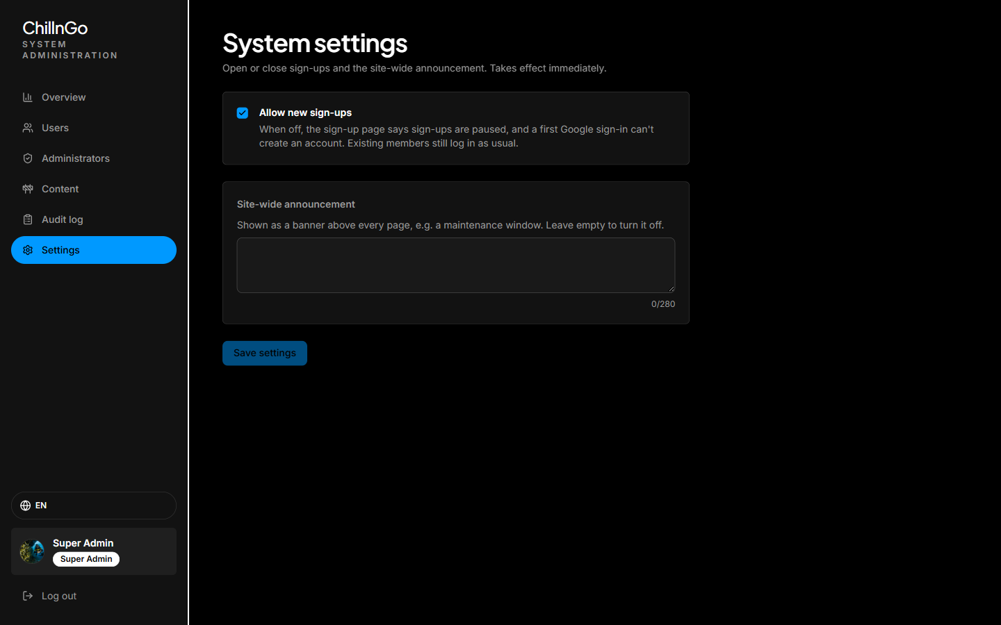
Figure 58: System settings screen
Function Details:
Validation:
- Only the Super Admin can open these sections.
- The announcement has at most 280 characters.
Business Rules:
- Settings take effect immediately; an audit trail is kept for every admin action (CR-007).
Functionalities
Normal case:
- The Super Admin reviews the log or saves the settings.
- The system applies the settings at once.
Abnormal case:
- No matching log entries: an empty state is shown.

3.18 FE-16: Premium Membership

3.18.1 Buy Premium
Function trigger:
The traveler opens “Nâng cấp Premium” in the account menu (web) or the menu screen (mobile), or the link shown in the livestream setup.
Function description:
- Actors: Traveler, PayOS
- Purpose: Pay for Premium to get more AI requests, 1080p livestreams, replays kept longer and the crown badge.
Data Processing:
- The screen shows the Free and Premium benefits and the plans read from the API: 30 days for 49,000 VND and 365 days for 490,000 VND.
- “Thanh toán” creates a pending order valid for 15 minutes and a PayOS checkout link; the buyer scans the VietQR code with a banking app (the mobile app opens the page inside the app).
- PayOS calls the signed webhook; the order turns paid once and premiumUntil is extended by the plan’s days from the current end date, or from now when Premium has run out.
- Back on the payment result screen, the app asks the API about the order every 2.5 seconds (the API checks pending orders with PayOS) until it is paid, cancelled or expired.
Screen layout:
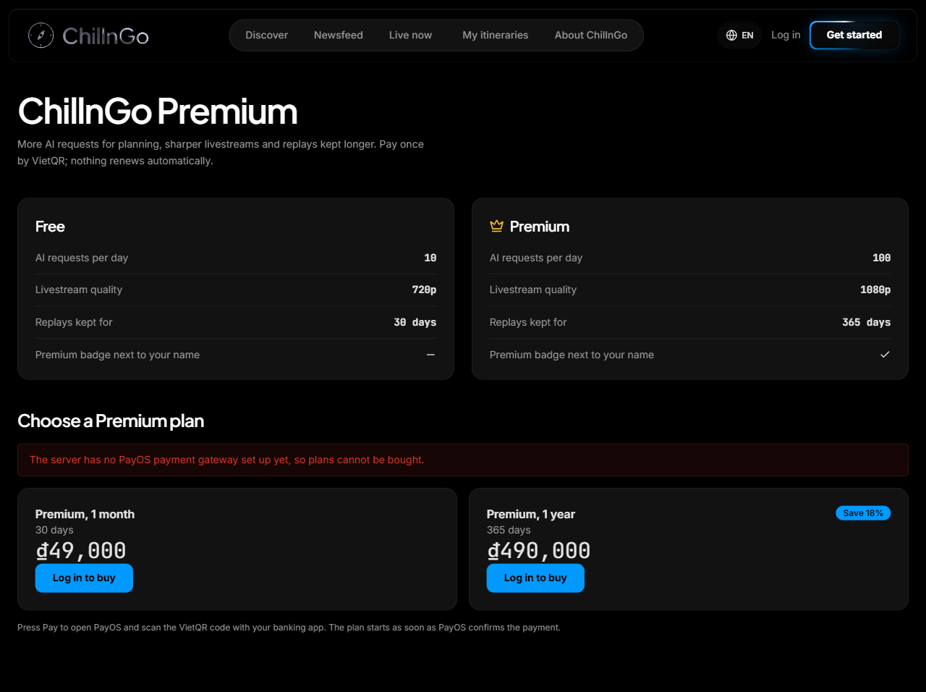
Figure 59: ChillnGo Premium screen
Function Details:
Validation:
- The traveler must be signed in.
- The plan must be one of the plans the API lists.
- At most 10 unpaid orders per person per hour (HTTP 429).
Business Rules:
- BR-023, BR-024, BR-025 and BR-026.
Functionalities
Normal case:
- The traveler pays; the result screen shows “Thanh toán thành công” with the plan’s end date (MSG16), the crown badge appears and a notification is sent.
Abnormal case:
- PayOS keys not configured: the Pay buttons are disabled and MSG19 is shown.
- The buyer cancels or the link expires: the order becomes cancelled or expired and nothing is charged (MSG18).
- No confirmation within 3 minutes: MSG17 is replaced by a note that the plan starts as soon as PayOS confirms; the order stays in the order history.
- The amount paid is lower than the order: the order is not fulfilled.

3.18.2 View Order History
Function trigger:
The traveler or business owner scrolls to “Lịch sử đơn hàng” on the Premium screen.
Function description:
- Actors: Traveler, Business Owner
- Purpose: Check past payments and finish paying an unpaid order.
Data Processing:
- The API lists the user’s 50 latest orders, newest first: plan, order code, date, amount and status.
- A pending order keeps its PayOS link while it can still be paid (“Tiếp tục thanh toán”).
Screen layout:
Order history list on the ChillnGo Premium screen.
Function Details:
Validation:
- Only the signed-in user’s own orders are returned.
Business Rules:
- BR-025.
Functionalities
Normal case:
- The list is shown with each order’s status.
Abnormal case:
- No orders yet: “Bạn chưa có đơn hàng nào.” is shown.

3.19 FE-17: Business Accounts & Sponsored Suggestions

3.19.1 Register / Edit Business Page
Function trigger:
The user opens “Doanh nghiệp của tôi” in the account menu (web) or the menu screen (mobile).
Function description:
- Actors: Business Owner
- Purpose: Open a business page for a homestay, hotel, restaurant, café or tour.
Data Processing:
- The form takes the name, type, address (with a pin picked on the map on the web), province or city, phone, website, price range, opening hours, description and up to 8 photos uploaded to Cloudinary.
- The API creates the business with status “pending” and a unique address (/b/<name>); the owner sees “Chờ duyệt”.
- Editing saves the changes; a rejected page goes back to “pending”. A page hidden by an admin cannot be edited.
Screen layout:
My business screen: registration form, status card, details and the “Đề xuất” card.
Function Details:
Validation:
- Name 2–80 characters, address 5–200, phone 8–15 digits, website a valid URL, photos HTTPS addresses, the lowest price not above the highest.
Business Rules:
- BR-028 and BR-030.
Functionalities
Normal case:
- The page is saved and waits for an admin; the owner is notified of the decision.
Abnormal case:
- The account already has a business: MSG21.
- Invalid input: the field message from the API is shown.

3.19.2 Manage Business Ads
Function trigger:
On My business, the owner presses “Viết bài mới”, or “Sửa” / “Xoá” on an ad.
Function description:
- Actors: Business Owner
- Purpose: Advertise offers, rooms or menus on the business page (and on Discover while the package runs).
Data Processing:
- An ad has a title (3–120 characters), text (10–3000), up to 6 photos and an optional offer line (up to 80 characters).
- Ads are listed on the business page newest first; a deleted ad disappears at once.
- Other users can report a business page or an ad; moderators hide or remove it from the report queue.
Screen layout:
Ad editor (dialog on the web, sheet on mobile) and the ads list on My business.
Function Details:
Validation:
- Only the owner can write, edit or delete the ads of their business; a hidden business cannot post.
Business Rules:
- BR-029.
Functionalities
Normal case:
- The ad is saved and shown on the business page.
Abnormal case:
- Invalid input or a hidden business: the API refuses with a message.

3.19.3 Buy the “Đề xuất” Package
Function trigger:
The owner of an approved business presses “Mua gói” (or “Gia hạn”) on the “Gói Đề xuất” card.
Function description:
- Actors: Business Owner, PayOS
- Purpose: Be suggested on Discover for 30 days.
Data Processing:
- The same PayOS flow as 3.18.1 runs with the product business_boost_month (199,000 VND).
- When the order is paid, promotedUntil of the business is extended by 30 days; the card shows “Đang được đề xuất đến …”.
Screen layout:
“Gói Đề xuất” card on My business, then the PayOS page and the payment result screen.
Function Details:
Validation:
- The business must be approved.
Business Rules:
- BR-023, BR-024, BR-025 and BR-029.
Functionalities
Normal case:
- The business and its ads appear in “Gợi ý nổi bật”.
Abnormal case:
- Business not approved: the button is disabled and the API answers BUSINESS_NOT_APPROVED.

3.19.4 View Sponsored Suggestions & Business Page
Function trigger:
Anyone opens Discover, or a business card or ad in “Gợi ý nổi bật”.
Function description:
- Actors: Guest, Traveler
- Purpose: Discover places to stay, eat and visit, and contact them.
Data Processing:
- Discover shows up to 8 sponsored businesses in random order and up to 8 of their latest ads, each marked “Tài trợ”.
- The business page shows photos, type, address (opens Google Maps), phone (opens the dialer), hours, prices, website, description and ads.
Screen layout:
“Gợi ý nổi bật” row on Discover and the business page (/b/:slug).
Function Details:
Validation:
- Only approved businesses that are not hidden are public; their owner also sees a pending or hidden page, marked.
Business Rules:
- BR-029.
Functionalities
Normal case:
- The suggestions and the page are shown.
Abnormal case:
- No sponsored business: the row is not shown.
- Unknown or non-public page: not found.

3.19.5 Review Business Pages
Function trigger:
An Admin with the businesses permission, or the Super Admin, opens “Doanh nghiệp” in the admin console.
Function description:
- Actors: Admin, Super Admin
- Purpose: Keep business pages genuine before they are public.
Data Processing:
- Pages are listed by status (pending oldest first, approved, rejected, hidden) with photos, address, phone, owner and description; a search box filters by name, address or phone.
- Approve and restore act at once; reject and hide ask for a reason. Each decision is written to the audit log and the owner is notified.
Screen layout:
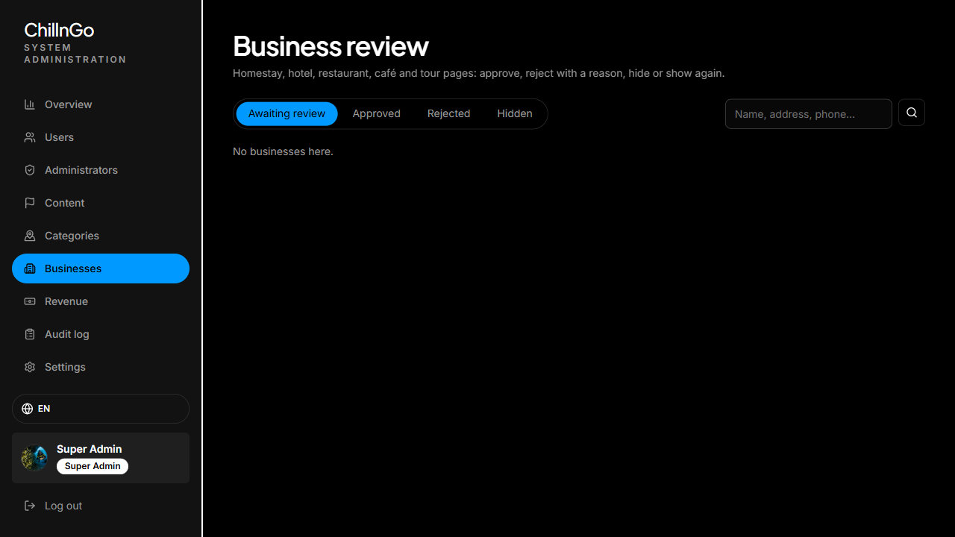
Figure 60: Business review screen
Function Details:
Validation:
- A decision must match the current status (for example only a pending page can be rejected); otherwise 409.
Business Rules:
- BR-028 and BR-030.
Functionalities
Normal case:
- The status changes and the owner receives a notification (MSG20).
Abnormal case:
- Reject or hide without a reason: refused.

3.19.6 View Revenue & Orders
Function trigger:
An Admin with the revenue permission, or the Super Admin, opens “Doanh thu”; the overview also shows the 30-day revenue and the Premium members.
Function description:
- Actors: Admin, Super Admin
- Purpose: Follow the platform’s income.
Data Processing:
- Shows total revenue and paid orders, the last 30 days, revenue per plan, current Premium members and businesses being suggested.
- Lists every order with buyer, plan, amount, status and time, filterable by status and paged 20 at a time.
Screen layout:
Admin console, “Doanh thu” section (web and mobile).
Function Details:
Validation:
- Read-only; needs the revenue permission.
Business Rules:
- BR-023.
Functionalities
Normal case:
- The summary and the orders are shown.
Abnormal case:
- No orders: an empty state is shown.

3.20 FE-19: Travel News Aggregation

3.20.1 Manage News Sources
Function trigger:
An Admin with the news permission, or the Super Admin, opens “Tin tức” → “Nguồn” in the admin console and clicks “Thêm nguồn” or the pencil of a source.
Function description:
- Actors: Admin, Super Admin
- Purpose: Choose where the Newsfeed’s travel news comes from.
Data Processing:
- Types: news site (RSS/Atom link), Google News by keyword, YouTube channel (channel link; its feed is found automatically) and social media (platform + keyword or page link, fetched by the worker).
- Options: words an item must contain (any of them) and words it must not contain, accents ignored; a default region; the interval (30 minutes to 7 days); on/off; auto-post.
- “Thử nguồn” reads the source once without saving and shows how many items it has and the first five.
- The list shows each source’s type, last fetch (with its error), new items, posted and waiting counts; the on/off and auto-post boxes save at once. Deleting a source keeps the news it brought.
- Every change is written to the audit log.
Screen layout:
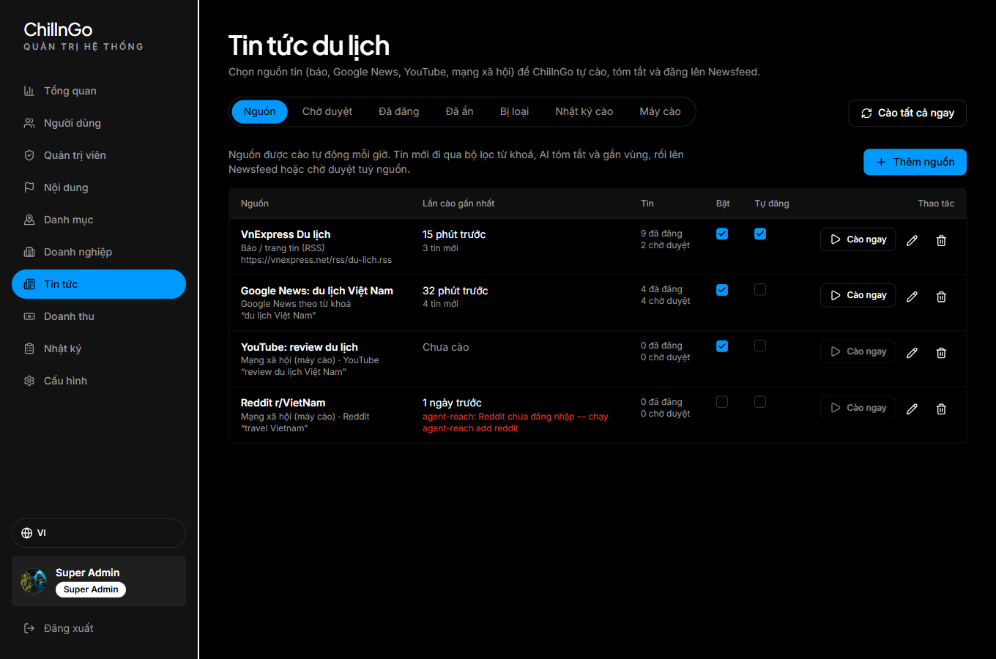
Figure 61: Admin, news sources
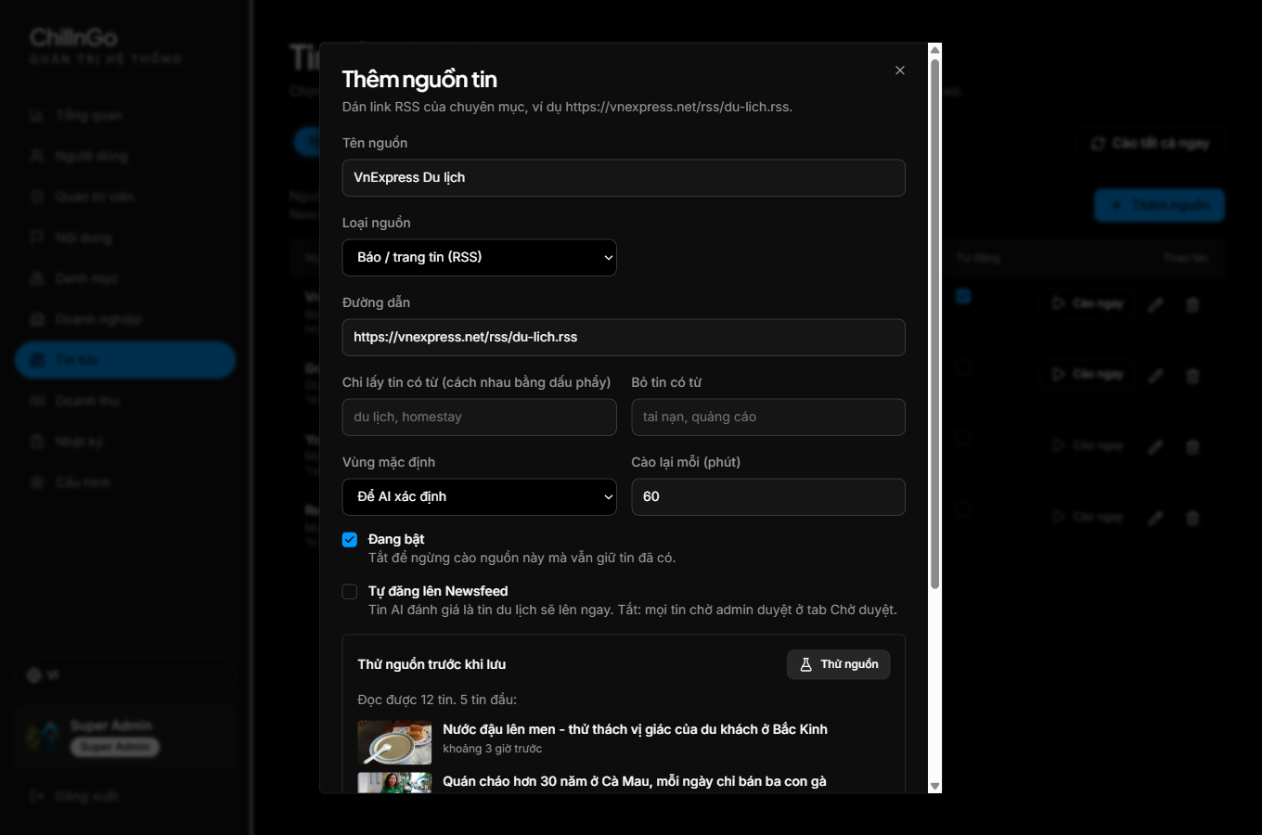
Figure 62: Add a news source, with “Thử nguồn”
Function Details:
Validation:
- Name 2–80 characters; RSS and YouTube need an https:// link; Google News needs a keyword; social media needs a platform and a keyword or a link; at most 30 keywords each.
Business Rules:
- BR-038 and BR-039.
Functionalities
Normal case:
- The admin tests the source, saves it, and it is fetched at the next run or with “Cào ngay”.
Abnormal case:
- The link is not a feed: “Không đọc được tin nào: đường dẫn không phải RSS/Atom hoặc nguồn đang trống.” (MSG29)
- The source does not answer within 12 seconds: the error is shown and logged.

3.20.2 Fetch News and Write Posts with AI
Function trigger:
Every hour (GitHub Actions) and once a day (Vercel cron) the scheduler calls GET /api/news/cron; an admin clicks “Cào ngay” on a source or “Cào tất cả ngay”.
Function description:
- Actors: Admin, Super Admin, News sources
- Purpose: Bring in new travel news without anyone copying it by hand.
Data Processing:
- The API takes up to 12 enabled sources whose interval has passed (all of them for “Cào tất cả ngay”) and reads each feed.
- Each item’s link is made canonical (tracking parameters, “m.” and “www.” removed); items failing the keywords are filtered; a link or a title the source already brought in the last 14 days is a duplicate.
- New items are stored “queued”. For up to 6 of them per run the API opens the original article and extracts its main text (given to the AI only, never stored) and up to 12 pictures (cover first; icons, thumbnails and duplicates are left out). The AI answers whether it is travel news and writes a Vietnamese headline, a 2–3 sentence summary and up to 8 paragraphs in its own words using only what the article says, plus a region and the catalog destinations it names.
- Travel news is posted at once when the source auto-posts, otherwise it waits for review; items the AI judges off-topic are rejected. Without an AI provider, items keep the source’s title and excerpt. News published before posts existed is written by later runs.
- Every fetch is written to the fetch log (“Nhật ký cào”), kept 30 days.
Screen layout:
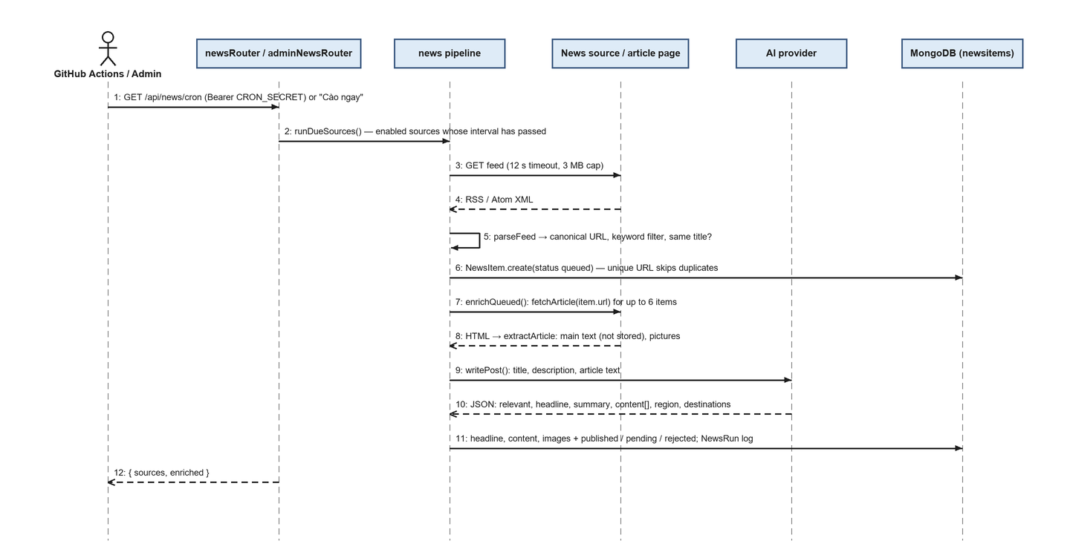
Figure 63: Sequence of a scheduled fetch
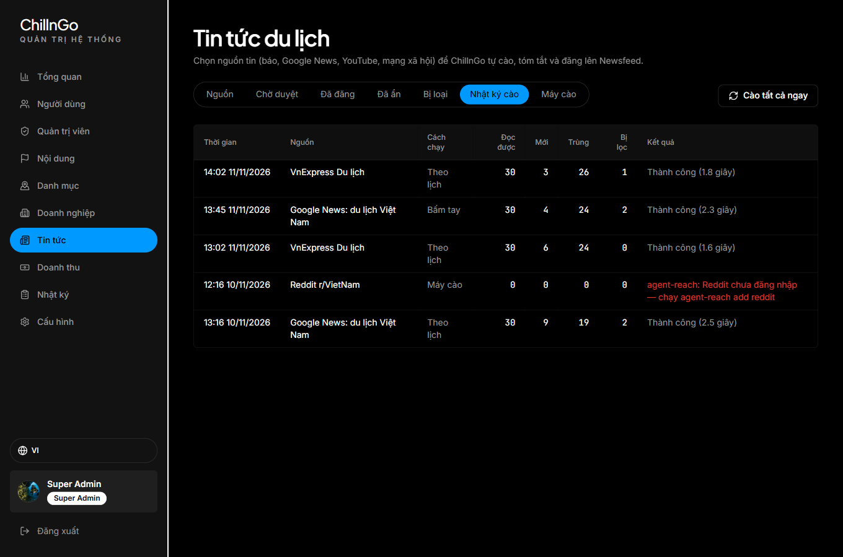
Figure 64: Admin, fetch log
Function Details:
Validation:
- The cron call needs the CRON_SECRET bearer token; a wrong or missing token gets 401.
Business Rules:
- BR-036, BR-037 and BR-038.
Functionalities
Normal case:
- New items appear in “Chờ duyệt” or directly in the Newsfeed; the admin sees “Đã cào {n} nguồn: …” (MSG28).
Abnormal case:
- A source fails (HTTP error, timeout, not a feed): its last error is shown in the list and the run continues with the next source.
- The AI fails 3 times on an item: the excerpt is used and the item follows the source’s auto-post setting.
- The article page cannot be read (the site blocks automated reading, or the link is a Google News redirect): the AI writes a shorter post from the title and description, with the feed’s picture if any.

3.20.3 Review Travel News
Function trigger:
The admin opens the “Chờ duyệt”, “Đã đăng”, “Đã ẩn” or “Bị loại” tab of “Tin tức”.
Function description:
- Actors: Admin, Super Admin
- Purpose: Keep only relevant, correct news in the Newsfeed.
Data Processing:
- Each item shows its picture, source, date, title (opens the original), summary, regions, places and, when posted, its clicks.
- Decisions, one by one or for the selected items: waiting → post or reject; posted → hide; hidden → show again; rejected → post.
- “Sửa bài” edits the headline (at most 200 characters), the summary (600), the paragraphs (at most 8, 1,500 characters each), the regions and the places, and removes pictures (the first one left is the cover); “Viết lại bằng AI” reads the original again and replaces the post. Posted news can be pinned to the top of the “Tin du lịch” tab and opened with “Xem trang tin”.
- News hidden through a user report also appears in “Đã ẩn”. Every decision is written to the audit log.
Screen layout:
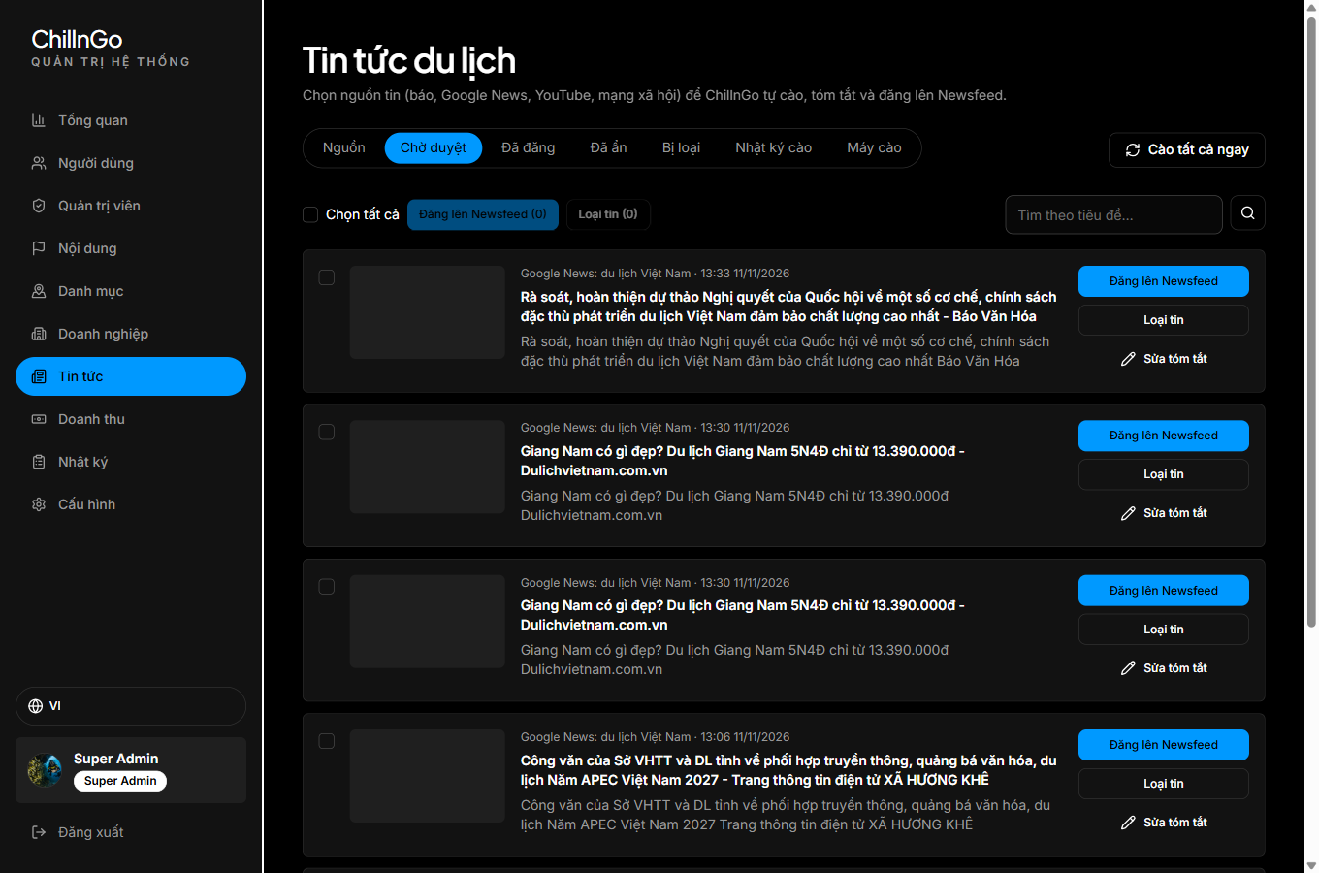
Figure 65: Admin, news waiting for review
Function Details:
Validation:
- A decision applies only from the statuses listed; otherwise “Trạng thái tin đã thay đổi. Hãy tải lại danh sách.”
Business Rules:
- BR-036 and BR-038.
Functionalities
Normal case:
- The admin posts the relevant news; it appears in the Newsfeed at once.
Abnormal case:
- The item was decided by someone else meanwhile: 409 and the list reloads.

3.20.4 Send Social Media News (Worker)
Function trigger:
The admin opens “Tin tức” → “Máy cào” and clicks “Tạo mã”; the worker runs on its schedule (Task Scheduler or cron).
Function description:
- Actors: News worker, Admin, Super Admin
- Purpose: Bring in news from social media, which needs logged-in accounts and cannot be fetched by the server.
Data Processing:
- “Tạo mã” shows a new key once (cgw_…); only its SHA-256 hash and first characters are stored, and a new key replaces the old one. “Thu hồi mã” revokes it.
- The worker reads the key from worker.env, asks GET /api/news/worker/sources for the due social media sources, runs “agent-reach <platform> search <keyword>” (or “agent-reach read <link>”) and posts the items or the error to POST /api/news/worker/ingest.
- The API treats the items exactly like those of server-side sources (3.20.2); the tab shows the key’s hint, when it was created, when the worker last connected and how many social sources are on.
Screen layout:
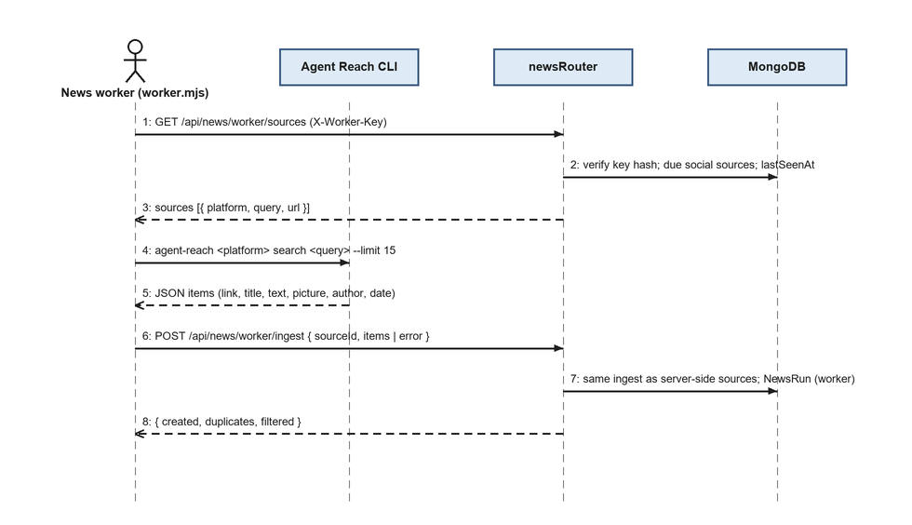
Figure 66: Sequence of the news worker
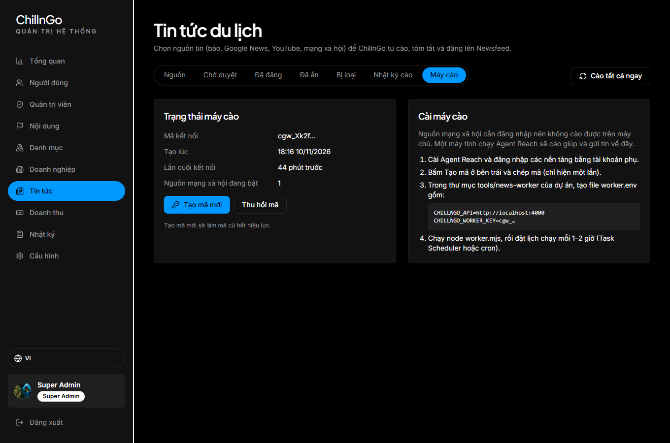
Figure 67: Admin, news worker key
Function Details:
Validation:
- Every worker call needs the X-Worker-Key header with the current key; a wrong key gets 401.
Business Rules:
- BR-039.
Functionalities
Normal case:
- The worker prints one line per source (✓ fetched / new / duplicates / filtered) and the items appear in the review queue.
Abnormal case:
- A platform is not logged in on the worker: Agent Reach’s error and hint are sent and shown as the source’s last error.
- The key was revoked: the worker stops with 401 until a new key is set.

4. Non-Functional Requirements

4.1 External Interfaces

4.1.1 Database Interfaces
- The system shall use MongoDB Atlas, accessed through Mongoose, as the primary database for accounts, journeys, itineraries, check-ins, livestreams, social interactions, AI drafts and audit data.
- Stops store latitude/longitude and each journey keeps its route as GeoJSON. Indexes cover frequent queries (status, author, date), unique pairs (follows, likes, livestream viewers, one live stream per host) and automatic expiry (notifications after 90 days, AI drafts after 24 hours).

4.1.2 API Interfaces
- The system shall expose a REST API developed with Node.js, Express 5 and TypeScript; input is validated with zod and errors are returned as { message, code }. The API runs as a Vercel serverless function or as a normal Node process.
- Authentication shall use JWT bearer tokens (HS256) valid for 7 days by default, without refresh tokens. Passwords are hashed with bcrypt; Sign in with Google is verified with Google’s ID token. Login, write, AI and livestream endpoints are rate-limited.
- The API shall support CORS for the web frontend origin(s).

4.1.3 Frontend Interfaces
- The web application shall be developed with React 19, Vite and TypeScript (React Router, TanStack Query, Zustand, Tailwind CSS, Radix UI) and shall be available in Vietnamese, English, Chinese, Japanese and Korean.
- The application shall be responsive across desktop, tablet, and mobile screen sizes.
- A Flutter mobile app (Android and iOS) shall provide the same screens for phones and use the same REST API.

4.1.4 External Service Interfaces
- The system shall integrate with Mapbox GL JS for maps, route drawing and place search; shortened Google Maps links pasted by users are resolved by the API.
- The system shall integrate with Cloudinary for avatars, covers, journey and check-in photos, using signed uploads sent directly from the browser.
- The system shall send confirmation emails and temporary passwords over SMTP (nodemailer).
- The system shall integrate with Google Identity (Sign in with Google), LiveKit Cloud (livestream rooms, recording and AI inference) and a private S3-compatible bucket for livestream recordings.
- The AI features shall call Google Gemini and LiveKit Inference, in that order of fallback, within a daily limit per user (10 requests, 100 with Premium).
- The system shall integrate with PayOS for VietQR payments: payment links and payment status over HTTPS with the channel’s client id and API key, signed with its checksum key; PayOS calls a signed webhook (POST /api/billing/payos-webhook) when a payment arrives.

4.2 Quality Attributes

4.2.1 Usability
Task Completion Times:
- Login: < 5 seconds
- Create trip post (3-day itinerary): < 5 minutes
- Copy a trip post: < 5 seconds
- Create an AI Copy draft: 20–60 seconds
UI/UX Standards:
- The system shall use a clean, card-based layout suited to visual travel content (photos, maps).
- The system shall support real-time form validation, clear error messages, and touch-friendly mobile interactions.

4.2.2 Reliability
- Availability: the system shall maintain at least 99% uptime.
- Data Accuracy: input validation shall be enforced for all user data and file uploads.
- MTTR (Mean Time To Repair): critical issues < 8 hours; minor issues < 48 hours (reasonable target for an academic project).

4.2.3 Performance
- Newsfeed/Explore query response time: < 2 seconds
- Trip post detail load time (including map render): < 3 seconds
- The system shall support at least 100 concurrent users for the academic release.
- Storage capacity shall be at least 2GB for the initial release.

5. Requirement Appendix

5.1 Business Rules
ID | Rule Definition
BR-001 | A journey is created with at least one day; publishing requires a title and a summary. A journey has at most 60 days and a day at most 30 stops.
BR-002 | Only the author of a journey can edit, publish, duplicate, delete or restore it.
BR-003 | A journey has exactly one region, one season and one budget level, up to 20 free tags (1–40 characters each), and a duration derived from its days.
BR-004 | A user cannot follow themselves, and staff accounts (Admin, Super Admin) cannot be followed.
BR-005 | A user can only like a given journey once; liking again removes the like (toggle).
BR-006 | A comment has 1–1000 characters; replies are one level deep.
BR-007 | A comment can be deleted by its writer or by the journey’s author; the journey’s author can also hide it from everyone else.
BR-008 | Cloning creates an independent Itinerary; edits to the Itinerary never modify the original journey. Only published journeys (or the user’s own) can be Copyd.
BR-009 | Merged days are appended at the end of the itinerary and renumbered; the user may reorder them afterwards.
BR-010 | The total estimated cost of an itinerary is recalculated whenever a day is added, removed, reordered or merged.
BR-011 | Draft and deleted journeys and check-ins are visible only to their author; they never appear in the Newsfeed, Discover or search.
BR-012 | A locked account cannot log in; its open sessions get 401 and are signed out, its live stream ends and it leaves follower counts until unlocked. Admins lock regular users only; nobody can lock the Super Admin or their own account.
BR-013 | Discover lists published journeys ordered by saves and engagement; search matches titles, places and tags.
BR-014 | A password has 6–72 characters with at least one uppercase letter and one special character.
BR-015 | After 20 failed login attempts from one IP within 15 minutes, further attempts are refused (HTTP 429) until the window ends.
BR-016 | Deleted journeys and check-ins stay in Recently deleted for 30 days; afterwards they and their images are deleted permanently.
BR-017 | Email confirmation links are single use and valid for 24 hours; a new link can be requested once a minute.
BR-018 | A host can have only one live stream at a time; a stream whose host is away for more than 45 seconds ends automatically.
BR-019 | Each user may make 10 AI requests per day on the free plan and 100 with Premium (AI Copy, AI merge, chat edits); a failed AI call gives its request back; AI drafts expire after 24 hours.
BR-020 | A journey can have at most 10 companions, and only friends (users who follow each other) can be invited.
BR-021 | An itinerary keeps at least 1 and at most 60 days.
BR-022 | A check-in has up to 4 photos and needs at least a photo, a feeling or a caption.
BR-023 | Premium costs 49,000 VND for 30 days or 490,000 VND for 365 days; the “Đề xuất” package costs 199,000 VND for 30 days. Prices are set by the system.
BR-024 | Plans do not renew automatically: each payment adds its days to the time left, or counts from the payment when the plan has run out.
BR-025 | An order can be paid for 15 minutes. It is fulfilled exactly once, only after a valid PayOS signature or PayOS status, and only when the amount paid is at least the order amount.
BR-026 | Premium gives 100 AI requests a day, 1080p livestreams, replays kept 365 days and a crown badge; the free plan gives 10 AI requests, 720p and 30 days.
BR-027 | A replay’s keeping time follows the host’s plan when the replay becomes ready; afterwards the file is deleted and the stream shows no replay.
BR-028 | Each account can register one business page; it is public only after an admin approves it. Editing a rejected page sends it back to review.
BR-029 | Only approved, not hidden businesses with a running “Đề xuất” package appear in “Gợi ý nổi bật”, marked “Tài trợ”, in random order. Buying the package needs an approved business.
BR-030 | Rejecting or hiding a business requires a reason, which is sent to its owner.
BR-031 | Users can report a journey, comment, check-in, account, business page or ad once each, at most 20 reports an hour, never their own content; content reported by 5 different people is hidden until a moderator decides.
BR-032 | A password reset link is single use and valid for 60 minutes; a new one can be requested once a minute; setting a new password signs out every open session.
BR-033 | No account is ever deleted through the application: banning means locking the account, and unlocking undoes it.
BR-034 | A destination that still has places, or a place a journey links to, cannot be deleted from the AI catalog.
BR-035 | A moderator can stop any live stream; it ends at once, its recording is kept and the host is told the reason.
BR-036 | A news post is written by the AI from the original article and always links to it; the original’s text is never stored, and its pictures are not copied but shown from the source by link.
BR-037 | A news item is stored once: a link equal to a known one after removing tracking parameters, or the same title from the same source within 14 days, is a duplicate.
BR-038 | Auto-posting sources publish the items the AI judges to be travel news; other sources put them in the review queue; items judged off-topic are rejected. Without AI, auto-posting sources publish and the others wait.
BR-039 | A source is fetched when its interval (30 minutes to 7 days) has passed, at most 12 per run; social media sources are fetched only by the worker with the current key.
BR-040 | “Dành cho bạn” shows one travel news item after every three journeys, check-ins or replays; pinned news comes first in the “Tin du lịch” tab.
BR-041 | A news post has a headline of at most 200 characters, a summary of at most 600, at most 8 paragraphs and at most 12 pictures over https; the first picture is the cover.

5.2 Common Requirements
ID | Rule Definition
CR-001 | The system must display journey and itinerary routes on an interactive map (Mapbox), with a static fallback when no map token is configured.
CR-002 | The system must support responsive design across desktop, tablet and mobile screen sizes.
CR-003 | The system must implement role-based access control distinguishing Guest, Traveler, Admin (per-module permissions) and Super Admin; the API re-reads the role and lock status on every request.
CR-004 | The system must support cross-browser compatibility (Chrome, Firefox, Edge, Safari).
CR-005 | All pages must load in under 3 seconds under standard internet conditions.
CR-006 | The system must perform automated backups of the database on a regular schedule.
CR-007 | An audit trail must be maintained for all admin actions.
CR-008 | The system must ensure uploaded images are validated (file type, size limit) before storage.
CR-009 | The web interface must be available in Vietnamese, English, Chinese, Japanese and Korean.
CR-010 | The web and the mobile (Flutter) clients must use the same REST API and the same data shapes.
CR-011 | Payment notices must be verified (signature, amount) before a plan is granted; card and bank details are never received or stored by ChillnGo.

5.3 Application Messages List
# | Message code | Message Type | Context | Content
1 | MSG01 | Toast message | Login failed | Incorrect email or password.
2 | MSG02 | Toast message | Register success | Account created successfully.
3 | MSG03 | In red, under text box | Input-required fields | The * field is required.
4 | MSG04 | Toast message | Trip post created | Trip post published successfully.
5 | MSG05 | Toast message | Trip post deleted | Trip post deleted successfully.
6 | MSG06 | Toast message | Copy success | Trip Copyd to your itineraries.
7 | MSG07 | Toast message | Comment posted | Comment added successfully.
8 | MSG08 | Toast message | Follow success | You are now following this user.
9 | MSG09 | Toast message | Password reset by admin | A temporary password has been emailed to the user.
10 | MSG10 | In red, under text box | Register: password confirmation | Passwords do not match.
11 | MSG11 | Toast message | Account locked | This account has been locked. Please contact support.
12 | MSG12 | In line | Search result | No trip posts found.
13 | MSG13 | Toast message | Email not confirmed | Please confirm your email before logging in, or resend the confirmation email.
14 | MSG14 | Toast message | AI daily limit | You have used all {n} of today’s AI requests. Come back tomorrow or upgrade to Premium for more.
15 | MSG15 | Toast message | Restore expired | This item is past its restore period and was deleted permanently.
16 | MSG16 | In line | Payment success | Payment successful. {plan} is valid until {date}.
17 | MSG17 | In line | Waiting for PayOS | Confirming your payment… Please keep this page open.
18 | MSG18 | In line | Payment cancelled or expired | The order was cancelled or expired. You have not been charged.
19 | MSG19 | In line | Payments not configured | The server has no PayOS payment gateway set up yet, so plans cannot be bought.
20 | MSG20 | Notification | Business reviewed | “{name}” has been approved and is now public. / “{name}” was not approved: {reason}
21 | MSG21 | Toast message | Second business | Each account can register only one business.
22 | MSG22 | Toast message | Report sent | Thank you, we’ll look into it.
23 | MSG23 | Toast message | Reported twice | You have already reported this.
24 | MSG24 | In line | Reset link requested | If an account uses this email, a link to set a new password is on its way.
25 | MSG25 | In line | Reset link invalid | The password reset link is invalid, already used or expired.
26 | MSG26 | Notification | Live stream stopped | Your livestream was stopped for breaking the community rules: {reason}
27 | MSG27 | Toast message | News saved / unsaved | News saved. / News unsaved.
28 | MSG28 | In line | Fetch finished | Fetched {sources} sources: {created} new items, AI processed {enriched}, {failed} sources failed.
29 | MSG29 | In line | Source unreadable | Couldn’t read any items: the link isn’t RSS/Atom or the source is empty.
30 | MSG30 | Dialog | New worker key | Copy this key into worker.env now. Once you close this dialog you can’t see it again.
31 | MSG31 | In line | The AI could not write a post | The AI couldn’t write this post. Try again later.

5.4 Other Requirements
Other requirements of the current release:
- Internationalisation: the web app switches between Vietnamese, English, Chinese, Japanese and Korean from the globe button; the choice is remembered, and content written by users is shown as written.
- Mobile: the Flutter app for Android and iOS mirrors the web screens and uses the same API; an unsigned iOS build can be produced by a manual GitHub Actions workflow.
- Demo data: seed scripts create the demo accounts, the Super Admin, and the destinations, places and checklist templates used by the AI Copy.
- Privacy: the privacy policy (/privacy) describes order data, business pages and sponsored suggestions; sponsored suggestions use no personal data and ChillnGo never receives card or bank details.

