**Question 1:** Complete all parts of the first page of the software requirements specification. (1 point)

Software Requirements Specification

for

< FU Library Management System> (0.25 point)

Version 1.0 approved

Prepared by <Huỳnh Chí Bảo>

<FPU University HCM>

<24-Jul-2023

**Question 2:**

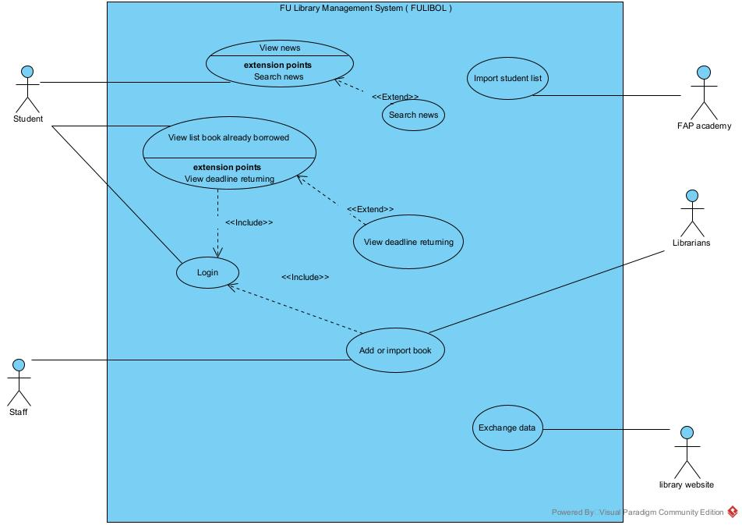

Use case diagram is an effective way to visualize the interaction between actors and the software system. One Use case diagram need one rectangle which represents one system or one software application. One oval represents one use case. The name of the use case must begin with the verb and follow by an object.

1. In this exam paper, the name of the rectangle is: Student
2. The actor may be human, other software systems or devices. In this exam paper, list the name of >= 3 actors is: Student, Staff, FAP Academy
3. In this exam paper, list the name of >= 5 use cases are: View news, search news, import student list, view list book is borrowed, view deadline returning, login, add or import book
4. The actors are inside or outside of the rectangle? FAP Academy
5. The ovals represent the use cases are inside or outside of the rectangle? Librarians
6. The primary actor of the use case **Add Book** is: Librarians
7. The secondary actor of the use case **Add Book** is: Staff
8. Based on the fact you already used http://ds.libol.fpt.edu.vn website. The use cases in this exam paper may have relationship.

8.a List the name of two use cases that have **extend** relationship: View list book already borrowed, View deadline returning

8.b The name of **base use case (in 8.a)** is: View list book already borrowed,

8.c The name of **extend use case (in 8.a)** is: View deadline returning

8.d The dashed line with an arrow that points to which use case? View list book already borrowed(student write the name of use case) (0.1 point)

1. Based on the fact you already used http://ds.libol.fpt.edu.vn website website, the use cases in this exam paper may have relationship.

9.a List the name of two use cases that have **include** relationship: Add or import book, Login

9.b The name of **based use case (in 9.a)** is: : Add or import book

9.c The name of **include use case** **(in 9.a)** is: Login

9.d The dashed line with an arrow that points to which use case? …… (student write the name of use case) (0.2 point)

**Question 3:** Writing detail one use case, the use case **Add book** in the following format. (4 points)

|  |  |  |  |
| --- | --- | --- | --- |
| **Use Case Specification** | | | |
| **Use Case ID and Name:** | **BOOKS.MGT.01 – Add book** | | |
| **Created By:** | **Huỳnh Chí Bảo** | **Date Created:** | **24-JUL-2023** |
| **Primary Actor:** | **Staff** | **Secondary Actors:** |  |
| **Trigger:** | **A staff indicates that he/she wants to add a book to a system** | | |
| **Description:** | **The “Add book” use case represent the process performed by the staff to system for student can see a new books are updated** | | |
| **Preconditions:** | **PRE 1 – The FULIBOL website is connected and functioning correctly**  **PRE 2 - The staff need login to the website FULIBOL**  **PRE 3 – The barcode of book are active for staff scan to add to system** | | |
| **Post–conditions:** | **POST 1 - The systems show successfully**  **POST 2 – The barcode has same content as details of book** | | |
| **Normal Flow:** | **1 – The staff initiates the “Add book” by open website** [**http://ds.libol.fpt.edu.vn**](http://ds.libol.fpt.edu.vn)  **2 – The staff login by their account google with @fpt.edu.vn email**  **3 – The staff click to add a new book**  **4 – The website shows info to staff can scans of product**  **5 – For each book scans, the website identifies book details: id, name, price and deadline to return a book** | | |
| **Alternative Flows:** | **1 - AF: The staff forgot password to login to the system**  **- The system manually ask staff to reset password**  **- Staff can change password by google**  **2 – AF: The barcode not active**  **- The staff can’t press id of book into info to add** | | |
| **Exceptions:** | **At any time, the website cannot communicate with the server/core system ( due to network malfunction/technical issues ), the system displays an error message. The student can report** | | |
| **Priority:** | **High (Medium, Low)** | | |
| **Frequency of Use:** | **N/A** | | |
| **Business Rules:** | 1. **The system doesn’t allow staff login with different account with email @fpt.edu.vn** 2. **The system doesn’t auto restart new deadline for student** | | |
| **Other Information:** | **N/a** | | |
| **Assumptions:** | **N/a** | | |

**Question 4:** writing 2 non-functional requirements.

a. The most important non-functional requirement is "Response Time" which refers to the time taken by the software system to respond to user inputs or events. The response time should be specified in milliseconds (ms) and should be measurable during testing. For example:

* The system shall respond to user interactions within 200 milliseconds for 90% of the test cases. The response time will be measured from the moment the user initiates an action to the moment the system acknowledges the action.
* The login process shall complete within 3 seconds for 95% of login attempts. The time will be measured from the user entering their credentials to the system displaying the user's personalized dashboard.

b. The second important non-functional requirement is "Scalability," which refers to the system's ability to handle an increasing number of users, data, or transactions without compromising performance. The scalability should be defined in terms of concurrent users or data load. For example:

* The system shall support a minimum of 1000 concurrent users without any degradation in response time or system performance. The test will be conducted by simulating 1000 simultaneous user interactions.
* The database should handle a dataset of 1 million records without any noticeable increase in query response time. The test will involve loading the database with 1 million records and measuring the query response time for various database operations.