TP3 - Lancer de rayons et intégration numérique
HUYNH Cong Lap - 11419778 - Travail seul

Partie 1 : Visualisation - Partie 1.cpb

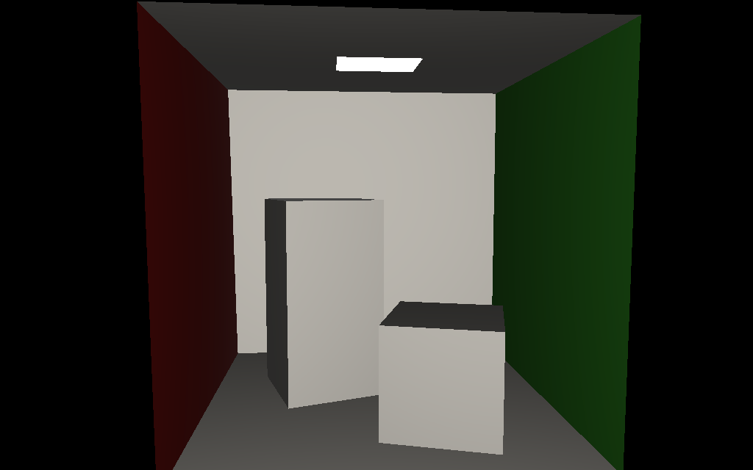

Cornell.obj + orbiter.txt

I implement Phong lighting: Diffuse + Ambient (Not yet global illumination) + Specular
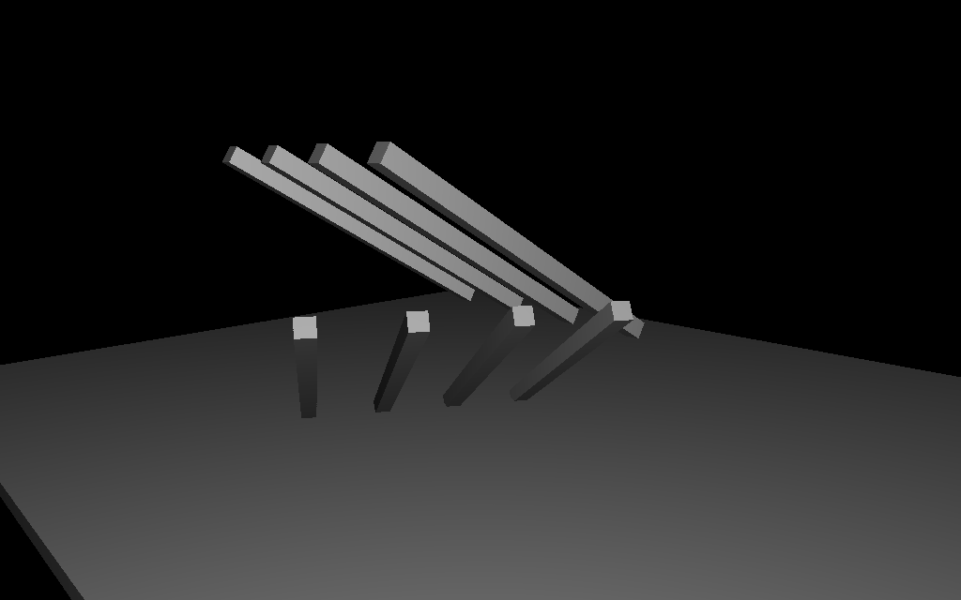
Shadow.obj + shadow.txt (orbiter)

Fruit Scene with Phong Lighting:

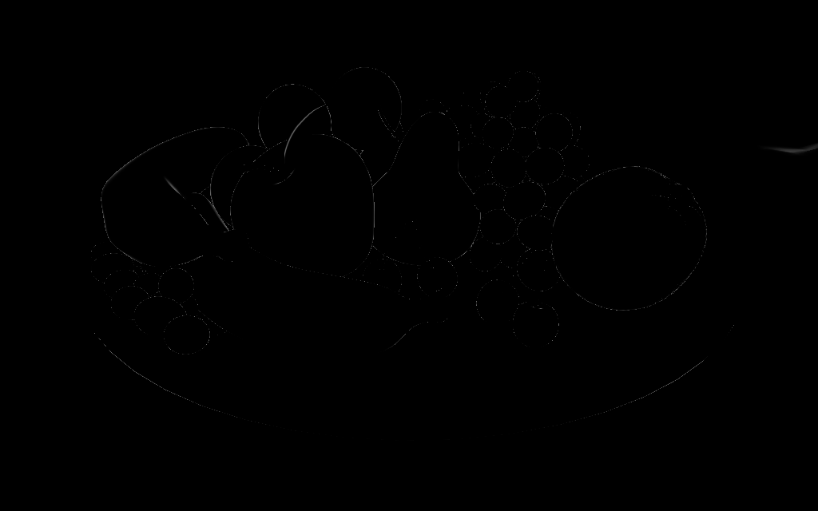
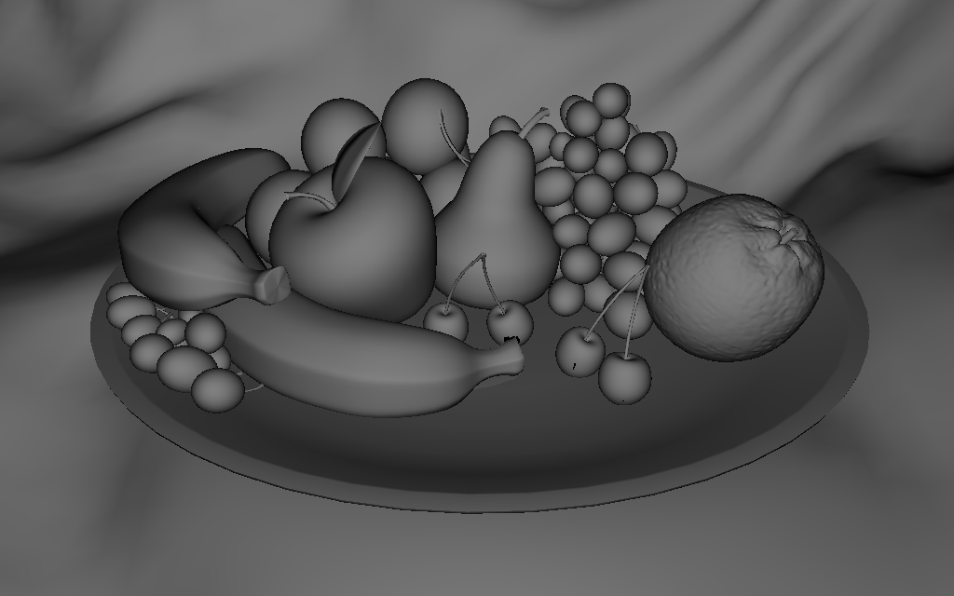

Specular + Diffuse

Partie 2 : Éclairage ambiant - Partie 2.cbp

Spirale de Fibonacci VS Directions aléatoires

Spirale de Fibonacci perturbée
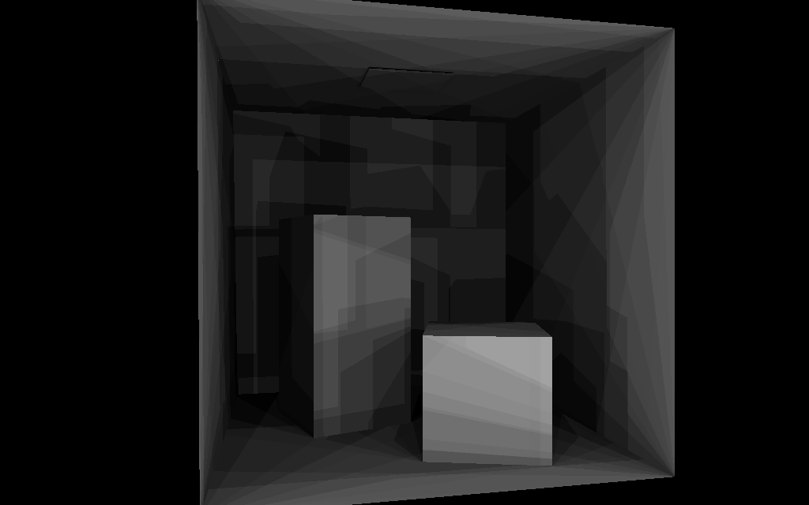
32 directions
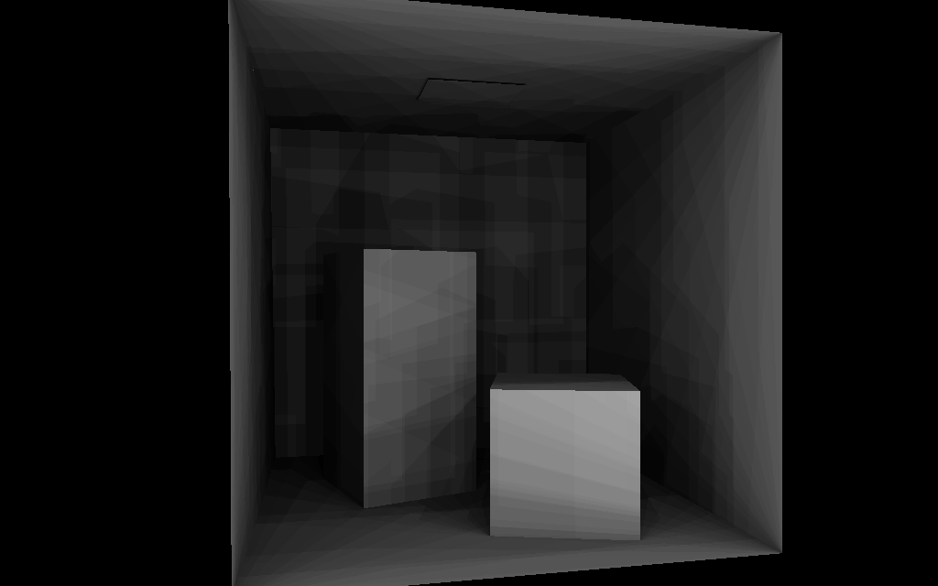
64 directions
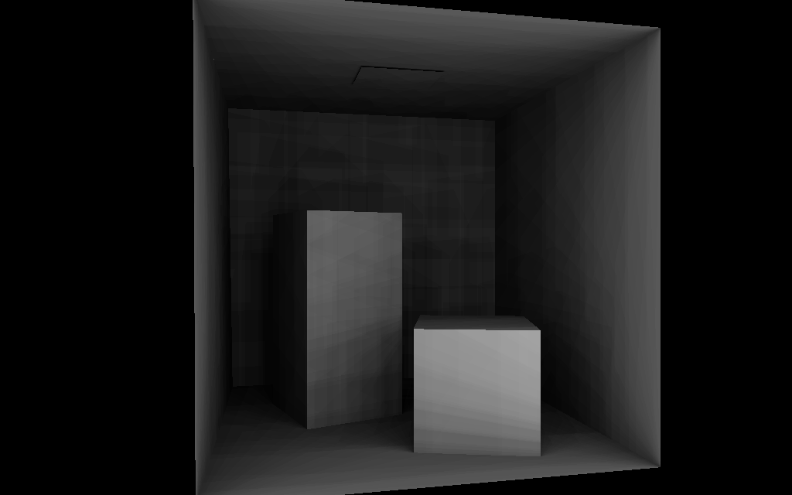
128 directions
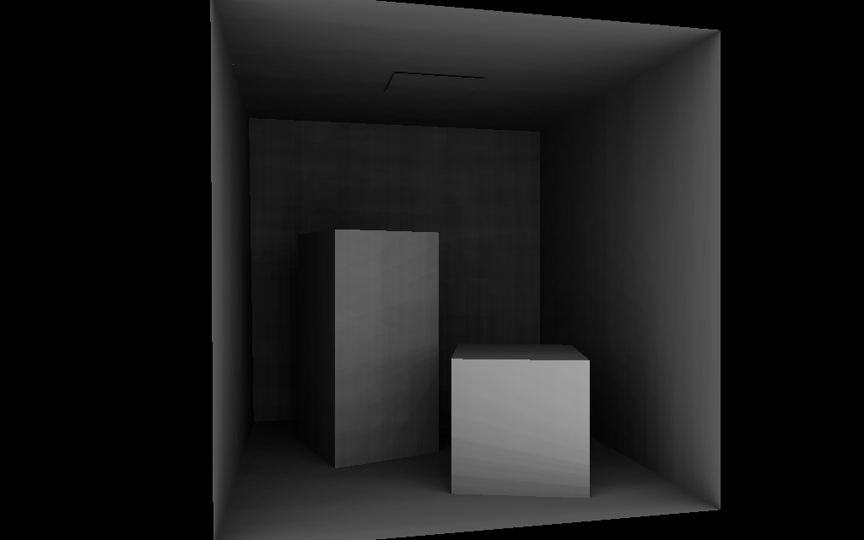
256 directions

Directions aléatoires

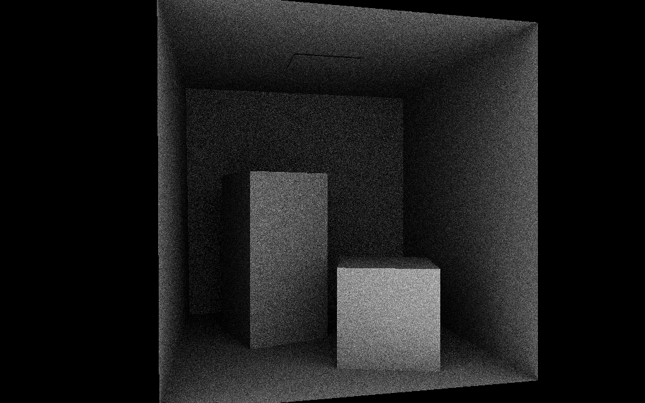
32 directions
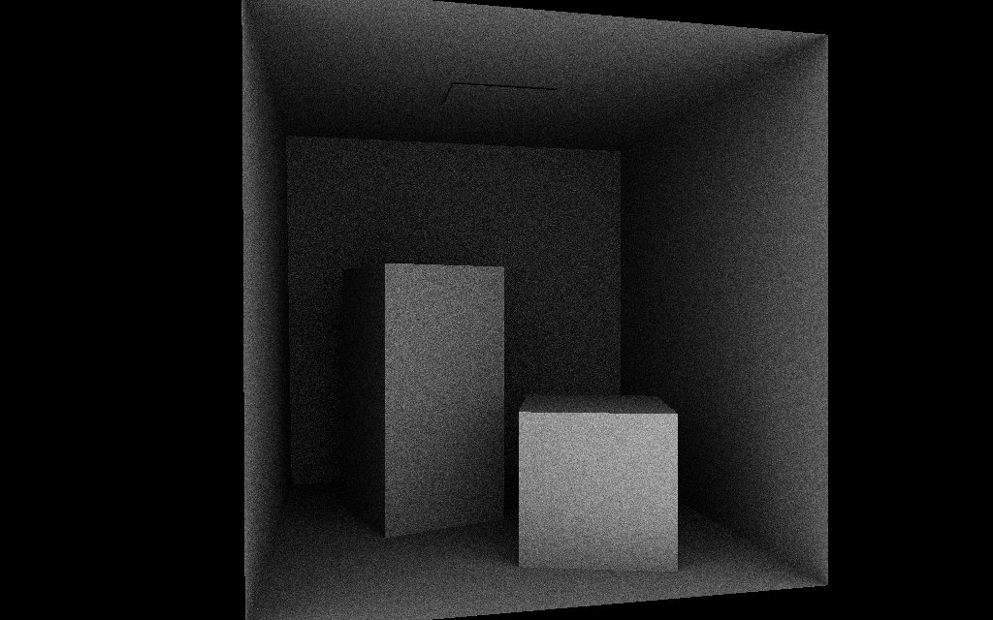
64 directions
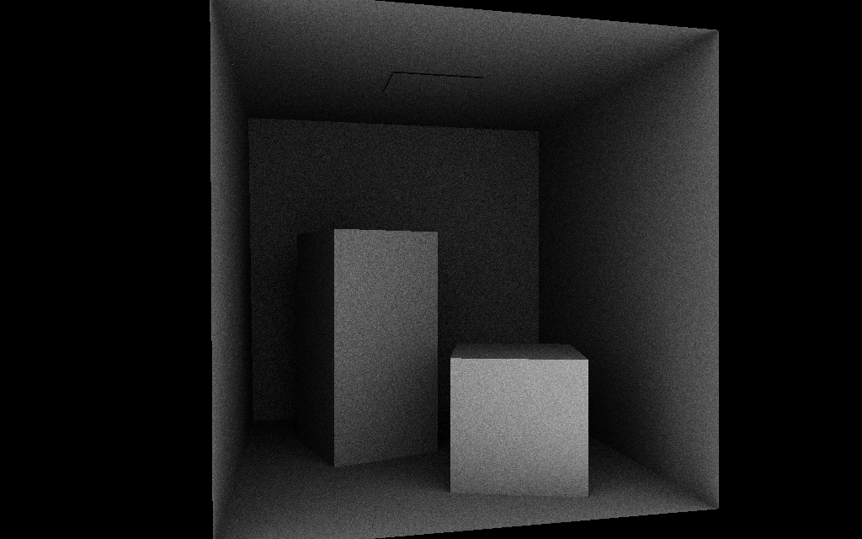
128 directions
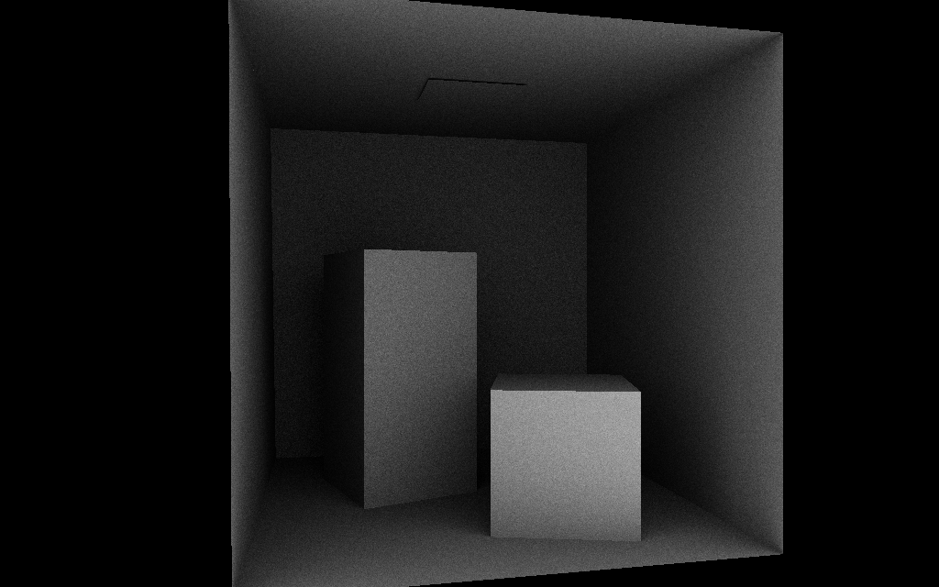
256 directions

Partie 3 : Structures accélératrices - Partie 3.cbp
BVH et algorithme de parcours pour calculer la diffusion d'une scène "ouverte" – Parcours ordonné
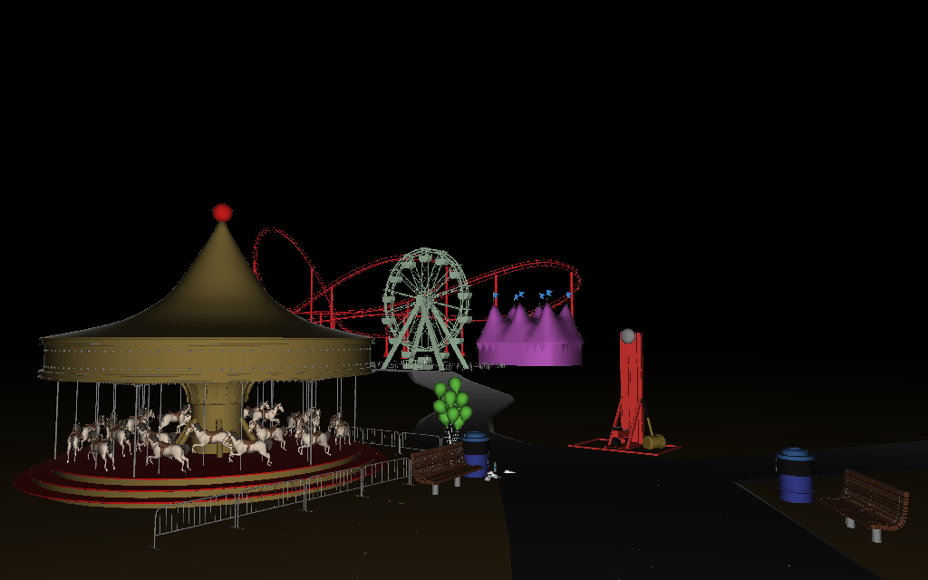
TheCarnival.obj - Triangles: 449 858 - SAH cost: 21,7 - Nodes: 889 715
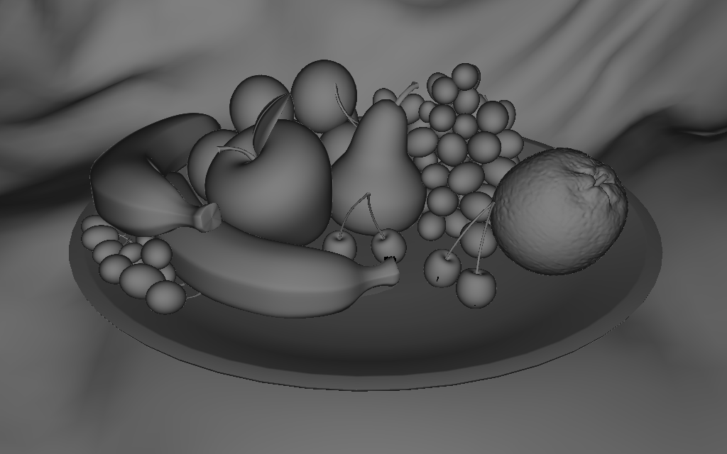
Fruit_v2.obj - Triangles: 207 226 - SAH cost: 40,48 - Nodes: 414451
BVH et algorithme de parcours pour calculer l'éclairage ambiant d'une scène "ouverte" – Parcours ordonné
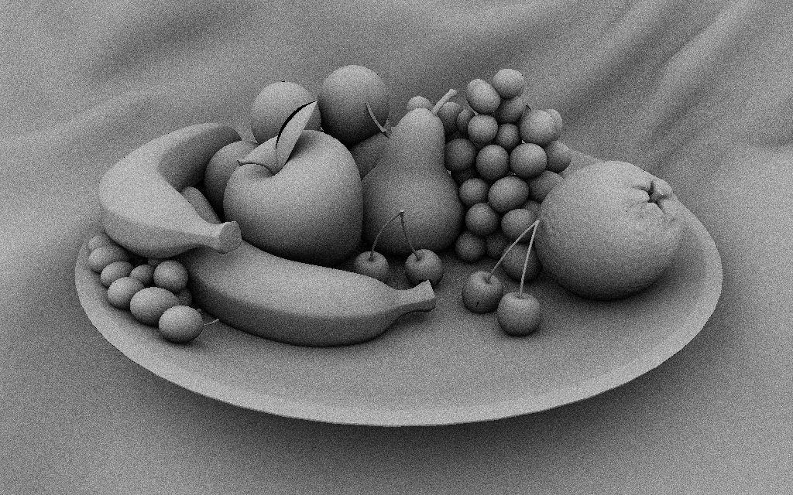
fruit_v2.obj + fruit_v2.txt - 64 directions aléatoires – Global Ambient
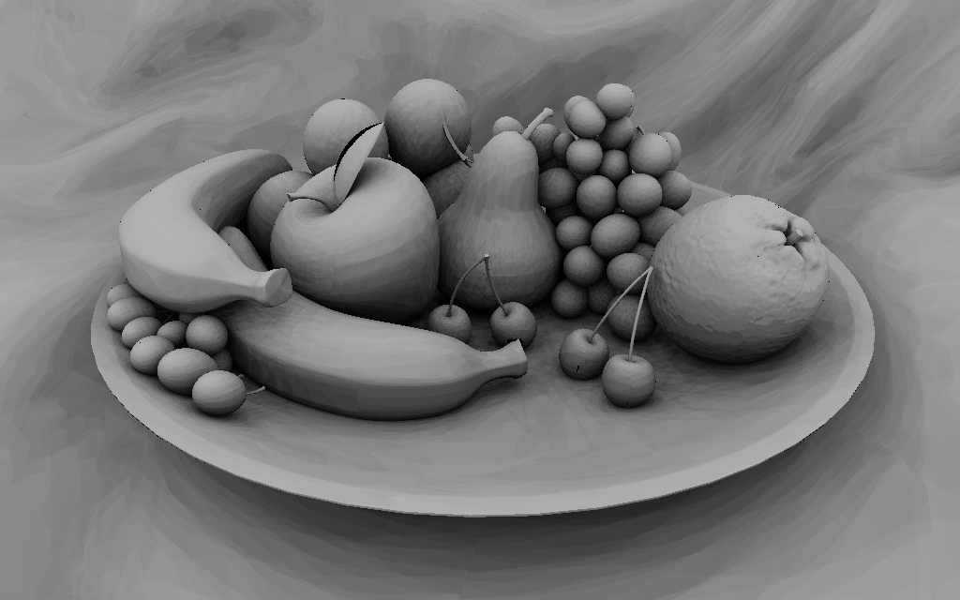
fruit_v2.obj + fruit_v2.txt - 64 directions Spirale de Fibonacci perturbée – Global Ambient

Partie 4 : Avec des shaders
Lighting diffuse for Cornell.obj
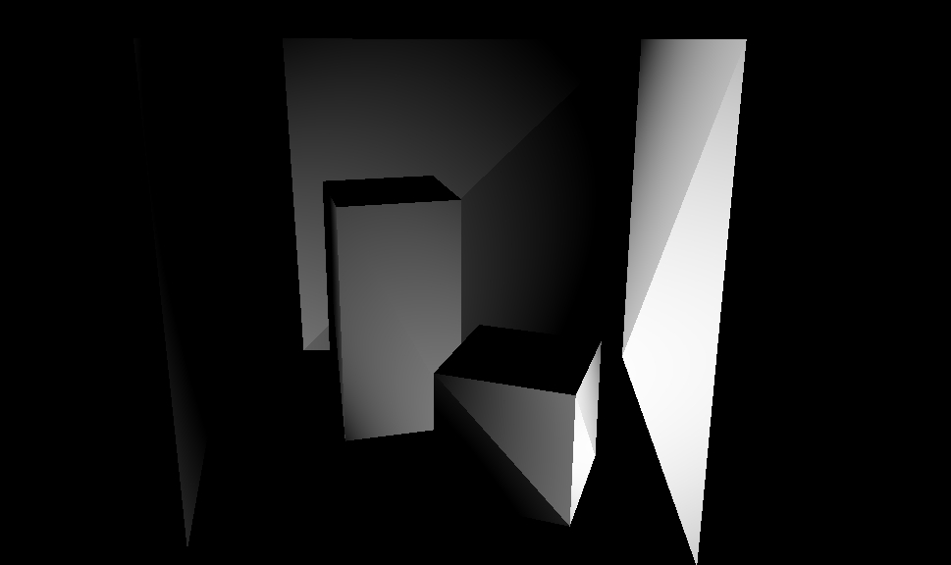
Using BVH avec shaders - Not finished yet

Because a shader doesn’t support recursion, my solution for this part to traverse nodes in the shaders: Non recursive Inorder traversal for a Threaded Binary Tree
- https://en.wikipedia.org/wiki/Threaded_binary_tree
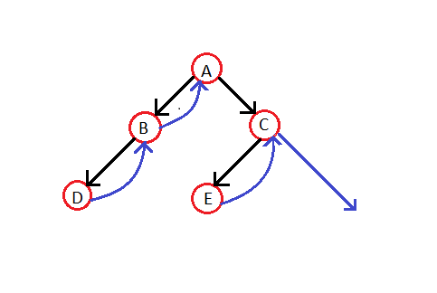

Algorithm
Step-1: For the current node check whether it has a left child which is not there in the visited list. If it has then go to step-2 or else step-3.
Step-2: Put that left child in the list of visited nodes and make it your current node in consideration. Go to step-6
Step-3: Print the node and If node has right child then go to step 4 else go to step 5
Step-4: Make right child as current node.
Step-5:if there is a thread node then make it the current node.
Step-6: if all nodes have been printed then END else go to step 1

