FASHION

import numpy as np

from keras.utils import np_utils

from keras.datasets import fashion_mnist

from keras.models import Sequential

from keras.layers import Dense, Dropout

from tensorflow.keras.optimizers import RMSprop

import matplotlib.pyplot as plt

(x_train, y_train),(x_test,y_test) = fashion_mnist.load_data()

print('Kích thước x_train: ', x_train.shape)

print('Kích thước y_train: ', y_train.shape)

print('Kích thước x_test: ', x_test.shape)

print('Kích thước y_test: ', y_test.shape)

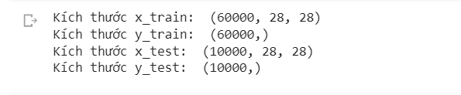

x_train = x_train.reshape(60000,784)

x_test = x_test.reshape(10000,784)

x_train = x_train.astype('float32')

x_test = x_test.astype('float32')

x_train /=255

x_test /=255

y_train = np_utils.to_categorical(y_train,10)

y_test = np_utils.to_categorical(y_test,10)

model = Sequential()

model.add(Dense(512,activation='relu',input_shape=(784,)))

model.add(Dropout(0.2))

model.add(Dense(512,activation='relu'))

model.add(Dropout(0.2))

model.add(Dense(10,activation='softmax'))

model.summary()

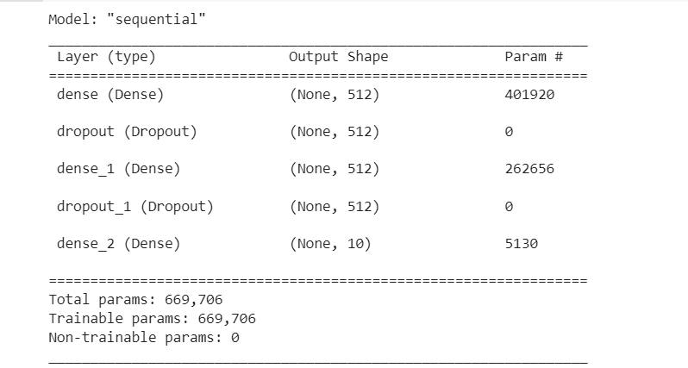

model.compile(loss='categorical_crossentropy',optimizer=RMSprop(), metrics=['accuracy'])

model.compile(loss='categorical_crossentropy',optimizer=RMSprop(), metrics=['accuracy'])

from keras.callbacks import EarlyStopping

history = model.fit(x_train,y_train,batch_size=128,epochs=200,verbose=1,

                    validation_split=0.2,callbacks=[EarlyStopping(monitor='val_loss',patience=100)])

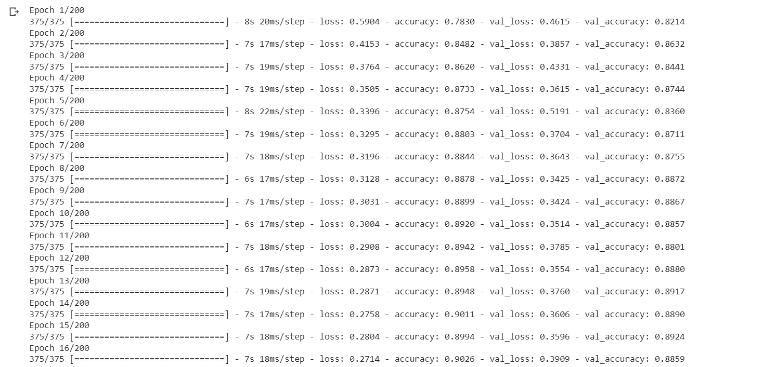

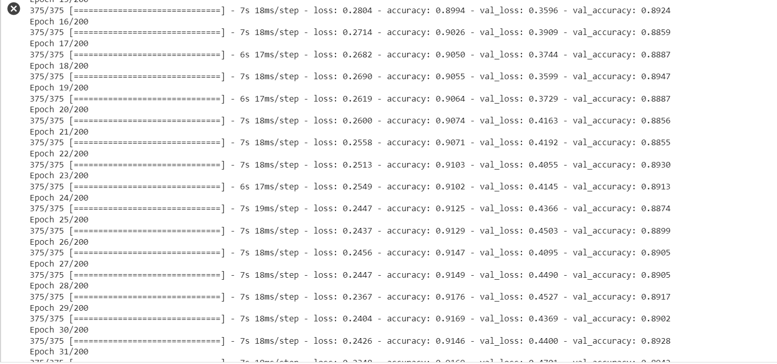

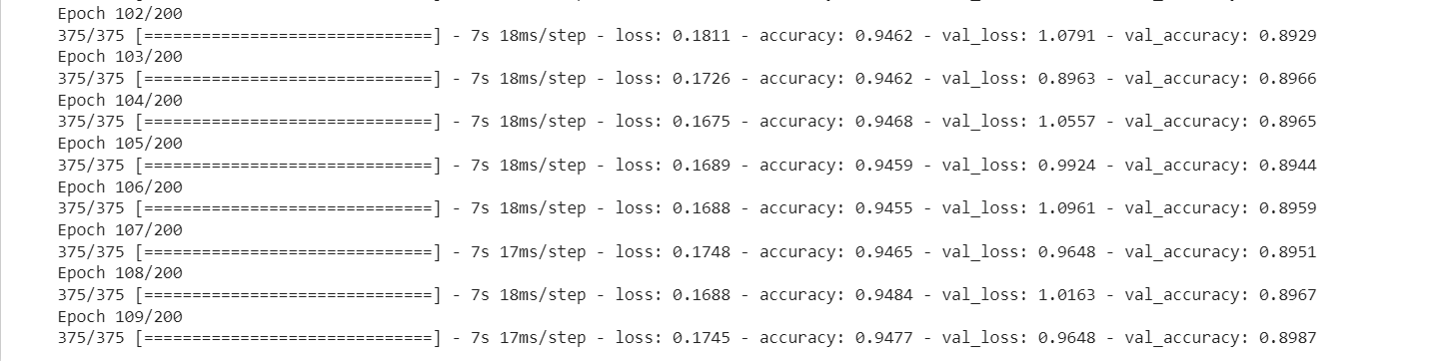

score = model.evaluate(x_test,y_test,verbose=0)

print('Sai số kiểm tra là: ',score[0])

print('Độ chính xác kiểm tra là: ',score[1])

#vẽ đồ thị

plt.plot(history.history['accuracy'])

plt.plot(history.history['val_accuracy'])

plt.title('model accuracy')

plt.ylabel('accuracy')

plt.xlabel('epochs')

plt.legend(['train','Validation'])

plt.show()

