|  |  |
| --- | --- |
| Khoa: Khoa học Máy tính  **Bộ môn: Xử lý ngôn ngữ tự nhiên** | Môn: Nguyên lý và phương pháp lập trình  Năm học: 2018-2019 (HK1)  Lớp: CS111.J12 |
| Họ và Tên: Nguyễn Huỳnh Đức  MSSV: 16520240 | |
| **BÀI TẬP 2** | |

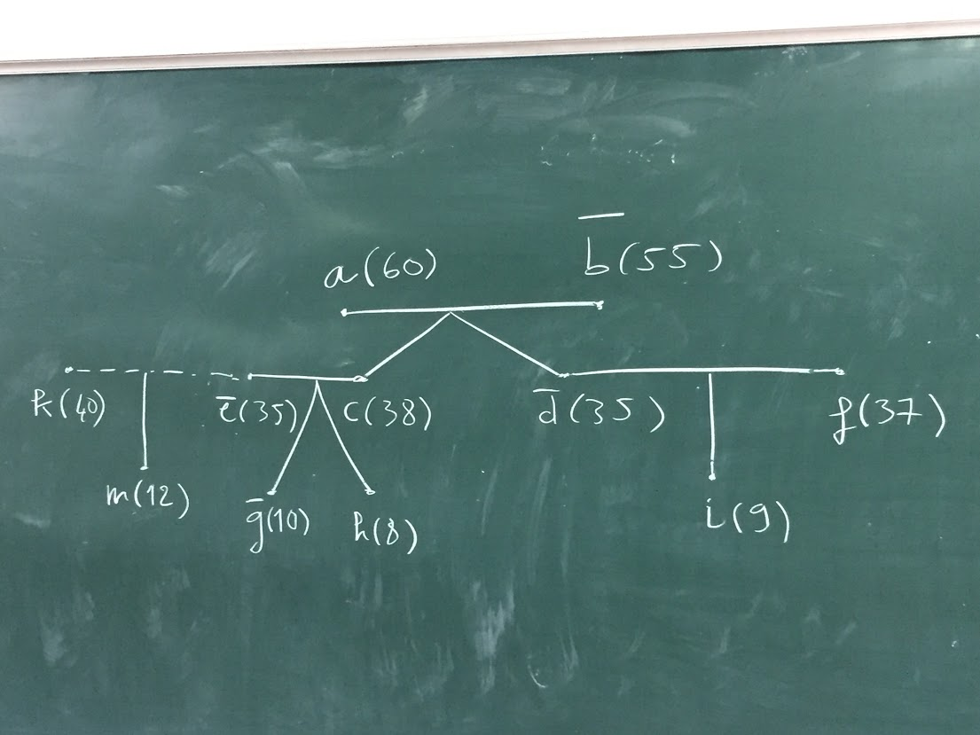

Question list is possible:

* “**age**” is a fact: -example age(a, 60).
* “**sex**” is a fact: -example sex(a, male).
* “**married**” is a fact: -example married(a, b).
* “**oldMarried**” is a fact : -example oldMarried(e, k).
* “**parent**” is a fact: -example parent(a,c).
* “**husband**” is a rule: -example husband(a, b).
* “**wife**” is a rule: -example wife(b, a).
* “**oldHusband**” is a rule: -example oldHusband(k,e).
* “**oldWife**” is a rule: -example oldWife(e,k).
* “**parent-in-law**” is a rule: -example parentInLaw(a,f).
* “**father**” is a rule: -example father(a,c).
* “**father-in-law**” is a rule: -example fatherInLaw(a,f)
* “**mother**” is a rule: -example mother(b,d).
* “**mother-in-law**” is a rule: -example motherInLaw(b,f).
* “**child**” is a rule: -example child(d,a).
* “**child-in-law**” is a rule: -example childInLaw(f,a).
* “**son**” is a rule: -example son(c,a).
* “**son-in-law**” is a rule: -example sonInLaw(f,a).
* “**daughter**” is a rule: -example daughter(d,a).
* “**daughter-in-law**” is a rule: -example daughterInLaw(e,a).
* “**brother**” is a rule: -example brother(c,d).
* “**brother-in-law**” is a rule: -example brotherInLaw(c,f).
* “**sister**” is a rule: -example sister(d,c).
* “**sister-in-law**” is a rule: -example sister(e,d).
* “**halfBrother**” is a rule: -example halfBrother(m,h).
* “**halfSister**” is a rule: -example halfSister(g,m).
* “**cousin**” is a rule: -example cousin(i,g).
* “**grandfather**” is a rule: -example grandfather(a,g).
* “**grandmother**” is a rule: -example grandmother(b,g).
* “**grandchild**” is a rule: -example grandchild(g,b).
* “**uncle**” is a rule: -example uncle(f,g).
* “**aunt**” is a rule: -example aunt(d,g).
* “**nephew**” is a rule: -example nephew(h,i).