**xFlash工具工作教程**

xFlash Tool Work Guideline



|  |  |  |  |  |  |
| --- | --- | --- | --- | --- | --- |
| 部门 Department | CC-DA/EDB6-CN | | 系统 System |  | |
| 最新版本  latest Version | V2.0 | | 文档号 No. |  | |
| 安全等级  Confidentiality | Internal | | 分类 Filing | Checklist | |
|  |  |  |  |  |  |
| 作者 Author | PAN Wenjie | | 部门 Department | CC-DA/EDB6-CN | |
| 签名 Signature |  | | 日期 Date |  | |
|  |  |  |  |  |  |
| 审核 Checked |  | | 部门 Department |  | |
| 签名 Signature |  | | 日期 Date |  | |
|  |  |  |  |  |  |
| 释放 Release |  | | 部门 Department |  | |
| 签名 Signature |  | | 日期 Date |  | |

Contents

中文手册 3

1. 目的 3

2. 范围 3

3. 如何替换软件 3

3.1 Block判断 3

3.2 双Block切分 4

4. 如何刷写 5

4.1 刷写界面的打开 5

4.2 环境配置 6

4.3 开始刷写 8

English Handbook 9

1. Purpose 9

2. Scope 9

3. How to replace SW 9

3.1 Block judgment 9

3.2 Double block segmentation 10

4. How to flash 11

4.1 Open the flashing interface 11

4.2 Environment configuration 12

4.3 Start flashing 14

# 中文手册

# 1. 目的

此文档提供一份使用手册给每个需要使用xFlash tool的人。xFlash tool仅提供给博世内部使用，不允许释放给客户。

# 2. 范围

此文档应用于使用xFlash tool更新软件。

# 3. 如何替换软件

## 3.1 Block判断

找到需要替换的软件(.hex文件)，打开该软件，查看该软件具有下**图3. 1** (a) 中单个Block 0 ，还是图 3.1 (b) 中Block 0和Block 1。

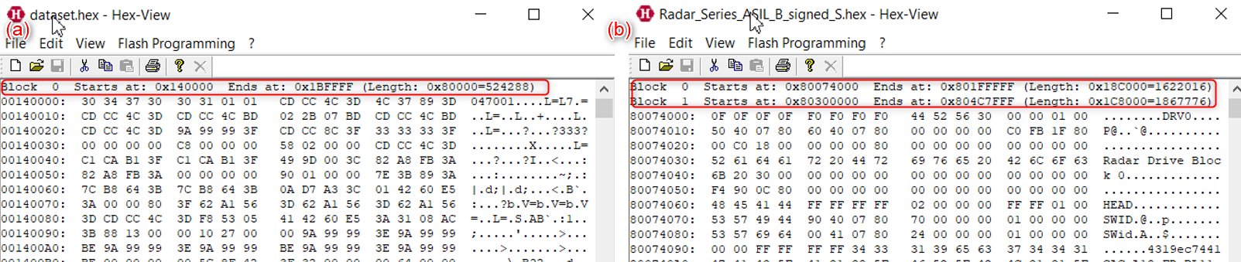

**图3. 1** SW打开界面

若新软件仅含有单个Block 0，则将新版的软件覆盖老版软件替换掉就行，如**图3. 2**所示:

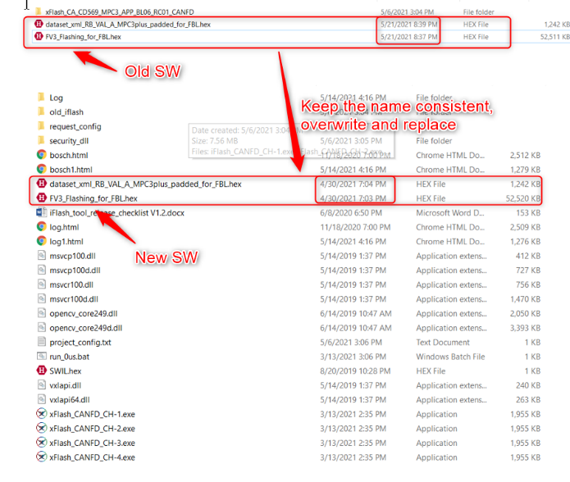

**图3. 2**软件替换

若新软件同时含有Block 0和Block 1，则需要进行切分，具体切分步骤如下3.2节所示。

## 3.2 双Block切分

**步骤1：**

点击剪切动作

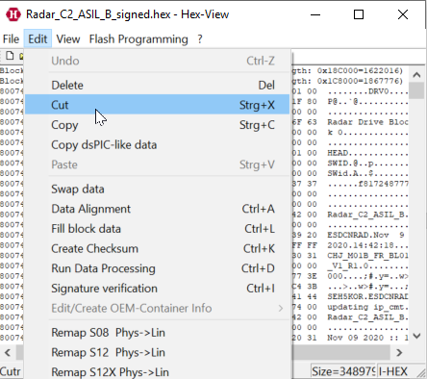

**步骤2：**

如果要获取Block 0 hex 文件，输入Block 1 地址

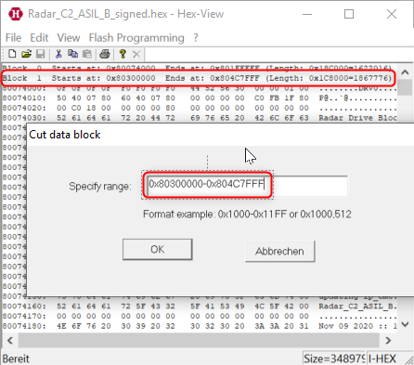

**步骤3：**

另存为另一个十六进制文件

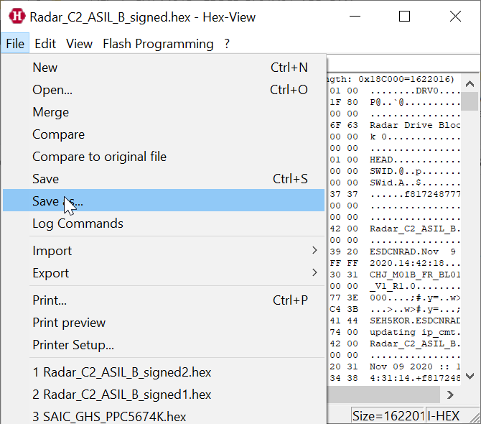

注意：另一个Block 1是通过类似的步骤生成的

**步骤4：**

将剪切后的新版的软件覆盖掉原老版软件

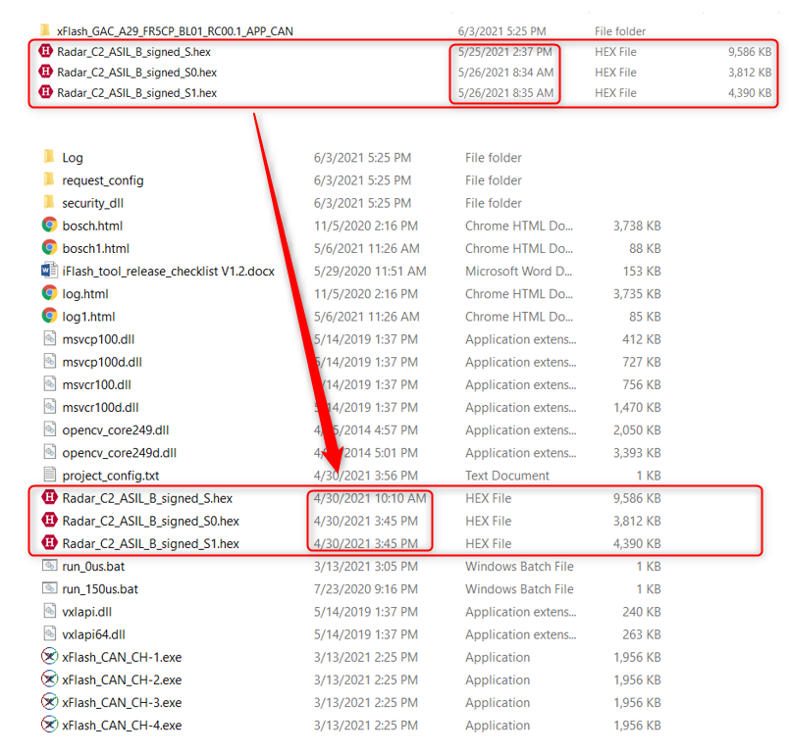

**图3.3** 剪切后软件替换

# 4. 如何刷写

## 4.1 刷写界面的打开

**步骤1：**

当仅连1个通道时，打开 “ xFlash_CANFD_CH-1.exe ”（CANFD协议）或 “ xFlash_CAN_CH-1.exe ” （CAN协议）开始刷写。具体见下**图4. 1**的红色正方形框，其中**图4. 1**(a) 表示为CANFD工具界面，图4. 1 (b) 表示为CAN 工具界面。

如果需要4通道刷写，双击打开“ run_0us.bat ”，具体见下**图4. 1**的绿色框。

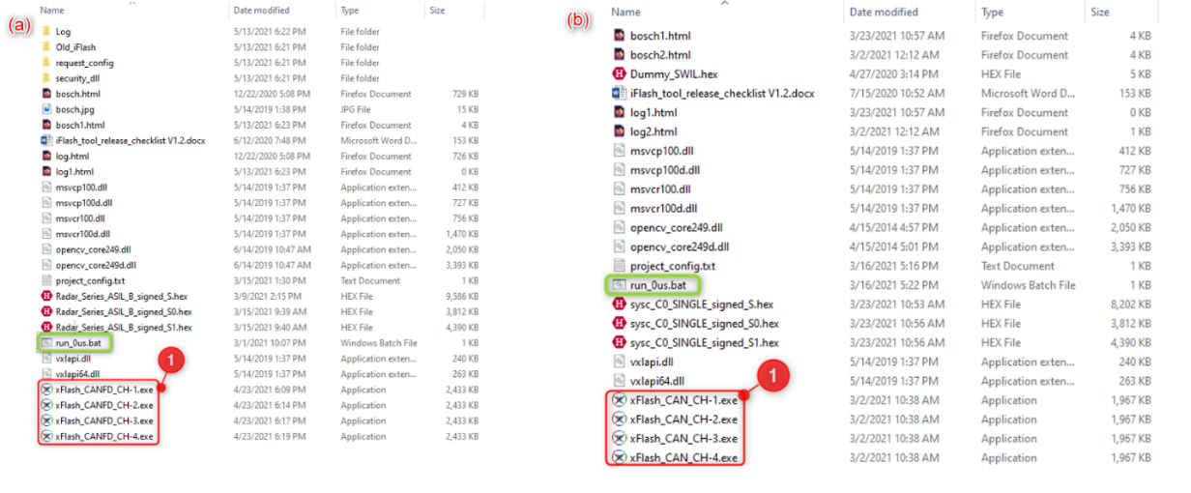

图4. 1 xFlash工具配置图：(a) CANFD工具; (b) CAN工具。

**步骤2：**

在xFlash工具界面，选择需要的 .exe文件打开，然后点击‘ Open Bus ’按钮准备刷写，如**图4. 2**中2号红色方框所示。

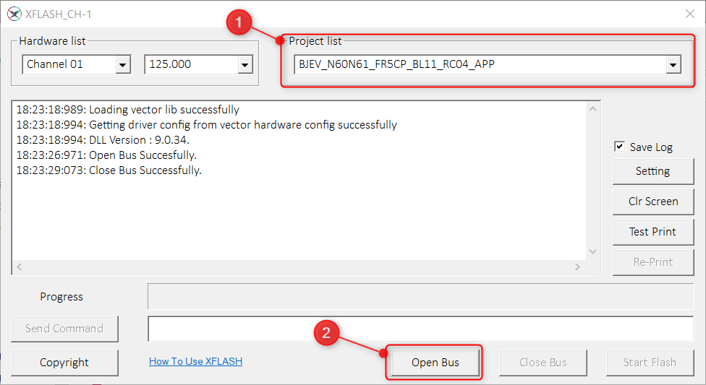

**图4. 2** xFlash刷写界面

注意事项：若存在下**图4. 3**所示红色方框内‘ Open Bus ’选项变灰无法点击的现象，说明环境配置存在问题，正确环境配置步骤如下4.2节所示。

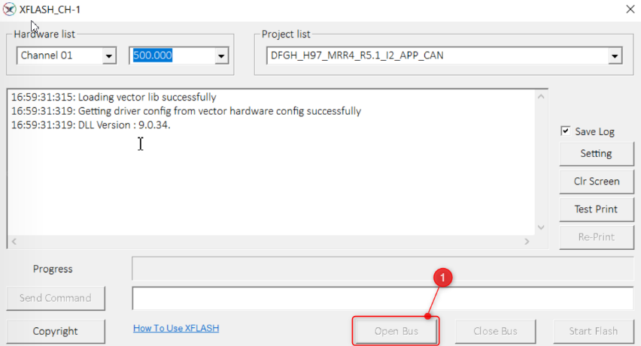

**图4. 3** 环境配置错误界面

## 4.2 环境配置

**步骤1：**

刷机前，确认控制面板中是否有“ Vector Hardware ”，如**图4. 4**所示。 如果“ Vector Hardware ”不存在，则必须先安装驱动程序包。

驱动软件包link: \\bosch.com\dfsrb\DfsCN\DIV\XC\Engineering\domain\DA\04_Driving\03_BSW\00_BSW_General\00_Tools\02_CAN_TOOLS\Vector_Driver_Setup_10_2_0

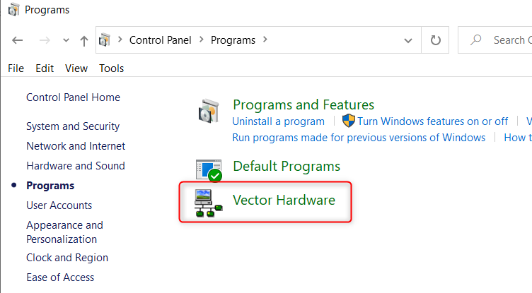

**图4. 4**Vector Hardware界面

**步骤2：**

不管使用什么类型的vector cancaseXL，配置步骤都是一样的。本说明以vector 5610A cancaseXL为例，其余1630A、1640A等也一样。单击“控制面板”中的选项，如下**图4. 5**所示。

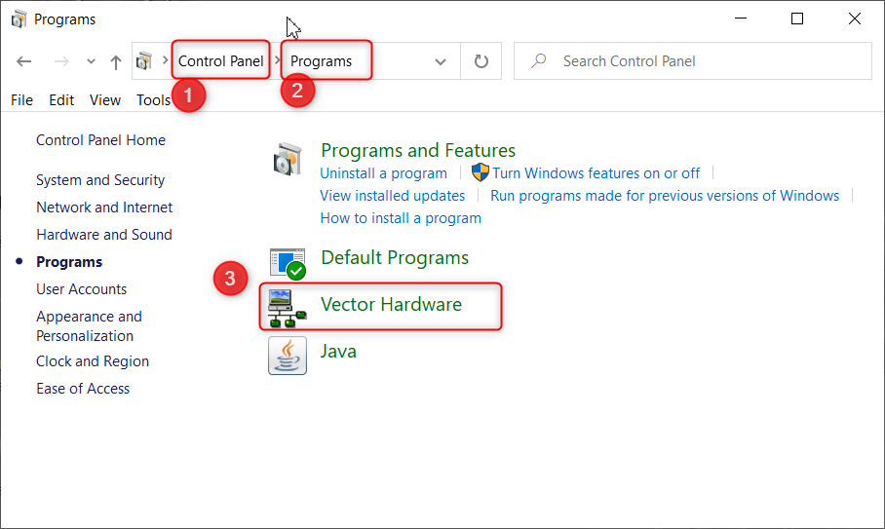

**图4. 5** 控制面板界面

**步骤3：**

右键单击“ xFlash ” （1号红圈），选择“ Application channel usage ”（2号红圈），将CAN 通道改为4个（3号红圈），如下**图4. 6**所示

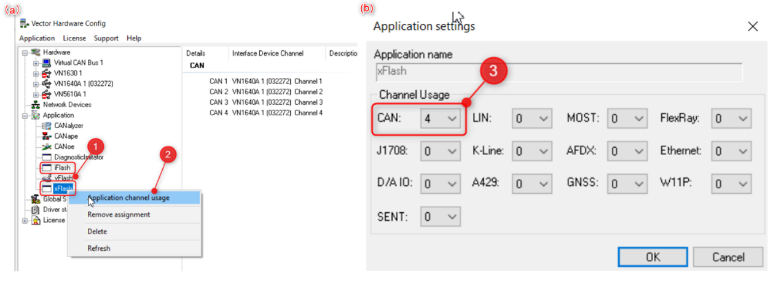

**图4. 6**配置通道界面

**步骤4：**

右键单击CAN通道，选择VN5610A和通道3，如下**图4. 7**所示。 然后对其他通道执行相同的操作。

（注：由于VN5610A只有2个CAN通道，在CAN3和CAN4中重复选择）

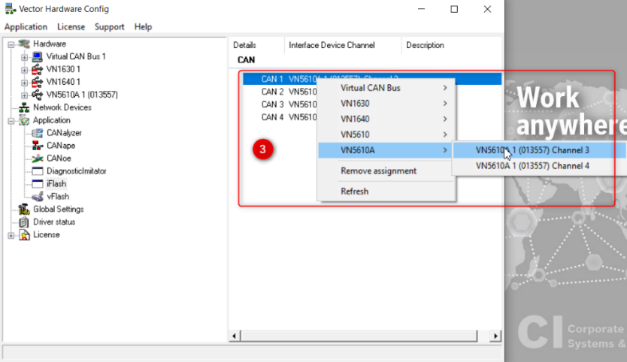

**图4. 7** 通道选择

## 4.3 开始刷写

在xFlash工具界面，点击“ Start Flash ”按钮进行刷写

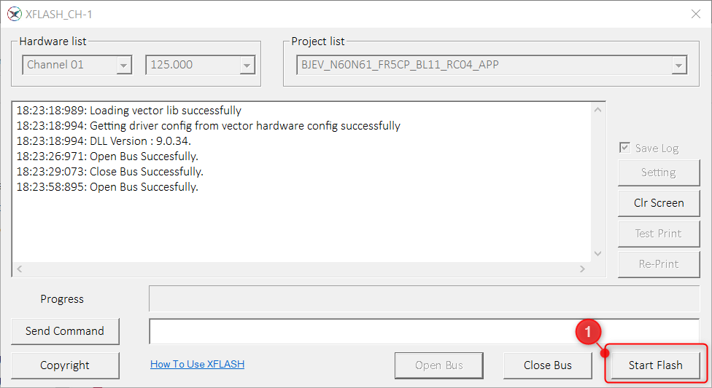

**图4. 8** 开始刷写界面

# English Handbook

# 1. Purpose

This document is to provide usage guideline for anyone who want to use xFlash tool. This xFlash tool is only for BOSCH internal use, not allowed to release to customer.

# 2. Scope

This document is applied to SW upgrade with xFlash tool.

# 3. How to replace SW

## 3.1 Block judgment

Find the SW (.hex file) that needs to be replaced, open the SW, and check whether the software has a single Block 0 in **Fig 3. 1**(a) or Block 0 and Block 1 in **Fig 3. 1**(b).



**Fig 3. 1** SW open interface

If the new SW only contains a single Block 0, just replace the old SW with the new version of the SW, as shown in the **Fig 3. 2** below:

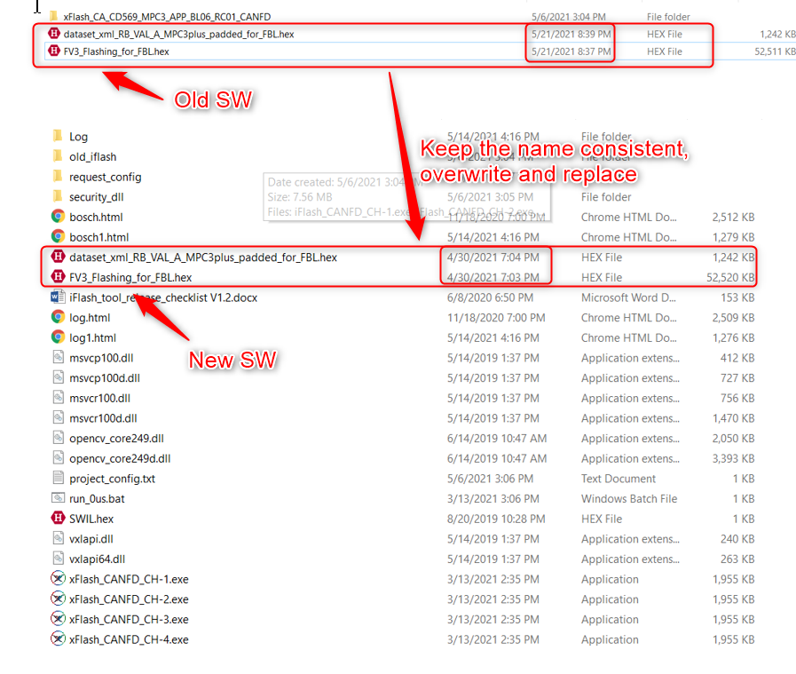

**Fig 3. 2**SW replacement

If the new SW contains both Block 0 and Block 1, it needs to be segmented. The specific segmentation steps are shown in section 3.2 below.

## 3.2 Double block segmentation

**Step1.**

Click cut action



**Step2.**

If want to get block0 hex file, type block1 address.



**Step3.**

Please save as another hex file.



Note: The another Block 1 is generated by similar steps.

**Step 4.**

Overwrite the old version of the new software after cutting.



**Fig 3. 3** Software replacement after cut

# 4. How to flash

## 4.1 Open the flashing interface

**Step 1.**

When only 1 channel is connected, open "xFlash_CANFD_CH-1.exe" (CANFD protocol) or "xFlash_CAN_CH-1.exe" (CAN protocol) to start flashing. For details, see the red square box in **Fig 4. 1**below, where **Fig 4. 1**(a) represents the CANFD tool, and **Fig 4. 1**(b) represents the CAN tool.

If you need 4-channel flashing, double-click to open "run_0us.bat", see the green box in **Fig 4. 1**below for details.

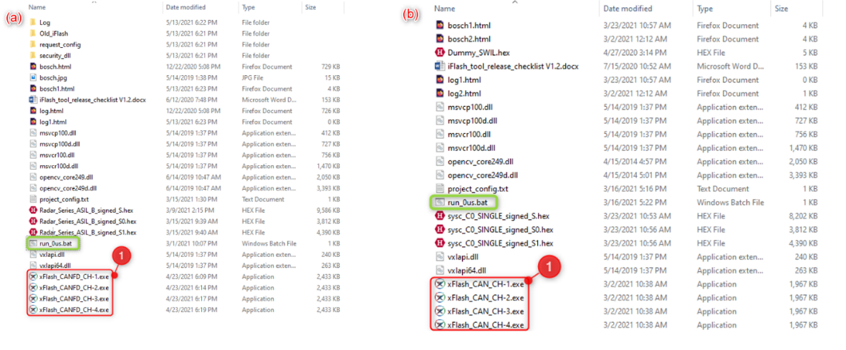

**Fig 4. 1**xFlash tool configuration: (a) CANFD tool; (b) CAN tool.

**Step 2.**

On the xFlash tool interface, select the desired .exe file to open, and then click the ‘Open Bus’ button to prepare for flashing, as shown in the red box No. 2 in **Fig 4. 2**.



**Fig 4. 2**xFlash tool screen

Note: If there is a phenomenon that the ‘Open Bus’ option in the red box shown in **Fig 4. 3** is grayed out and cannot be clicked, it indicates that there is a problem with the environment configuration. The correct environment configuration steps are shown in section 4.2 below.



**Fig 4. 3**Environment configuration error interface

## 4.2 Environment configuration

**Step 1.**

Before flashing, confirm whether there is "Vector Hardware" in the control panel, as shown in **Fig 4. 4**. If "Vector Hardware" does not exist, the driver package must be installed first.

Driver package link: \\bosch.com\dfsrb\DfsCN\DIV\XC\Engineering\domain\DA\04_Driving\03_BSW\00_BSW_General\00_Tools\02_CAN_TOOLS\Vector_Driver_Setup_10_2_0



**Fig 4. 4** Vector Hardware interface

**Step 2.**

No matter what type of vector cancaseXL is used, the configuration steps are the same. This description takes vector 5610A cancaseXL as an example, the other 1630A, 1640A, etc. are also the same. Click the option in "Control Panel", as shown in the **Fig 4. 5** below.



**Fig 4. 5** Control Panel Interface

**Step 3.**

Right-click “xFlash” (red circle No. 1), select “Application channel usage” (red circle No. 2), and change the CAN channels to 4 (red circle No. 3), as shown in the **Fig 4. 6** below.

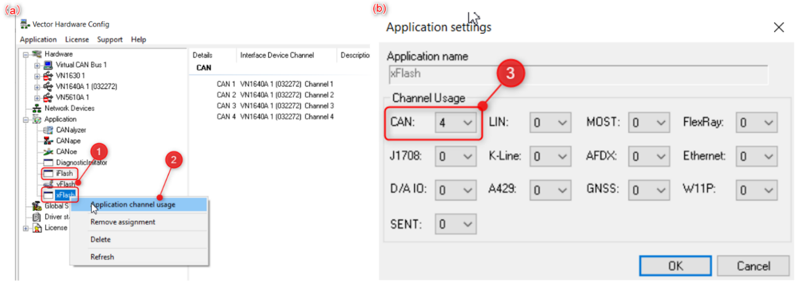

**Fig 4. 6** Configure channel interface

**Step 4.**

Right-click the CAN channel, select VN5610A and channel 3, as shown in **Fig 4. 7** below. Then perform the same operation on the other channels.

(Note: Since VN5610A has only 2 CAN channels, repeat the selection in CAN3 and CAN4)



**Fig 4. 7** Channel selection

## 4.3 Start flashing

On the xFlash tool interface, click the "Start Flash" button to flash.



**Fig 4. 8** Start flashing interface

**Version History**

|  |  |  |  |  |  |
| --- | --- | --- | --- | --- | --- |
| Version | Date | Reviser | Reviewer | Change History | Link |
| 1.0 | 20210513 | Ye Qiuze | Ye Qiuze | Original version |  |
| 2.0 | 20210604 | PAN Wenjie |  |  |  |