SMART HOME
WITH
RASPBERRY PI 3
PROJECT
Design Document
Version 1.0

Ngo Dinh Truong B1607136
Thai Thi Thuy Huynh B1605217
Dam Thien Nhan Van B1606951

Instructor : TS Truong Minh Thai

Document Revision History

Date | Version | Description | Author
21/01/2019 | 1.0 | Initial draft

Contents
1. Introduction 7
1.1 Purpose 7
1.2 System Overview 7
1.3 Design Objectives 7
1.4 References 7
1.5 Definitions, Acronyms, and Abbreviations 7
2 Design Overview 8
2.1 Introduction 8
2.2 Environment Overview 8
2.3 System Architecture 8
2.3.1 Top-level system structure of Fuel level controller 8
2.3.2 Level Monitoring Sub-system 9
2.3.3 Fuel Subsystem 10
2.4 Constraints and Assumptions 11
3 Interfaces and Data Stores 12
3.1 System Interfaces 12
3.1.1 Login interface 12
3.1.2 Interface for control 13
3.2 Data Stores 13
3.3 Design basis 13
4 Structural Design 14
4.1 Design Explanation and Rationale 14
4.2 Initialization algorithm 15
4.3 Master program 17
5 Supplementary Documentation 18

1. Introduction
This section addresses the purpose of this document including the intended audience, an introduction to the problem and a detailed view of the project's design. In the discussion, the design of the final system including several detailed diagrams will be described in detail.

Purpose
This software design document describes the architectural design and detailed design of the software. Describe how the main data or system entities are stored, processed and organized. In addition, this document also shows the interface design and how to handle for each specific function in the system.

System Overview
In this project, We will control the LED with arduino and raspberry pi 3 on the website in a simple and professional way.It works on python environment in Raspi.

Design Objectives
As controller we are using Raspberry Pi 3 powered development board in order to control the appliances. On this control board you can adjust the appliances according to your needs. There are buttons in order to start or stop the appliances and an adjust button in order to adjust the temperature or the program information of the appliances. These adjustments can also be done using the application via Internet. After you adjust the configuration you want, it also sends the information to the system In order to protect the synchronization between the system and the controller.

References
Elliot Mackenzie, Radoslaw Kieltyka, Team dataplicity, <https://www.hackster.io/ >, date of access: 29/03/2019.
Arduinovn , <http://arduino.vn/tutorial/5433-nra-phan-1-bat-tat-led-don-gian-tren-web>, date of access: 10/1/2019.
Tuan Nguyen, Raspi.vn , <http://raspi.vn/2016/10/30/dieu-khien-thiet-bi-trong-nha-voi-raspberry-pi-va-relay/>.

Definitions, Acronyms, and Abbreviations
- GPIO is an uncommitted digital signal pin on an intergrated circuit or electronic circuit board whose behavior including whether it acts as input or output is controllable by the user at run time.
- HTTP is an application protocol for distributed, collaborative, hypermedia information systems, HTTP is the foundation of data communication for the World Wide Web, where hypertext documents include hyperlinks to other resources that the user can easily access.

- RF : Radio frequency is the oscillation rate of an alternating electric current or voltage or of a magnetic, electric or electromagnetic field or mechanical system in the frequency range from around twenty thousand times per second (20 kHz) to around three hundred billion times per second (300 GHz).

Design Overview

Introduction
Remote control of LED lights is attached to Raspberry Pi GPIO using WebServer and deep data hole.

Environment Overview
The user will access the web client and click on the light button, by socketio, so the event is immediately updated to the server.The server side will receive and send control data to the Serial public which is here arduino.
At the same time the server side also returns the status of turning on the lights for the client, so when we open another tab, we will update the status of the light being turned on.The Raspberry service runs the file to create the server.

System Architecture
There are four components in this system:
- Breadboard with LED lights attached to GPIO on Raspberry Pi
- Web application on Raspberry Pi
- Application of Websockets server on Raspberry Pi
- Internet browser

Top-level system structure of Fuel level controller

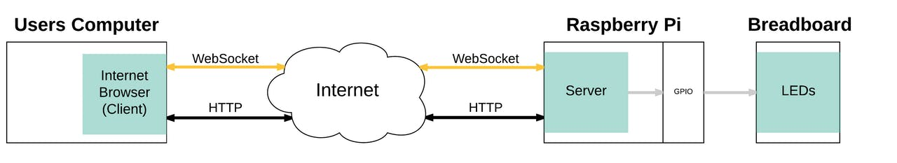

There are four major components in this system: Breadboard with LED lights attached to GPIO on Raspberry Pi.Web application on Raspberry Pi .Application of Websockets server on Raspberry Pi , Internet browser. The interaction between the systems is bi-directional.

Level Monitoring Sub-system
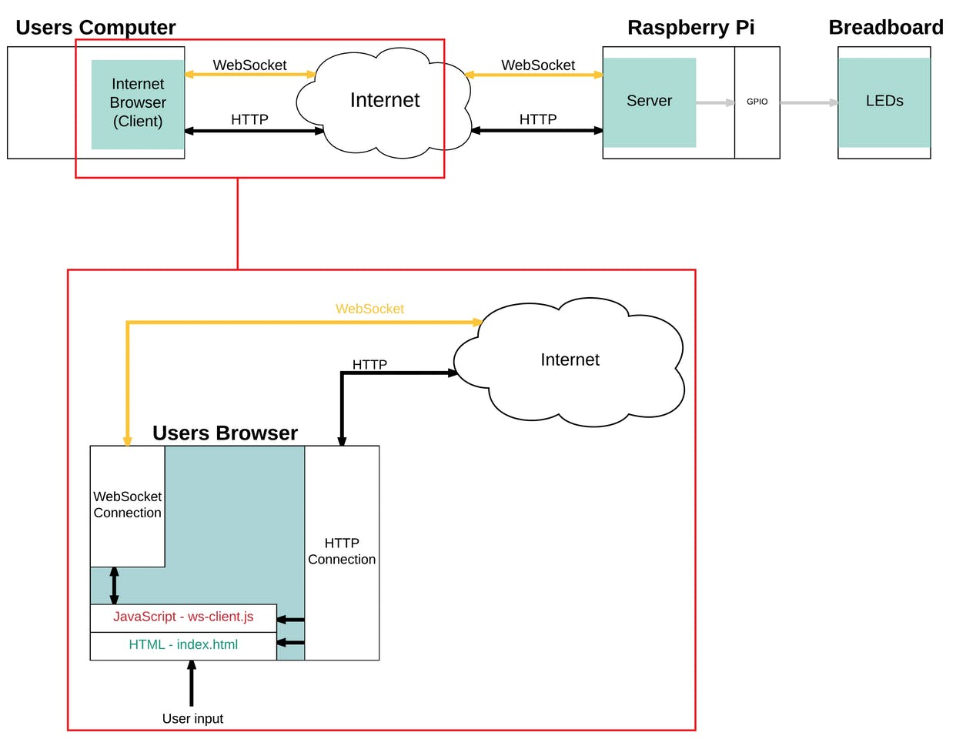
On page load: HTML and JavaScript files are delivered through the HTTP connection. The browser renders HTML, then JavaScript.The running JavaScript creates a WebSocket connection.

Fuel Subsystem
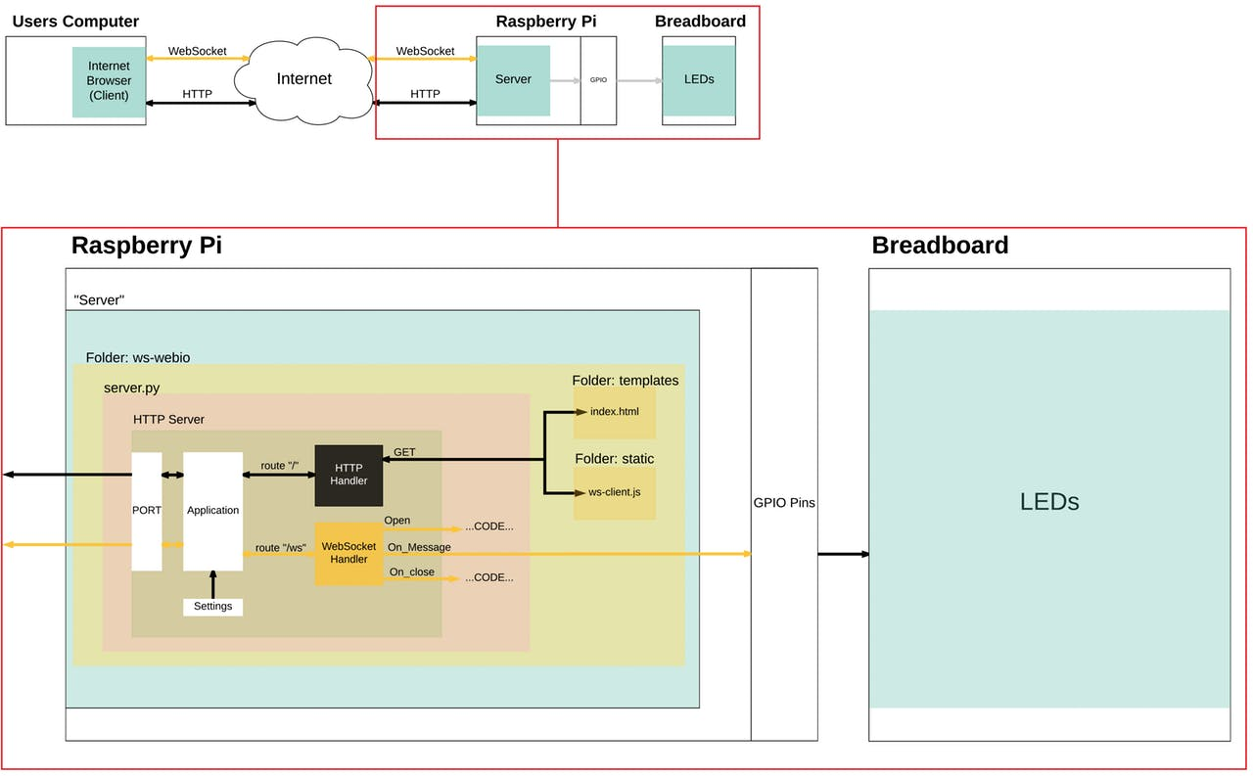
An HTTP Server (part of the Tornado framework). This server listens for client connections and forwards them to the core application.A Tornado application. This sits inside the HTTP Server and maps given routes to "handlers" for further processing.Application settings which tell the application where to find resources, such as the static files we intend to present to the web browser.
Handlers. This is where the magic happens: when your browser sends a request or an event, handlers are where these requests or events will be processed. In this application, the handlers are responsible for both returning the static files to the web browser upon request, and also for operating the receiving end of the WebSocket and controlling the local GPIOs.

Constraints and Assumptions
Raspberry Pi 3 is small, low-cost single computer board with a credit card, saving (because the power supply for RPi is only 5V) introduced by the Raspberry Pi Foundation, accompanied by CPU, GPU, USB port and I / O pins and capable of performing some simple functions like a normal computer
Beside there are limitation as:
- The current supplied to the Raspberry depends on the number of peripheral deives connected to it. If there is only Raspberry Pi alone without connecting to any device, the Model B series onely need 700mA to 100mA to work, with the model a product line being lower, the A series only need 500mA is working.
- For each case you have to consider or pay attention to the power line such as: Safety pins of GPIO pins at 16mA, all safety pins at 50mA,HDMI ports use 50mA,camera modules use 250mA, keyboard and mouse use from 100mA to 1000mA. So when connect to devides should read the parameters provided by the manufacture to connect correclty to the Pi in order to avoid unnecessary damage.

Interfaces and Data Stores

Use the GUI or command interface when programming programming, control on the Raspberry pi 3 broad.
User interaction interface - raspberry pi 3 broad (configuration interface): can use many ways such as using terminal window, or use GUI interface exclusively for Pi with remote desktop or use connected LCD directly to display.
User interface -broad raspberry (console): Set up an interactive Website interface between users - devices

System Interfaces

Login interface
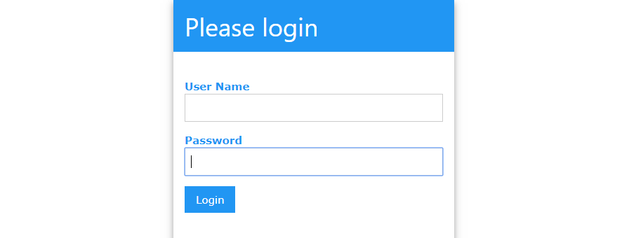
The following interface will appear asking you to enter your Pi username and password

Interface for control

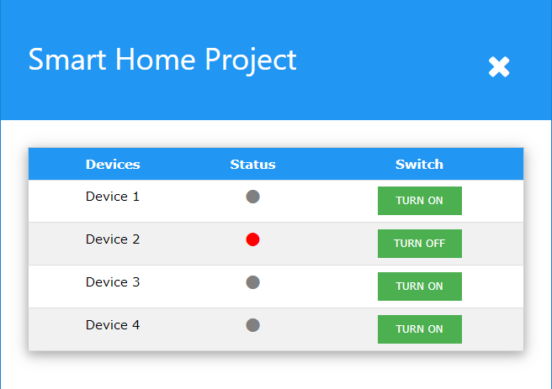
Click the buttons on the page to switch ON/OFF the LEDs !

Data Stores
In control systems, it is often divided into two parts:
Control part (algorithm, calculations, processing, ...).
Motivation part (to control peripheral devices needing large capacity such as light bulbs, motors, ...)

Design basis
The interface is implemented on the principle of friendliness, proximity to the user, simple, easy to use but ensures the necessary functions.
- Website interface to interact with users - device (LED).

Structural Design

Design Explanation and Rationale

To implememnt a good management machenism, devices need to solve many different problems. The first thing to consider is distinguishing devices to control. Since devices and web-servers connect to the center via TCP-IP, it is necessary to distinguish the web-server. How to extract data from the server and send that data to device.
Each deivce will have a unque ID code; When the device connect to the center ( master), it sends the divice initialization information including the ID code to the Master to confirm. Note that the master will know in advance which devices are avaible. If the devices is in the management list, it will accept the device initialization and save the information. It is this information used to distinguish the device.
Turn Pi into a real web-server with the aim of controling in-house IoT devices via web-interface( it means you can access the Pi with the browser to control)
Below is a description of the system model:

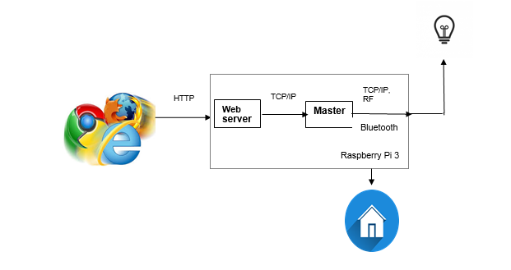

Initialization algorithm
- Master side :
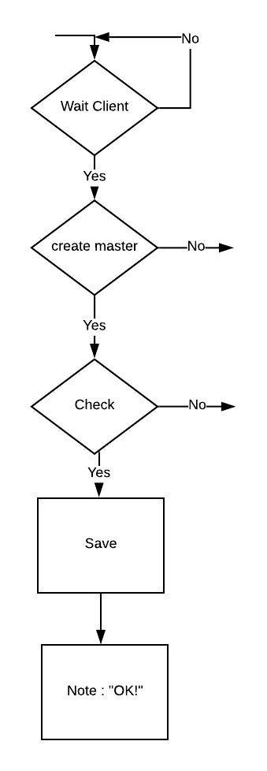

Step 1. Wait for the signal to connect from the client.

Step 2. Check if the information is initialization information.

Step 3. If it is correct, check if the device has the device listed.

Step 4. If yes, save the device information (possibly IP address). In essence, this program saves file-descriptor corresponding to the device.

Step 5. Send feedback message that has successfully initialized.

- Client side :
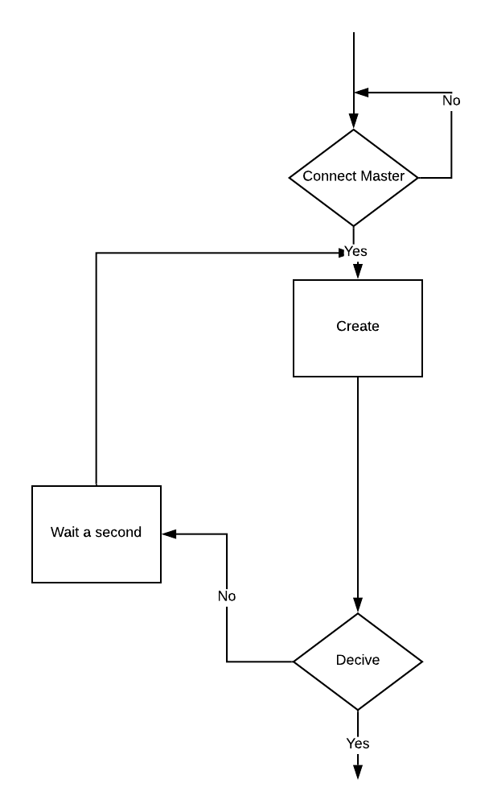

Step 1. Connect to Master.

Step 2. Submit initialization information. The initialization information can be a string of characters in which a special character string representing that is initialized.

Step 3. Wait for the response from Master. If there is no "OK" return signal, the initialization will be resent.

Master program

Master's complete algorithm

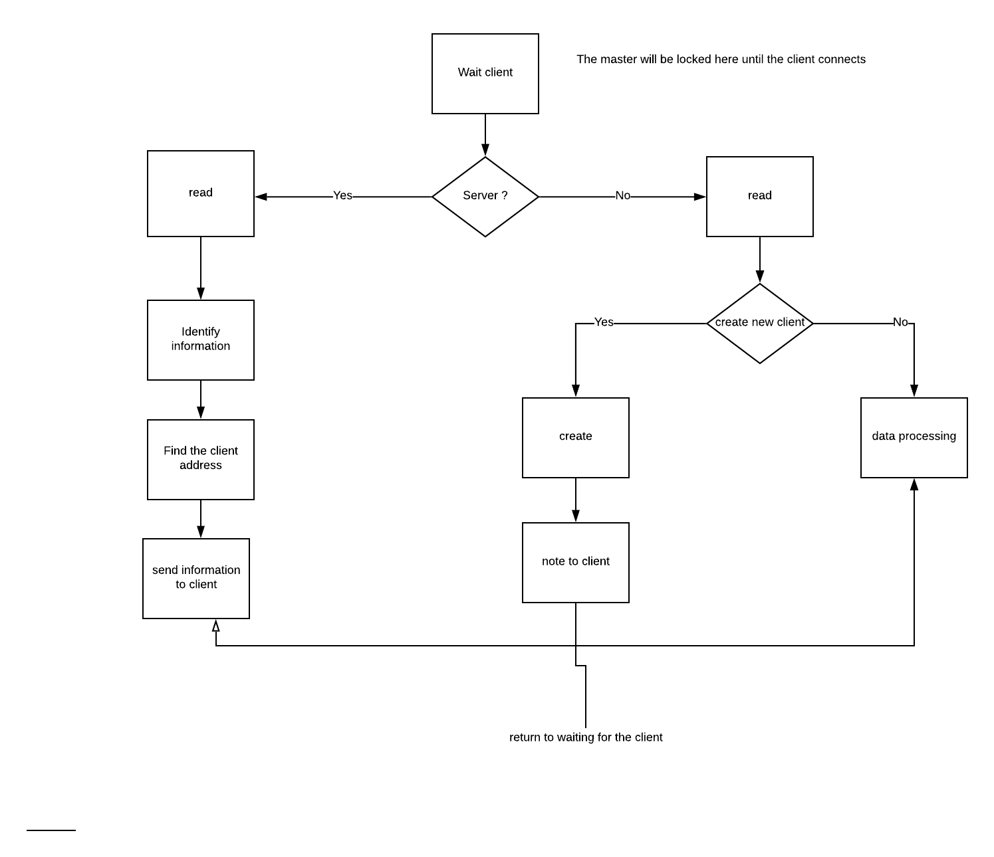

Supplementary Documentation
Phuc Le Van , Lập trình Raspberry Pi,< https://raspberrypi.vn/lap-trinh-raspberry-pi/cai-dat-qt-cho-raspberry-pi-chay-raspbian-3003.pi > , date of access 27/03/2019.
Technical Reference Manual (PDF) <https://espressif.com/sites/default/files/documentation/esp8266-technical_reference_en.pdf>

