SYSTEM OVERVIEW

INTRODUCTION

CONCEPT

PURPOSE

SCOPE OF THE PROJECT

INTRODUCTION

For software developers who are struggling to improve software quality in Fujitsu.

The quality risk manager is a software development support tool that can tell developers the software quality risk when source codes are committed.

Unlike other static analysis tools, our project has self-learning function that is suitable for each team.

But this is just prototype for Proof of Concept

CONCEPT

Our assumption is that bug fix commit is non-bug commit which its message containing ‘fix’ word.

In the previous commits of this bug fix commit, there is at least one commit containing bug.

PURPOSE

Our purpose is to train a machine learning model that can predict the commit whether it includes bug or non-bug

SCOPE OF THE PROJECT

We examined this prototype to ReactiveX/RxJava repository on GitHub.

There are 2 branches in this repository, our working branch is 2.x of this repository

There were 5376 commits by the date July 11th and we used those commits

There are 1115 commits that contain ‘fix’ in their message and we assume these commits are non-bug commits.

We found 93 bug commits based one bug fix commit’s information. 9 commits in 1115 non-bug commits are assessed as bug commits

Our dataset includes 1115 non-bug commits and 93 bug commits in ReactiveX/RxJava repository

The figures below show explanation

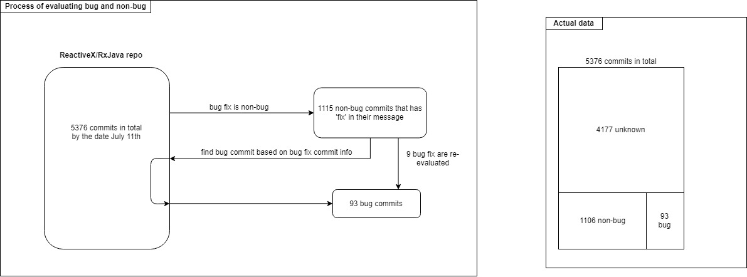

Figure 1: Process of evaluating commit



Figure 2: Actual data