Bài 1:

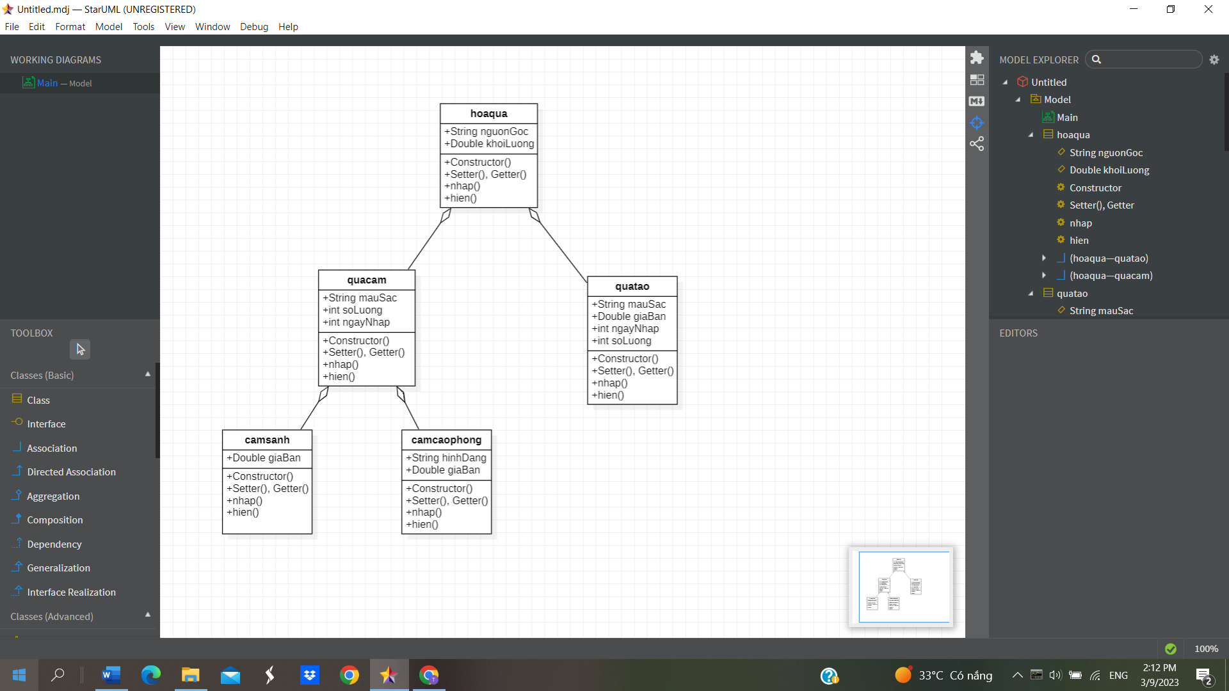

public class hoaqua {

private String nguonGoc;

private Double khoiLuong;

public hoaqua()

{

}

public hoaqua(String nguonGoc, Double khoiLuong)

{

this.nguonGoc = nguonGoc;

this.khoiLuong= khoiLuong;

}

public String getNguonGoc() {

return nguonGoc ;

}

public void setNguonGoc(StringnguonGoc) {

this.nguonGoc = nguonGoc;

}

public Double getKhoiLuong() {

return khoiLuong;

}

public void setKhoiLuong(Double khoiLuong) {

this.khoiLuong = khoiLuong;

}

public void nhap()

{

Scanner sc= new Scanner(System.in);

System.out.print("Nguồn gốc: ");

nguonGoc= sc.nextLine();

System.out.print("Khối Lượng: ");

khoiLuong= sc.nextLine();

public void hien()

{

System.out.print("{nguonGoc: "+ getNguonGoc() + ", khoiLuong: "+

getKhoiLuong()+ "}");

}

}

public class quacam extends hoaqua {

private String mauSac;

private Int soLuong, ngayNhap;

public quacam()

{

}

public quacam(String mauSac, int soLuong, int ngayNhap)

{

this.mauSac = mauSac;

this.soLuong= soLuong;

this.ngayNhap=ngayNhap;

}

public String getMauSac() {

return mauSac ;

}

public void setMauSac(String mauSac) {

this.mauSac = mauSac;

}

public Int getSoLuong() {

return soLuong;

}

public void setSoLuong(Int soLuong) {

this.soLuong = soLuong;

}

public Int getNgayNhap() {

return ngayNhap;

}

public void setNgayNhap(Int ngayNhap) {

this.ngayNhap = ngayNhap;

}

public void nhap()

{

Scanner sc= new Scanner(System.in);

System.out.print("Màu Sắc: ");

mauSac = sc.nextLine();

System.out.print("Số Lượng: ");

soLuong= sc.nextLine();

System.out.print("Ngày Nhập: ");

ngayNhap= sc.nextLine();

public void hien()

{

System.out.print("{mauSac: "+ getMauSac() + ", soLuong: "+

getSoLuong()+”, ngayNhap:”+ getNgayNhap()+ "}");

}

}

public class quatao extends hoaqua {

private String mauSac;

private Double giaBan;

private Int soLuong, ngayNhap;

public quatao()

{

}

public quatao(String mauSac, double giaBan, int soLuong, int ngayNhap)

{

this.mauSac = mauSac;

this.giaBan =giaBan;

this.soLuong= soLuong;

this.ngayNhap=ngayNhap;

}

public String getMauSac() {

return mauSac ;

}

public void setMauSac(String mauSac) {

this.mauSac = mauSac;

}

public Double getGiaBan() {

return giaBan ;

}

public void setGiaBan(Double giaBan) {

this.giaBan = giaBan;

}

public Int getSoLuong() {

return soLuong;

}

public void setSoLuong(Int soLuong) {

this.soLuong = soLuong;

}

public Int getNgayNhap() {

return ngayNhap;

}

public void setNgayNhap(Int ngayNhap) {

this.ngayNhap = ngayNhap;

}

public void nhap()

{

Scanner sc= new Scanner(System.in);

System.out.print("Màu Sắc: ");

mauSac = sc.nextLine();

System.out.print("Giá Bán: ");

giaBan = sc.nextLine();

System.out.print("Số Lượng: ");

soLuong= sc.nextLine();

System.out.print("Ngày Nhập: ");

ngayNhap= sc.nextLine();

public void hien()

{

System.out.print("{mauSac: "+ getMauSac() + ",giaBan:”+getGiaBan()+”, soLuong: "+

getSoLuong()+”, ngayNhap:”+ getNgayNhap()+ "}");

}

}

public class camsanh extends quacam {

private Double giaBan

public camsanh()

{

}

public camsanh(Double giaBan)

{

this.giaBan = giaBan;

}

public Double getGiaBan() {

return giaBan ;

}

public void setGiaBan(Double giaBan) {

this.giaBan = giaBan;

}

public void nhap()

{

Scanner sc= new Scanner(System.in);

System.out.print("Giá Bán: ");

giaBan = sc.nextLine();

public void hien()

{

System.out.print("{giaBan: "+ getGiaBan()+ "}");

}

}

public class camcaophong extends quacam {

private String hinhDang

private Double giaBan

public camcaophong()

{

}

public camcaophong(Double giaBan, String hinhDang)

{

this.giaBan = giaBan;

this.hinhDang = hinhDang;

}

public Double getGiaBan() {

return giaBan ;

}

public void setGiaBan(Double giaBan) {

this.giaBan = giaBan;

}

public String getHinhDang() {

return hinhDang ;

}

public void setHinhDang(String hinhDang) {

this.hinhDang = hinhDang;

}

public void nhap()

{

Scanner sc= new Scanner(System.in);

System.out.print("Giá Bán: ");

giaBan = sc.nextLine();

System.out.print("Hình Dạng: ");

hinhDang = sc.nextLine();

public void hien()

{

System.out.print("{giaBan: "+ getGiaBan()+ ",hinhDang:”+getHinhDang()+ "}");

}

}

Bài 3:

* Có 3 quan hệ thừa kế.Trong đó, lớp circle, lớp rectangle thừa kế lớp shape, lớp square thừa kế lớp rectangle. Vì lớp circle dùng lại các thuộc tính của lớp shape chứ không phải lớp rectangle
* package thucHanh5;

public class Shape {

private String color = "red";

private boolean filled = true;

public Shape() {

}

public Shape(String color, boolean filled) {

super();

this.color = color;

this.filled = filled;

}

public String getColor() {

return color;

}

public void setColor(String color) {

this.color = color;

}

public boolean isFilled() {

return filled;

}

public void setFilled(boolean filled) {

this.filled = filled;

}

public String toString() {

return " color=" + color + ", filled=" + filled ;

}

}

package thucHanh5;

public class Circle extends Shape {

private final float PI=3.14f;

private double radius=1.0;

public Circle() {

}

public Circle(double radius) {

this.radius = radius;

}

public Circle(String color, boolean filled, double radius) {

super(color, filled);

this.radius=radius;

}

public double getRadius() {

return radius;

}

public void setRadius(double radius) {

this.radius = radius;

}

public double getArea() {

return this.PI\*this.radius\*this.radius;

}

public double perimeter() {

return 2\*this.PI\*this.radius;

}

public String toString() {

return super.toString()+" PI=" + PI + ", radius=" + radius ;

}

}

package thucHanh5;

public class Rectangle extends Shape {

private double width = 1.0;

private double length = 1.0;

public Rectangle() {

}

public Rectangle(double width, double length) {

this.width = width;

this.length = length;

}

public Rectangle(double width, double length, String color, boolean filled) {

super(color, filled);

}

public double getWidth() {

return width;

}

public void setWidth(double width) {

this.width = width;

}

public double getLength() {

return length;

}

public void setLength(double length) {

this.length = length;

}

public double getArea() {

double Area = (this.length \* this.width);

return Area;

}

public double getPerimeter() {

double Perimeter = (this.length + this.width) \* 2;

return Perimeter;

}

public String toString() {

return super.toString()+"width=" + width + ", length=" + length ;

}

}

package thucHanh5;

public class Square extends Rectangle {

public Square() {

}

public Square(double side) {

super.setLength(side);

super.setWidth(side);

}

public Square(double side, String color, boolean filled) {

super.setLength(side);

super.setWidth(side);

this.getColor();

this.isFilled();

}

public double getSide() {

return super.getLength();

}

public void setSide(double side) {

super.setLength(side);

super.setWidth(side);

}

public void setWidth(double side) {

this.getWidth();

}

public void setLength(double side) {

this.getLength();

}

public String toString() {

return super.toString()+"Side=lenght=width = " + getSide();

}

}

package thucHanh5;

import java.util.Scanner;

public class main {

public static void main(String[] args) {

Square sq = new Square();

System.out.println("nhap side");

Scanner sc = new Scanner(System.in);

sq.setSide(sc.nextDouble());

System.out.println(sq);

}

}