Exercise 1
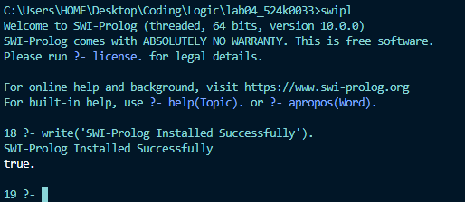

Exercise 2
After consulting the files and running the listing command, we get this:
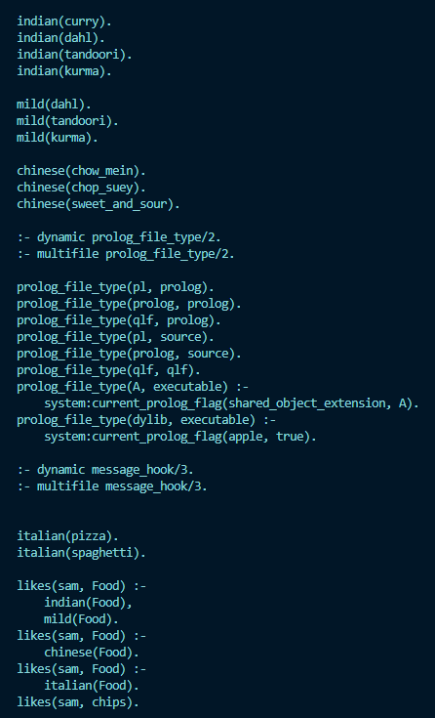
After that, we run the following commands:
- mild(X).
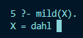
Running the mild(X) command will display the first mild flavor in the listing
- indian(X).
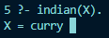
Same as before, running the indian(X) command will display the first indian flavor in the listing
- likes(sam,X).
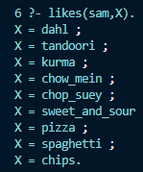
Uniquely, by using the ; key we can display the next result of the query rather than just returning the first result. The command (combined with the ; key) shows all possible flavors that Sam likes
How did we get these results? They all stem from “facts” that have been written in the likes.pl (i.e mild(dahn)), a statement that is unconditionally true. A group of these statements are called a predicate, and so far, we have:
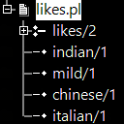
The commands we ran are called Queries, where we either prove if something is a fact or retrieve info using a variable(an uppercase latter).

Exercise 3
After setting up the necessary file, consulting the greeting.pl and running the greet command we get this:
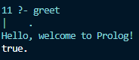
By running the head(greet) command, we run all of the commands inside of the body (anything after the “:-“ characters). The body consists of calls to make to predicate, aka to affirm if the rule is true or false. Since the body just consists of a singular write command, then the output will always be the outputted string and true.

Exercise 4
After editing the greeting.pl to this,
greet(Name) :-write('Hello, '), write(Name), write('! Welcome to Prolog!').
and running the command with ‘Alice’ as the newly added variable, we get this
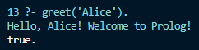
The result is like the previous exercise, but this time we edited the greet command to be a predicate with a variable named Name with the domain of any valid names (or strings, but coherently it should only be names). So, whenever we run the command, we must provide a name for the greet command.

Exercise 5
Once we have written and consulted the family.pl, running the first command we get this:
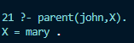
The result is like in exercise 2, where we ran a query to find if there is any stated relationship (in this case, parental relationship) between john and anyone else (Mary and Peter, but we only return the first result)
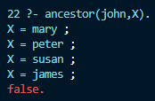
The query here returns more than just John’s parent, but also Mary and Peter’s parents as well. To break this down, we need to revise the code we have written
ancestor(X, Y) :-parent(X, Y).
This is the first rule (not a fact), where the ancestor of someone is basically their parents. In discrete structure, we would say “The ancestor of someone includes the parent of that person”. Because of this, the first 2 results are John’s parents. But we get the last two results because of the second rule:
ancestor(X, Y) :-parent(X, Z), ancestor(Z, Y).
Essentially, if Z is the parent of X, and if Y is the ancestor (through the first or second rules) of Z, then Y is the ancestor of X. Combined with the previous rule, this is known as a Recursion. Where the first rule acts as the base case and the second rule is the recursive step, stopping once we get a False (or in the worst case, never stopping).
Using the command we ran above as an example; we check and return using the first rule (Mary and Peter). Once we move onto the second rule, we backtrack for the first query(parent(john,Z)->mary), check for their ancestor(ancestor(mary,Y)) and return if there is an answer(susan). This continues on until John has no more ancestors, which the program returns False meaning it has searched every fact in the code.
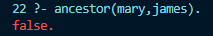
The final query returns false due to Mary and James belonging to 2 different bloodlines, or more accurately because Mary has no direct relationships to James or any indirect relationships that satisfy the ancestor rules to James.

Exercise 6
Consulting the code and running the first query, we get this result:
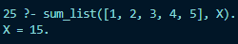
We can confirm that the expected sum is 15(1+2=3,3+3=6,6+4=10,10+5=15), but the steps getting here is a bit more complex than what we have seen before.
The query activates a recursive descent, a classic type of recursion. The program breaks down the list one element at a time until it hits an empty list before adding the numbers as it returns.
sum_list([H|T], Sum) :-sum_list(T, Rest), Sum is H + Rest.
For the first parameter, we separate the array into two parts. The head (containing only the first number) and the tail (containing the rest), once that is done, we pass the tail and create a variable Rest to the recursive call to calculate the sum of the tail; only after this recursion returns the value of Rest do, we add the head (H) to it (Sum is H + Rest) to produce the final answer.
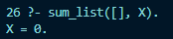
Finally, this query is simple to explain. The query looks through the database for anything that matches, which our base case does and returns 0.

