Lab 2 Report, developed by 524K0033 – Huỳnh Trung Tín

Introduction
This lab focuses on connecting a SQL Database and a window form via a connection string, utilizing SQL’s commands in C#(CRUD operations and Login functions) and using a window form to call other window forms

Exercises
- Login Window Form
For this exercise, In this exercise, I set up a database named Lab2DB and created a tblUsers table to store user credentials. Then I connected the database to the window form by adding the connection string in the app.config, before using it to establish an Sqlconnection and Sqlcommand with parameters to securely query the database and verify if the entered credentials matched a record in tblUsers. Additionally, I learned about ExecuteScalar, which executes the query and returns the first column of the first row
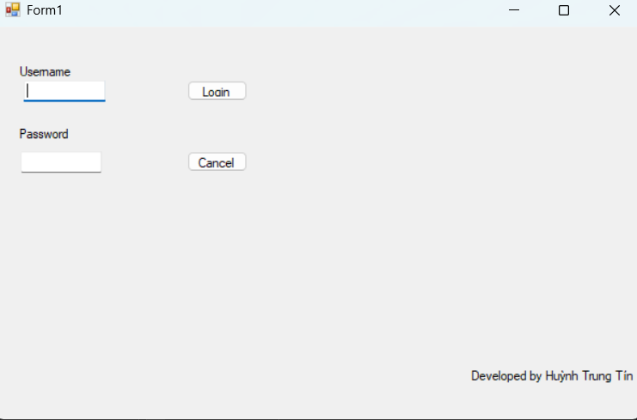
- CRUD Operations Window Form
I established another database for this exercise like how I did before with a different table named tblStudents to store student’s info. Once the connection is established, I learned how to perform more SQl commands such as the CRUD operations(Create, Update and Delete) and displaying data into a data grid view.
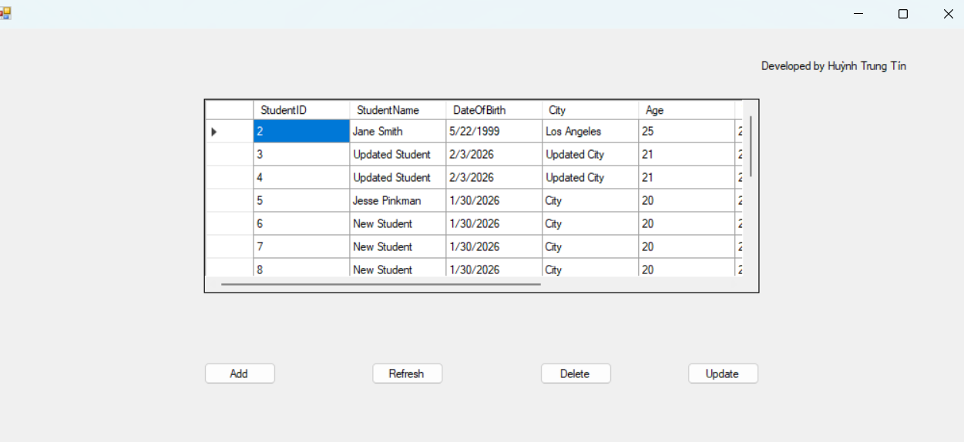
- Student Management Windows Form Application
This homework assignment combines the knowledge from the previous exercises and apply them in a more advanced way, demonstrating the complex workaround when working with foreign constraints in relationships, displaying data depending on user’s input and storing a procedure inside C#. While running window forms inside a form using a menustrip
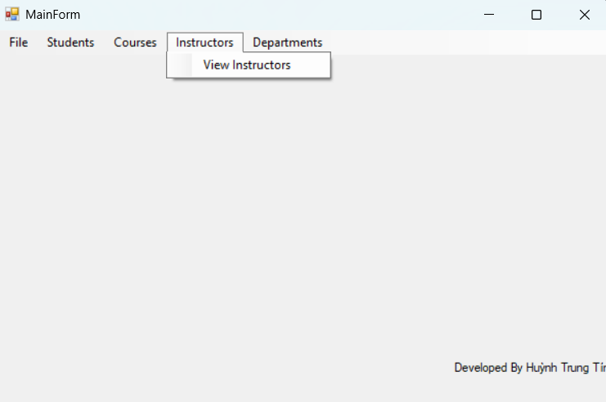
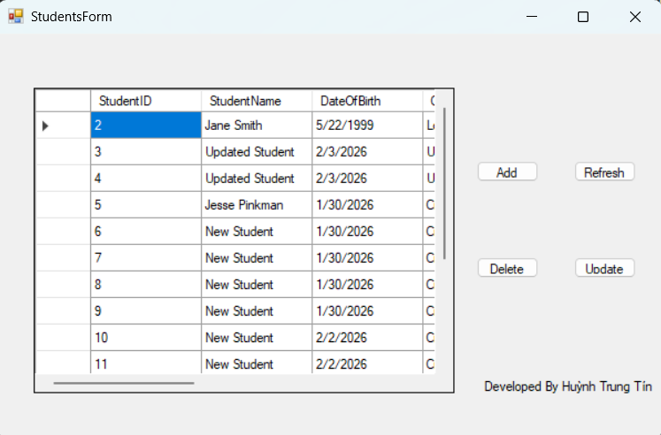

Conclusion
Through these exercises, I gained practical experience in connecting .NET applications to SQL Server. I learned how to manage connection strings efficiently using App.config, implement authentication logic, and handle relational data interactions through CRUD operations. Working around foreign constraints was the biggest challenge, though once I got the steps and how to do it the first time, the process became more natural

