Các lệnh cơ bản thao tác với Docker
- docker-version
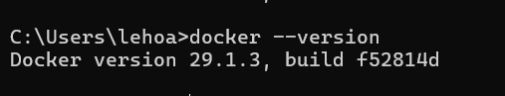
- docker run hello-world
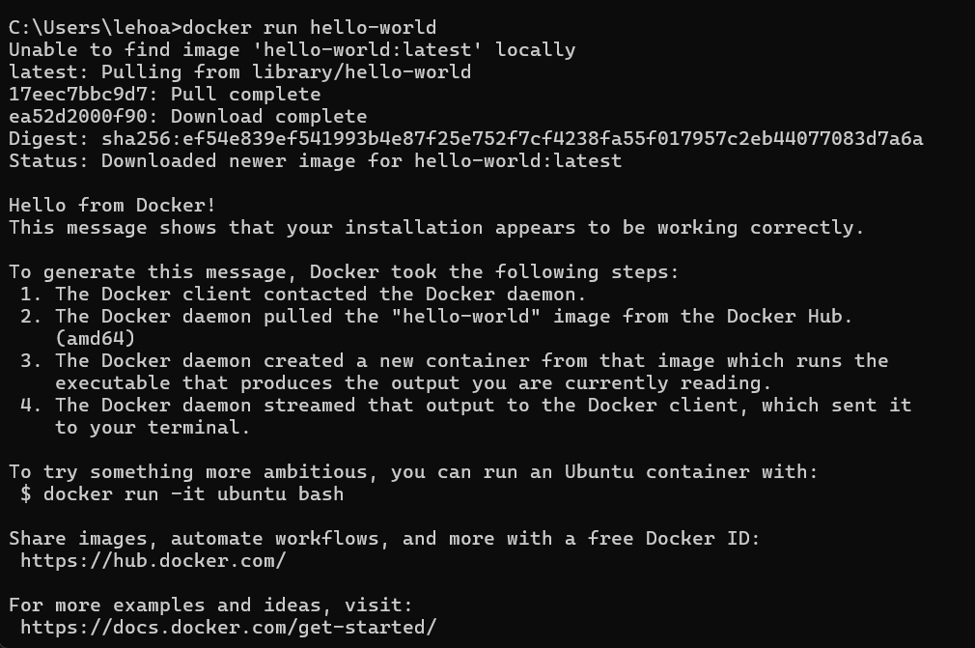
- docker pull nginx
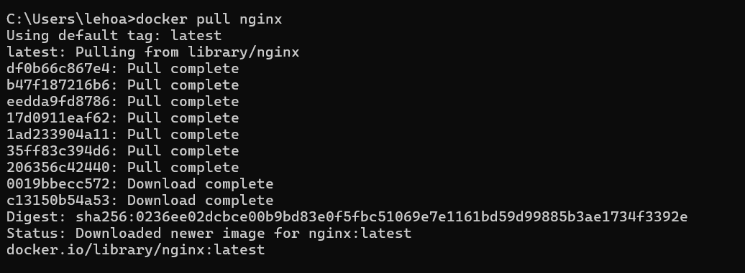
- docker images
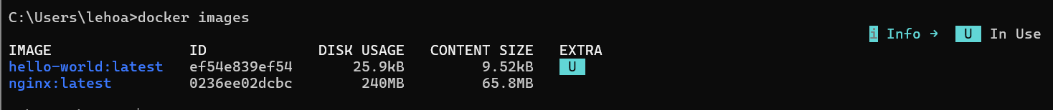
- docker run -d nginx
- docker ps
- docker ps -a
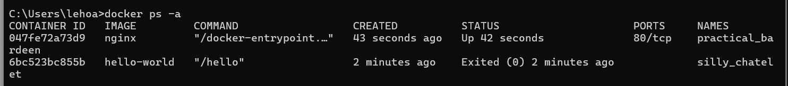
- docker logs <container_id>
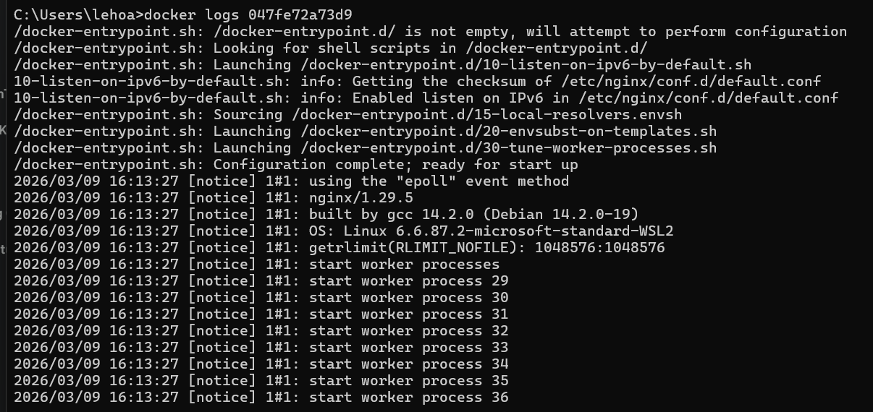
- docker exec-it <container id> /bin/sh
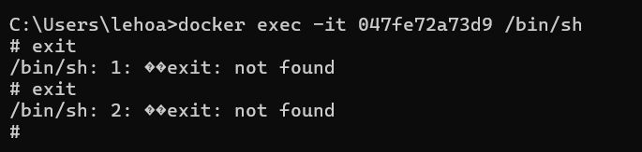
- docker stop <container_id>
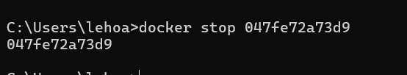
- docker restart <container id>
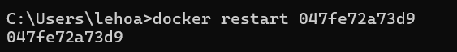
- docker rm <container_id>
- docker container prune
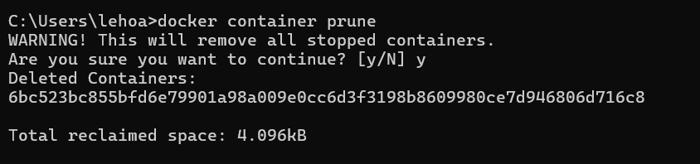
- docker rmi <image_id>
- docker image prune -a
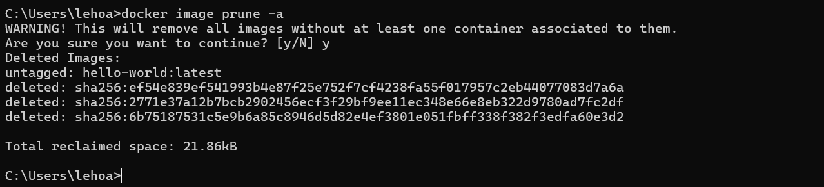
- docker run -d -p : nginx
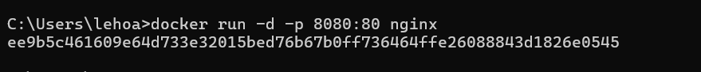
- docker inspect <container_id>
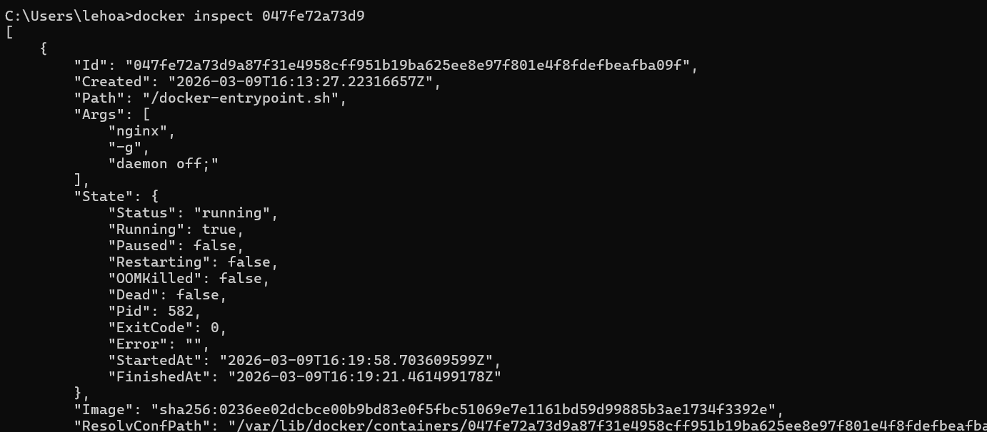
- docker run -d -v mydata:/data nginx
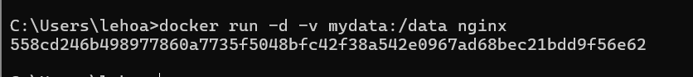
- docker volume ls
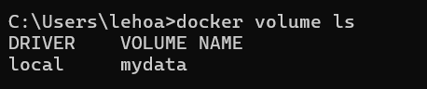
- docker volume prune
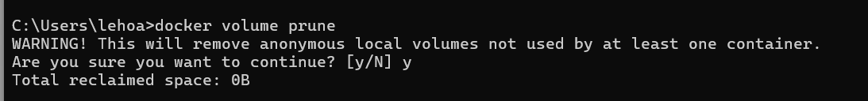
- docker run -d --name my_nginx nginx
- docker stats
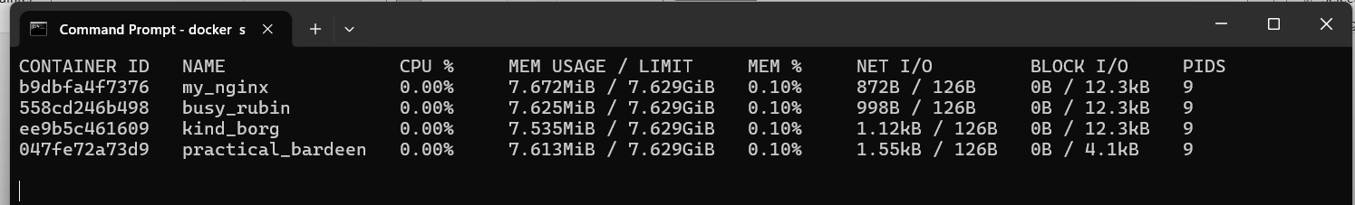
- docker network ls
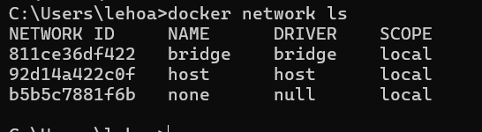
- docker network create my_network
- docker run -d --network my_network --name my_container nginx
- docker network connect my_network my_nginx
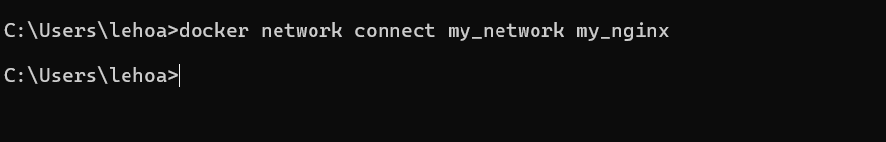
- docker run -d-e MY_ENV=hello_world nginx
- docker logs -f my_nginx
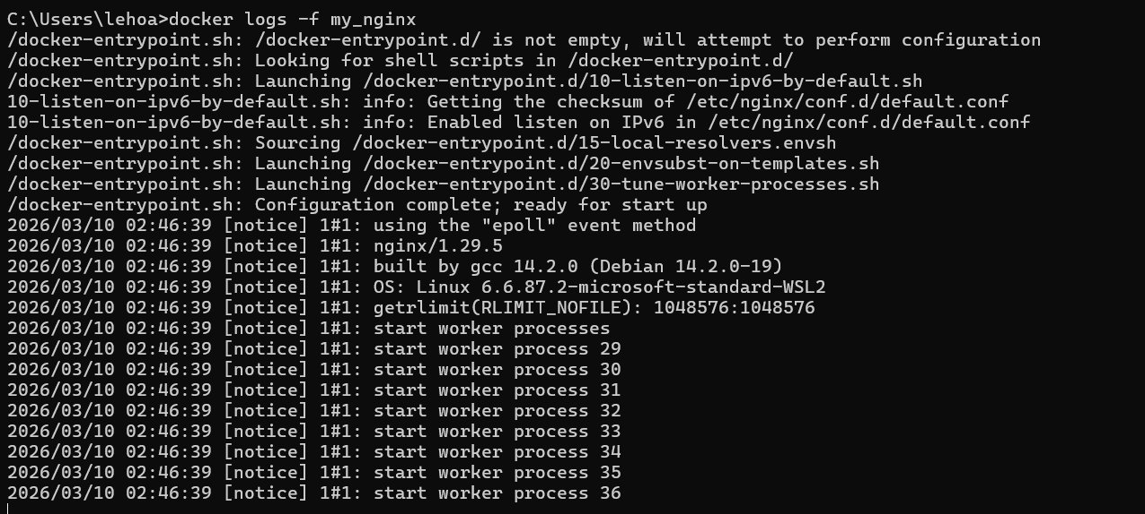
- FROM nginx
COPY index.html /usr/share/nginx/html/index.html
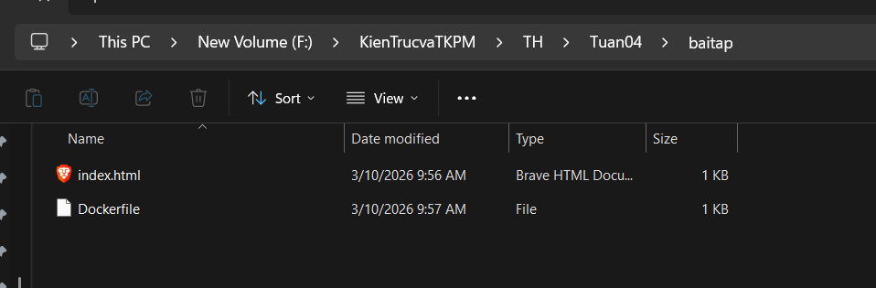
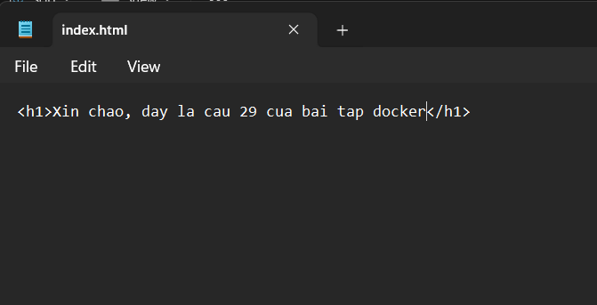
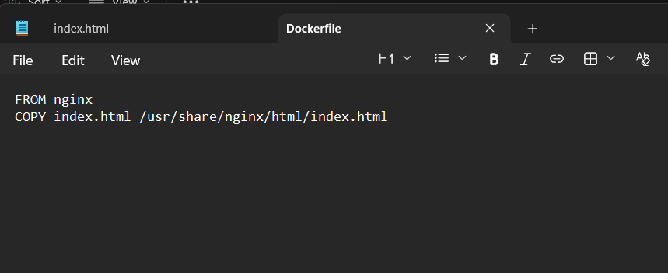
- docker build -t my_nginx_image.
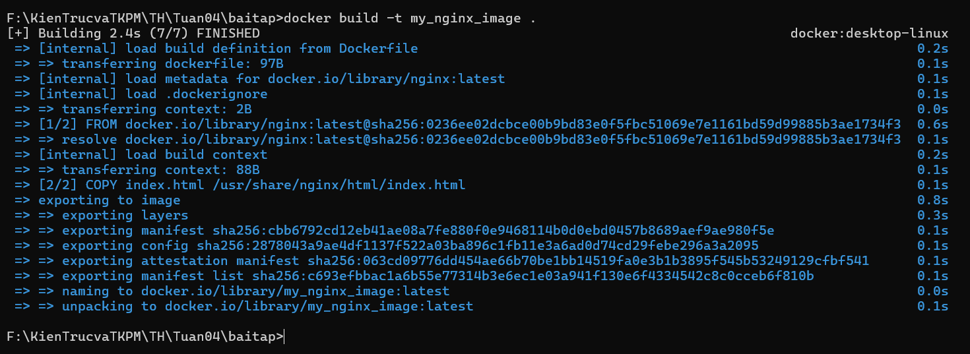
- docker run -d -p : my_nginx_image
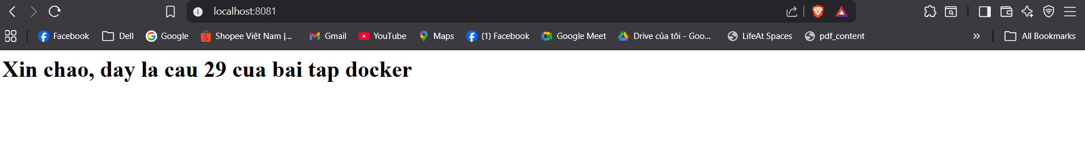
Dùng VS code, code FE, BE, DB và file .yml:
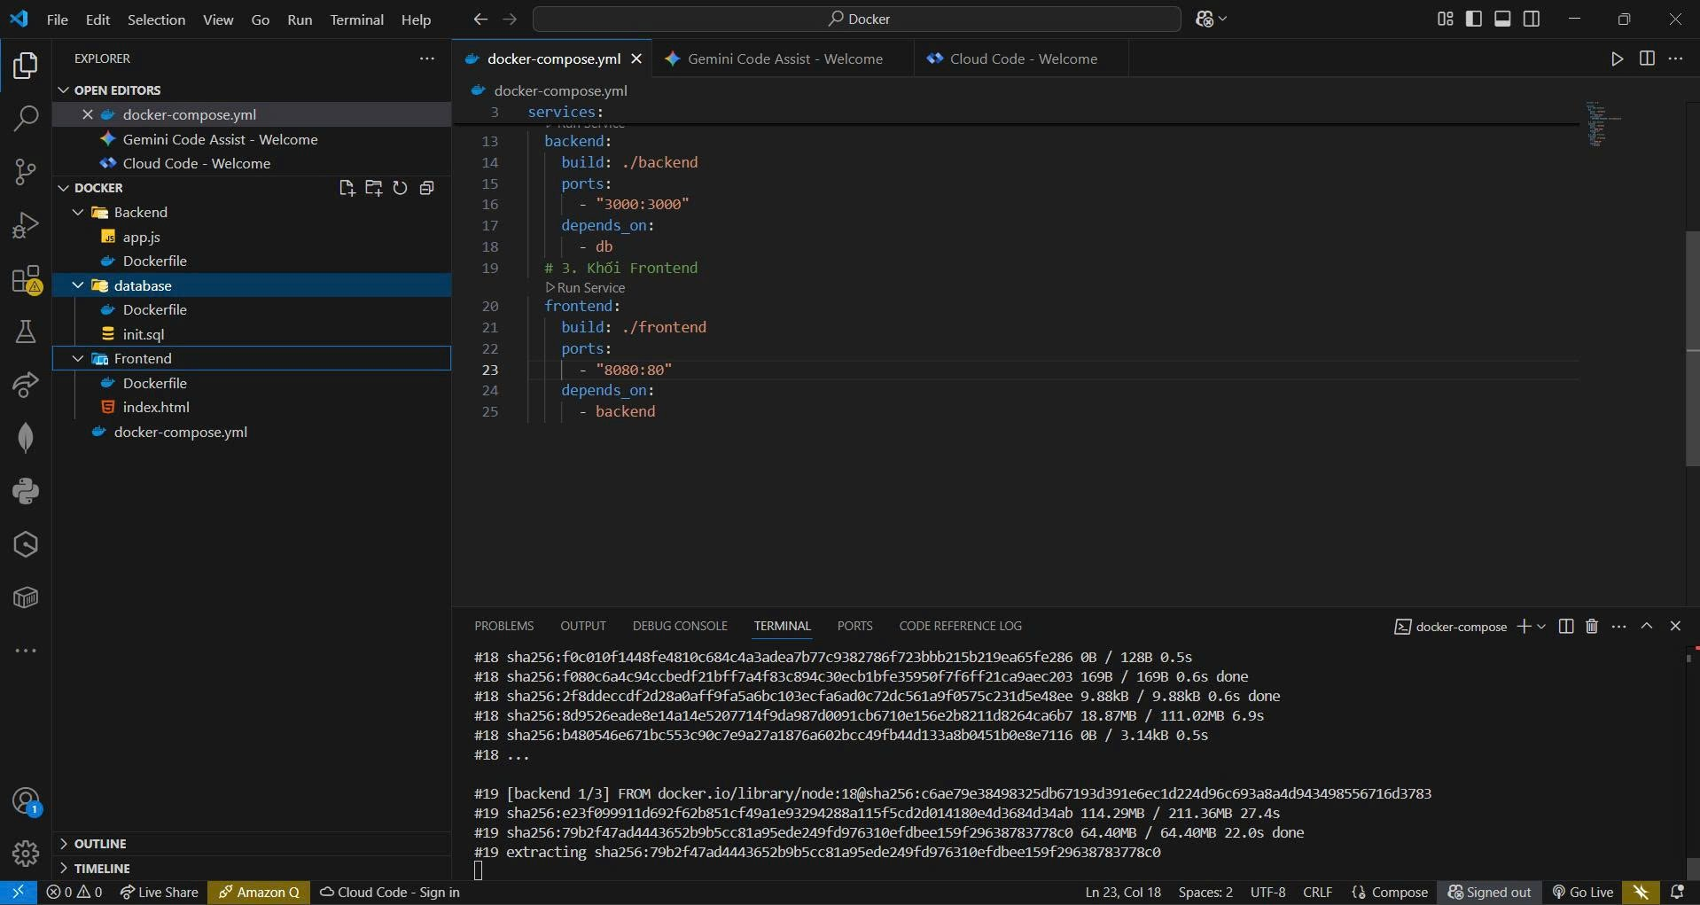

Chạy lệnh run :
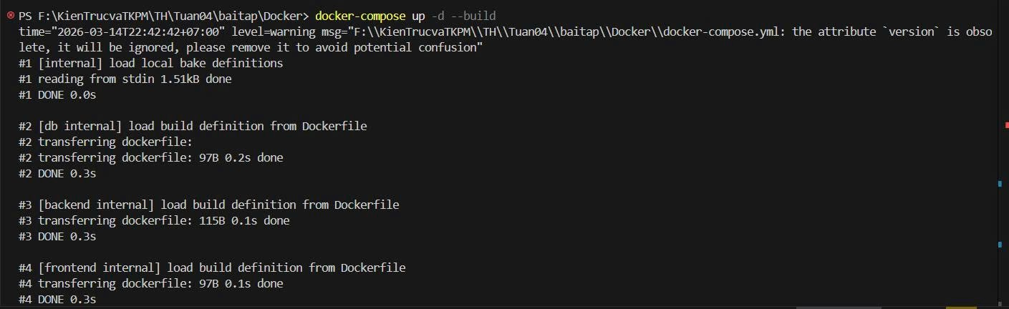
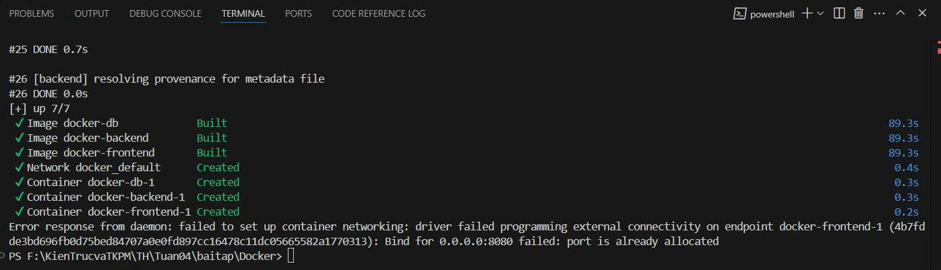
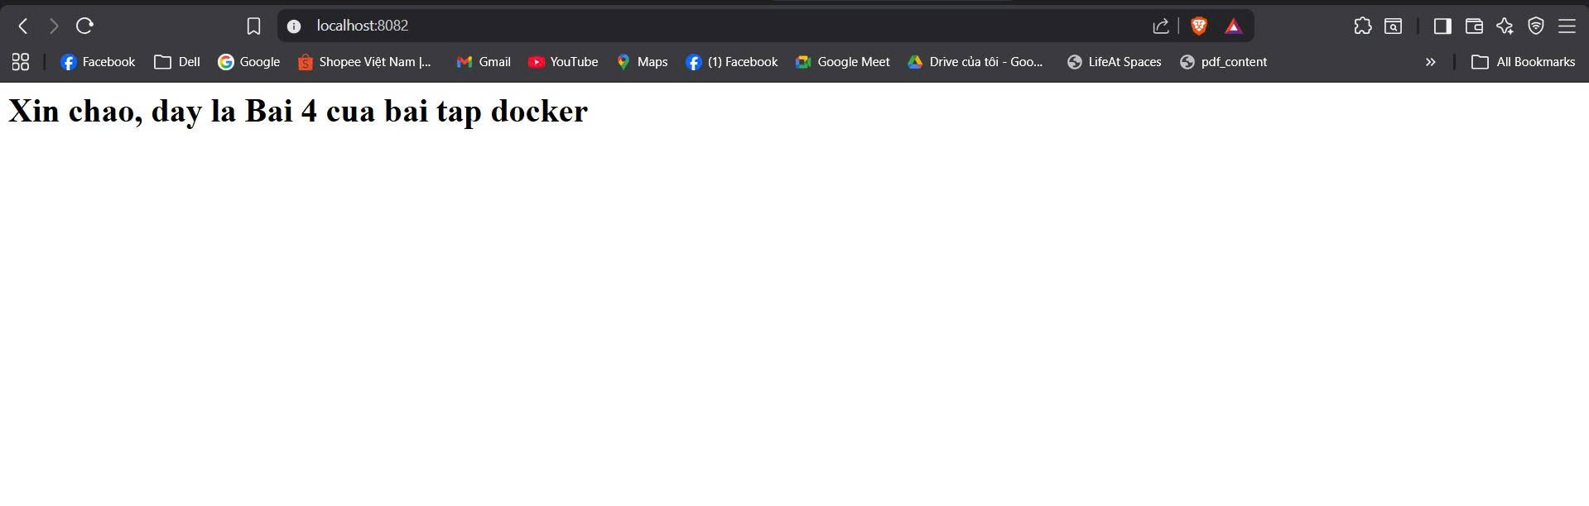
Sửa FE rồi run lại :
