1 | docker compose version  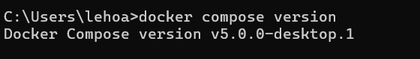
2 | docker compose up  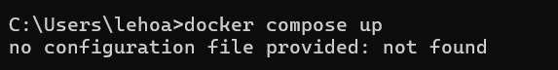  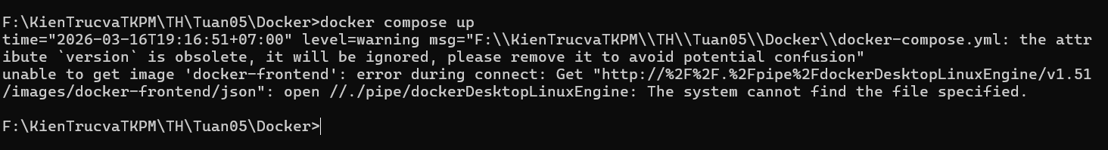
3 | docker compose up -d  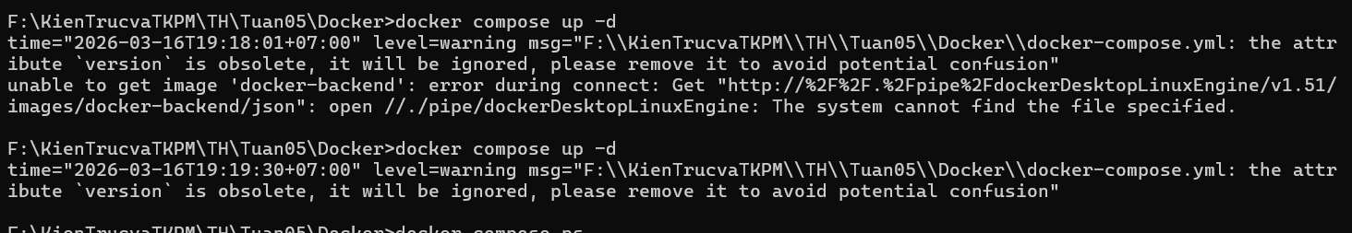
4 | docker compose ps  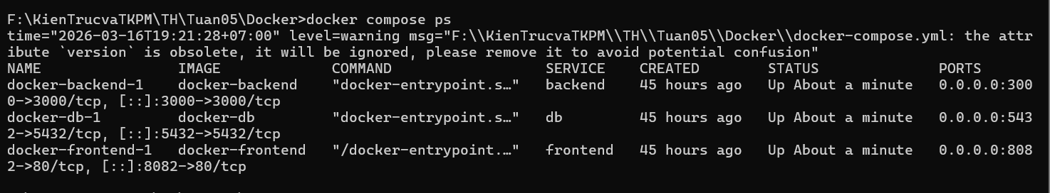
5 | docker compose down  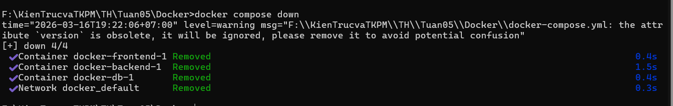
6 | docker compose restart
7 | docker compose logs -f
8 | docker compose build  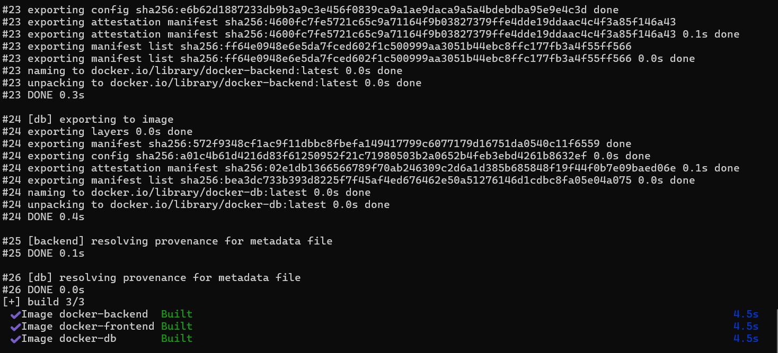
9 | docker compose exec <service_name> <command>
10 | docker compose down -v
11 | docker compose run <service_name> <command>
12 | docker compose stop <service_name>
13 | docker compose rm <service_name>
14 | docker compose config
15 | docker compose up -d --build

