# Install XCTU - Linux

By default, access to the serial and USB ports in Linux is restricted to root and dialout group users. To access your XBee devices and use XCTU to communicate with them, your Linux user must belong to this group.

To add your Linux user to the dialout group:

1. Open a terminal console.
2. Execute this following command, where **<user>** is the user you want to add to the dialout group.:

sudo usermod -a -G dialout <user>

1. Log out and log in again with your user in the system.

Then download and install XCTU:

1. Go to [www.digi.com/xctu](http://www.digi.com/xctu).
2. Click **Download XCTU**.
3. Under **Utilities**, click the Linux installer link.
4. When the file has finished downloading, run the executable file and follow the steps in the XCTU Setup Wizard. A “What’s new” dialog appears when installation is complete.

Link download: <http://ftp1.digi.com/support/utilities/40002881_G.run> or

<https://www.digi.com/products/xbee-rf-solutions/xctu-software/xctu#productsupport-utilities>

cd /Dowload/[40002881_G.run](http://ftp1.digi.com/support/utilities/40002881_G.run)

**chmod a+x 40002881_G.run -> sudo ./40002881_G.run**

## Configure Your Xbees

You will need to configure your XBee modules so they can communicate.  The first part of this configuration involves setting the Channel, PAN ID, and Address values

Channel: The channel calibrates the operating frequency within the 2.4GHz 802.15.4 band. Your XBees must be on the same channel to communicate with one another.

PAN ID (Personal Area Network ID): Your XBees must share the same PAN ID to communicate with one another. You can choose a value between 0 and 0xFFFF.

Addressing: Each XBee has a source address (referred to as “MY address”) and a destination address (which has Destination High or DH and destination Low or DL). An XBee’s destination address specifies to which source address it can send data. You can specify a universally unique address by using the 64-bit address printed on the back of the module, use a shorter 16-bit address (unique within a network).

**Note:** Additionally, each XBee in a network plays a role. The three role options are Coordinator, End Device, and Router.

**Step 1: Open XCTU → cd /opt/Digi/XCTU-NG$ sudo ./app**

**Step 2: Plug your first XBee into an Explorer module, and connect to your computer’s USB port via a USB cable.**

**Step 3: Open XCTU and click “Discover devices.”**

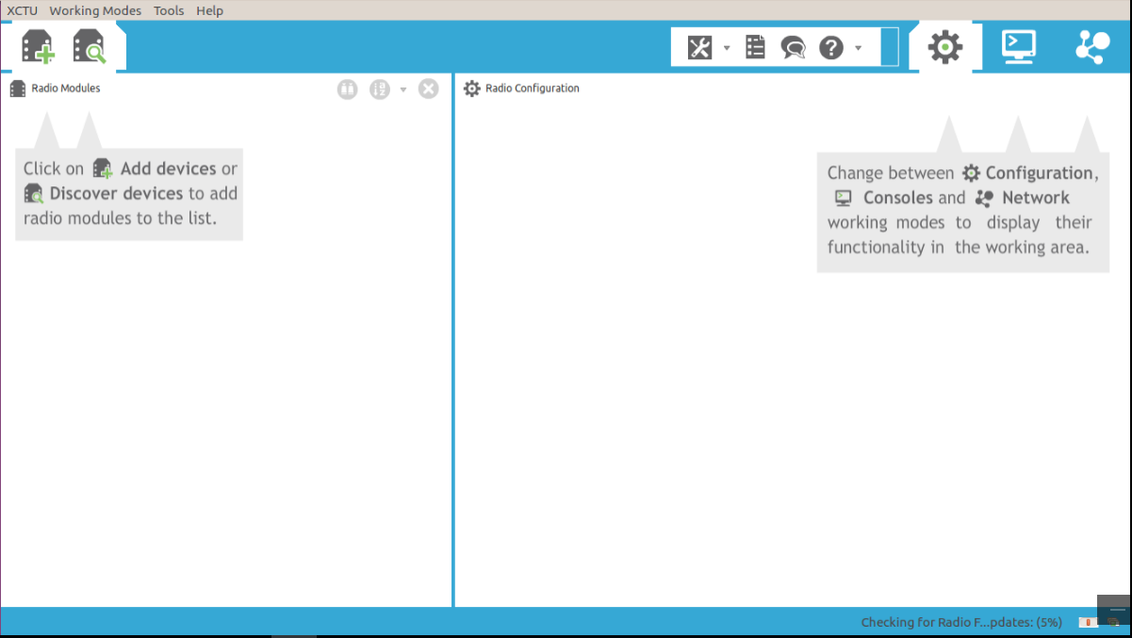

**Step 4: Select the port to be scanned. Then on the next page, select the settings as shown below. Click “Finish.”**

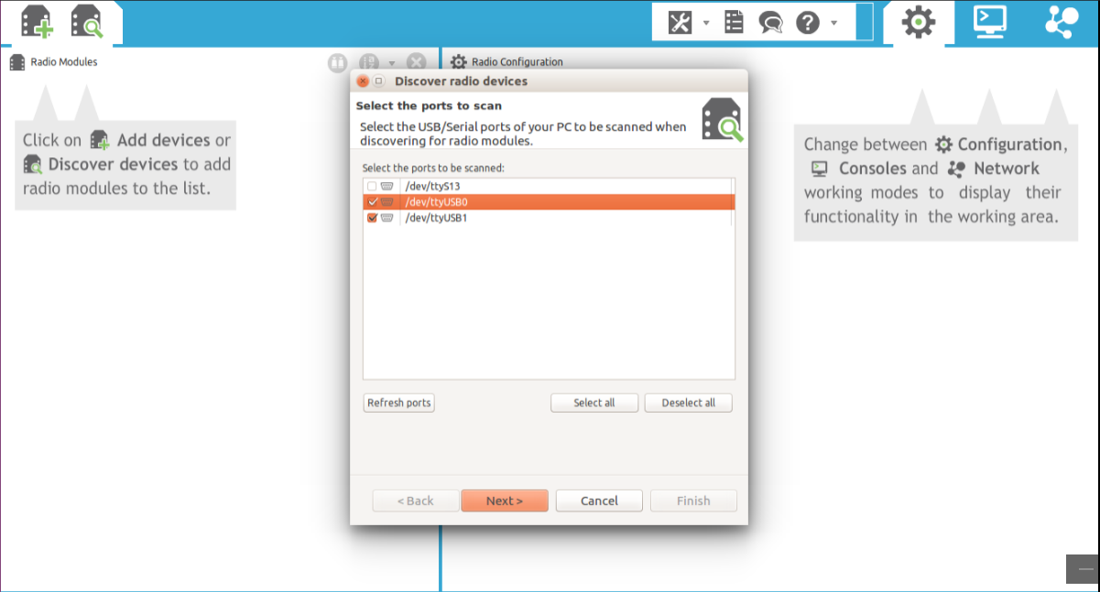

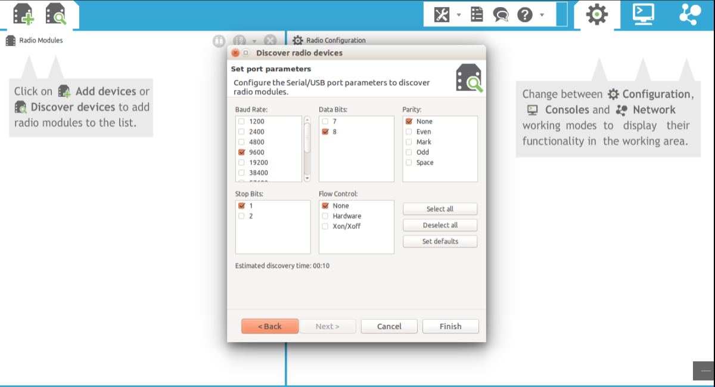

**Step 5: Your device should appear on the “Devices discovered” list. Click “Add selected devices” for your module.**

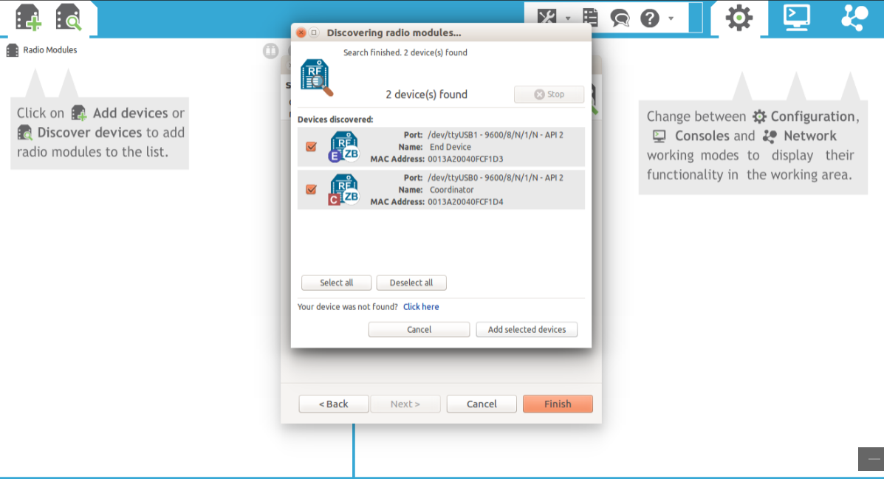

**Step 6: With the Gear icon selected, click the radio module in the left-hand menu. This should open up a long list of settings.**

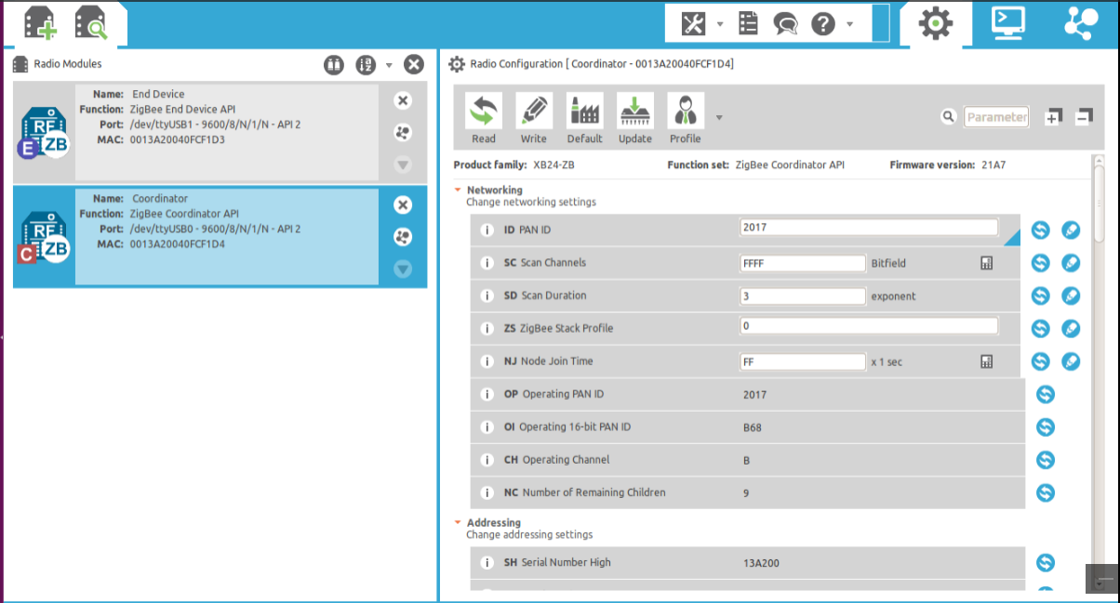

* 1. **Update firmware settings **
  2. **Pick function set for device is Coordinator, Router or End device.**

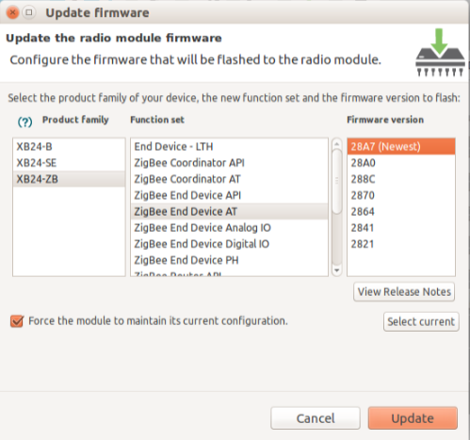

* 1. **Example configuration the following parameters: AT mode**

|  |  |  |  |
| --- | --- | --- | --- |
| **Param** | **Xbee A** | **Xbee B** | **Effect** |
| **ID** | **2017** | **2017** | Defines the network that a radio will attach to. This must be the same for all radios in your network. |
| **JV** | **_** | **Enable[1]** | Verifies if a coordinator exists on the same channel to join the network or to leave if it cannot be found. |
| **CE** | **Enable[1]** | **-** | Sets the device as coordinator. |
| **DH** | **13A200** | **13A200** | Defines the destination address (high part) to transmit the data to. |
| **DL** | **40FCF1D3** | **40FCF1D4** | Defines the destination address (low part) to transmit the data to. The address 0000000000000000 can be used to address the coordinator |
| **NI** | **Coordinator** | **EndDevice** | Defines the node identifier, a human-friendly name for the module. |
|  |  |  |  |

***— keep the default value***

* 1. Write the settings of all XBee modules with the **Write radio settings**button https://www.digi.com/resources/documentation/Digidocs/90001942-13/resources/images/rf_kits/btn_write_settings_19x20.png at the top of the Radio Configuration section.

**EndDevice:**

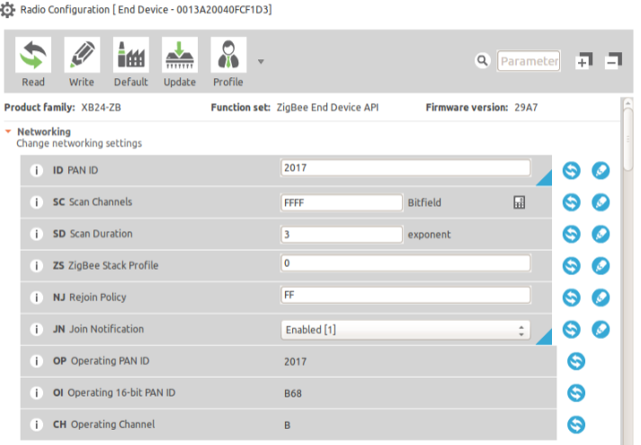

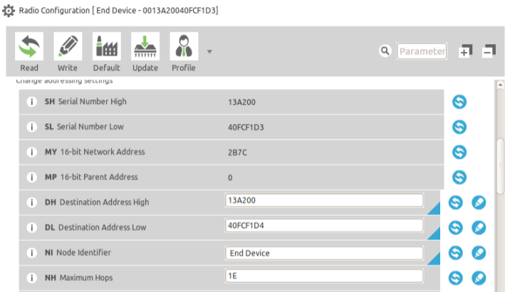

**Coordinator:**

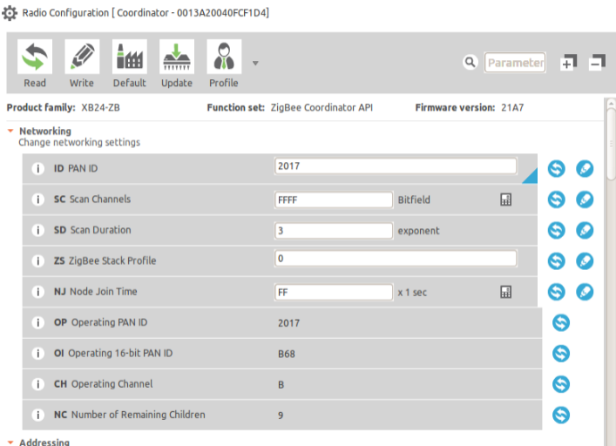

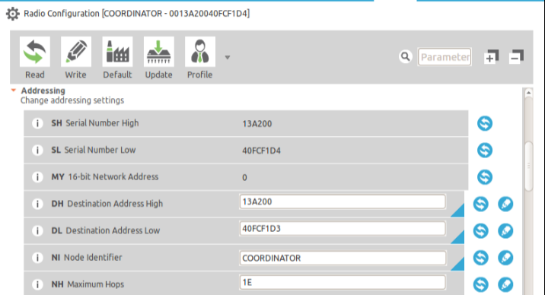

**Step 7: Run a Communication Test**

* + 1. Click the **Discover radio nodes in the same network** button of the first radio module.

The device searches for radio modules in the same network. You should see both devices available. Select both of them and click “Add selected devices.”

* + 1. Click one of the modules in the left-hand column. Now select the Console icon to view the console. Click “Open.” -> Repeat for the other module, opening up a console ->Type into one console. You should see the result echoed back in the other console.

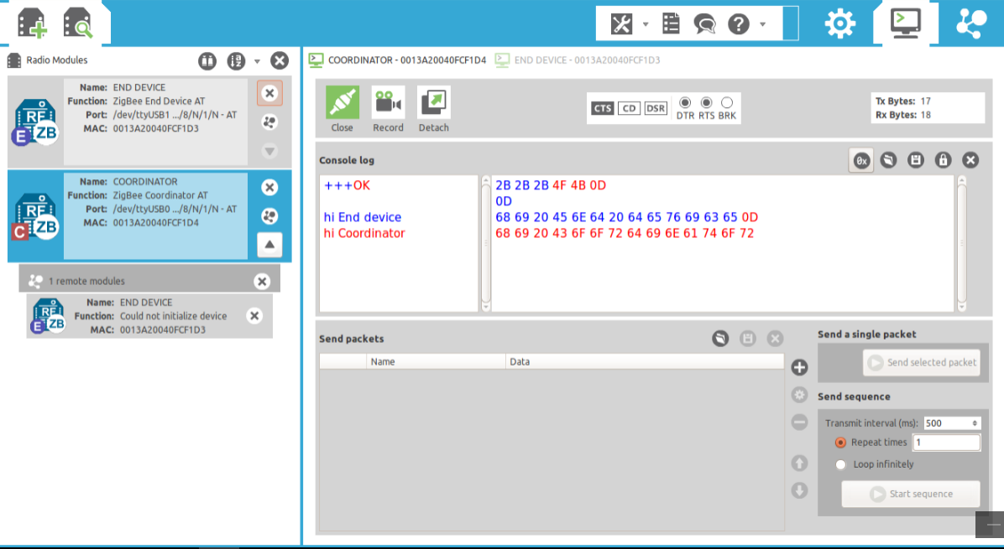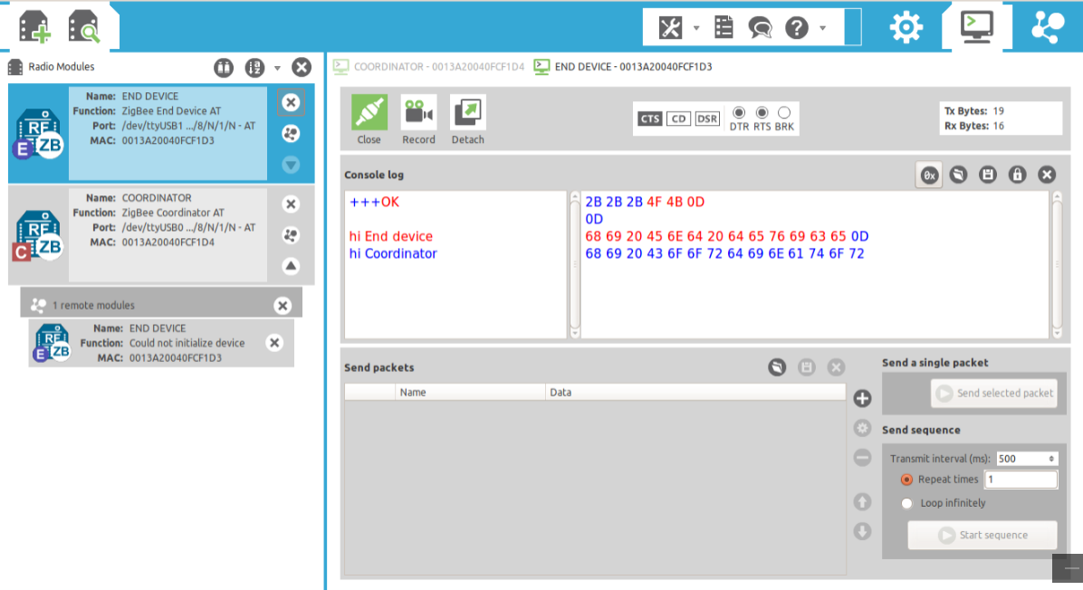

RX: hi Coordinator

TX: hi Coordinator

RX: hi End device

TX: hi End device