Install JDK

1. Before you set up Android Studio, be sure you have installed JDK 6 or higher (the JRE alone is not sufficient)—JDK 7 is required when developing for Android 5.0 and higher. To check if you have JDK installed (and which version), open a terminal and type javac -version. If the JDK is not available or the version is lower than 6, [go download JDK](http://www.oracle.com/technetwork/java/javase/downloads/index.html)
2. Launch the .exe file you just downloaded.
3. Follow the setup wizard to install Android Studio and any necessary SDK tools.

On some Windows systems, the launcher script does not find where Java is installed. If you encounter this problem, you need to set an environment variable indicating the correct location.

Select **Start menu > Computer > System Properties > Advanced System Properties**. Then open **Advanced tab > Environment Variables** and add a new system variable JAVA_HOME that points to your JDK folder, for example C:\Program Files\Java\jdk1.7.0_21

Download Android Studio from:

<https://developer.android.com/sdk/installing/index.html?pkg=studio>

Start Android Studio

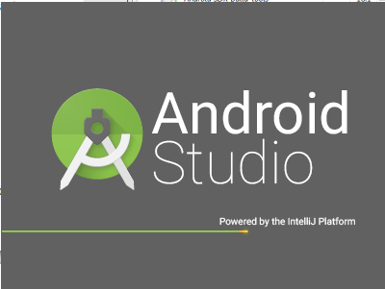

Click Configure button from the Home Screen:

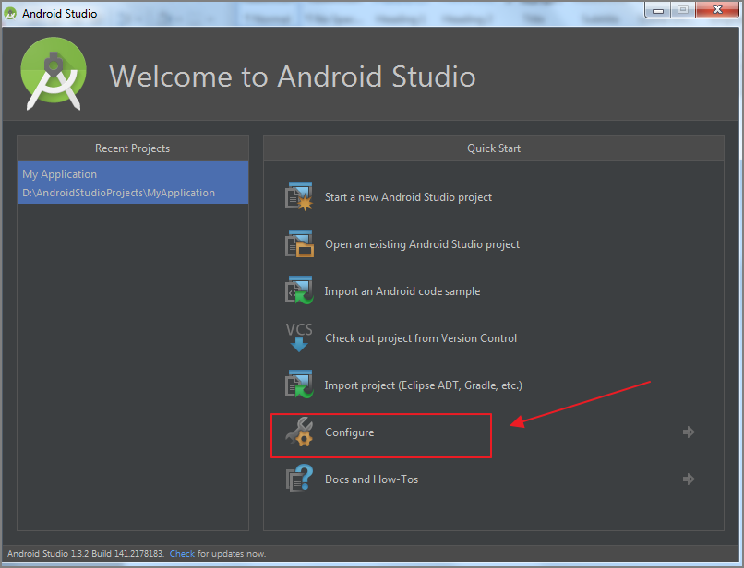

Then click “SDK Manager”

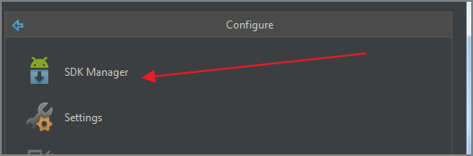

In the Android SDK Manager Dialog, Scroll to “Android 5.1.1 (API 22) and select the options as shown below and click Install button.

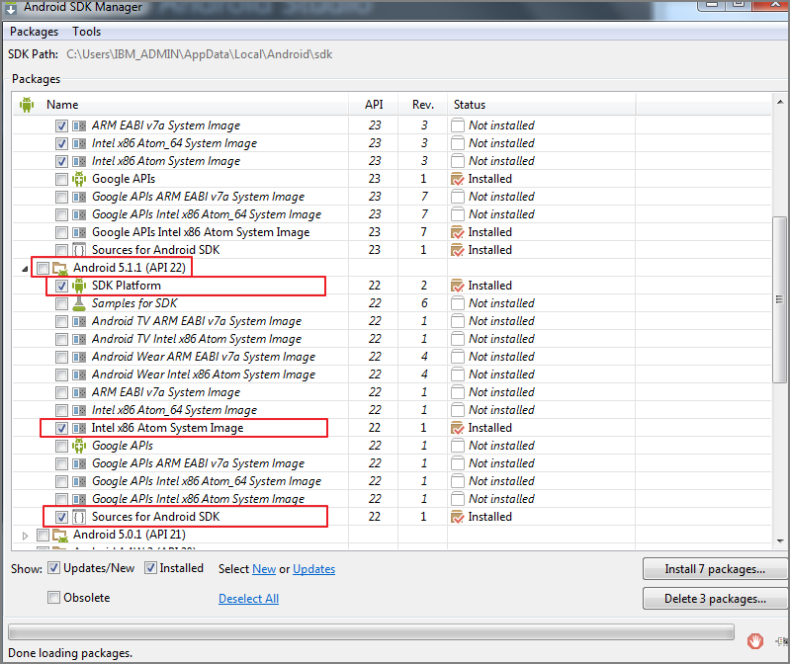

Once API 22 is installed, Create a new Project from Home Screen:

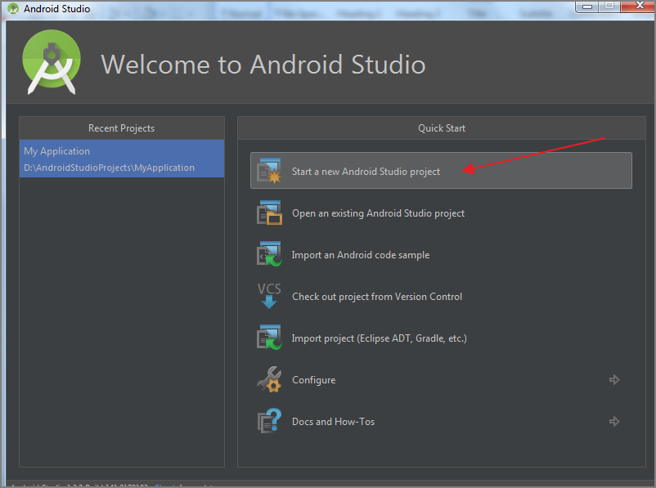

Give any name to application

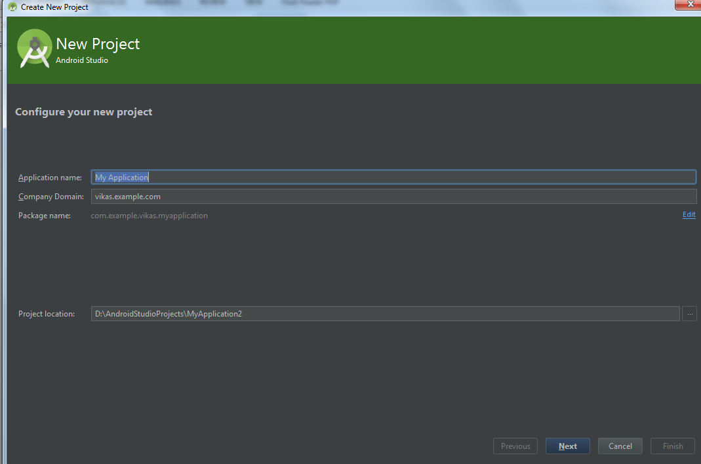

Select API 22 option as Minimum SDK

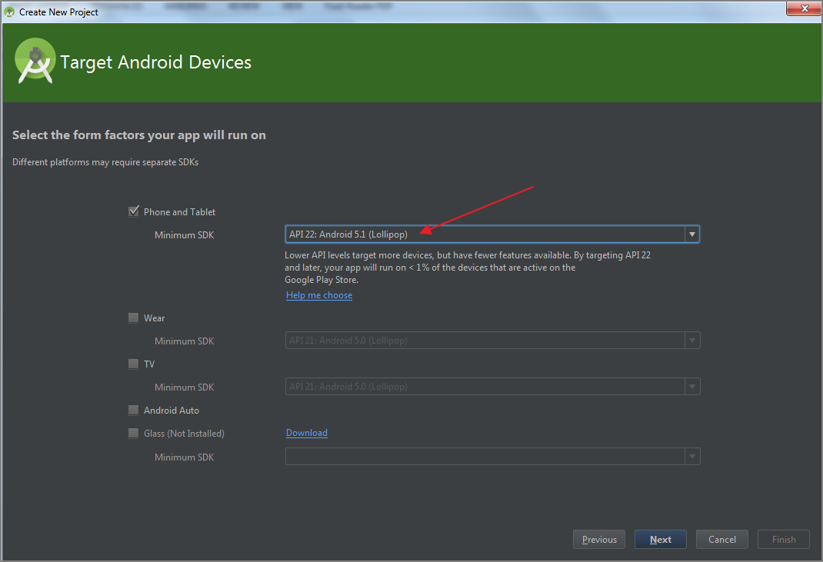

Select Add “No Activity” and Click “Finish” button.

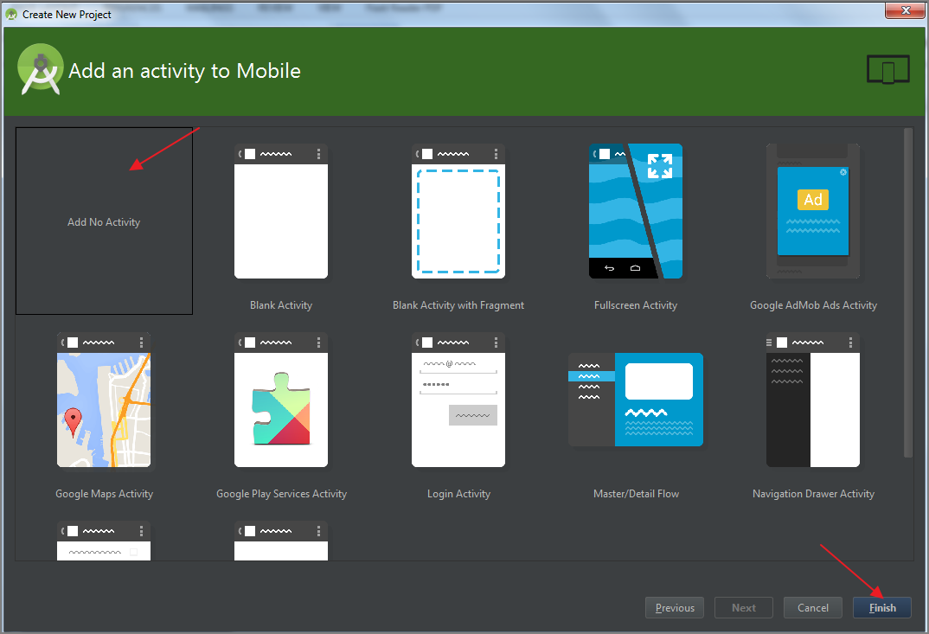

From Opened Studio Window, goto Tools 🡪 Android 🡪 AVD Manager

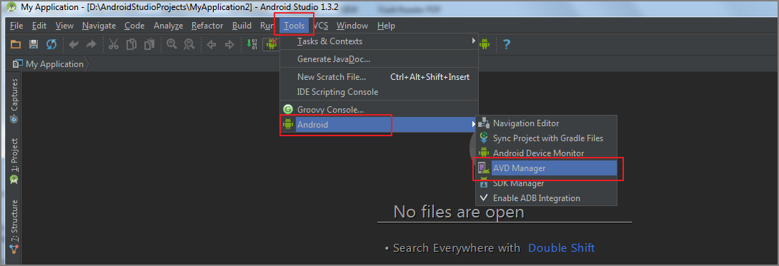

Create a Virtual Device:

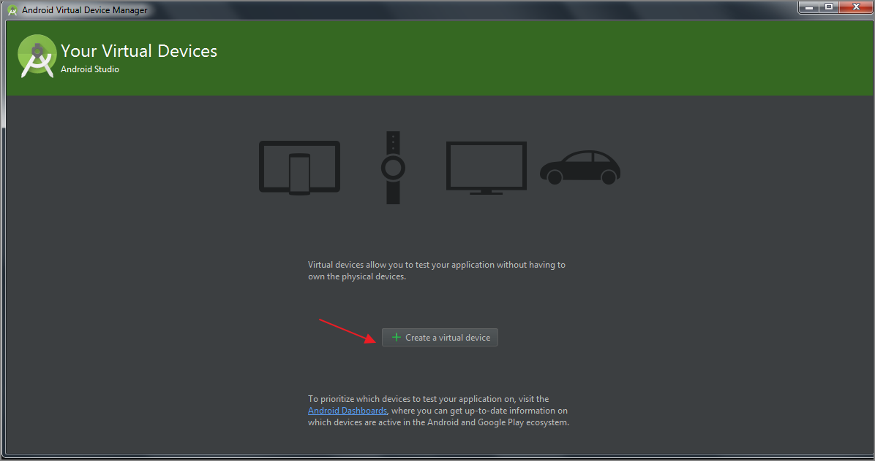

Select default Nexus 5 and click Next button:

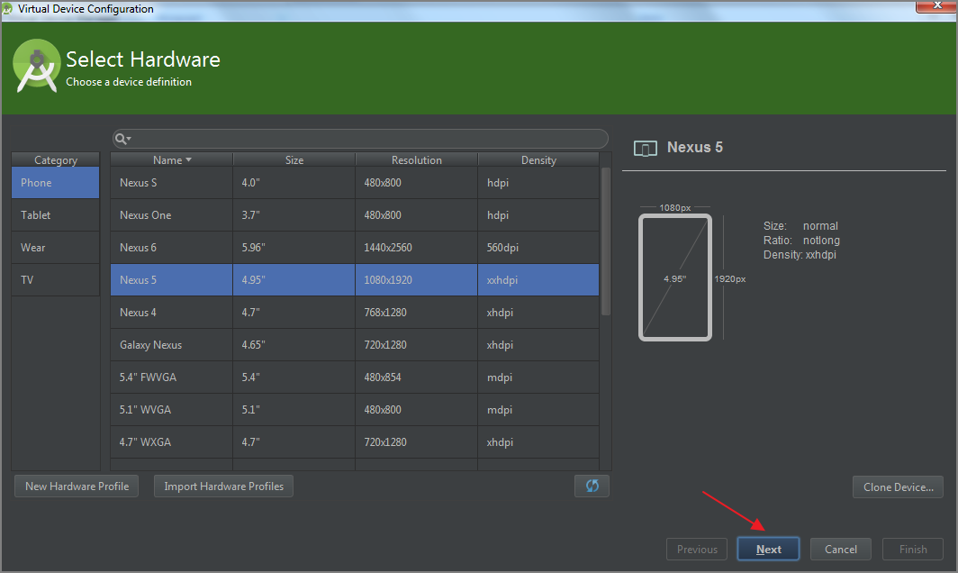

Select API 22 as shown below:

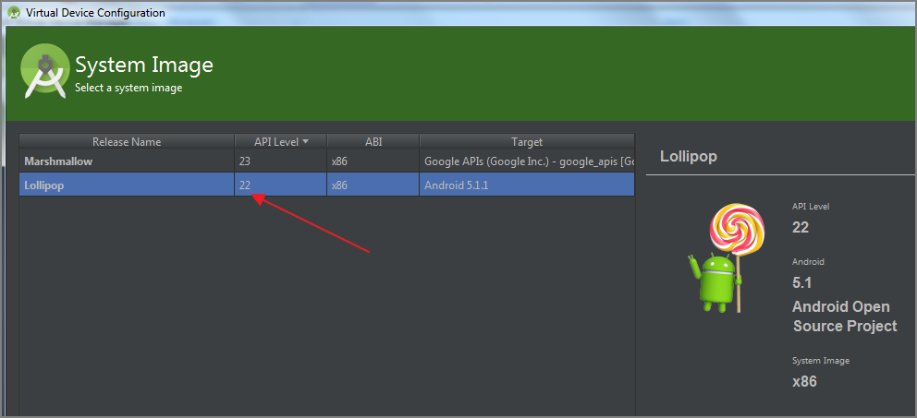

Click “Show Advanced Settings” 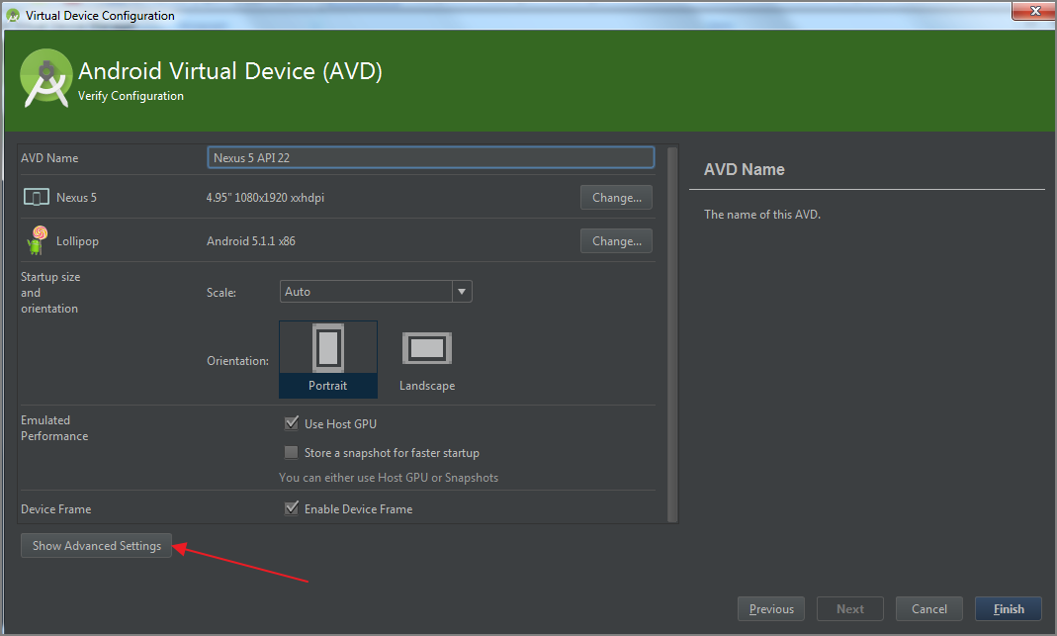

Scroll to the bottom of settings and ensure “Enable keyboard input” is checked. Once done, click the Finish button.

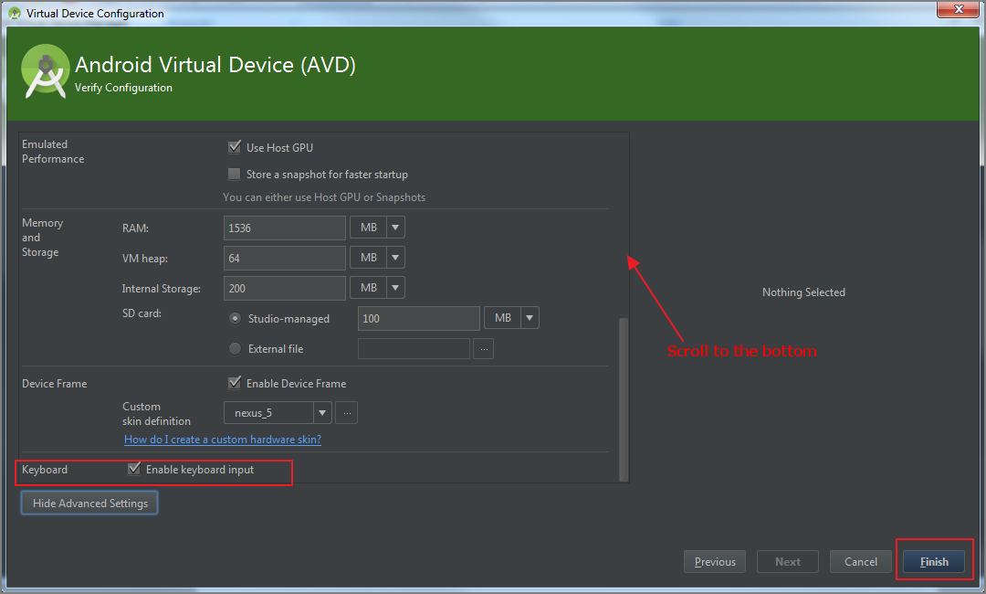

AVD Manager will show the newly created Virtual Device. Click the Play button to start the device:

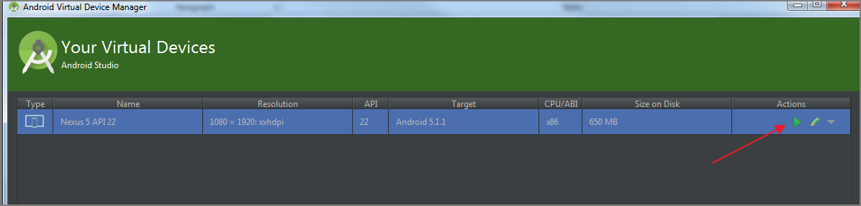

Once started, the Android 5.1 Virtual device should be visible to play with:

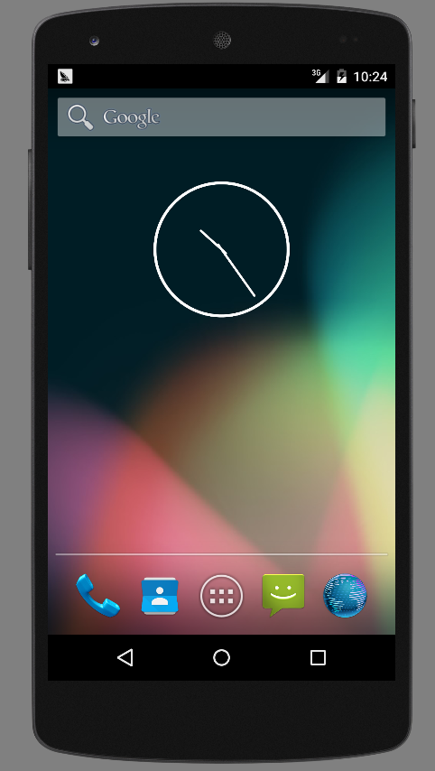

That’s all !