**Install MetalLB use LoadBalancer**

**Author**: Bui Doan Quang Huy

Link: <https://mvallim.github.io/kubernetes-under-the-hood/documentation/kube-metallb.html>

1. **Apply the LoadBalancer service deploy**

kubectl apply -f **loadbalancer-service.yaml**

#File **kube-service-load-balancer.yaml**

apiVersion: v1

kind: Service

metadata:

name: loadbalancer

labels:

app: guestbook

tier: frontend

spec:

selector:

app: guestbook

tier: frontend

type: LoadBalancer

ports:

- name: http

port: 80

targetPort: 80

protocol: TCP

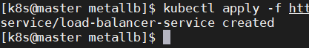

1. **Query the state of service**

kubectl get svc -o wide



1. **Instal metallb**

kubectl apply -f **metallb.yaml**

kubectl get deploy -n metallb-system -o wide

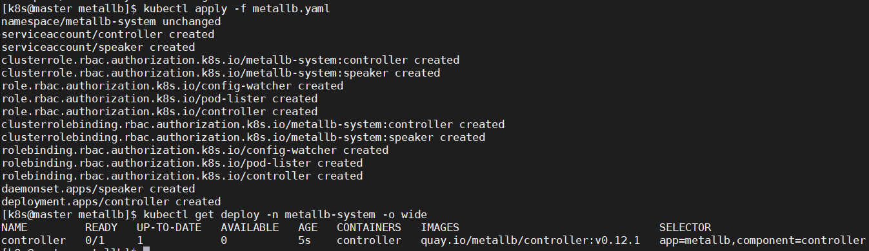

1. **Config MetalLB**

kubectl apply metallb-config.yaml -f

#file **metallb-config.yaml (addresses is IP worker)**

apiVersion: v1

kind: ConfigMap

metadata:

namespace: metallb-system

name: config

data:

config: |

address-pools:

- name: default

protocol: layer2

addresses:

- **10.1.20.11-10.1.20.12**

1. **Check**

kubectl get deploy controller -n metallb-system -o wide

kubectl get svc load-balancer-service -o wide

