bttl

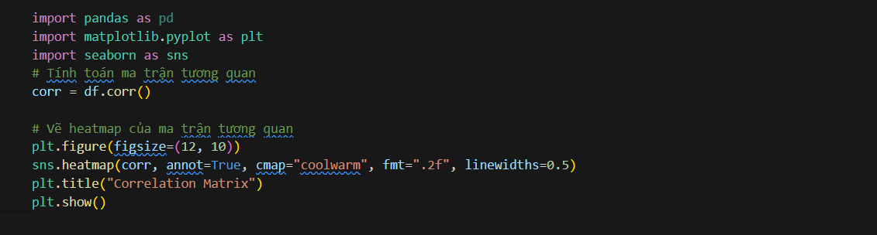

Btvn

