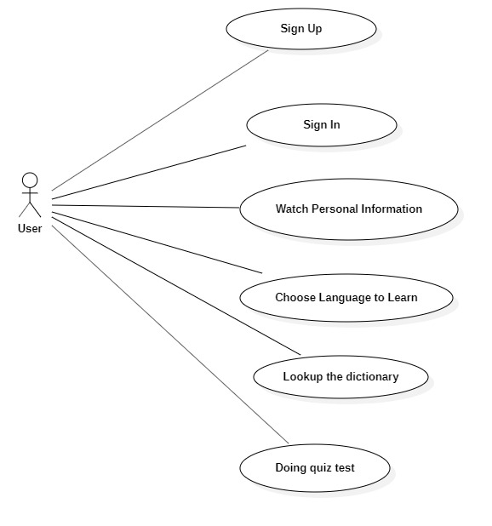

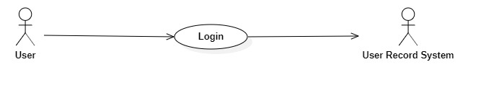

|  |  |
| --- | --- |
| **User Login** | |
| Actors | User, User Record System |
| Description | User login in the system to use the software |
| Data | username |
| Stimulus | Interface to write the username and the button to enter the system |
| Respone | Login succeed |
| Comments | The user has to write the information account correctly to enter the system |

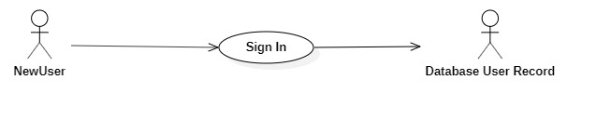

|  |  |
| --- | --- |
| **Sign In** | |
| Actors | NewUser, Database User Record |
| Description | The new user has to register the account |
| Data | Username, password |
| Stimulus | Interface to write the username and password |
| Respone | User registration is successful |
| Comments | The newuser has to adhere to the system’s naming guidelines |

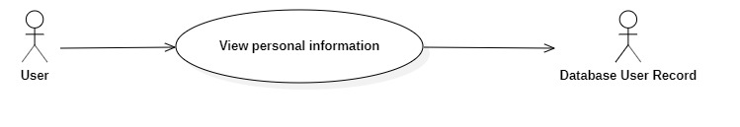

|  |  |
| --- | --- |
| **Viewing personal information** | |
| Actors | User, Database User Record |
| Description | User can view personal information about themselves |
| Data | Username, phone number, address, email. |
| Stimulus | User is allow to see its own personal information |
| Respone | The table shows all personal information of user |
| Comments | Look up or change the information if needed. |

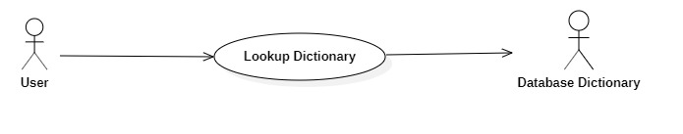

|  |  |
| --- | --- |
| **Lookup Dictionary** | |
| Actors | User, Database Dictionary |
| Description | User can look up any words directly in the system without looking upon the dictionary |
| Data | words |
| Stimulus | The interface has the search button to search any words |
| Respone | The meaning of each word is listed on the system and some example of it |
| Comments | You must have written the correct word |

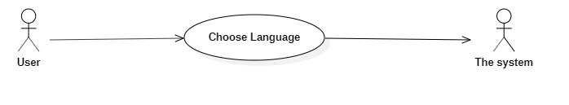

|  |  |
| --- | --- |
| **Choose Language to learn** | |
| Actors | User, The system |
| Description | Choose a language to learn and this language chosen will be applied to all the system |
| Data | Language provided by the system |
| Stimulus | The interface to choose a certain language |
| Respone | All the system will be applied with the language you choose |
| Comments | Choose one language |

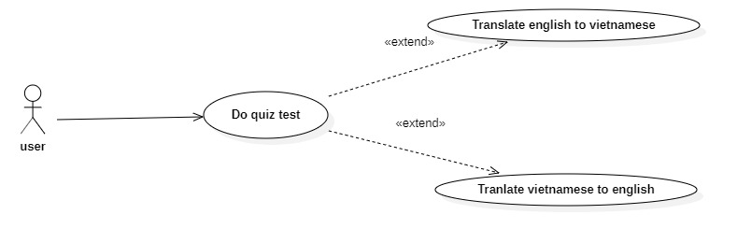

|  |  |
| --- | --- |
| **Do quiz test** | |
| Actors | User |
| Description | Doing quiz tests to enhance your current English level, we can choose two types of quiz including translate English and Vietnamese. The system will choose the appropriate level of user |
| Data | Quiz test taken from the system |
| Stimulus | The interface resembles a mini-game, choosing any word to fill in the blanks |
| Respone | The results of each level will be shown when you finished one level. |
| Comments | Must be answered correctly. |

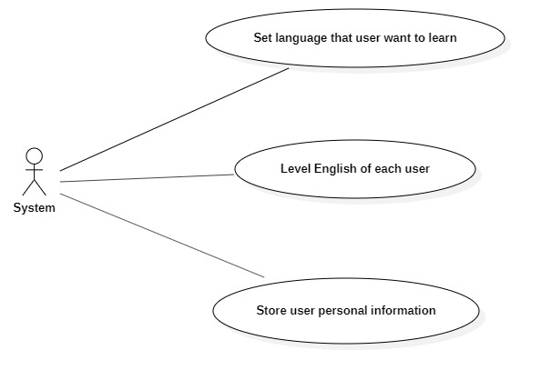

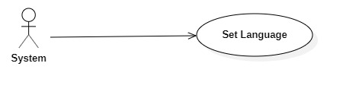

|  |  |
| --- | --- |
| **Set Language** | |
| Actors | System |
| Description | Set the language for all the interface |
| Data | Langugue that the system supports |
| Stimulus |  |
| Respone | All of the functions or buttons will be shown in English. |
| Comments | Choose the correct language you want to learn |

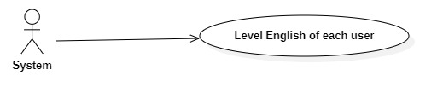

|  |  |
| --- | --- |
| **Level English** | |
| Actors | System |
| Description | Control levels of each user |
| Data | Scores of each user has achived |
| Stimulus |  |
| Respone | Current level of each user |
| Comments | Show the correct level of the user. |

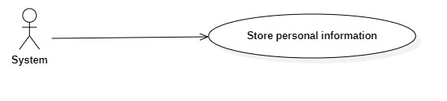

|  |  |
| --- | --- |
| **Store personal information** | |
| Actors | System |
| Description | Store personal information of each user |
| Data | Username, pass, phonenumber, address |
| Stimulus |  |
| Respone | User information table |
| Comments | Store and show personal information in a suitable way. |