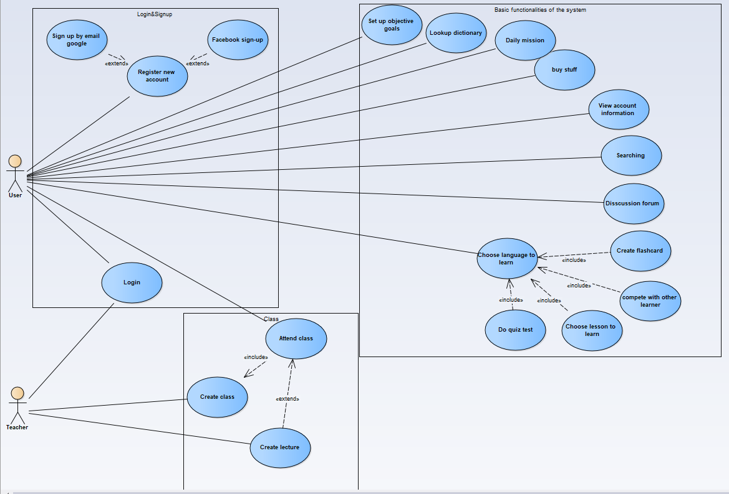

Overview of use case diagram

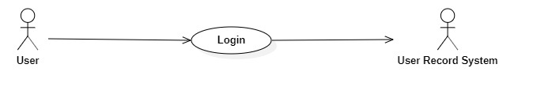

|  |  |
| --- | --- |
| **User Login** | |
| Actors | User, User Record System |
| Description | User login in the system to use the software |
| Data | username |
| Stimulus | Interface to write the username and the button to enter the system |
| Respone | Login succeed |
| Comments | The user has to write the information account correctly to enter the system |

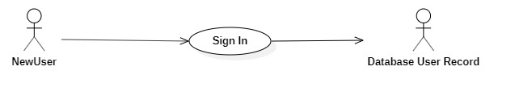

|  |  |
| --- | --- |
| **Sign In** | |
| Actors | NewUser, Database User Record |
| Description | The new user has to register the account |
| Data | Username, password |
| Stimulus | Interface to write the username and password |
| Respone | User registration is successful |
| Comments | The newuser has to adhere to the system’s naming guidelines |

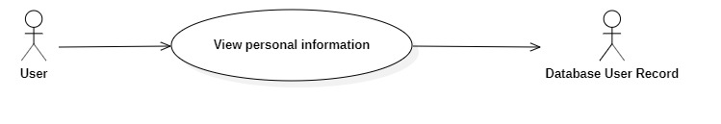

|  |  |
| --- | --- |
| **Viewing personal information** | |
| Actors | User, Database User Record |
| Description | User can view personal information about themselves |
| Data | Username, phone number, address, email. |
| Stimulus | User is allow to see its own personal information |
| Respone | The table shows all personal information of user |
| Comments | Look up or change the information if needed. |

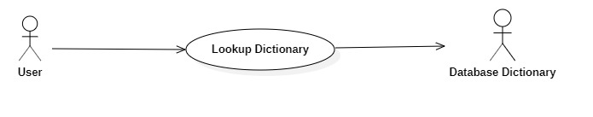

|  |  |
| --- | --- |
| **Lookup Dictionary** | |
| Actors | User, Database Dictionary |
| Description | User can look up any words directly in the system without looking upon the dictionary |
| Data | words |
| Stimulus | The interface has the search button to search any words |
| Respone | The meaning of each word is listed on the system and some example of it |
| Comments | You must have written the correct word |

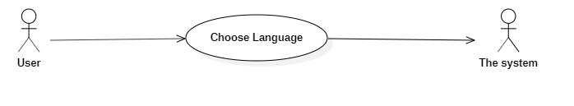

|  |  |
| --- | --- |
| **Choose Language to learn** | |
| Actors | User, The system |
| Description | Choose a language to learn and this language chosen will be applied to all the system |
| Data | Language provided by the system |
| Stimulus | The interface to choose a certain language |
| Respone | All the system will be applied with the language you choose |
| Comments | Choose one language |

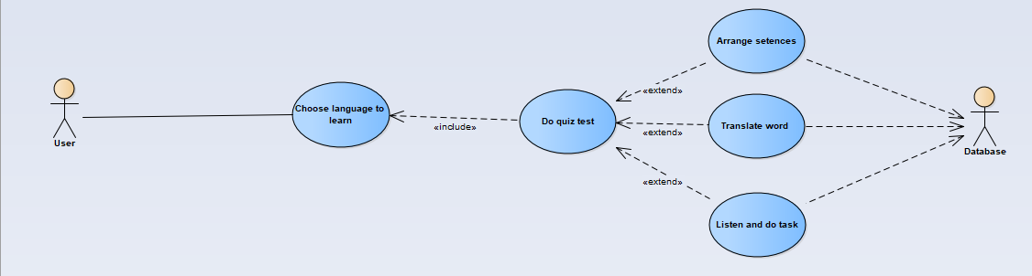

|  |  |
| --- | --- |
| **Do quiz test** | |
| Actors | User, Database |
| Description | Doing quiz tests to enhance your current English level, we can choose two types of quiz including arrange setences, translate word, listen and do task. The system will choose based on the appropriate level of user |
| Data | Quiz test taken from the system database. |
| Stimulus | The interface resembles a mini-game, choosing any word to fill in the blanks |
| Respone | The results of each level will be shown when you finished one level. |
| Comments | Must be answered correctly. |

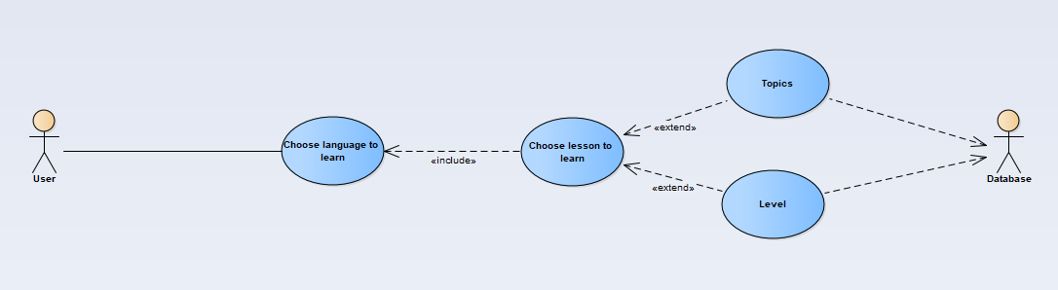

|  |  |
| --- | --- |
| **Choose lesson to learn** | |
| Actors | User, Database |
| Description | User can choose whichever lesson they want to based on the topic or what they have progressed. |
| Data | Provided by the database itself and its equivalent data record. |
| Stimulus | The interface resembles UI with many options of lesson to choose and learn from. |
| Respone | After choosing the lesson will be opened and start. |
| Comments | Just choose whatever they want based on what user want to do. |

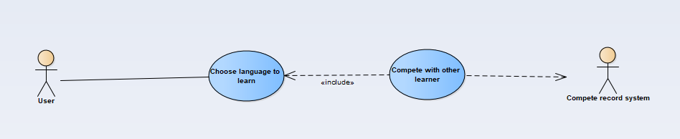

|  |  |
| --- | --- |
| **Compete with other learner** | |
| Actors | User, system |
| Description | Users can compete each other to try out their best and receive reward. |
| Data | Leaderboard. |
| Stimulus | Show leadearboard and challenge that user could participate in and compete. |
| Respone | Start the challenge and end with the result on the leaderboard. |
| Comments | Do the best out of it to reach high on the leader board. |

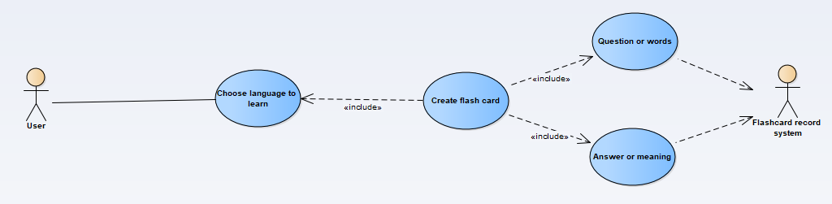

|  |  |
| --- | --- |
| **Create flash card** | |
| Actors | User, system |
| Description | User can create flash card to practice, have a overview of what they have learnt, a flash card must have a question/words and answer/meaning. |
| Data | Infomration of every flashcard. |
| Stimulus | UI with many functionality that user could create, delete flashcard,… |
| Respone | Data of the flashcard is stored in the record system and user could retrieve it and interact with it again. |
| Comments | Create flashcard and could change it anytime. |

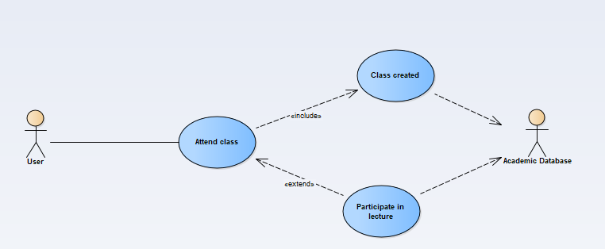

|  |  |
| --- | --- |
| **Attend class created by Teacher** | |
| Actors | User, system database |
| Description | User can attend class created by his teacher. After joining in, user could participate in lecture and learn from it. |
| Data | Data privded from the academic database. |
| Stimulus | Simple UI to join the class and get the most out of knowledge of the lecture. |
| Respone | Progress user have made will stored back in the academic database. |
| Comments | Learn the best out of the course and complete it. |

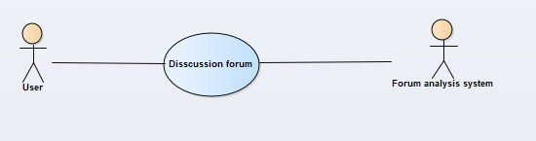

|  |  |
| --- | --- |
| **Disscussion forum** | |
| Actors | User, Forum analysis system |
| Description | This is a place to discuss topics related to language learning, some great learning tips or tricks, or suggestions for making the application to be better . |
| Data | The interactive learners comment |
| Stimulus | Displays a forum where users can post or share things related to language learning |
| Respone | Bonus points for participating in interactive commenting and being awarded a title in front of your name make your account look more impressive |
| Comments | Users will be warned or blocked if they use vulgar words or regularly post unrelated content. |

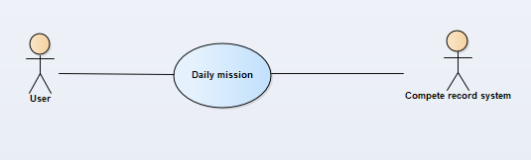

|  |  |
| --- | --- |
| **Daily mission** | |
| Actors | User, system |
| Description | User completes the daily task |
| Data | From our database to motivate learners |
| Stimulus | The user interface shows tasks to do each day |
| Respone | Earn bonus points to use for other things |
| Comments | User can view task completion progress |

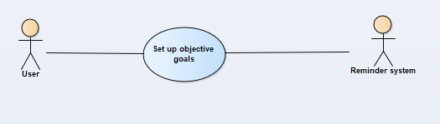

|  |  |
| --- | --- |
| **Set up objective goals** | |
| Actors | User, Reminder system |
| Description | Set a daily learning goal,and study time |
| Data | From our database to motivate learners |
| Stimulus | User interface shows the timeframe for reminders and goals they want to learn |
| Respone | Reminds to learn according to user set time, and progress set against goals |
| Comments | Users can turn off this function |

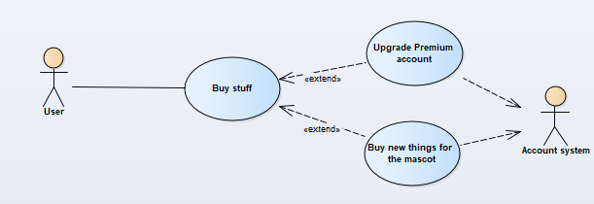

|  |  |
| --- | --- |
| **Buy stuff** | |
| Actors | User, Account system |
| Description | Users can use bonus points to buy items, costumes for their mascots (each account will have its own mascot representing that account), or use real money to upgrade the Premium account to get can not be advertised when completing each lesson, and additional permission to download lessons offline |
| Data | Will be stored in Account database |
| Stimulus | User interface to allow user to buy costumes for mascot or upgrade premium account |
| Respone | Account will be upgraded premium |
| Comments | The account after the upgrade can be used on any platform in the app |

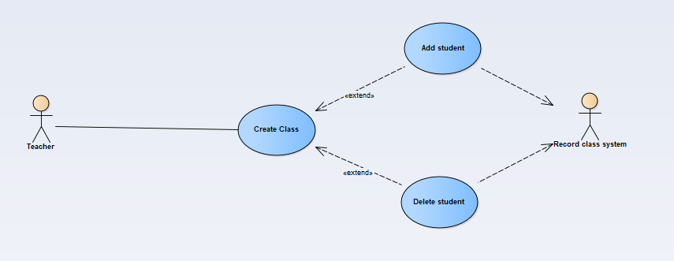

|  |  |
| --- | --- |
| **Create Class** | |
| Actors | Teacher, system |
| Description | Teacher can create classs and modify it. |
| Data | Information of class |
| Stimulus | User interface to allow teacher to create class |
| Respone | Data of the class is stored in the class record system. |
| Comments | Teacher could have a look on the class and modify it. |

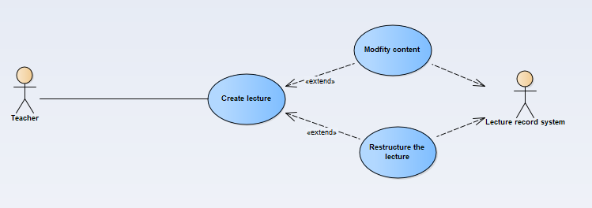

|  |  |
| --- | --- |
| **Create lecture** | |
| Actors | Teacher, system |
| Description | Teacher can create lecture and modify it. |
| Data | Detailed information of the lecture. |
| Stimulus | User interface to allow teacher to create lecture |
| Respone | Data of the class is stored in the lecture record system. |
| Comments | Teacher could have a look on what he teaches and modify it if needed. |