# **Composite Index**

Suppose that we have a table **boarding_passes** with data like this

After taking a closer look, I see that the **seat_no** has the highest cardinality and the **boarding_no** column with the second position. Along with that it has 7.925.812 records, suitable for index testing.

We will go ahead on implementing the index like this under below

CREATE INDEX idx_boarding_passes_boarding_seat_no ON bookings.boarding_passes USING btree (seat_no, boarding_no);

Result without index

With index

Both **seat_no** and **boarding_no columns**

EXPLAIN ANALYSE  
SELECT *  
FROM bookings.boarding_passes  
WHERE seat_no = 'A11' AND boarding_no = 139;

With **seat_no** column only

EXPLAIN ANALYSE  
SELECT *  
FROM bookings.boarding_passes  
WHERE seat_no = 'A11';

With **GROUP BY** and **WHERE** statement

EXPLAIN ANALYSE  
SELECT boarding_no, *count*(*) AS cnt  
FROM bookings.boarding_passes  
WHERE seat_no = '10A'  
GROUP BY boarding_no

Without index

With index

Reverse condition statements

EXPLAIN ANALYSE  
SELECT *  
FROM bookings.boarding_passes  
WHERE boarding_no = 139  
 AND seat_no = 'A11';

Still apply index

Only contains the second index column (**boarding_no**)

EXPLAIN ANALYSE  
SELECT *  
FROM bookings.boarding_passes  
WHERE boarding_no = 139;

Does not apply index

Theory confirmation: Composite index columns with high cardinality (**seat_no, boarding_no**) prove to significantly improve the efficiency of the query while retrieving information based on indexed columns. Also, the query must include the first-most indexed column to work and continue with next indexed columns.

**Index Failure 01**

Trigram indexes

CREATE EXTENSION pg_trgm;  
  
CREATE INDEX idx_boarding_passes_seat_no_trigram ON bookings.boarding_passes USING gin (seat_no gin_trgm_ops);

Collate index

CREATE INDEX idx_boarding_passes_seat_no_collate ON bookings.boarding_passes USING btree (seat_no collate "C");

Theory confirmation: It does apply index when the character **“%”** doesn’t first appear in the compare string but for the two indexes **trigram** and **collate** it is much slower when compared **to seq scan (full table scan)**

**Index Failure 02**

CREATE INDEX idx_boarding_passes_boarding_seat_no ON bookings.boarding_passes USING btree (seat_no, boarding_no);

EXPLAIN ANALYSE  
SELECT *  
FROM bookings.boarding_passes  
WHERE seat_no = 'A11' OR boarding_no = 139;

Theory confirmation: The query with **OR** condition will not apply index even though both **seat_no** and **boarding_no** have been indexed as the query will start to sequentially scan the table again.

**Index Failure 03**

CREATE INDEX idx_boarding_passes_boarding_no ON bookings.boarding_passes USING btree (boarding_no);

EXPLAIN ANALYSE  
SELECT *  
FROM bookings.boarding_passes  
WHERE boarding_no = '139';

Result

Theory confirmation: Passed in the string number force the type casting from string to int. Therefore, the index was successfully fully applied even though the **boarding_no** column has the datatype of integer.

**Index Failure 04**

CREATE INDEX idx_boarding_passes_boarding_seat_no ON bookings.boarding_passes USING btree (seat_no, boarding_no);

EXPLAIN ANALYSE  
SELECT *  
FROM bookings.boarding_passes  
WHERE *length*(seat_no) = 2;

Theory confirmation: Using function on indexed column (**seat_no**) won’t work.

**Index Failure 05**

CREATE INDEX idx_boarding_passes_boarding_no ON bookings.boarding_passes USING btree (boarding_no);

EXPLAIN ANALYSE  
SELECT *  
FROM bookings.boarding_passes  
WHERE boarding_no - 1 = 138;

Result

Theory confirmation: Using expression on indexed column (**boarding_no**) won’t apply index as well

However, when the index involves multiple columns, the index would work as normal but for the non-expression indexed column

CREATE INDEX idx_boarding_passes_boarding_no ON bookings.boarding_passes USING btree (boarding_no, seat_no);

EXPLAIN ANALYSE  
SELECT *  
FROM bookings.boarding_passes  
WHERE boarding_no - 1 = 138 AND seat_no = 'A11';

Result

**Index Clustering and Non-Clustered Index**

**Query before clustering index**

-- Test Query 1: Range scan on boarding_no  
EXPLAIN (ANALYZE, BUFFERS)  
SELECT * FROM boarding_passes  
WHERE boarding_no BETWEEN 1 AND 100  
ORDER BY boarding_no;

-- Test Query 2: Specific flight lookup  
EXPLAIN (ANALYZE, BUFFERS)  
SELECT * FROM boarding_passes  
WHERE flight_id = 169878  
ORDER BY boarding_no;

Cluster index column **boarding_no**

CREATE INDEX idx_boarding_passes_boarding_no  
 ON boarding_passes USING btree (boarding_no);

CLUSTER boarding_passes USING idx_boarding_passes_boarding_no;

**Query after clustering index**

-- Test Query 1: Range scan on boarding_no  
EXPLAIN (ANALYZE, BUFFERS)  
SELECT * FROM boarding_passes  
WHERE boarding_no BETWEEN 1 AND 100  
ORDER BY boarding_no;

-- Test Query 2: Specific flight lookup  
EXPLAIN (ANALYZE, BUFFERS)  
SELECT * FROM boarding_passes  
WHERE flight_id = 169878  
ORDER BY boarding_no;

Conclusion: After cluster index on column **boarding_no**, the number of IO on buffer memory has been reduced significantly as expected.

**Non-clustered index test case**

-- Test Query:  
EXPLAIN (ANALYZE, BUFFERS)  
SELECT bp.*  
FROM boarding_passes bp  
WHERE seat_no = '30A'  
ORDER BY boarding_no;

Result

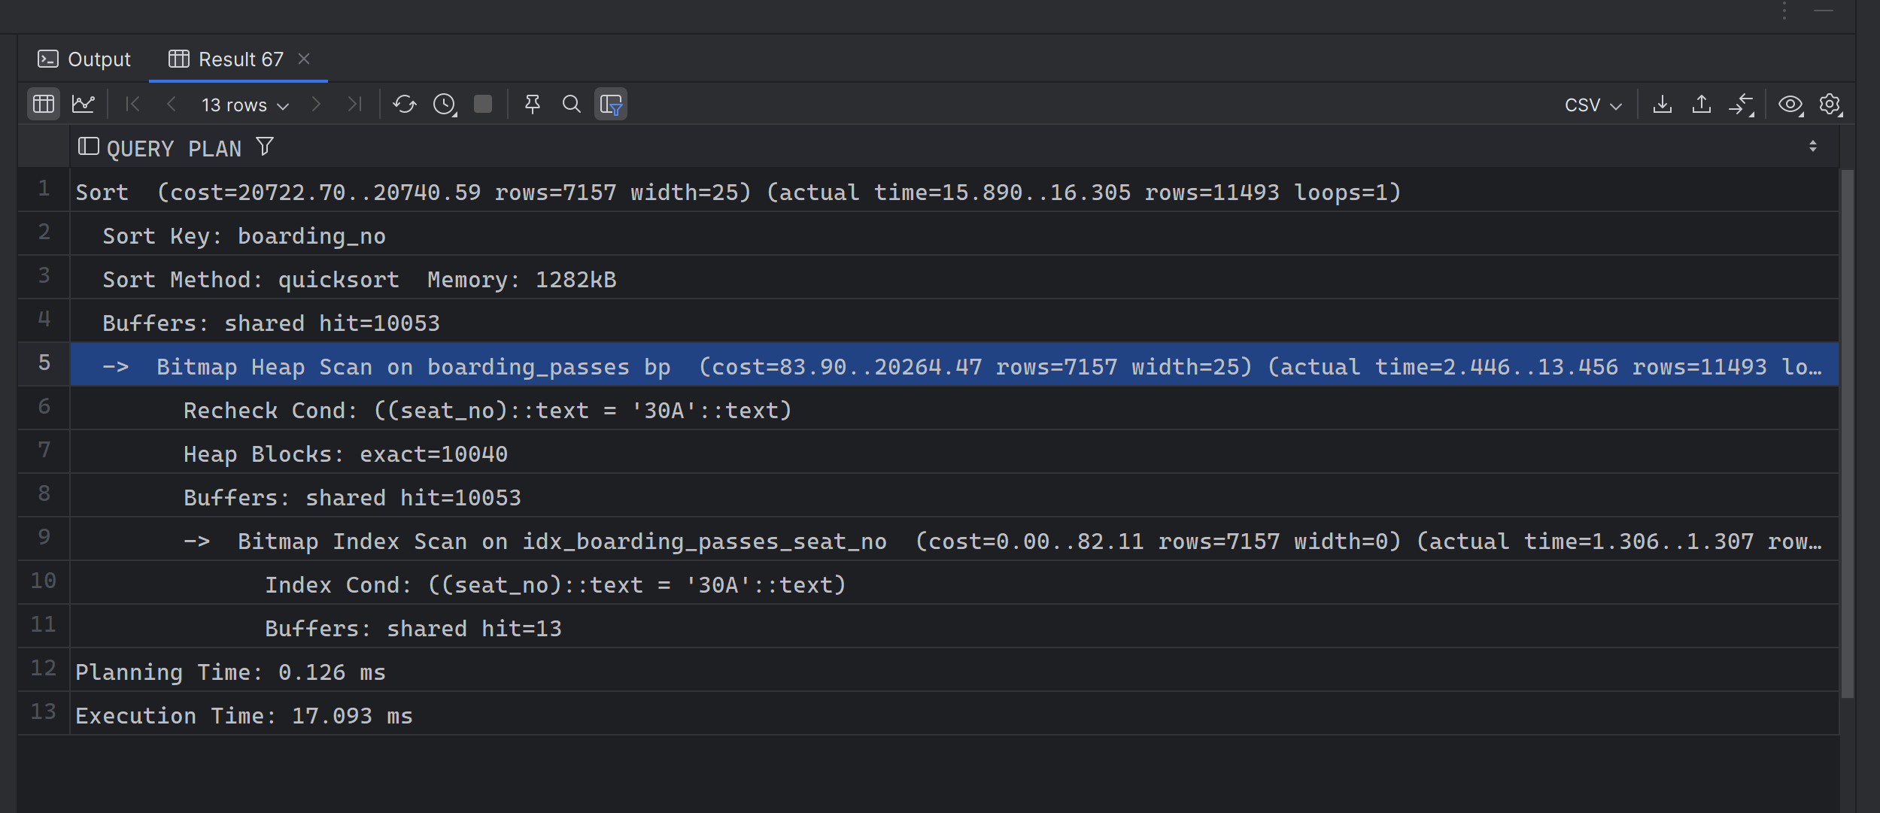

The result does show that for a query using secondary index (**seat_no**) would take two read disks. One for non-clustered, the other if for the clustered index.