

**C:\xampp\htdocs\labTasks\download.png**

**PROJECT PROPOSAL**

|  |  |
| --- | --- |
| **Project Title:** | **Mobile Application for Karachi Electric (K.E) Underground Transmission Lines of 220kv to 132kv** |
| **Duration:** | 10 - 12 Months |
| **Budget Required (PKR)** | 2350,355 |
| **Organization Name** | Sir Syed University of Engineering & Technology |
| **Organization Address** | ST-16 University Rd, Block 5 Gulshan-Iqbal, Karachi, Karachi City, Sindh |
| **Project Team** | Omama Israr  Syed Osama Ali  Syed Huzaifa Ali  Shayan Faiz |
| **Project Supervisor** | Engr. Rabia Siddiqui |
| Lecturer |
| Computer Engineering Department |
| rabiasid@ssuet.edu.pk |
| **Project Co-Supervisor** | Dr. Rukaiya |
| Lecturer |
| Computer Engineering Department |
| rukaiya@ssuet.edu.pk |

**Table of Contents**

1. MOTIVATION 4

2. OBJECTIVE 4

5. PROPOSED SOFTWARE DETAILS 11

6. SOFTWARE REQUIRMENTS 11

7. APPLICATION OF PROJECT 12

8. COSTING 12

9. PROJECT TIMELINE 14

10. CONCLUSION 15

## MOTIVATION

With the technological advancements and digitization, the automation in managing and controlling routine activities of companies is a dire need. Many time the events reporting, is reaching to the concern personals e.g., supervisors, managers involve more steps than required and usually add delays to take immediate action for the reported problem. This motivated us to propose a solution to automate the event reporting and managing the routine activities without delays. The main reason or motivation behind this project is to build an application in which the company can easily gather their data in a single platform and manage the reported events smartly rather than handle manually, which will save the time and log all the activities for later reference and reporting.

We are developing an application-based solution to gather a scattered data to make it useful and implement numerous features based on it, for example the location tracing of linemen at the transmission line, mark them on-duty, and provision of reporting to only concern persons in the company so that immediate actions can be taken.

## OBJECTIVE

1. **Description of the Project:**

“Mobile Application to Automate Karachi Electric (K.E) Underground Transmission Lines of 220kv to 132kv” is a mobile application that tends to perform data analysis on the data driven by the SCADA IOT setup already installed by the K.E to take a note of transmission line 24/7 and 365 days. It is ambitioned to even locate the underground transmission line of 220kv to 132kv and its working personnel. This project is ought to be a game changer for the power companies that helps them to identify power theft, unwanted people around heavy transmission lines, maintenance planning and scheduling, smart discrepancy identification, and many other features

1. **Problem Statement:**

Following issues have been identified by K.E representative for which an efficient solution is required

1. Lack of bonding/communication gap among the underground transmission line personnel (supervisors, linemen, and patrollers).
2. Delayed discrepancy alert system as it moves through a prolonged channel.
3. Live tracking of underground transmission line personnel (supervisors, linemen, and patrollers) is being done in a scattered way that is WhatsApp Live location feature **(whats the problem inhaving live location feature, write here).**
4. Underground transmission line data is being mapped using google earth in a scattered way and hence cannot be integrated.

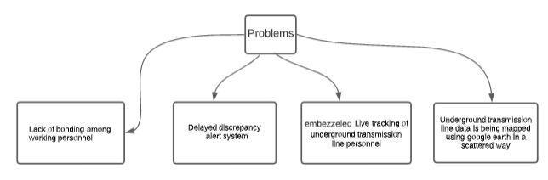

1. **Proposed Solution:**

The solution proposed rest with the development of this application. Developers of this mobile application are careful with the requirement, K.E representative listed and are trying to provide an automated solution **(as discussed ahead in this proposal).** Cherry top explanation for the solution is to gather a scattered data into one form in an automated way.

1. **METHODOLOGY:**

The designed mobile application will cover four modules and will be able to run both on Android and IOS phones. The application will need to be installed on linemen, supervisor, other KE personnel phones. The alert system will notify the reporting problem and for the actions taken by the mangers on the reported problem. Furthermore, the desktop application can also be designed for continuous monitoring to run at control center. The new modules can be added in the application based on the future requirements as the proposed solution is adaptable and scalable.

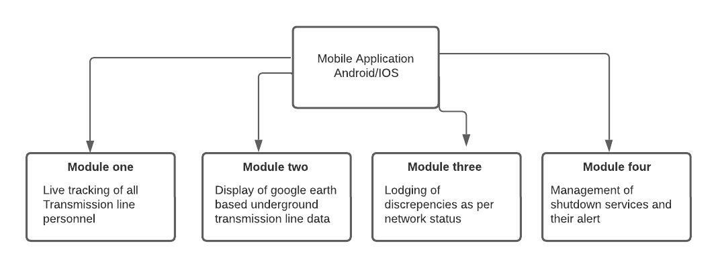

1. **MODULE-WISE DESCRIPTION**

* **Module 1**

1. **DESCRIPTION**

Module one as described by the client was to add a feature that enables the admin to track location of the patrollers, supervisors or linemen who are present there currently at their designated area of underground transmission line of 220kv to 132kv. This would help the client not only to trace its employees but also to maintain the discipline in terms of absence.

1. **REQUIRMENTS**

Team of developers, while adding this feature to the mobile application would require the

1. Location data for underground transmission lines (mapped form)
2. Data for the patrollers, supervisors, and linemen that suffice their place of designation, time, day, and shift.
3. **PROCEDURE**

Team of developers have yet visualized the solution to this feature as asked by the client by using the current GPS (Global positioning system) location of a certain employee and ingesting it with the dynamic data as provided by client using the cloud computing technologies.

**IV. GRAPHICAL EXPLANATION**

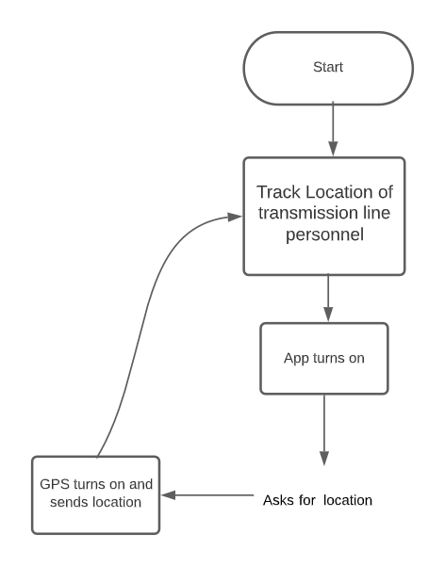

* **Module 2**

1. **DESCRIPTION**

Module two deals with the data mapping for underground transmission line of 220kv to 132kv using mobile application.

1. **REQUIRMENTS**

Team of developers, while adding this feature to the mobile application would require the

1. Location data for underground transmission lines mapped on google earth (as sufficed by the client)
2. **PROCEDURE**

Team of developers have proposed the solution to this feature in such a way that mapped data of underground transmission lines of 220kv to 130kv (ON GOOGLE EARTH) will be fetched and be embedded to the application as a feature.

**IV. GRAPHICAL DESCRIPTION**

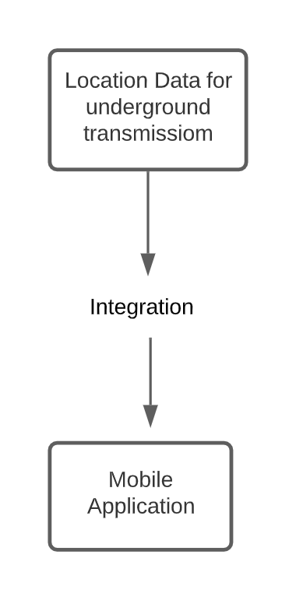

* **Module 3**

1. **DESCRIPTION:**

Module three deals with the feature of lodging the discrepancies as per network status. Feature as elucidated in model will allow the admin to read the discrepancy as lodged by the transmission line personnel (linemen, patroller or supervisor). As described by the client the intensity of discrepancy will be judged first then on its basis the alert will be sent to the respective or nearby teams of engineers or managers

Three main options

1. High priority (for high level issues)
2. Medium priority (for mid-level issues)
3. Low priority (for temporary issues)

In case of any certain discrepancy alert would be conveyed by the means of buzzer.

1. **REQUIRMENTS**

This feature to be developed requires

1. Transmission lines live data
2. Alert insertion from Transmission line personnel
3. **PROCEDURE**

Based on the data being received by the underground transmission line personnel (linemen, supervisors, or patroller), first the intensity would be judged on the basis of the transmission line data and hence after this stage the decided discrepancy alert would be sent to the representatives.

1. **GRAPHICAL DESCRIPTION**

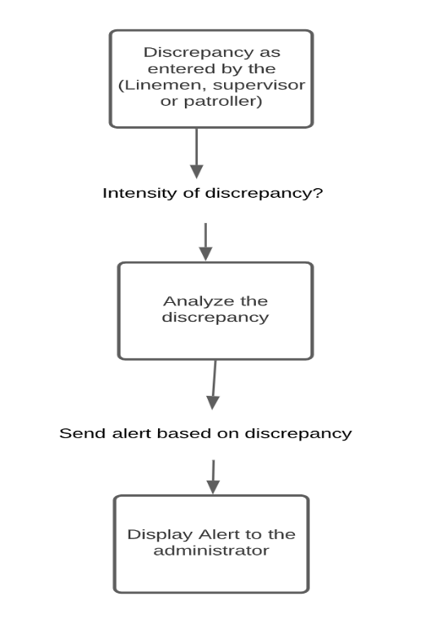

* **Module 4**

1. **DESCRIPTION**

This module of the application deals with the management of shutdown services planned or unplanned on daily basis (procurement). Basically, module four proposed a feature that will inform the representatives of Karachi Electric about the planned or unplanned (sudden) shutdown services maybe for maintenance or an emergency, will be notified to them for the sake of information.

1. **REQUIRMENTS:**

This feature will require

1. Live transmission data
2. Preparation of log out of the transmission line live data
3. **PROCEDURE**

Live data from transmission will be assessed for any shutdown service other than this log maintained by the transmission line personnel will also help in the management of shut down planning. In case of maintenance shut down following process is to be followed.

**Process:** Line man-> Supervisor -> Store In charge

List of items (Equipment list, quantity, Issuance date)

**IV. GRAPHICAL DESCRIPTION**

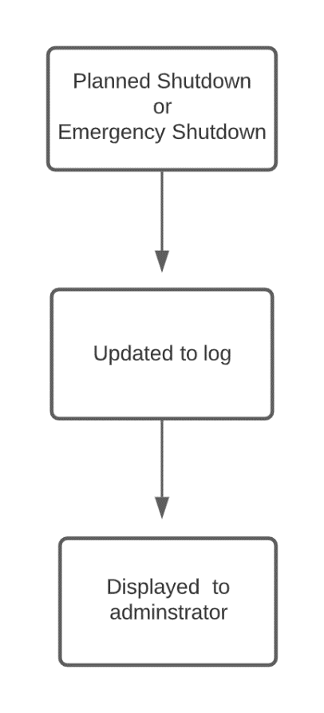

1. **IMPLEMENTATION**

The project is divided into these major phases as follows

* **DESIGN PHASE**

The phase needs all the tools and expertise, to deal with the UI or layout of our application. The team and experts tentatively decided to use adobe Xd and figma.

In first step, the team will develop UI (user interface) designs of how our application will look like, as the team will make sure the simple design which will be easy to use for the user.

**ADD WIREFRAMES HERE**

* **DEVELOPMENT PHASE**

1. **First Phase (front end)**

As this stage will begin, the design sheets prepared using different UI software will now be given a life by coding or programming the front end of our application.

1. **Second Phase (Backend Implementation Phase)**

Second phase of our application development solely deals with the back-end development and implementation. Application of the concepts of cloud computing and development of APIs will be taking place in this second phase.

* **TESTING PHASE**

Testing phase plays a very important role in the success of any project. So as the team of developers reaches to the testing phase, their main motive will be furnishing app and testing using the data that will be suffices by the representatives of K-electric. The main concern would be to rectify it with the user or client’s need. Several testing methods will be used which may include Unit tests, Integration tests, Functional tests, and End-to-end tests. This phase will also include the training of users such as linemen, mangers, and other KE persons.

* **EVALUATION PHASE**

This phase will lead us to complete demonstration of the project showing its complete functionality for each developed module.

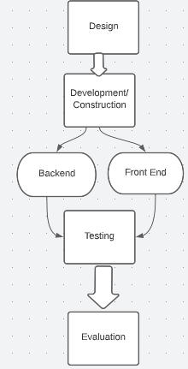

## PROPOSED SOFTWARE DETAILS

In perspective of development, the project is divided into front-end development and backend development.

Front-end development mainly deals with the user interface or user interaction with the mobile application whereas backend mainly deals with the data management and its orientation. Technologies as per planned to be used:

* Front end mobile application development includes Flutter
* Technologies as planned to be used for backend includes Cloud (Azure or AWS), mongo DB

## SOFTWARE REQUIRMENTS

The mobile application to be developed will run on the IOS as well as Android mobile systems therefore following this scenario best software framework to work with is flutter

For the Development of designs or ideas of screens to be developed and provide user interface, Adobe Xd and Figma are sighted to be used by the team, to develop modern and catchy designs based on the color theme of K.E logo.

For backend services MongoDb, amazon AWS are to be used because of their space and ease of cloud computing

## APPLICATION OF PROJECT

The proposed project can be a game changer! yes in such a way that it is ought to automate the way things work. As instructions from the client speaks that the application should keep track of the transmission line personnel (done by map tracking), which will automate the attendance system for pupil assigned duties in that particular area and on the same time the transmission system will be secured. Another part of the application comprised of the Fault management in transmission line (notified using continuous data from transmission line), that will provide an easy and automated way to detect which area of transmission is affected hence on the whole this is not just a specific application but can be modified as per requirements and needs

## COSTING:

|  |  |  |  |  |
| --- | --- | --- | --- | --- |
| **Requirements** | **Specifications** | **Quantity** | **Cost**  **(in Rupee)** | **Justification** |
| **Trainings/Workshops** | | | | |
| Professional training on **“FLUTTER**”  (Duration: 02 Months) | Covers a wide range of flutter development topics. • Demonstrates visual, behavioral and motion rich Flutter widgets. • Displays step-by-step lab exercises to build flutter apps. • Includes guides to build Google Maps apps. • Presents Android and iOS app publishing guidelines. | 4 Members | **Per member** fee=Rs. 12000/-  **Rs. 48000/-** | For front end development of the application |
| **“AWS Cloud Computing course”**  (Duration: 2.5 Months) | main features and capabilities of the Power BI mobile apps | 4 members | **Per member**  Fee=Rs. 6100  **Rs. 24400/-** | For back-end development of the application |
| **Total Trainings Cost** |  |  | **72500/-** |  |

|  |  |  |  |  |
| --- | --- | --- | --- | --- |
| **Software/Services** | | | | |
| **AZURE POWER BI PRO Service Subscription** | Power BI Pro is a cloud-based, self-service BI tool that is available as a SaaS solution. |  | **for $9.99** user/month  **Rs. 2,234.76/-**  **8 months usage= 17,878.08** | For data storage, connectivity, and compute service |
| **UI/UX Designing & Development**  **(FIGMA)** | Figma is a collaborative web application for interface design, with additional offline features enabled by desktop applications **for macOS and Windows.** |  | FREE | For UI designing of our application |
| **Testing Tool**  **For Android** | [**Selenium**](https://www.selenium.dev/)**The best way to do that is to automate tests that run against your application on every deployment** |  | FREE | For Testing |
| **Total Services Cost** |  |  | **17,878-/ Rs** |  |

|  |  |  |  |  |
| --- | --- | --- | --- | --- |
| **Equipment/Consumables** | | | | |
| **INTERNET DEVICES** | **1.5 MB** | 02 | **1699 X 2= 3398**  **Monthly package=** Rs.1200/  **2 device 8 month =**Rs.19200/  (Each device) | To make sure availability of internet |
| **HIGH PROCESSING LAPTOP (2019 OR 2018) GENERATION** | **Core i7/ Core i9**  **120/ 200 GB** | 02 | **Per Laptop 60k to 80k (tentative)**  **In case Rs 80000/-**  80000 x2 = 160000  **In case Rs 60000/-**  60000 x2 = 120000 | High speed and max memory sized laptops will be required for continuous development purposes |
| **Short term/ Long term Consultant** | **Expert in UI designing & cloud** | 02 | **Per day estimation of cost for screen designing UI =15,000/10=1,500**  **For cloud consultancy=30,000/30=1,000** | For making our application more advance |
| **Travelling cost** |  | 04 | 20000/- | In order to move from one place to another for the purpose of development travelling cost is requested. |
| **Total Consumables Cost** |  |  | **204,200 (in case of laptop worth 60000 each)**  **304,200 ( in case of laptop worth 80000 each )** |  |
| **Total Budget Cost**  **(In Rupee)** | **294,578 -/ Rs** (in case of laptop worth 60000-/ Rs each)  **~~894,578 -/ Rs~~** ~~(in case of laptop worth 80000-/ Rs each)~~ | | | |

**ADD YOUR REQUIREMNTS HERE PHASE WISE.. PHASE ONE MONEY, DATA ETC**

## PROJECT TIMELINE (Add Gant chart) also testing and evaluation phases are to be added in the time line… the project should start from February 2023 as its is not approved yet by KE)

|  |  |  |  |
| --- | --- | --- | --- |
| Task Name | Duration | Start | Finish |
| **User Interface designing phase** | **23 days** | **Wed 12/21/22** | **Fri 1/20/23** |
| Designs development using UI tools |  |  |  |
| **Development Schedule for modules** | **150 days** | **Sat 1/21/23** | **Sun 8/20/23** |
| **Module 1** | **42 days** | **Sat 1/21/23** | **Mon 3/20/23** |
| Live tracking of transmission line personnel |  |  |  |
| **Module 2** | **23 days** | **Tue 3/21/23** | **Thu 4/20/23** |
| Display of google earth data for underground transmission line |  |  |  |
| **Module 3** | **42 days** | **Fri 4/21/23** | **Mon 6/19/23** |
| Lodging of discrepancies according to network status |  |  |  |
| **Module 4** | **44 days** | **Wed 6/21/23** | **Sun 8/20/23** |
| Management of shutdown services and their alerts |  |  |  |

## CONCLUSION

The application is to be designed for Karachi electric department to automate the reporting and tsk management on 220kv to 132kv underground transmission lines, The application will include features: Application for department Data mapping, lineman real time monitoring, Fault update by buzzer (discrepancy), and Managing maintenance shutdowns updates.

Developers have planned to engineer this application with the great zeal by using top and latest framework that includes flutter for front end, cloud AWS, AZURE like technologies for backend.

The team is convinced that not just the power industry, but this mobile application is applicable in many other industries like agriculture, construction, distribution, and many others where efficient task management and tracking is needed.