**Lab # 8**

**Objective: Implement Server Site Scripting On MY SQL and**

1. To understand the concept of Database and to get to know about MySQL.
2. To study the relational logical structure and to get an idea of Design and Data Entry Mode.
3. To design a Database in XAMPP (MySQL) and insert a table that holds fields and records of Login information.

**Theory:**

This lab is mainly concerned with the learning of the concept of Database and to get aware of the Database of XAMPP i.e. MySQL. This lab also deals with the knowledge of relational logical structure and different modes of backend database. In this lab we will also design a database using MySQL.

**Exercise:**

The following illustrates the BikeStores database diagram:

The BikeStores sample database has two schemas sales and production, and these schemas have nine tables.

Create the given tables with the mentioned fields using XAMPP Server.

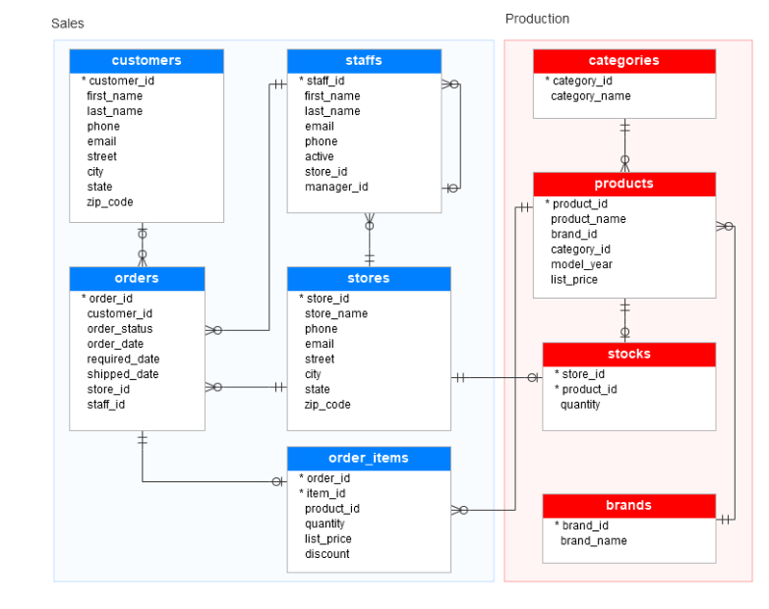

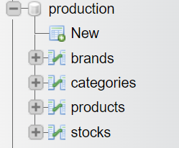 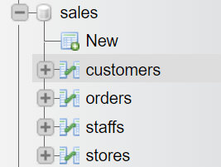

**Production Tables**

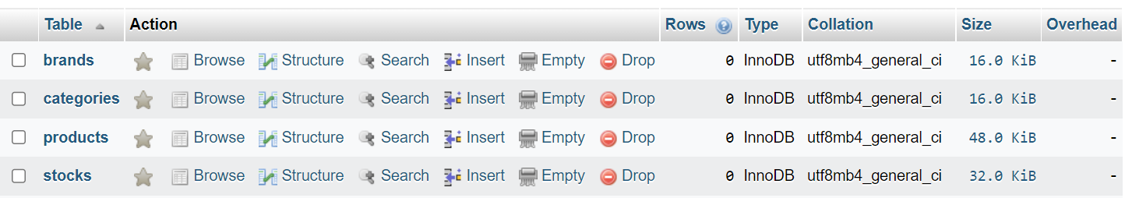

  


  


**Sales Table**

