Text Classification of Urdu News Dataset
A Machine Learning Approach
1. INTRODUCTION
This project focuses on the text classification of Urdu news headlines using machine learning techniques. Text classification is an important task in Natural Language Processing (NLP) that involves assigning text documents to predefined categories. In this project, different machine learning models are trained to automatically classify Urdu news headlines based on their content. The study explores how preprocessing, feature engineering, and classification algorithms affect the overall performance of the system.
1.1 Dataset Overview
The dataset used in this project consists of 10,000 Urdu news headlines collected from different news sources. The headlines are labeled into two predefined categories: Business & Economics and Entertainment.
The dataset is provided in CSV format, where each row contains a news headline along with its corresponding category label. This structured format makes it suitable for preprocessing, feature extraction, and model training.
1.2 Project Objectives
The main objectives of this project are as follows:
∙ To apply comprehensive text preprocessing techniques in order to clean and standardize Urdu text data
∙ To implement and analyze multiple feature engineering methods for converting text into numerical representations
∙ To train and evaluate different machine learning classification algorithms on the dataset
∙ To compare the performance of all models using evaluation metrics and identify the best-performing approach for Urdu news text classification
2. BACKGROUND
Text classification is one of the most important tasks in Natural Language Processing (NLP). It involves teaching computers to automatically categorize text documents into predefined classes [1]. For example, a news article can be classified as Business, Sports, or Entertainment. Text classification is widely used in many real-world applications, such as spam email detection, sentiment analysis of product reviews, topic labeling of news articles, and social media content filtering [2].
The success of a text classification system depends heavily on how well the text is prepared and represented. Proper preprocessing helps remove noise, standardize the text, and focus on meaningful information, while effective feature representation converts text into a numerical format that machine learning models can understand [3]. Without these steps, even powerful algorithms may fail to accurately classify text.
2.1 Natural Language Processing
Natural Language Processing (NLP) is the field of computer science and artificial intelligence that enables computers to understand, interpret, and process human language [4]. NLP bridges the gap between human communication and machine understanding, allowing computers to analyze text or speech in a meaningful way.
Some of the most common NLP techniques used in text classification are:
∙ Tokenization: Breaking text into individual words or tokens
∙ Stemming: Reducing words to their root form (e.g., “running” → “run”) ∙ Lemmatization: Converting words to their base dictionary form
∙ Stopword Removal: Removing common words like “and”, “the”, which do not add value
∙ Feature Extraction: Representing text as numbers using techniques like Bag of Words, TF-IDF, or Word Embeddings[5]
These techniques transform raw unstructured text into structured numerical data, making it suitable for machine learning models [6]. Using NLP effectively ensures that models learn from relevant patterns and produce more accurate predictions in text classification tasks [7]
2.2 Related Work
Text classification has been widely studied in both academia and industry, and numerous approaches have been proposed over the years (8). Traditional machine learning algorithms such as Naive Bayes, Logistic Regression, and Support Vector Machines (SVMs) have been commonly used for classifying text. These methods are often combined with feature engineering techniques like Bag of Words, TF-IDF, and N-Grams to improve performance [8]
In recent years, deep learning methods, including Convolutional Neural Networks (CNNs) and Recurrent Neural Networks (RNNs), have gained popularity for text classification because they can automatically learn complex patterns from raw text data.[9] However, this project focuses on classical machine learning approaches to evaluate how different feature engineering techniques affect performance, providing insights into which traditional methods are still effective for Urdu news headline classification [10].
3. PROJECT METHODOLOGY
The project follows a systematic approach involving data preprocessing, feature engineering, model training, and evaluation. Each stage is carefully designed to ensure optimal performance.
3.1 Data Processing Pipeline:
Figure 1: Data Processing Flow Diagram
Figure 1 illustrates the complete data processing flow from raw dataset to final evaluation:
3.2 Preprocessing Steps
In this project, text preprocessing was performed using a step-by-step pipeline to clean and standardize the Urdu news headlines for machine learning.
3.3 Before Preprocessing
After tokenization (before applying preprocessing steps), different graphs and CSV files were generated to understand the initial behavior of the data. These visualizations help identify patterns, frequency distributions, and potential outliers in the raw text. The following graphs were created:
∙ Bar Graph: Shows the distribution of word frequencies
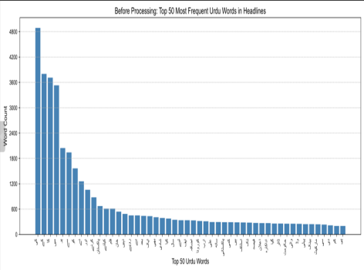 (Figure 1)
∙ Box Plot: Analyzes data spread and highlights outliers
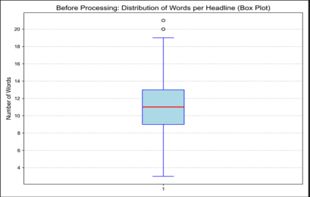
(Figure 2)
∙ Scatter Plot: Observes the relationship between words and their frequency 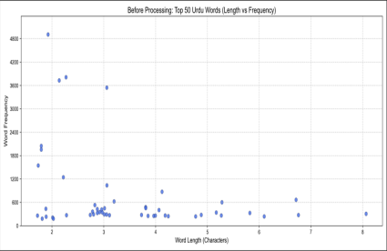
(Figure 3)
∙ Word Cloud: Visualizes the most frequent words in the dataset
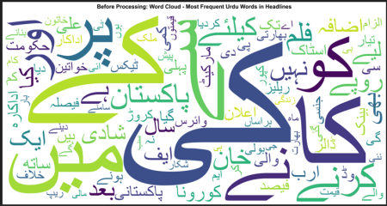
(Figure 4)
The corresponding CSV files were saved for reference and proof of the original data before preprocessing.
3.4 After Preprocessing
Once all preprocessing steps were applied, the same set of graphs and CSV files were generated again. This allows a clear comparison between the data before and after preprocessing, showing how cleaning and standardization affect the dataset. The graphs generated after preprocessing include:
∙ Bar Graph: Word frequency distribution after cleaning
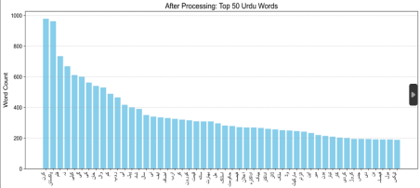 (Figure 5)
∙ Box Plot: Data spread and outliers after preprocessing
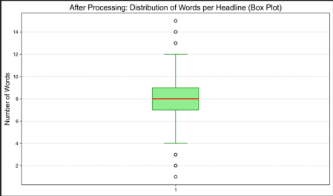
(Figure 6)
∙ Scatter Plot: Word frequency relationships after preprocessing
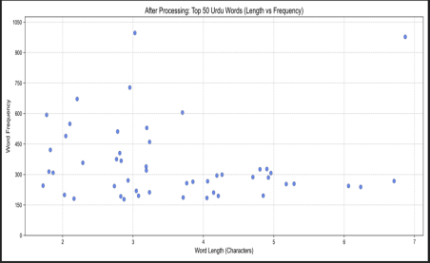 (Figure 7)
∙ Word Cloud: Most frequent words after preprocessing
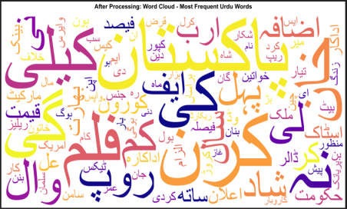
(Figure 8)
The corresponding CSV files for the preprocessed data were also saved as proof of the changes.
The preprocessing pipeline includes the following steps:
∙ Tokenization: Splitting text into individual words
∙ Stopwords Removal: Removing common words that do not add meaningful information
∙ Punctuation Removal: Removing special characters
∙ Lowercase Conversion: Converting all text into lowercase
∙ Stemming & Lemmatization: Reducing words to their root form
∙ Number Removal: Removing numeric values
∙ Single-Letter Token Removal: Removing single-character words 3.5 Feature Engineering Techniques
After preprocessing, feature engineering techniques were applied to convert text data into numerical form so that it can be used by machine learning models.
For each feature engineering technique:
∙ A separate CSV file was generated
∙ These CSV files were used as input for models and as experimental evidence The following feature engineering techniques were implemented:
• One-Hot Encoding: Binary representation of word presence
• Bag of Words (BoW): Frequency-based word representation
• N-Grams: Capturing word sequences (bigrams, trigrams)
• TF-IDF: Term frequency-inverse document frequency weighting • Word Embeddings: Dense vector representations capturing semantic meaning
3.4 Classification Algorithms
After feature engineering, different machine learning classification algorithms were trained and evaluated.For each classification algorithm:
∙ A confusion matrix graph was generated
∙ These graphs and files were used as proof of model performance The following classification algorithms were used:
∙ Naive Bayes: A probabilistic classifier based on Bayes’ theorem. 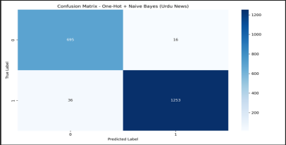 (Figure.1 One hot + Naïve Bayes)
∙ Logistic Regression: A linear probabilistic classifier.
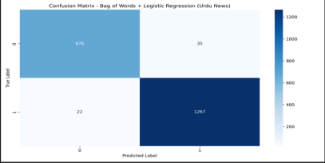 (Figure.2 Bag of words + Logistic Regression)
∙ Support Vector Machine (SVM): A classifier that finds the maximum margin 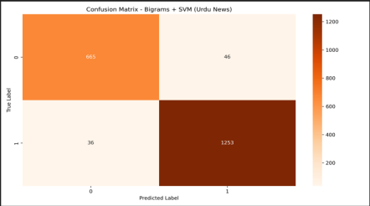 (Figure.3 Bigram + SVM)
∙ Random Forest: An ensemble model made of multiple decision trees. 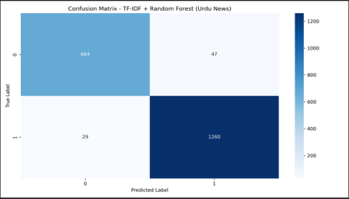 (Figure.4 TF-IDF + Random Forest)
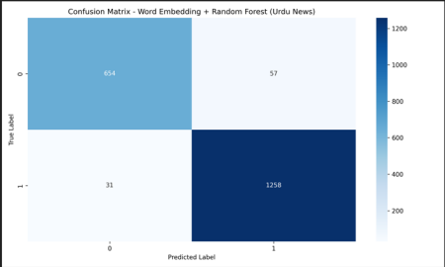 (Figure.5 Word Embedding + Random Forest)
4. PROPOSED MODEL ARCHITECTURE
The system architecture follows a modular design with distinct components for preprocessing, feature extraction, and classification. Figure 2 shows the complete system workflow:
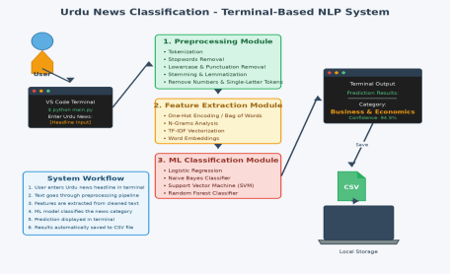Figure 2: System Architecture Diagram
4.1 System Components
4.1.1 Input Module
The system accepts Urdu news headlines through a terminal interface. Users can input headlines directly via the VS Code terminal or other command-line interfaces.
4.1.2 Preprocessing Module
This module handles all text cleaning operations including tokenization, stopword removal, normalization, and other preprocessing steps outlined in Section 3.2.
4.1.3 Feature Extraction Module
The feature extraction module transforms preprocessed text into numerical representations using the techniques described in Section 3.3. Different feature engineering methods can be selected based on the task requirements.
4.1.4 Classification Module
This module contains the trained machine learning models. It accepts feature vectors and produces category predictions with confidence scores.
4.1.5 Output Module
Prediction results are displayed in the terminal and automatically saved to a CSV file for further analysis. The output includes the predicted category and confidence score.
5. RESULTS AND DISCUSSION
This section presents the experimental results and discusses the performance of different feature engineering techniques combined with various classification algorithms.
5.1 Experimental Setup
The dataset was divided into training and testing sets to evaluate model performance. In addition, models were also evaluated on the full dataset to analyze overall learning behavior.
∙ Training Set: 8,000 headlines (80%)
∙ Test Set: 2,000 headlines (20%)
∙ Full Dataset Evaluation: All 10,000 headlines
Evaluating the models on both the test set and the full dataset helps in understanding generalization performance as well as overall accuracy when more data is available.
5.2 Performance Comparison
Table 1 shows the accuracy results for different combinations of feature engineering techniques and classification algorithms.
Feature  Engineering | Algorithm | Test Accuracy | Full 10k  Dataset  Accuracy
Bag of Words | Logistic Regression | 97.15% | 99.05%
One-Hot Encoding | Naive Bayes | 97.40% | 98.49%
N-Grams (Bigrams) | SVM (Linear) | 95.90% | 99.18%
TF-IDF | Random Forest | 96.20% | 99.24%
Word Embeddings | Random Forest | 95.60% | 99.12%

Table 1: Performance Comparison of Different Approaches
5.3 Discussion
5.3.1 Model Performance Analysis
All feature engineering techniques, when combined with their respective classification algorithms, achieved strong performance with accuracy above 95% on the test set. This indicates that the preprocessing and feature extraction steps were effective.
The highest test set accuracy was achieved by One-Hot Encoding with Naive Bayes (97.40%), followed closely by Bag of Words with Logistic Regression (97.15%). These results show that simple feature representations with probabilistic or linear models work very well for text classification tasks.
When evaluating models on the full 10k dataset, accuracy increased significantly for all approaches, with values above 98%. This improvement suggests that models benefit from larger training data, allowing them to learn more representative patterns from the text.
The TF-IDF with Random Forest achieved the highest full dataset accuracy (99.24%), indicating that combining weighted text features with an ensemble learning method can improve overall performance. Similarly, N-Grams with Linear SVM also showed a notable improvement on the full dataset, highlighting the importance of capturing word sequences.
Overall, the comparison between test accuracy and full dataset accuracy demonstrates that:
∙ Models perform better when trained and evaluated on more data
∙ Different feature engineering techniques have varying strengths depending on the algorithm used
∙ Simple models can still achieve competitive results when proper preprocessing is applied.
5.3.2 Feature Engineering Insights
Key observations from the experiments:
• Simple Features: Bag of Words and One-Hot Encoding, despite their simplicity, achieved excellent results due to the clear distinction between news categories.
• Context Capture: N-Grams captured word sequences but showed slightly lower accuracy, possibly due to increased feature sparsity.
• Semantic Information: TF-IDF and Word Embeddings provided better semantic understanding but required more computational resources.
• Algorithm Selection: Different algorithms performed optimally with different feature types, highlighting the importance of proper pairing.
5.3.3 Error Analysis
Analysis of misclassified instances revealed that errors primarily occurred in headlines containing ambiguous vocabulary that could belong to both categories. For example, news about entertainment industry business deals or economic aspects of entertainment sectors posed classification challenges.
6. CONCLUSION
This project successfully demonstrated the application of various machine learning techniques for Urdu news classification. The comprehensive approach involving multiple preprocessing steps, diverse feature engineering methods, and different classification algorithms provided valuable insights into text classification challenges.
6.1 Key Findings
• All implemented approaches achieved accuracy rates above 95%, demonstrating the effectiveness of classical machine learning for Urdu text classification.
• One-Hot Encoding with Naive Bayes provided the best test set performance at 97.40% accuracy.
• Proper preprocessing and feature engineering are crucial for achieving high classification accuracy.
• The choice of feature engineering technique should be matched with appropriate classification algorithms for optimal results.
6.2 Future Work
Several directions for future research include:
• Expanding the dataset to include more categories and a larger number of samples • Implementing deep learning approaches such as LSTM and BERT models • Exploring ensemble methods combining multiple classifiers
• Developing a web-based interface for real-time classification
• Investigating cross-domain transfer learning for Urdu NLP tasks
6.3 Final Remarks
The project demonstrates that effective text classification for Urdu language can be achieved using classical machine learning approaches when combined with appropriate preprocessing and feature engineering. The modular architecture developed allows for easy experimentation with different techniques and provides a solid foundation for future enhancements.
7. References
[1] Z. Li et al., “A unified understanding of deep nlp models for text classification,” IEEE Trans. Vis. Comput. Graph., vol. 28, no. 12, pp. 4980–4994, 2022.
[2] Z. Yong, L. Youwen, and X. Shixiong, “An improved KNN text classification algorithm based on clustering,” J. Comput., vol. 4, no. 3, pp. 230–237, 2009.
[3] A. H. Aliwy and E. A. Ameer, “Comparative study of five text classification algorithms with their improvements,” Int. J. Appl. Eng. Res., vol. 12, no. 14, pp. 4309–4319, 2017.
[4] K. Ahmed, M. Ali, S. Khalid, and M. Kamran, “Framework for Urdu News Headlines Classification.,” J. Appl. Comput. Sci. Math., no. 21, 2016, Accessed: Jan. 05, 2026.
[5] M. Razno, “Machine learning text classification model with NLP approach,” Comput. Linguist. Intell. Syst., vol. 2, pp. 71–73, 2019.
[6] H. Wu, Y. Liu, and J. Wang, “Review of Text Classification Methods on Deep Learning.,” Comput. Mater. Contin., vol. 63, no. 3, 2020, Accessed: Jan. 05, 2026. [Online]. Available:
[7] S. M. Hassan, F. Ali, S. Wasi, S. Javeed, I. Hussain, and S. N. Ashraf, “Roman-urdu news headline classification with ir models using machine learning algorithms,” Indian J. Sci. Technol., vol. 12, no. 35, pp. 1–9, 2019.
[8] U. Arshad, K. I. Malik, and H. Arooj, “Urdu news content classification using machine learning algorithms,” 2022, Accessed: Jan. 05, 2026.
[9] A. Patra and D. Singh, “A survey report on text classification with different term weighing methods and comparison between classification algorithms,” Int. J. Comput. Appl., vol. 75, no. 7, 2013, Accessed: Jan. 05, 2026.
[10] U. Arshad, K. I. Malik, and H. Arooj, “Urdu News Content Classification Using Machine Learning Algorithms,” LGU Res J Comput Sci IT Univ Lahore Sargodha Campus Sargodha Pak. Tech Rep, vol. 6, no. 1, 2022, Accessed: Jan. 05, 2026.

