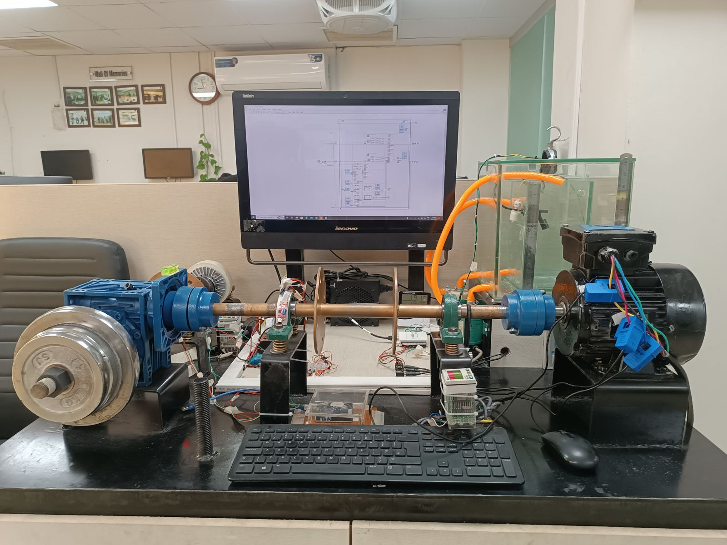
DETAILED DESCRIPTION OF INDUSTRIAL TEST RIG SIMULATOR
Table of Contents
1. Introduction 1
1.1) Overview 1
1.2) Types of Sensors 1
1.3) Other Technical Hardware used in System 2
2. System Block Diagram 4
3. Hardware Connection 7

List of Figures
Figure 1: Horizontal Water Level Sensor 2
Figure 2: Vertical Water Level Sensor 2
Figure 3: SCT-030 Current Sensor 2
Figure 4: Temperature and Humidity Sensor 3
Figure 5: Tachometer with Incremental Encoder 3
Figure 7: ATX Power Supply 3
Figure 8: Induction Motor 4
Figure 9: NI USB-6008 DAQ Device 4
Figure 10:KTC Tension Controller with Powder Brake and Electromagnetic Clutch 4
Figure 11:Industrial Test Rig Block Diagram 7
Figure 12: Tachometer Pinout 9
Figure 13: 2-Channel Relay Setup 9
Figure 14: Industrial Test Rig Simulator Hardware Connection Schematic Diagram 11

List of Tables
Table 1: Power Supplies Used in System 4
Table 2: 3-Phase Motor Specification 4
Table 3: Magnetic Pump Specification 5
Table 4: Power Supplies Used by Devices 8
Table 5: DAQ Device Connections 12

Introduction

Overview
An industrial test rig simulator is basically a system that is designed to essentially replicate the functionality of real industrial machinery or equipment, thereby allowing actual situations to be tested, troubleshoot, and experimented without risking or costing real-world machinery. With the helps of sensors, we will be able to acquire the actual situation of the system/ equipment’s used in plants. This document includes the description about sensor used in this setup, their functionality in the system, operational information and hardware circuit implementation.

Types of Sensors
Different types of analog and Digital Sensors have been used in this industrial test rig simulator. The sensors that are used in this setup is given below:
- 1x Horizontal Water Level Sensor.
- 1x Vertical Water Level Sensor.
- 3x AC Current Sensor.
- 1x Temperature and Humidity Sensor.
- 2x Tachometers with Incremental Encoder.
- 3x 3-Dimensional Accelerometers.
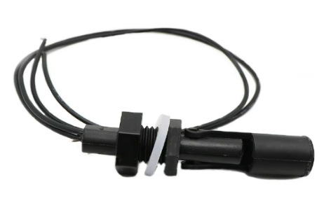
The analog sensors such as AC current sensors and accelerometers gives an analogue output while the digital sensors such as horizontal water level, vertical level sensor, tachometer gives us digital output.
- Horizontal Water Level Sensor
The horizontal water level sensor is used to identify water level in the system. They are installed at such systems where vertical space is not favourable. It is the passive sensor which only have two signals that is signal and ground. The sensor is installed in a water tank to measure water level of the tank and take necessary action according to the situations. The sensor is shown in figure 1.
Figure 1: Horizontal Water Level Sensor
- Vertical Water Level Sensor
The vertical water level sensor is like horizontal water sensor as discussed above that is used to identify vertical water level in the system. It is the passive sensor which only have two signals that is signal and ground. The sensor is shown in figure 2.
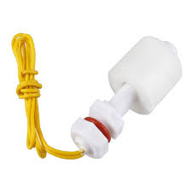

Figure 2: Vertical Water Level Sensor
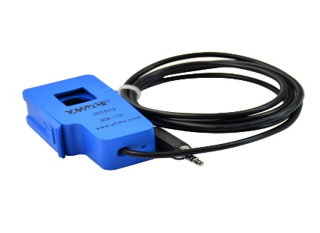
- AC Current Sensor
The SCT-013-030 is a non-invasive AC Current Sensor Clamp Sensor 30A i.e. it is a current transformer that can be used to measure AC current up to 30 amperes. This SCT-013-030 Non-invasive AC Current Sensor 30A clamped around the supply line can measure a load up to 30 Amps and allow you to calculate how much current pass through it.
Figure 3: SCT-030 Current Sensor
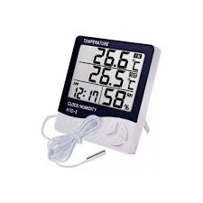
- Temperature and Humidity Sensor
Digital Thermometer and Hygrometer HTC-2 are 3 in 1 meter. This HTC 2 humidity meter allows you to display time clock, temperature, humidity and alarm function with a single cell. This digital meter has temperature range: -50 ~ 70 degrees (-58 ~ 158 ° F), large character LCD display, easy to read, lower power consumption This temperature and humidity meter can show temperature, humidity and time display simultaneously as shown in figure 4.
Figure 4: Temperature and Humidity Sensor
- Tachometers with Incremental Encoder
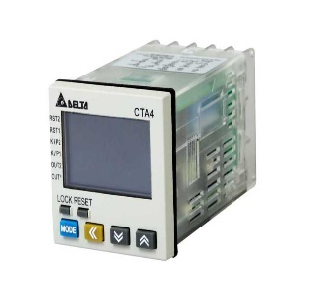
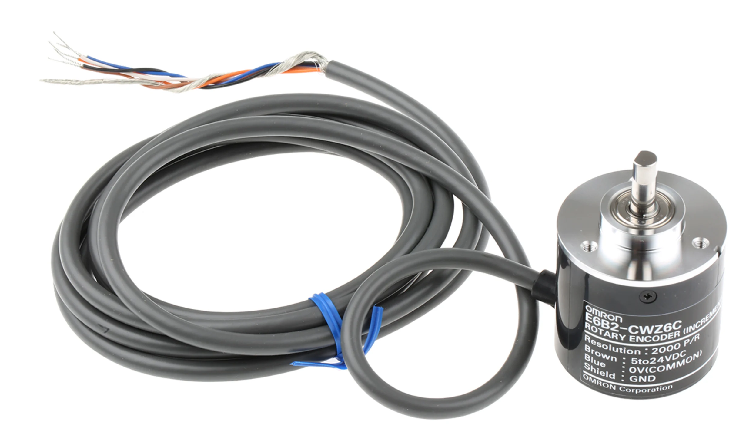
CTA-4001A is a 3 in 1 device having timer / counter/ tachometer function with mixed timer and counter function. The 6-digit LCD display allow you to read this function with more accuracy and precisely. Different input like NPN/ PNP allow you to measure the function with different devices/sensors. The tachometer is shown in figure 5. In this application of industrial test rig, we use this device in tachometer with incremental encoder (E6B2-CWZC) to measure the number of rotation (rpm) of 3-phase induction motor. The 2000 pulses per revolution substantially improve measuring accuracy. The encoder is NPN has an open collector output as shown in figure 5.
Figure 5: Tachometer with Incremental Encoder

Other Technical Hardware used in System
Some other technical other than the sensors have been used in this system such as ATX power supply, 3-phase Induction motor, Data Acquistion Module, KTC power brake system with mechanical clutch, Relay module with magnetic drive pump, Current amplification circuit using BJT. The functionality of each hardware is discussed below:
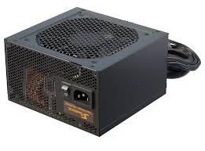
- ATX Power Supply
The ATX power supply is to power up the modules/ sensors used in the system. Total 6 supplies coming out from the supply that is mainly divide into two class i.e. Main supplies and Aux supplies. We are using only +12V and +5V supplies that is sufficient in our system while other supplies are of no use in the system. The ATX supplies used in the system for the respected sensor/module is shown in table 1. The ATX supply is shown in figure 7.
Figure 7: ATX Power Supply

Power Supply | Used in
12V | Relay Module
5V | Tachometer, Incremental Encoder
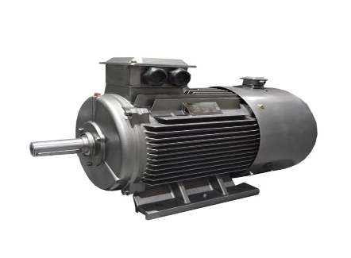
Table 1: Power Supplies Used in System
- 3-Phase Induction Motor
A 3-phase induction motor is a device that does electromechanical energy conversion. It converts three-phase electrical power input into mechanical power output. The 3-phase AC is given at the input of the motor and the rotation of the motor in rpm is measured using incremental encoder and displayed rpm at the tachometer display LCD screen. The specification of motor is shown in table 2.
Figure 8: Induction Motor
Parameter | Specification
Supply Voltage | 220V AC 3-Phase
Rating | 1.5hp
Rpm | 1450
Capacity | 1.1KW
Table 2: 3-Phase Motor Specification
- Data Acquistion Device
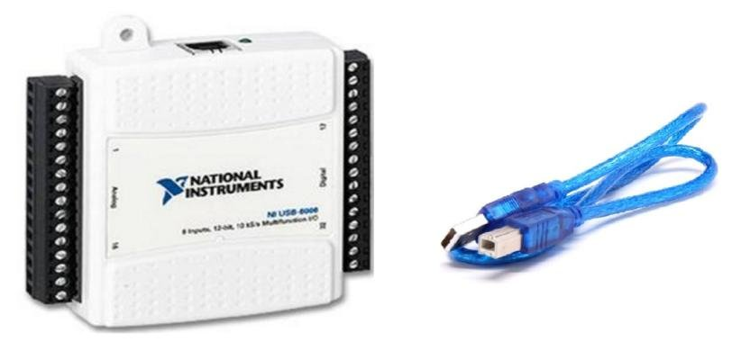
NI USB-6008 data acquisition device is used in this setup which is designed for basic data logging and measurements of sensor values. This DAQ device has 8-analog input channels and 16 digital channels with a sampling rate of 10 KS/s. The analog sensors are connected at an analog channel while the digital sensors are connected at the digital channels of the DAQ. The DAQ device has a software support like LabView to view the measurement values and log these values in some file format like text or excel. The DAQ device is shown in figure 9.
Figure 9: NI USB-6008 DAQ Device
- KTC Tension Controller with Powder Brake and Electromagnetic Clutch
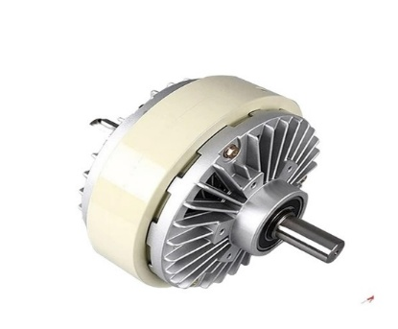
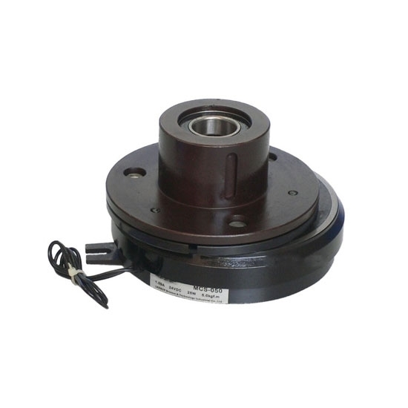
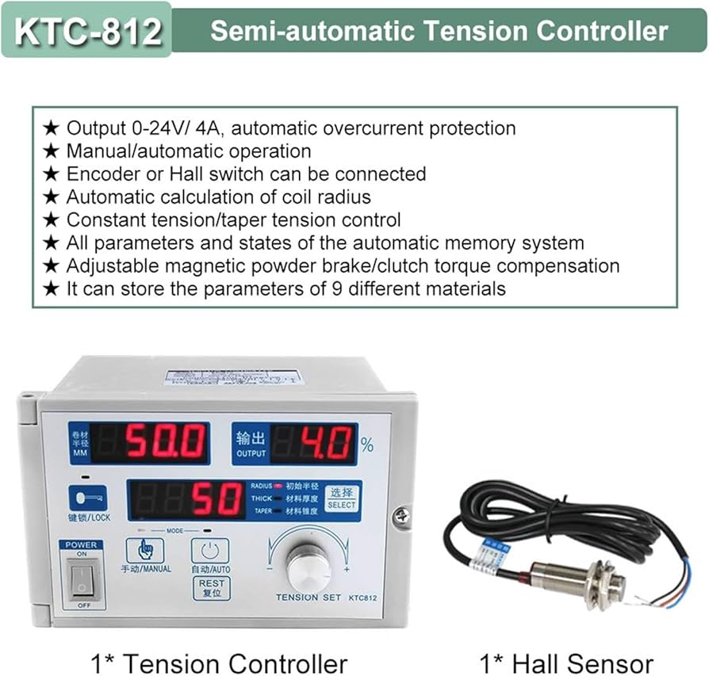
The KTC-812 tension controller is a device that is used to manage and control tension in various industrial and domestic applications with an option of adjustable torque, automatic tension calculation and over current protection. The powder brake is introduced in a system with a tension controller to apply a braking mechanism system when we want to increase load/tension on the system. Similarly, electromagnetic clutch is used to engage or disengage the shaft which is connected with the powder brake. When it is connected with brake shaft it acts as a tension/load which is applied to the system.
KTC Tension Controller
Magnetic Powder Brake
Electromagnetic Clutch
Figure 10:KTC Tension Controller with Powder Brake and Electromagnetic Clutch
- 2-Channel Relay Module with Magnetic Drive Pumps
A 2-channel relay module is a device that allows you to control two separate circuits with a single module. The relay channel is used to drive the magnetic drive pumps. The input of the relay channel is dependent on the value of water level sensor as described above. If the sensor detects decrease in the water level in tank, the pump starts and maintain the water level of the tank. As, relay module works on active low signal so whenever it detects a low level at its input, it will turn on the pump. The specification of the drive pump is shown in table 3, and both the relay and pump are shown in figure 11.
Parameter (Magnetic Drive) | Specification
Supply Voltage | 220V AC
Current Rating | 0.08A
Frequency | 50Hz
No of Poles | 2
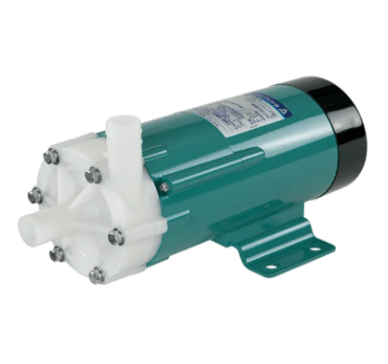  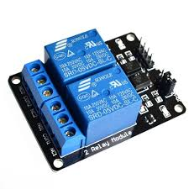  Max Capacity  2-Channel Relay Module  Magnetic Drive Pump | 5.5/6 l/m
Table 3: Magnetic Pump Specification

- Current Amplification Circuit Using BJT
As the switching of relays are totally dependent on the measurement of water level sensors. The maximum current output of USB-6008 is 8mA approximately while the current required by the relay module is minimum 30mA. So, a circuit is designed using BJT to provide adequate amount of current to relay module. For this purpose, NPN transistor is used in switching configuration. As, the DAQ device digital lines are internally pull up. For this purpose, we used a NOT gate at the specific output lines which is connected with the BJT so that the relays do not on when the DAQ device is powered on and unless the LabView is code run on the PC.

System Block Diagram
The Industrial Test Rig replicates the behaviour of industrial equipment’s at a smaller level without damaging the actual equipment which is being used in complex plants. This will save us in many aspects like cost-effective solution, time saving and do not disturb the working condition or environment in which the system is working. The sensors/devices which want to implement on plant in future will be implemented on the system which is smaller in form factor than the actual system, but the functionality of both systems is the same. For this a small setup in designed and developed on which multiples analog and digital sensors have been installed on the system. In this system, it will actually monitor the status of the sensor and determine the remaining useful life of the equipment’s. Many sensors like accelerometer, accelerometers, tachometers etc will be used to measure sensor reading, displays the real-time behaviour of the system and predicts if any of the fault occur or will occur nearby in the system.
First of all, A three phase induction motor is used in the system having a capacity of 1.5hp is installed in a system to actually give a rotary moment in the system on which multiple mechanical and electrical equipment’s are attached. The actual rpm of motor is approx. 1500rpm. The motor is connected to bearing, flywheel and worm gear through a mechanical shaft as shown in figure 11. When the motor shaft rotates, it also rotates all these mechanical equipment attached to it as well. To accurately measure the rpm of motor, tachometer sensor with incremental encoder is attached using a pulley-based system. The pully is connected to mechanical shaft and incremental encoder and displays the rpm on tachometer LCD. If rpm decreased than the minimum threshold value, the output of tachometer will be changed and observed on real-visualization screen. When the motor’s rpm pass through the gear worm, it will actually reduce the rpm to 1:7 and the rpm after gear worm will approx. 185. So, again to measure rpm after gear, a similar setup is installed and measure rpm after worm gear. For the accurate current measurement, a non-invasive current sensor as discussed above is installed on the three phase AC lines of the induction motor to continuously measure the current consumption of the motor. Accelerometers are also introduced in the system to measure and monitor the vibrational effect of the system. Three accelerometers are used for this purpose and for each single axis (X, Y and Z), each accelerometer gives vibration of single axis being used. Two water level are installed in a water tank to monitor the level of fluid(water) present in tank. If the water level decrease due to any sudden change like attack on sensor reading or sensor data manipulation so that the sensor detects any changes, it will give signal to DAQ and DAQ will give output signal to 2-channel module which turn on the magnetic motor pump
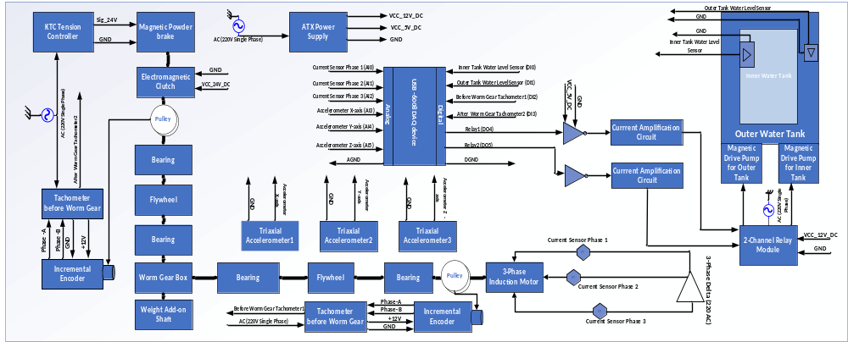Figure 11:Industrial Test Rig Block Diagram
which will maintain the level. This feature is added in the system to verify if any cyber attack performed on the system. So, the system detects it and inform the concerned person so that any misuse of classified data can be used by some unknown person. To turn on relay a current amplification is used as discussed above to accurately turn on or off the relay module. All the sensors value are monitored through a data acquisition device of National Instrument NI-USB6008, and these values are stored in text file to utilize by end-user and this file is utilized for real-time data visualization of sensors. A weight on mechanism using shaft is used to introduce the load effect on the induction motor. When load increase, the rpm of motor reduces and vice versa helps us to give estimated rpm on a specified load applied to system.

Hardware Connection
As different types of sensors (analog and digital sensors) are used in this industrial test rig setup on which some of the sensors are passive sensors like water level sensor, some of them uses only digital supplies like relay, electromagnetic clutch while some of them use both AC and DC supplies both like tachometers. Current sensors are non-invasive category type sensors that work on the principle of electromagnetic induction is another type of passive sensor having built-in resistor in it that we will give output in the form of voltage. Accelerometers are current source sensors that need constant current source (4-10mA) for proper functionality. The table 4 describes the basic supply (AC or DC) that is used by the sensors or technical hardware used in industrial test rig setup.
Device | Power Supply | Voltage | Output
AC Induction Motor | AC | 220V (Three Phase) | Nil
Tachometer | - AC  - DC | - 220V (Single Phase)  - 5V | Digital
Incremental Encoder | DC | 12V | Digital
2-Channel Relay Module | DC | 12V | AC
Electromagnetic Drive Water Pump | AC | 220V (Single Phase) | Nil
24V DC Adapter | AC | 220V (Single Phase) | 24V DC
Electromagnetic Clutch | DC | 24V | Nil
KTC-812 Controller | AC | 220V (Single Phase) | DC (0-24V)
Powder Brake | DC | 0 to 24V | Nil
ATX Power Supply | AC | 220V (Single Phase) | 5V DC  12V DC
Water Level Sensor | Passive | Nil | Digital
Current Sensor | Passive | Nil | Analog
Accelerometers | Constant Current Source | 4-10mA | Analog
Table 4: Power Supplies Used by Devices
- 3-Phase Induction Motor
So, first of all you need a 3-phase AC supply in order to start the induction motor to start the rotary movement in the system. The motor is connected in 3-phase delta configuration. By using delta configuration, it will provide higher power and torque to motor. When the motor starts it will rotate the shaft with its maximum rpm when no load is applied at motor.
- Tachometer With Incremental Encoder
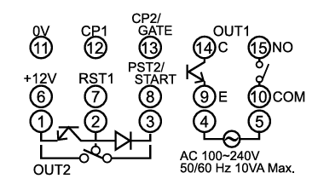
For rpm measurement, a tachometer which need 220V single phase is required at pin 4 and 5 of the tachometer. The pinout configuration of tachometer is shown in figure 12. The tachometer is operated in tachometer configuration. For accurate setting, please refer to tachometer datasheet/ manual. As, tachometer OUT1 is open collector. So, we need a pull-up resistor at its output to correctly operate the built-in transistor and record the data on DAQ device accurately. For that, 4.7KΩ resistor is pull with 5V DC of ATX power supply. Tachometer is used with incremental encoder, which measures the number of rotation and gives a signal if rotations of motor are out of set threshold. The incremental encoder needs supply voltage between 5-24V so for that we provide dc supply 12V which is available on pin#11 of tachometer. So, the output of incremental encoder (Phase A, Phase B) is given at tachometer pin #12,13. The pin#14 of tachometer is connected with pull-up resistor as well as the Digital pin (P0.2) of DAQ while the pin#9 and 11 are connected with the ground pin of ATX supply. As, two tachometers are used. Same setup is used for other tachometer as well as incremental encoder, but the output of tachometer is connected at the Digital pin (P0.3) of DAQ.
Figure 12: Tachometer Pinout
- 2-Channel Relay Module
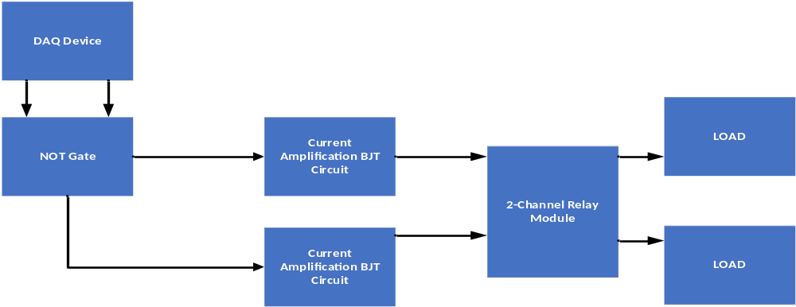The 2-channel Relay Module operates on a 12V DC supply which is provided through ATX power supply. As, the relay works on active low signal so it will turn on the relays when the input signal is low. To effectively switching the relays, the relays need minimum current of 30-40mA, but the current provide by the DAQ pins is approximately 8mA. For accurate current amplification, a transistor is used for current amplification in common emitter configuration as a switch. As, relay are worked on active low while NPN transistor goes in active region when signal is high on its base. The output (collector) is connected to digital input pin of the relay module. As, the DAQ digital pins are internally pull-up. So, when the DAQ is powered on, it will give high signal at the base and turn on the relay load. For that purpose, an inverter gate (SN7404hcn) is used between the DAQ pin and transistor base so that when the DAQ is connected with PC it will not turn on the load automatically unless the code is run on the DAQ. As, it is two channel relays, so two setups of transistor are used. Both the input that is connected to inverter gate is coming out from DAQ digital pin (P0.4 and P0.5 respectively). The block diagram is of this setup is show in figure 13.

Figure 13: 2-Channel Relay Setup
- Electromagnetic Water Pumps
The Electromagnetic pumps are connected to Relay module. The relay module will turn on or off the pump depending on the signal based on the input of relay module. The pump will work on AC (220V single phase). The main line is connected with AC supply while the neutral line of motor is connected to NO and COM points of the relay. This will act as a switch between this point for controlling the electromagnetic pumps.
- Electromagnetic Clutch
Electromagnetic Clutch is used to connect to two shafts of the system. This will provide a continuous rotary movement to two disconnected shafts. As, magnet is present in the clutch, when current passes through the magnetic, it will generate magnetic field around it and helps to connect the shaft. This electromagnetic clutch will work on 24V DC voltage, which is provide through a 24V,0.75A DC adapter.
- KTC-812 Controller with Powder Brake
KTC-812 is an automatic/manual tension controller which is used to provide tension on some system. This tension controller needs a 220V AC at its input for power and creates a DC signal up-to 24V depending upon tension created by the controller manually using a knob on the controller or automatically by using a hall effect sensor. The powder brake is introduced in the system with tension controller to introduce the effect of load on the system which helps in visualizing the motor current capacity as well as rpm measurement when the load increases. The powder brake contains two signals i.e. signal and ground that are connected at the output of tension controller signal named as 24V and GND. The tension on the system is adjusted manually right now. Powder brake also contains a magnet in it so that if the current/voltage increase, more magnetic field will be generated, and more load is applied at the system.
- ATX Power Supply
ATX power supply is used in the system to provide a DC voltages which is used by the system sensors. The power supply operates on 220V AC and generates six DC voltages at the output. We only use two supplies (+5V and +12V) out of six supplies. The PS-ON pin on the ATX connector is connected with ground pin to work the supply in idle mode.
- Water Level Sensor
Two water level sensors i.e. Horizontal and Vertical are used in the system. Both of these sensors are passive sensors that does not any supply to operate. So, these sensors are connected at DAQ digital pins. These sensors are connected at the digital pin (P0.0 and P0.1) of DAQ device respectively.
- Current Sensor
This current sensor is non-invasive type AC sensor that means we do not need to connect it in series with the AC supply line. We have connected on power line like clamp meter, and it will measure the current. The current sensor is an analog sensor, and it will connect at pin#AI0, AI1, AI4 of the analog pins of DAQ device.
- Accelerometer Sensor
The accelerometers used in this setup works on a 2-line setup works system on which the signal acts on a power line as well as signal line on a same line. As, this sensor needs a constant current source. The three accelerometers are used separately for each axis and the signals are connected gives analog signal at the output. So, these signals are connected at the analog pins# AI5, AI2 and AI6 respectively.
The complete schematic diagram is shown in figure 14 which shows us all the device’s connections of the setup.

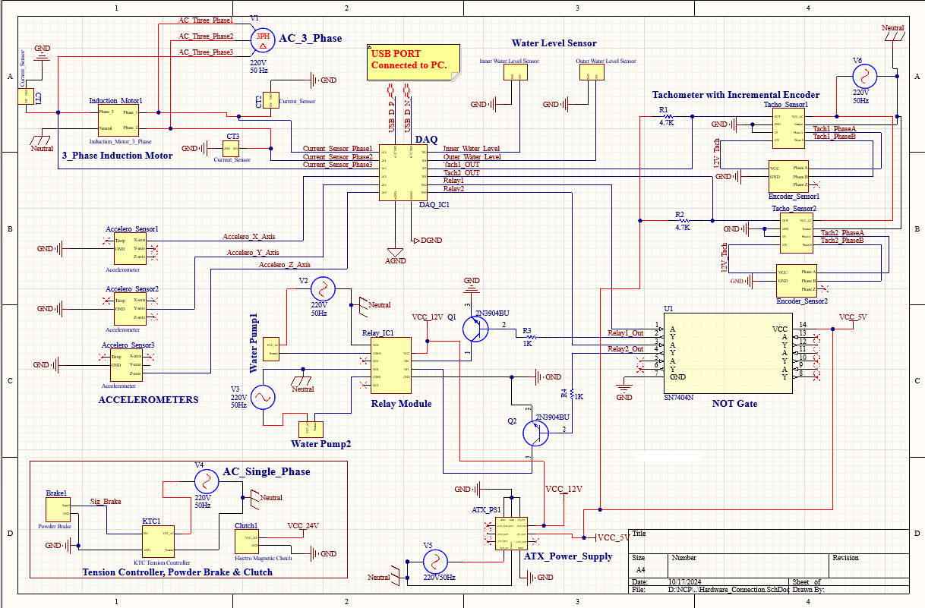
Figure 14: Industrial Test Rig Simulator Hardware Connection Schematic Diagram

- USB-6008 DAQ Device
As the DAQ devices is powered up using USB. The device is connected to PC and program is loaded through LabView into the device. The connection which are connected to DAQ is shown in table 5.
DAQ Connected to | DAQ Pin# | PIN Name
Current Sensor | 2,3,5 | AI0, AI4, AI1
Accelerometers | 6,8,9 | AI5, AI2, AI6
Horizontal Water Level | 17 | P0.0
Vertical Water Level | 18 | P0.1
Tachometer1 | 19 | P0.2
Tachometer2 | 20 | P0.3
Relay1 input | 21 | P0.4
Relay2 input | 22 | P0.5
Table 5: DAQ Device Connections

