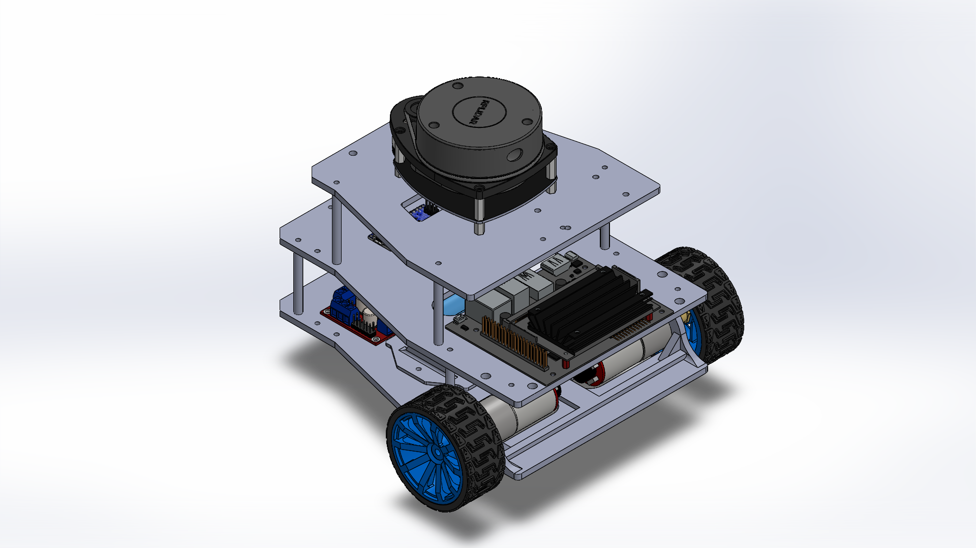
TECHNICAL DESCRIPTION OF SWARM VEHICLE ROBOT
Table of Contents
List of Figures II
List of Tables II
1. Introduction 1
1.1. Overview 1
2. Mechanical Design of the System 1
2.1. Mechanical Plate Design and Dimensions 1
2.1.1. Bottom Plate of Robot 1
2.1.2. Centre Plate of the Robot 1
2.1.3. Top Plate of the Robot 2
2.1.4. Battery Holder 2
2.2. Mechanical Wheel of System 2
2.3. Load Handling and Deformation 3
2.4. Complete Mechanical Assembly of System 3
3. Electrical Design of the System 4
3.1. Arduino Nano Development Board 4
3.2. Jetson Nano Development Board 4
3.3. 11.1V Li-Ion Rechargeable Battery 4
3.4. Encoder DC Motor (GA25-370) 4
3.5. Motor Driver Shield (L298N) 5
3.6. IMU Sensor (MPU-6050) 5
3.7. 2D-LIDAR (YDLIDAR G4) 6
3.8. Depth Camera (RealSense D435) 6
4. Block Diagram of the System 6
5. Hardware Connection of the System 7
6. Assembly Instruction 7
7. Conclusion 7

List of Figures
Figure 1: Bottom Plate of Robot 1
Figure 2: Centre Plate of Robot 2
Figure 3: Top Plate of Robot 2
Figure 4: Battery Holder 2
Figure 5: Mechanical Wheels 2
Figure 6: Deformation Analysis 3
Figure 7: Swarm Vehicle Robotic Car 3
Figure 8: Arduino Nano V3 4
Figure 9: Jetson Nano Development Kit 4
Figure 10: Li-Ion Battery 4
Figure 11: Encoder DC Motor 5
Figure 12: Motor Driver Shield 5
Figure 13:IMU Sensor 5
Figure 14: 2D LIDAR 6
Figure 15: Depth Camera 6
Figure 16: System Block Diagram 7
Figure 17: Assembly Instruction 8
Figure 18: Hardware Connection of System 9

List of Tables
Table 1: Encoder DC Motor Pinout 5
Table 2: Motor Driver Shield Pinout 5
Table 3: IMU Sensor Pinout 6
Table 4: Hardware Connections 10

Introduction

1.1. Overview
The Swarm Vehicle Robot is a specialized platform for developing and implementing swarm intelligence ideas. It features a tiny yet sturdy architecture and incorporates many sensors, DC motors, and processing units to enable autonomous tasks like navigation, communication between different sensors, and complex decision-making. The robot is designed for efficiency and versatility, allowing it to function independently. The Swarm Vehicle Robot employs modular hardware and software framework, ensuring adaptability for research and practical applications. With the help of sensors, we will be able to acquire the actual real -time environment in which the vehicle is moving. This document includes a detailed description of the mechanical and electrical design of the vehicle, its functionality, and schematics of the system.

Mechanical Design of the System
The key component which plays an important role in the self-designed systems is the mechanical system. Multiple issues with stability, system movement under specific conditions, and equal component weight distribution are resolved by a stable mechanical design, which creates issues for the system. For this core concept of mechanical design, the mechanical chassis should have flexible environment adaptability and low weight to avoid major problems. The robot chassis is constructed using Chlorinated Polyethylene (CPE) material which offers a balance of flexibility and durability. The lightweight construction ensures providing impact resistance and thermal stability for reliable performance in various conditions. The Manufacturing method of FDM 3D printing enables material efficiency which helps in rapid prototyping, allowing for swift iterations and enhancements throughout the development process.

2.1. Mechanical Plate Design and Dimensions
The mechanical design of the system is built with keeping in mind the that the dimensions of the system plates should be easily printed by the 3D printer. For this purpose, the FDM 3D printing of four plates of Chlorinated Polyethylene (CPE) material is used as a low-cost effective solution for the robot vehicle chassis. The four plates of the system are as follows:
- Bottom Plate.
- Centre Plate.
- Top Plate.
- Battery Holder.

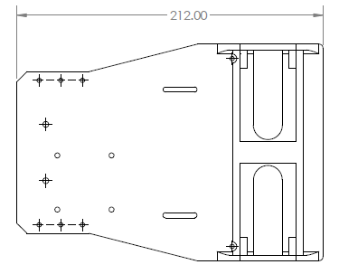
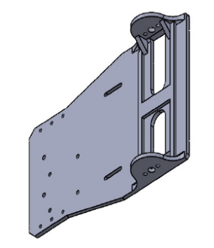
2.1.1. Bottom Plate of Robot
Figure 1: Bottom Plate of Robot
The bottom plate of the system contains the main electrical components (motors) which helps the system to create friction against the surface using wheels for movement. This plate needs to be rigid so that when the vehicle moves, the weight of the DC motors on the system will not bend and the robot car goes steadily and accurately. This plate mainly uses to control the movement of the system. The dimension of the plate is 212 x 150 (mm) with thickness of 3mm as shown in figure 1. The bottom plate mainly consists of following components: motor driver shield, DC motors, caster ball wheel and battery.

2.1.2. Centre Plate of the Robot
The centre plate of the system contains the main control system which controls and make decisions for the system to move accordingly in real-time scenarios. This plate needs to be stable during the vehicle movement so that an abrupt signal will not affect the decision of the robot vehicle. The dimension of the plate is 212 x 150 (mm) with thickness of 3mm as shown in figure 2. The centre plate mainly consists of following components: Arduino nano development board, Jetson Nano Development kit, IMU- Sensor and Depth camera.
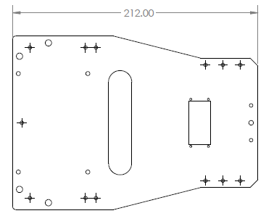
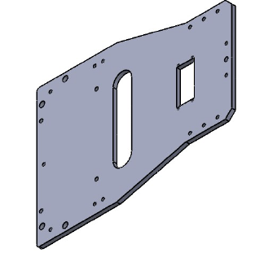
Figure 2: Centre Plate of Robot

2.1.3. Top Plate of the Robot
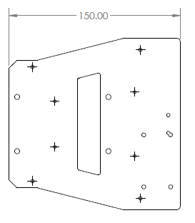
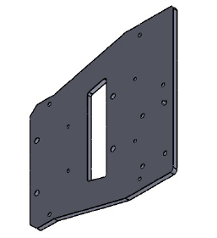
The top plate of the system mainly contains LIDAR sensor on it. The LIDAR creates a map of its surrounding, so it should be mounded steadily on this plate. The dimension of the plate is 150 x 150 (mm) with thickness of 3mm as shown in figure 3.
Figure 3: Top Plate of Robot

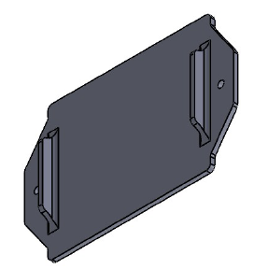
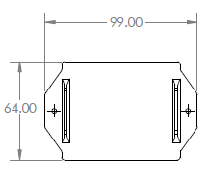
2.1.4. Battery Holder
Figure 4: Battery Holder
The battery holder plate is mainly designed to hold the battery of the system. It should be screwed on the bottom plate and has a mechanism of easily removed and installed the battery to the system without dismantling the whole system. The dimension of the plate is 99 x 64 (mm) as shown in figure 4.

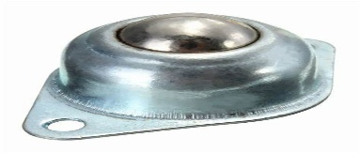
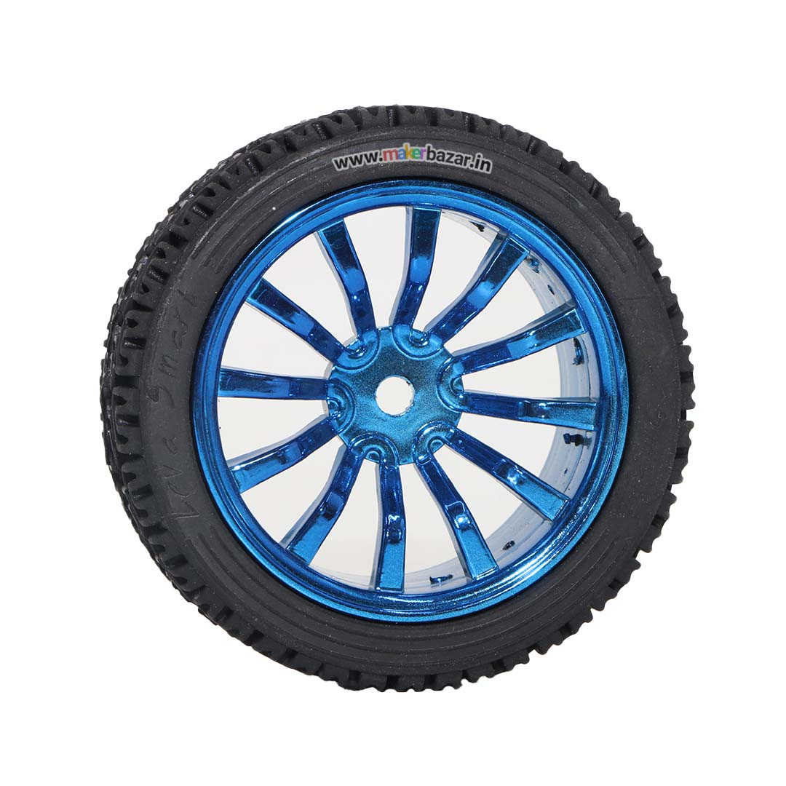
Mechanical Wheel of System
Figure 5: Mechanical Wheels
The chassis is equipped with two rear-driven wheels for propulsion and a front cluster ball wheel for enhanced stability and manoeuvrability, ensuring smooth navigation across a variety of surfaces, including small uneven terrain and smooth floors. The rear wheels feature a 65mm diameter, 27mm width, and an inside corner-to-corner measurement of 12mm, designed with high-grip rubber for exceptional traction and durability. The fronts cluster ball wheel provides omnidirectional movement, enabling the robot to pivot and turn smoothly without compromising stability as shown in figure 5. This combination of precision engineering and high-performance materials ensures reliable control, adaptability, and robust performance in dynamic environments and real time scenarios

2.3. Load Handling and Deformation
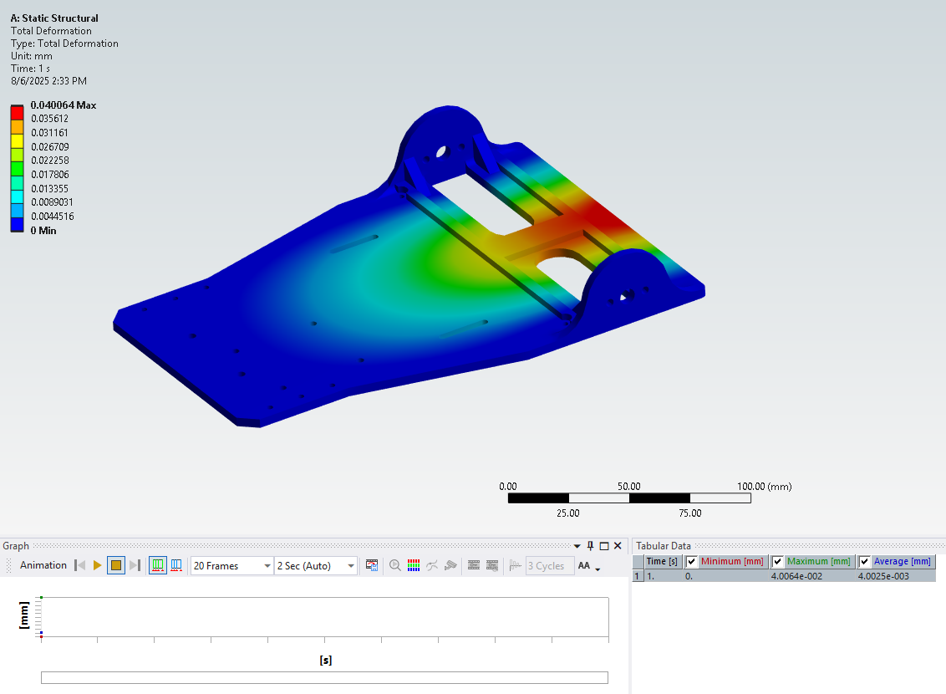
The design was validated with finite element analysis (FEA) under a 2 kg payload, simulating the total weight from electronics and sensors. The critical regions with minimal deformation were near the motor mount sections, proving structural reinforcement effectiveness.
Figure 6: Deformation Analysis

2.4. Complete Mechanical Assembly of System
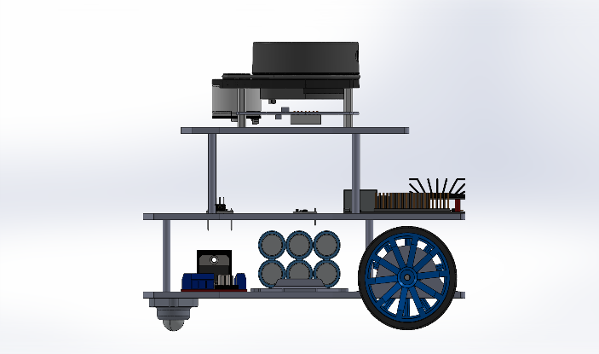
All the plates of the system are assembled with the components as shown in figure 7. The brass standoff spacers are used between the plates of the chassis. A total length of 55mm spacer were placed used between the plates to provide enough height to install the electronic components on the plates. It is a 2- wheel robot having ball caster wheel on the front and controllable wheel on the rear side of the robot.
Figure 7: Swarm Vehicle Robotic Car

Electrical Design of the System
The electrical design of a system includes the planning, development, and integration of electrical components to ensure functionality, efficiency, and safety. It involves selecting appropriate power sources, wiring configurations, circuit protection, and control mechanisms to meet operational requirements. A well-structured electrical design not only optimizes performance but also minimizes energy consumption and enhances system reliability. The robot chassis consist of following electrical components which are used in the two-wheeler swarm vehicle robot.
- Arduino Nano Development Board (low- end microcontroller)
- Jetson Nano Development Board (High-end microcontroller)
- 11.1V Li-Ion Rechargeable Battery
- Encoder DC Motor (GA25-370)
- Motor Driver Shield (L298N)
- IMU Sensor (MPU-6050)
- 2D-LIDAR (YDLIDAR G4)
- Depth Camera (RealSense D435)

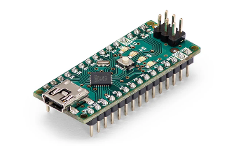
3.1. Arduino Nano Development Board
Figure 8: Arduino Nano V3
The Arduino Nano V3 is a compact, versatile, and widely used microcontroller board based on the ATmega328P microcontroller. The board operates at 5V and can be powered via a 7-12V input voltage (VIN) or directly through the 5V pin. It includes a mini-USB port for programming and power supply, making it easy to connect. The easy- to use programming of this microcontroller is responsible for low-level DC motor control of the swarm vehicle and sensor integration.

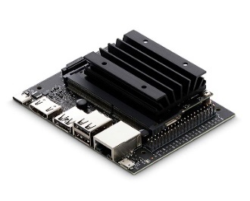
3.2. Jetson Nano Development Board
Figure 9: Jetson Nano Development Kit
Jetson Nano is a powerful and compact embedded computing platform equipped with a 64-bit quad-core ARM Cortex-A57 CPU and a 128-core NVIDIA Maxwell GPU, delivering robust computational power for running AI algorithms and deep learning models. It supports 4GB of LPDDR4 RAM, ensuring smooth multitasking and efficient data processing. The expansion is mounted on the kit, which utilizes 11.1v from battery and runs the kit. The Jetson Nano Development Kit is used to implement AI algorithm due to its high-level computation, including AI-based navigation and decision-making which helps the swarm vehicle to work on different environmental scenarios.

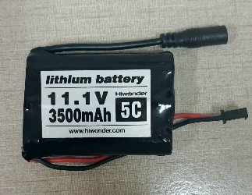
3.3. 11.1V Li-Ion Rechargeable Battery
Figure 10: Li-Ion Battery
A reliable and efficient energy source is used to power the system. For that purpose, the system is powered by an 11.1V, 3500mAh lithium-ion battery as shown in figure 10. This battery offers a high energy density, ensuring a compact yet powerful solution for the robot. With a 3500mAh capacity, it delivers sustained power for prolonged usage while maintaining a lightweight profile.

3.4. Encoder DC Motor (GA25-370)
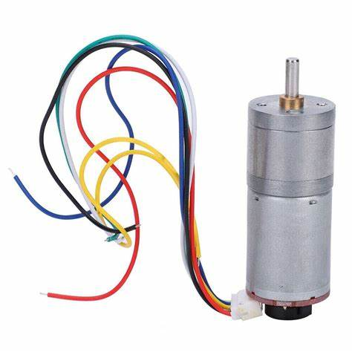
An encoder DC motor is essential for robotic applications, providing precise speed and position control. It has built-in encoder that generates feedback signals, enabling accurate motion tracking and closed-loop control. The GA25-370 motors run at a nominal voltage of 12V and have a rated speed of 280 RPM under no-load conditions as shown in figure 11. The motors are equipped with a built-in quadrature encoder, which typically generates 11 pulses per revolution (PPR). The pinout of this encoder motor is shown in table 1. Due to its compact and durable design having 25mm diameter and a metal gearbox enhances the robot's efficiency, stability, and responsiveness in dynamic environments.
Figure 11: Encoder DC Motor
Colour | Pin# | Functionality
Red | 1 | Motor+
Black | 2 | GND
Yellow | 3 | Encoder Signal Feedback1
Green | 4 | Encoder Signal Feedback2
Blue | 5 | +5V
White | 6 | Motor-

Table 1: Encoder DC Motor Pinout

3.5. Motor Driver Shield (L298N)
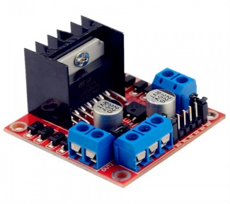
A motor driver shield is a crucial component and act as an interface between a microcontroller and the motors, providing the necessary power amplification and direction control. The L298N Motor Driver Module is a dual H-bridge motor driver integrated circuit designed to control and drive DC motors as shown in figure 12. The L298N Motor Driver Module is capable of driving two DC motors. It supports a wide operating voltage range, typically from 5V to 35V, and can deliver a continuous current of up to 2A per channel (with a peak current of 3A). The pinout of this module is shown in table 2.
Figure 12: Motor Driver Shield
Pin Name | Functionality
ENA | Enable pin for Motor A
IN1 | PWM Signal Motor
IN2 | PWM Signal Motor
IN3 | PWM Signal Motor
IN4 | PWM Signal Motor
ENB | Enable pin for Motor B
OUT1 | Motor Connection
OUT2 | Motor Connection
OUT3 | Motor Connection
OUT4 | Motor Connection
V_{CC} | Supply Voltage for Motors
GND | Ground
V_{ref} | Reference Voltage  Internal Reference: Jumper is connected  External Reference: Jumper is not connected
Table 2: Motor Driver Shield Pinout

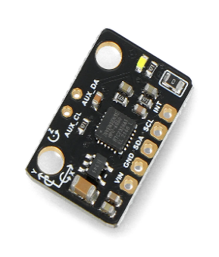
3.6. IMU Sensor (MPU-6050)
Figure 13:IMU Sensor
The MPU-6050 is a 6-axis Inertial Measurement Unit (IMU) sensor that integrates a 3-axis gyroscope and a 3-axis accelerometer, making it ideal for motion tracking, robotics, and gesture-based applications. it features a Digital Motion Processor (DMP) that handles motion calculations internally, reducing the processing load on the microcontroller. It communicates with microcontroller (Jetson Nano) via the I2C interface as shown in table 3.
Pin Name | Functionality
V_{CC} | Supply Voltage (+5V)
GND | Ground
SCL | Serial I2C Clock
SDA | Serial I2C Data
Table 3: IMU Sensor Pinout

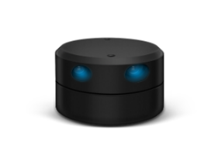
3.7. 2D-LIDAR (YDLIDAR G4)
Figure 14: 2D LIDAR
The YDLIDAR G4 is a 360-degree 2D LiDAR sensor, designed for applications requiring precise environmental mapping and navigation. Utilizing triangulation technology, it delivers high-frequency and high-accuracy distance measurements. This sensor features a high-speed ranging capability with a frequency of up to 9000Hz, enabling rapid acquisition of detailed point cloud data for accurate environmental representation. It offers an extended detection range, capable of identifying objects within a radius of up to 16 meters, accommodating various operational environments. The G4 supports an adjustable scanning frequency between 5Hz and 12Hz It provides high angular resolution, featuring an angular resolution of 0.28 degrees, ensuring precise detection and mapping of environmental features.

3.8. Depth Camera (RealSense D435)
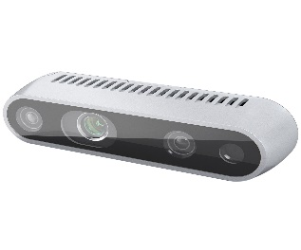
A depth camera is a device that captures three-dimensional information about a scene by measuring the distance between the camera and objects within its field of view. This capability enables applications such as gesture recognition, object tracking, and environmental mapping in robotics. The depth camera connects with jetson Nano hardware to provide the real time video feed to the system.
Figure 15: Depth Camera

Block Diagram of the System
The Swarm Vehicle replicates the autonomous systems that operate collectively to perform complex tasks efficiently. Inspired by natural swarms like birds, fish, and insects, these vehicles communicate and collaborate to achieve objectives such as surveillance, coordination and control, environmental monitoring, and military applications. Unlike a single autonomous vehicle, swarm vehicles rely on decentralized control, self-organization, and real-time data sharing to adapt to dynamic environments. Their ability to function as a coordinated unit enhances redundancy, scalability, and robustness, making them ideal for missions in unknown terrains.
The block diagram of a swarm vehicle provides a structural overview of its key components and their interactions. Different types of sensors like LIDAR, depth camera and IMU are integrated on the robot chassis for the environmental perception, communicate between the modules. The Arduino microcontroller is mainly utilized in this system for the low-level programming of the system. The DC motors are controlled through low-level microcontroller (Arduino) through motor driver shield. The 11.1V battery is used to provide accurate and sufficient power to the motors. The block diagram of the swarm vehicle is shown in figure 16.
The main controller Jetson Nano board provides a smooth platform for implementing AI and robotics algorithms on the system and communicates with other modules and devices to control the autonomous decisions. The communication between both the high-end controller (Jetson Nano) and low-end controller (Arduino) is perform through the UART communication protocol via USB port. The Arduino takes the feedback pulses from the encoder available on the motor to create feedback closed loop system for accurate and precise movement of the robot. The 2D LIDAR sensor maps the overall environment in which the robot chassis is moving and helps the AI algorithm which is implemented on the main controller to control the movement of the robot so that it does not hit with any objects present in the environment. With the help of depth camera, AI models can get the real time feed of the environment and helps the robot to implement AI algorithms like gesture recognition, object tracking, 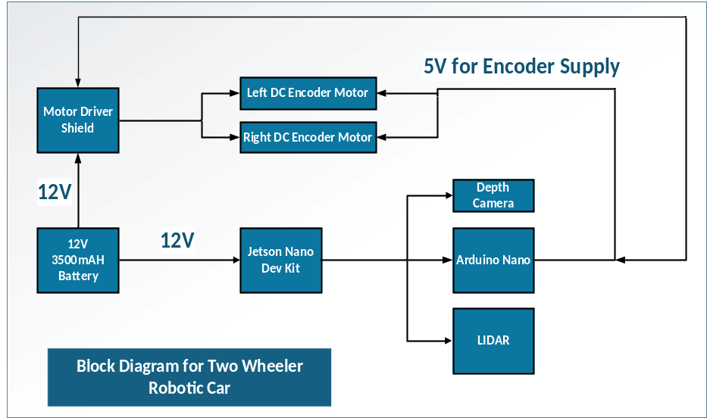obstacle avoidance and swarm applications.

Figure 16: System Block Diagram

Hardware Connection of the System
The system mainly utilizes two voltage sources:
1. The 12V, 3500mAh battery is consumed by the motor driver shield, Jetson Nano expansion board which converts it to 5V on which Jetson Nano controller runs.
2. The 5V available on the Arduino is used by motor encoder for the encoder pulses and used by the motor driver as an external voltage reference to the driver.
The battery consumption time on full load is approximately 1.5 to 2 hours on full charged. The PWM pulses given to the encoder which control the direction and speed of the motor is connected with Arduino digital pins to generate the PWM signals. As, the enable pins for the motor (ENA and ENB signals) are shorted with 5V voltage source through a jumper available on the module so that it will always enable and ready to take any PWM signal input. Two DC motors are connected at a time at the motor driver on the available connector having pins OUT1, OUT2, OUT3 and OUT4 respectively. To communicate the motor and control the motor speed, the Arduino is connected to Jetson Nano via USB port through USB cable. Similarly, the depth camera and LIDAR are USB powered so they are connected also with USB port available on the Jetson Nano. The connection between different modules is shown in table 4. The complete electrical schematic diagram of the robot is show on figure 18.

Assembly Instruction
Follow the steps to assemble the swarm vehicle correctly as shown in figure 17.

Conclusion
The critical aspects of the swarm vehicle of the robot are discussed including the mechanical, electrical, block diagram and overall workflow of the system. The mechanical design was created to assure structural integrity and endurance, and the hardware components were carefully chosen to fulfill performance and compatibility standards. The electrical design focused on power distribution, signal integrity, and safety considerations. The block diagram provided a high-level overview of system interactions, and the schematic design detailed the circuit implementation for precise execution. By integrating these elements cohesively, we have created a robust foundation for system development. This structured approach ensures that the design meets technical requirements and operational expectations, paving the way for successful implementation and deployment.
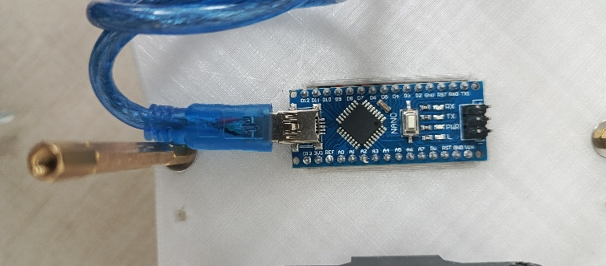
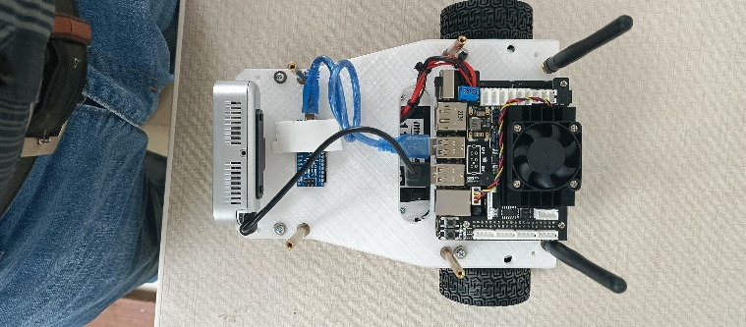
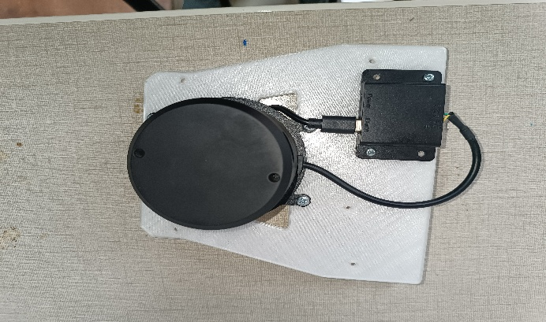
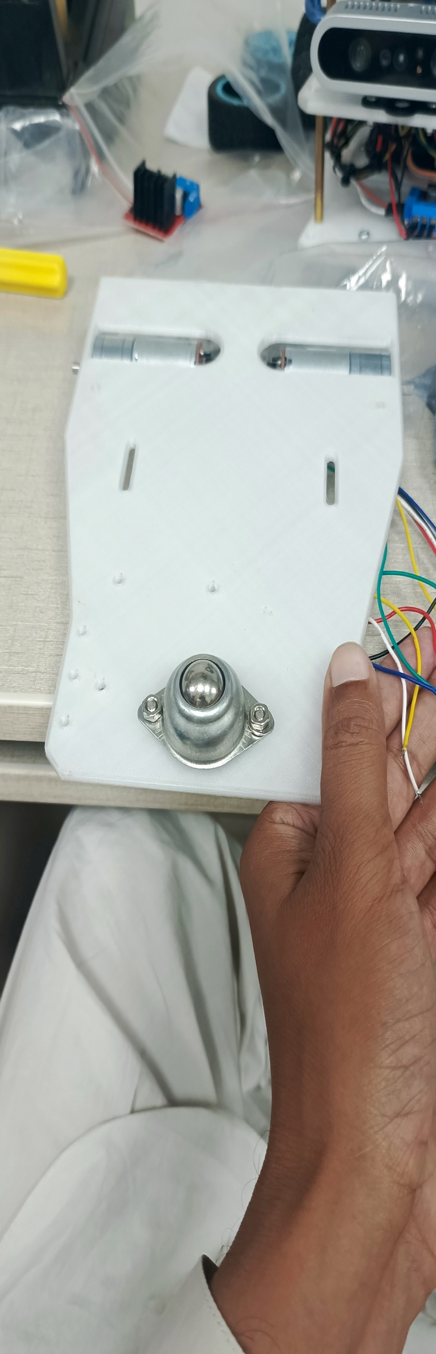
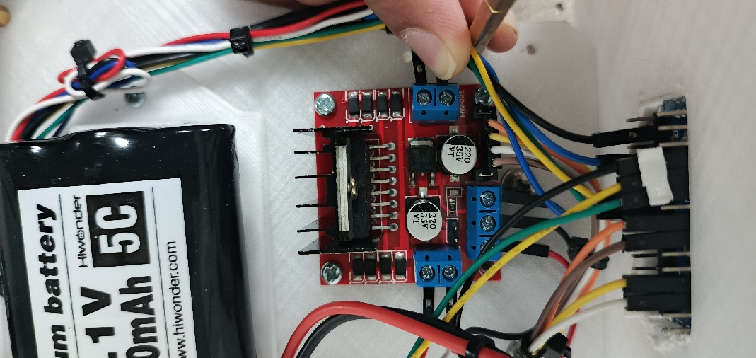
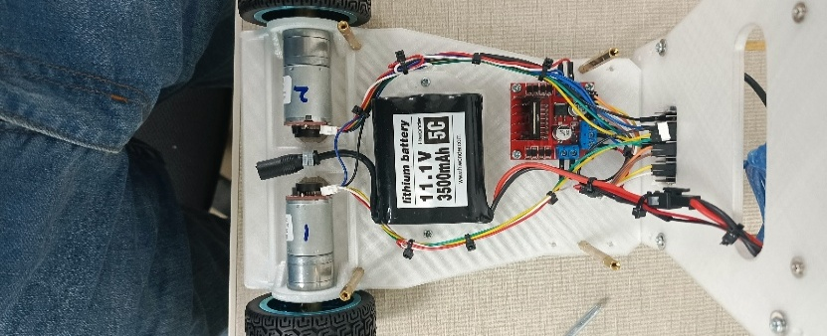
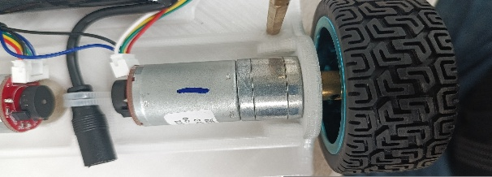
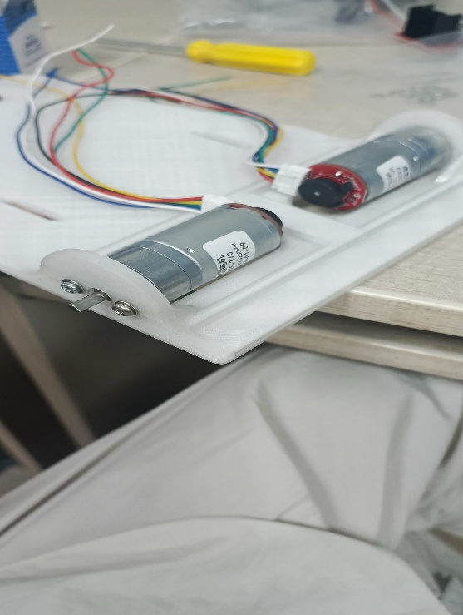
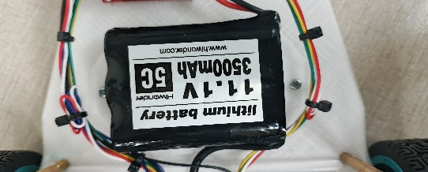
Mount the Arduino Nano onto the centre layer of the robotic car chassis using two M1 screws, aligning it with the pre-drilled holes. Position it for easy access to the USB port and wiring connections.

Step 7: Installing the Arduino Nano
Securely mount the Jetson onto the centre layer of the robotic car chassis using four female-to-female spacers, aligning with pre-drilled Then, install the camera into its designated slot with two M3 screws, ensuring it is firmly fixed and properly aligned for optimal performance antenna.

Step 8: Jetson & Camera Module Installation
Mount the Lidar module onto the Top layer of the robotic car chassis, aligning it with the designated mounting holes. Secure the module firmly using four M4 screws to ensure stability and precise sensor positioning for accurate data acquisition.
Step 9: Lidar Module Installation
Step 6: Installing the Caster Wheel
Attach the caster wheel to the underside rear of the robotic car chassis. Align the caster bracket with the pre-drilled holes on the chassis. Insert and tighten two M3 screws to secure the caster in place. Ensure the caster moves freely for smooth movement.
Install the motor driver module onto the robotic car chassis, aligning it with the pre-drilled mounting holes. Secure it firmly using four M3 screws to ensure mechanical stability and reliable electrical connections. This placement facilitates efficient integration with the power supply and control.

Step 4: Motor Driver Module Installation
In this step, connect the two DC motors to the motor driver according to the wiring diagram. Ensure that each motor's terminals are correctly linked to the corresponding outputs on the motor driver, securing reliable power and control for smooth operation.
system.
Step 5: Wiring the DC Motors to the Motor Driver
Insert the two coupling shafts into the output shafts of the DC encoder motors, ensuring a secure and aligned fit within the motor housing. Once the coupling shafts are properly installed, attach the tyres firmly onto each shaft, ensuring balanced rotation and stable movement during operation.
Step 2: Installation of Coupling Shafts and Tyres
Step 1: Installing DC Motors on the Chassis
Begin by positioning the first DC motor on the left side of the robotic car chassis and securing it with two M3 screws. Similarly, position the second DC motor on the right side and fasten it using two M3 screws, ensuring both motors are firmly fixed for optimal performance.

Step 3: Battery Holder and Installation
Mount the battery holder onto the robotic car chassis and secure it firmly using two M3 screws. Attach the two side support chips to the frame, ensuring proper alignment with the holder. Finally, install the battery into the holder, ensuring a stable and reliable connection.

Figure 17: Assembly Instruction for Swarm Vehicle

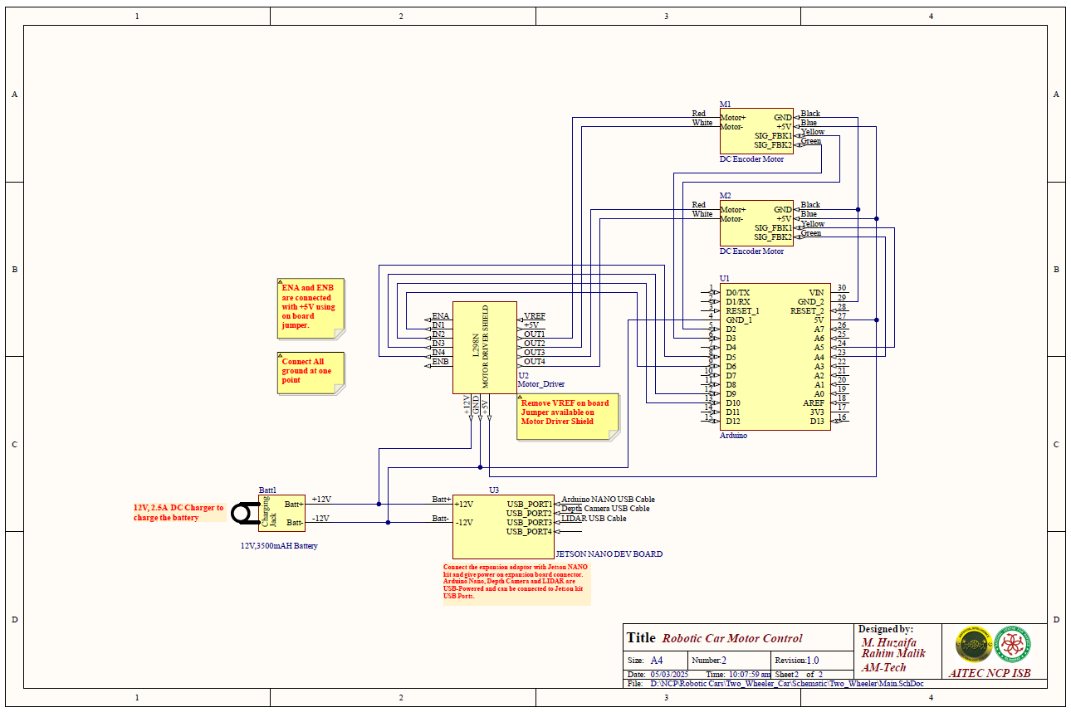
Figure 18: Hardware Connection of System

DC MOTOR1
Motor Signal | Connected to Motor Driver Shield |  | Connected to Arduino
Motor+ (Red) | OUT1 |  | -
GND (Black) | - |  | GND of Arduino board
Encoder Signal Feedback1 (Yellow) | - |  | D2
Encoder Signal Feedback2 (Green) | - |  | D3
+5V (Blue) | - |  | +5V of Arduino board
Motor- (White) | OUT2 |  | -
DC MOTOR2
Motor Signal | Connected to Motor Driver Shield |  | Connected to Arduino
Motor+ (Red) | OUT3 |  | -
GND (Black) | - |  | GND of Arduino board
Encoder Signal Feedback1 (Yellow) | - |  | A5
Encoder Signal Feedback2 (Green) | - |  | A4
+5V (Blue) | - |  | +5V of Arduino board
Motor- (White) | OUT4 |  | -
Motor Driver Shield
Signal |  | Connected to Arduino
IN1 |  | D6
IN2 |  | D10
IN3 |  | D9
IN4 |  | D5
ENA |  | Short with on board Jumper (5V)
ENB |  | Short with on board Jumper (5V)
+5V Voltage Supply
Signal |  | Connected to
+5V |  | Motor 1 Encoder V_{CC}
 |  | Motor 2 Encoder V_{CC}
 |  | Motor Driver Shield V_{ref}
+12V Voltage Supply
Signal |  | Connected to
+12V |  | Motor Driver Shield V_{cc}
 |  | Jetson Nano Expansion Module
GND |  | Connect all power supply and modules ground at one common point
Table 4: Hardware Connections
Connection between different modules of the robot vehicle:

