Technical Document: Mechanical Structure of Autonomous Mobile Robot

1. Overview
This document outlines the mechanical design and structure of a custom-built Autonomous Mobile Robot (AMR), primarily designed for indoor applications with modular sensing and computing capabilities. The robot frame consists of three 3D-printed plates made from CPE (copolyester) material, each with specific roles in supporting sensors, controllers, and drive mechanisms.

2. Material and Manufacturing
- Material: CPE (Copolyester)
- Manufacturing Method: FDM 3D Printing
- Plate Thickness: 3 mm (all three plates)
- Properties of CPE: High impact resistance, moderate flexibility, excellent dimensional stability under load and temperature.

3. Dimensions
Plate | Length (mm) | Width (mm) | Thickness (mm)
Bottom Plate | 212 | 150 | 3
Middle Plate | 212 | 150 | 3
Top Plate | 150 | 150 | 3

4. Structural Design and Mounting

4.1 Bottom Plate
- Function: Mounts the motors, caster wheel, and power electronics.
- Reinforcement: Structural ribs and thickened motor mount sections improve load-bearing capability near motor fixation areas.
- Drive System:
- 2 Rear Wheels: Driven by geared DC motors mounted on the bottom plate.
- 1 Front Caster Wheel: Provides passive stability and maneuverability.

4.2 Middle Plate
- Function: Hosts computing and control units.
- Components Mounted:
- NVIDIA Jetson Module
- Camera System
- Wiring Slots and Mounting Holes: Strategically designed for clean cable management and component mounting.

4.3 Top Plate
- Function: Sensor mounting.
- Components Mounted:
- 2D LiDAR Sensor (centered and raised using a standoff mount)
- Slots for airflow, wiring, and optional add-ons.

5. Load Handling and Deformation
The design was validated with finite element analysis (FEA) under a 2 kg payload, simulating the total weight from electronics and sensors.
- Max Deformation:

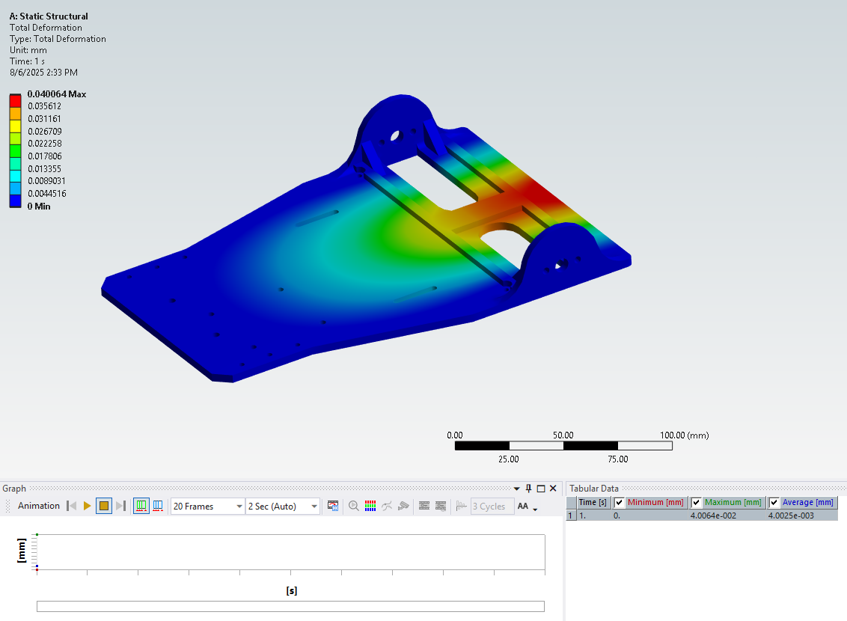
- Observation: The critical regions with minimal deformation were near the motor mount sections, proving structural reinforcement effectiveness.

6. Assembly and Modularity
All three plates are held together using M3 screws and standoffs.
The modular sandwich structure allows:
- Easy component replacement or upgrades.
- Quick access for maintenance.
- Light-weight yet rigid assembly, suitable for agile indoor navigation.

7. Summary
This AMR’s mechanical structure offers a lightweight, modular, and functional platform for autonomous tasks. The use of CPE and careful 3D printing design (with load-focused reinforcement) ensures structural durability, even with delicate components like Jetson and LiDAR mounted onboard.

