Customer Value Forecasting System: Modeling Purchase Lifecycles to Maximize Retention
Made by Huzaifa Saqib | 17 October 2026
Executive Summary
This project builds a customer value forecasting system on retail transaction data from January 2022 to December 2025. Using purchase history up to the end of 2024, it predicts how much each of 11,459 customers will spend in 2025, estimates whether each customer is still active, and flags customers who are drifting away. Probabilistic models (BG/NBD and Gamma-Gamma) were combined with XGBoost, and the outputs were turned into value segments, a time-to-second-purchase analysis, a churn and win-back framework, and a SHAP explanation of what drives the forecasts.
Headline | Result
Forecast accuracy (2,292 unseen customers) | Hybrid XGBoost: MAE 811.90, RMSE 1,436.69, R² 0.60. This beats the behavioural-only model (MAE 817.58) by under 1%.
What drives revenue | Spend per order (AverageOrderValue) and TotalRevenue account for about two-thirds of model importance. Purchase frequency barely matters.
Customer lifecycle | Roughly half of new customers make a second purchase within about 110 days, and about 90% do so eventually (read from the survival curve).
Churn | 3,481 customers (30.4%) are churned; 99.7% of them are in the Low-Value segment. Only 11 churned customers are VIP, Loyal or Occasional.
Win-back | 1,414 customers sit in the 300 to 400 day Win-Back window, 311 of them VIP or Loyal. A 10% recovery scenario is worth about $307,339 (assumption-based).

Main recommendation: act on the Win-Back window now, starting with the 311 high-value customers, build lifecycle nudges around the first 100 to 200 days after a first purchase, and treat the Low-Value segment with low-cost automated contact only. Section 7 gives the full action plan.
1. Data and Cleaning
The dataset holds order-line transactions (customer, order, product, category, country, date, quantity, unit price). The analysis window is 1 January 2022 to 31 December 2025. Revenue is Quantity x UnitPrice, summed to order level. Rows with negative quantity are kept as returns, so a customer's revenue is net of returns.
Issue found | Action taken | Reason
Missing values | Rows with missing fields dropped | Incomplete records cannot be modelled reliably
Mixed date formats | Parsed with flexible date parsing | Consistent time ordering
Dates outside 2022 to 2025 | Rows removed | Outside the analysis window
Negative unit prices | Converted to absolute values | Treated as sign entry errors
Zero quantity or zero price | Rows removed | No commercial meaning
Extreme prices (above 1,292.04) | Rows removed | Outliers chosen after inspecting the upper price percentiles
Inconsistent text | Trimmed and standardized IDs, product, category and country | Avoids duplicate labels
Country variants (UK, U.S.A., UAE...) | Mapped to United Kingdom, United States, United Arab Emirates | One label per country
2. Methodology
Design. The data was split in time. Orders up to 31 December 2024 form the calibration period used to build features; 2025 is the holdout period used as the target. 11,459 customers have at least one order before 2025.
Probabilistic models. BG/NBD (penalizer 0.001) uses each customer's repeat orders, recency and tenure to estimate the probability the customer is still active (P_active) and the expected number of 2025 purchases. Gamma-Gamma (penalizer 0.001) estimates expected order value from customers with repeat purchases. Predicted_2025_Revenue is expected purchases multiplied by expected order value.
Machine learning. Two XGBoost regressors predict each customer's actual 2025 revenue (zero if they did not buy): a behavioural model (21 inputs) and a hybrid model (25 inputs, adding the four probabilistic outputs). Settings: 500 trees, learning rate 0.05, depth 4, 80% row and column sampling, random seed 42. An 80/20 random split gives 9,167 training and 2,292 test customers.
Feature group | Features | Count
Lifecycle | TotalOrders, Frequency, Recency, Tenure | 4
Monetary | TotalRevenue, AverageOrderValue, RevenueStd | 3
Purchase timing | AverageInterval, IntervalStd | 2
Product variety | UniqueProducts, UniqueCategory | 2
Returns | ReturnCount, TotalReturnValue, ReturnRate | 3
Recent activity | RecentOrders90/180, RecentRevenue90/180 | 4
Missing-value flags | RevenueStd, AverageInterval, IntervalStd (missing for one-order customers) | 3
Probabilistic (hybrid only) | P_active, 2025_Predictions, Expected_Monetary_Value, Predicted_2025_Revenue | 4

Segmentation and lifecycle. Customers are ranked by hybrid predicted revenue: top 10% VIP, next 20% Loyal, next 20% Occasional, bottom 50% Low-Value. A Kaplan-Meier curve measures time from first to second purchase for customers acquired 2022 to 2024. Churn status uses days since last purchase at 31 December 2025: Active (under 300), Win-Back (300 to 400), Churned (over 400). Missing values: spread measures were set to 0 with a flag, and probabilistic gaps were filled with the median.
3. Results
3.1 Forecasting performance
Model | Target | MAE | RMSE | R²
BG/NBD + Gamma-Gamma | Purchase count | 1.11 | 1.60* | n/a
Behavioural XGBoost | Customer revenue | 817.58 | 1,440.29 | 0.60
Hybrid XGBoost | Customer revenue | 811.90 | 1,436.69 | 0.60
* The BG/NBD run reports a mean squared error of 2.55; the square root is shown for comparability. It measures purchase counts, so it cannot be compared directly with the revenue models.
The hybrid model improves MAE by about 0.7% and RMSE by about 0.25%, with identical R². On a single split this gap is too small to call a real improvement; most of the probabilistic information was already captured by the behavioural features.
3.2 Customer segments and churn status
Segment | Rule (predicted 2025 revenue) | Customers | Active | Win-Back | Churned
VIP | Top 10% | 1,145 | 1,076 (94.0%) | 68 (5.9%) | 1 (0.1%)
Loyal | Next 20% | 2,292 | 2,043 (89.1%) | 243 (10.6%) | 6 (0.3%)
Occasional | Next 20% | 2,292 | 2,010 (87.7%) | 278 (12.1%) | 4 (0.2%)
Low-Value | Bottom 50% | 5,730 | 1,435 (25.0%) | 825 (14.4%) | 3,470 (60.6%)
Total |  | 11,459 | 6,564 (57.3%) | 1,414 (12.3%) | 3,481 (30.4%)

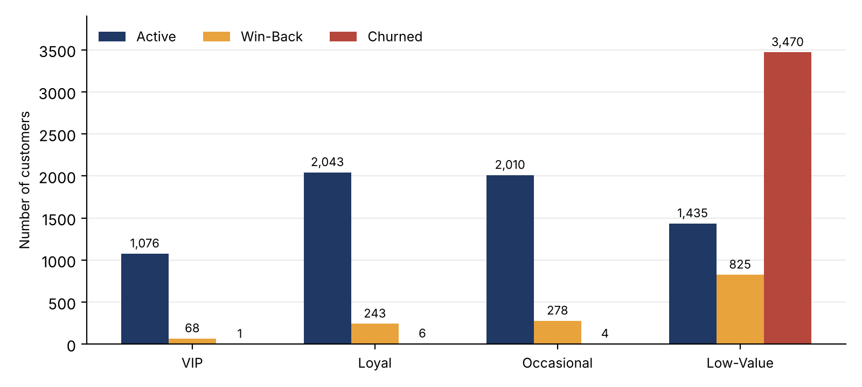
Figure 1. Customers by value segment and churn status.
Churn is almost entirely a Low-Value problem: 3,470 of the 3,481 churned customers (99.7%) are in that segment. Value segments and churn status are not independent, since both reflect how recently a customer has been buying.
3.3 Purchase lifecycle (Kaplan-Meier)
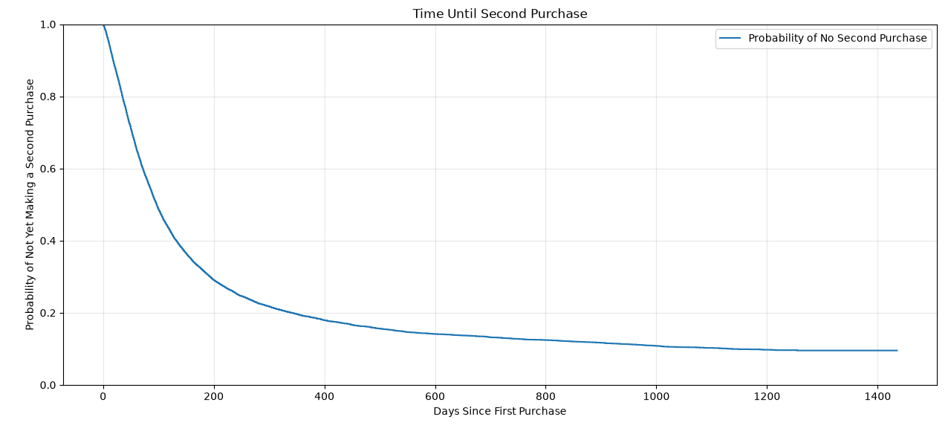
Figure 2. Probability that a customer has not yet made a second purchase.
Days since first purchase | Not yet made 2nd purchase | Made 2nd purchase
About 110 | About 50% | About 50%
200 | About 29% | About 71%
400 | About 18% | About 82%
1,000 and beyond | About 10% | About 90%
Values are read from the curve and are approximate.
Second purchases happen early: the curve drops fastest in the first 200 days and then flattens, so a customer who has not returned within about a year is unlikely to return without intervention.
3.4 Win-back simulation
Simulation item | Result
Total customers | 11,459
Win-Back customers available (300 to 400 days) | 1,414
Targeted (10% of the Win-Back pool) | 141 customers (1.23% of all customers)
Total predicted value in the Win-Back pool | $3,073,387.46
Projected revenue recovered (10% win) | $307,338.75
Increase vs. predicted revenue of Active customers | 1.2%

Recovery rate (illustrative) | Customers recovered | Revenue recovered | Uplift
5% | 71 | $153,669 | 0.6%
10% (simulated) | 141 | $307,339 | 1.2%
20% | 283 | $614,677 | 2.4%
The 5% and 20% rows scale the simulated 10% result in a straight line. They are illustrations, not forecasts, and exclude campaign costs.
4. Model Explainability (SHAP)
SHAP assigns each feature a fair share of the gap between a customer's prediction and the average prediction (baseline 1,802), using Shapley values from game theory. The contributions add up exactly to the prediction. It was applied to the 2,292 test customers of the hybrid model.
Rank | Feature | Mean |SHAP| (approx.) | Reading
1 | AverageOrderValue | 950 | Higher order value raises predicted revenue
2 | TotalRevenue | 560 | Past spend predicts future spend
3 | Expected_Monetary_Value | 165 | Smoothed order value (Gamma-Gamma)
4 | Predicted_2025_Revenue | 75 | Probabilistic revenue estimate
5 | IntervalStd | 65 | Variation in time between orders
Bottom | Frequency, RecentOrders90, ReturnRate | Under 10 | Little influence on the forecast

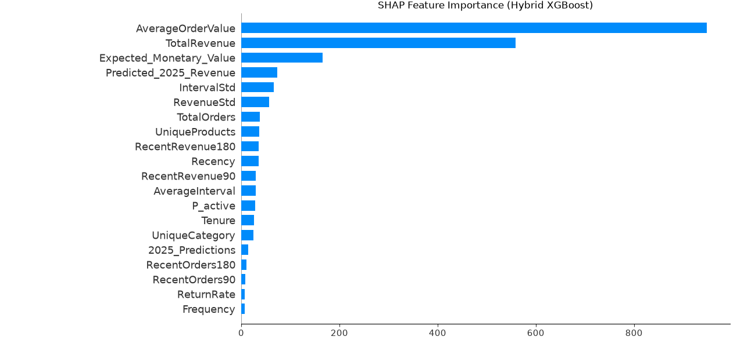
Figure 3. Mean |SHAP| feature importance (hybrid XGBoost).
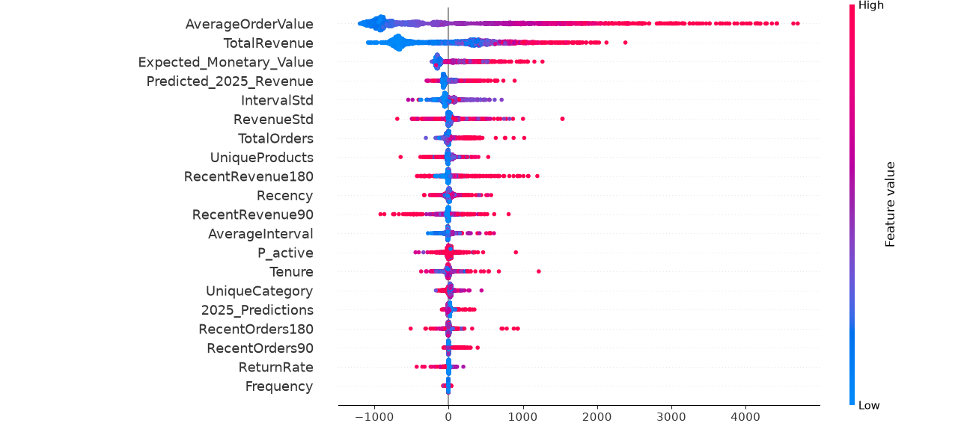
Figure 4. SHAP summary: each dot is a customer; red is a high feature value, blue is low.
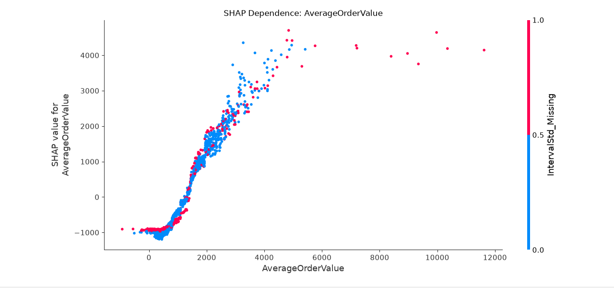
Figure 5. Effect of AverageOrderValue on the prediction: flat floor, steep climb, then a plateau.
- Spending dominates. AverageOrderValue and TotalRevenue make up about two-thirds of total importance. The four probabilistic features together hold about 13%, which explains the small hybrid gain.
- The order value effect is S-shaped. Below about 500 the effect is flat at roughly -1,000; from about 500 to 4,000 it rises almost linearly to about +4,000; above about 5,000 it levels off, probably because few customers have such values.
 | Cust04608 (highest forecast) | Cust00499 (lowest forecast)
Segment / churn status | VIP / Active | Low-Value / Win-Back
Orders to 2024 / average order value | 21 / 2,905 | 4 / -100
Main drivers | AOV +3,729; RevenueStd +1,535; TotalRevenue +1,515 | AOV -979; TotalRevenue -661; Expected_Monetary_Value -140
Predicted vs. actual 2025 revenue | 13,289 vs. 4,333 | -122 vs. 0
The highest forecast overshot by about 9,000, a typical case of the largest prediction also being the most over-optimistic. The lowest forecast is negative because the customer's returns exceeded purchases.
5. Assumptions
# | Assumption
1 | Customer revenue is net of returns; customers with no 2025 orders have 2025 revenue of zero.
2 | Behaviour from 2022 to 2024 is a fair guide to 2025, tested on a single holdout year with one random 80/20 customer split.
3 | Negative unit prices are sign errors; zero-price or zero-quantity rows are invalid; prices above 1,292.04 are outliers.
4 | BG/NBD assumes customers buy at random while active and can become inactive permanently; Gamma-Gamma assumes order value is unrelated to purchase frequency.
5 | The 300 and 400 day churn thresholds and the 10/20/20/50 segment cut-offs are business choices, not derived from the data.
6 | The win-back simulation assumes 10% of the Win-Back pool is recovered at its predicted value, with no campaign cost.
6. Limitations
Limitation | Impact
Returns counted as purchases | Return orders enter purchase frequency and the second-purchase event, and net-negative customers produce negative order values and one negative forecast (-122).
Segments use in-sample predictions | About 80% of customers were in the model's training data when segmented, so segment boundaries may be slightly optimistic.
No naive baseline or cross-validation | R² of 0.60 has no reference point, and the 0.7% hybrid gain is not shown to be statistically real.
Over-prediction at the extremes | The highest forecasts are the least reliable (13,289 predicted vs. 4,333 actual); sparse data at high order values limits learning there.
Win-back value is rough | Pool value rests on predicted purchases, which were rounded down to whole numbers, and on customers who are already 300 to 400 days inactive. Direction of error is uncertain.
BG/NBD validation | Predictions were truncated to integers and the 2.55 figure is a squared error, so the BG/NBD error is shown less precisely than it could be.
Overlapping features and association only | Correlated revenue features share SHAP credit, and SHAP shows what the model relies on, not what causes spending.
Descriptive survival analysis | The Kaplan-Meier curve has no customer-level drivers; the Cox model was not fitted.
7. Recommendations for Stakeholders
The actions below are ordered by expected value and ease. Treat revenue figures as scenarios and confirm each action with a controlled test before scaling.
When | Segment / area | What to do | Success measure
Now | Win-Back: VIP and Loyal (311) | Personal outreach with a tailored offer before these customers pass the 400 day line. | Reactivation rate; revenue vs. the $307k scenario
Now | Win-Back: Occasional (278) | Automated reminder sequence with a time-limited incentive. | Reactivation rate; cost per reactivation
Now | Low-Value (5,730; 3,470 churned) | Low-cost automated email only; avoid discounts and paid media. | Cost per customer kept low
Next | New customers | Trigger a follow-up around day 60 to 100 without a second purchase, since about half of new customers have made a second purchase by day 110. | Second-purchase rate within 200 days
Next | VIP (1,145) | Account management and an alert when a VIP nears the 300 day Win-Back line. | VIP Active rate (now 94%)
Next | Loyal to VIP | Grow order value through bundles, upsell and basket thresholds; the model shows order value, not frequency, drives revenue. | Average order value; share moving to VIP
Next | Returns | Review returns policy and capture return reasons; track net-negative customers. | Return rate; net revenue per customer
Later | Model governance | Refresh the model quarterly, fix the limitations in Section 6, and re-measure against a baseline. | MAE and R² vs. baseline each quarter
8. Technical Next Steps
- Fix the data logic: separate returns from purchases, clip forecasts at zero, and keep BG/NBD predictions as decimals.
- Prove the model: add a naive baseline (2025 revenue predicted as 2024 revenue) and 5-fold cross-validation for both models.
- Make segments honest: use out-of-fold predictions for segmentation, and set churn thresholds from purchase-interval data.
- Extend the analysis: fit a Cox model for second-purchase drivers, test a log-transformed target, and add costs and ROI to the win-back scenarios.

