
FAST- NATIONAL UNIVERSITY OF COMPUTER & EMERGING SCIENCES

DATA ANALYSIS FOR BUSINESs - I
Project Name: Trade Openness and Economic Productivity - Cross Country Analysis

Prepared by:
Huzaifa Saqib 25k-5033
Fatima Farhat 25k-5001
Sadhna Goswami 25k-5021
Noor Fatima Khan 25k-5027
Muhammad Hamza 25k-5034
Anas Shariq 23k-5043

Class: BSBA-2A
Course Instructor: Sir Anwar Mughees
Submission Date: 9th May 2026

Abstract
This study examines the relationship between trade openness and economic productivity across 125 countries using cross-sectional data from the World Development Indicators (WDI) for the year 2022. The dependent variable is GDP per capita, while the independent variables include trade openness, foreign direct investment inflows, electricity consumption, and mobile subscriptions per 100 people. Descriptive analysis reveals significant global income inequality, with most countries concentrated in the middle-income range. Results indicate that electricity consumption is the strongest predictor of GDP per capita (R² = 0.576), followed by mobile subscriptions (R² = 0.22) and trade openness (R² = 0.1589). Trade openness shows a consistent positive relationship with economic prosperity, supported by both regression analysis and income group comparisons. These findings suggest that trade openness, infrastructure, and digital connectivity together play significant roles in driving economic productivity across nations.

1. Introduction
In an increasingly globalized world, trade openness has long been considered a key driver of economic growth and productivity. Countries that engage more actively in international trade benefit from technology transfer, economies of scale, access to foreign capital, and greater market competition. However, the relationship between trade and economic prosperity is multidimensional infrastructure quality, digital connectivity, and foreign investment also play critical supporting roles.
This study investigates the following research question: Does greater trade openness, supported by FDI inflows and infrastructure development, translate into higher GDP per capita across countries?
Understanding this relationship has important implications for policymakers and businesses operating in emerging markets, particularly in regions like South Asia and Sub-Saharan Africa where trade policy reform is actively debated. By analyzing 125 countries simultaneously, this study provides a comprehensive global perspective on the drivers of economic productivity.

2. Data

Source and Sample

All data was retrieved from the World Bank's World Development Indicators (WDI) database.

Year: 2022 was selected as the base year as it provides the most complete cross-country coverage across all variables.

Sample: The initial dataset contained 266 observations including individual countries and World Bank regional aggregates. After removing three outliers Luxembourg (Trade % GDP: 412%), Hong Kong (384%), and Singapore (332%) due to their roles as international financial and re-export hubs, and dropping observations with missing values, the final sample consists of 125 countries.

Variable Definitions
Variable | Role | Description / WDI Code
GDP per Capita (USD) | Dependent (DV) | GDP per capita, constant USD (NY.GDP.PCAP.KD). Log-transformed for regression.
Trade (% GDP) | Independent (IV1) | Exports + Imports as % of GDP (NE.TRD.GNFS. ZS). Proxy for trade openness.
FDI Inflows (% GDP) | Independent (IV2) | Net FDI inflows as % of GDP (BX.KLT.DINV.WD.GD.ZS). Measures foreign investment.
Electricity Consumption | Independent (IV3) | Electric power consumption kWh per capita (EG.USE.ELEC.KH.PC). Physical infrastructure proxy.
Mobile Subscriptions | Independent (IV4) | Mobile cellular subscriptions per 100 people (IT.CEL.SETS.P2). Digital connectivity proxy.

Preprocessing and Dropped Observations
We dropped 141 observations (out of 266) that had missing values on at least one of the five key variables. Most of these were small territories (like American Samoa) or countries with very limited statistical reporting. No imputation was performed, as it could distort cross-country comparisons. The final sample of 125 countries provides solid geographic and income-level diversity.
GDP per capita was log-transformed before running OLS regressions. This is standard practice because income data is heavily right-skewed – a handful of very rich countries would otherwise pull the regression line away from the bulk of the sample.
3. Results

3.1 Summary Statistics
Table 1 below provides the key descriptive statistics for all variables in our dataset.

Table 1: Summary Statistics (n = 125 Countries)
Variable | Mean | Min | Max
GDP per Capita (USD) | 18,245 | 503 | 109,269
Trade (% GDP) | 89.3% | 2.7% | 205%
FDI Inflows (% GDP) | 3.8% | -5.9% | 16%
Mobile Subscriptions | 119.4 | 45.82 | 207
Electricity Consump. (kWh) | 4,215 | 15 | 23,373

3.2 GDP Distribution
The histogram of Log GDP per capita reveals an approximately normal distribution across 125 countries, with most countries concentrated between Log GDP values of 8.18 and 9.27, equivalent to GDP per capita of roughly $3,600–$10,600. Very few countries represent the extremely poor or extremely wealthy ends of the spectrum, highlighting significant global income inequality.

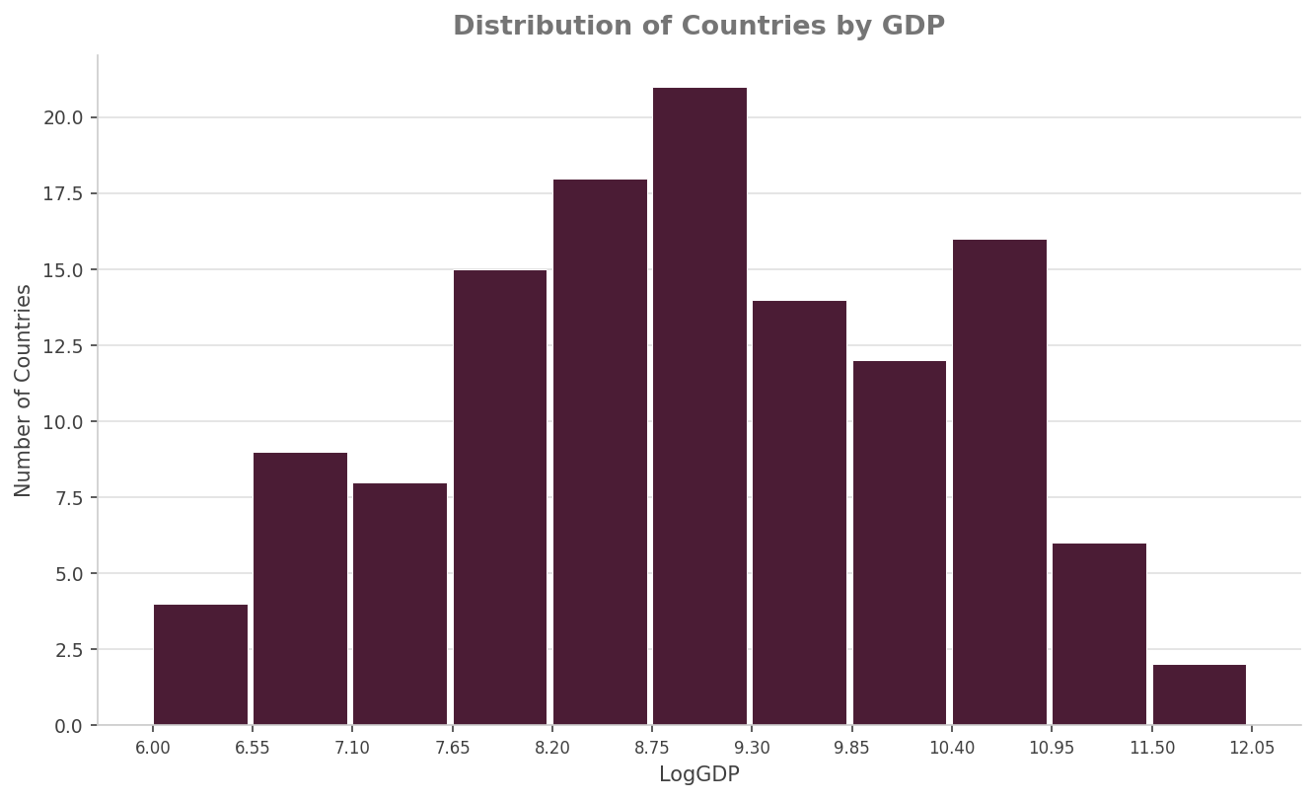

3.3 Scatterplots with OLS Fitted Lines:

The scatterplot between trade openness and Log GDP reveals a positive relationship (R² = 0.1589), indicating that countries with higher trade as a percentage of GDP tend to have higher GDP per capita. This finding is strongly supported by the bar chart analysis, which shows that high trade countries (above 100% GDP) have an average GDP of approximately $23,000, compared to $18,000 for medium trade countries and only $10,000 for low trade countries (below 60% GDP). This clear stepwise pattern confirms that trade openness is positively associated with economic prosperity across income levels.
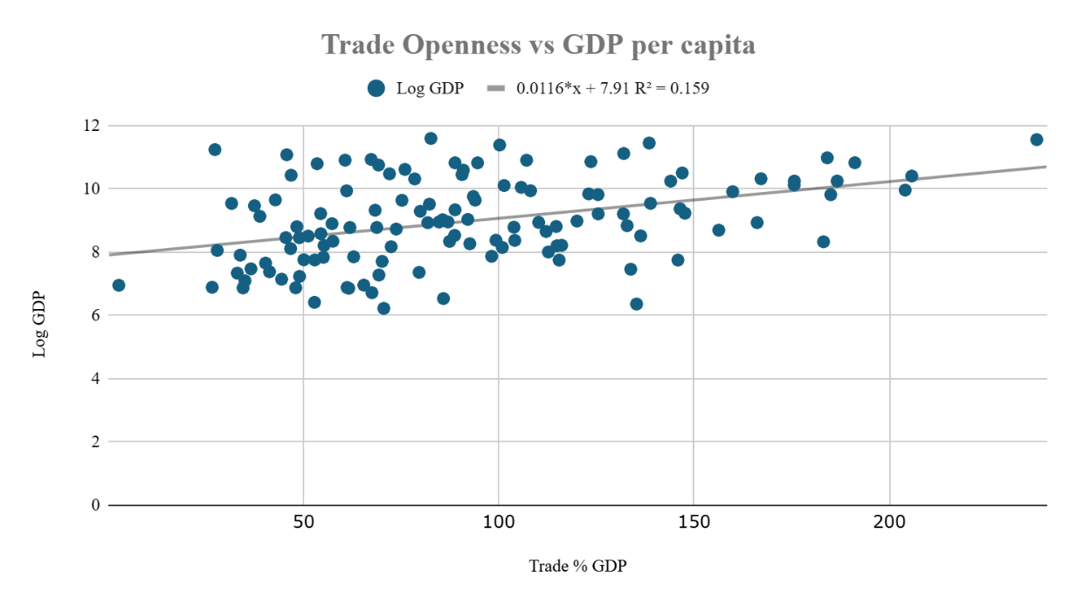

3.4 FDI and GDP:
The scatterplot between FDI inflows and Log GDP shows a limited linear relationship (R² = 0.001). While FDI is an important component of international economic integration, its direct impact on GDP per capita varies significantly across countries. In many developing nations, FDI tends to be concentrated in extractive industries such as mining and oil, which may not generate broad-based economic growth. This highlights the importance of complementary policies such as strong institutions and human capital development to maximize the productivity gains from foreign investment.

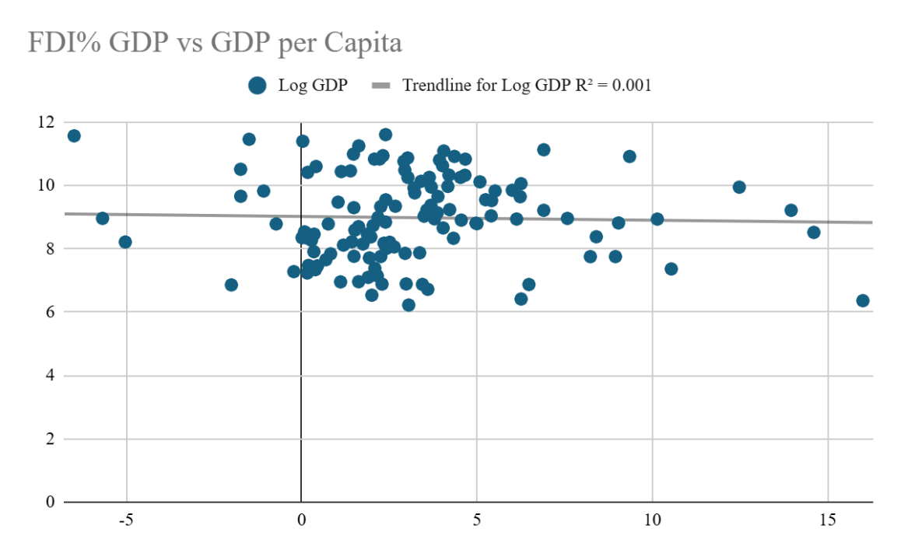

3.5 Electricity Consumption and GDP:
Electricity consumption emerges as the strongest predictor of GDP per capita among all variables analyzed (R² = 0.576). Countries with higher electricity consumption per capita consistently show higher GDP levels, confirming that energy infrastructure is a critical foundation for economic productivity. This strong relationship suggests that without adequate energy infrastructure, the benefits of trade openness and FDI cannot be fully realized.

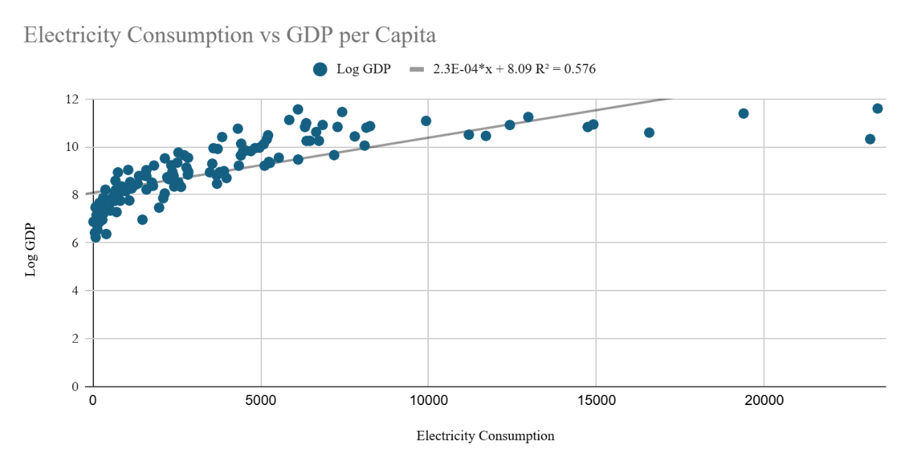

3.6 Mobile Subscriptions and GDP

Mobile subscriptions show a moderate positive relationship with GDP per capita (R² = 0.22), making it the second strongest predictor in this analysis. Countries with greater digital connectivity tend to have higher economic output, reflecting the growing importance of technology and communication infrastructure in driving modern productivity.
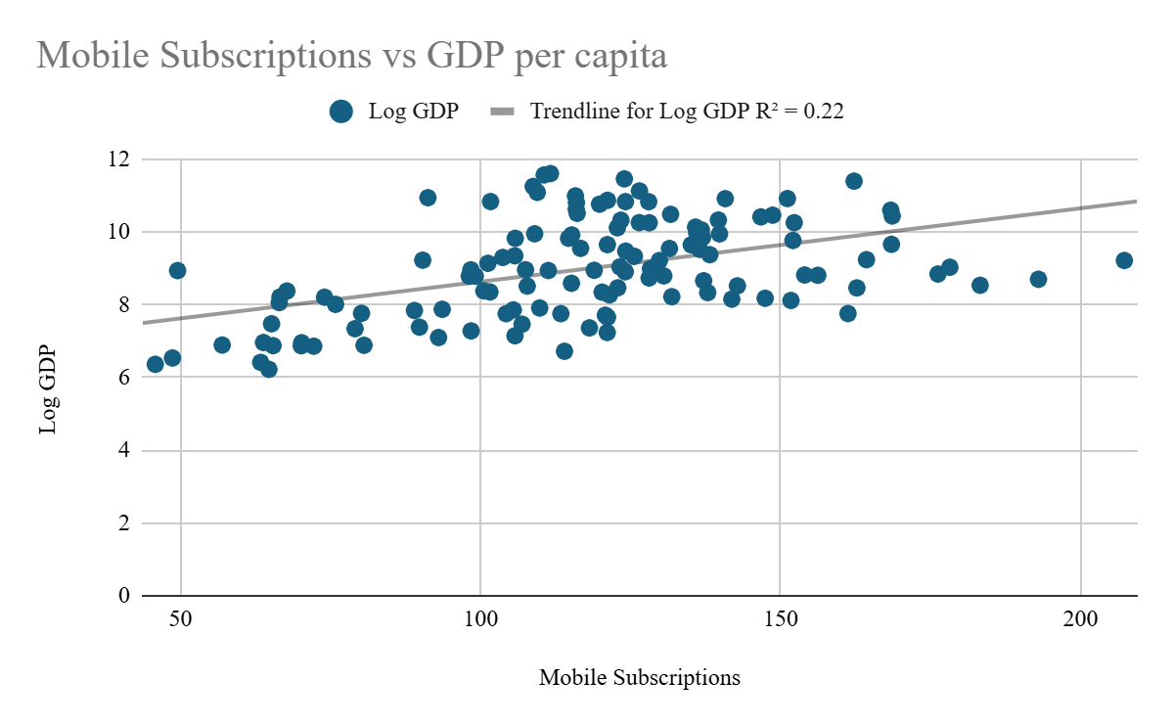
Distribution of Trade, FDI, and GDP per Capita
.

3.7 Global Income Inequality:

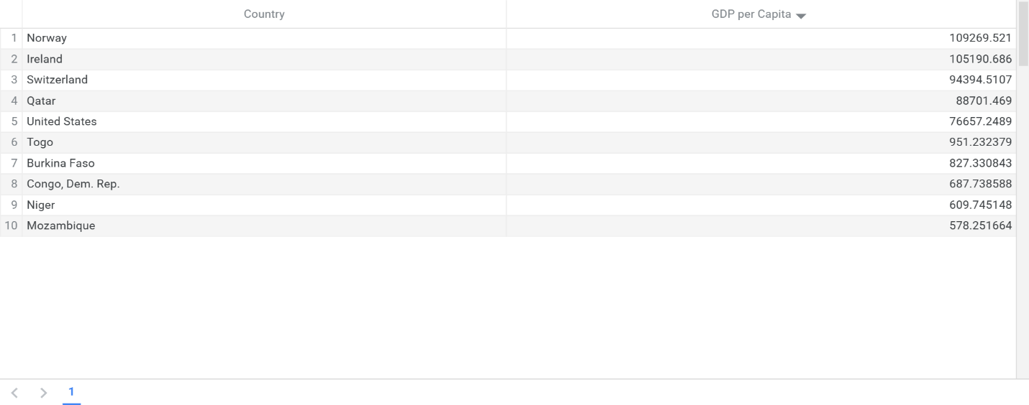

The table chart of top 5 richest VS poor shows 5 poorest countries dramatically illustrates global income inequality. Norway ($109,269) and Ireland ($105,190) lead the richest nations, while Mozambique ($578) and Niger ($609) represent the poorest a gap of nearly 200 times in GDP per capita. Notably, the richest countries tend to have both high trade openness and superior infrastructure, reinforcing the complementary role of these factors.

3.8 Trade Openness and GDP:

To further analyze this relationship, countries were divided into three trade groups based on their trade-to-GDP ratio. Low trade countries (below 60% GDP) had an average GDP per capita of approximately $10,000. Medium trade countries (between 60% and 100% GDP) had an average GDP per capita of approximately $18,000. High trade countries (above 100% GDP) had an average GDP per capita of approximately $23,000. This clear stepwise increase across groups strongly confirms that trade openness is positively associated with economic prosperity countries in the high trade group have more than double the average GDP of low trade countries.

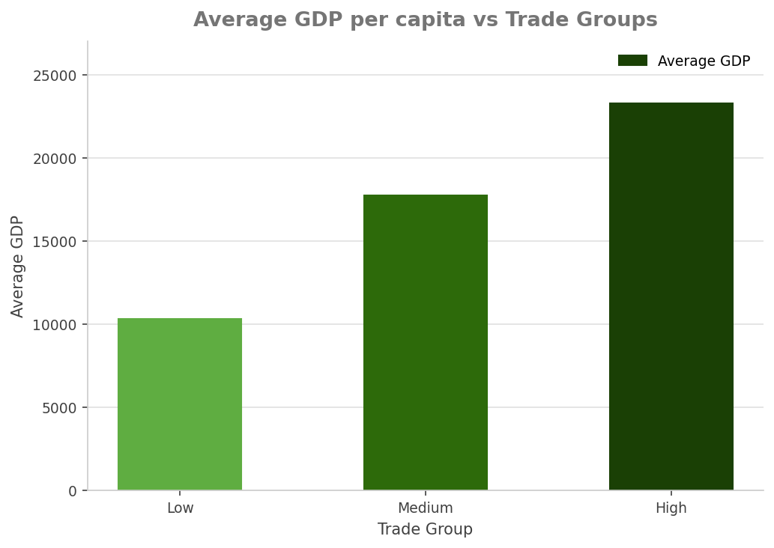
Average GDP per Capita by Trade Openness Group
4. Business Implications
Based on our analysis, we can draw a few actionable recommendations for businesses and policymakers operating in or targeting different markets:
- Policymakers in developing countries should invest in energy infrastructure and digital connectivity alongside trade liberalization policies
- Businesses expanding into emerging markets should assess infrastructure quality as a key indicator of economic potential and market readiness
- Governments should design FDI policies that channel foreign investment into productive sectors rather than purely extractive industries.

5. Conclusion

This study examined the relationship between trade openness, FDI, infrastructure, digital connectivity, and GDP per capita across 125 countries in 2022. The key findings are:
- Electricity consumption is the strongest predictor of economic prosperity (R² = 0.576)
- Mobile subscriptions show a moderate positive relationship with GDP (R² = 0.22)
- Trade openness shows a positive relationship with GDP (R² = 0.1589), with high trade countries having more than double the average GDP of low trade countries
- FDI shows a limited direct relationship with GDP, though its effectiveness depends on complementary institutional and human capital factors
- These findings collectively suggest that trade openness contributes meaningfully to economic prosperity, but its impact is amplified when supported by strong infrastructure and digital connectivity.
- Business Implications:
- Policymakers in developing countries should invest in energy infrastructure and digital connectivity alongside trade liberalization policies
- Businesses expanding into emerging markets should assess infrastructure quality as a key indicator of economic potential and market readiness
- Governments should design FDI policies that channel foreign investment into productive sectors rather than purely extractive industries

Limitations:
This study uses cross-sectional data from a single year (2022), which cannot establish causality. Regional aggregates were included alongside individual countries which may introduce some double counting. Future research should use panel data over multiple years to better capture dynamic relationships between trade, investment, and economic growth.

References
World Bank. (2022). World Development Indicators. Retrieved from https://datatopics.worldbank.org/world-development-indicators.

