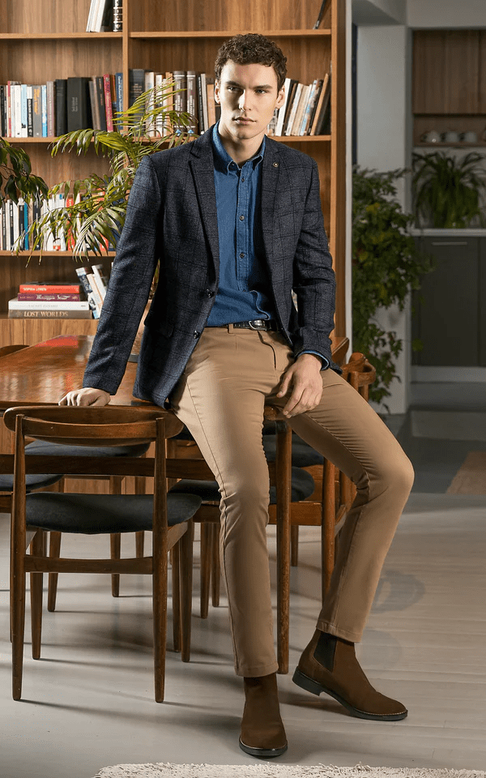**CASUAL COAT CHARCOAL GREY**

Sale priceRs.21,196.00

Self checked fabric notch lapel two-button style coat is a true stunner! The chest welt pocket and front flap pockets add a touch of sophistication, while the two side vents at the back ensure comfort and ease of movement.elbow patches add a unique and stylish flair, And let's not forget about the special charcoal lapel pin. You're ready to make a statement with this ensemble!