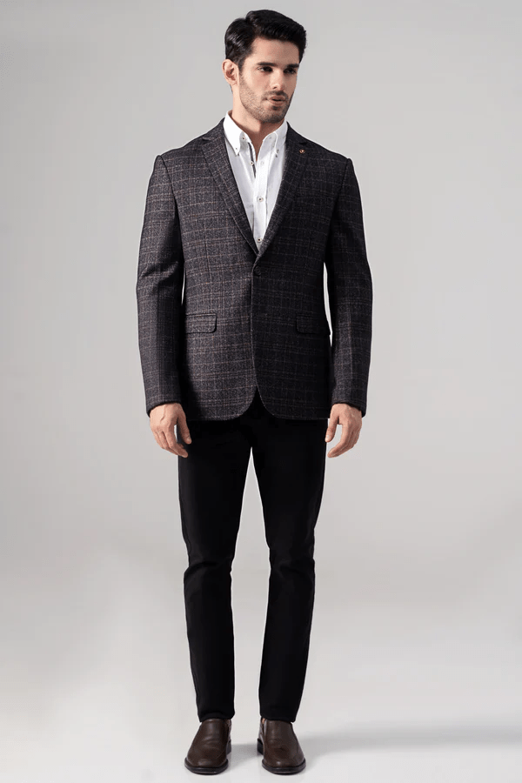**CASUAL COAT GREY KHAKI**

Self checked fabric notch lapel two-button style coat is a true stunner! The chest welt pocket and front flap pockets add a touch of sophistication, while the two side vents at the back ensure comfort and ease of movement. And let's not forget about the special charcoal lapel pin. You're ready to make a statement with this ensemble